Wrapper

Integer -> Double is not possible as they all belong to Number Class. Siblings

Interger-> int (AutoUnboxing) – double (implicit type cast)

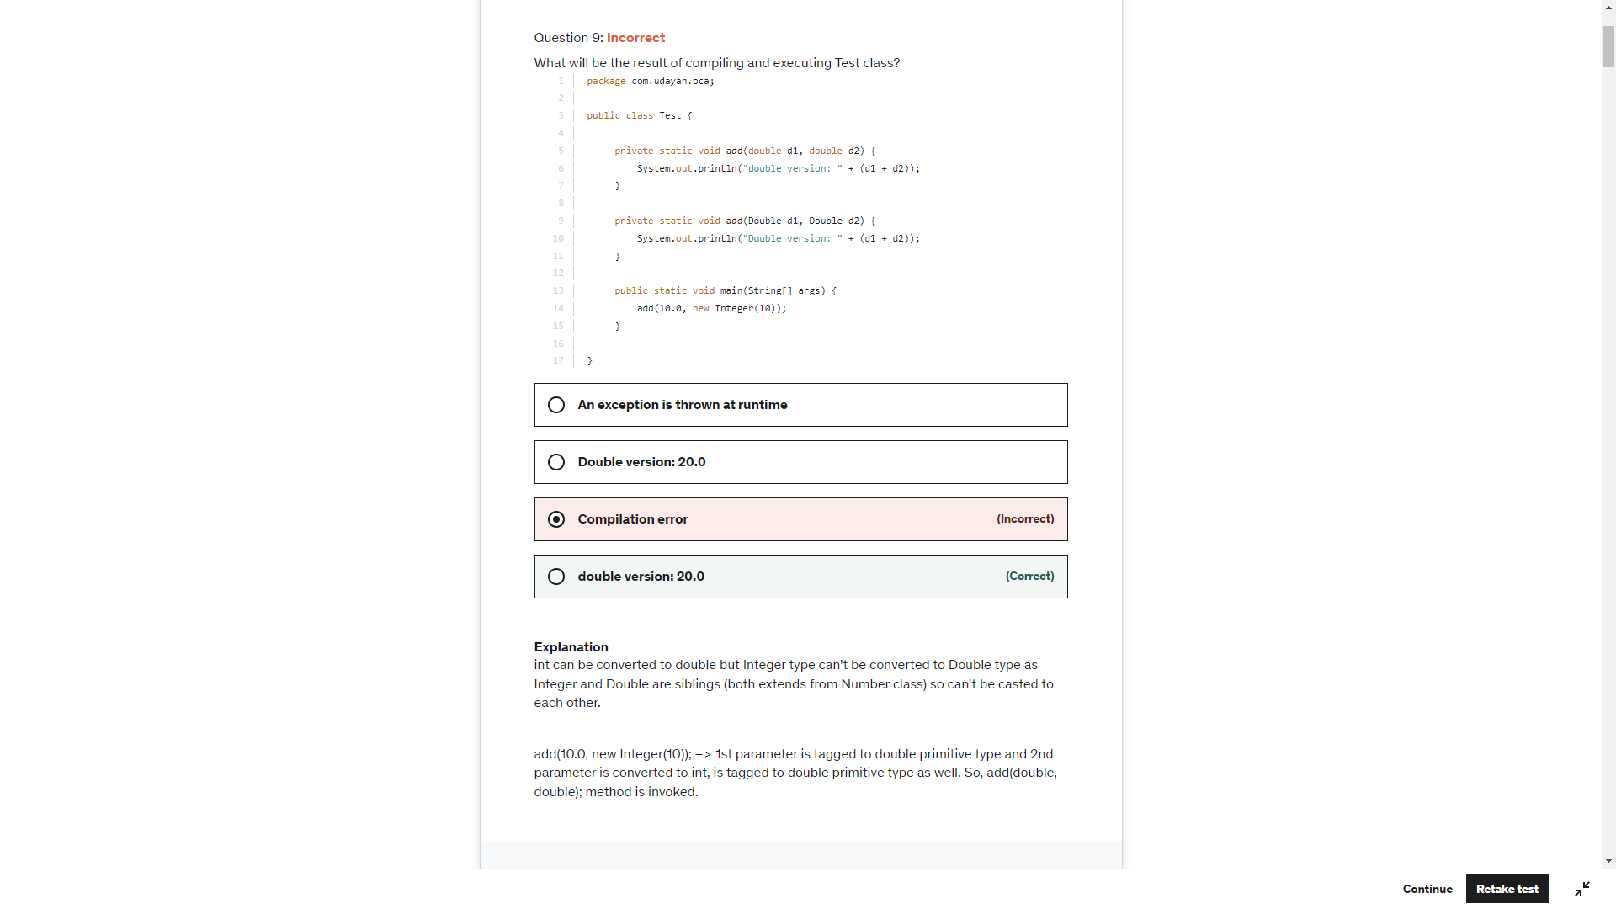

**Two instance of following wrapper objects**

**Boolean, Byte ,**

**Character from (\u0000 to \u007f (7f equals to 127))**

**Short and Integer from -128 to 127.  (Integer and short between value of -128 to 127, byte range) , created through autoboxing will always be same if their primitive values are same:**

Integer d2 = 127;  
Integer d3 = 127;  
System.*out*.println(d2==d3); - True

Boolean b = true;  
Boolean a = true;  
System.*out*.println(a==b); - True

Boolean b = null;  
System.*out*.println(b); -> null

System.*out*.println(b.toString()); -> Null Pointer Exception

Boolean b = null;  
if(b){ -> Unboxing of b produces null pointer exception  
 System.*out*.println("1");  
}

**For 1st statement, list.add(27); => Auto-boxing creates an integer object for 27.**

**For 2nd statement, list.add(27); => Java compiler finds that there is already an Integer object in the memory with value 27, so it uses the same object.**

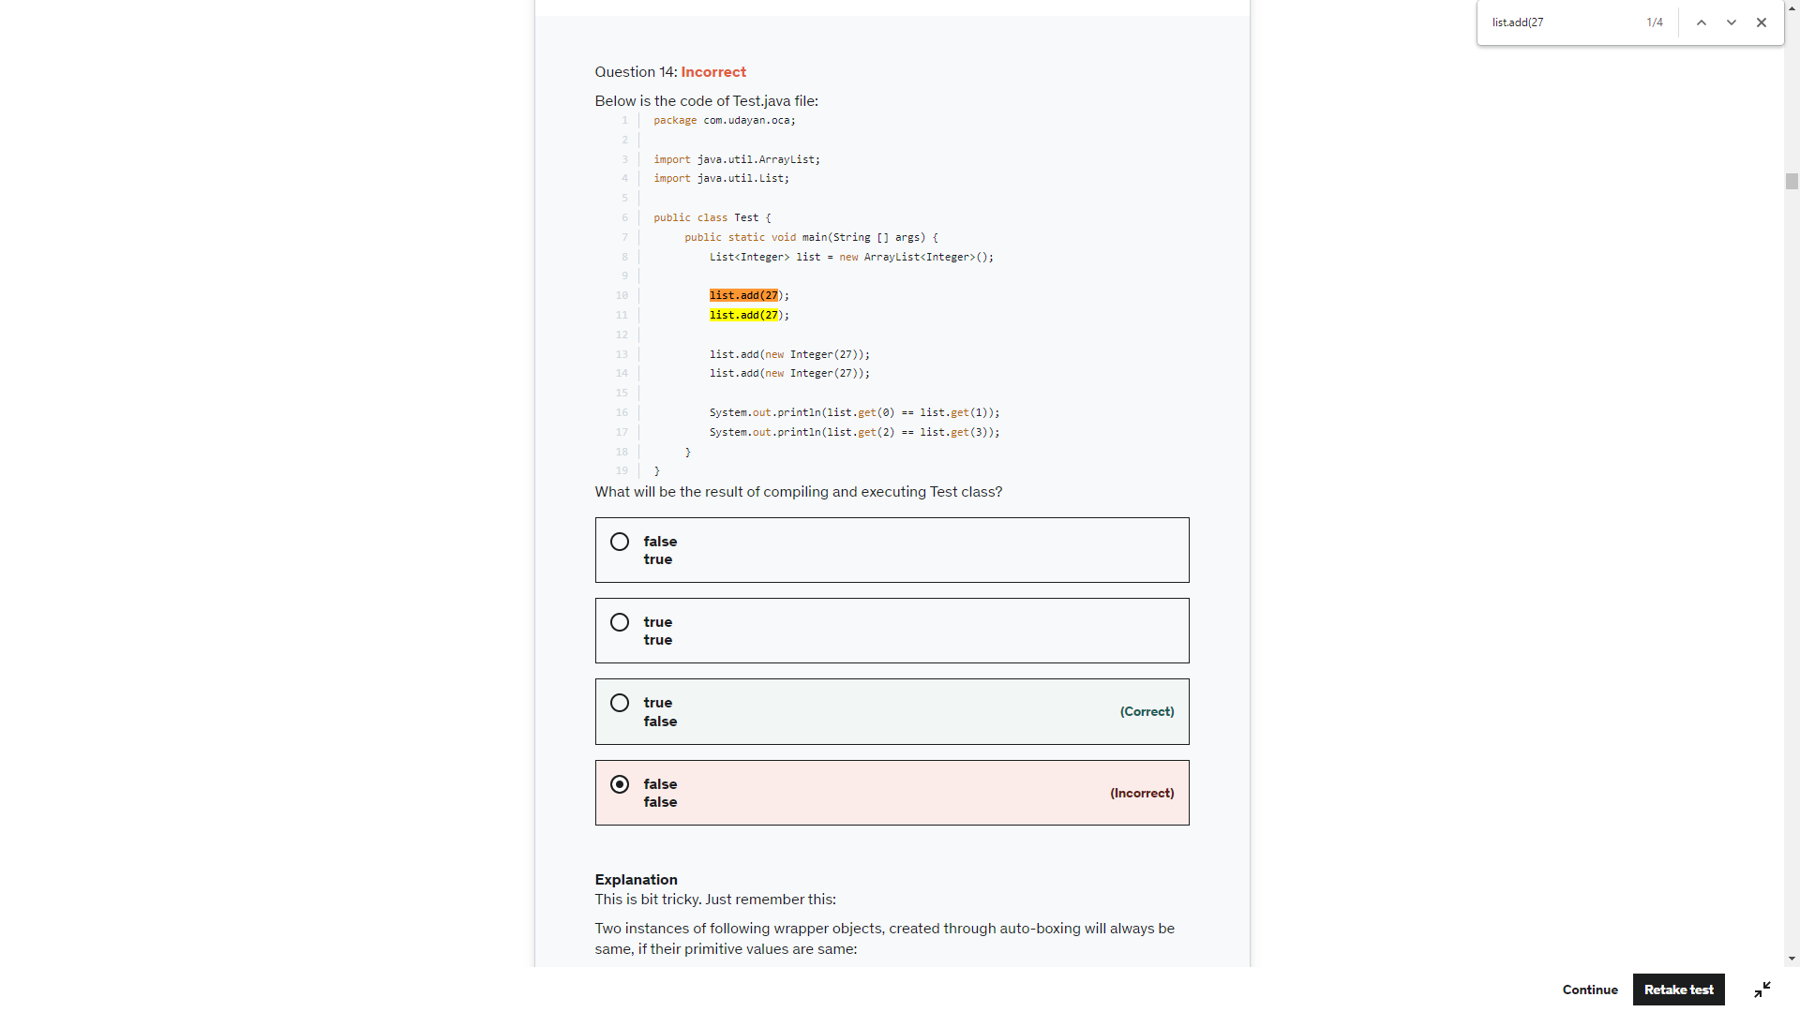

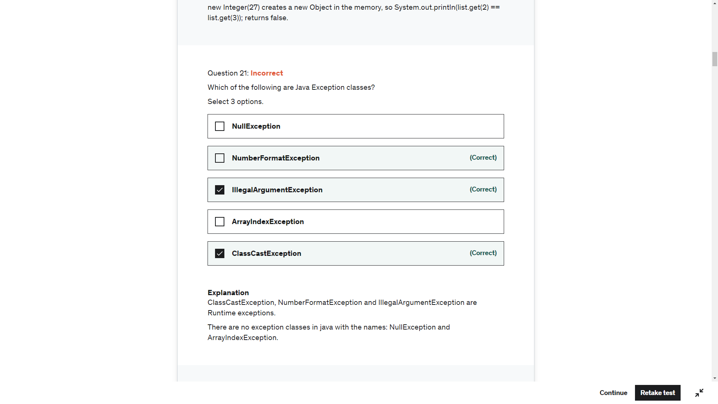

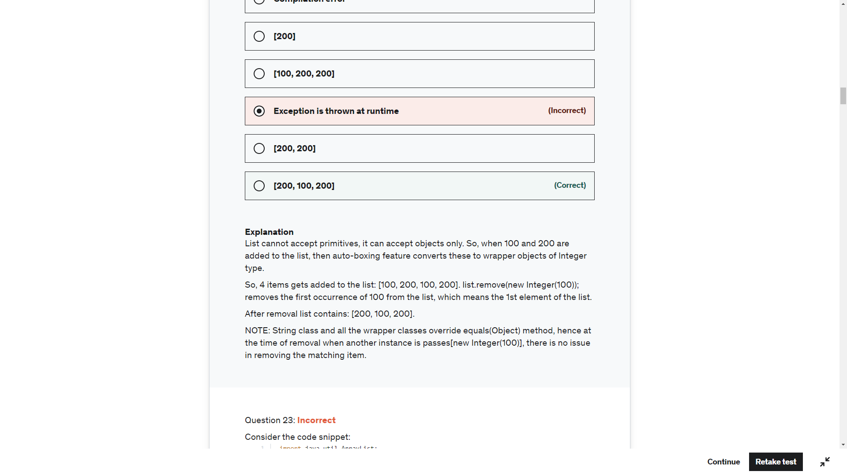

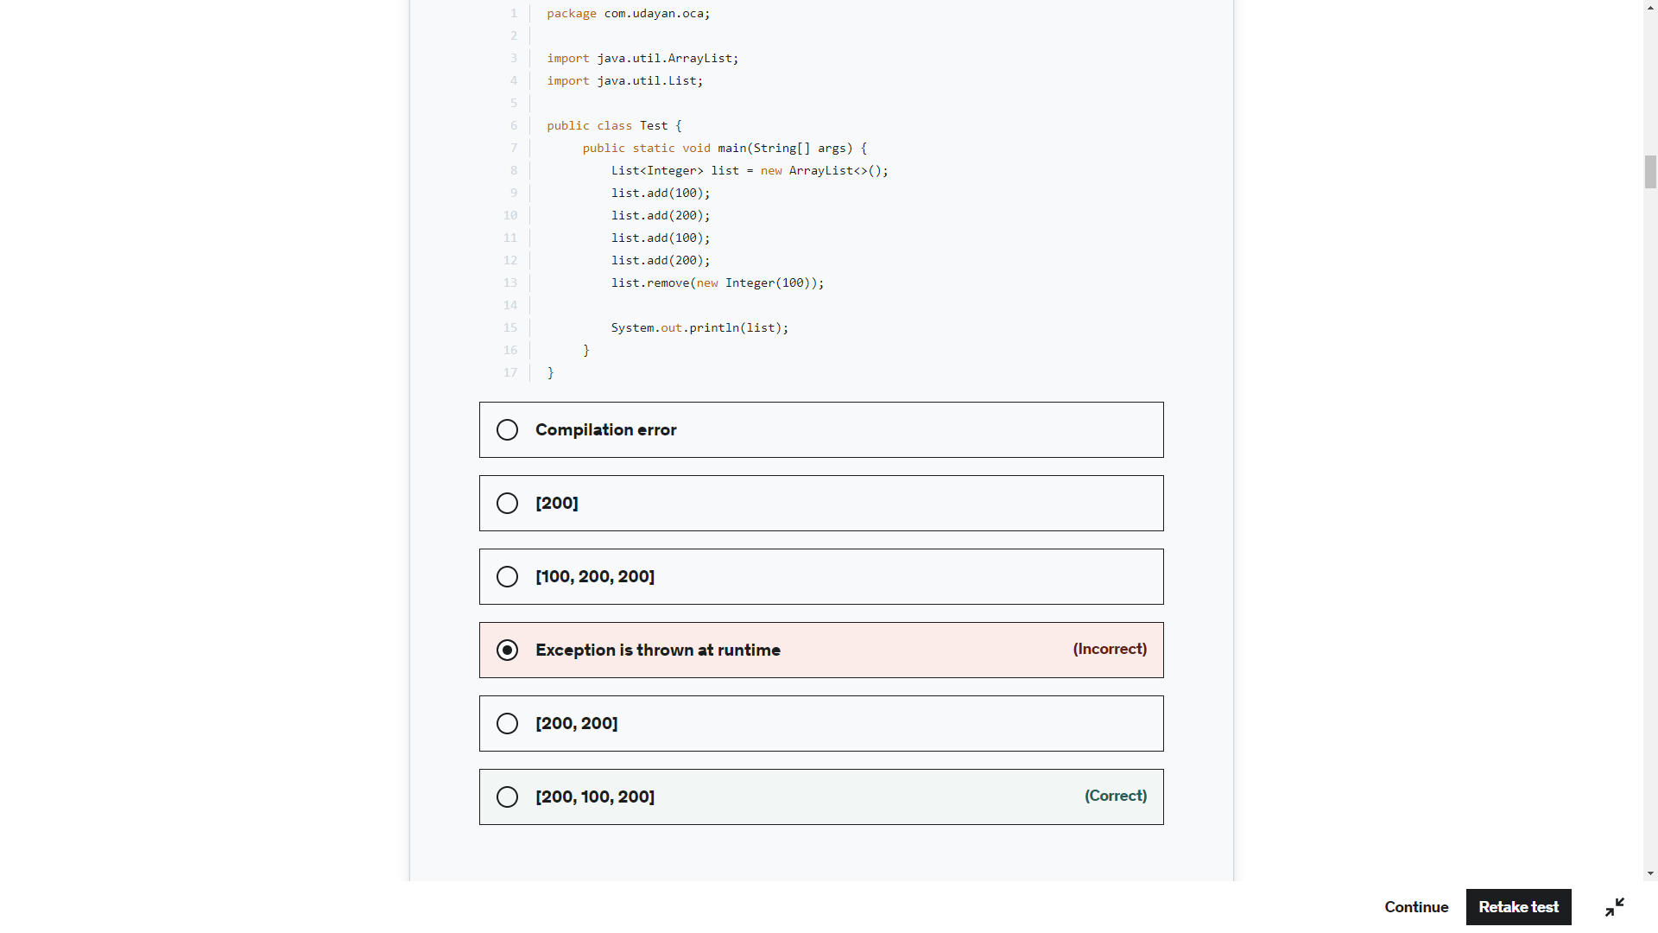

List<> list = new ArrayList(); - CE – Java Illegal start of type

List<> list = new ArrayList<>(); CE Illegal start of Type for List<>

List<> list = new ArrayList<String>(); CE Illegal start of Type for List<>

List list = new ArrayList<String>(); Valid (Warning) – Raw Use

List list = new ArrayList<>(); Valid (Warning) – Raw Use

List list = new ArrayList(); Valid (Warning) – Raw Use

List<String> list = new ArrayList(); Valid (Warning) – Raw Use

List<String> list = new ArrayList<>(); Valid No Warning

List<String> list = new ArrayList<String>(); Valid No Warning

Type parameter can be ignored from right side but <> need to there to avoid warning

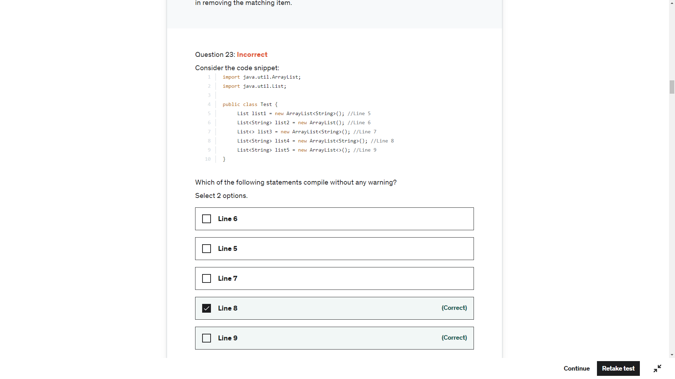

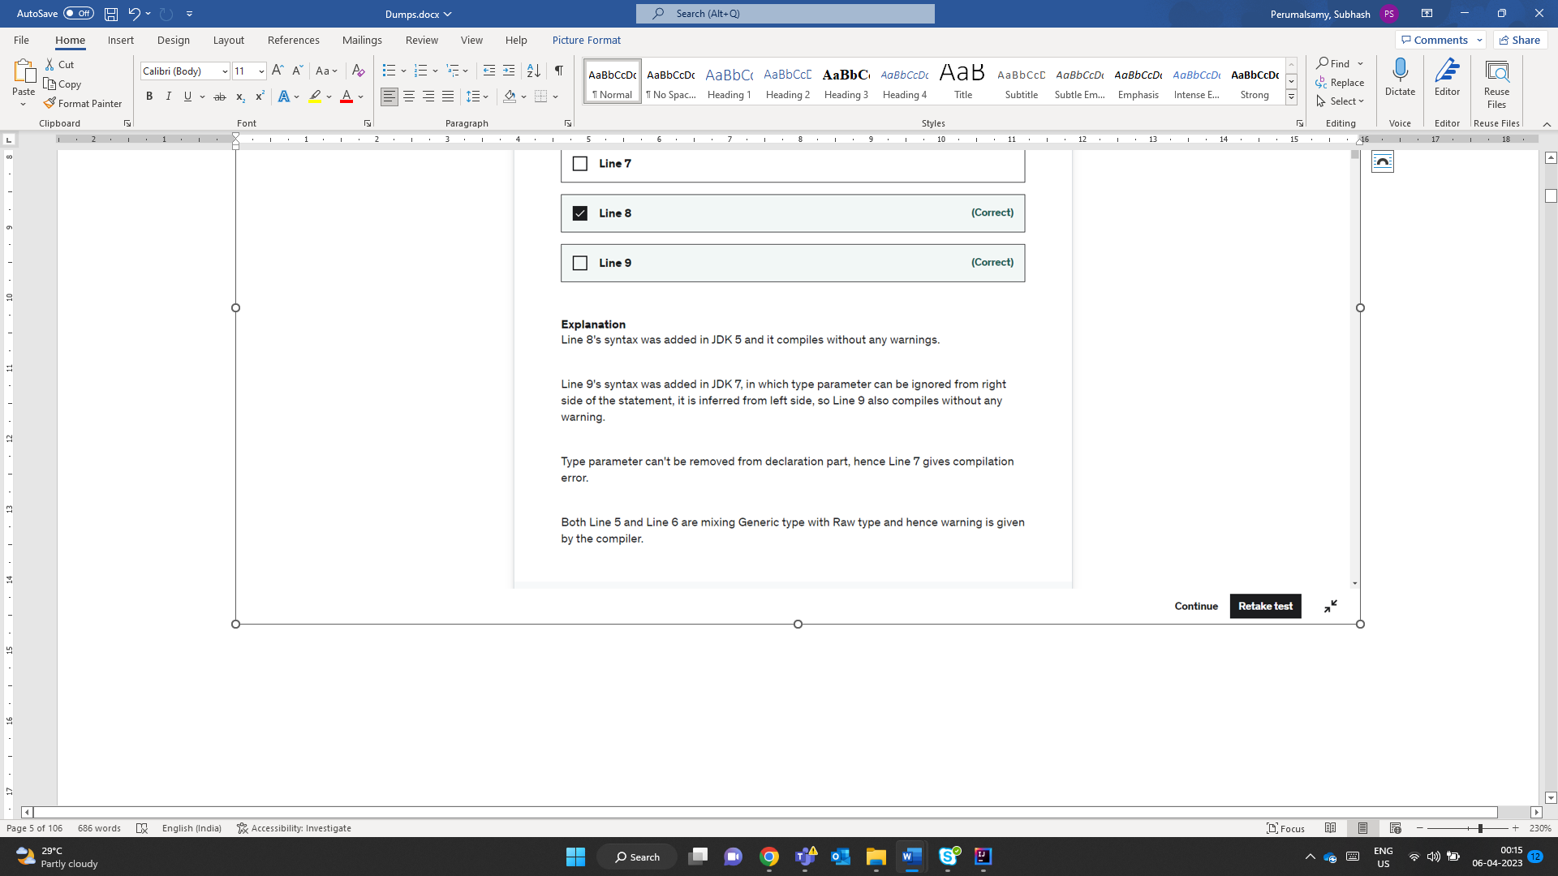

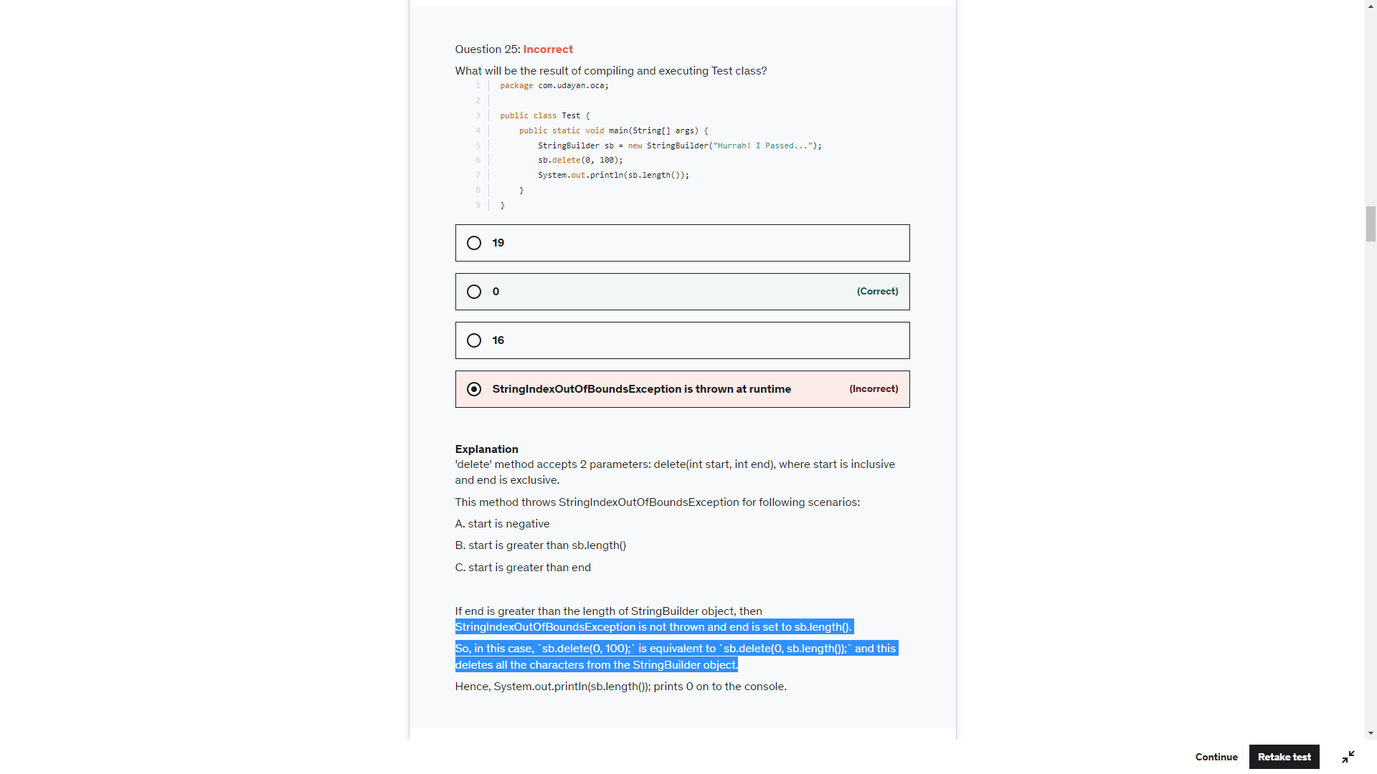

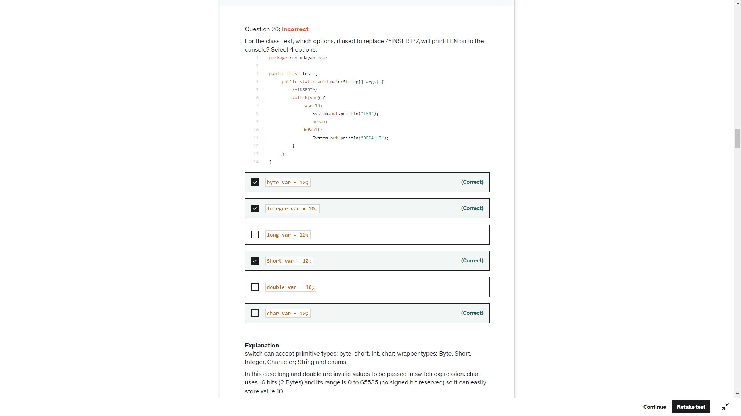

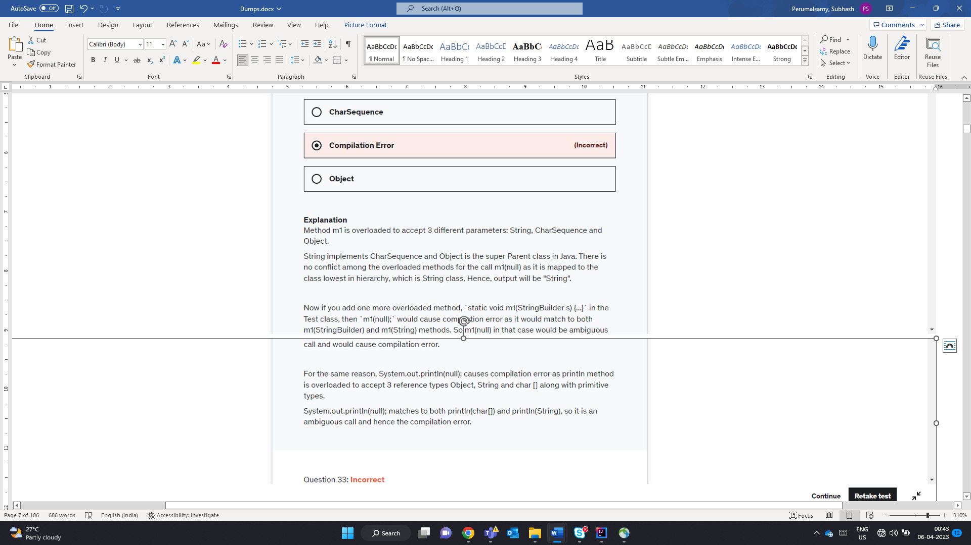

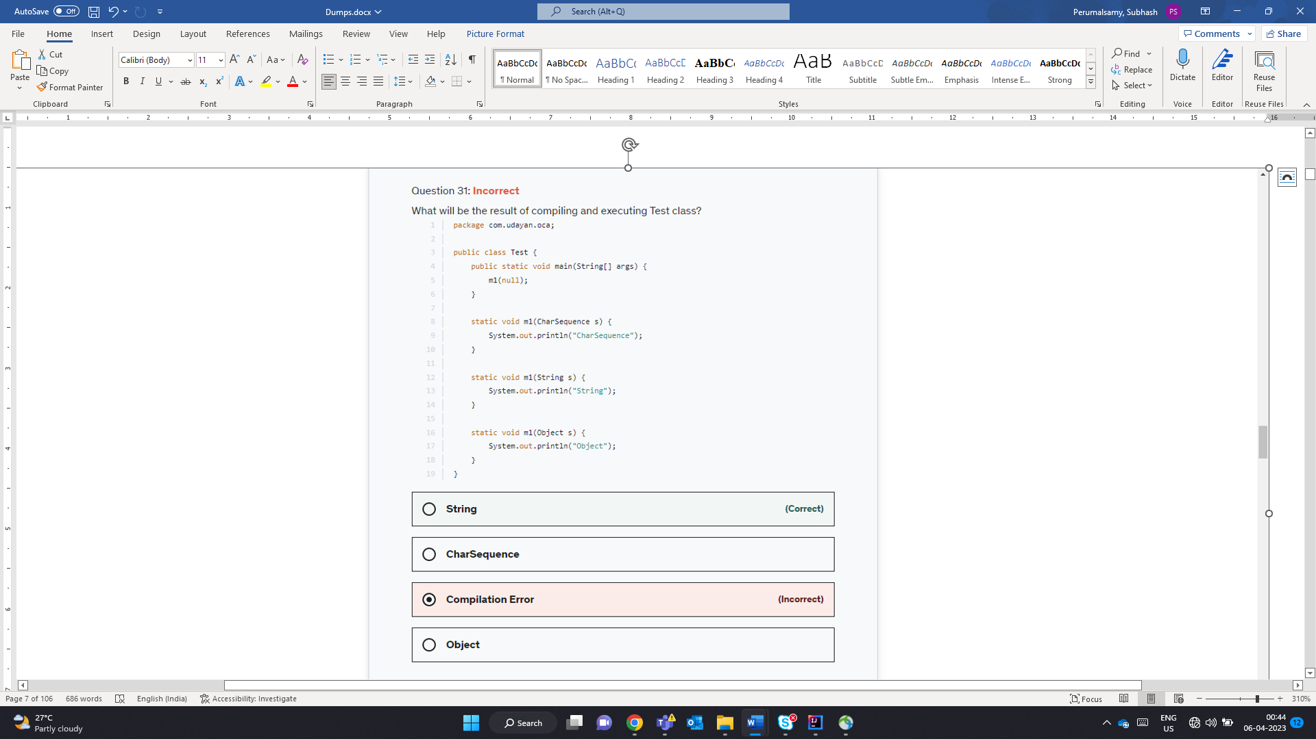

Double d = null;  
System.*out*.println(d+""); - No CE or RE

System.*out*.println(d+12); this would perform unboxing and null.doubleValue() – RunTime Exception

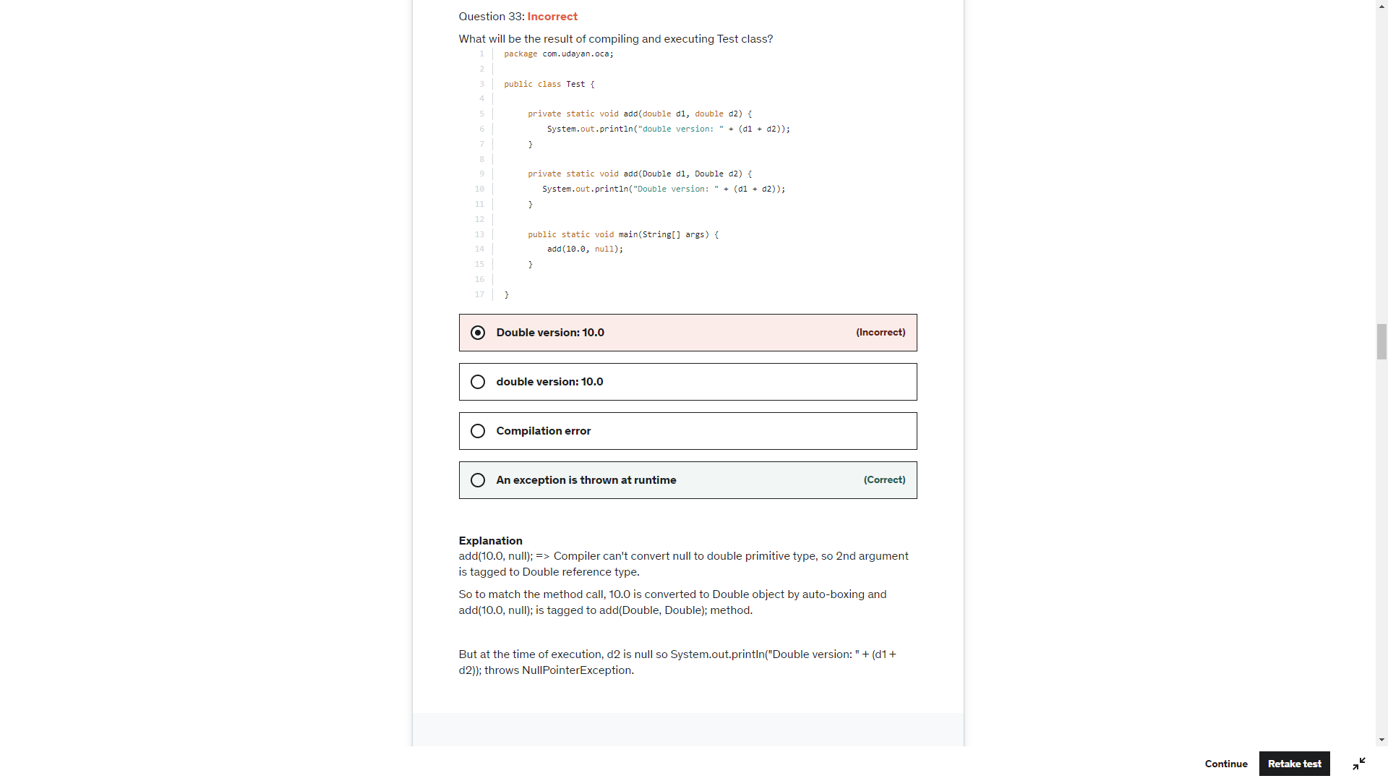

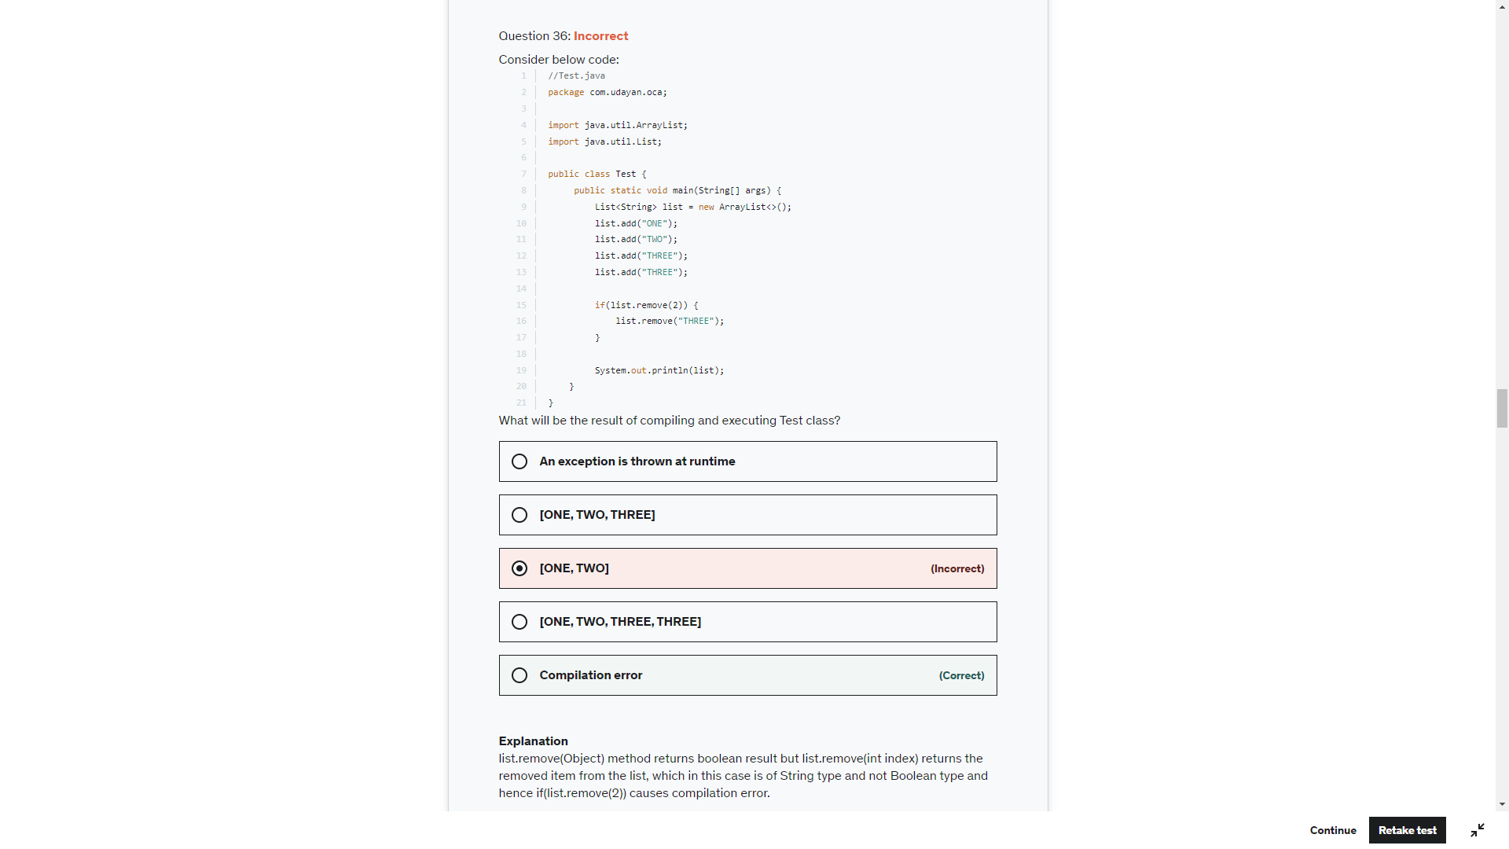

List.remove(0) -> returns the object -> null

List.remove(null)-> returns true if the object is found

If null is + “” -> No Run Time error. If it is an expression then RE

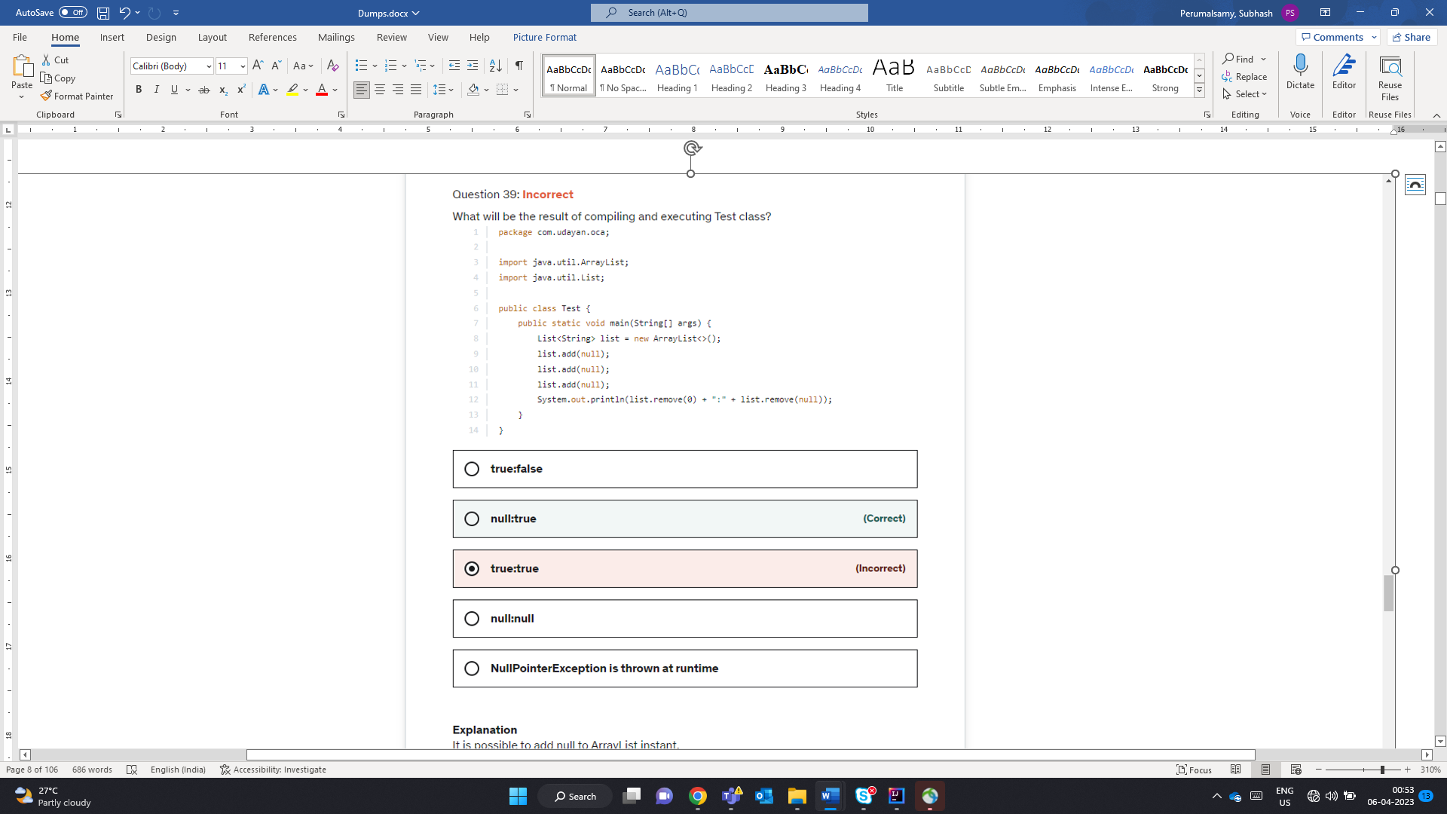

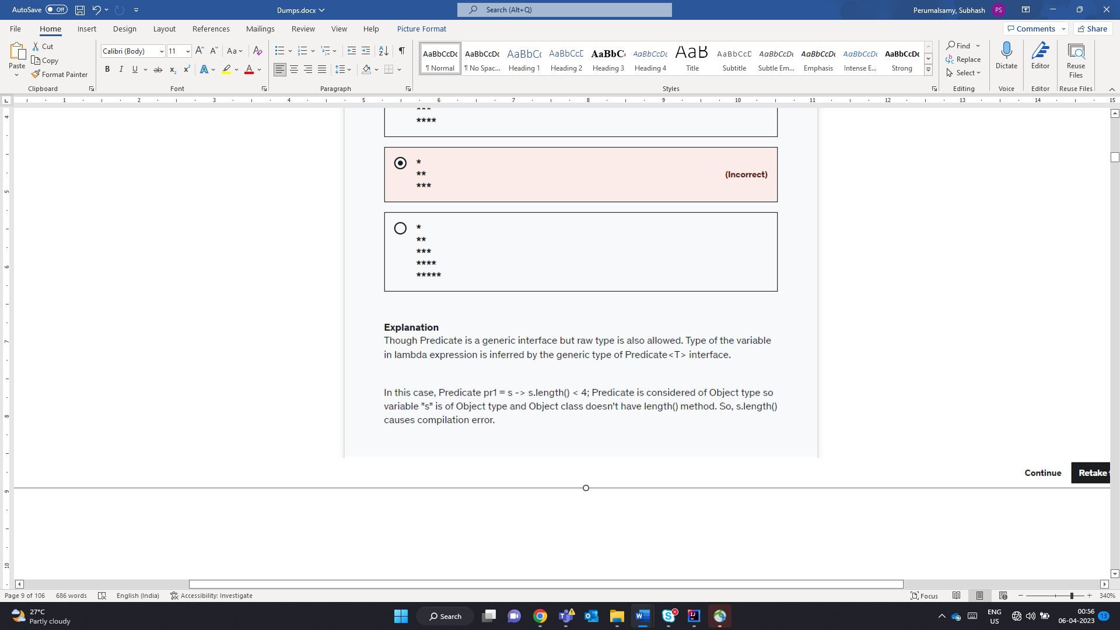

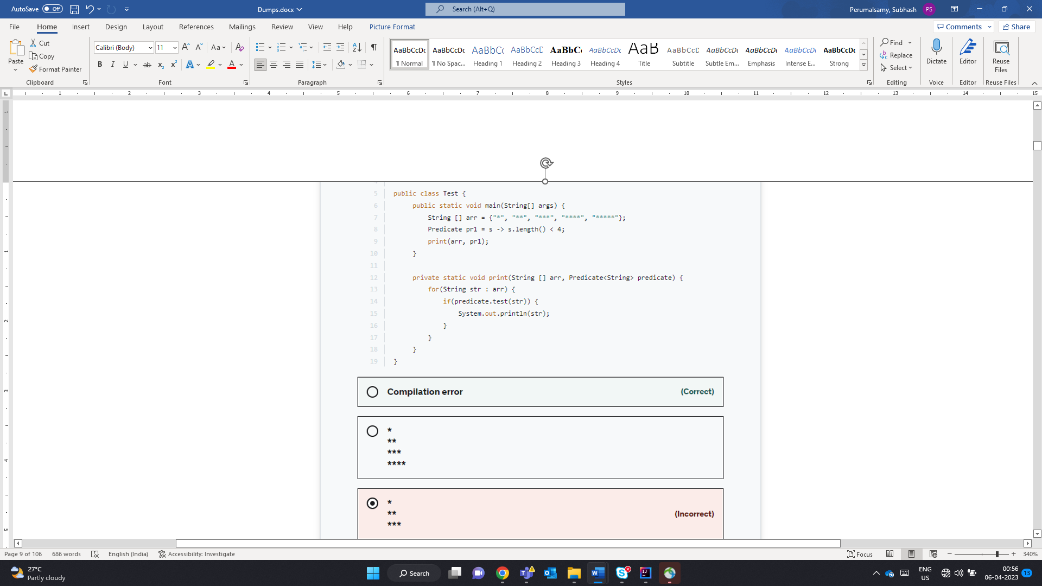

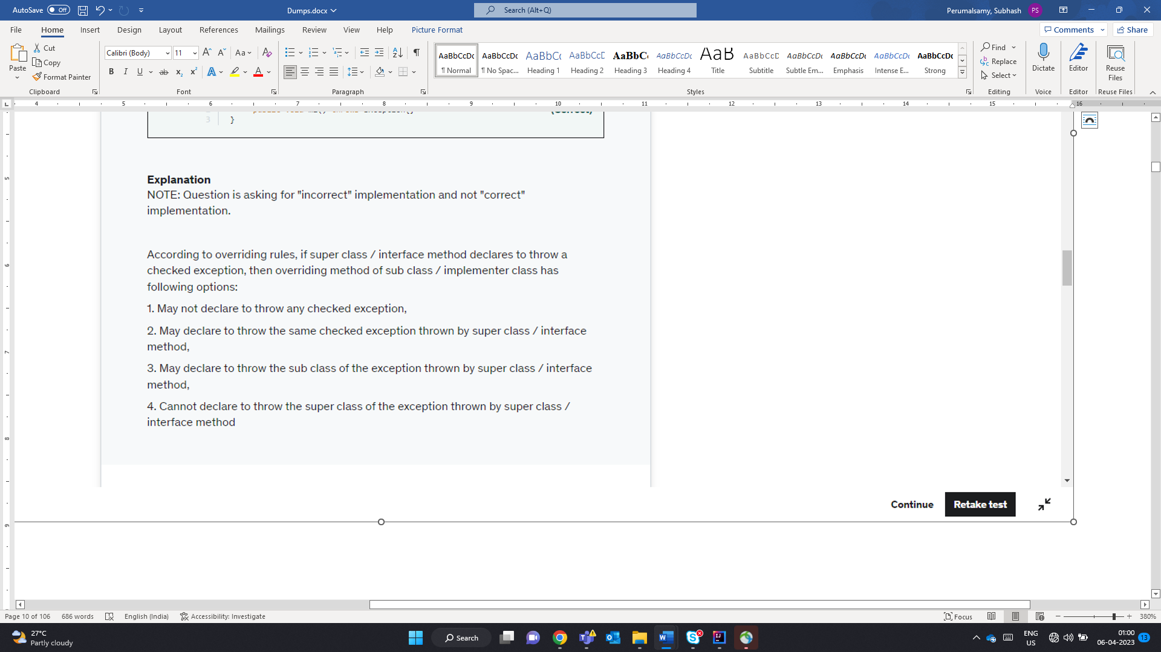

InCorrectly Implements

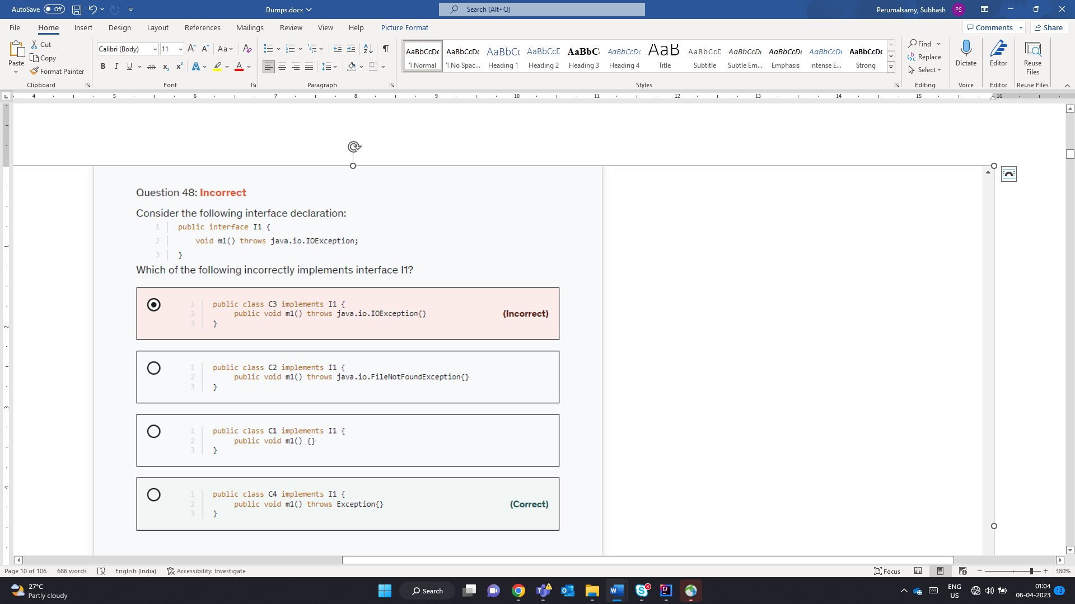

* **If the superclass method does not declare an exception**
  + If the superclass method does not declare an exception, subclass overridden method cannot declare the checked exception but it can declare unchecked exception.
* **If the superclass method declares an exception**
  + If the superclass method declares an exception, subclass overridden method can declare same, subclass exception or no exception but cannot declare parent exception.

When a new String object is created using new Keyword – 2 Objects gets created – Heap Area and SCP.

Compile Time constants -> Literals or Final Variable

Compile time string computation using concatenation will be referred is SCP

RunTime String Computation using concatenation will be referred are newly created. Therfore distinct (If the resultant Expression is not a constant Expression)

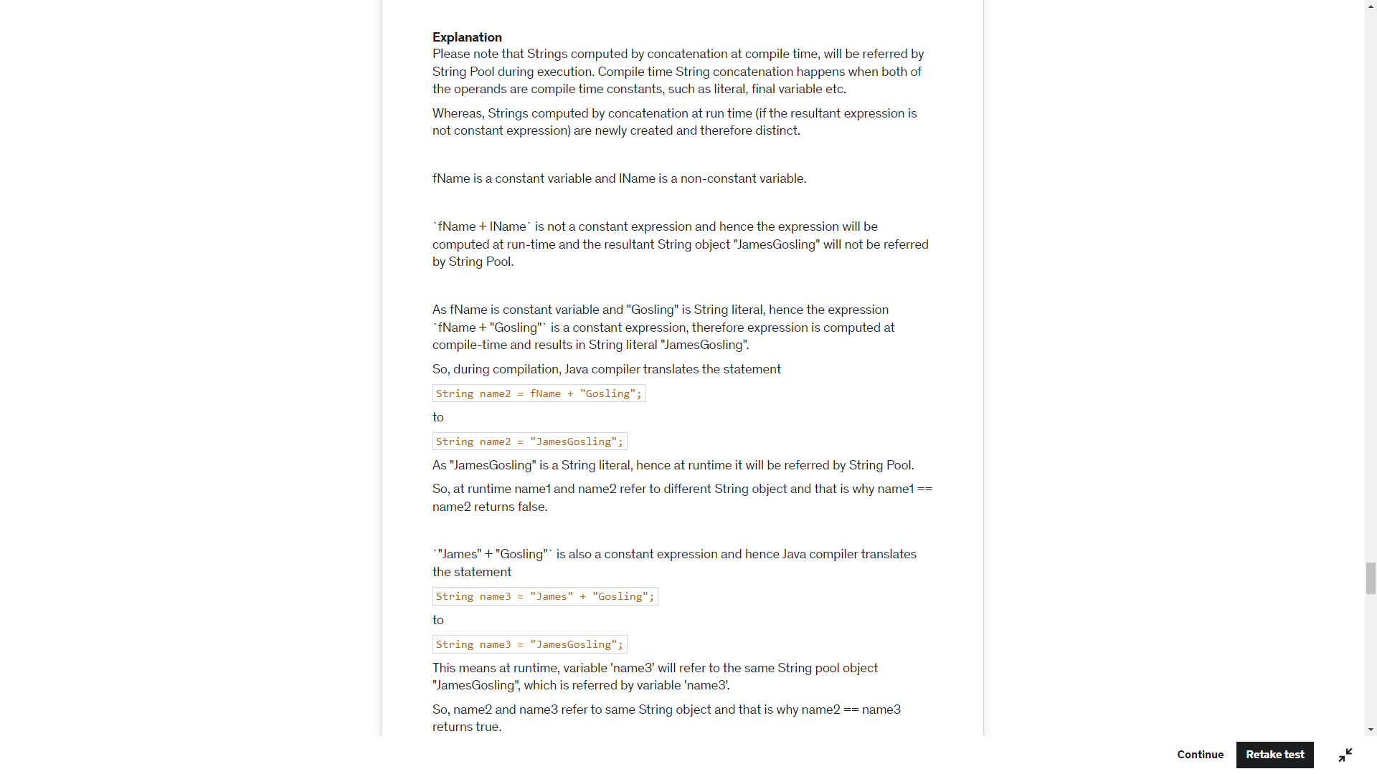

Fname – Constant

Lname – non constant

Name1 = fname+lname -> Non Constant -> Run Time NewObject

Name 2-> fname+ “Cosling” -> Final Constant + Literal Constant -> String Pool (JamesGosling)

Name 3 -> String Pool (JamesGosling)

False

True

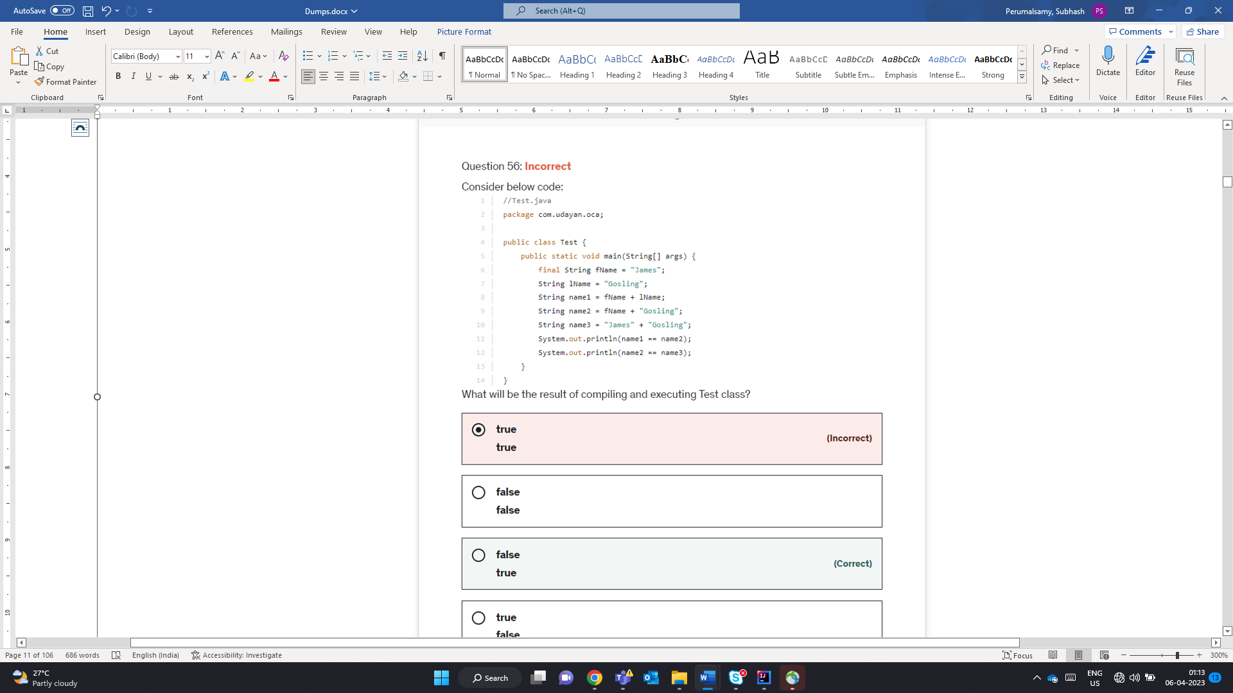

Only long float and double can be suffixed by l f d

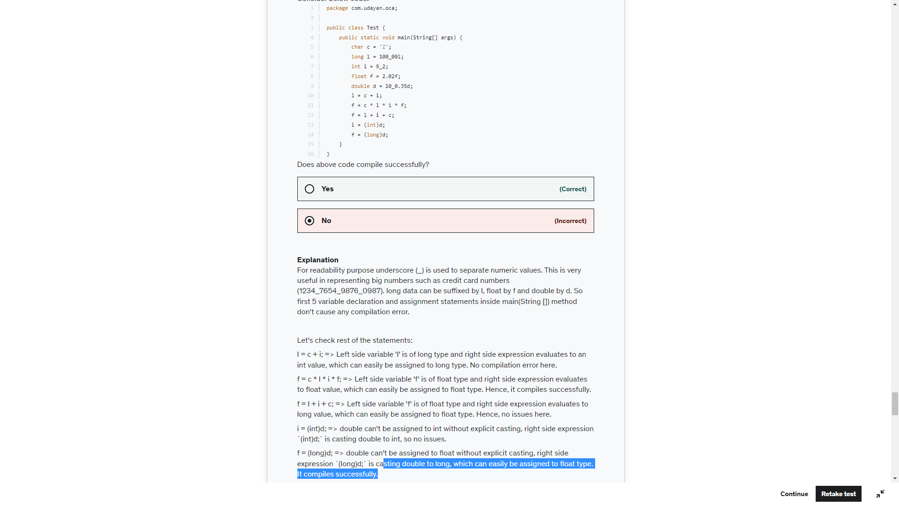

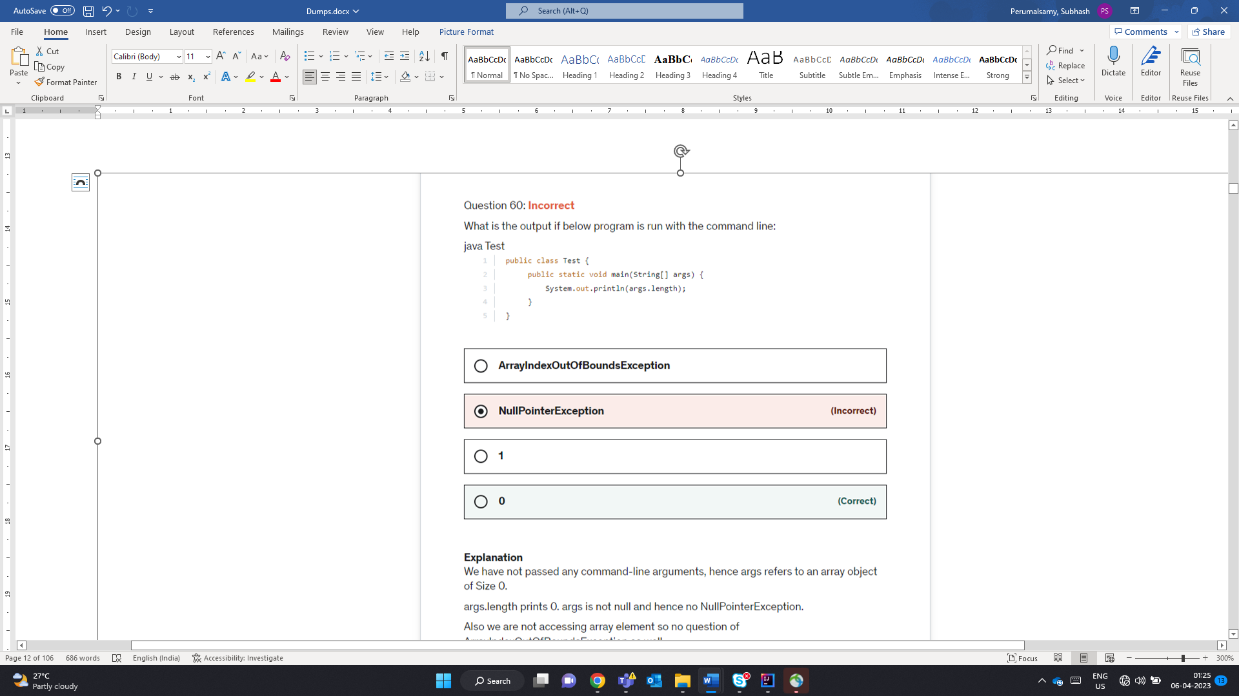

All wrapper classes are immutable. Any operations would create a new object and not modify the old

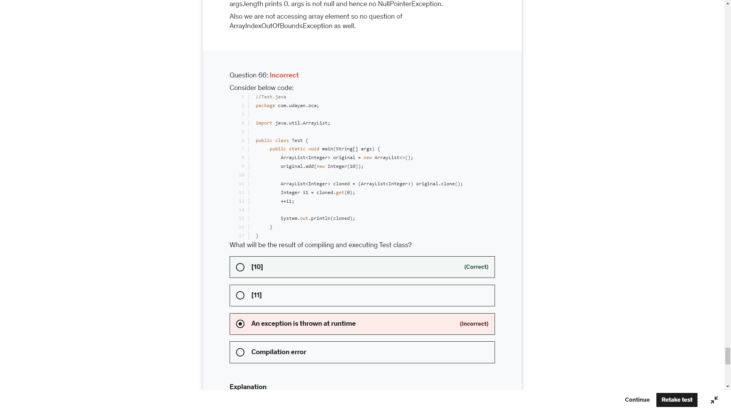

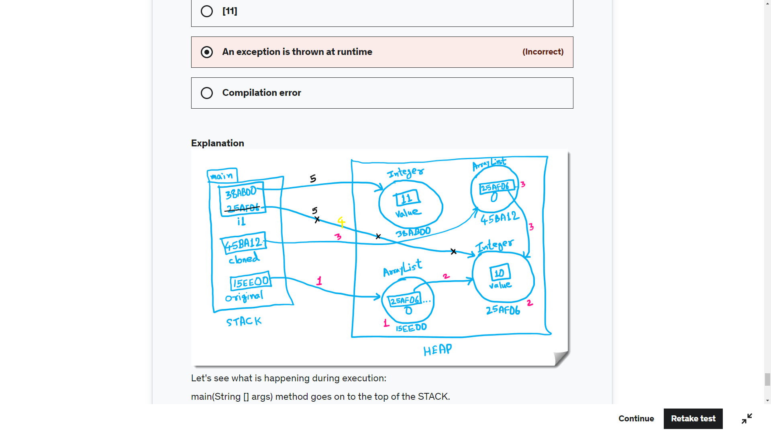

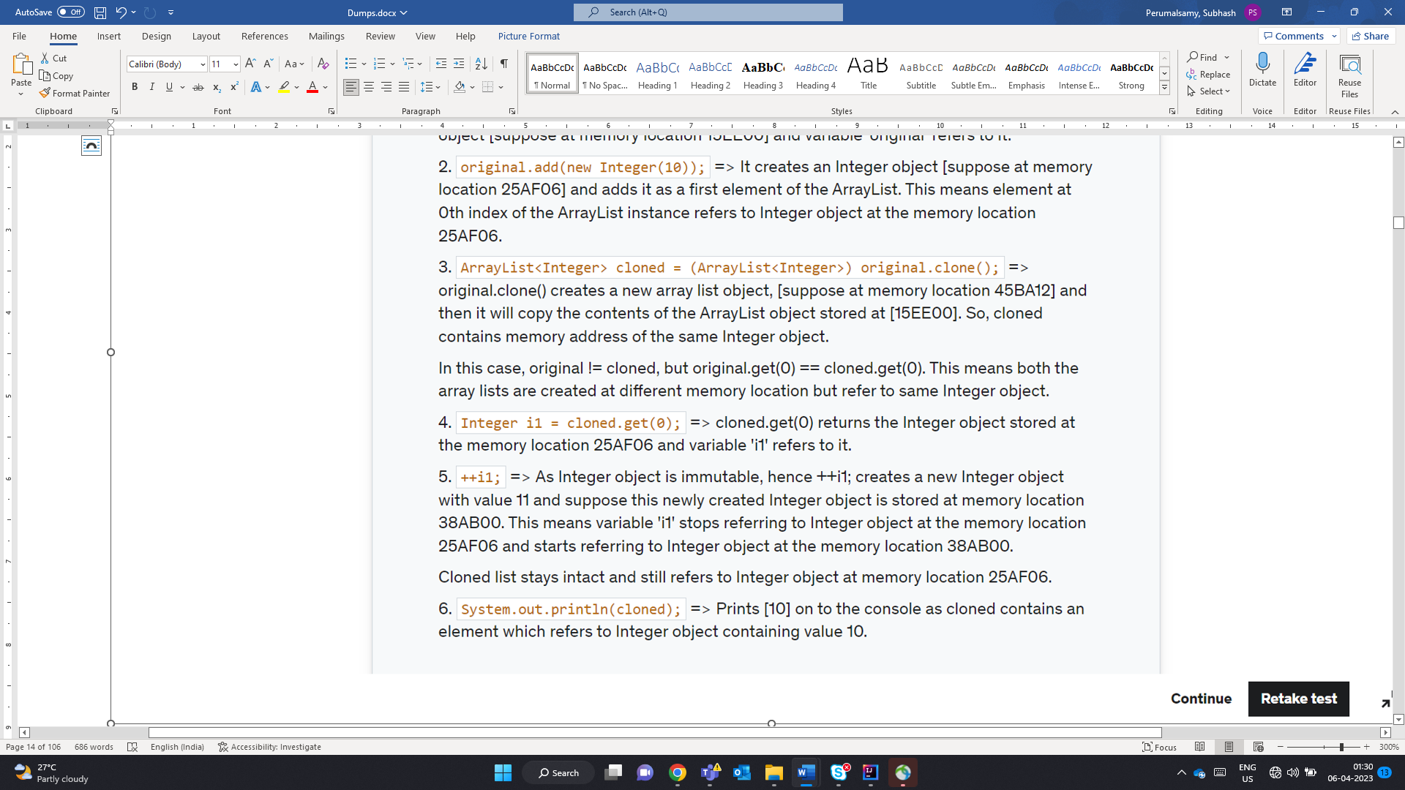

M – Month

m- minute

D- Day of the year

d- day of the month

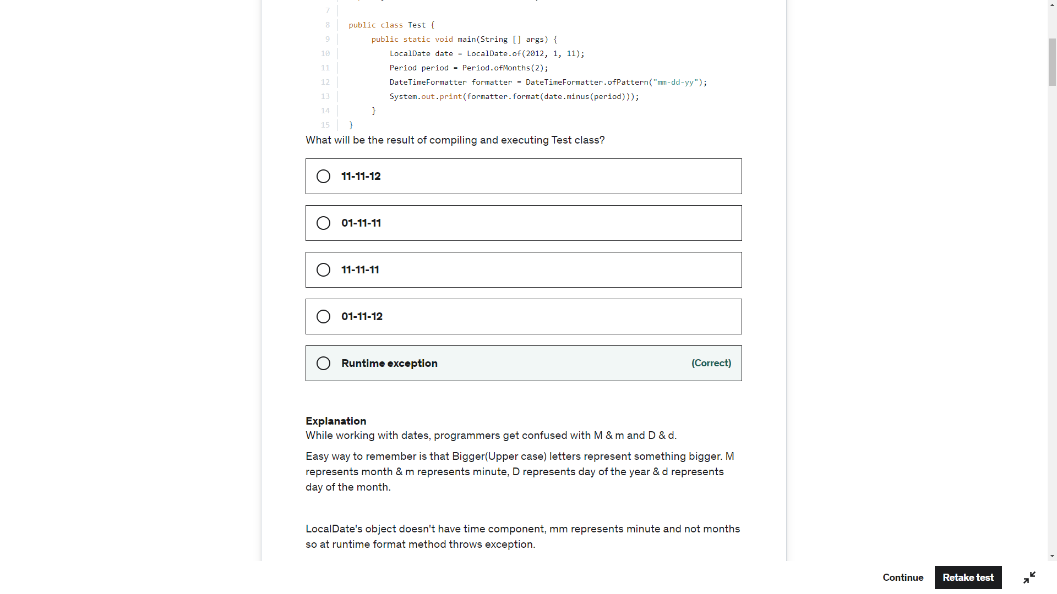

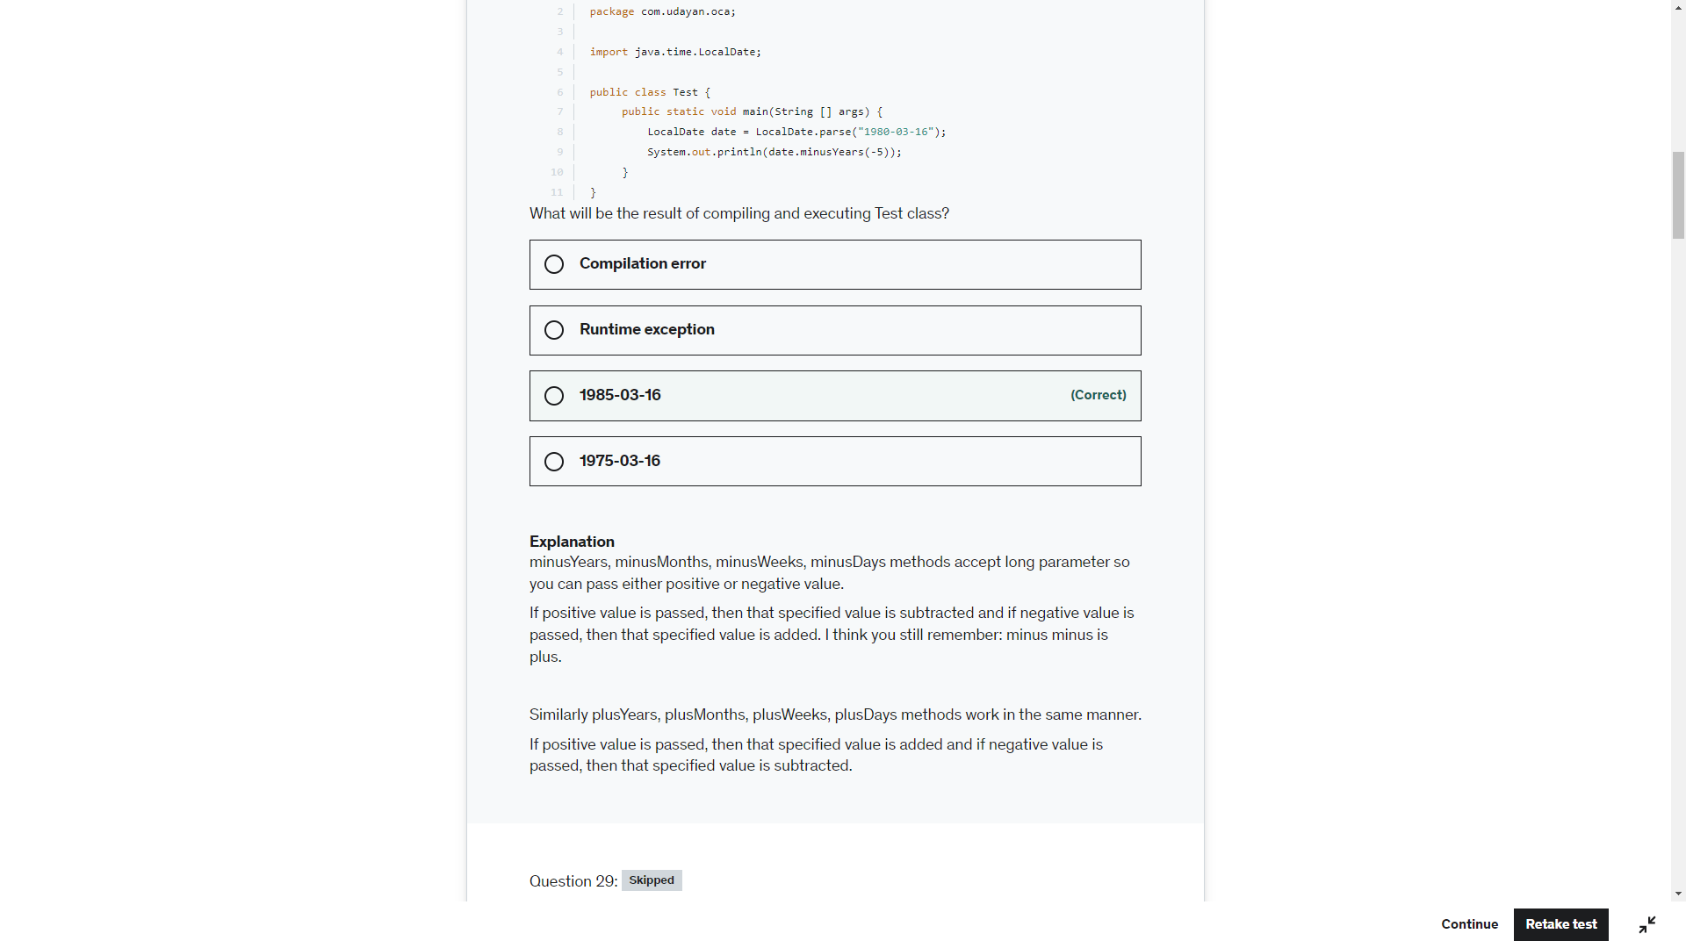

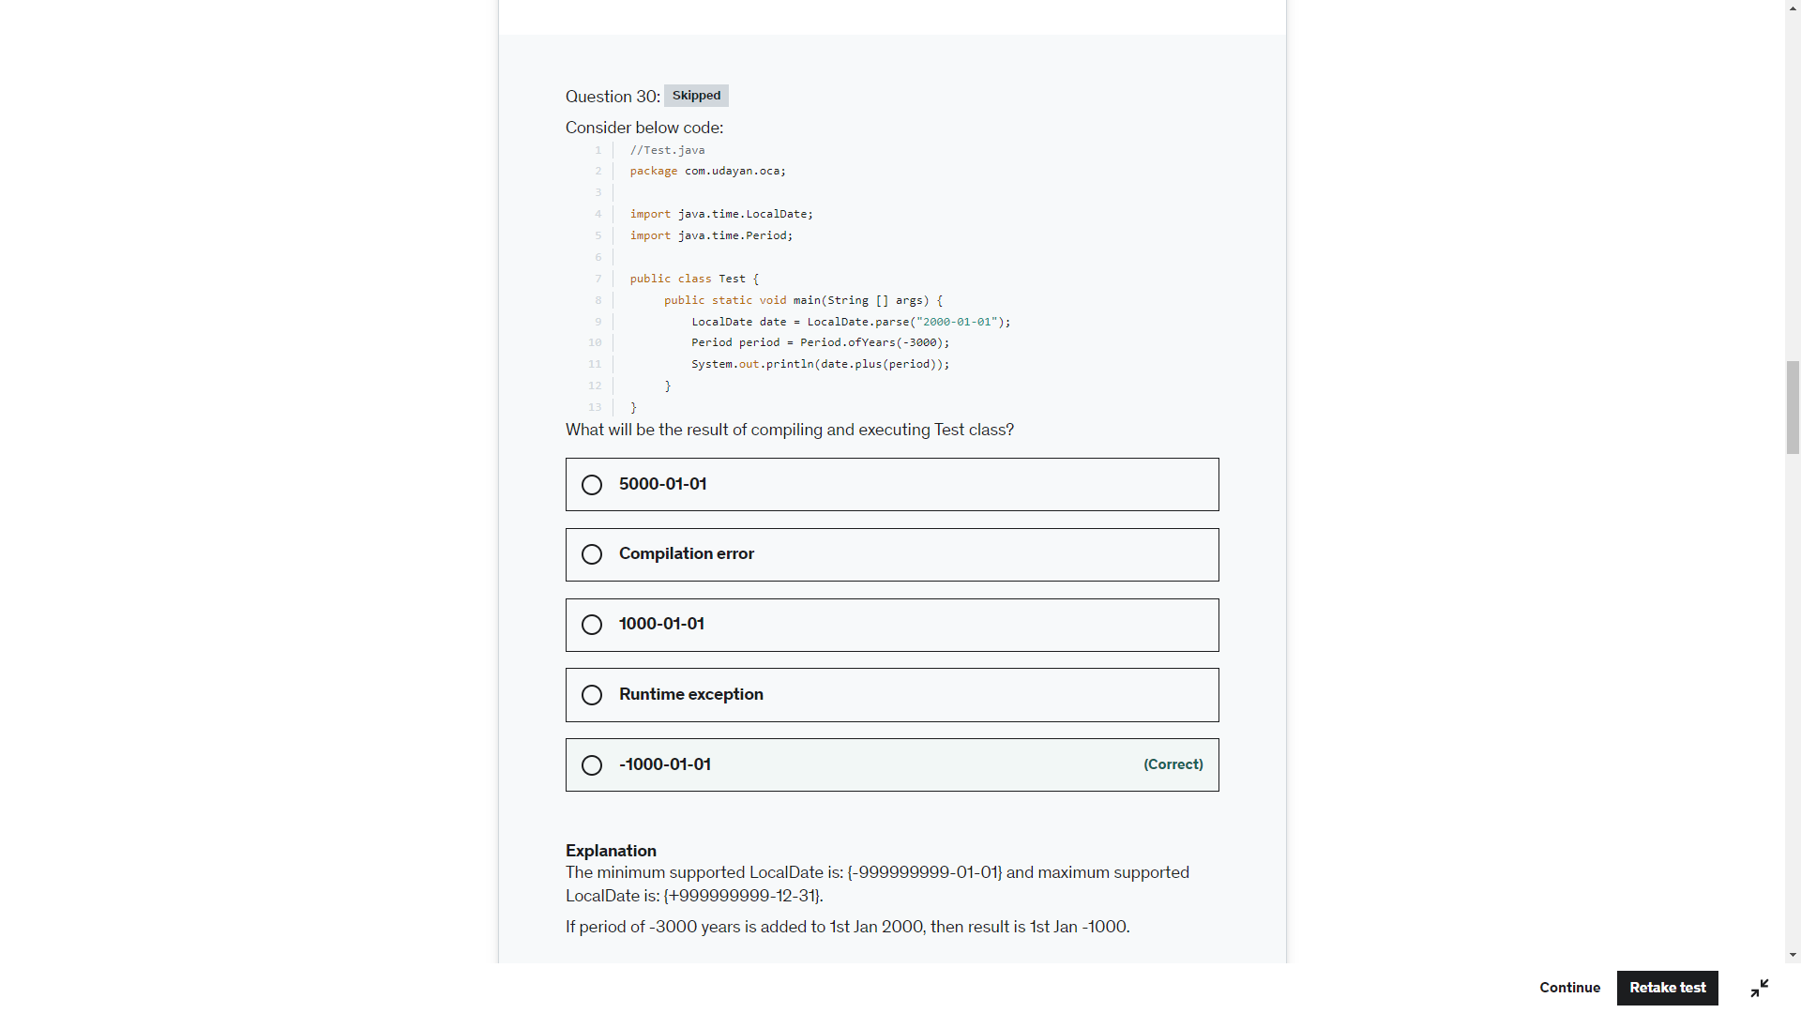

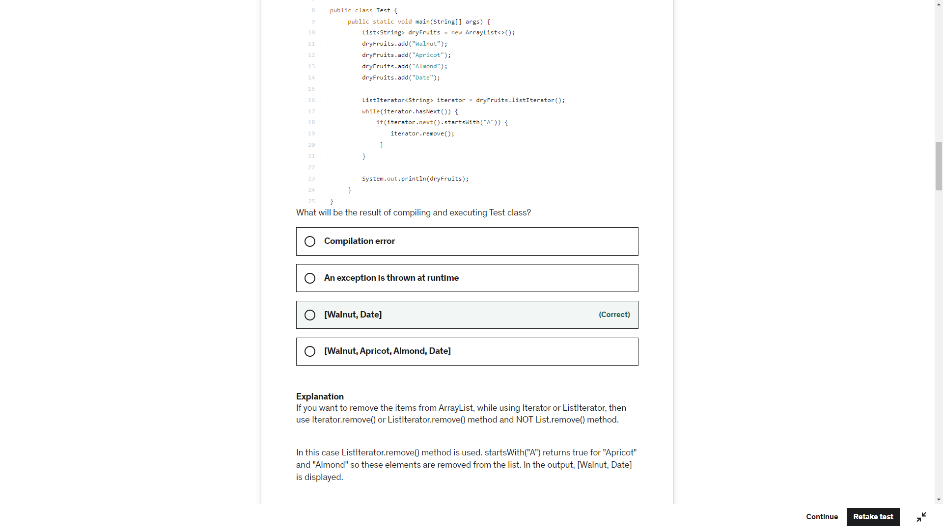

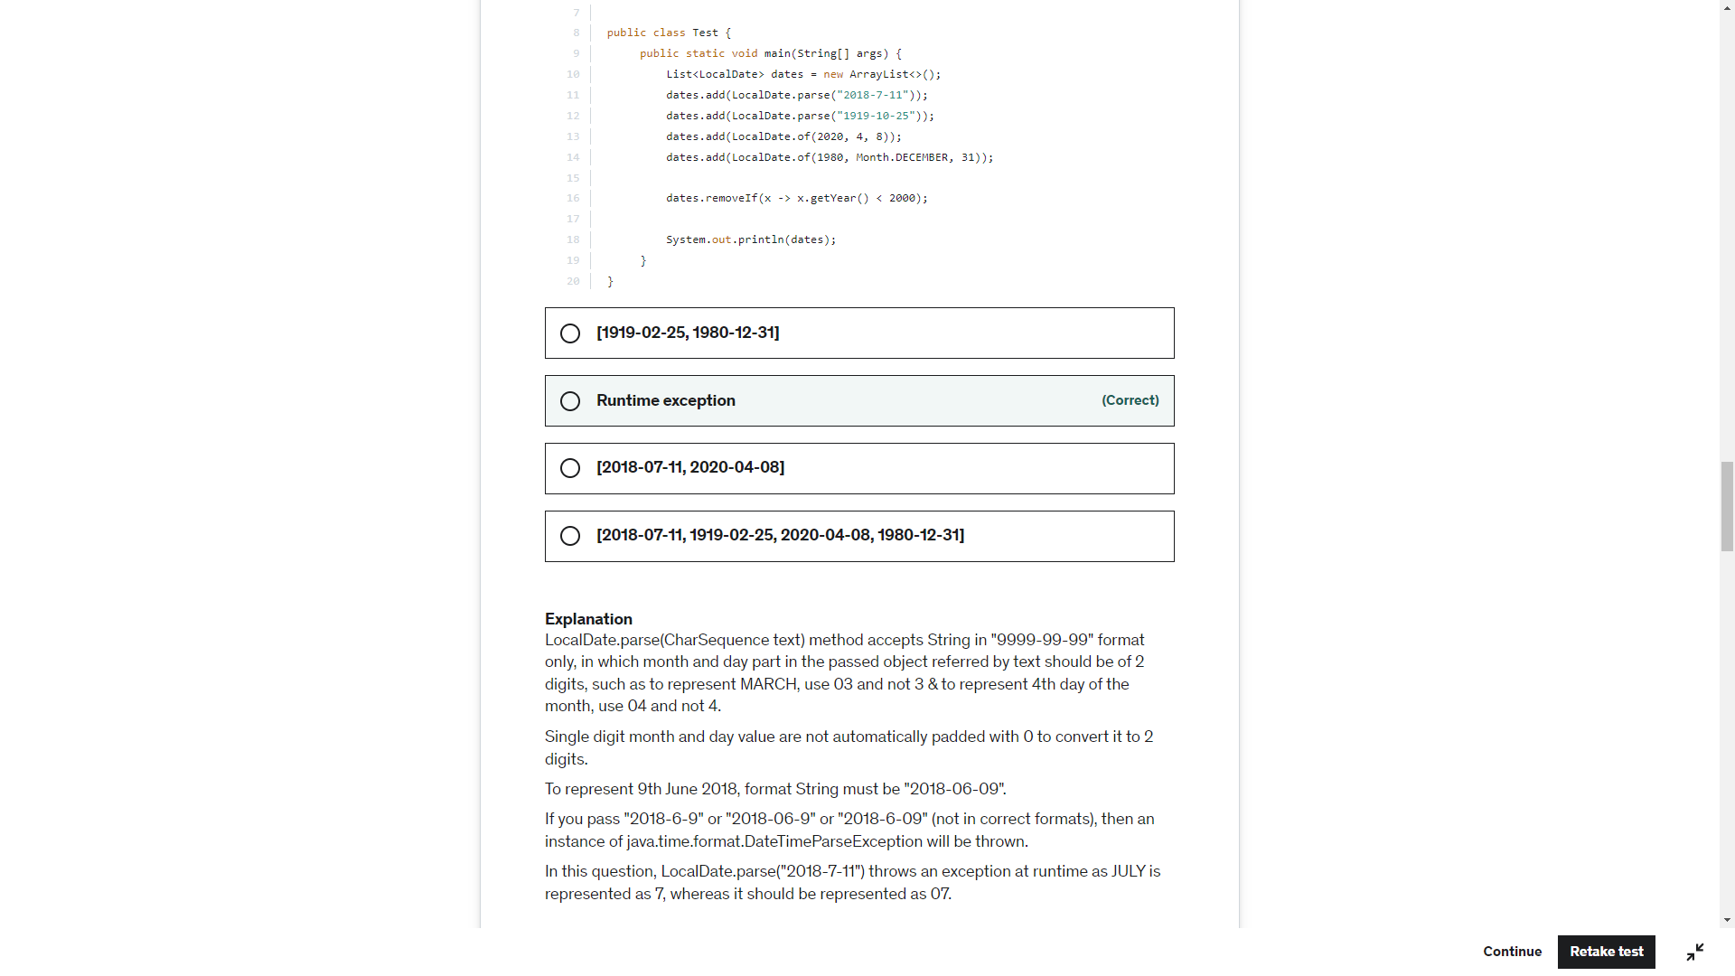

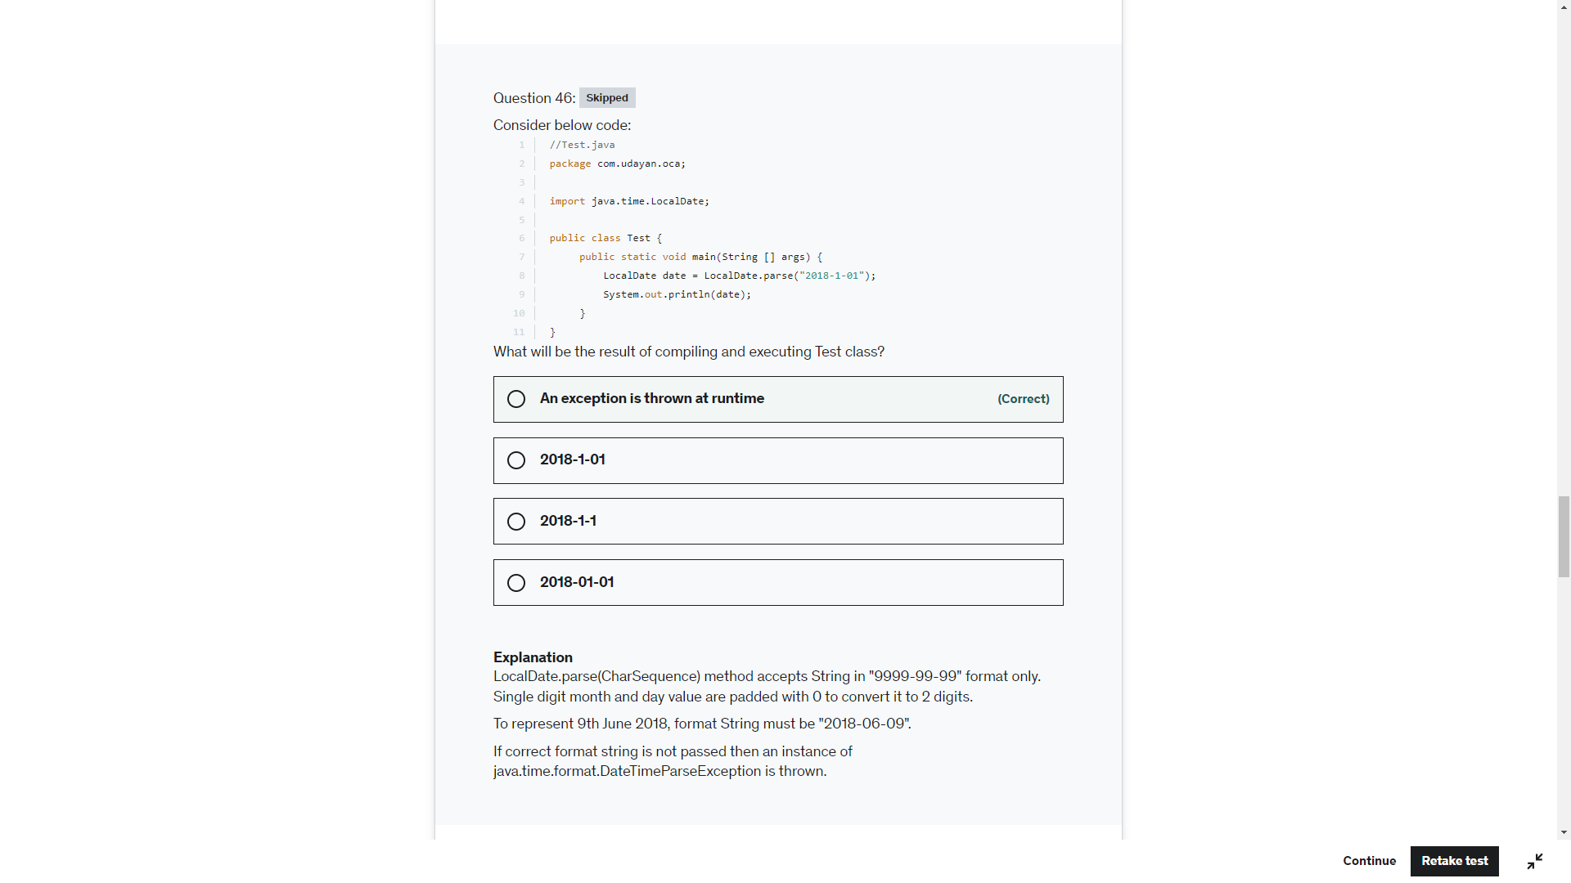

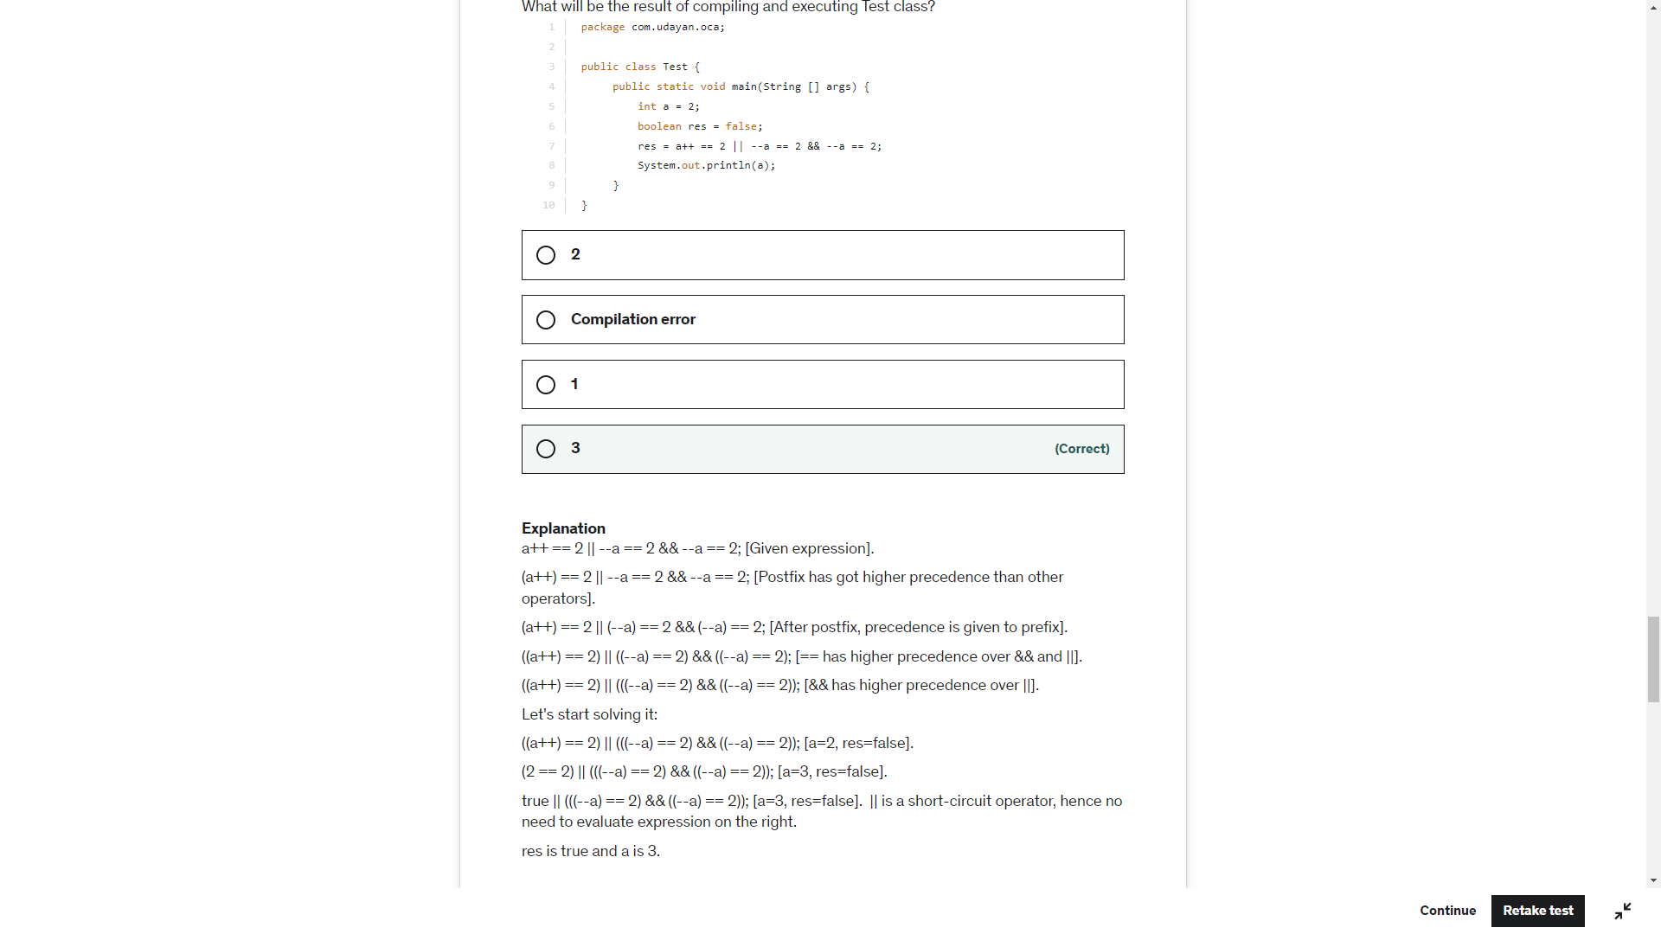

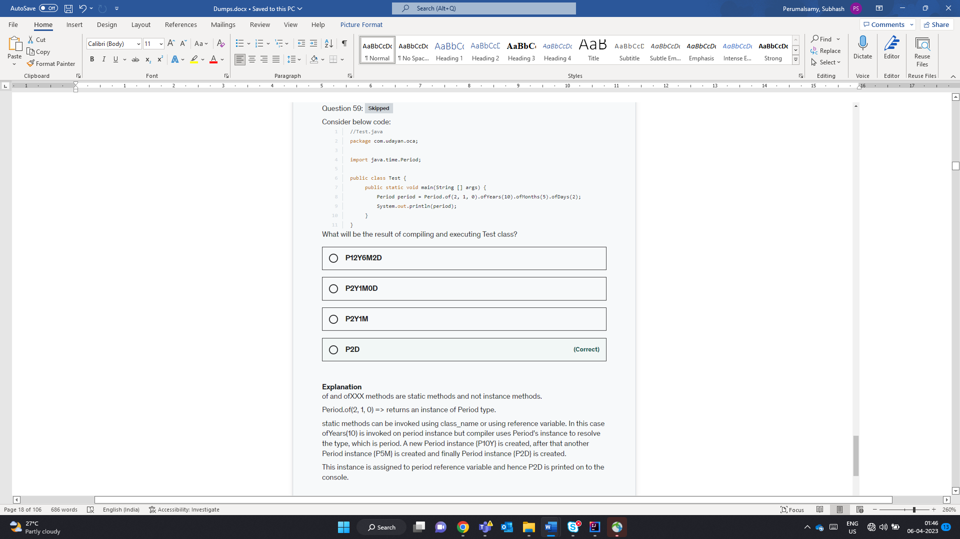

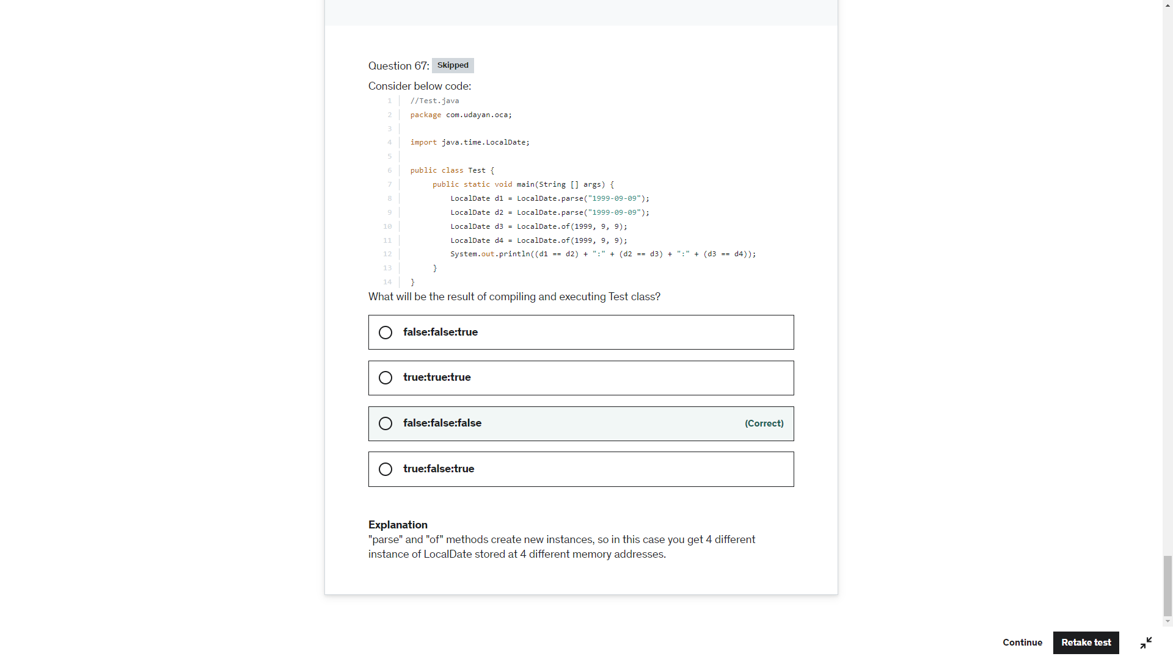

StringBuilder sb= New StringBuilder(null) -. Null pointer Exception

New StringBuilder().append(null) -> null value ambiguous between StringBuilder.append(String) or (CharSequence) or (Object ) or (StringBuilder) or (Char[])

String str = null;

Sop(str) -> null

Sop(null) -> CE ambiguous between String and Char[]

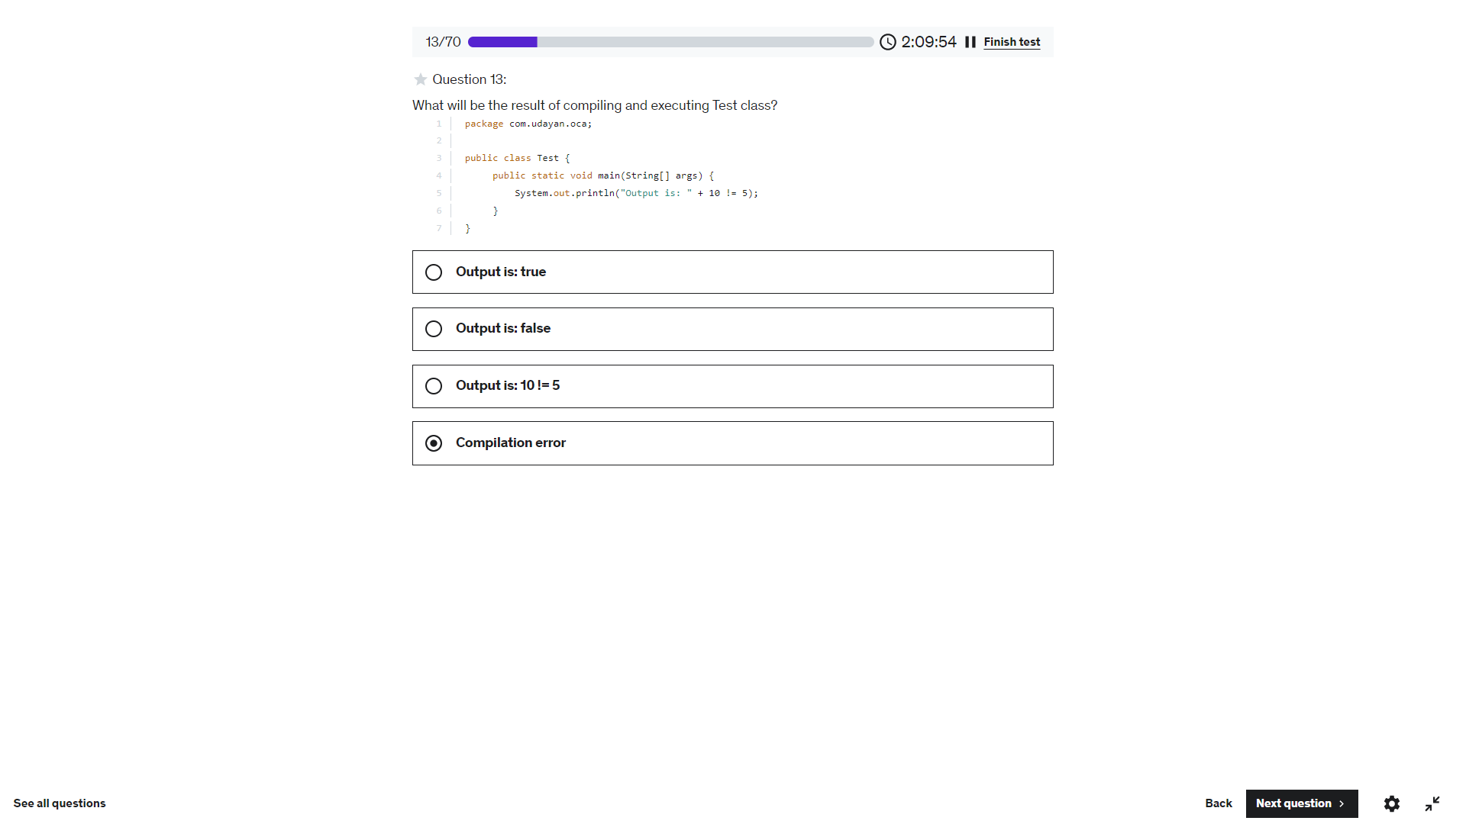

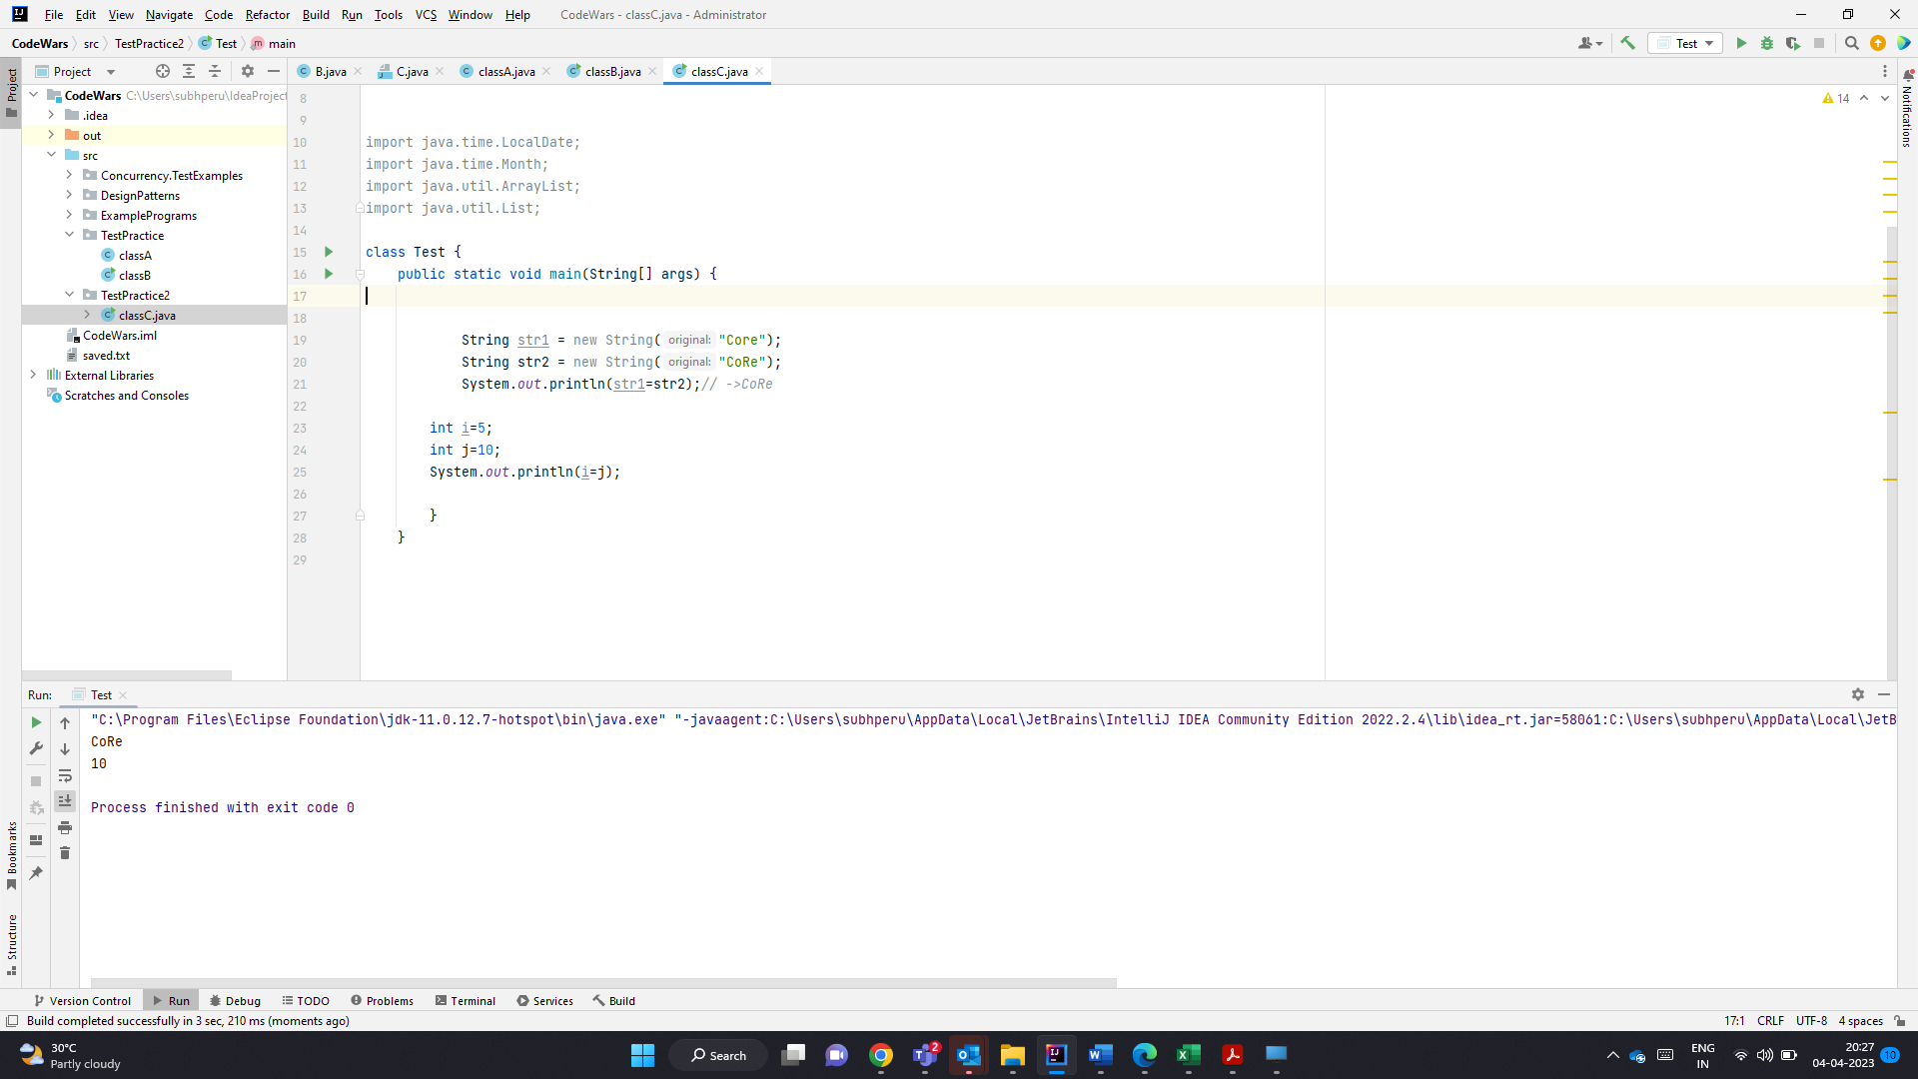

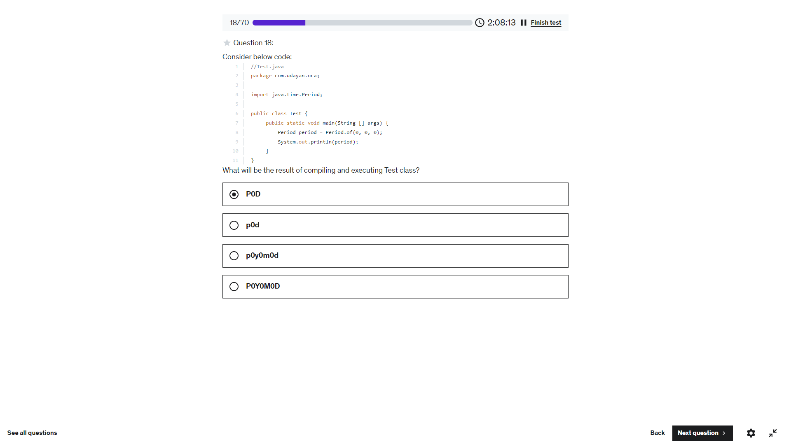

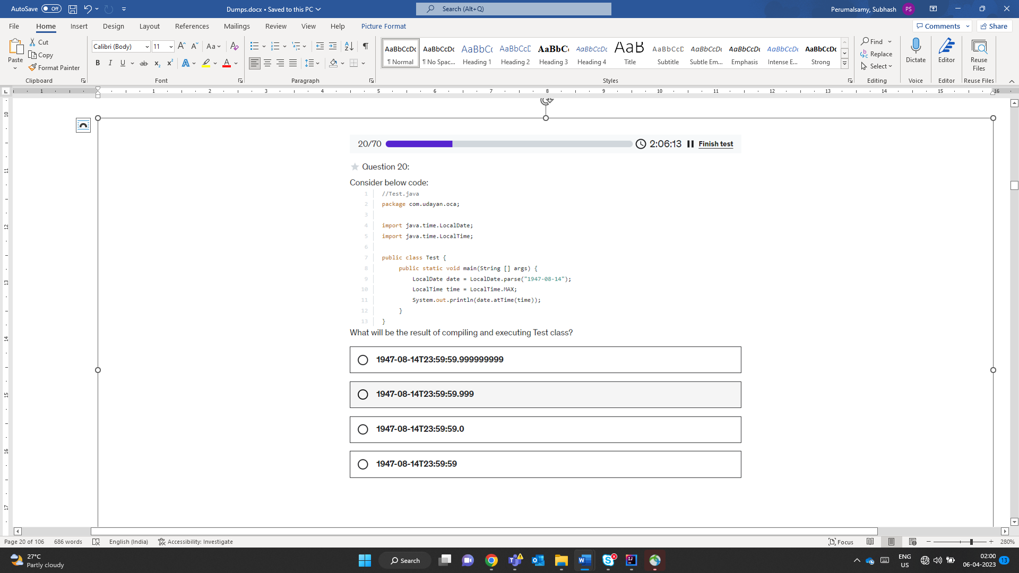

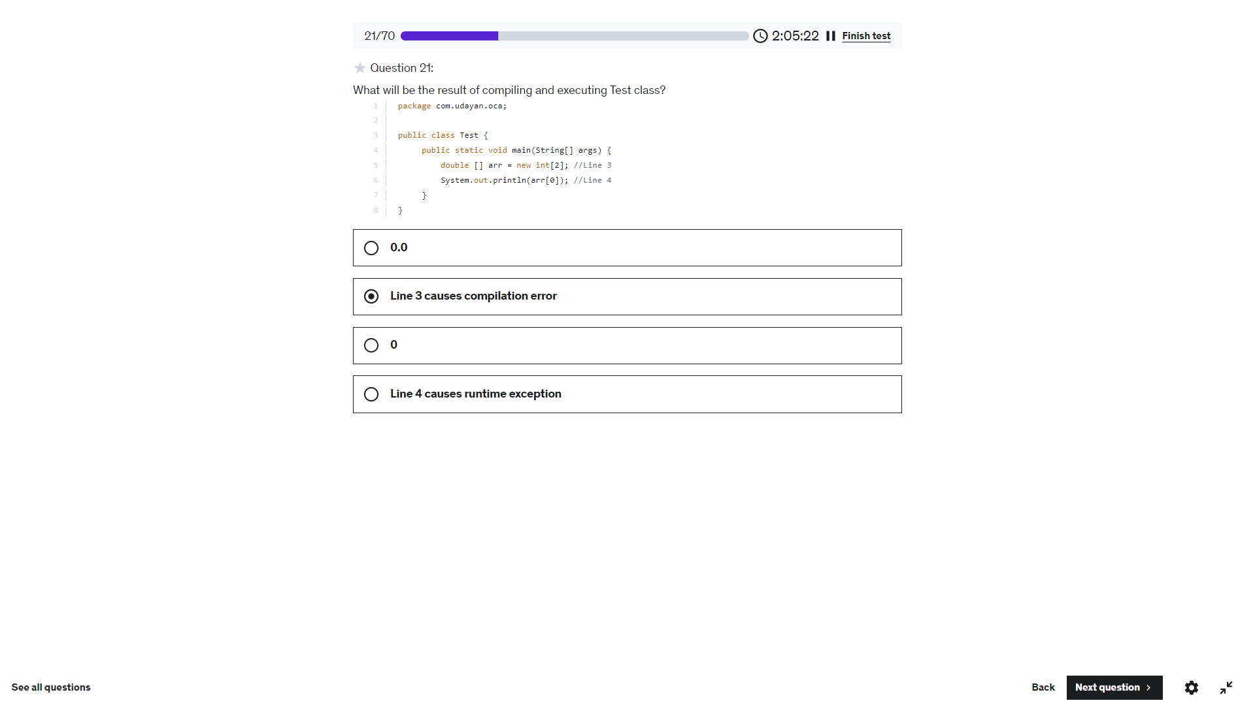

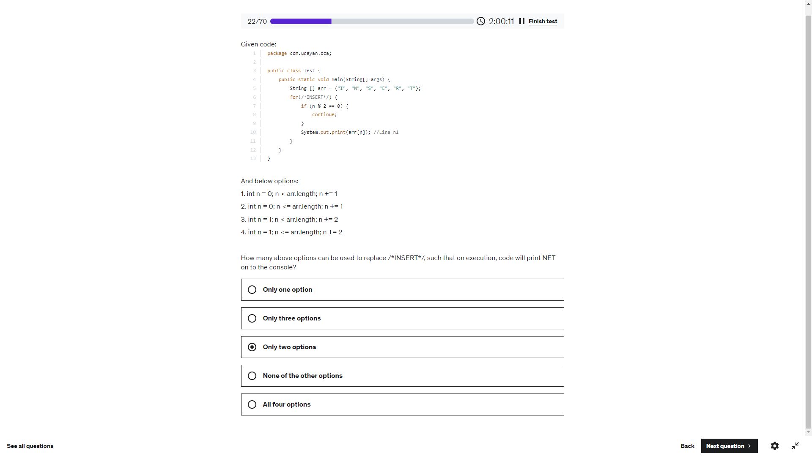

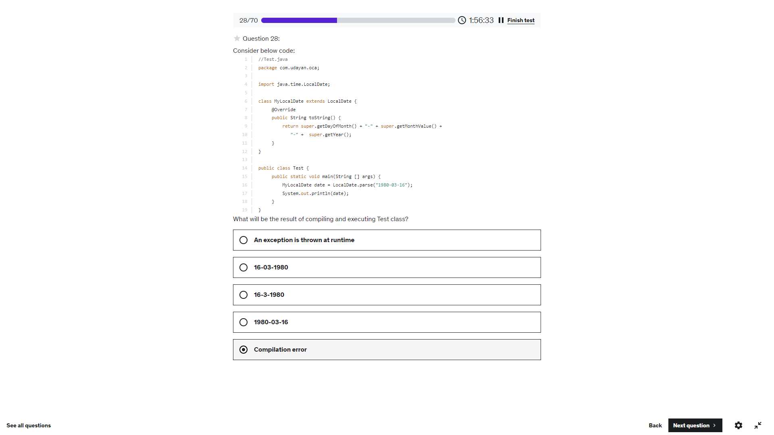

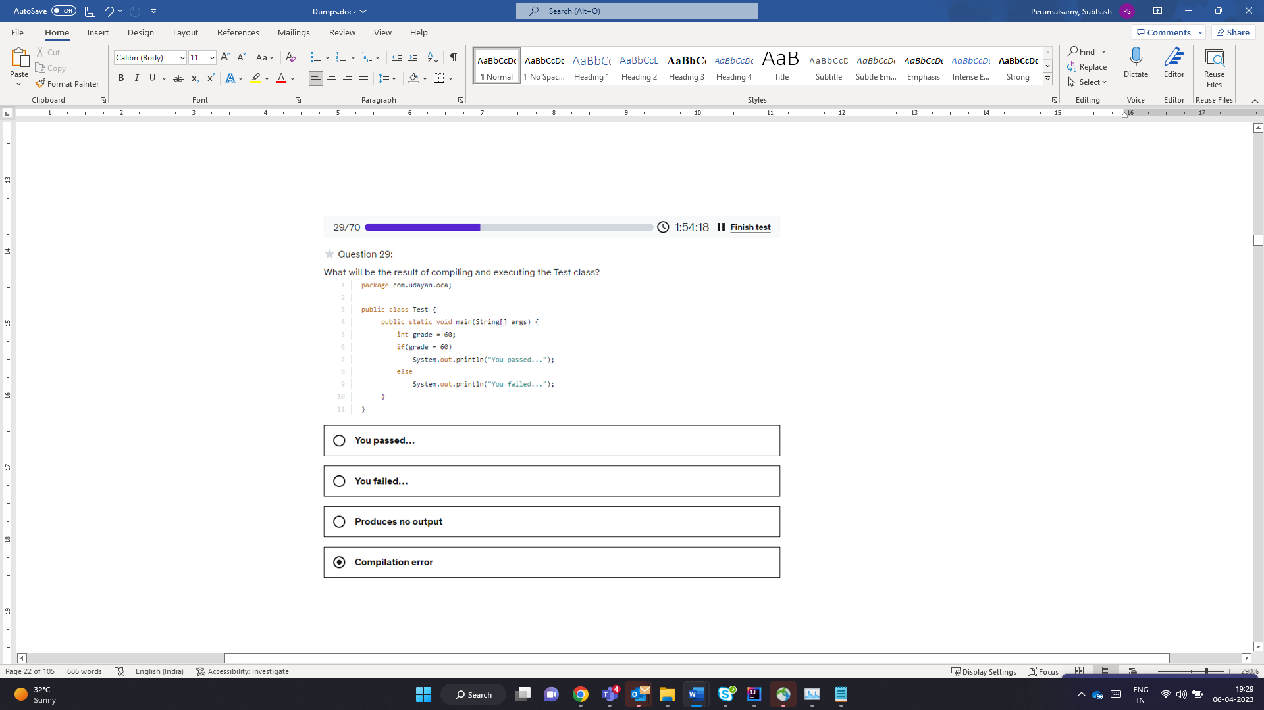

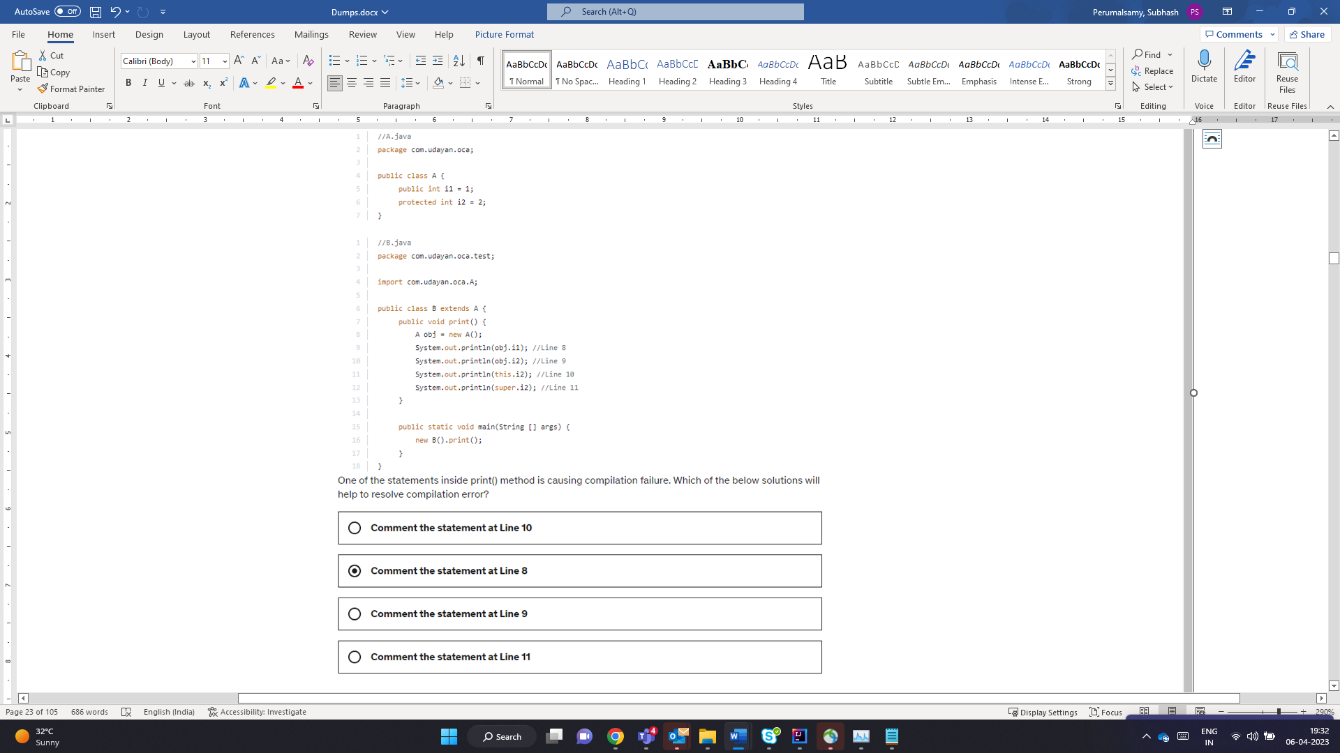

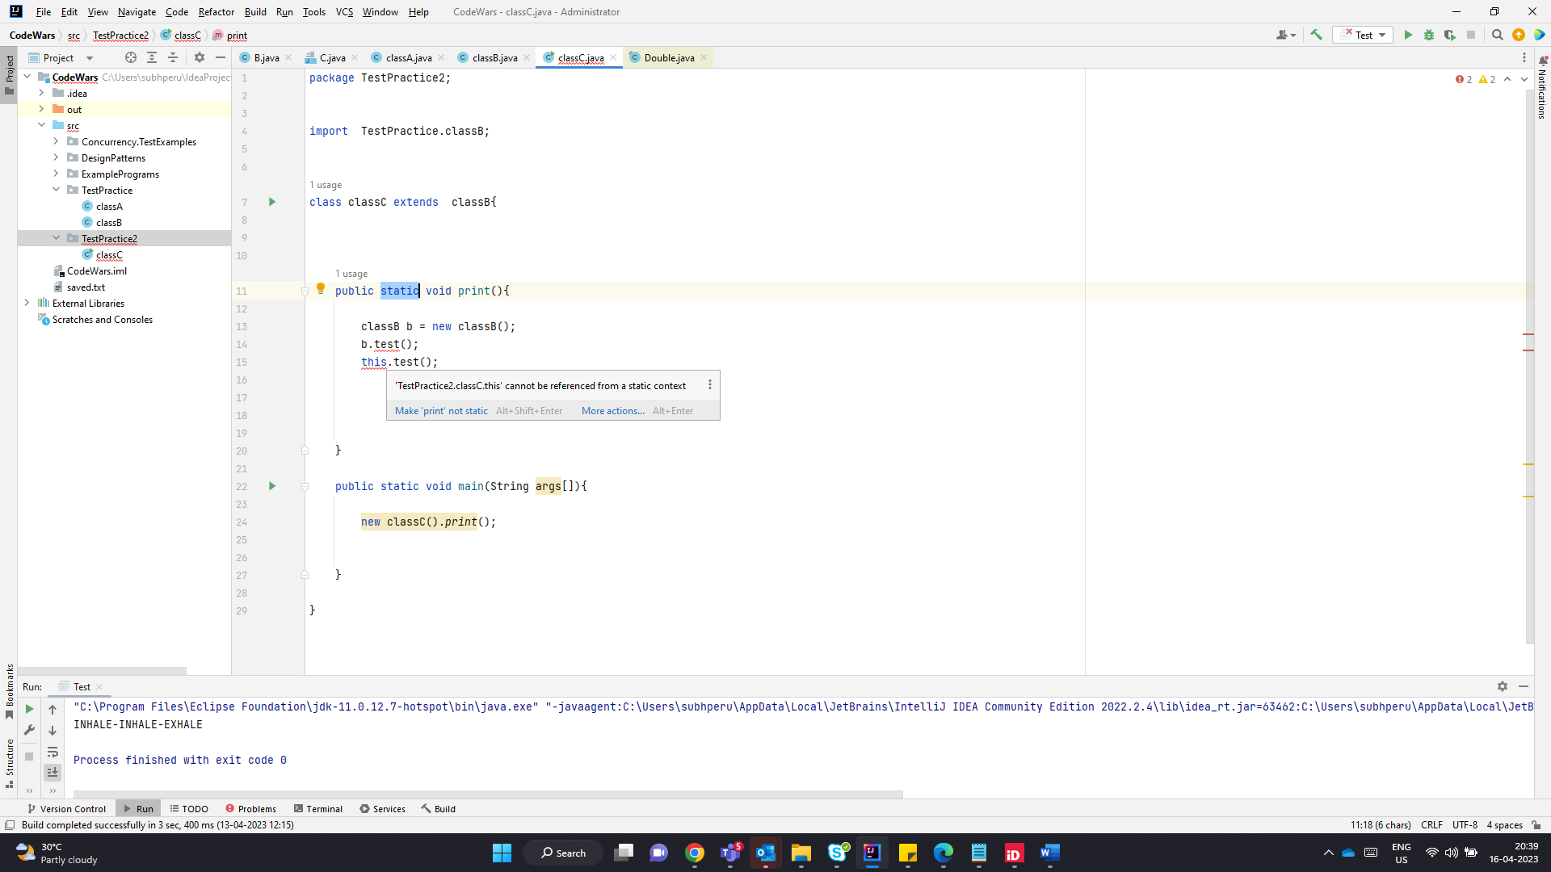

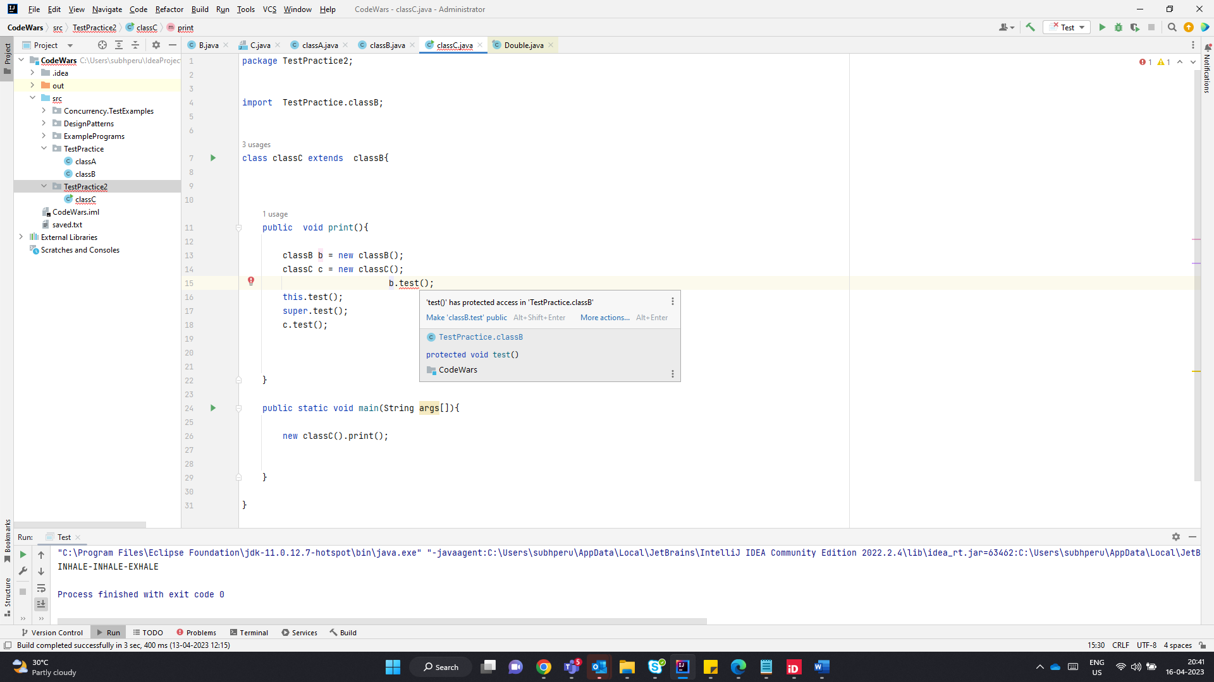

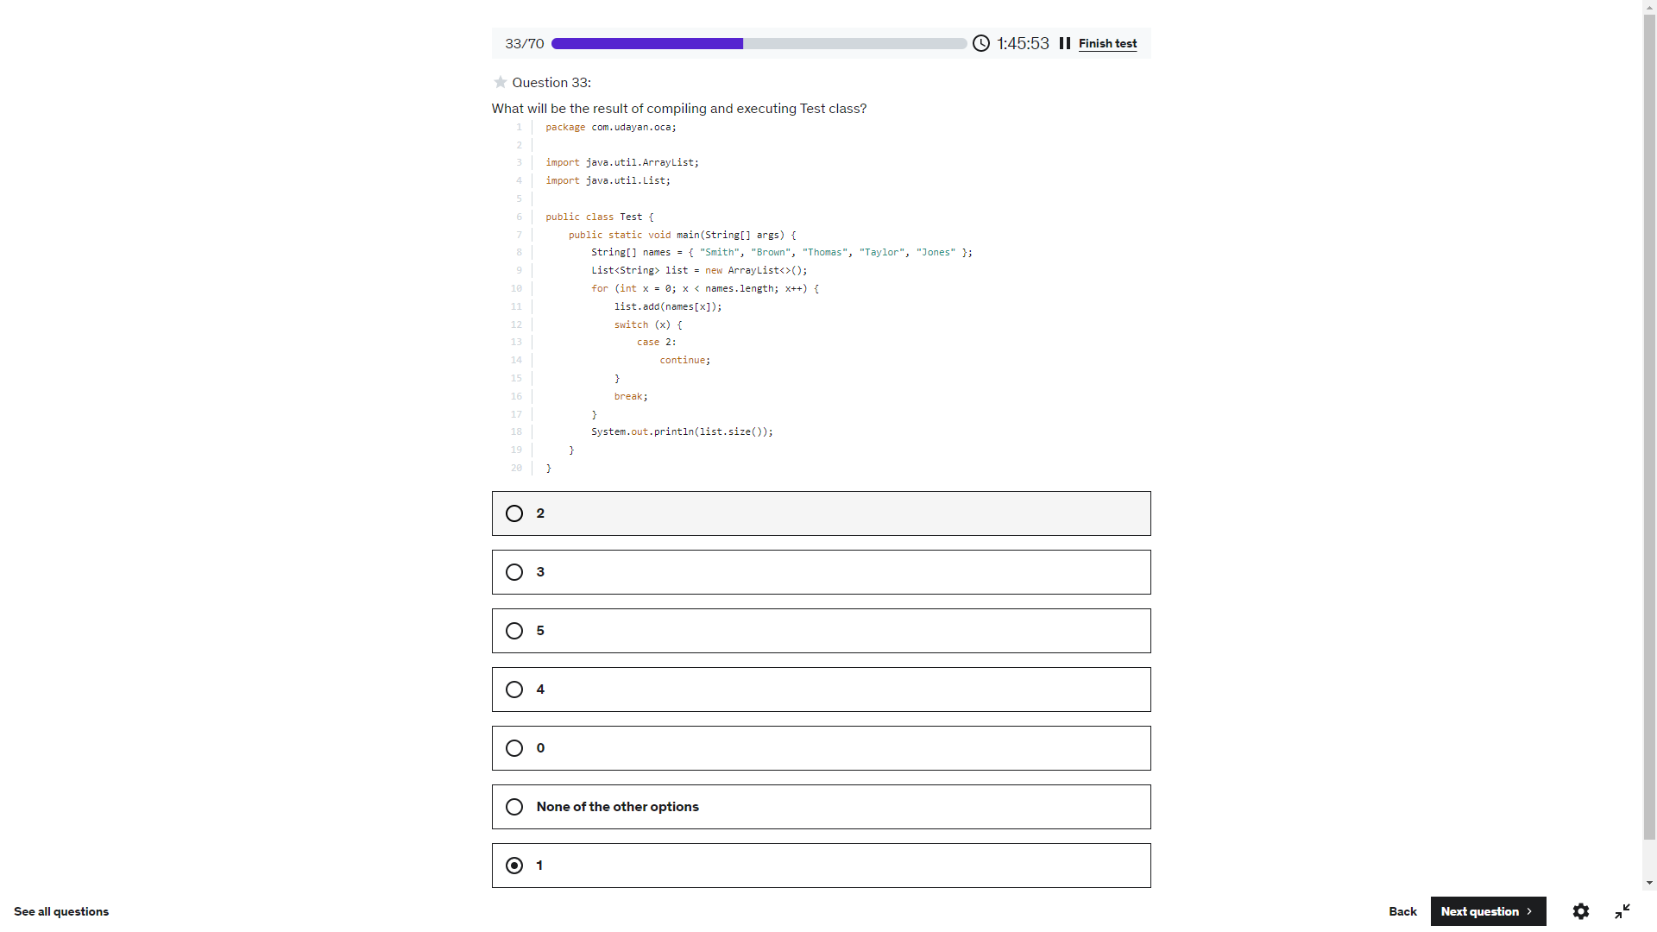

Index out of bound excpetion list. Remove(‘O’) will be converted to list.remove(79) and will throw RE

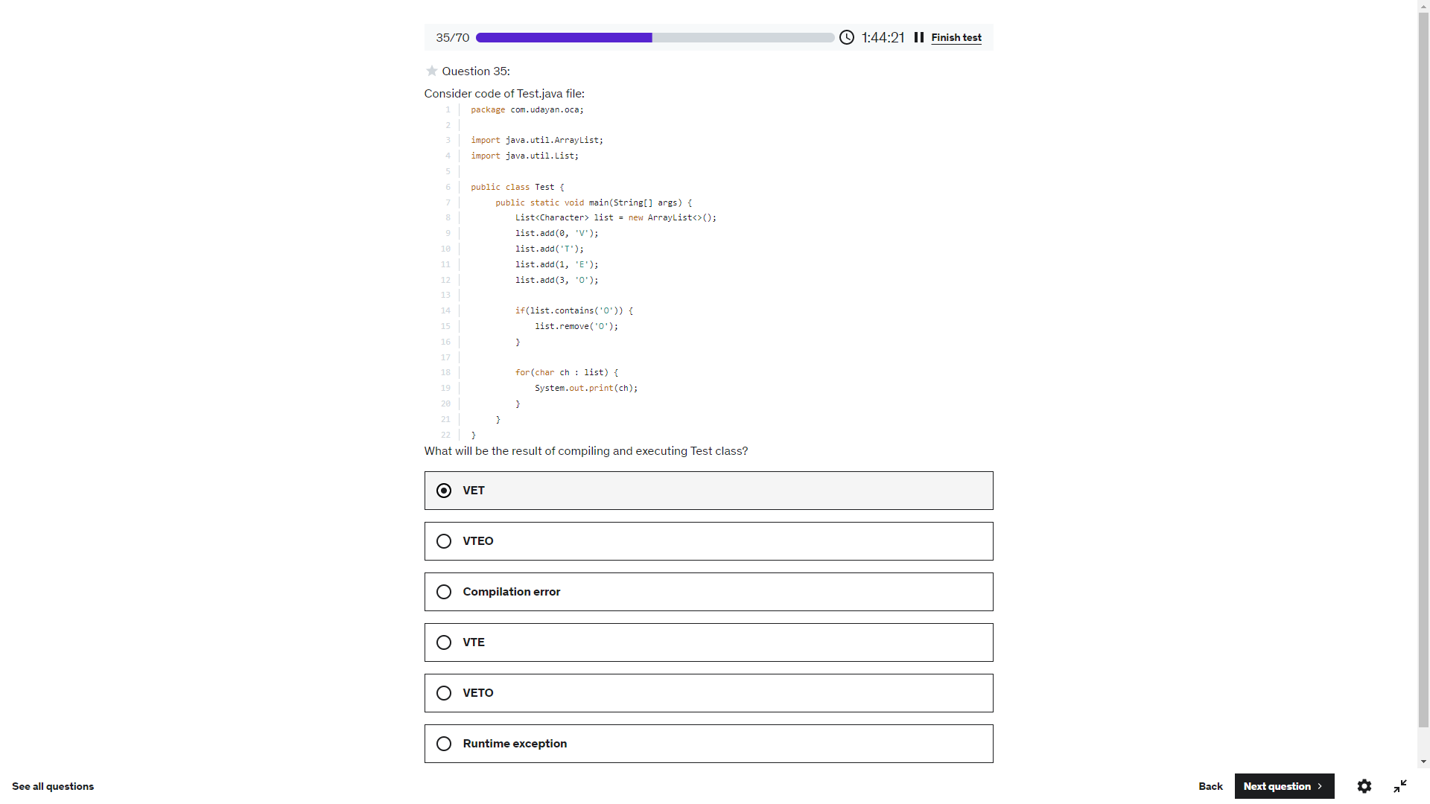

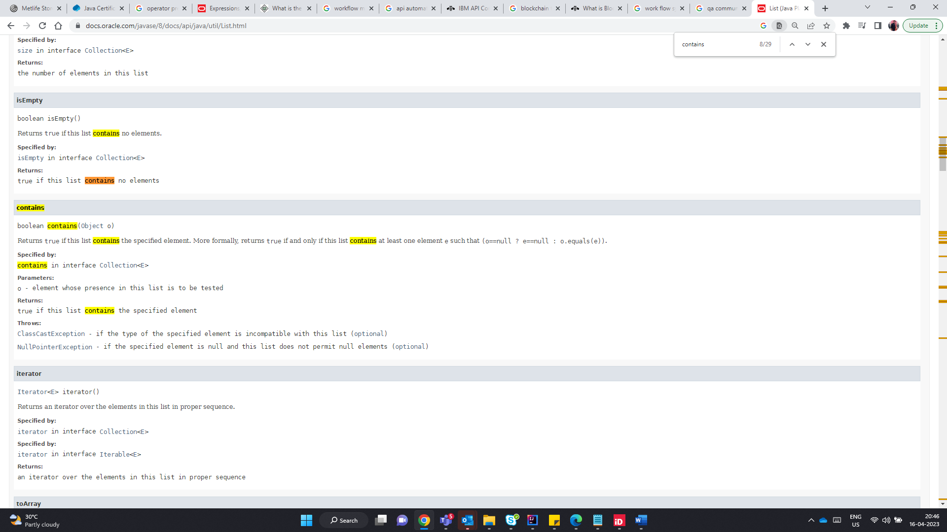

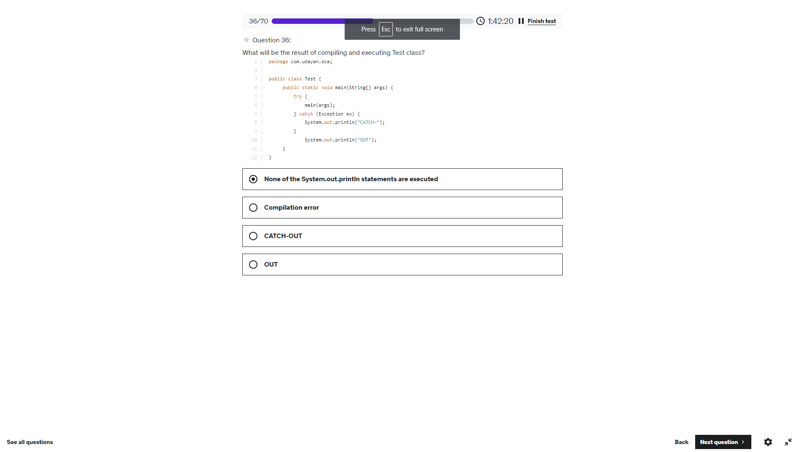

StackOverflow Error

s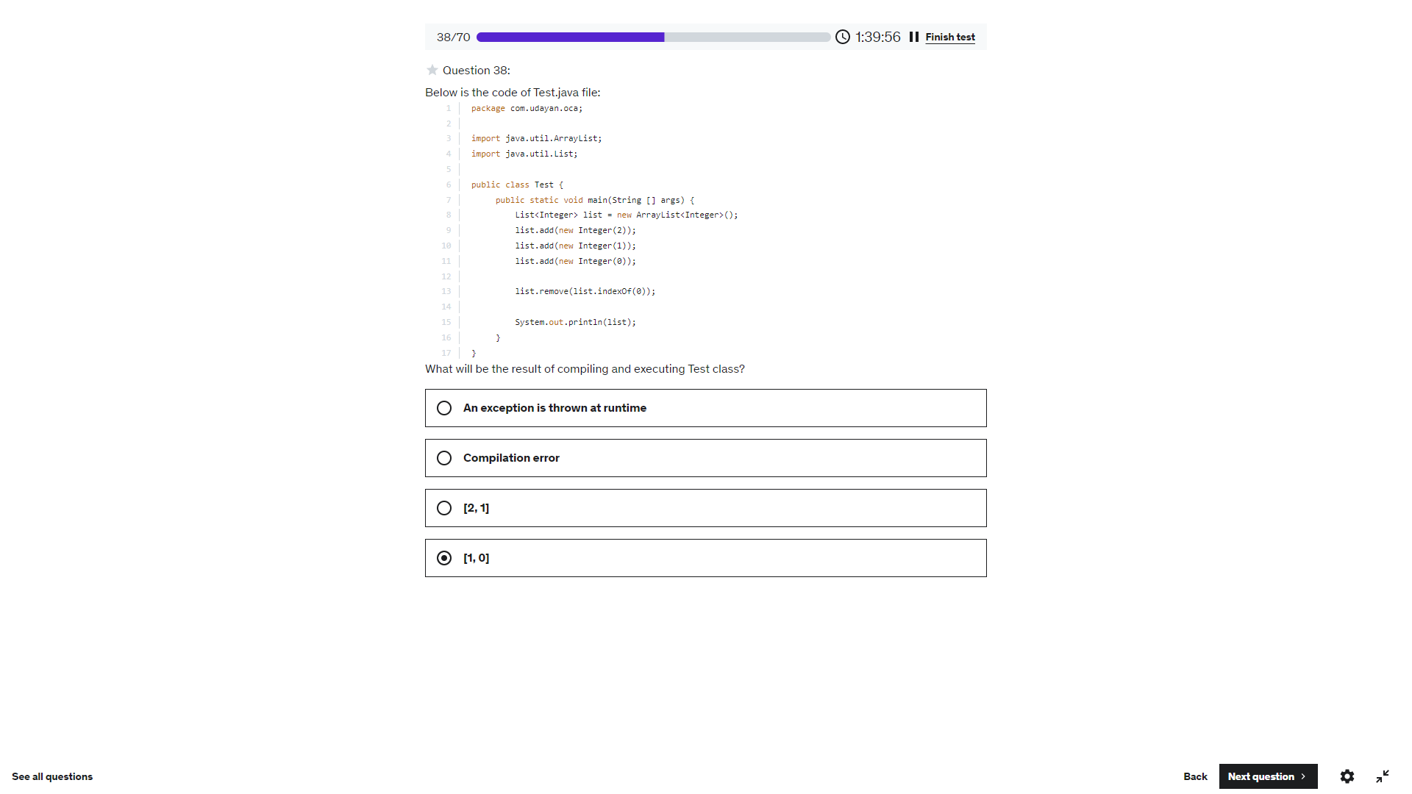

Very Important.

indexOf(Object) returns the index not the Object. If the object is found it returns the index of it. Else return -1.

List(-1) -> Returns Index Outofbound Exception . since its -1

[2,1]

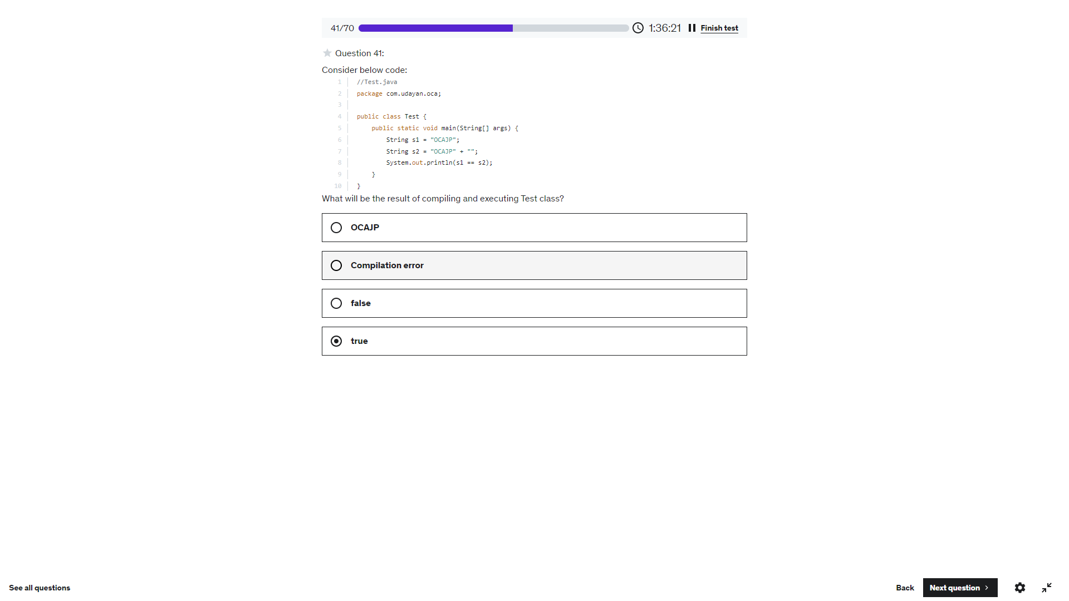

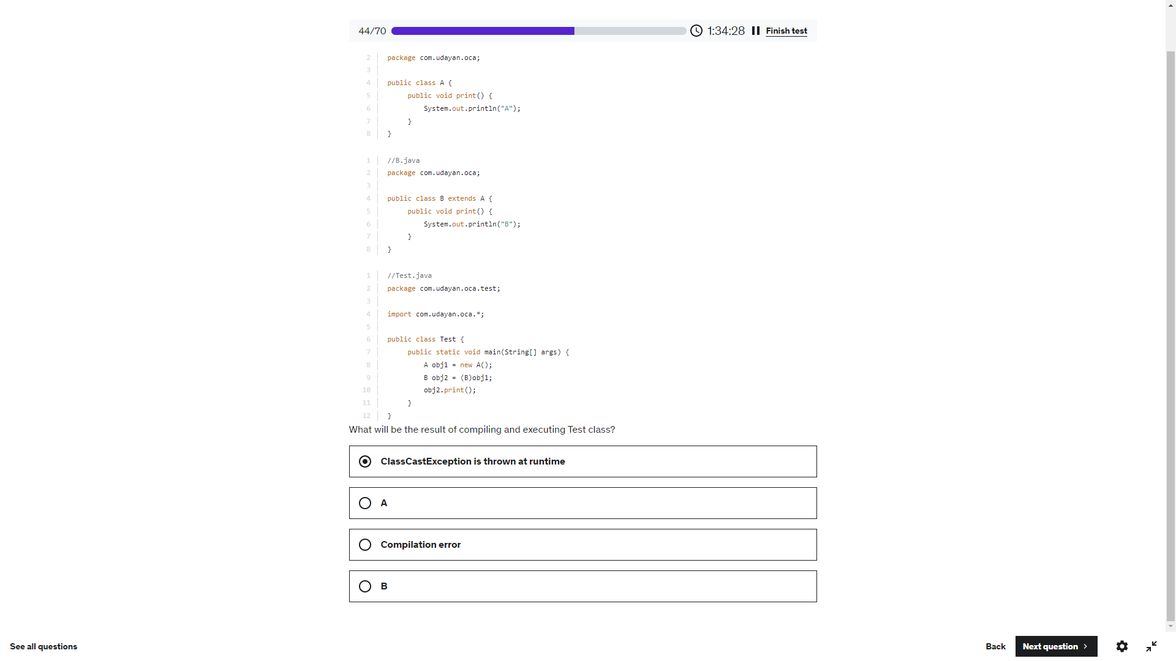

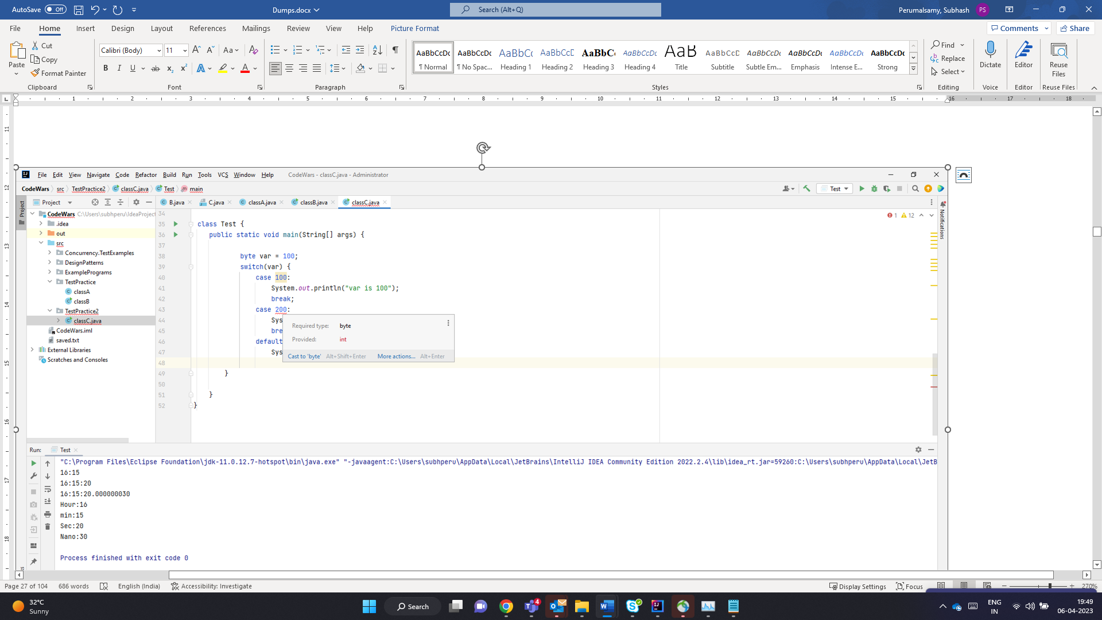

Super class throws IOException – Derived class can throw IOException or its child class Exceptio or not throw any exception.

But Derived class throw FileNotFoundException, either to be handled by try catch should declare throws – FileNotFoundException / IOException/ Exception or Throwable – can be used. But since Super class throws IOException- sub class cannot be clared using throws Exception or Throwable.

Hence we are left with IOException or FileNotFoundException. The below throws IOException which is the parent of FileNotFound which is ok – No issue with Derived class

Main Class – Has try catch for FileNotFoundException – but its not Handling IOException – So compile time error

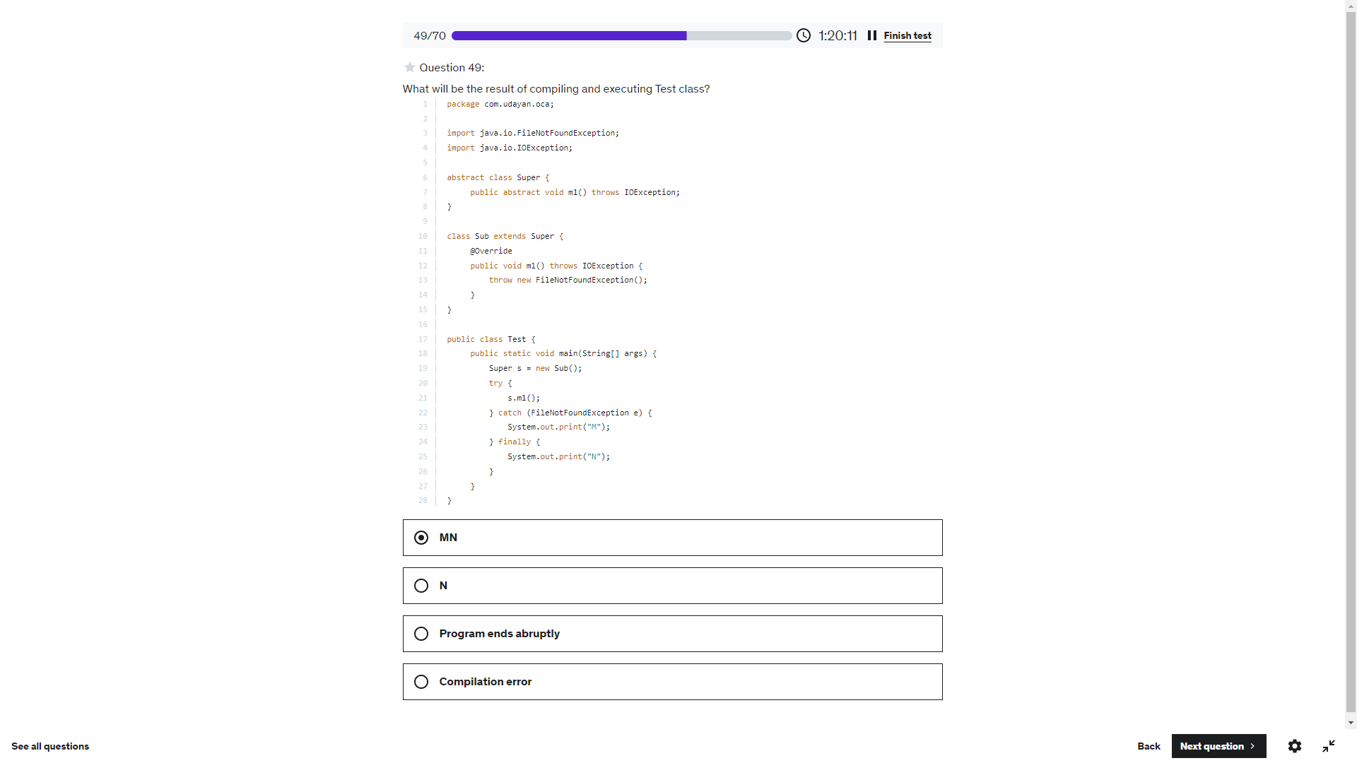

-100

101

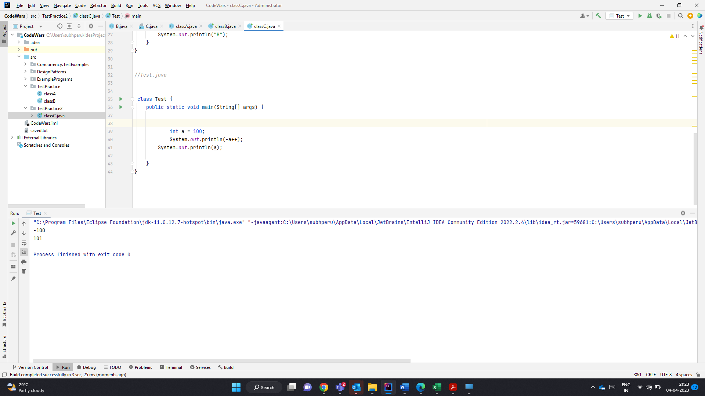

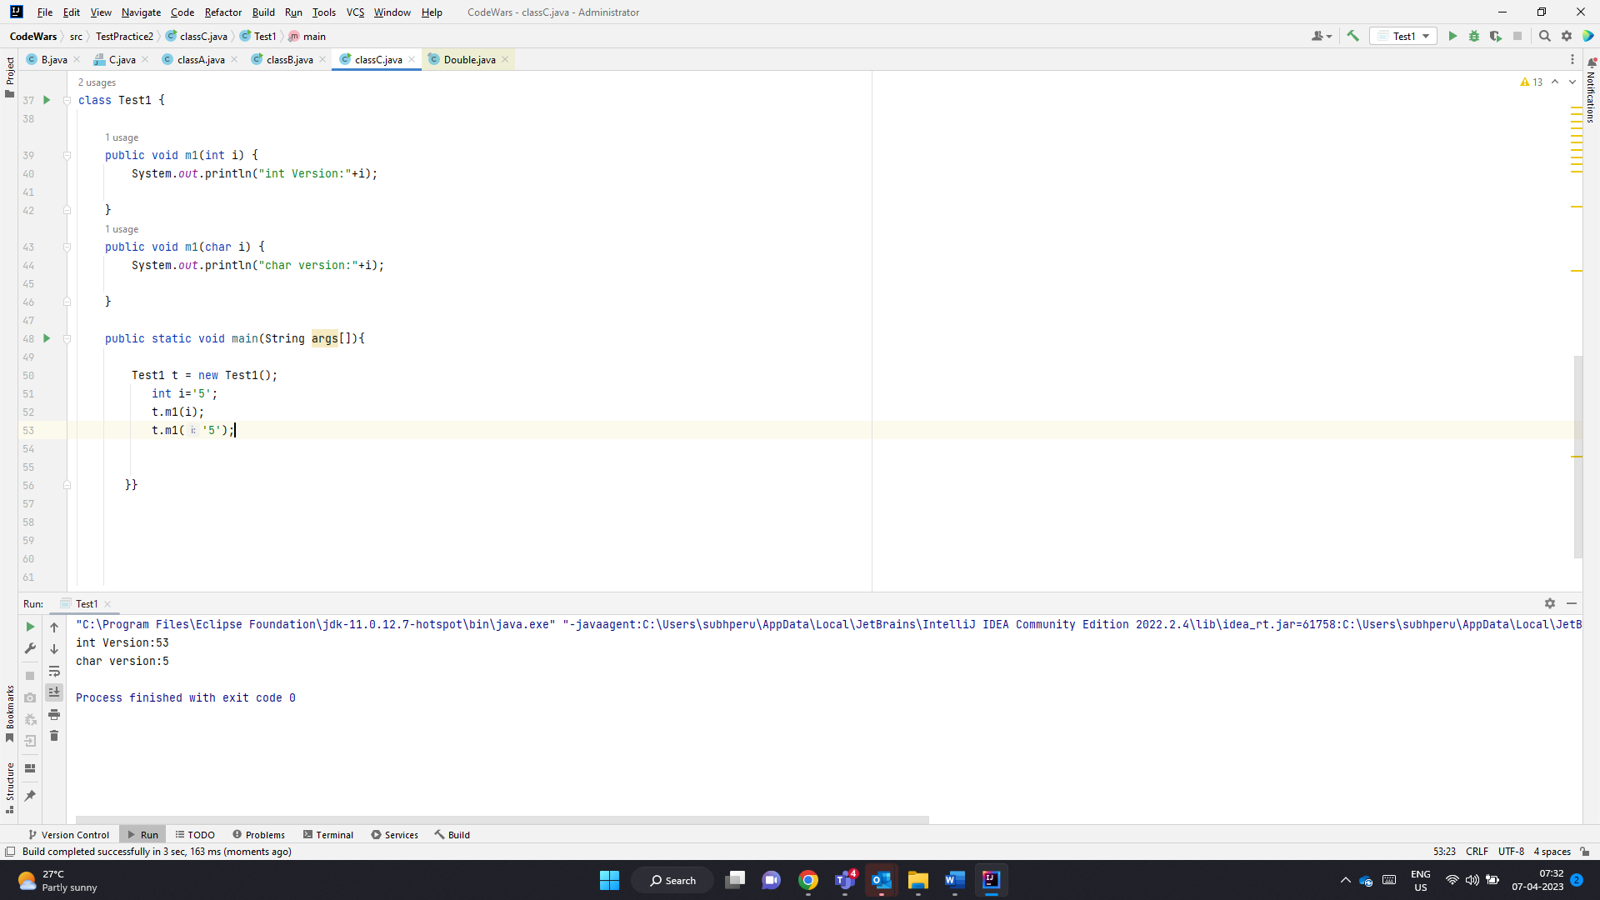

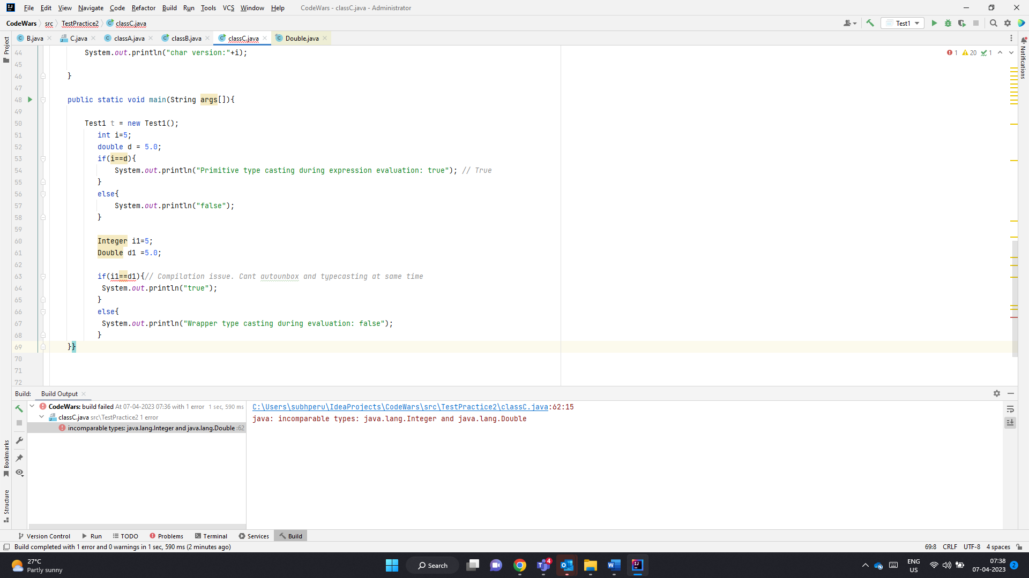

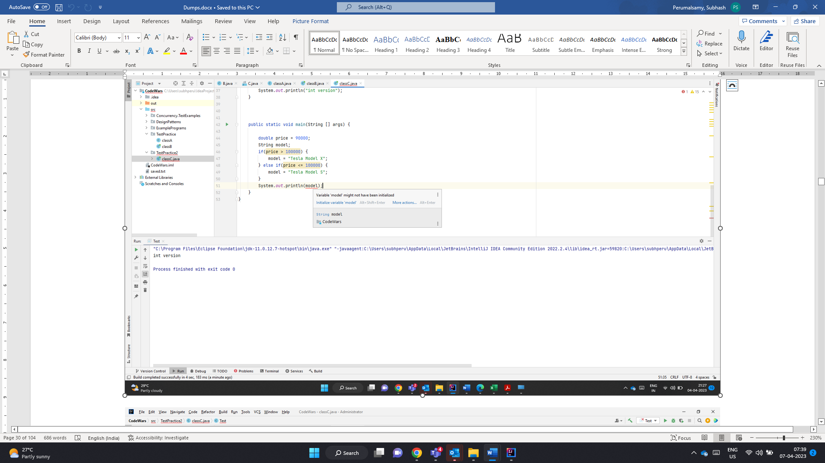

Void followed by method name

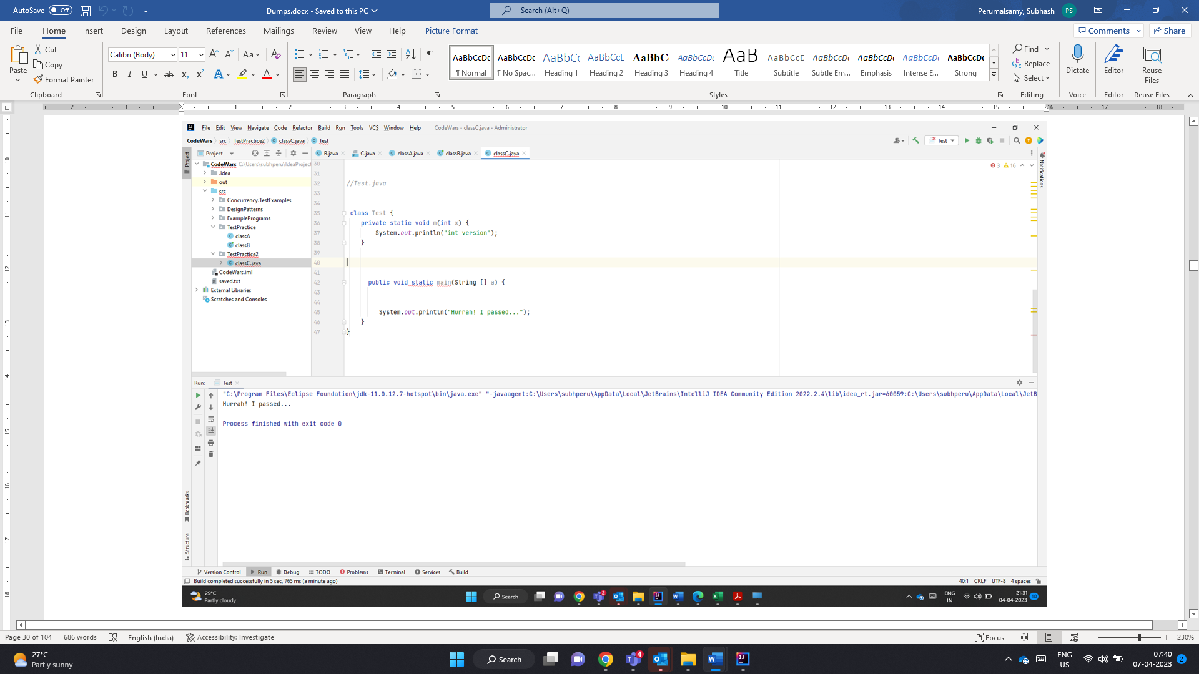

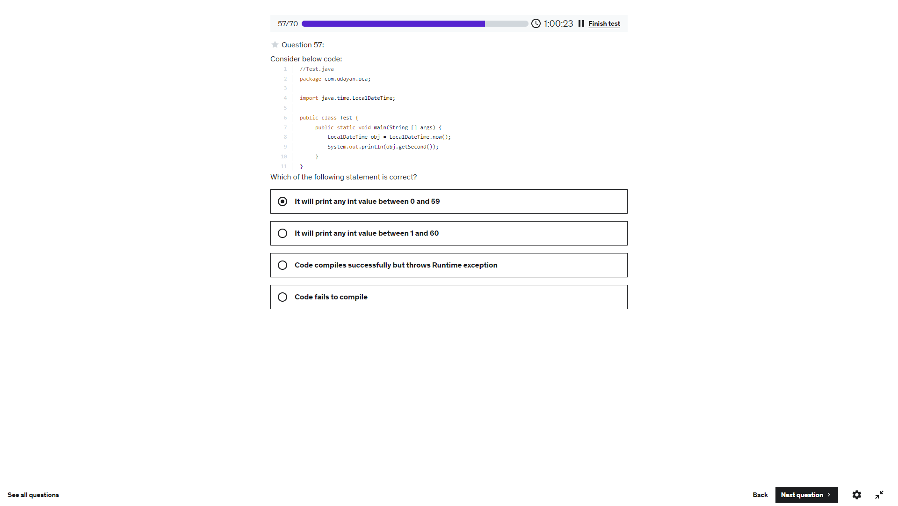

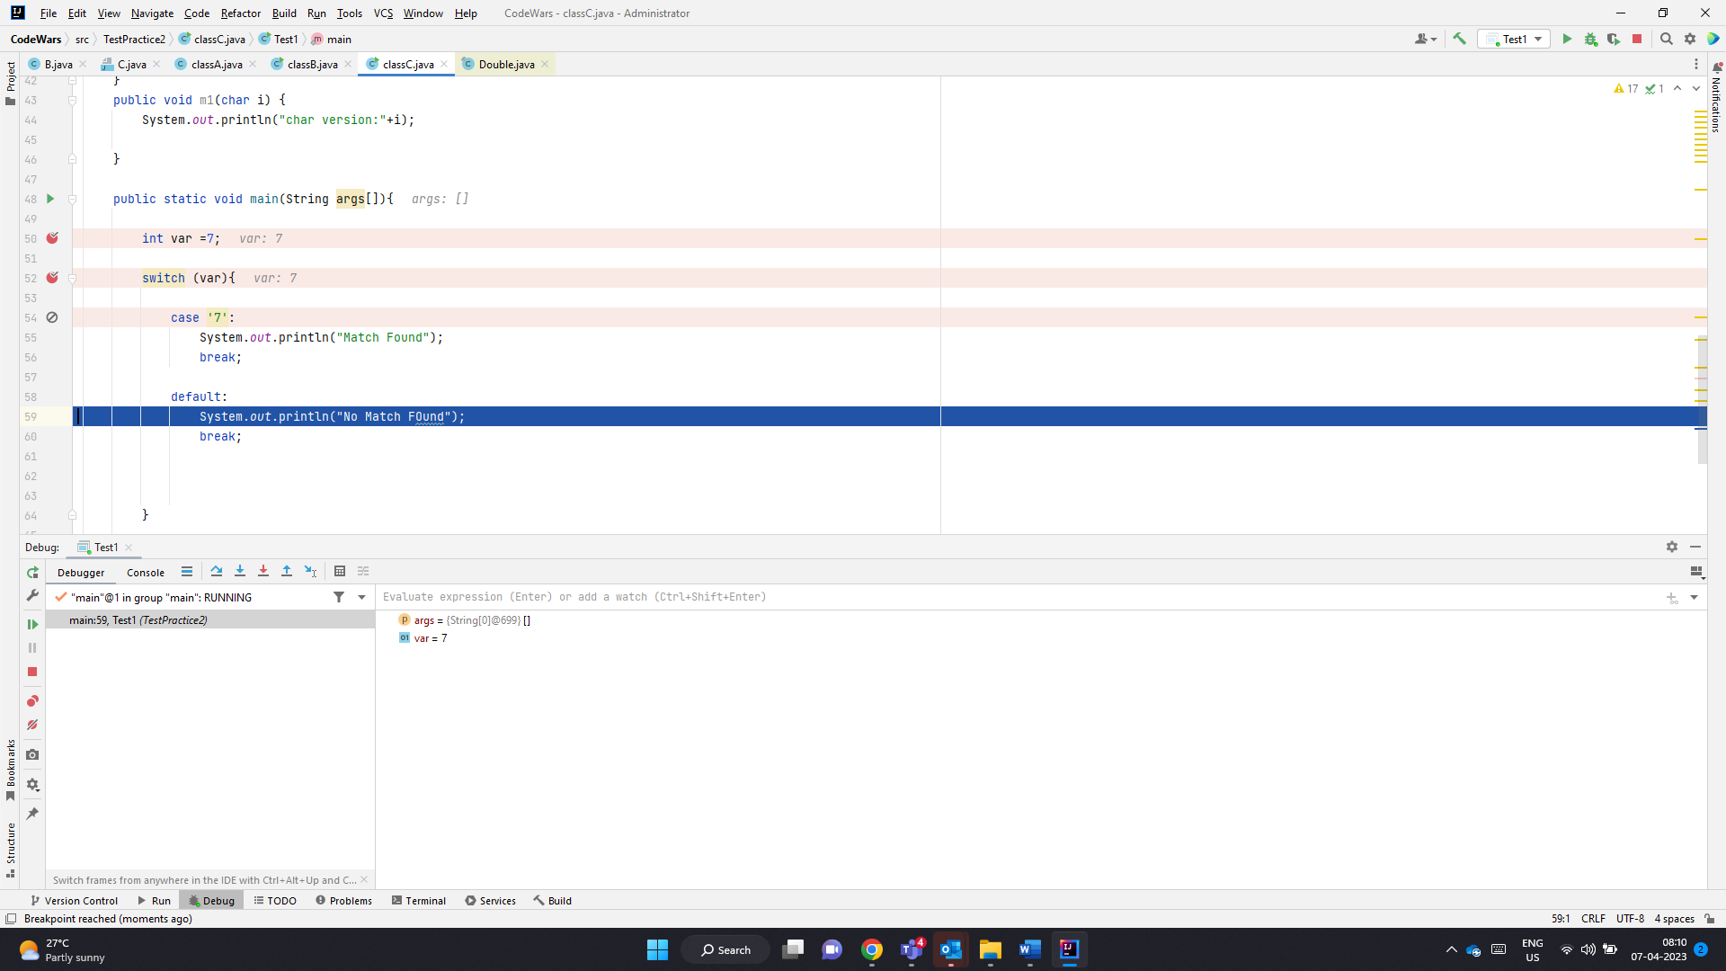

Var is int. Case Label ‘7’ char does not throw any error.

Executes Default

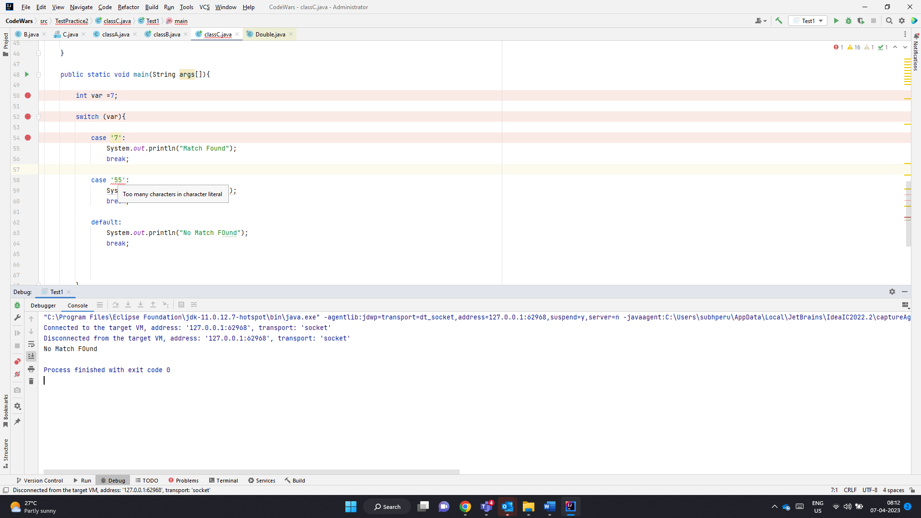

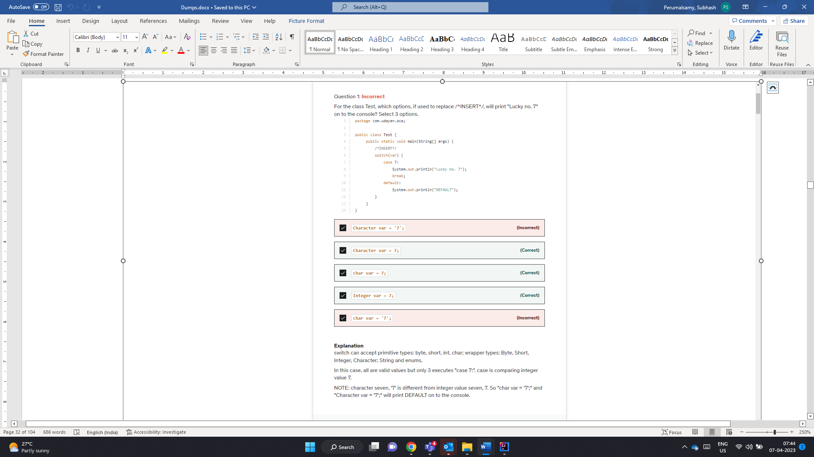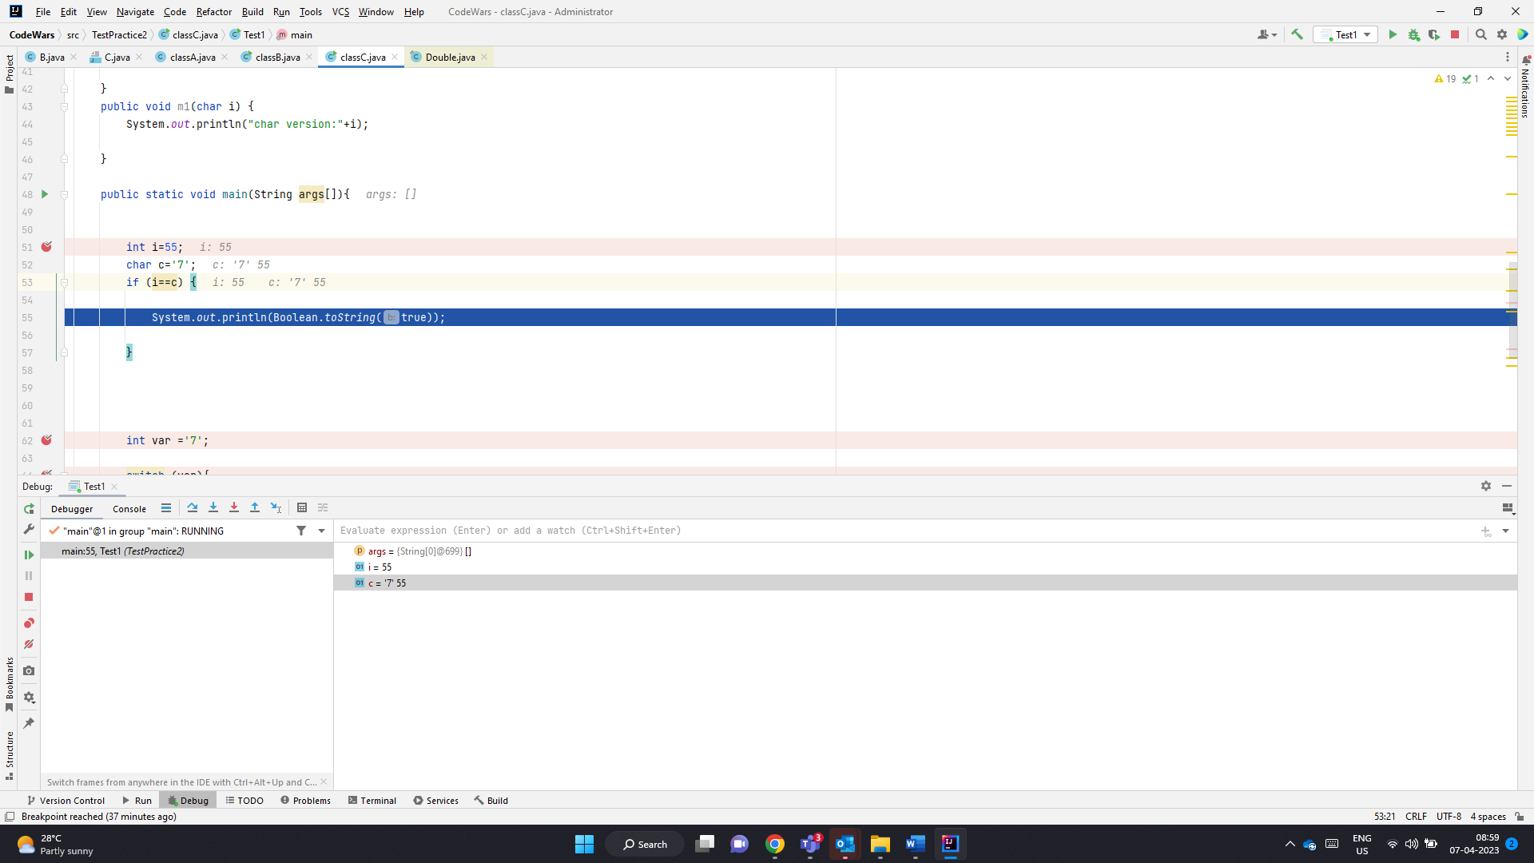

Character var=’7’

Here var-> Character. So Case 7: int 7 is converted to char

‘\u0007’ Mismatches

Character var =7 -> int to Char -> ‘\u0007’

Case 7: int->Char -> ‘\u0007’

Char var =7; int to Char -> ‘\u0007’

Case 7: int->Char -> ‘\u0007’

Integer var=7;-> Int 7

Case 7: int 7

Char var =’7’ ->’7’

Case 7 -> ‘\u0007’

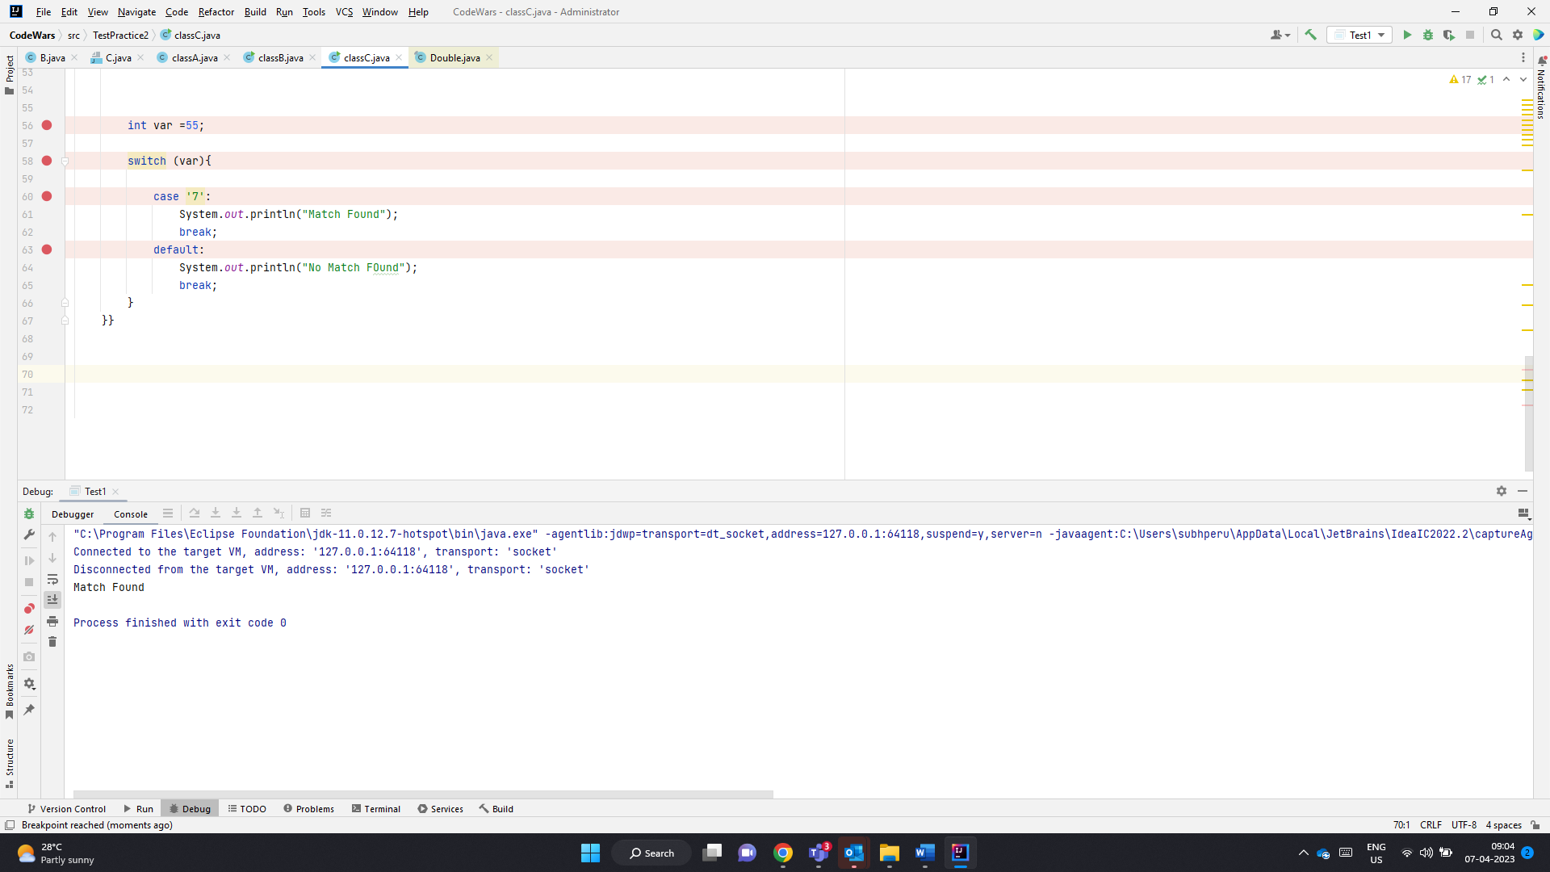

Here char ‘7’ in case label is converted to int 55 and comparison works

Character or char can always be converted to int . Even if the case label is char can be converted to int. Character comparison is always perofmed using int

Below char ‘7’ is converted to int 55 and there happens to be duplicate value.. SO CE

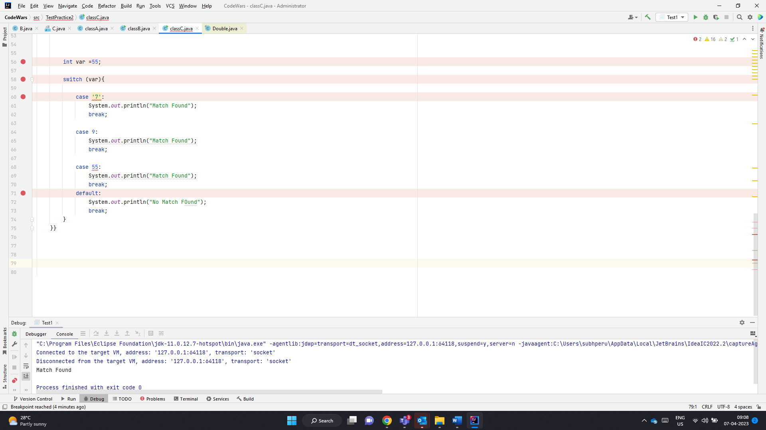

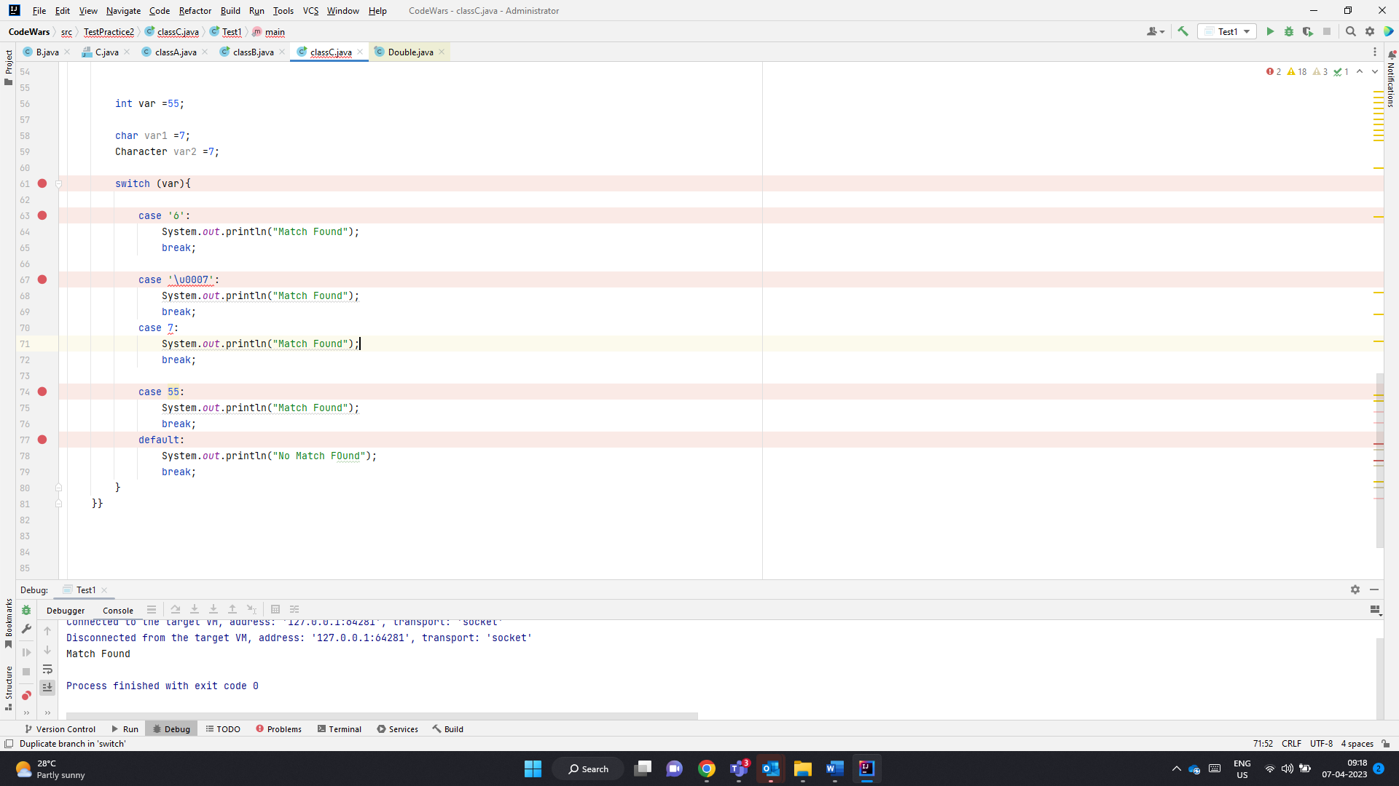

‘7’ == 7

9 ==’9’

Will always fail

‘7’==55 -> int value of ‘7’ will pass.

Chars are converted to int for expression evaluation

List cant accept primitives. So primitive ints are converted to Integers. When

1. E remove(int index): This method removes the element at the specified index and returns it. The subsequent elements are shifted to the left by one place. This method throws IndexOutOfBoundsException if the specified index is out of range. If the list implementations does not support this operation, UnsupportedOperationException is thrown.
2. boolean remove(Object o) This method removes the first occurrence of the specified Object. If the list doesn’t contain the given element, it remains unchanged. This method returns true if an element is removed from the list, otherwise false. If the object is null and list doesn’t support null elements, [NullPointerException](https://www.digitalocean.com/community/tutorials/java-lang-nullpointerexception) is thrown. UnsupportedOperationException is thrown if the list implementation doesn’t support this method.

[A,C,C,B,A]

[B]

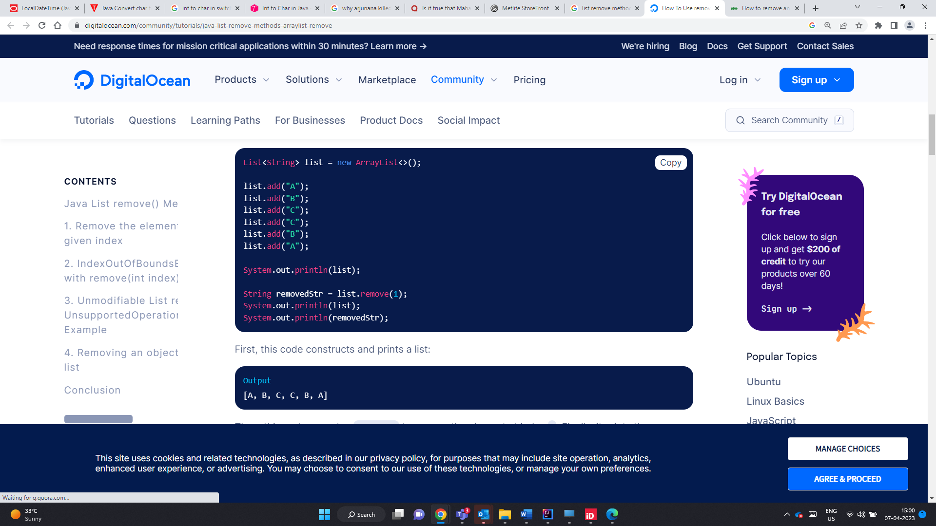

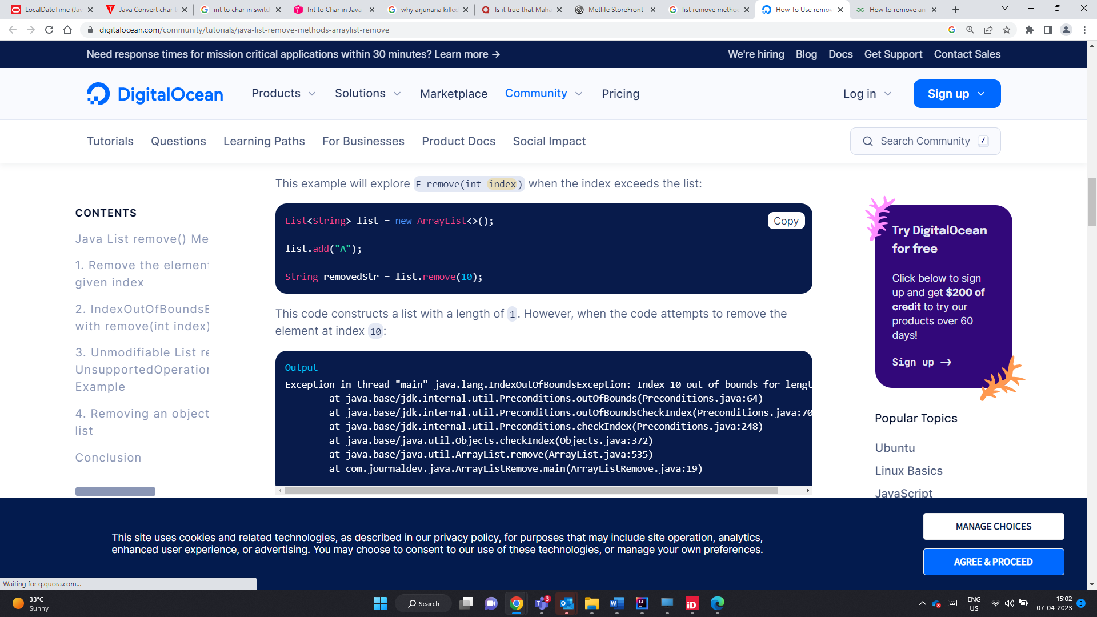

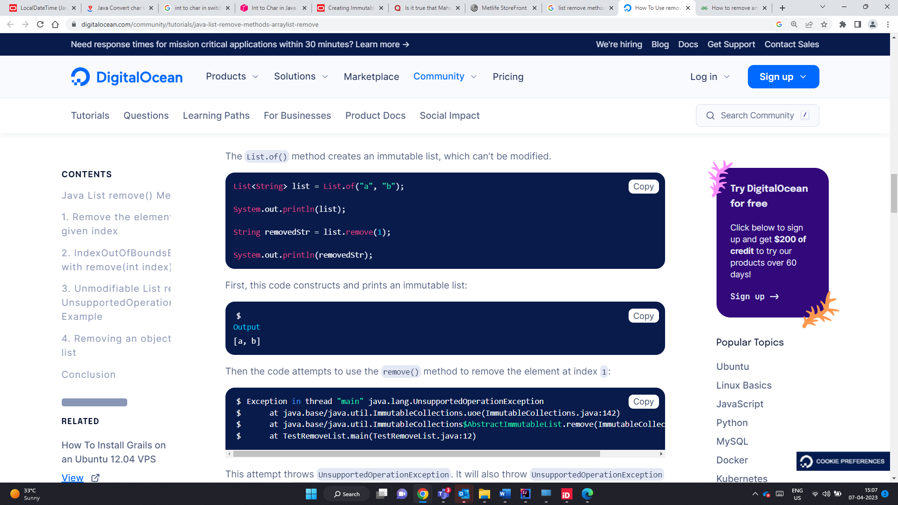

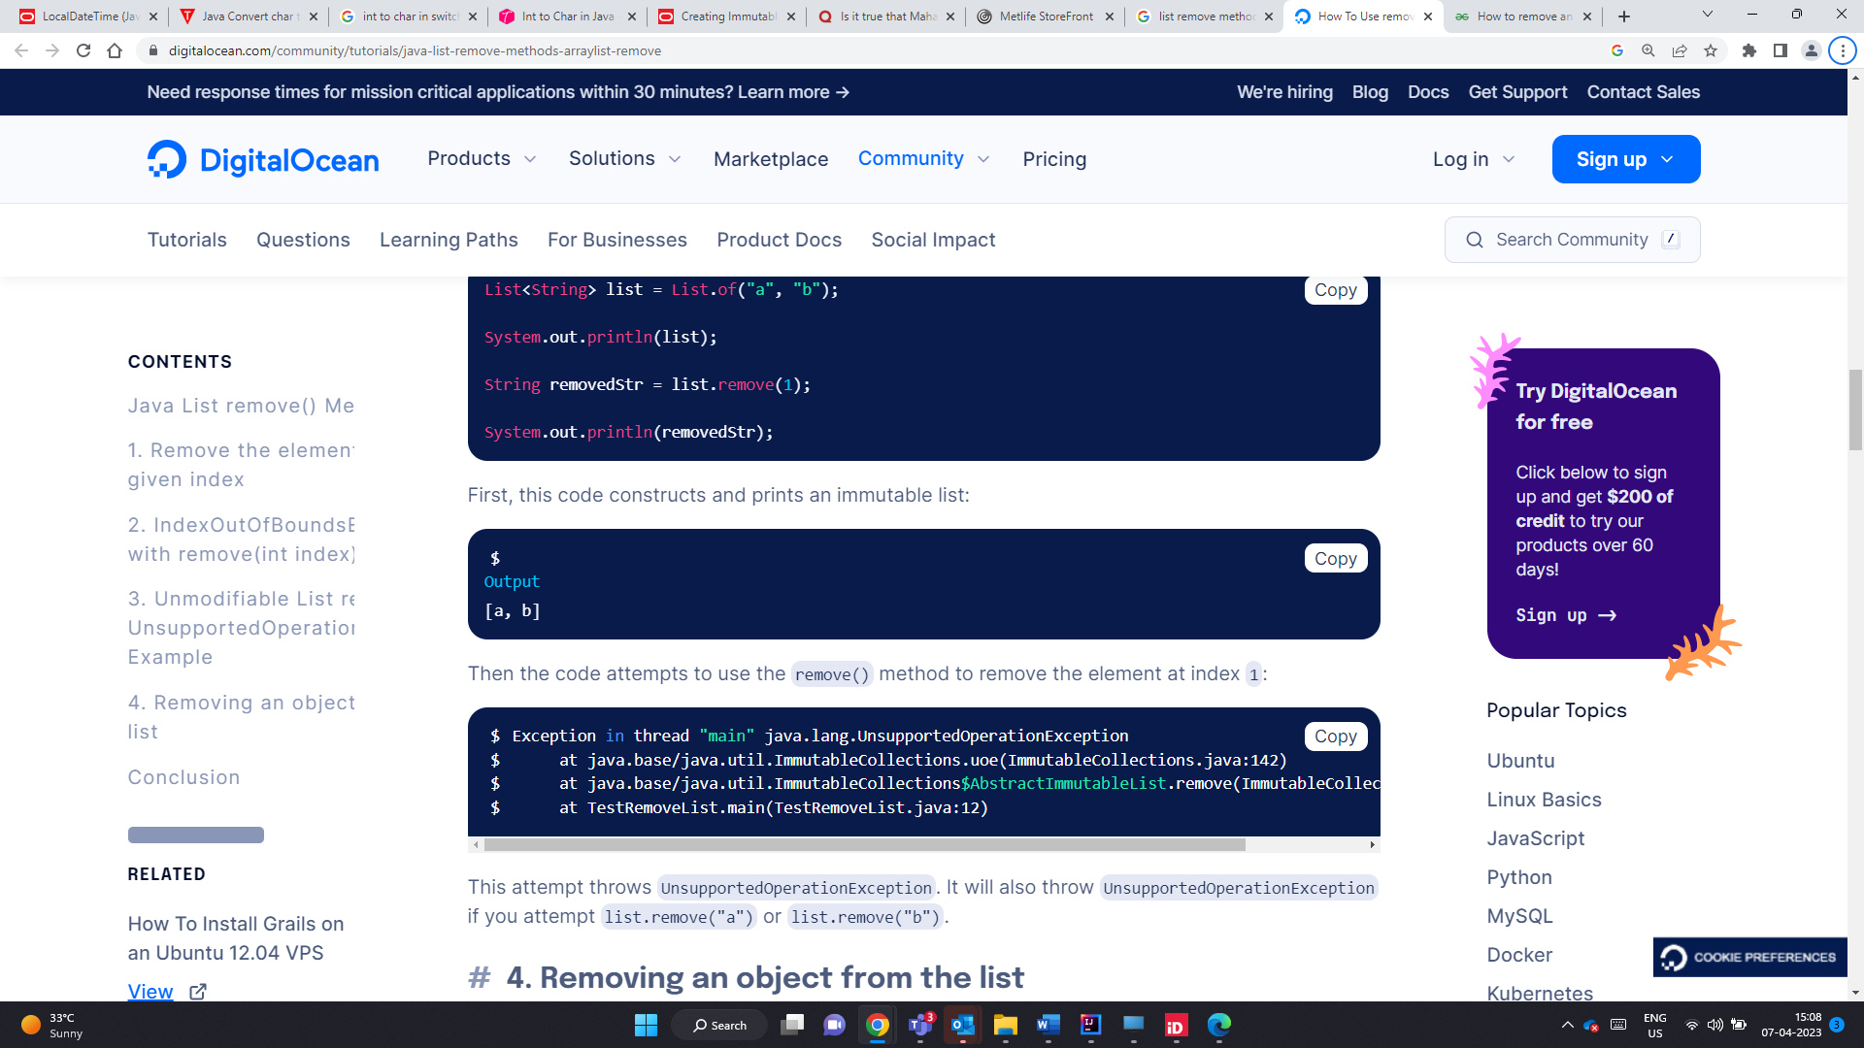

IndexOutOfBound Excpetion

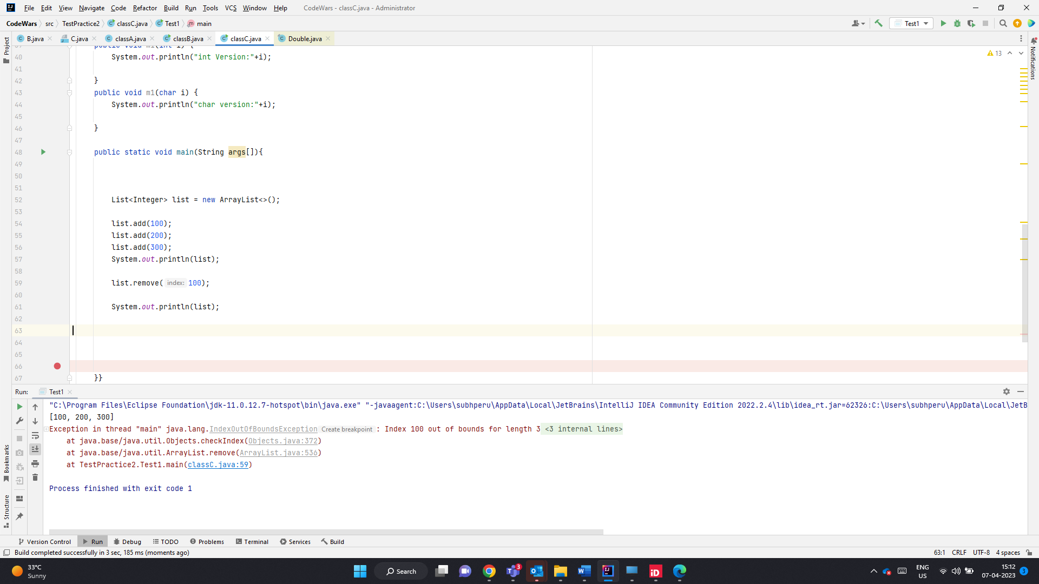

E remove(int index) -> method is overridden to remove the element at index.

Causes index out of bound exception

Since remove(int)- is a valid method it does not perform autoboxing in this case

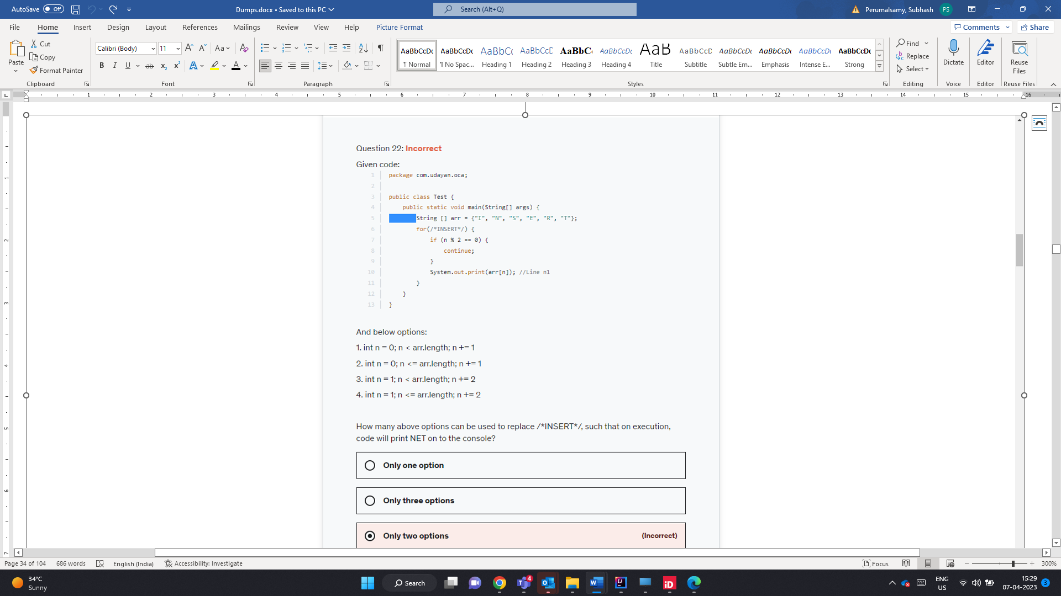

N E T – index 1 , 3 , 5 % 2 != 0 will be printed

0,2,4 nos % 2==0 so these nos will not be printed

1. 0,1,2,3,4,5 -> N E T will be printed
2. 0,1,2,3,4,5,6 -> Here arr[6] is not called . so no run time error.
3. 1,3,5
4. 1,3,5

All 4 are valid methods

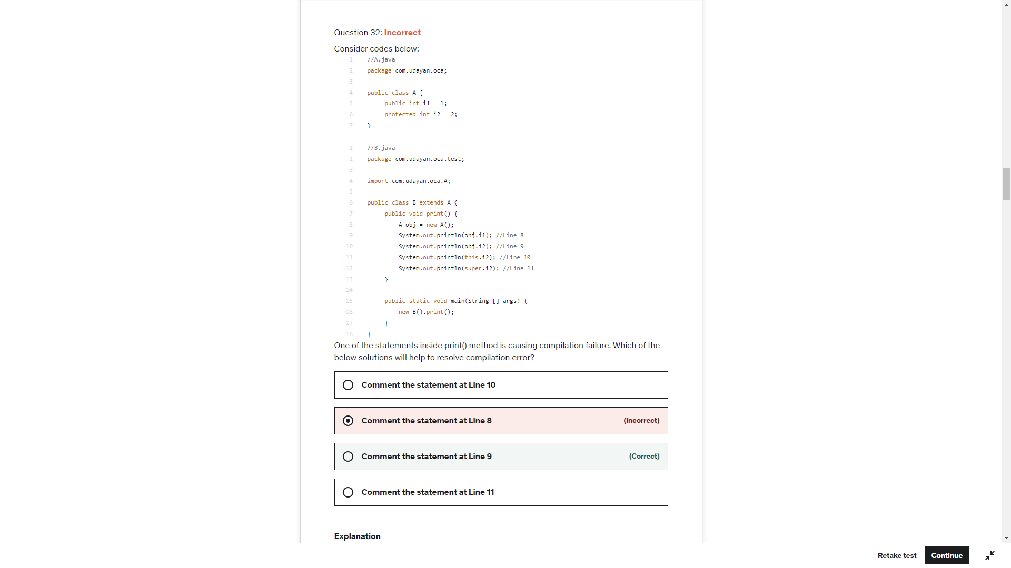

Current object is

Of type B which is of child class ref

And can access protected member of parent class

Obj.i1 is accessing public member-valid

Obj.i2 – Parent Ref accessing protected variable- Throws error in Derived class of diff package

This.i2-> current object which is child ref and is trying to i2 which is super class pro variable – valid

super.i2 -> current object which is child ref of A can access super class i2 - Valid

List.remove(int) – will always look for index value of int no matter what objects the list holds

List.remove(char) – will be converted to int (ASCII value of the character) and performs index retrieval

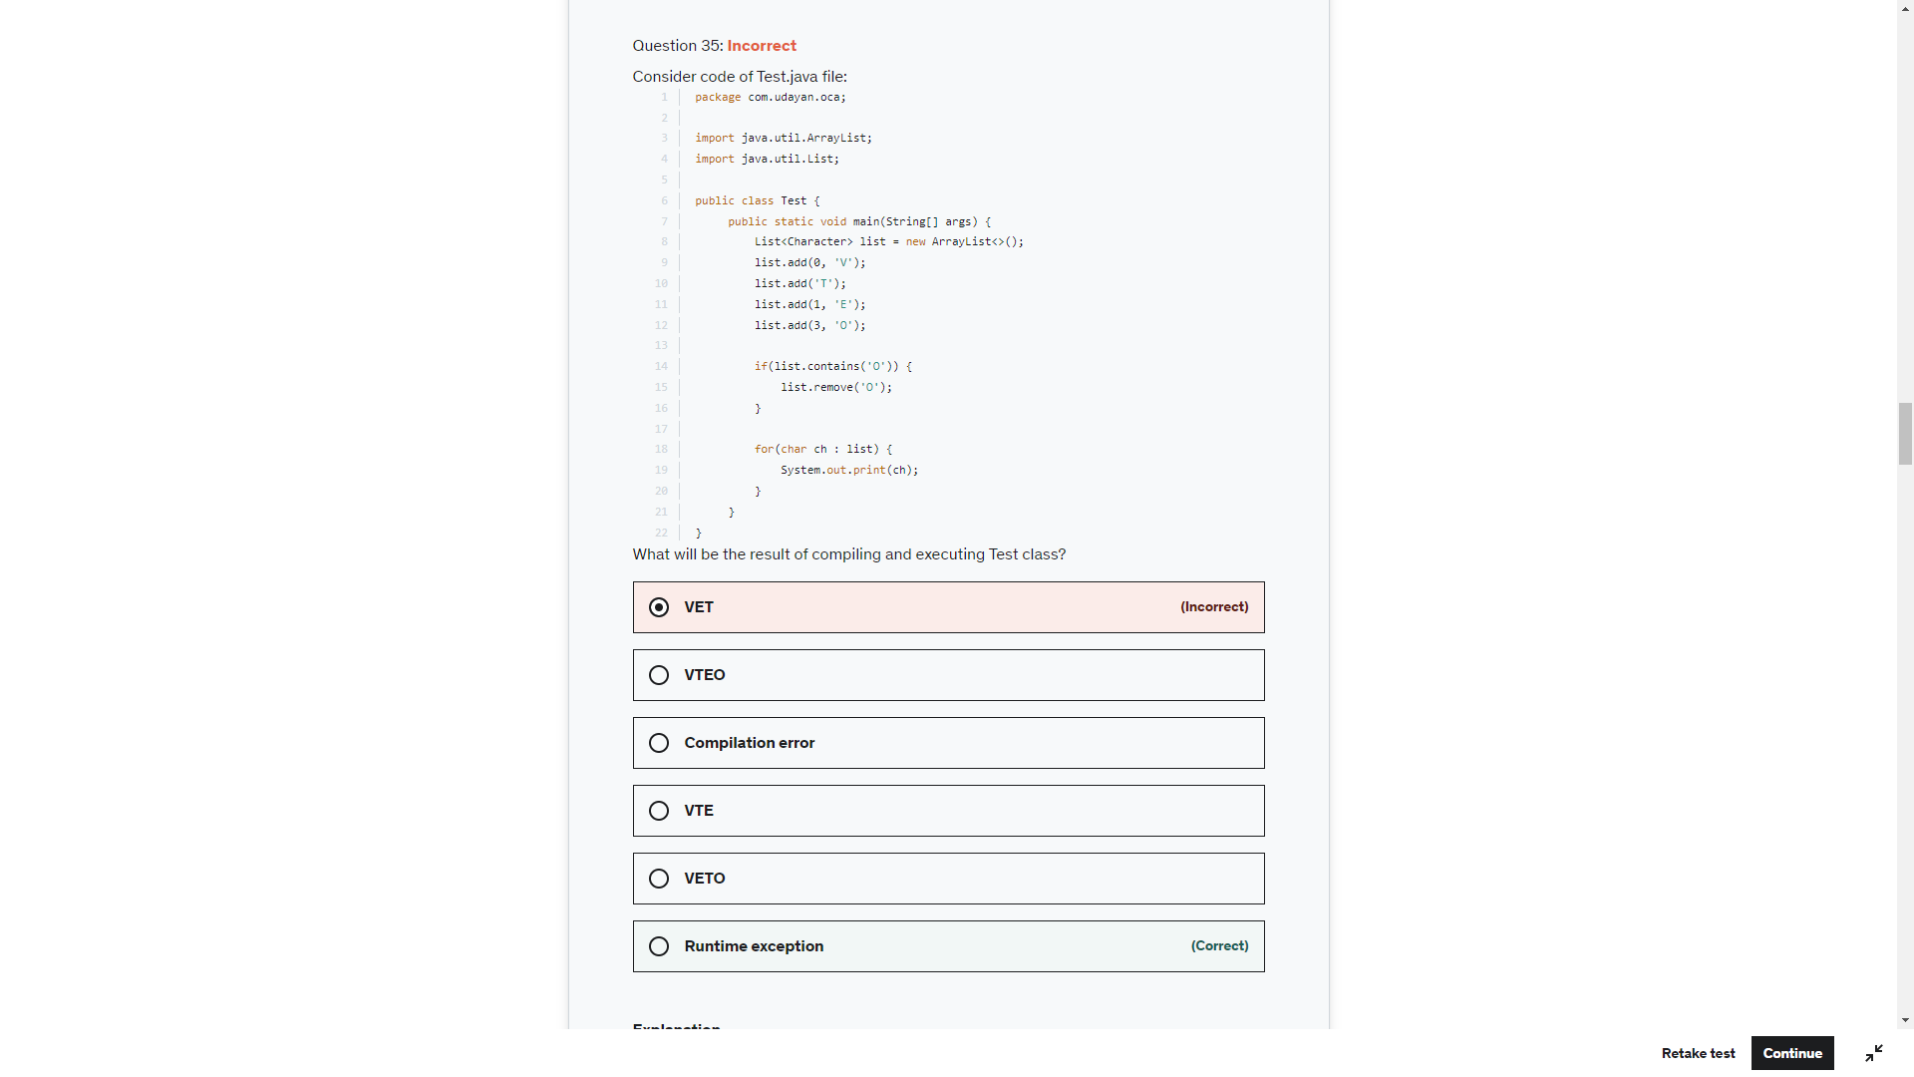

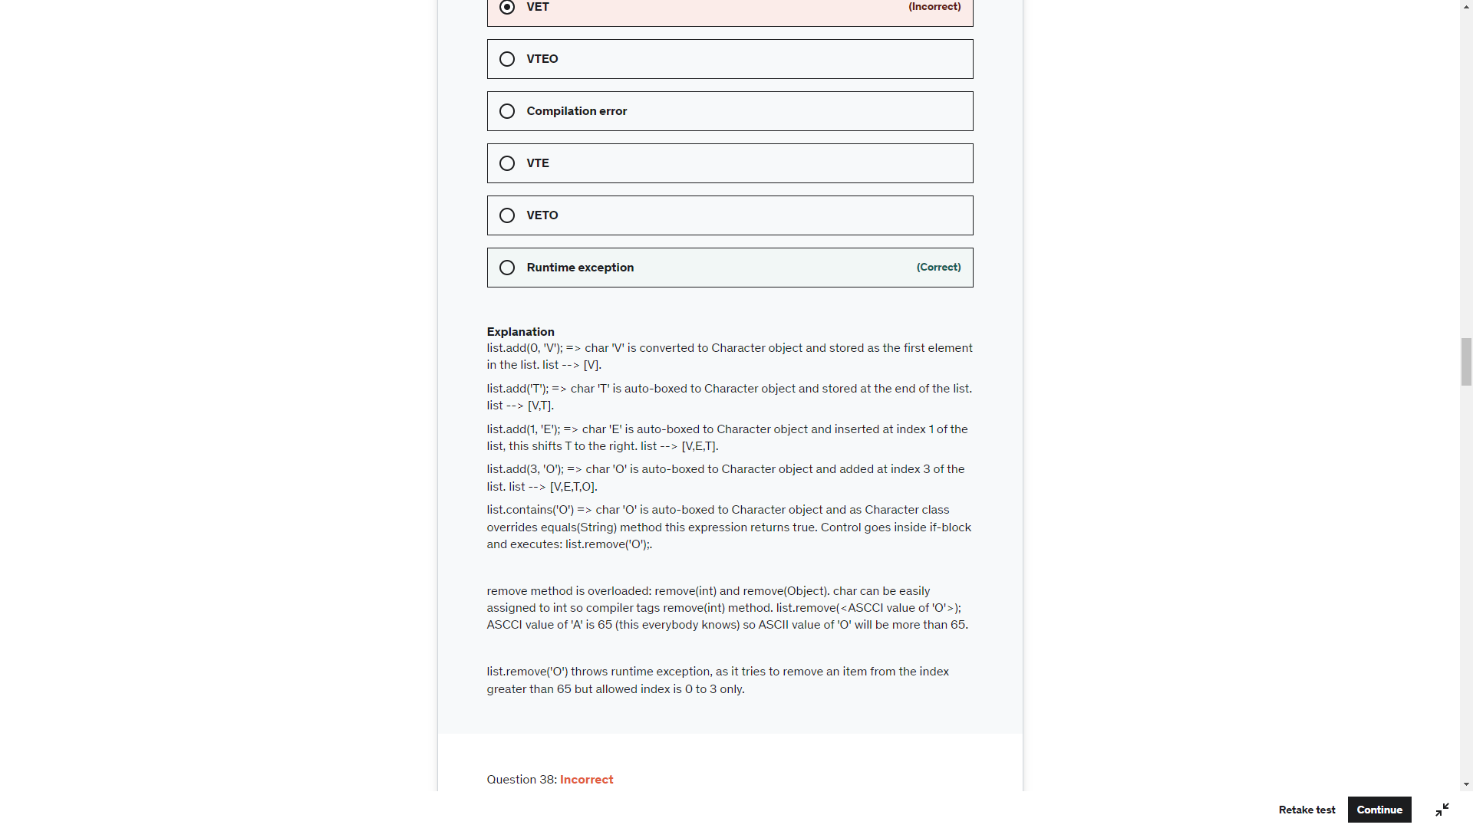

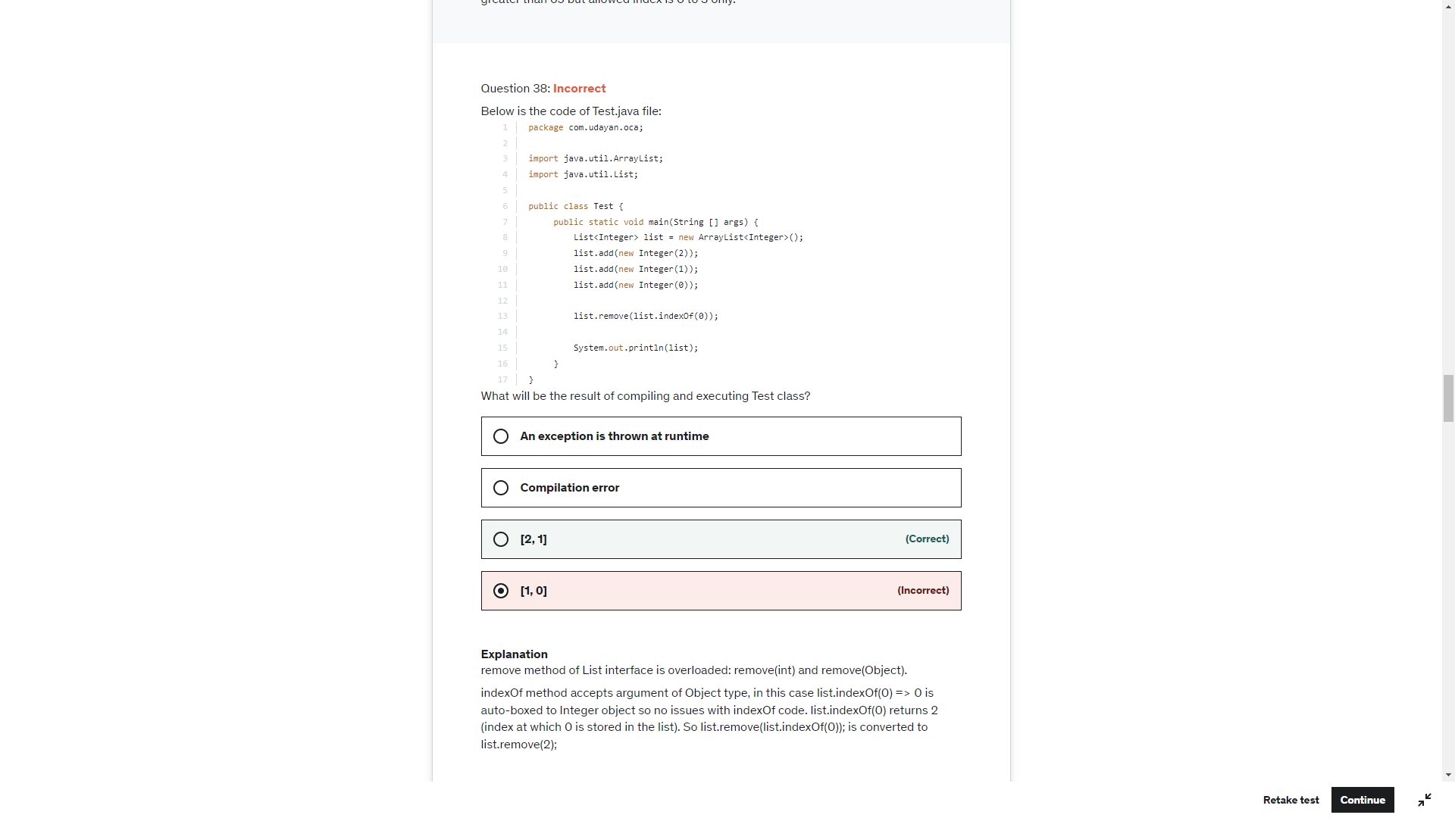

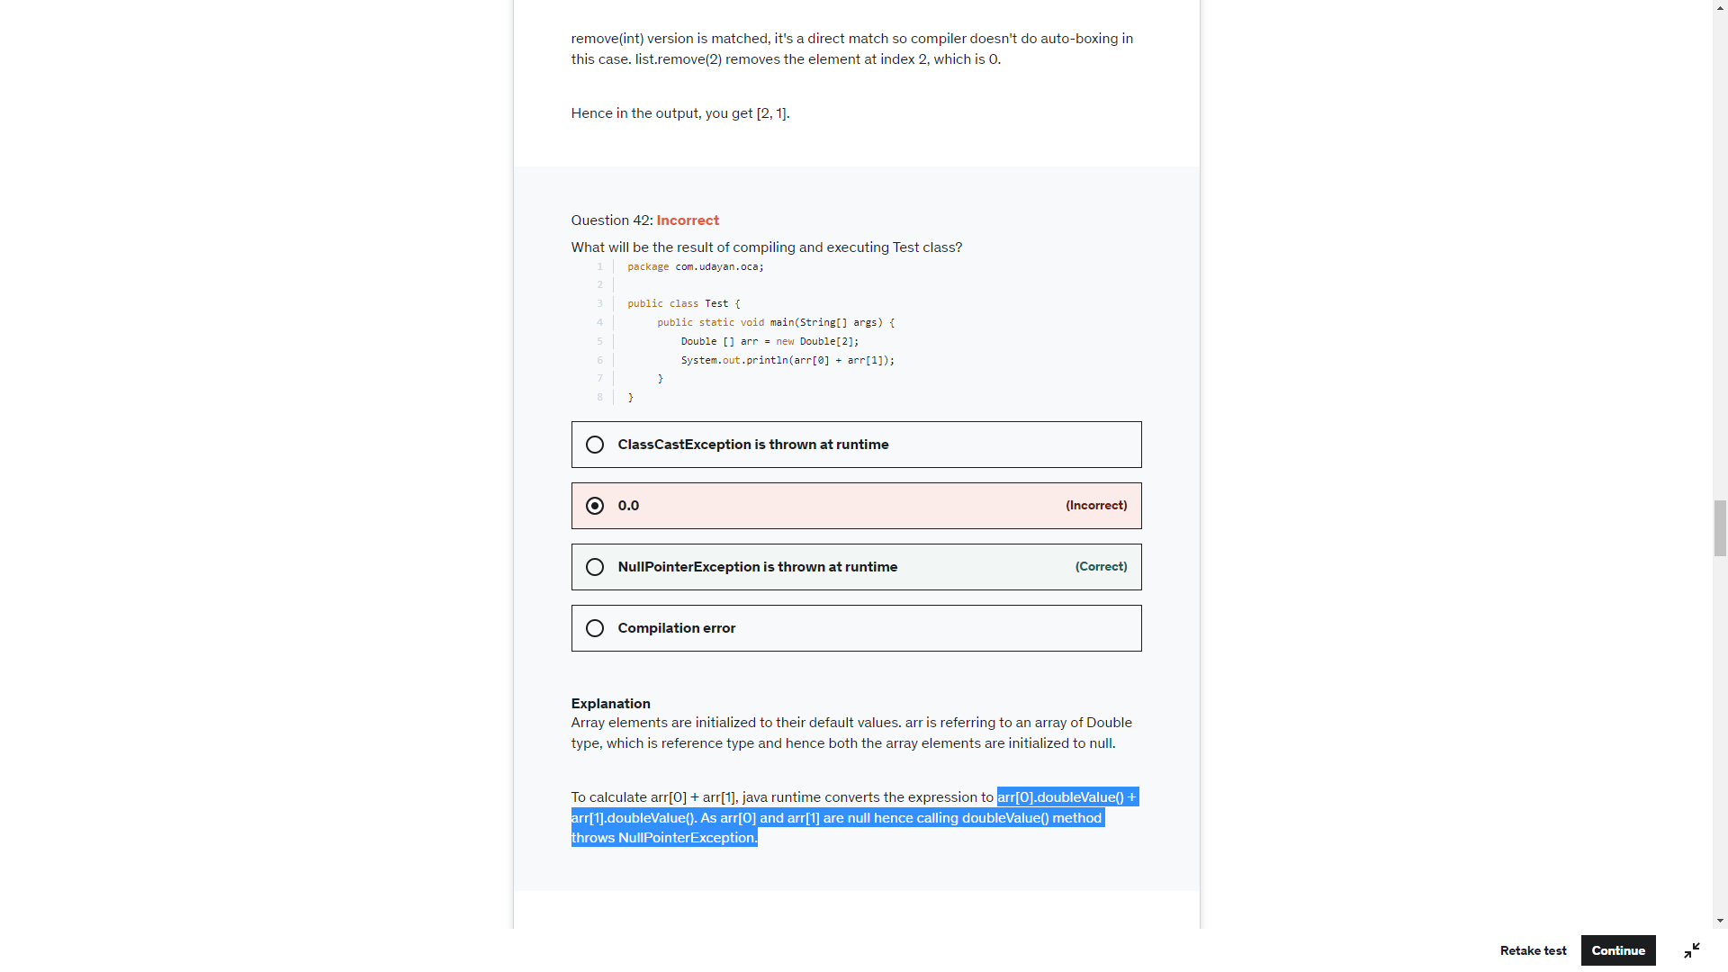

Arr[0]+”” will print null as toString() method will be call

Arr[0]+Arr[1] is an expression and tries to return the XXXValue() and throw RunTime Exception

To String is perfomed in first three cases and hence null

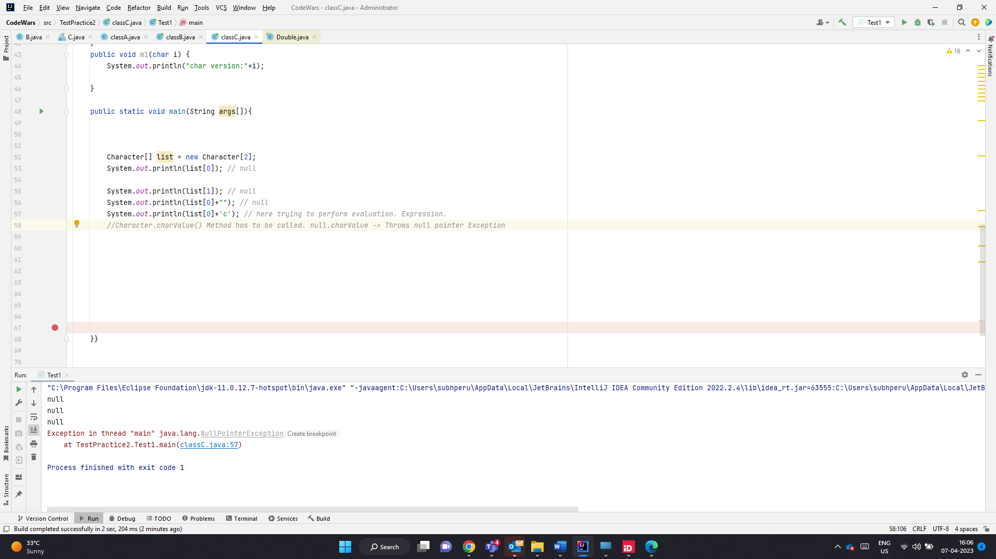

When an expression has to evaluated. Wrapper.xxxValue() will be called and on Null ref will throw null pointer exception

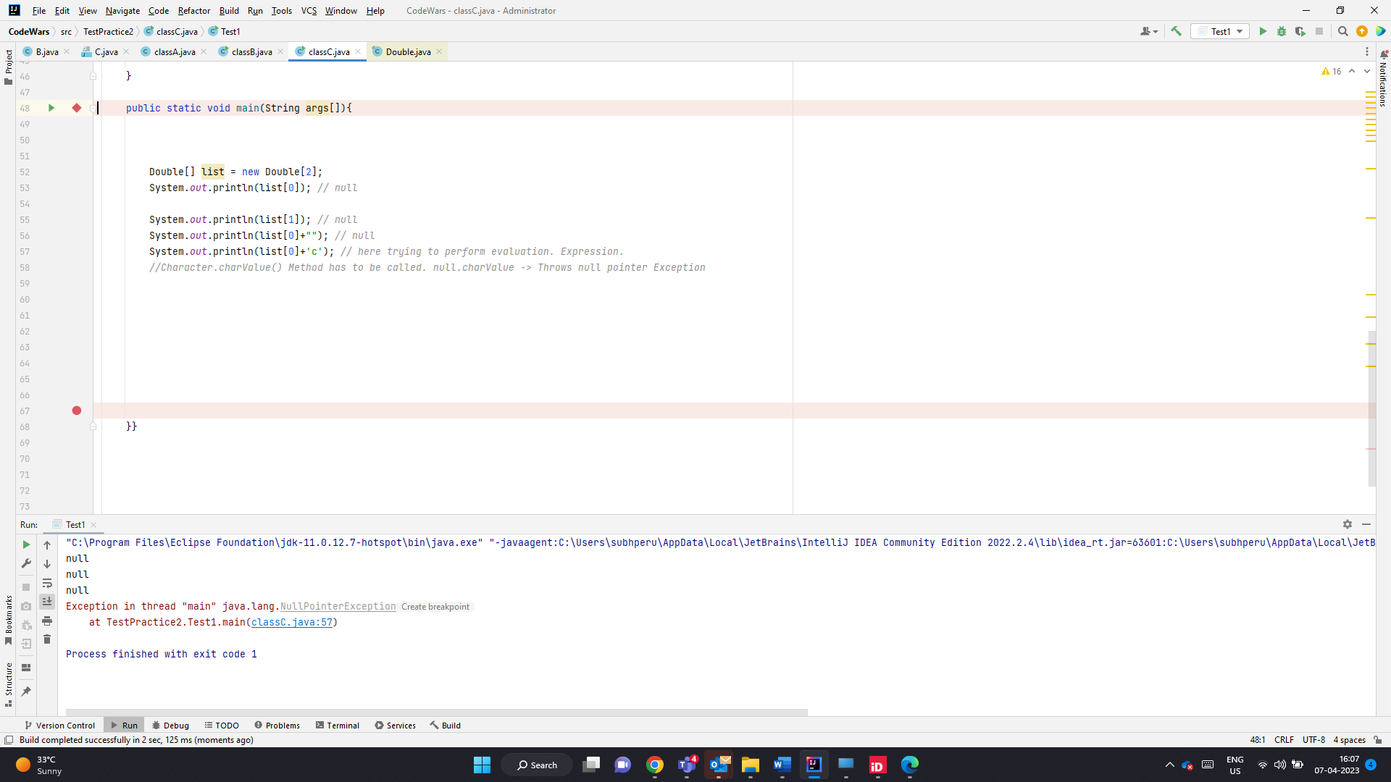

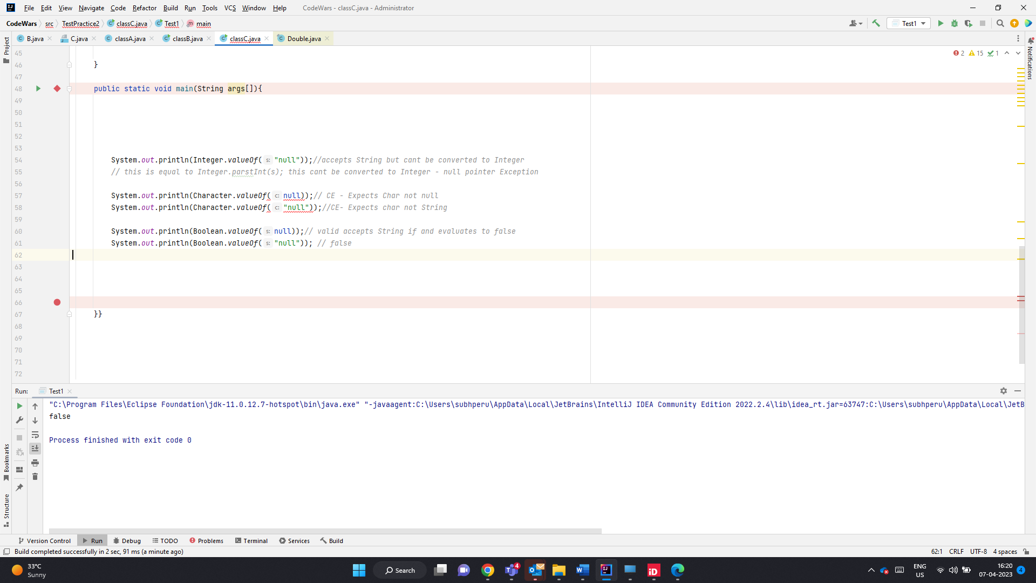

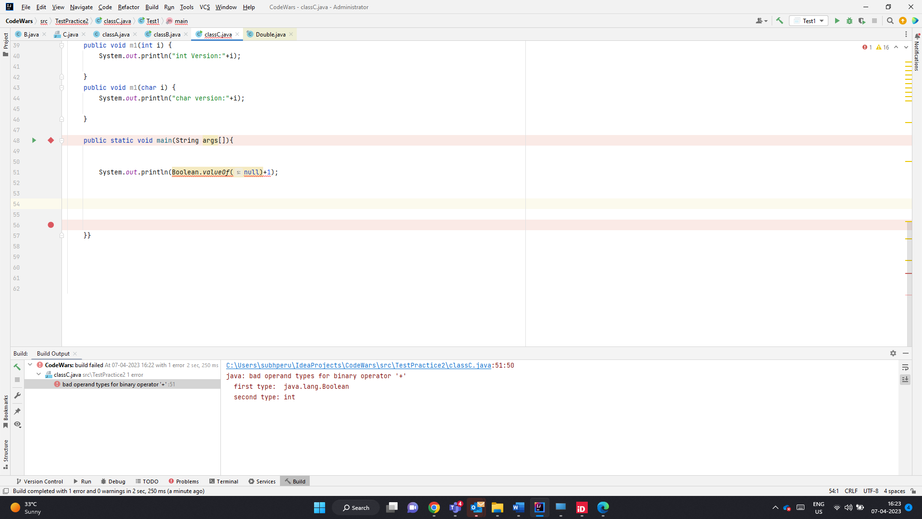

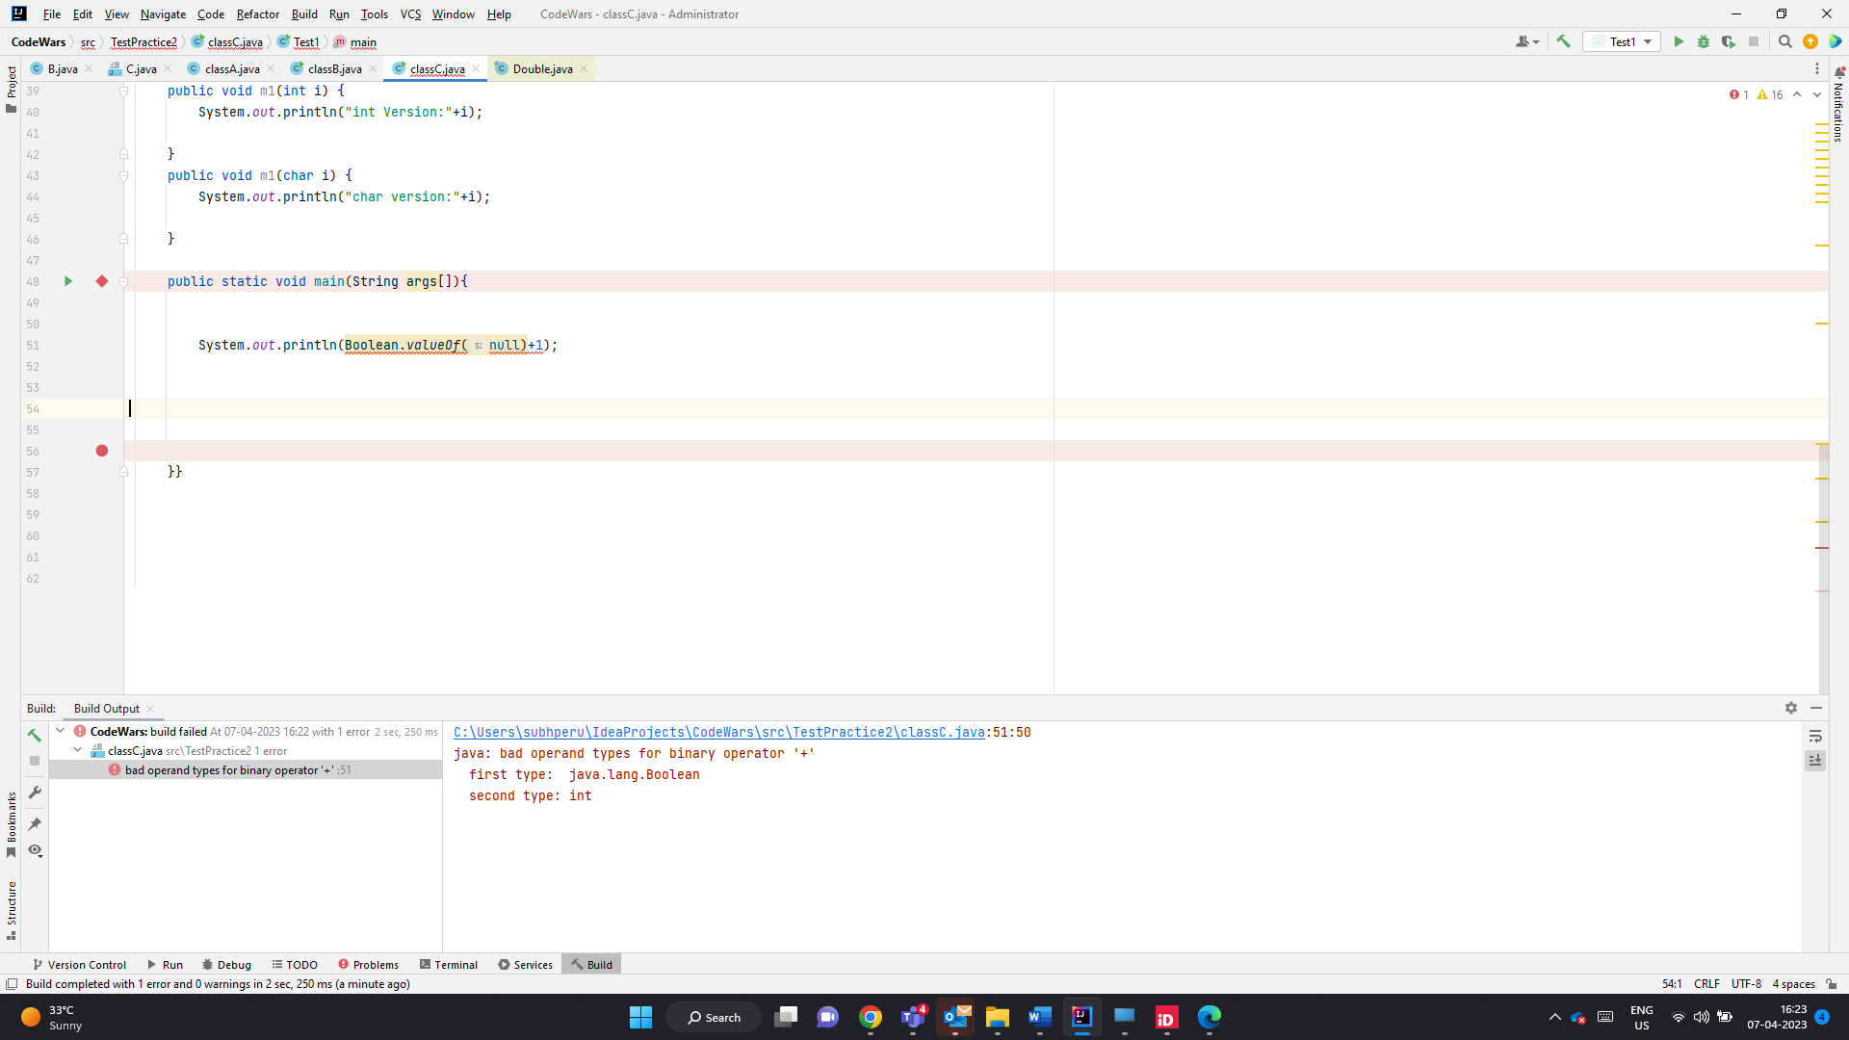

Null pointer Excpetion for below

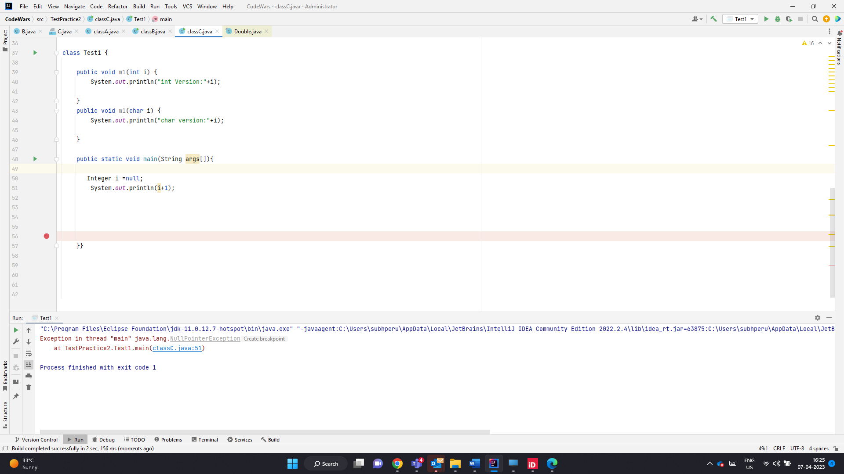

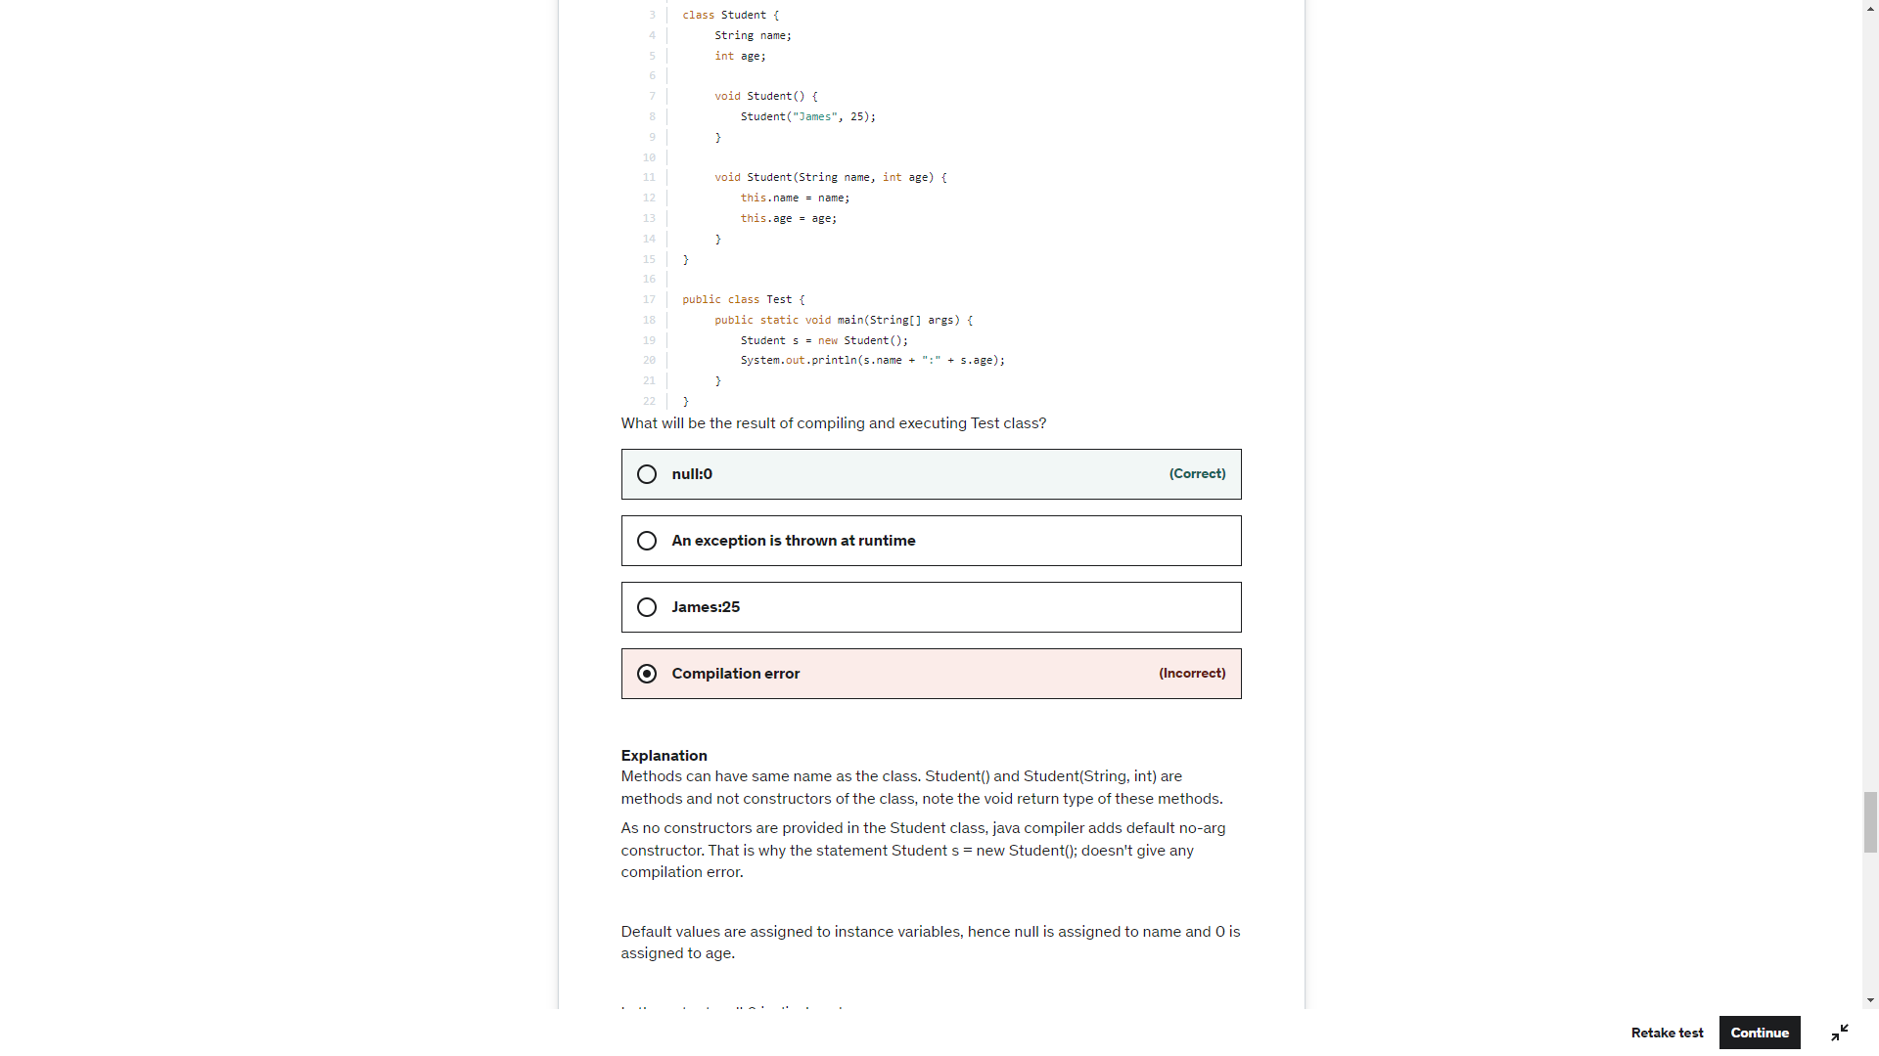

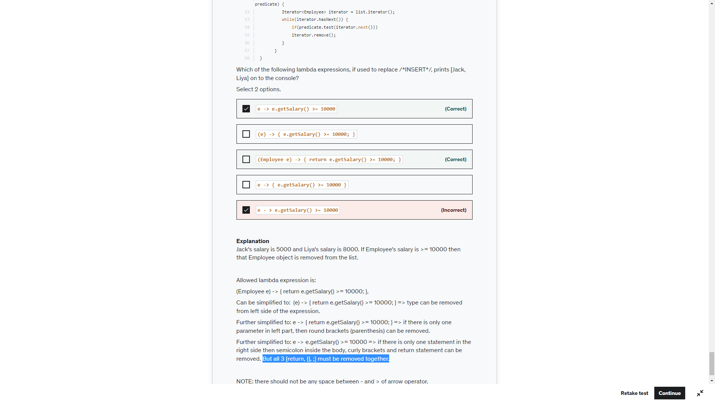

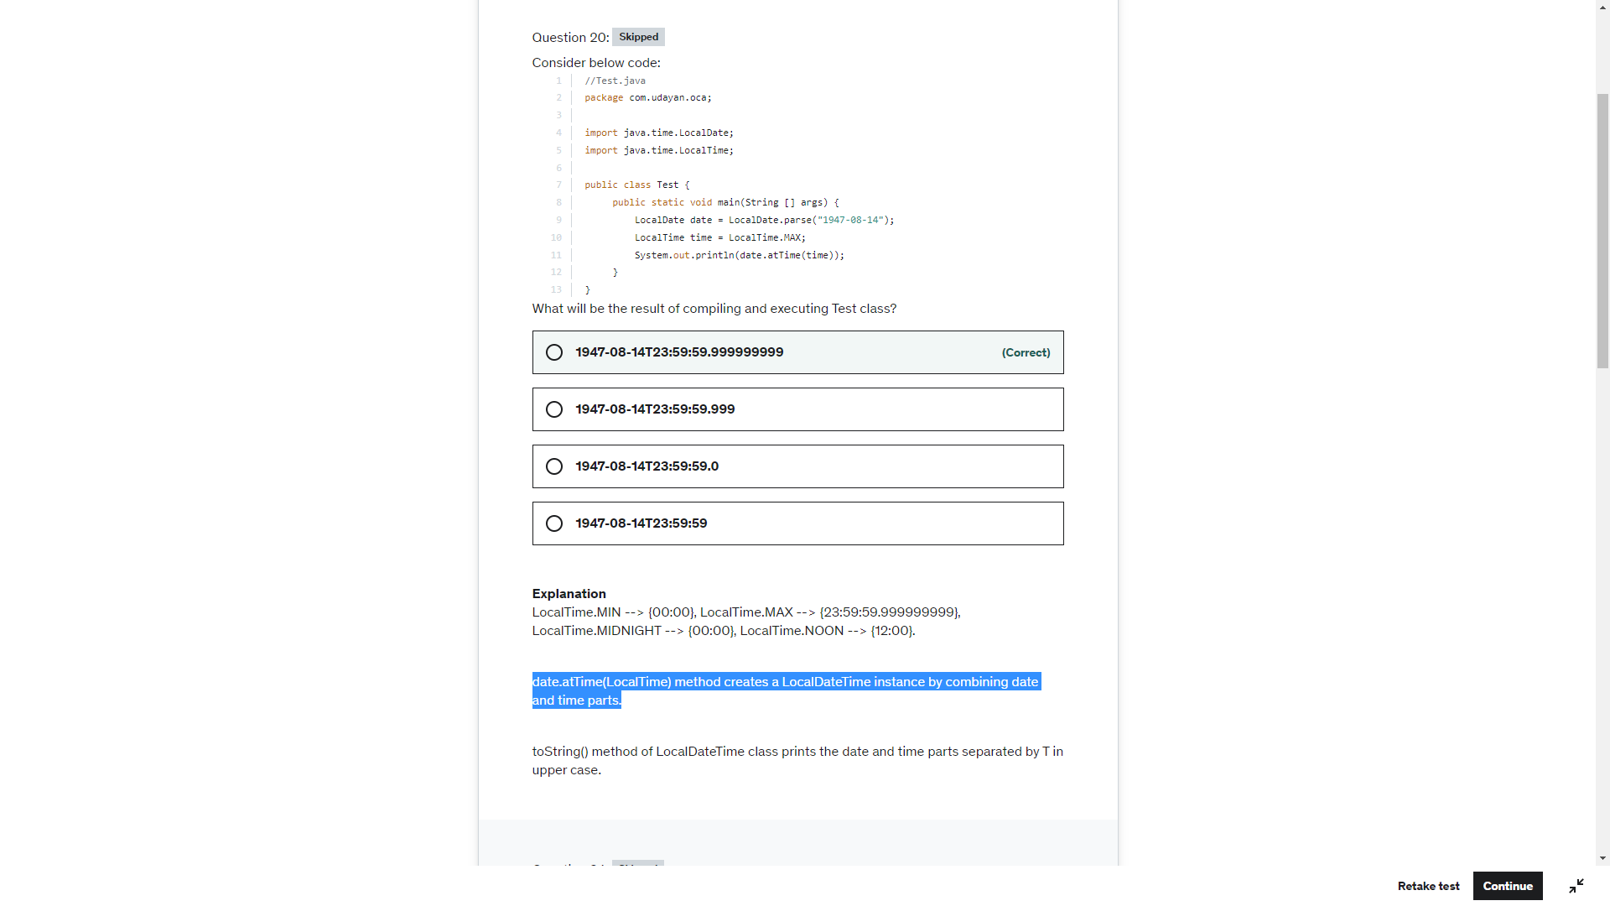

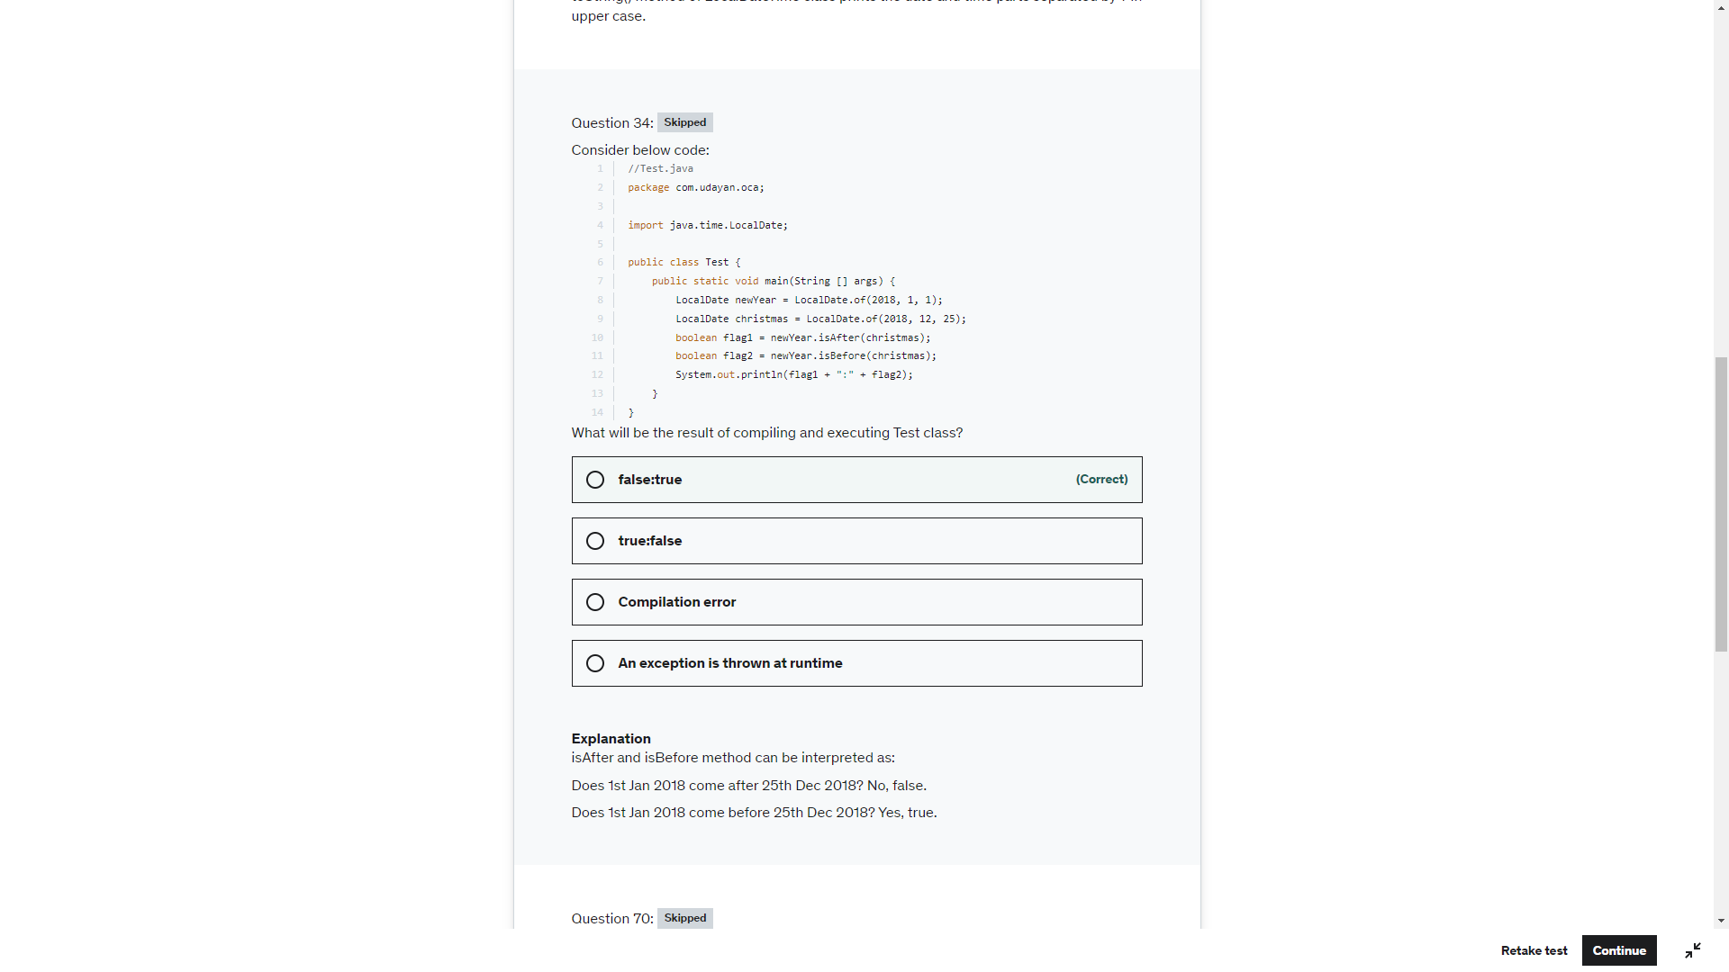

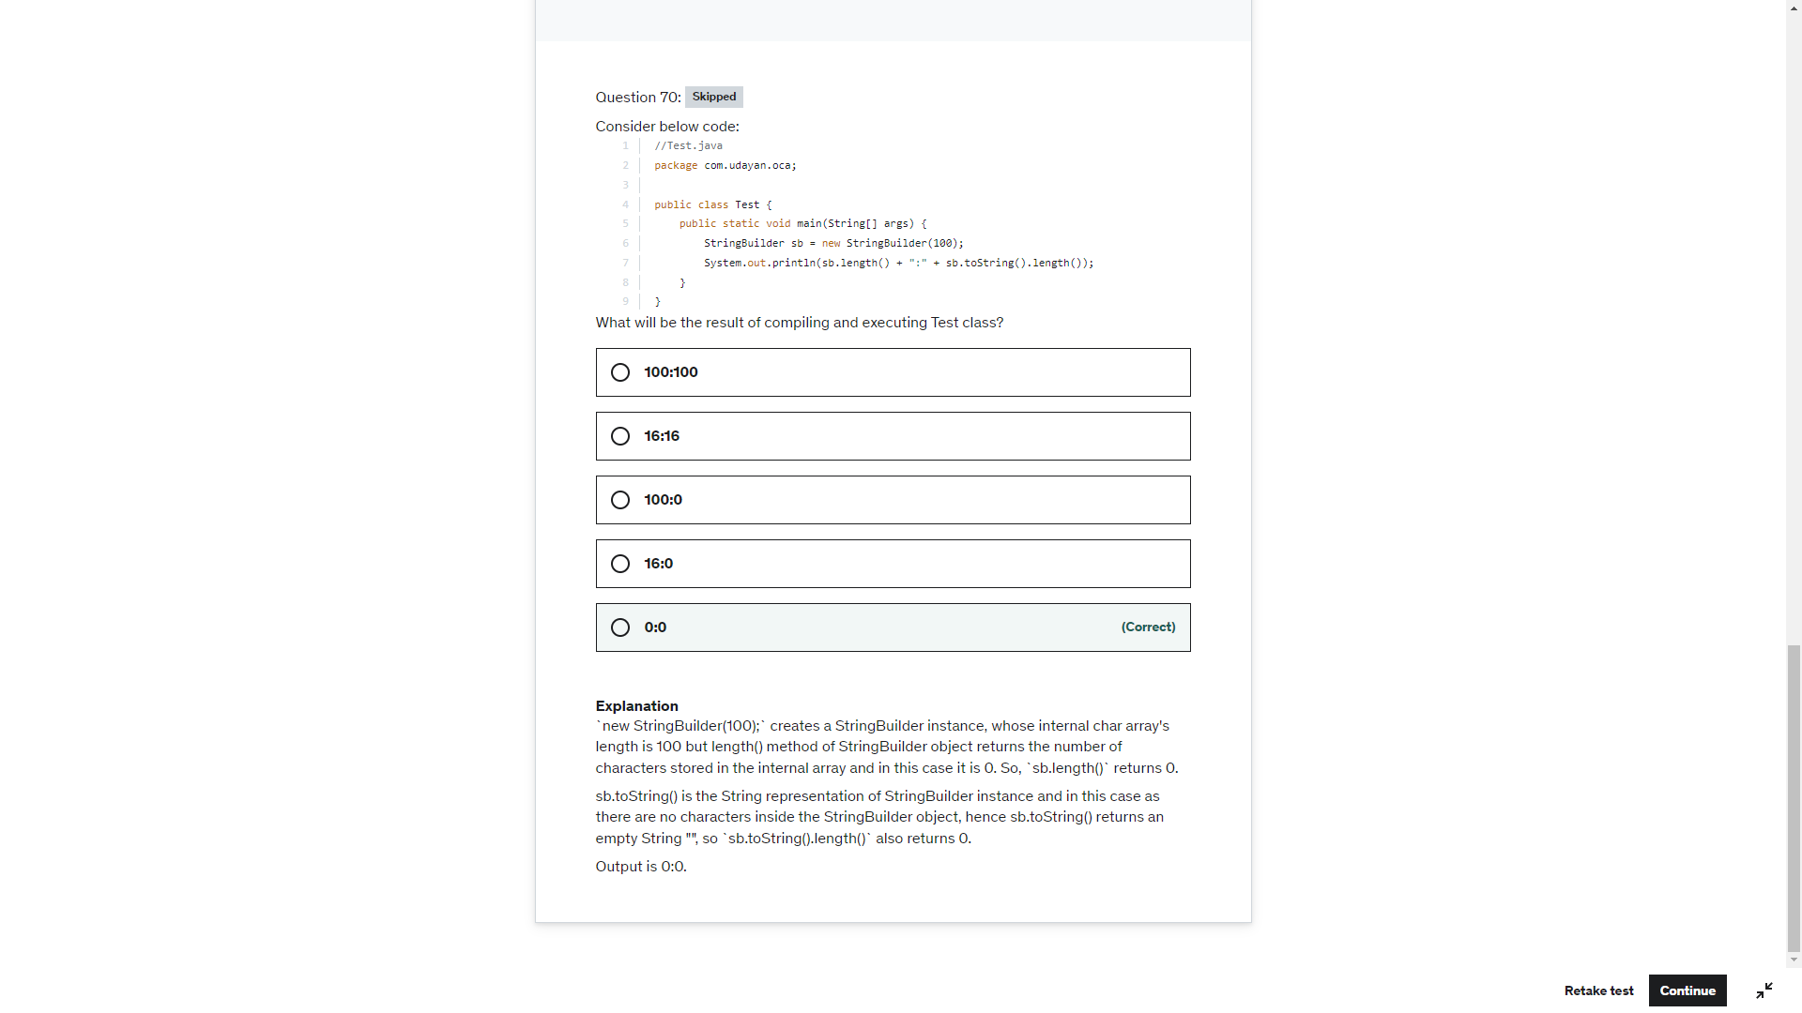

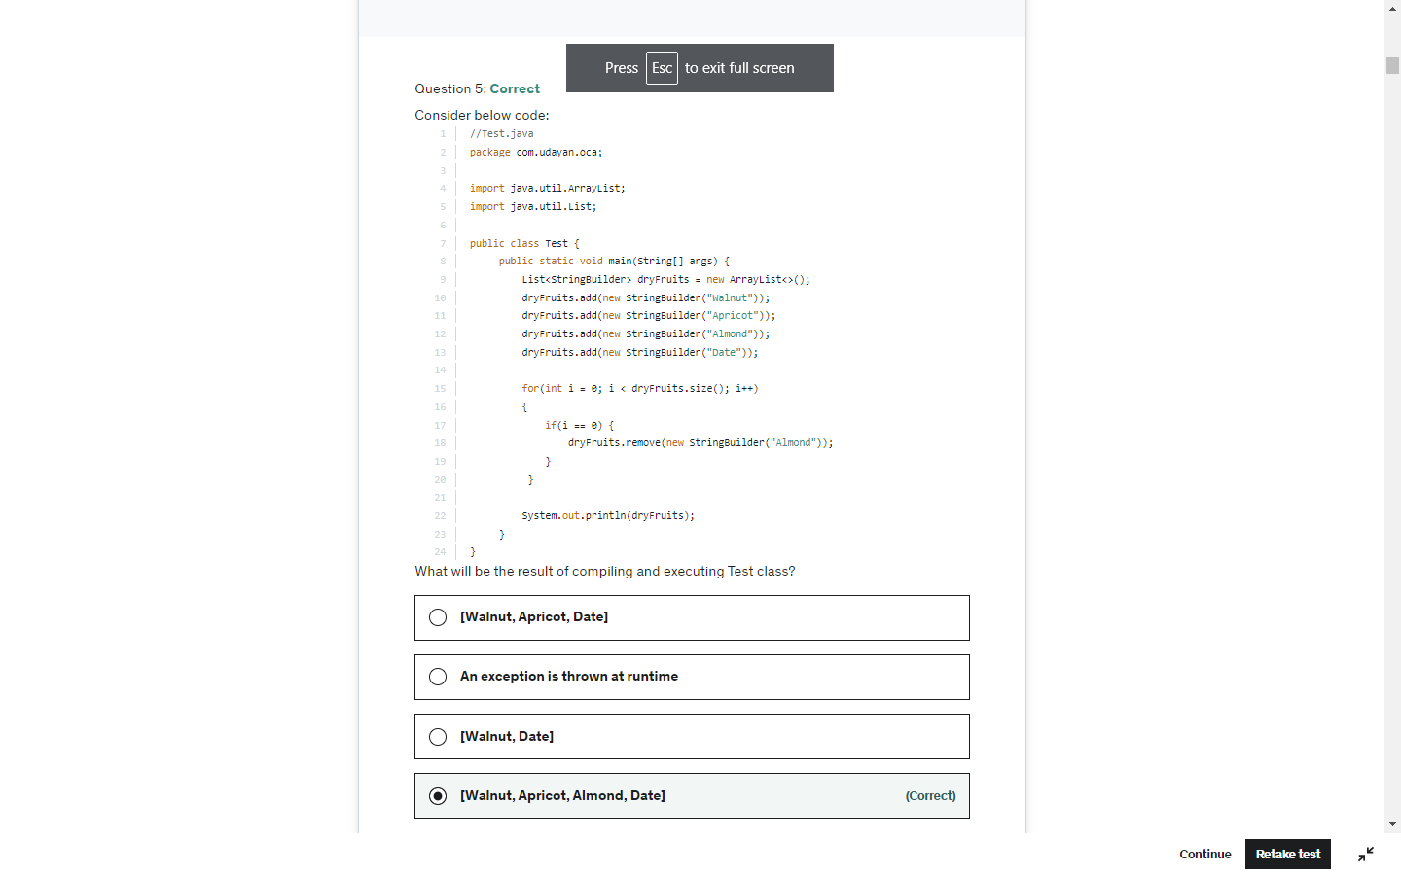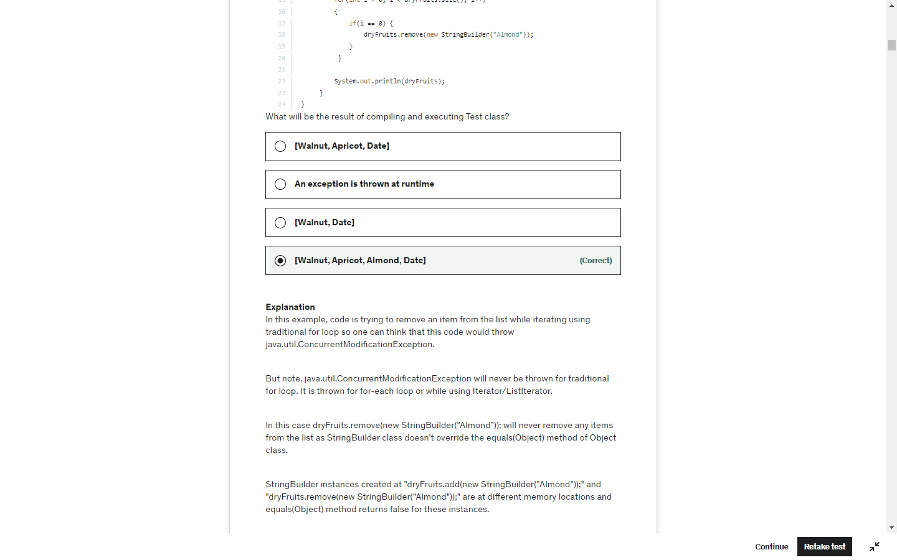

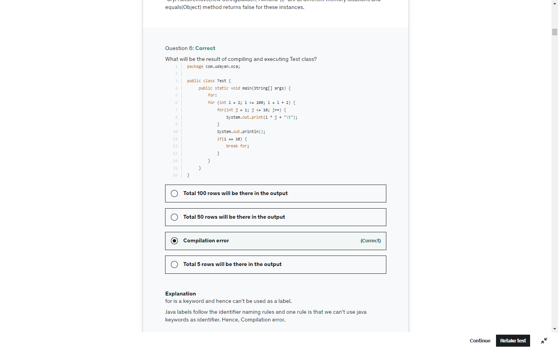

Interface methods are by default public and abstract

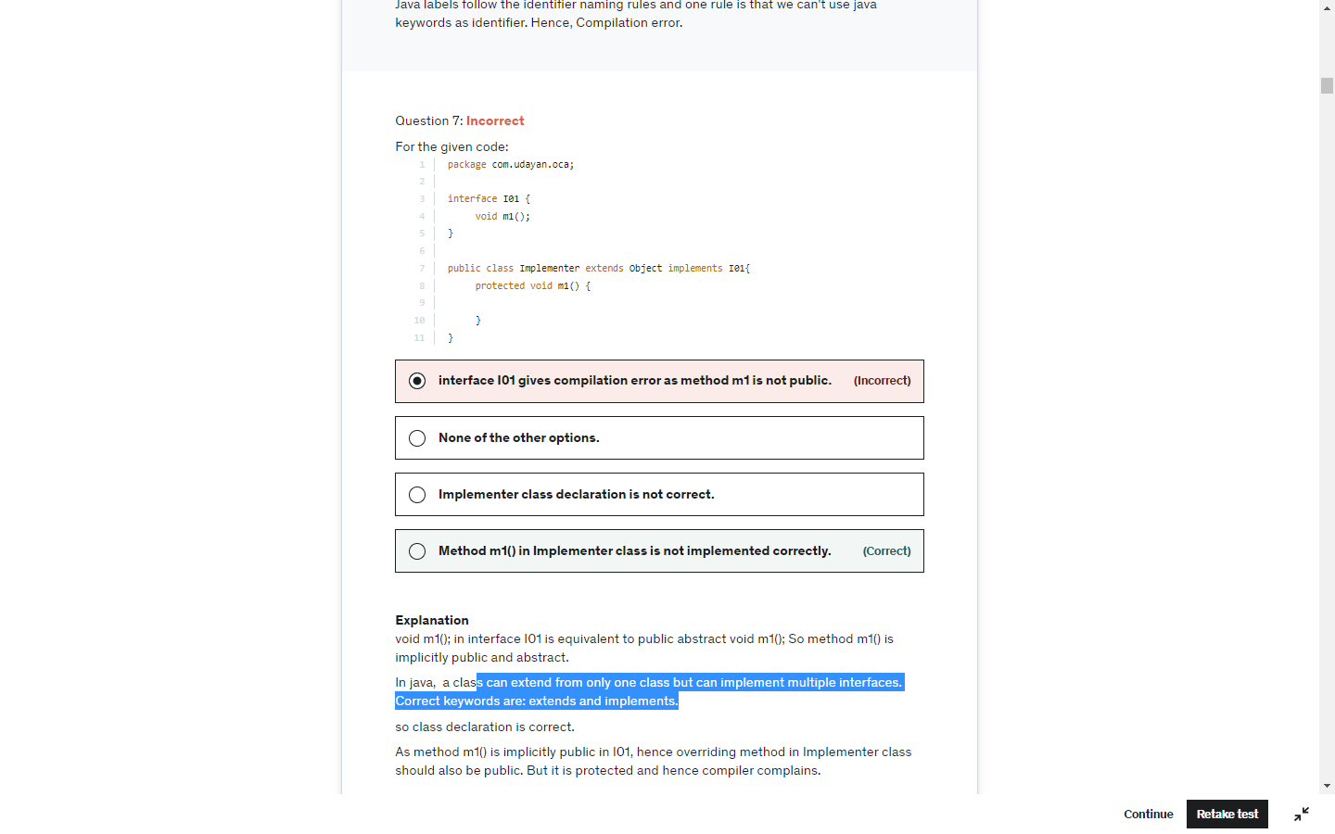

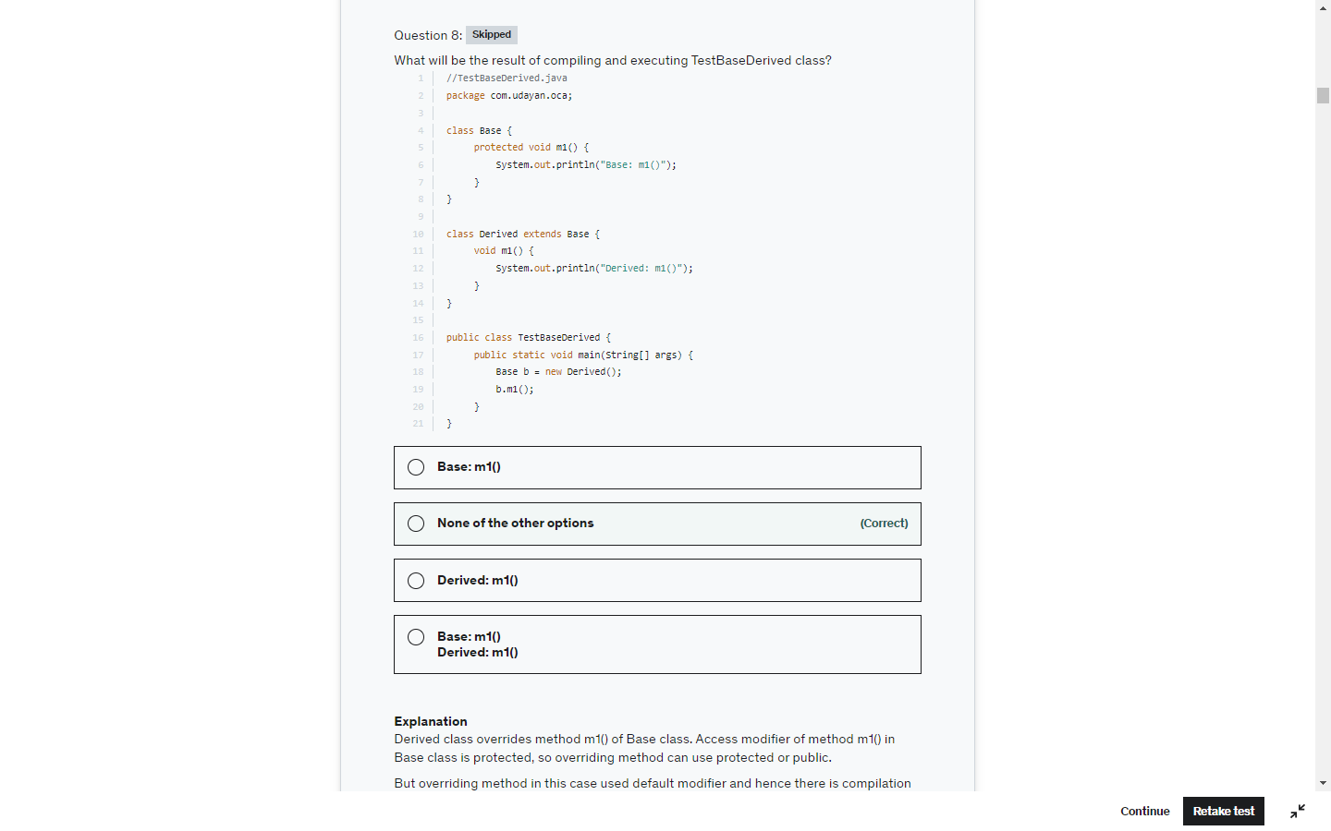

The **java instanceof operator** is used to test whether the object is an instance of the specified type (class or subclass or interface).

The instanceof in java is also known as type *comparison operator* because it compares the instance with type. It returns either true or false. If we apply the instanceof operator with any variable that has null value, it returns false.



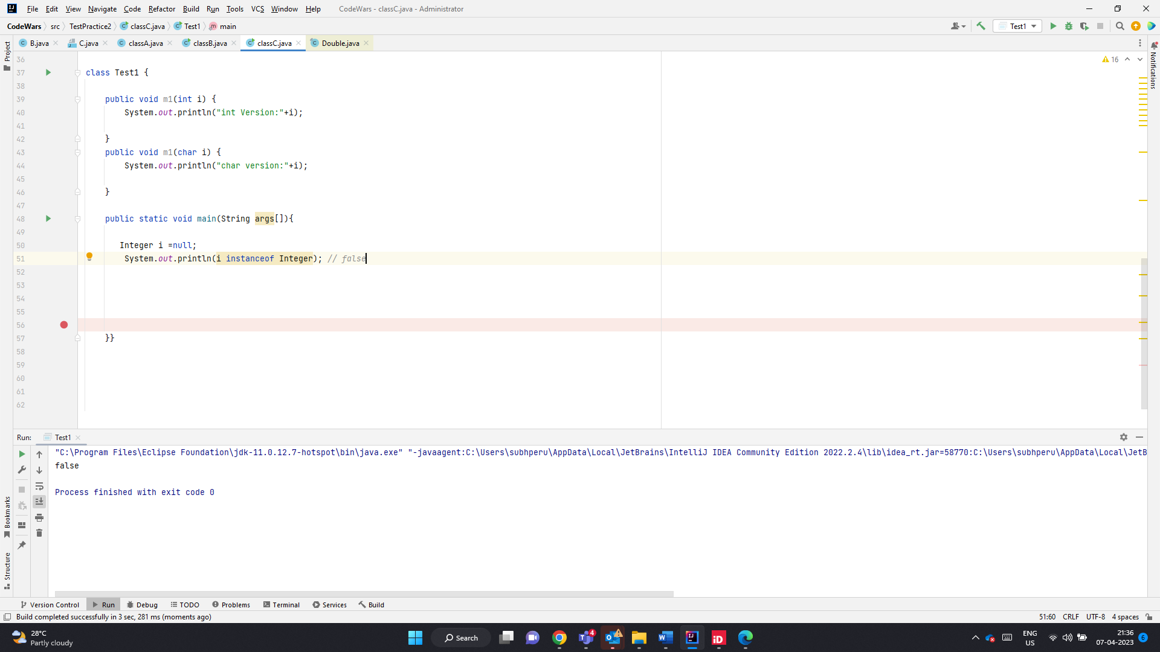

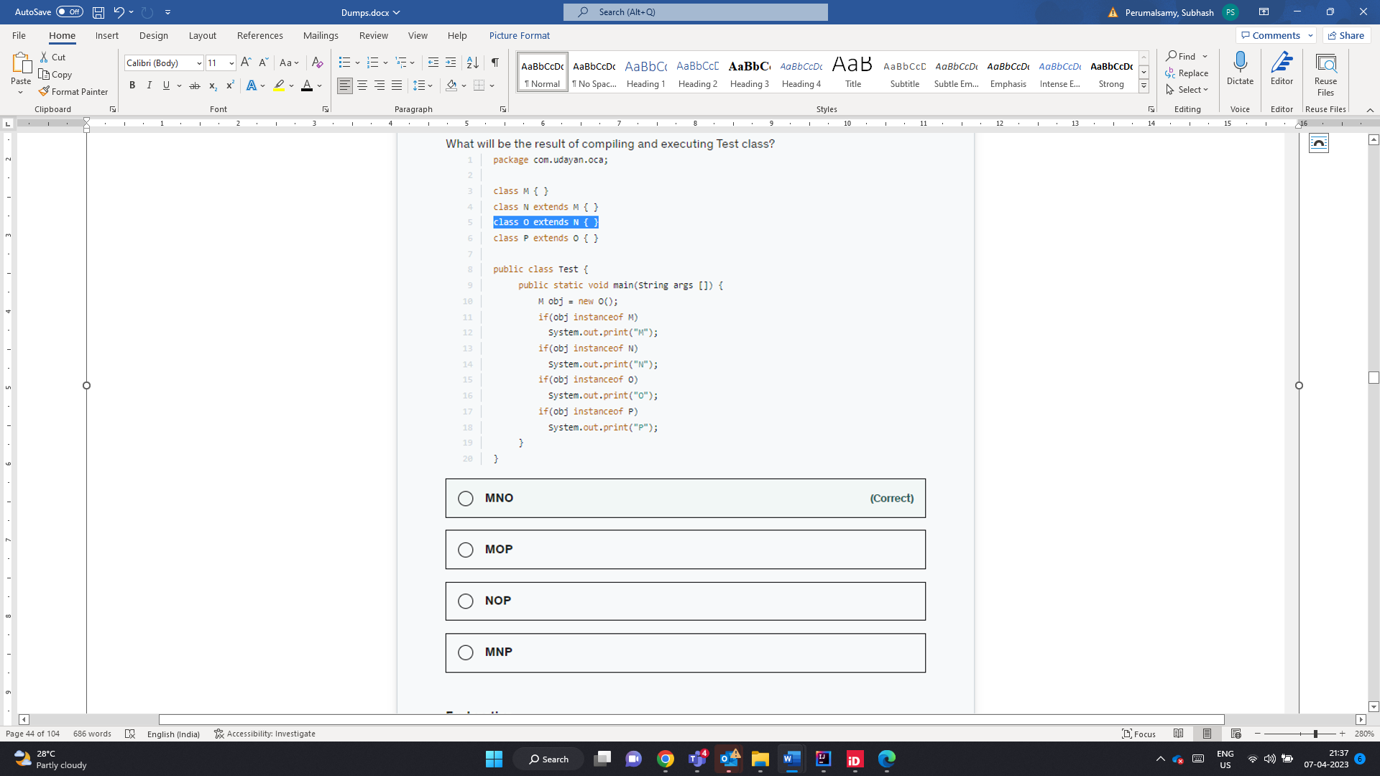

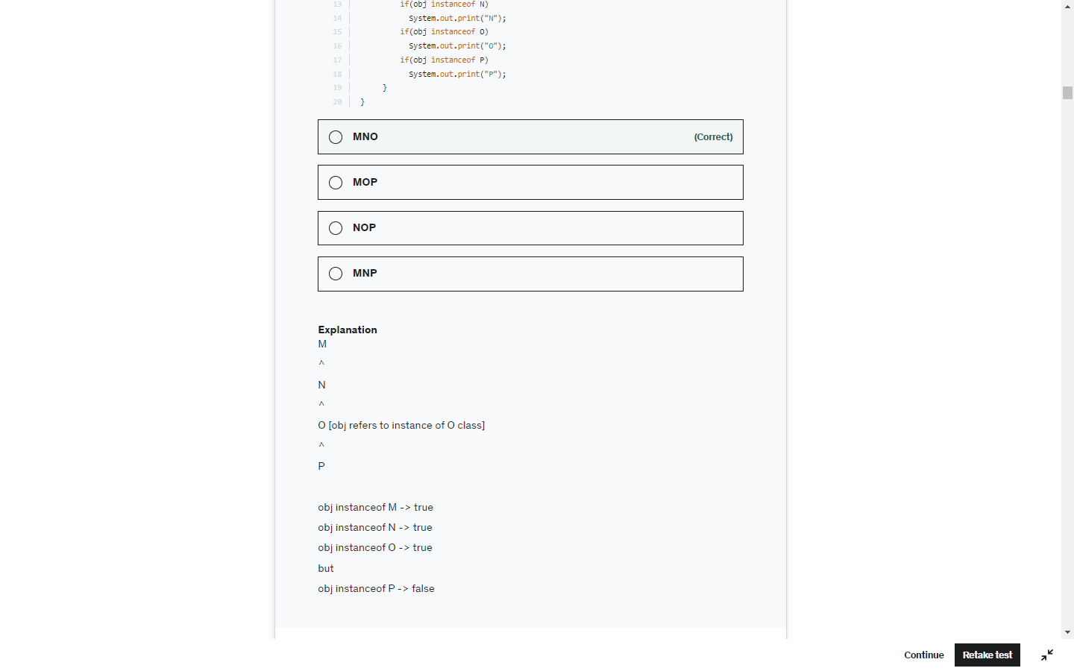

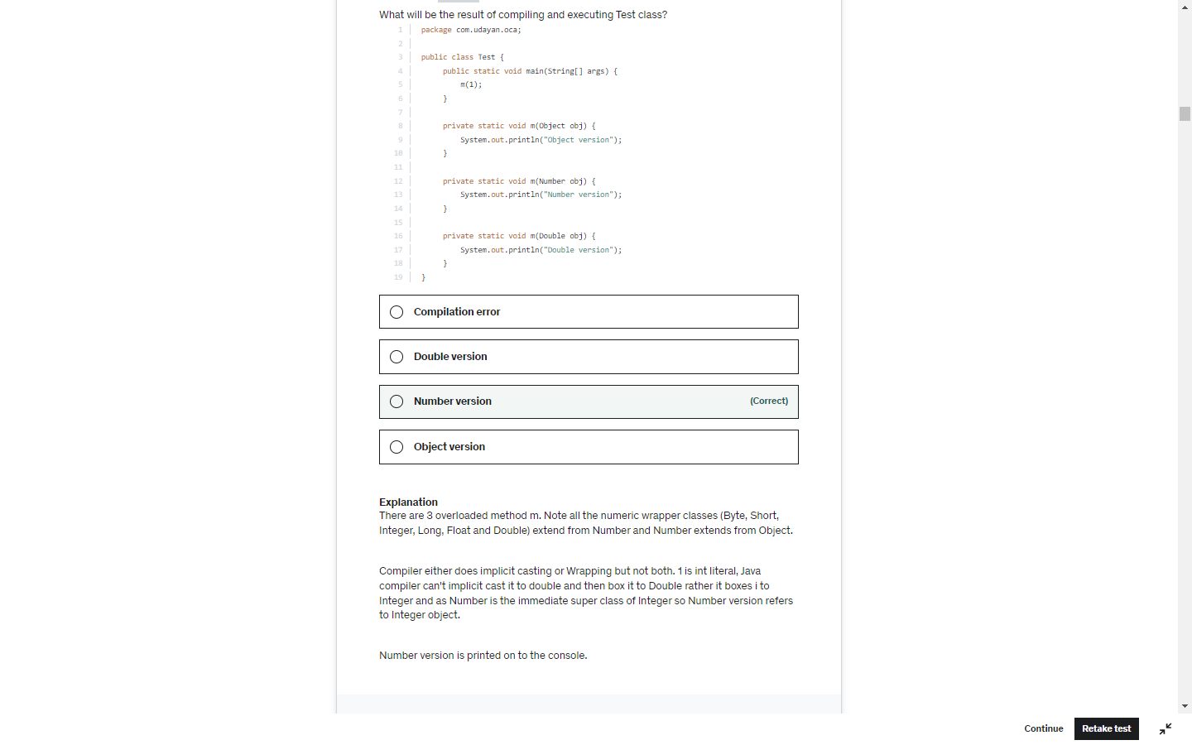

StringBuffer.delete(5,6) substring of (5-6) that is only 5

Sb.toString() creates a new String object. SB remains unaffected

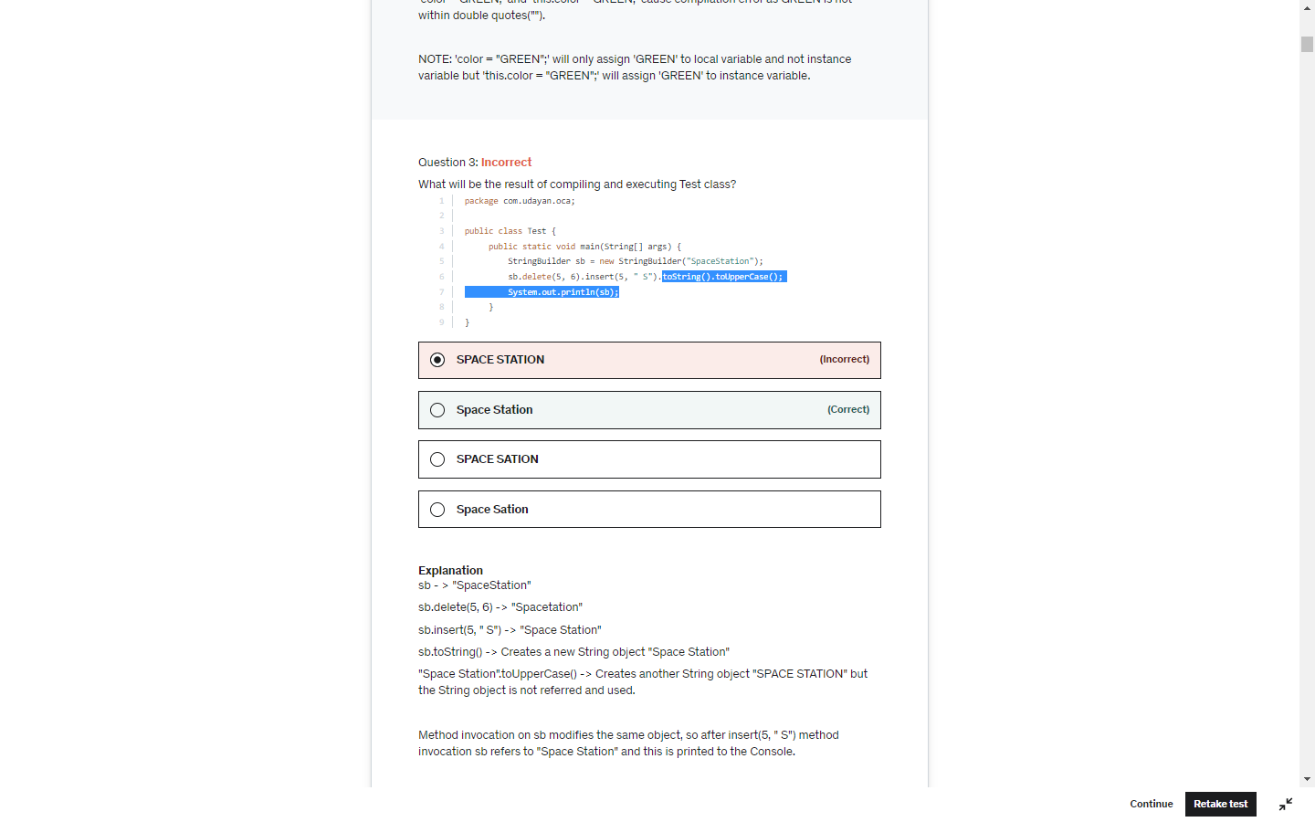

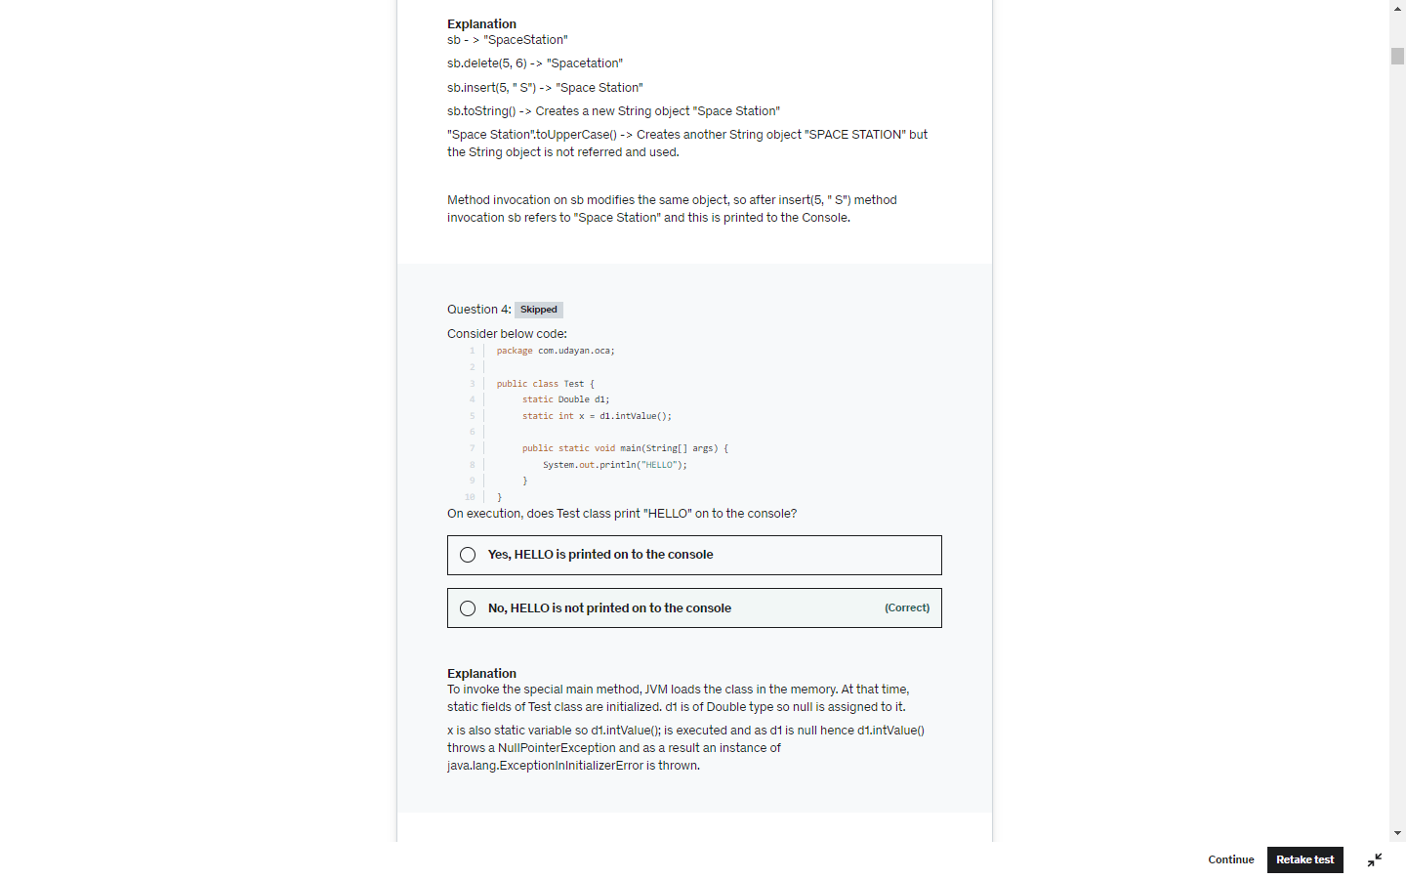

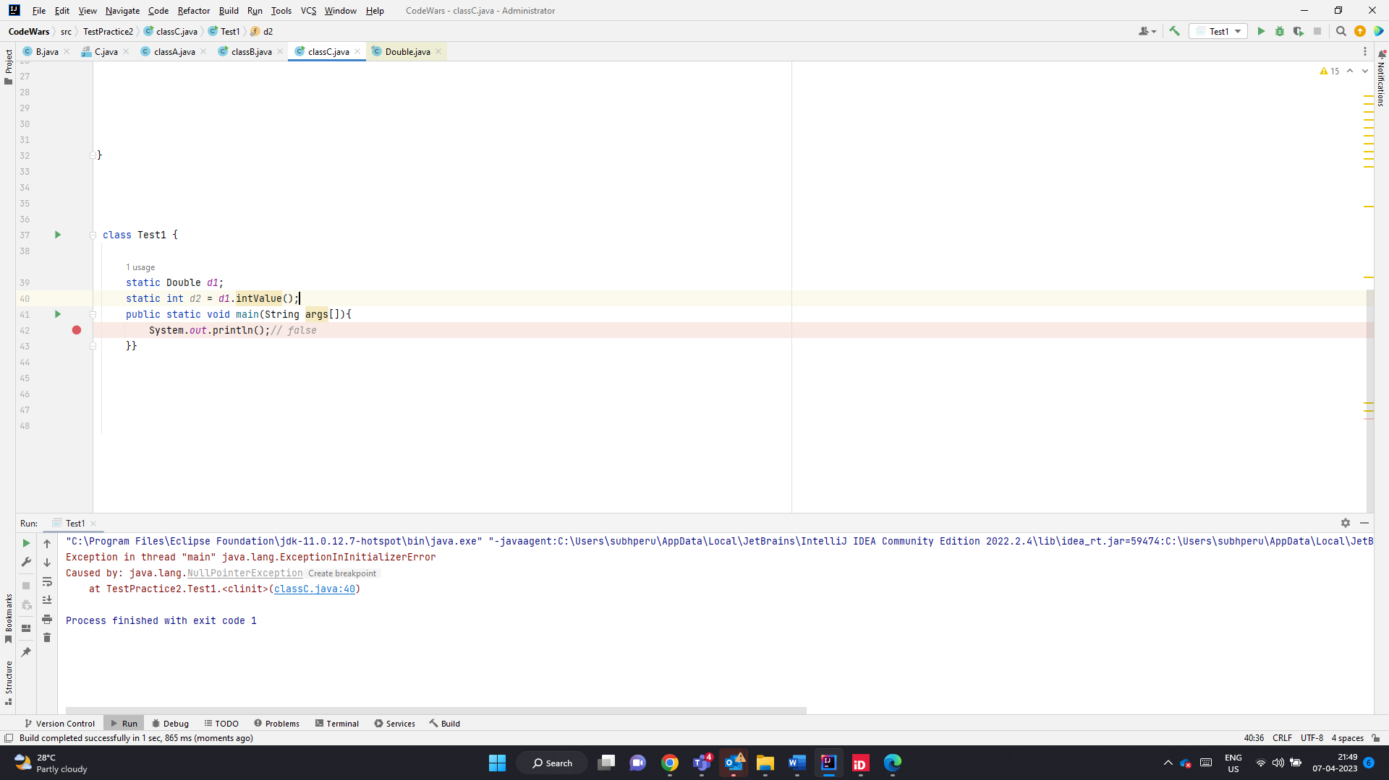

Assigning primitive constant int to Char and Character does not throw CE or RE. But assigning a method that returns int will throw CE.

Explicit type case is required in those case.

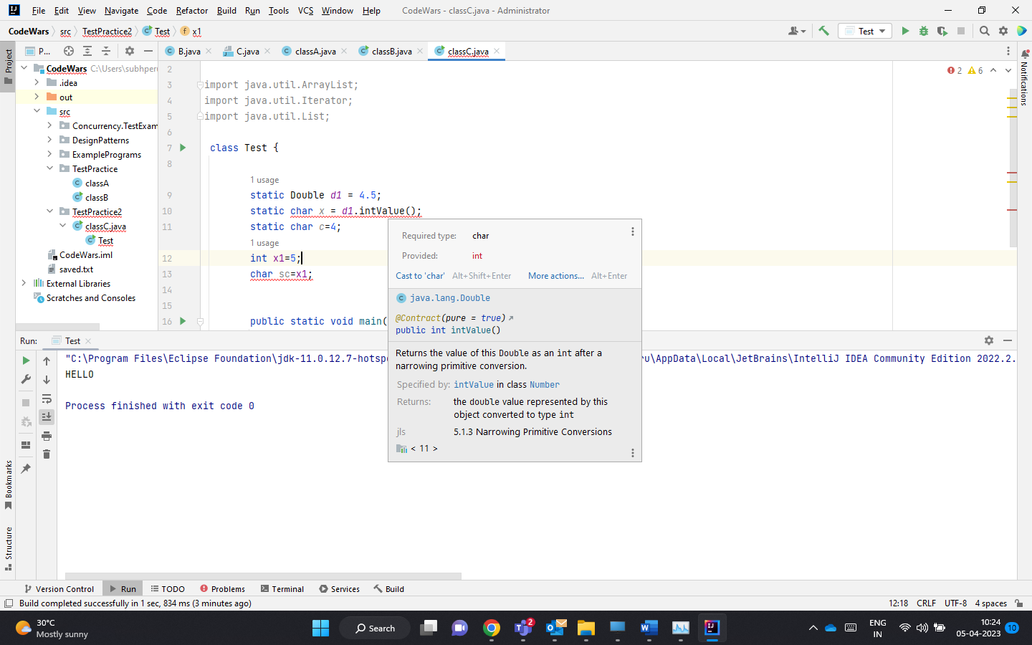

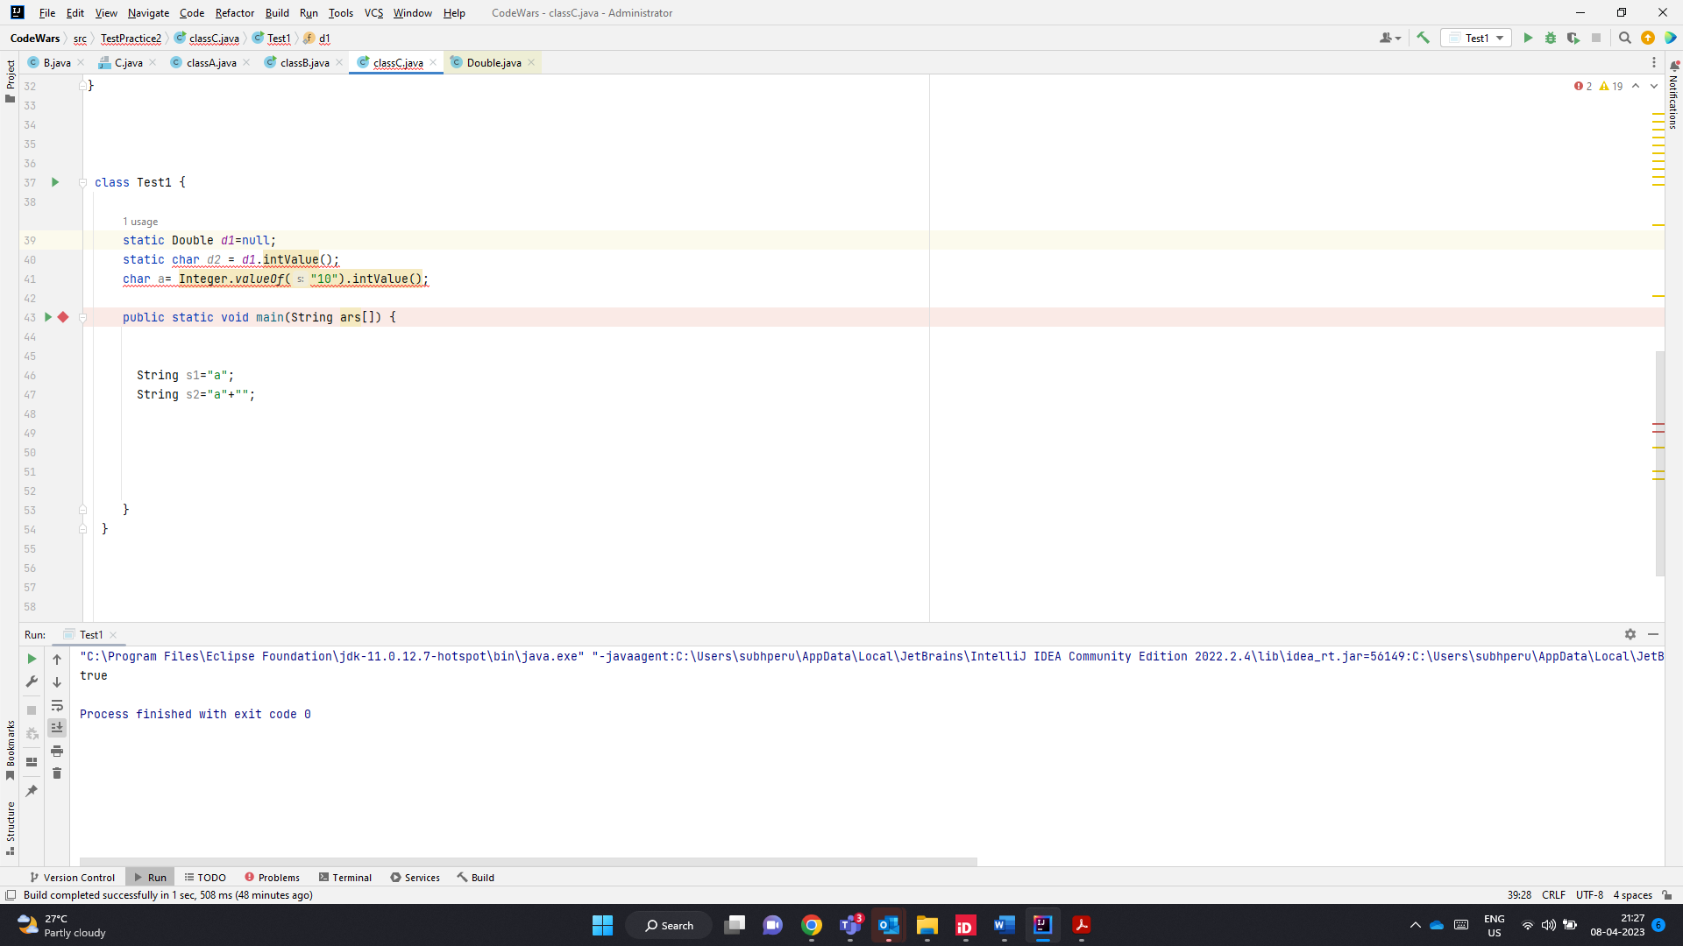

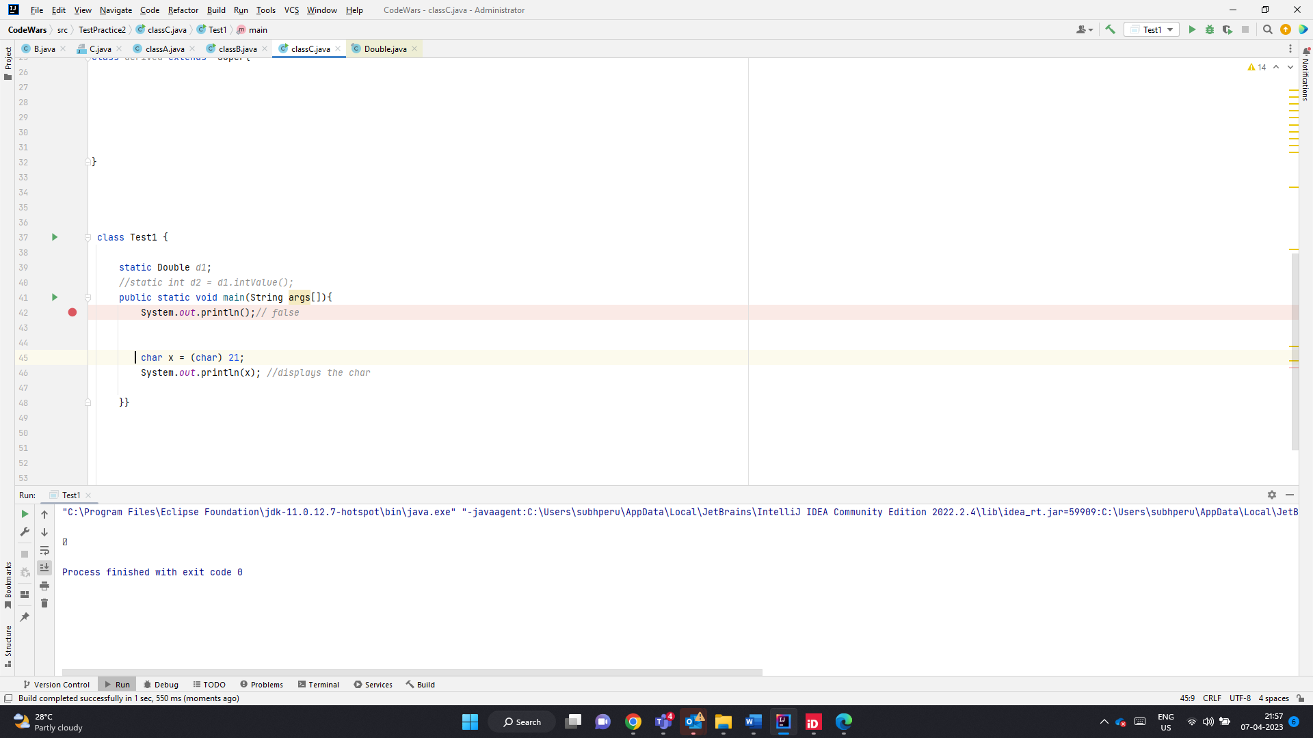

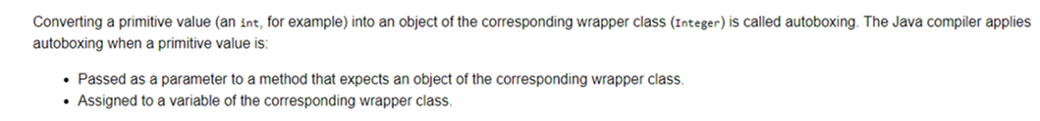

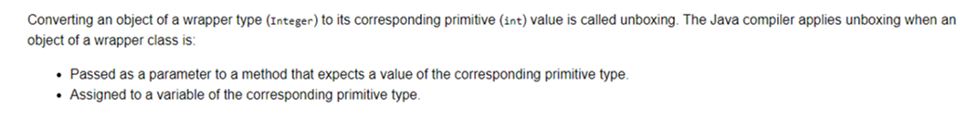

Char to int widening, Int to char is narrowing should be explicitly casting is req

1. **double** -> **float** -> **long** -> **int** -> **char** -> **short** -> **byte**

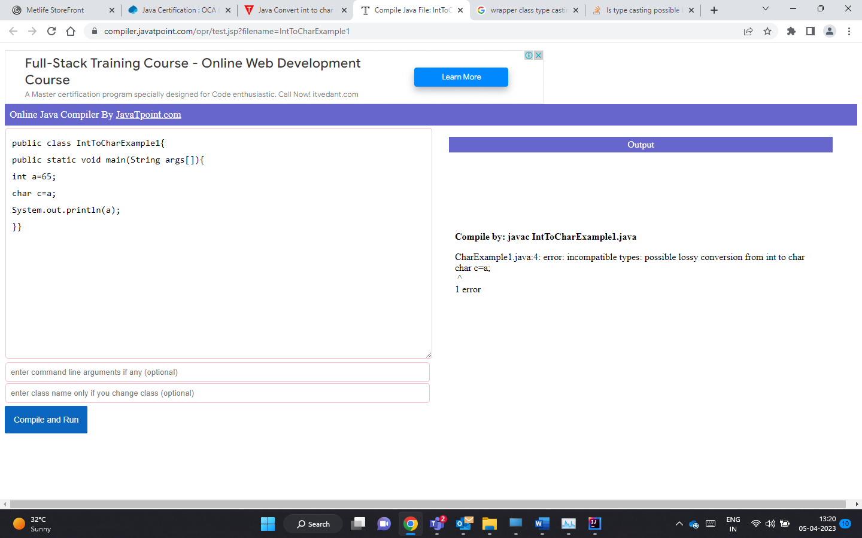

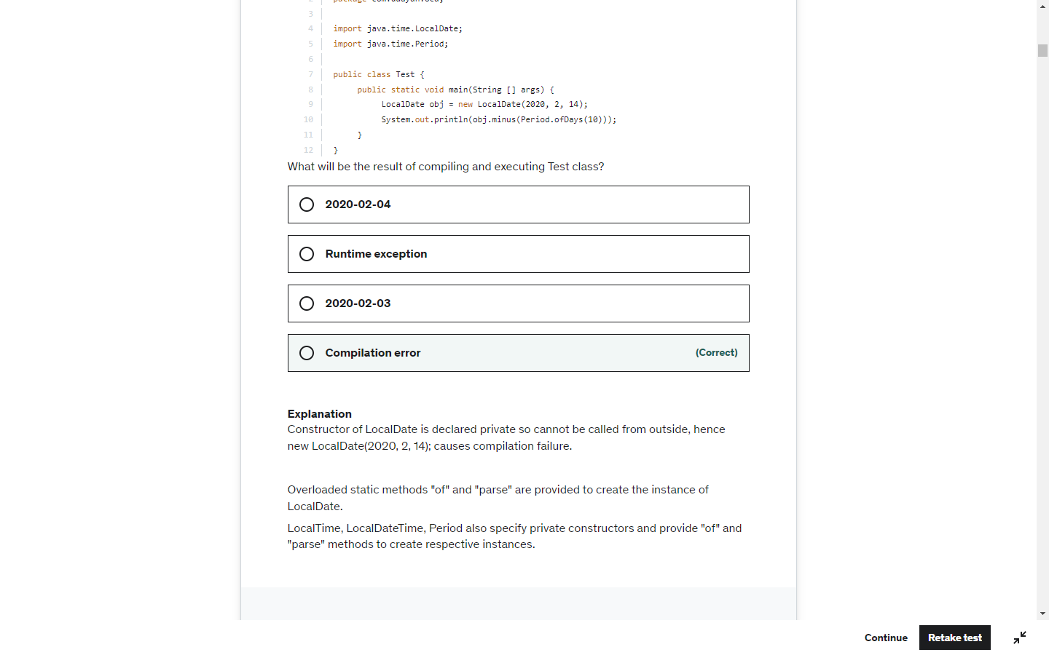

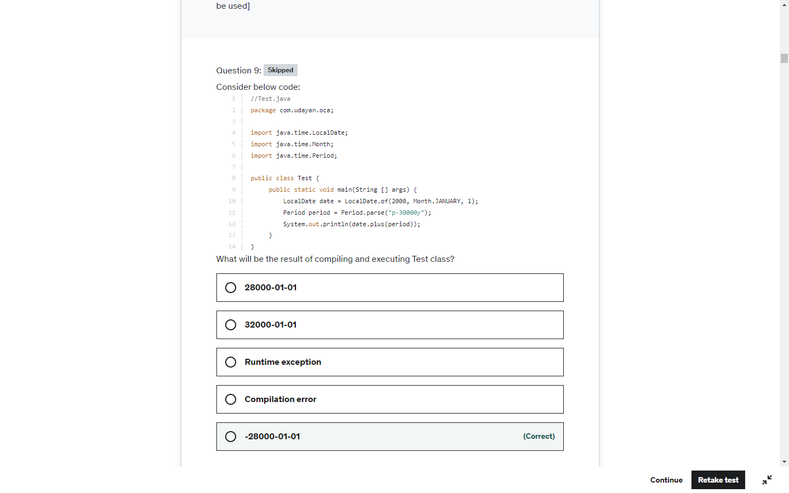

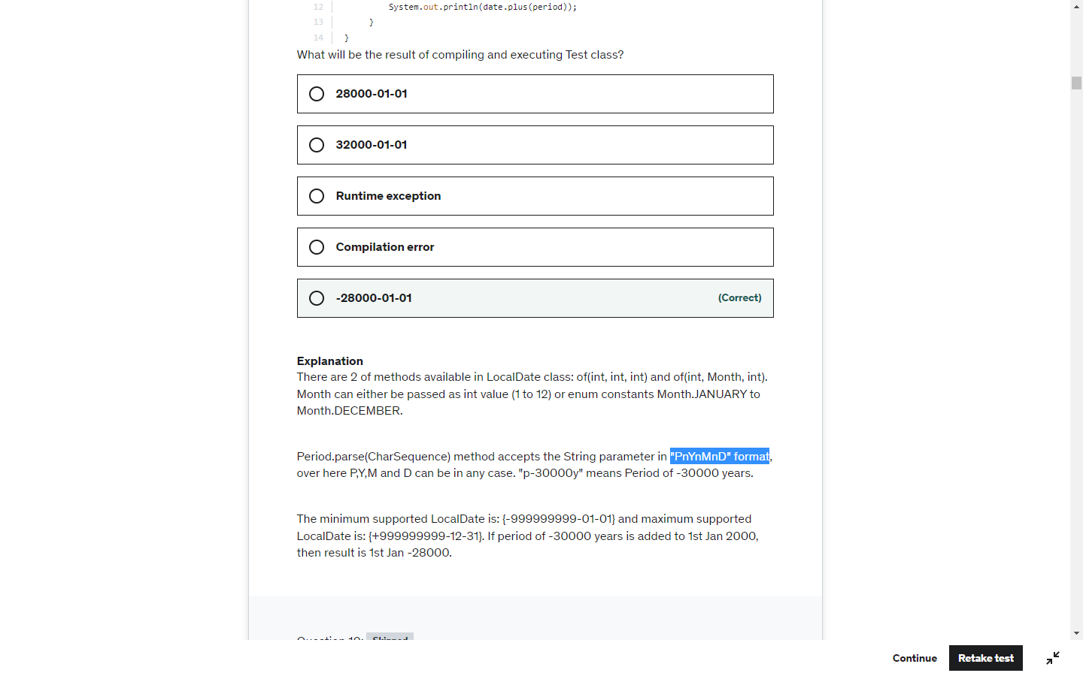

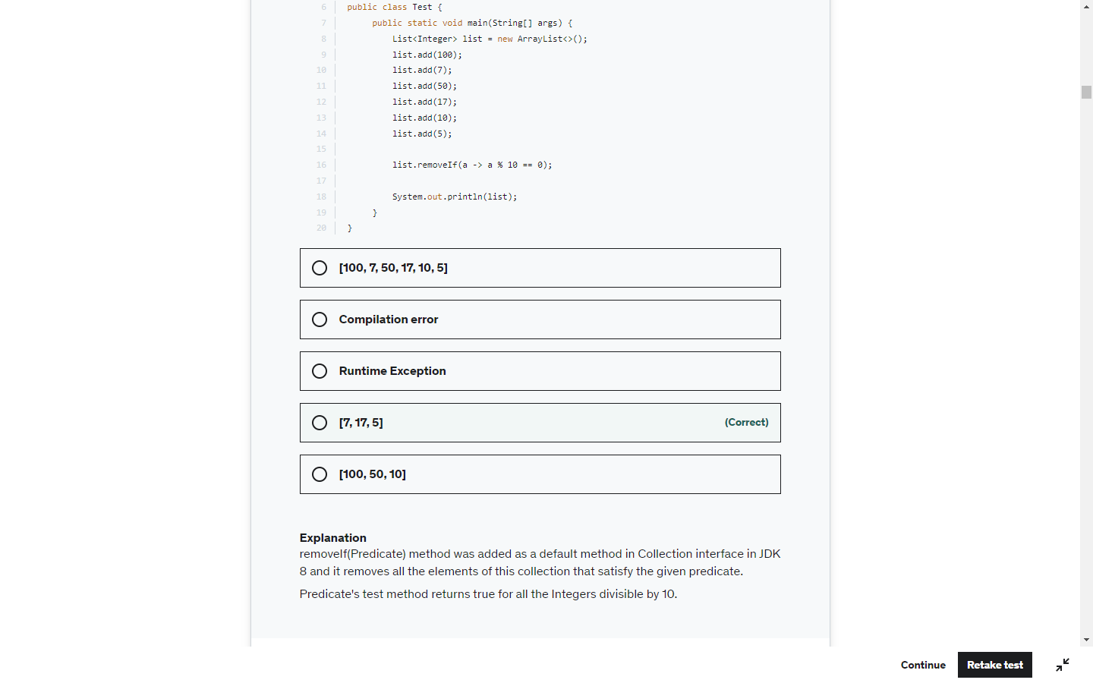

Loop 1-10

Will be skipped if start%2 ==0

So 2,4,6,8,10 will be skipped. 1,3,5,7,9 -> 25

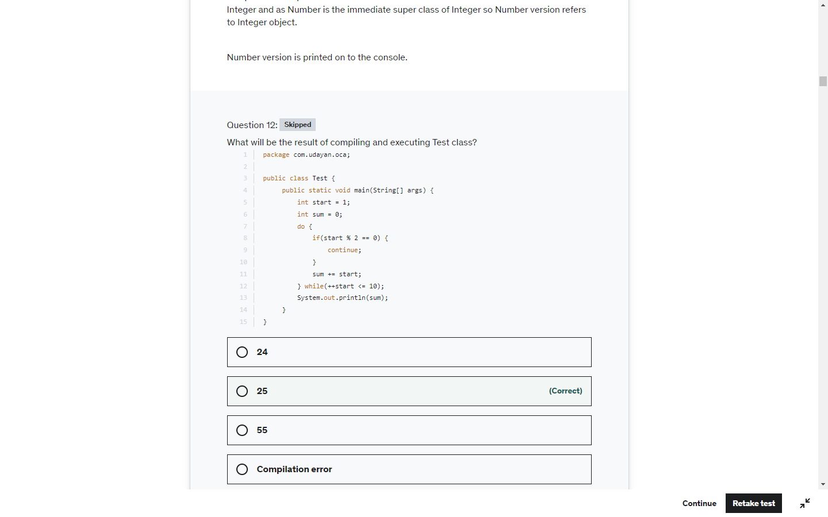

LocalDate. LocaDateTime .LocalTime or immutable . Here the date value is not changed

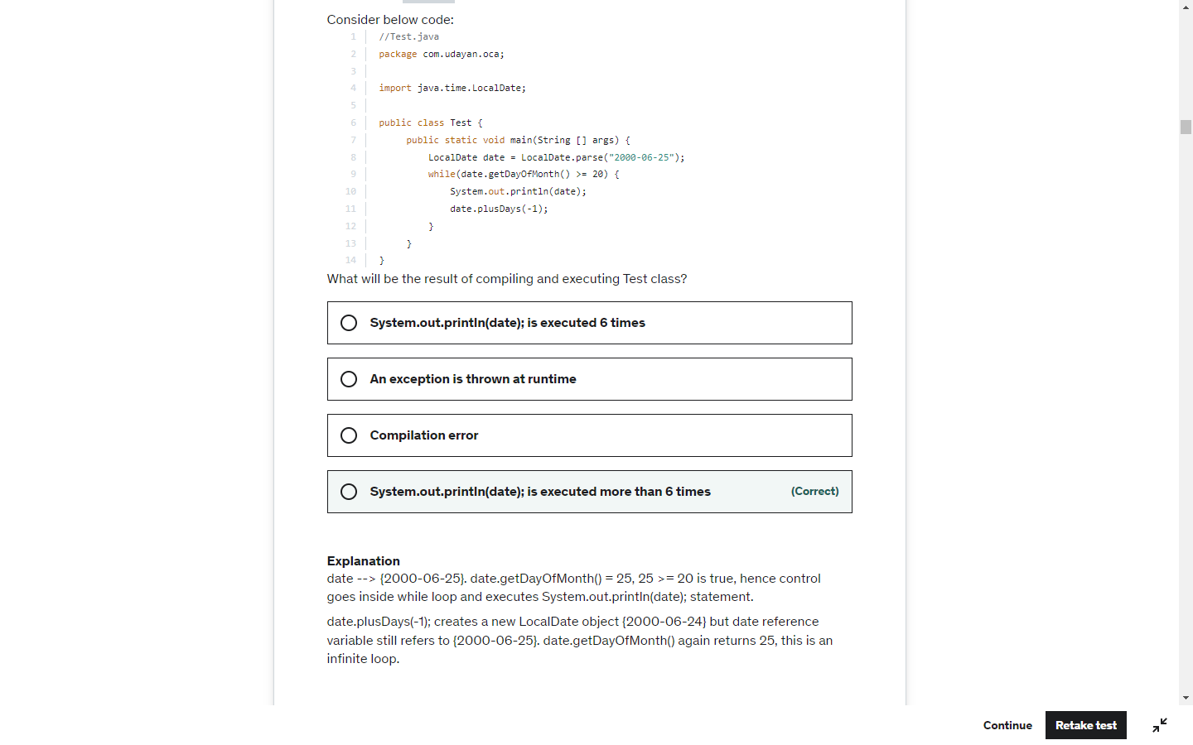

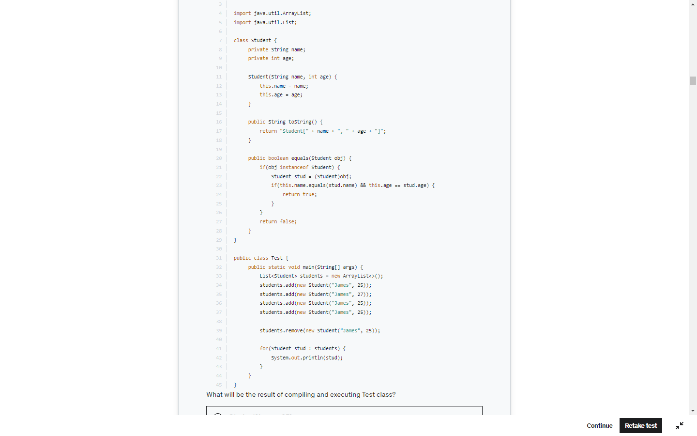

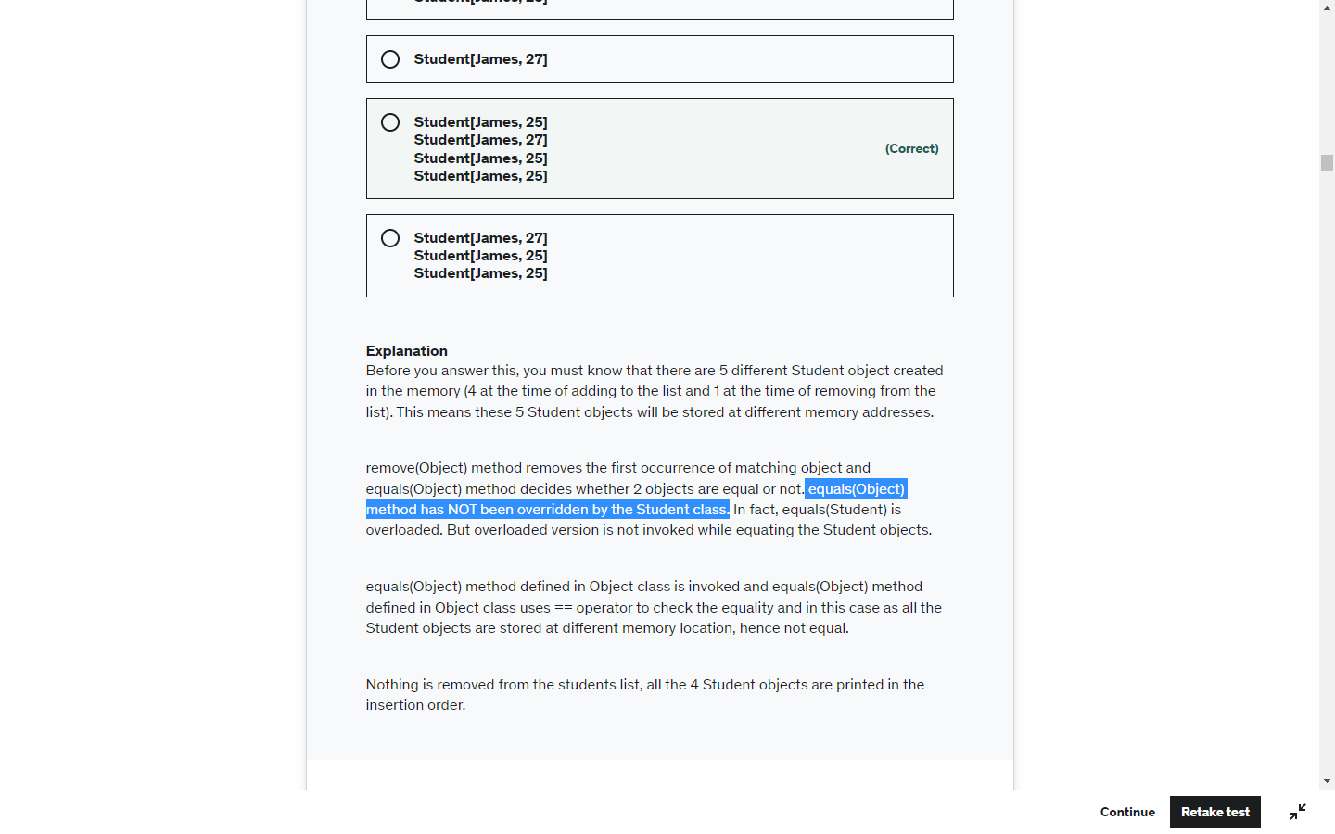

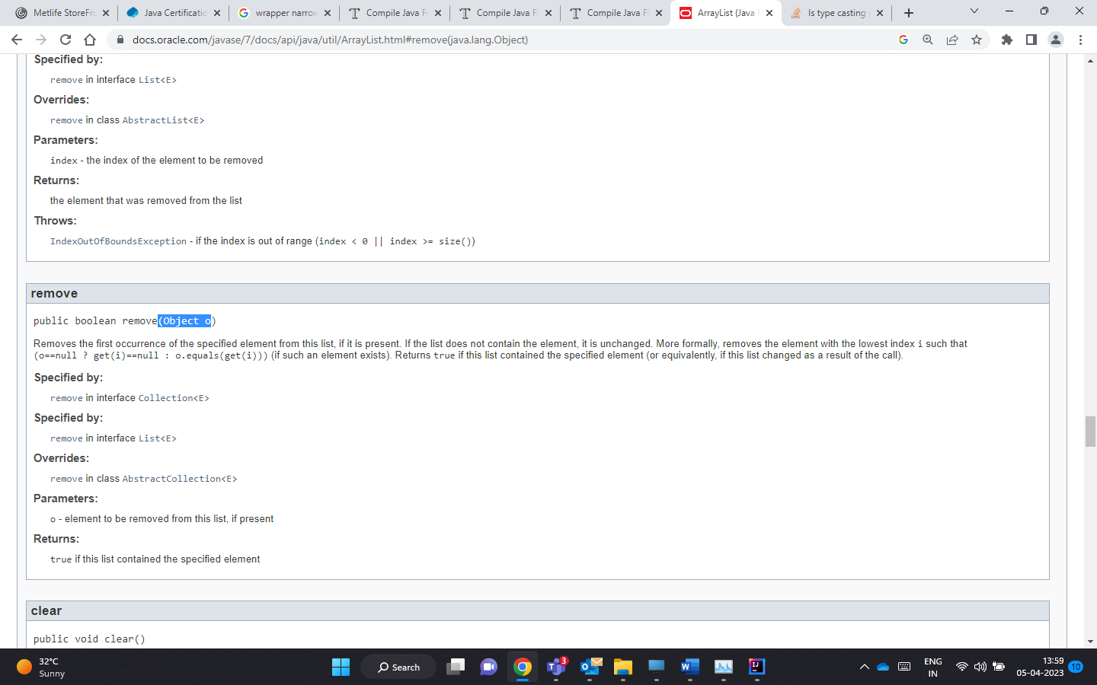

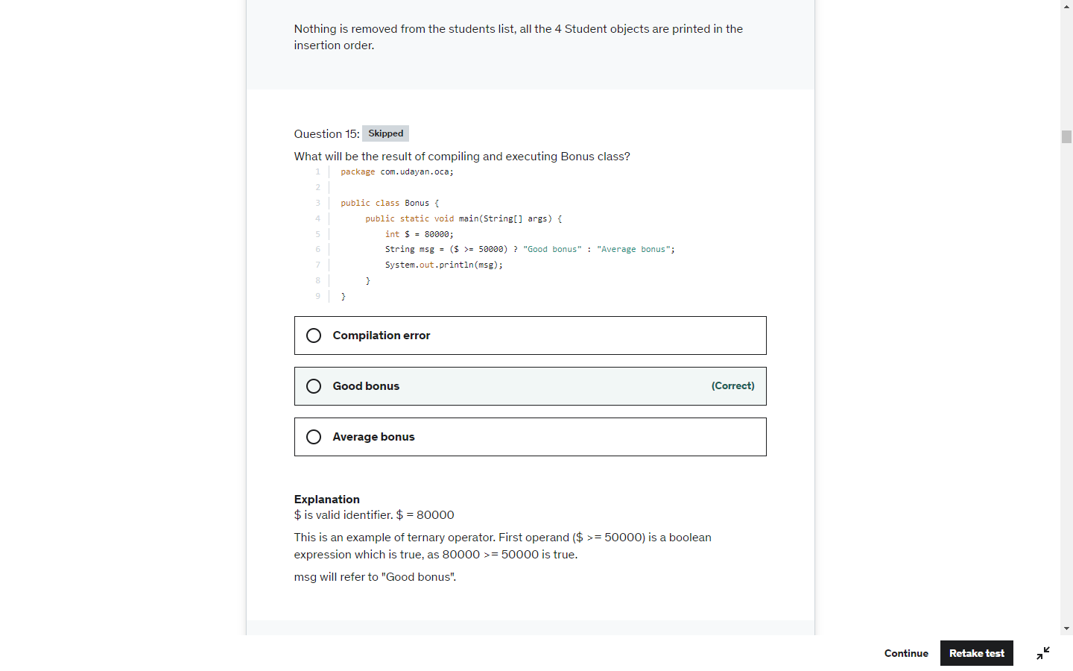

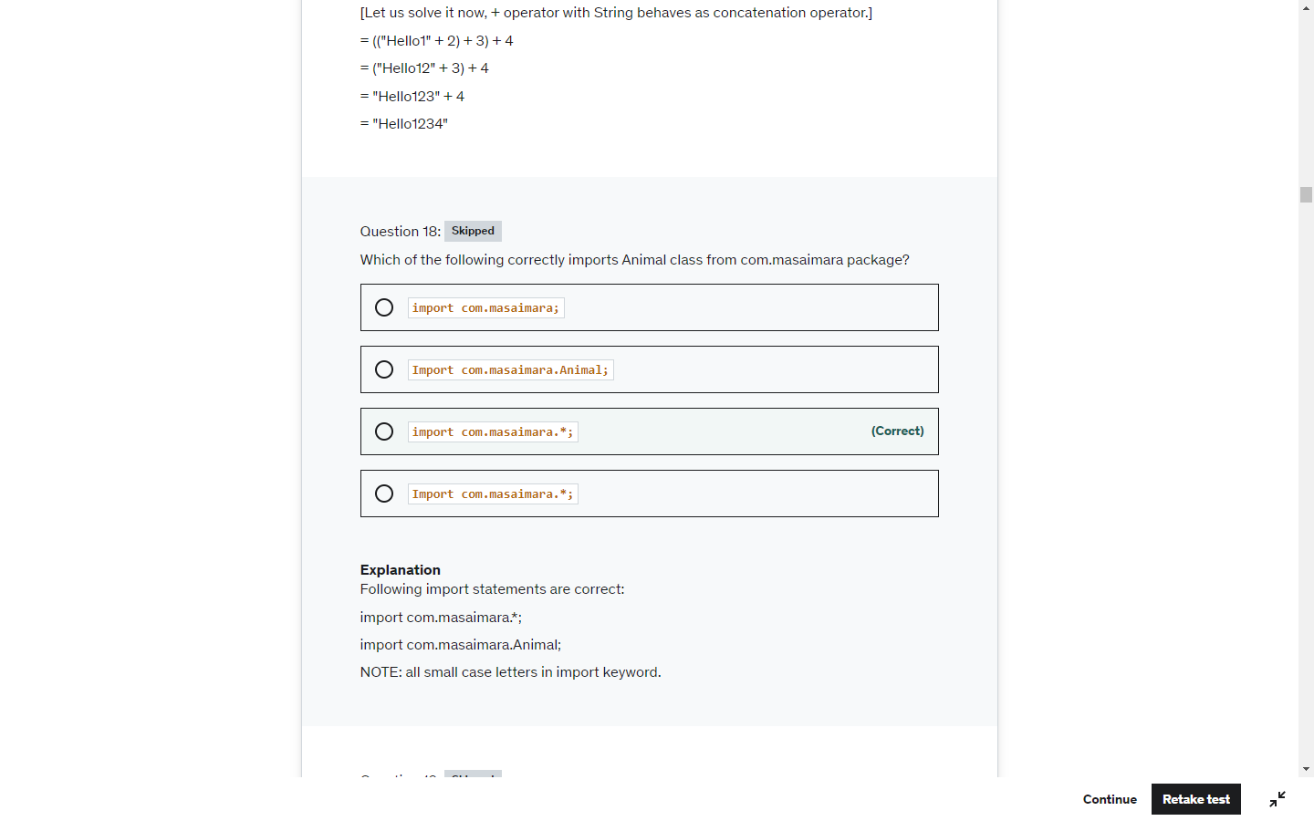

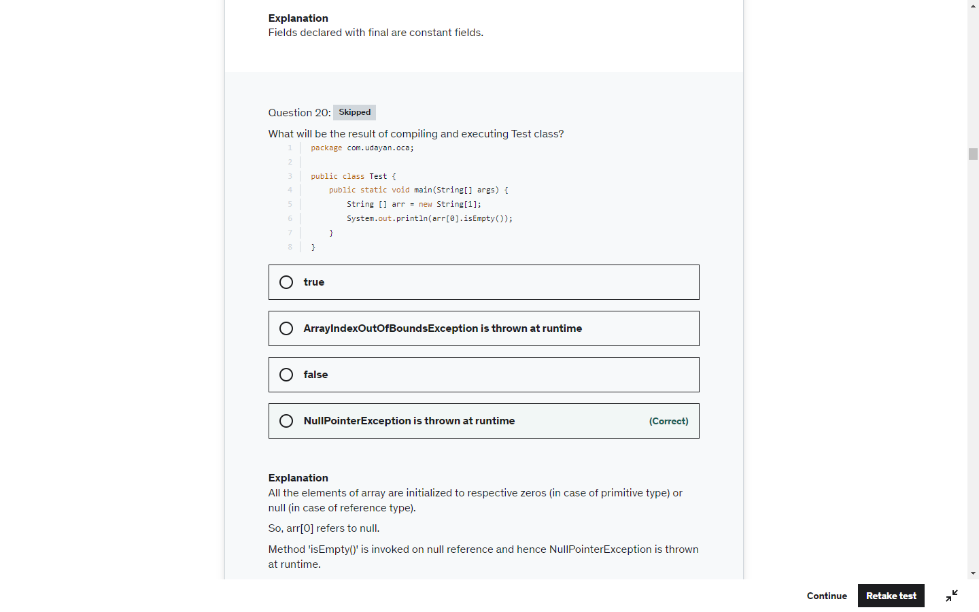

Again LocalDate LocalTime and LocalDateTime are immutable

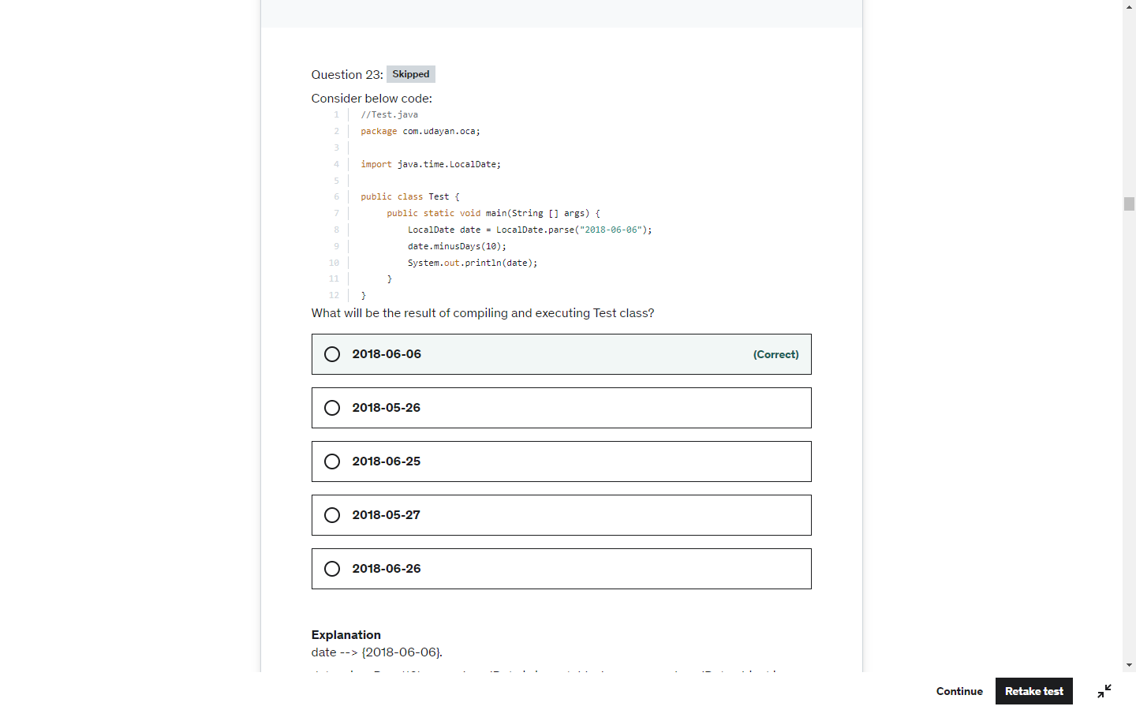

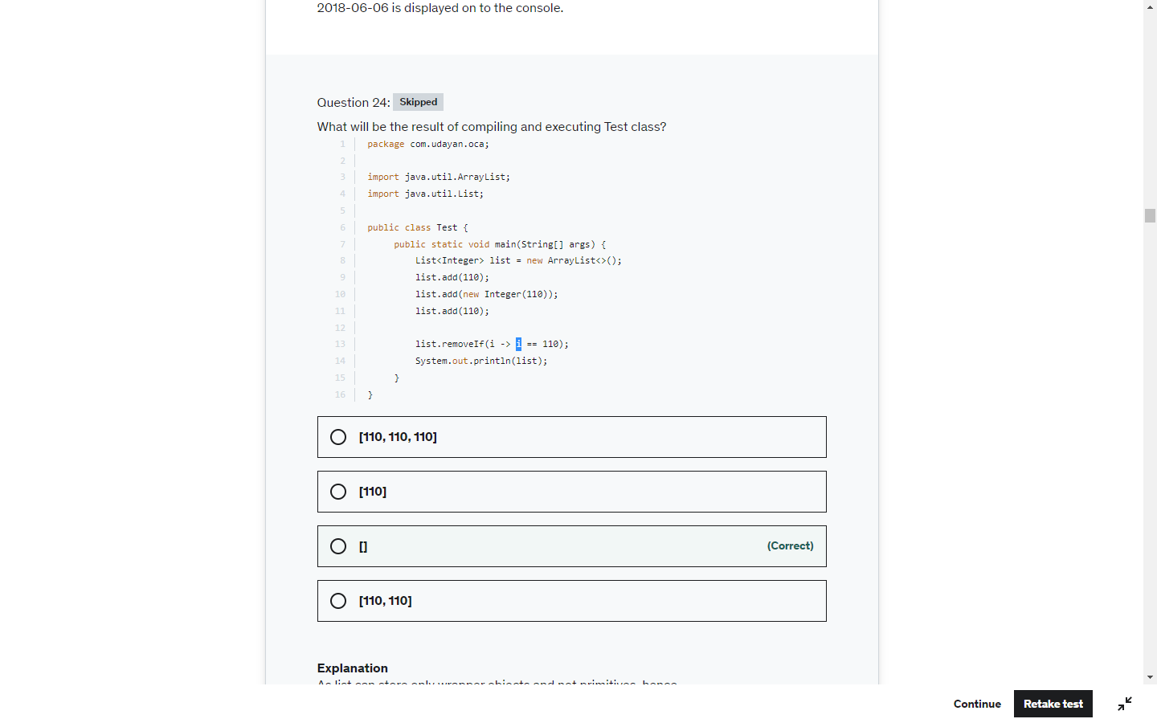

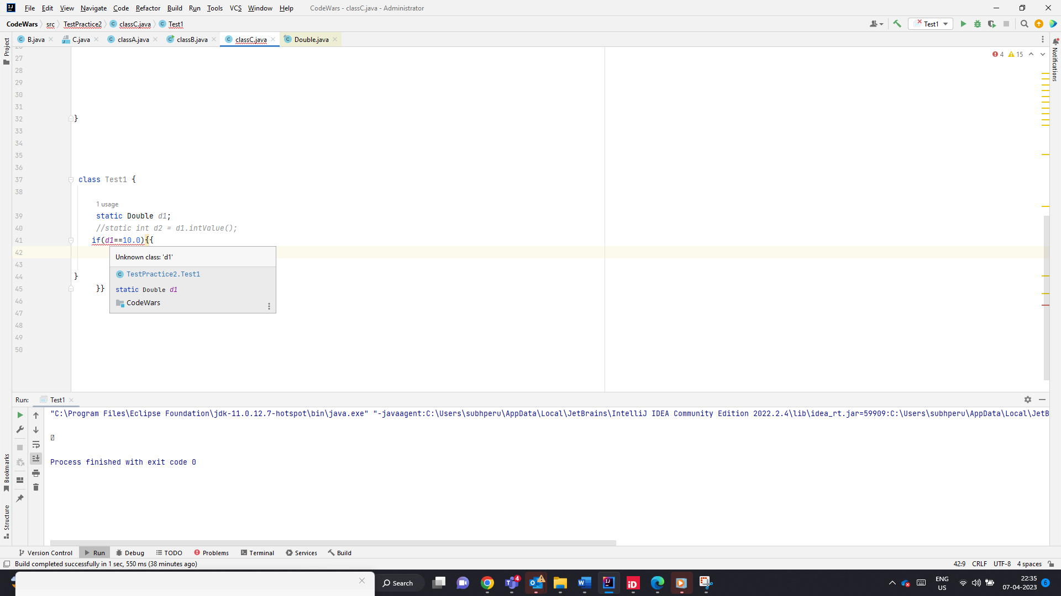

Null Pointer Exception, when doing Double.IntValue();

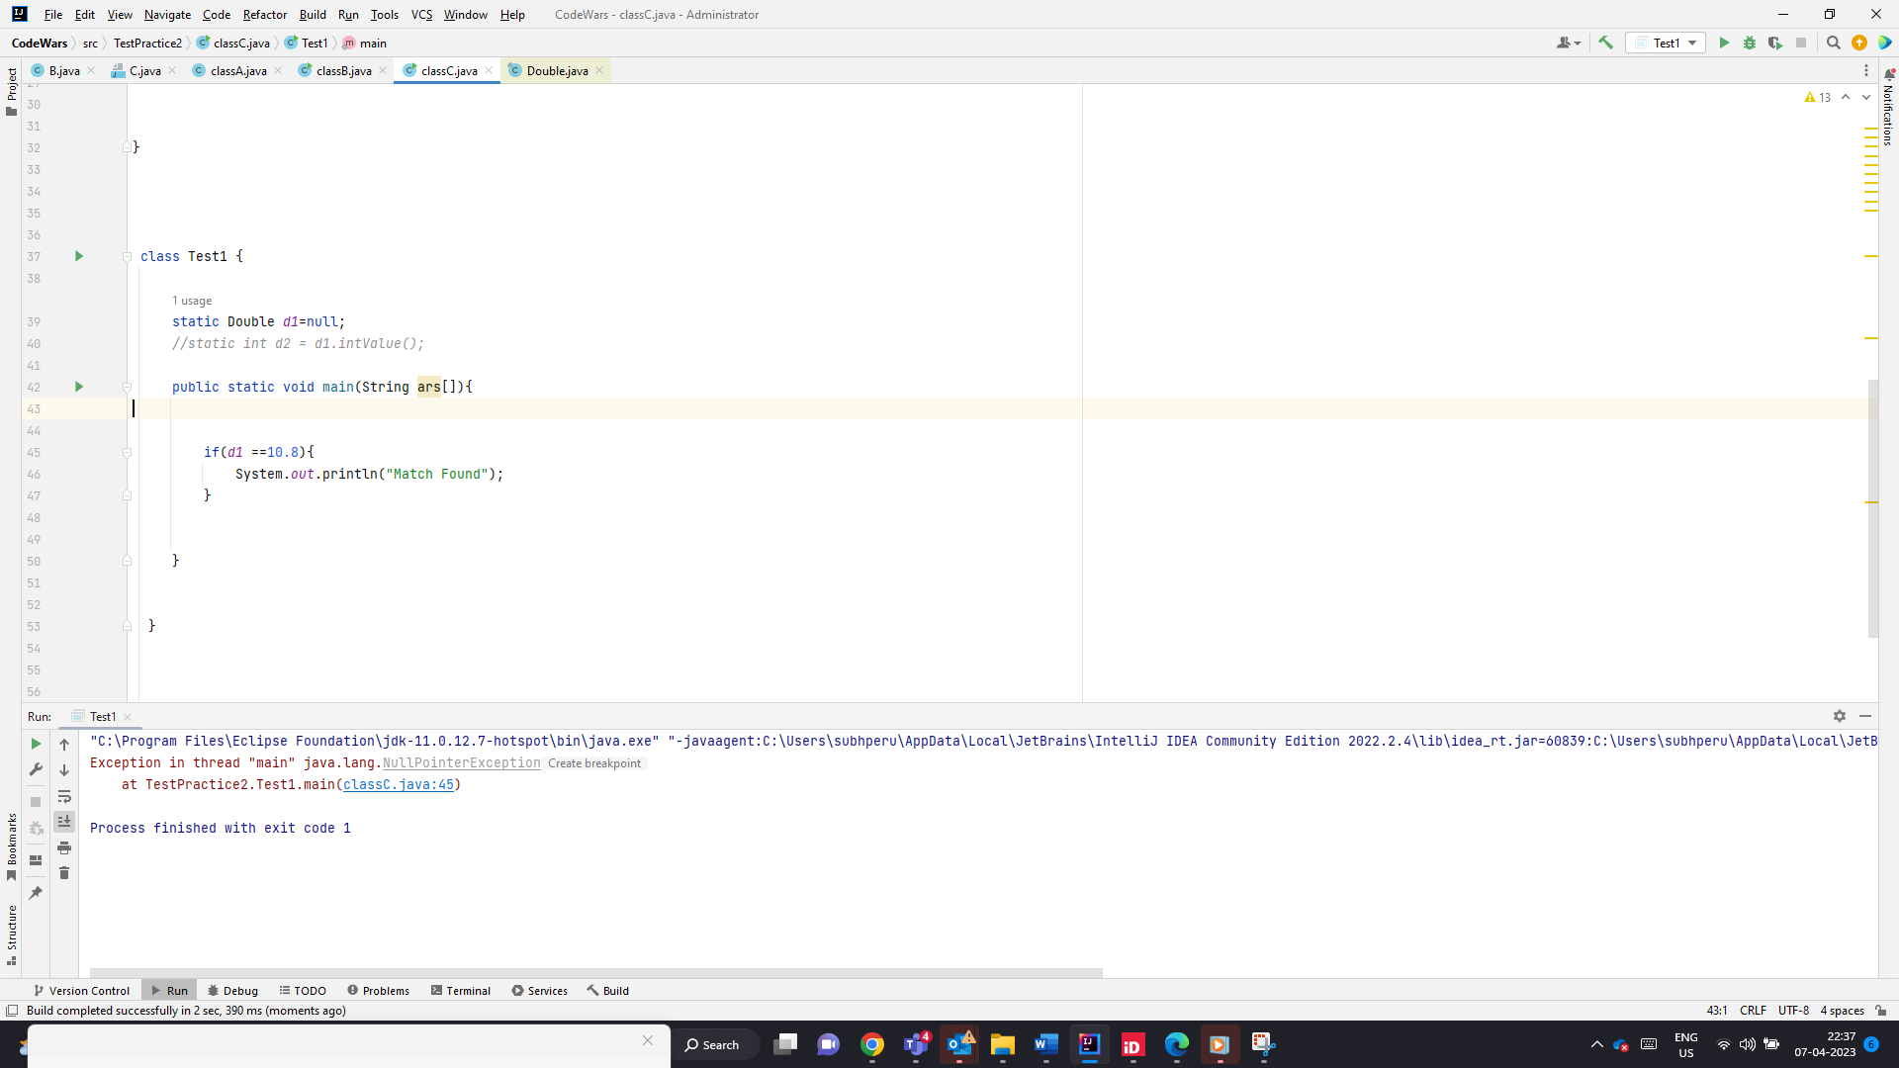

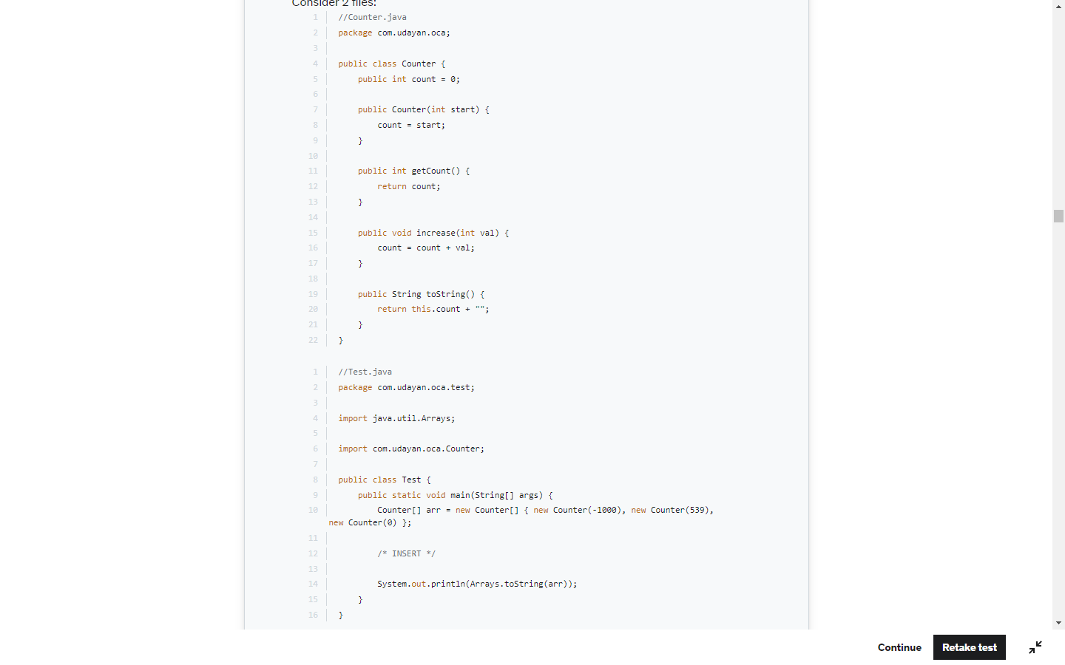

A number can be made 100 by subtracting the no with the same no and adding 100 to it

500+ (-500+100) or

500 + (100 – 500)

-2000

(-2000)+(100-(-2000))

-2000+2100=100

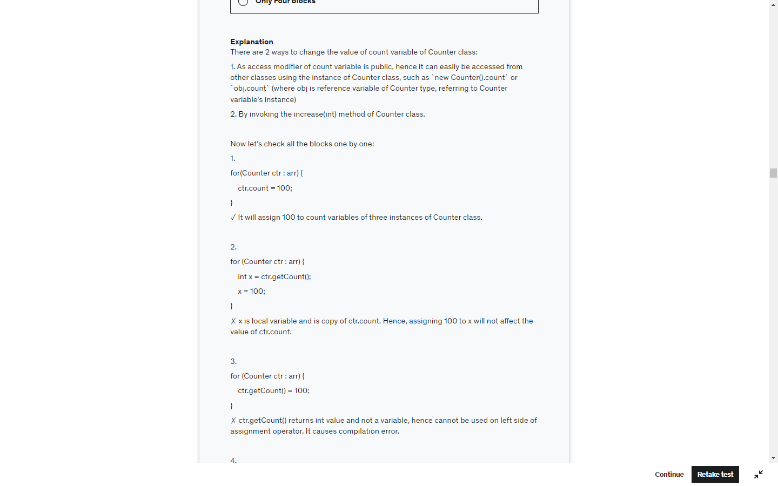

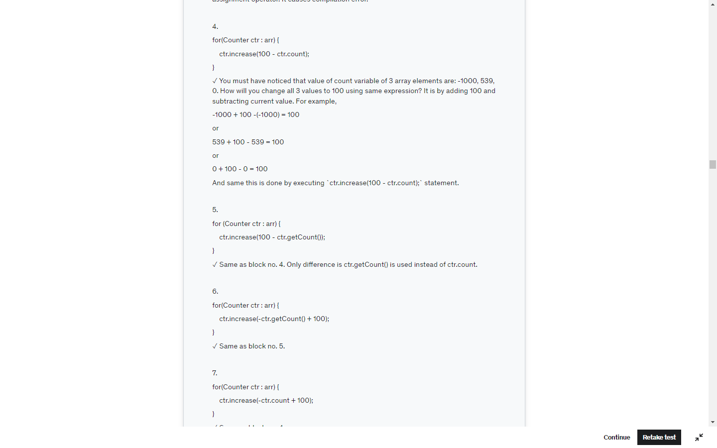

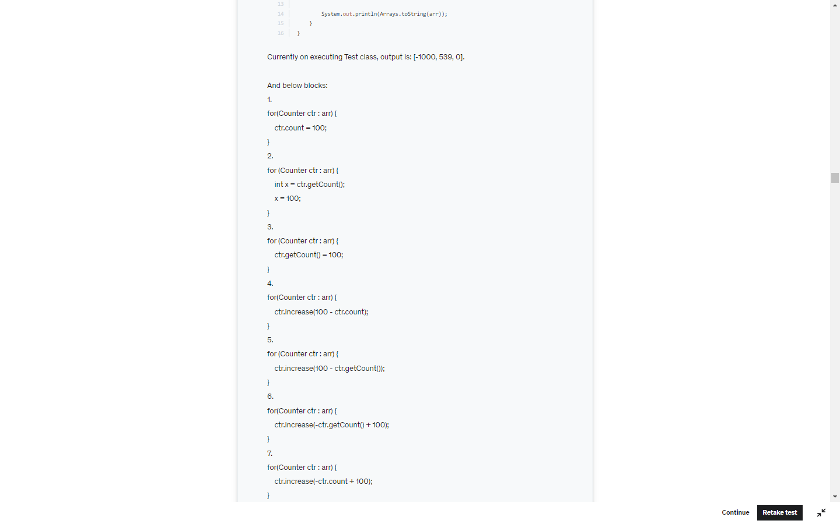

Runtime exceptions can occur anywhere in a program, and in a typical one they can be very numerous. Having to add runtime exceptions in every method declaration would reduce a program's clarity. Thus, **the compiler does not require that you catch or specify runtime exceptions** (although you can).

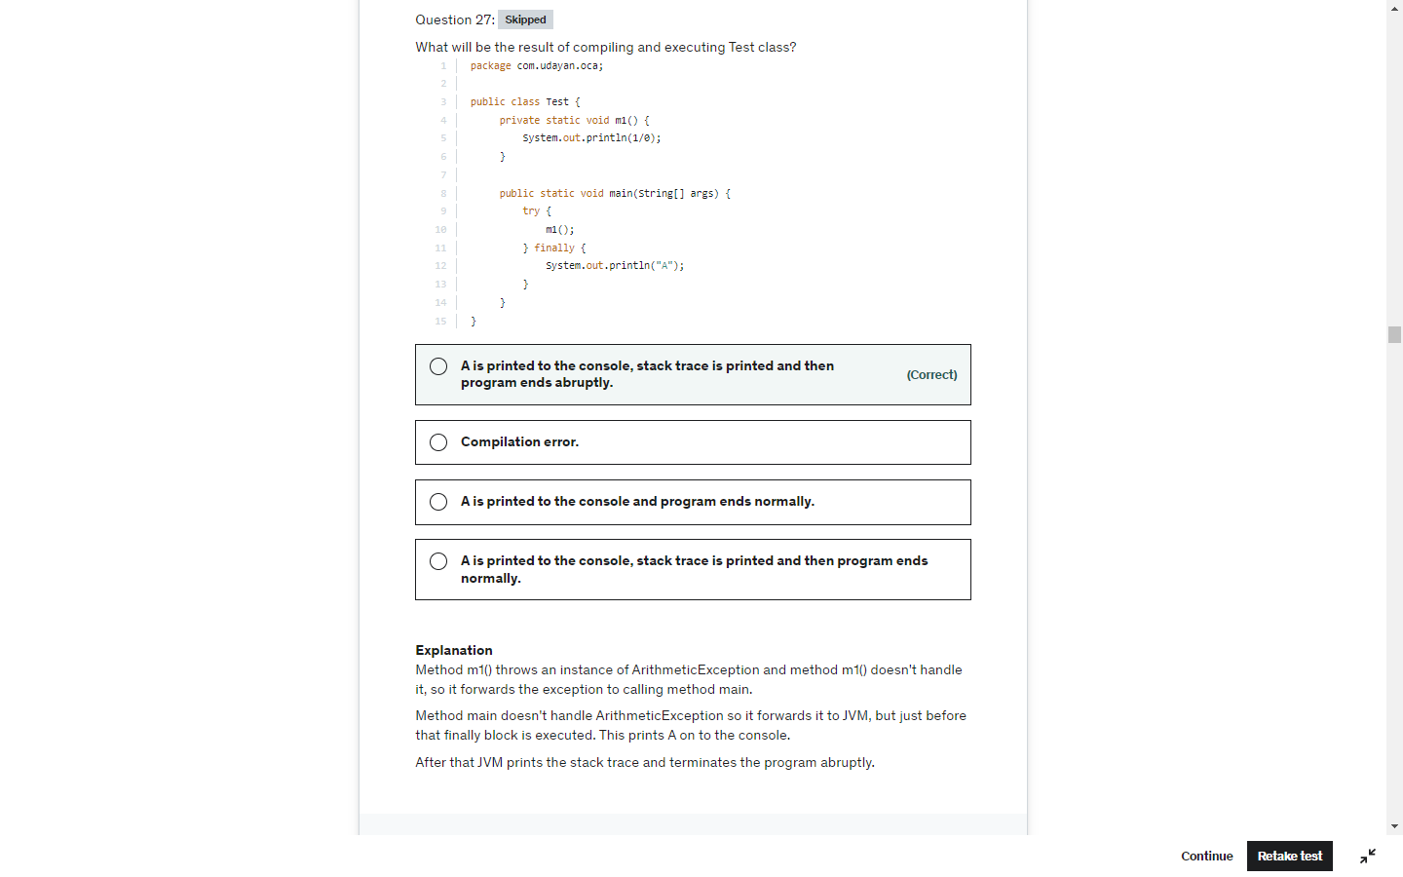

Don’t over see , check all details return type and the value returned

Int -> null . null is not a valid int value

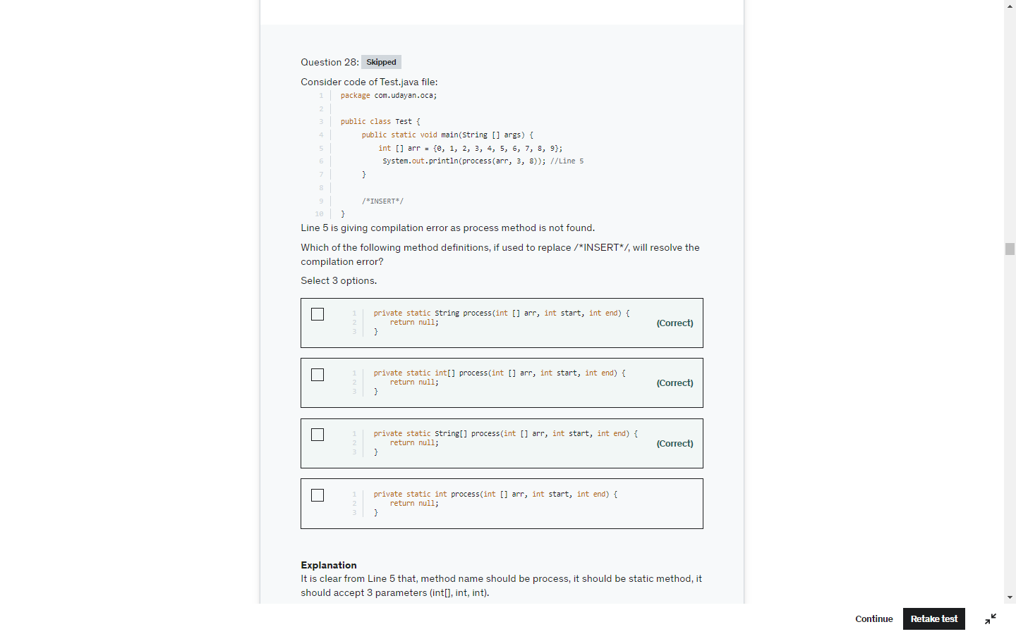

Here double 10.5 cant be implicitly converted to int so, compiler converts int to double implicity

And the value would be 10.0 so not equals.

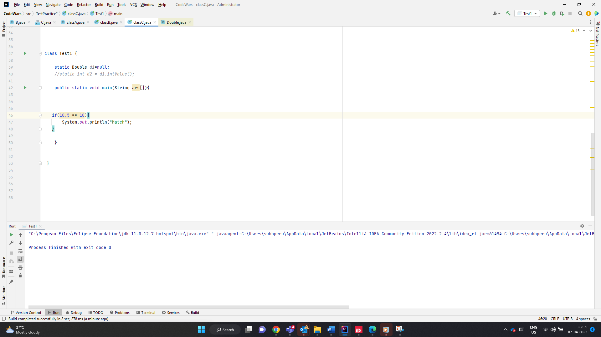

List.set -> Replcaes the element

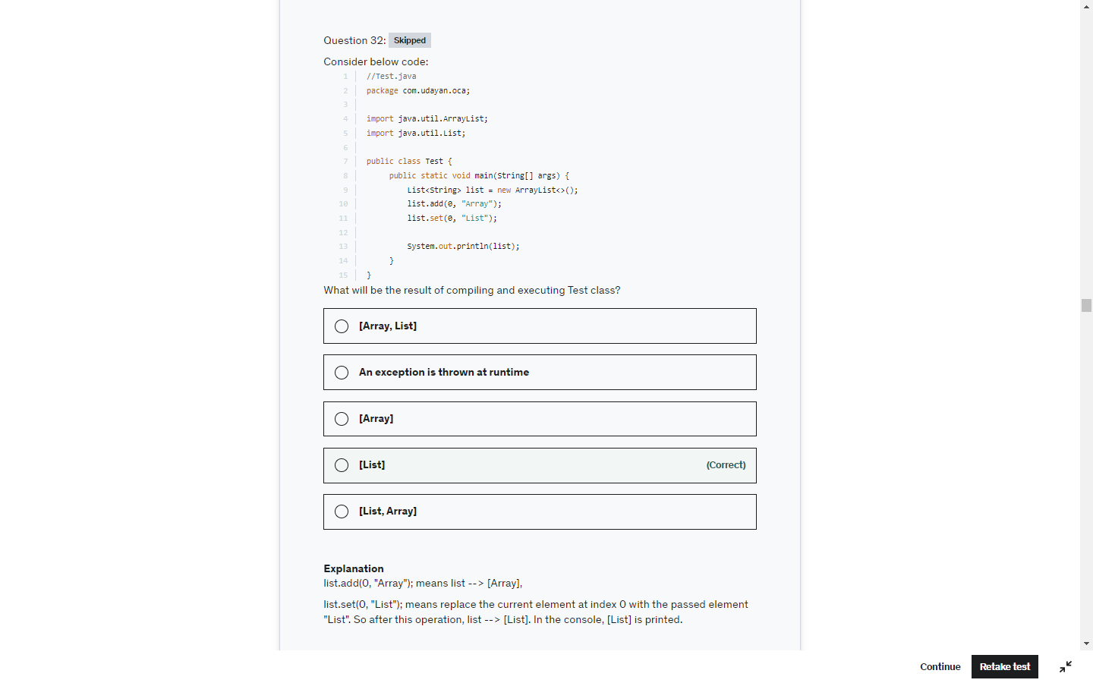

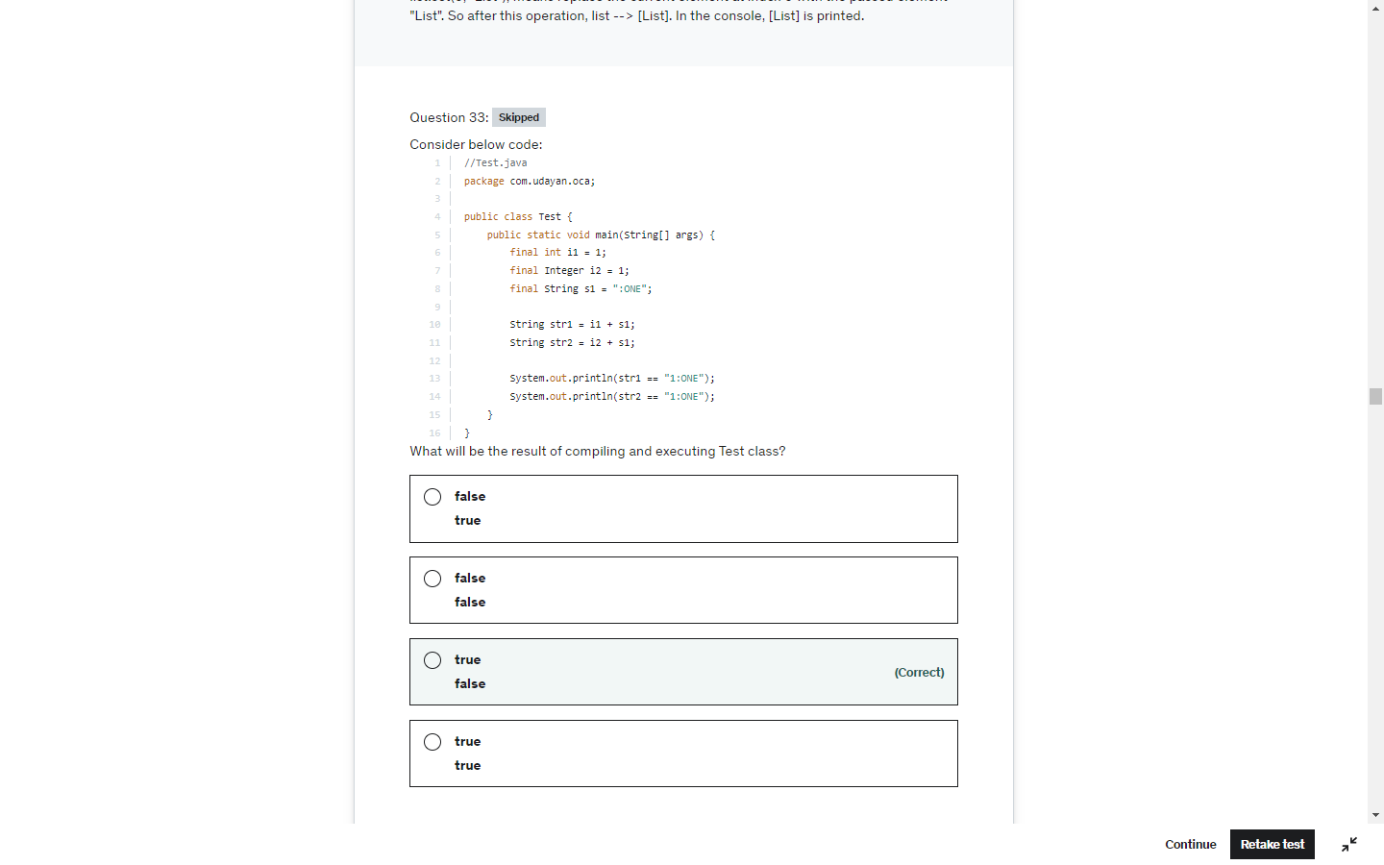

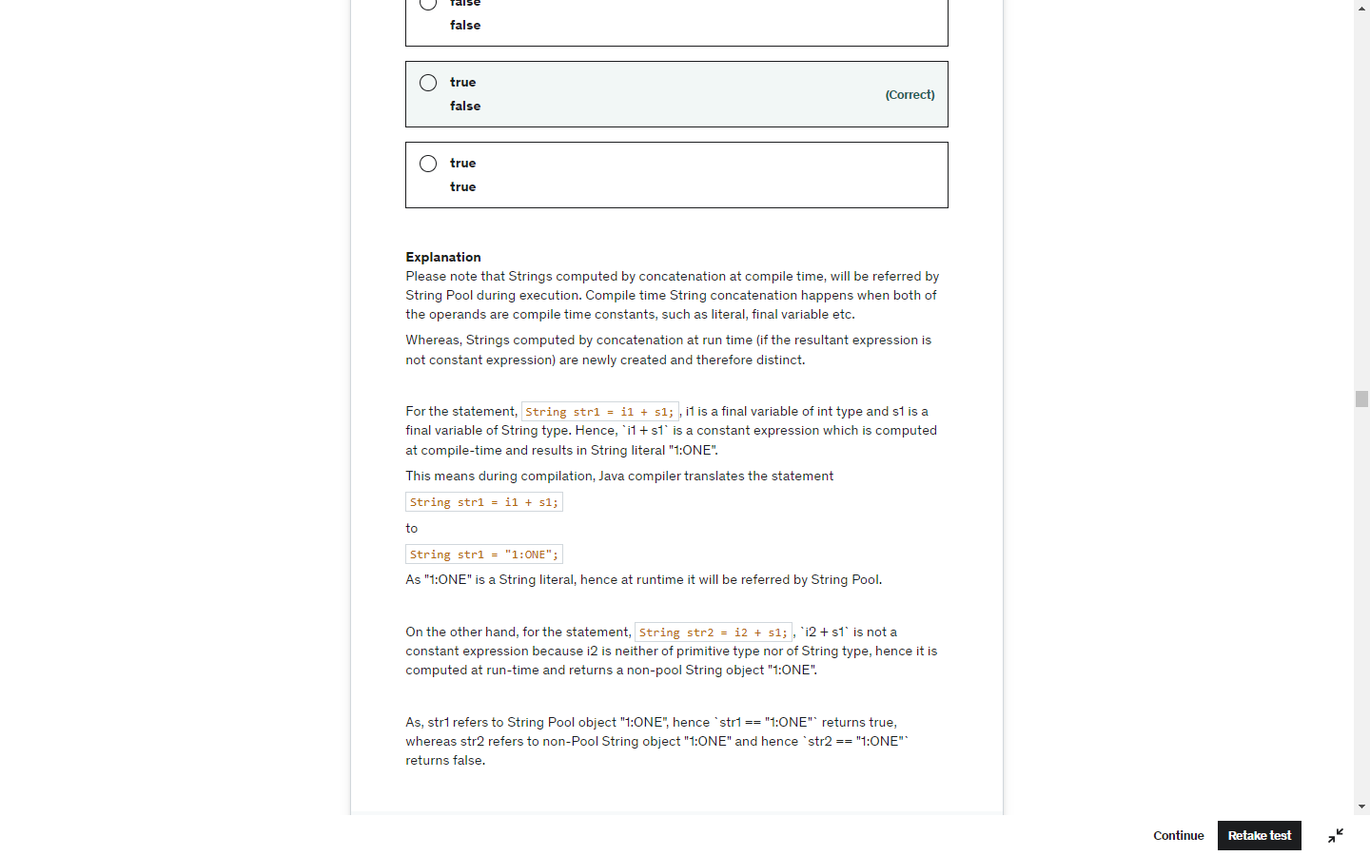

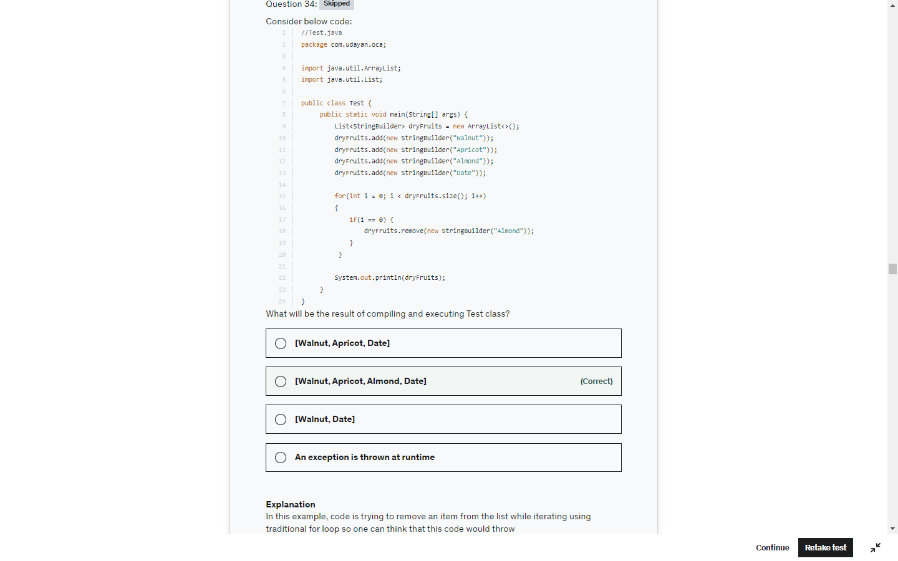

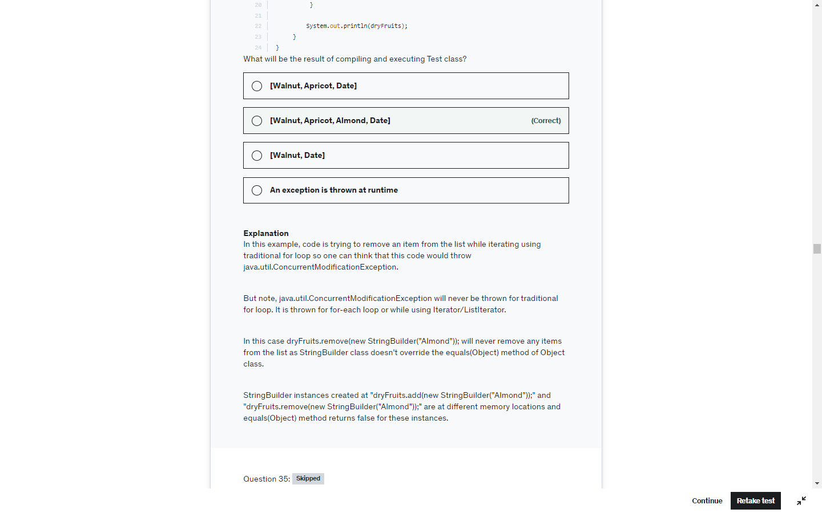

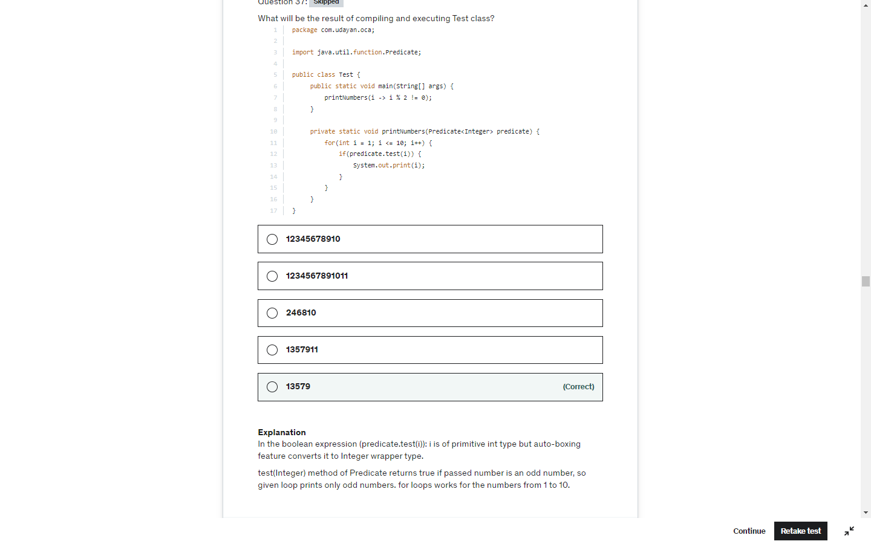

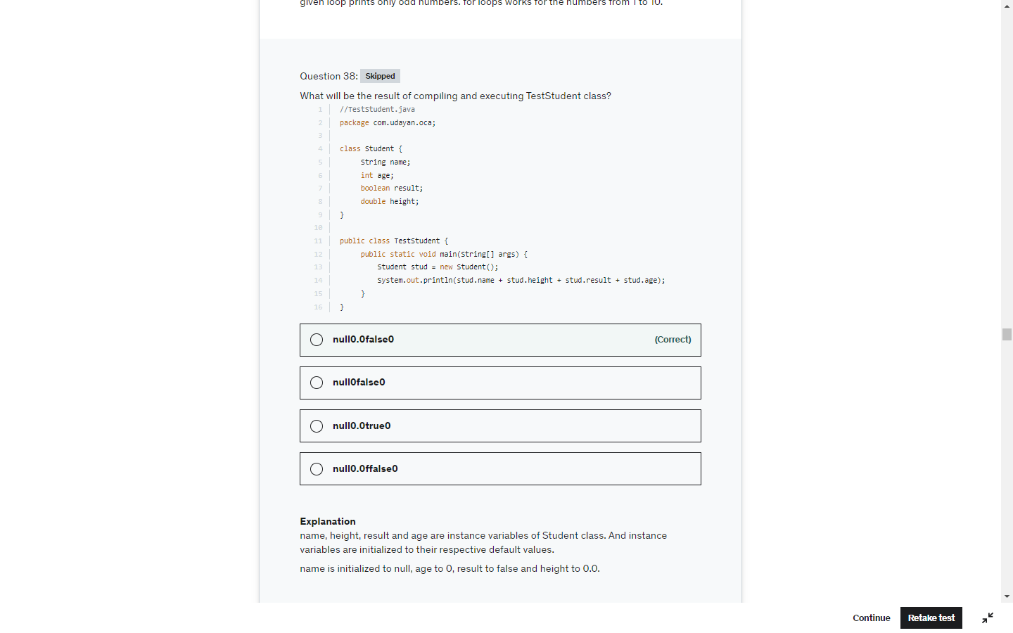

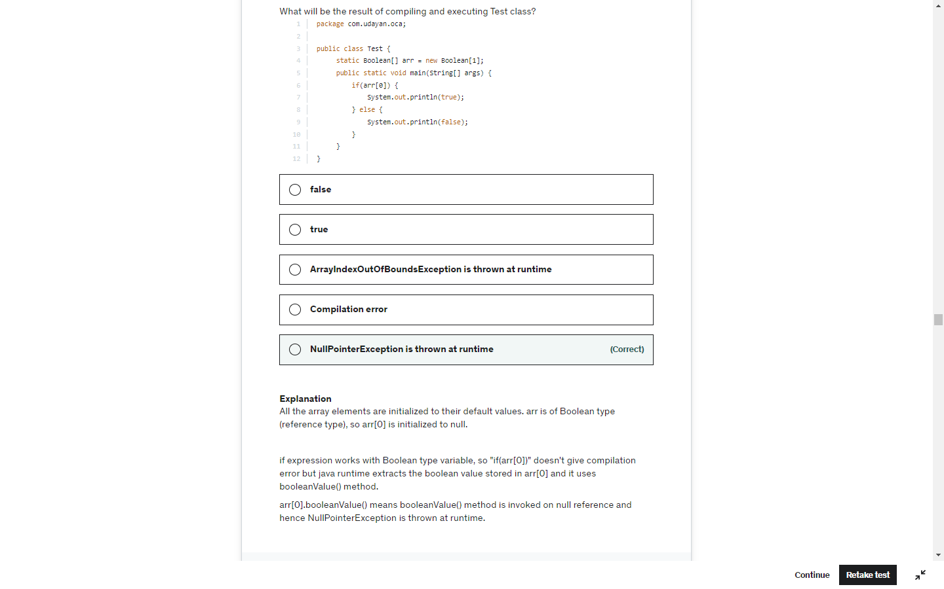

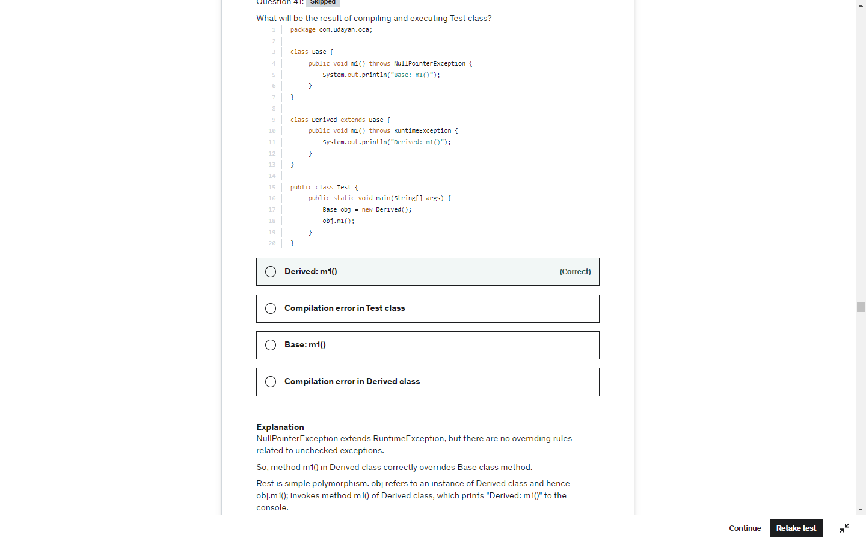

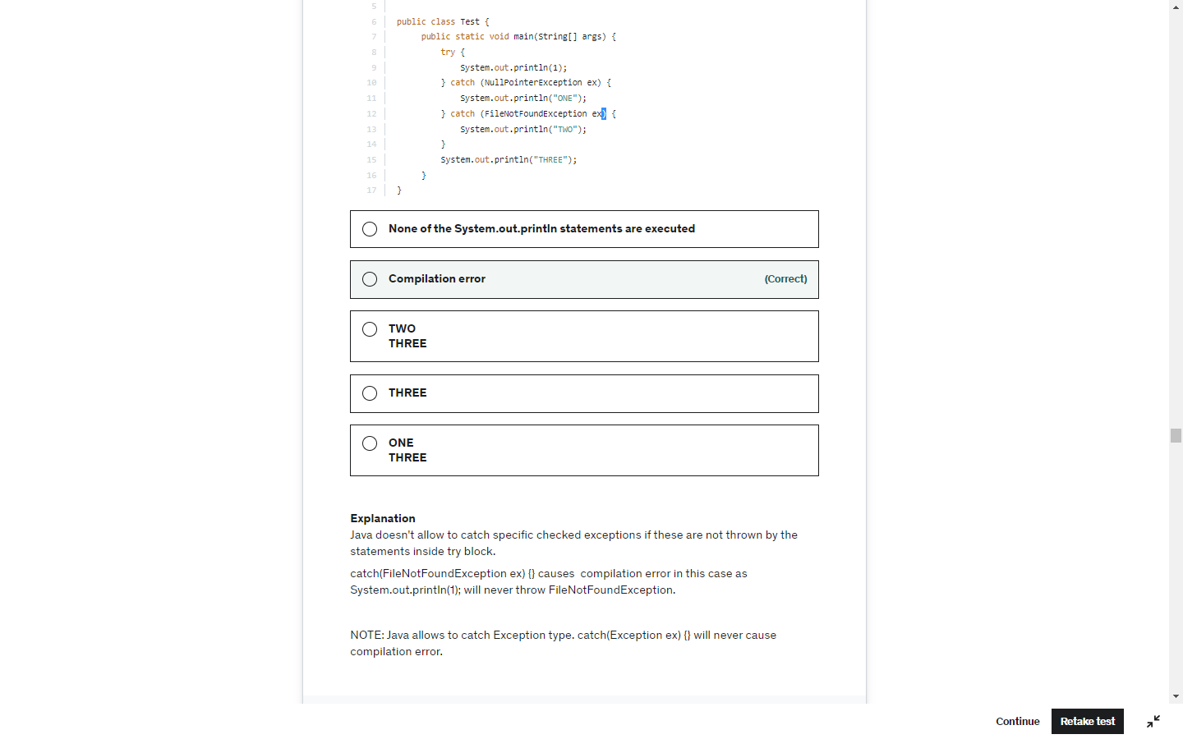

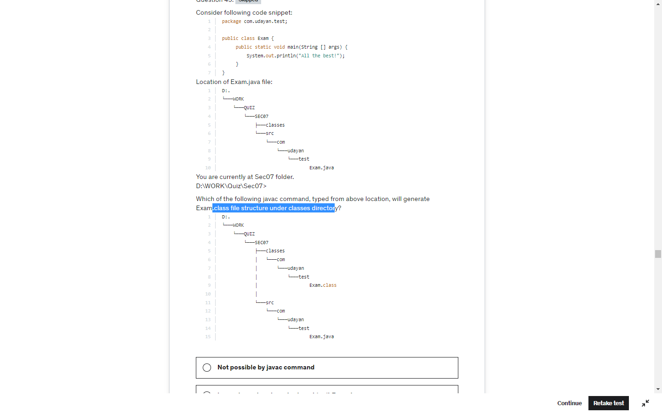

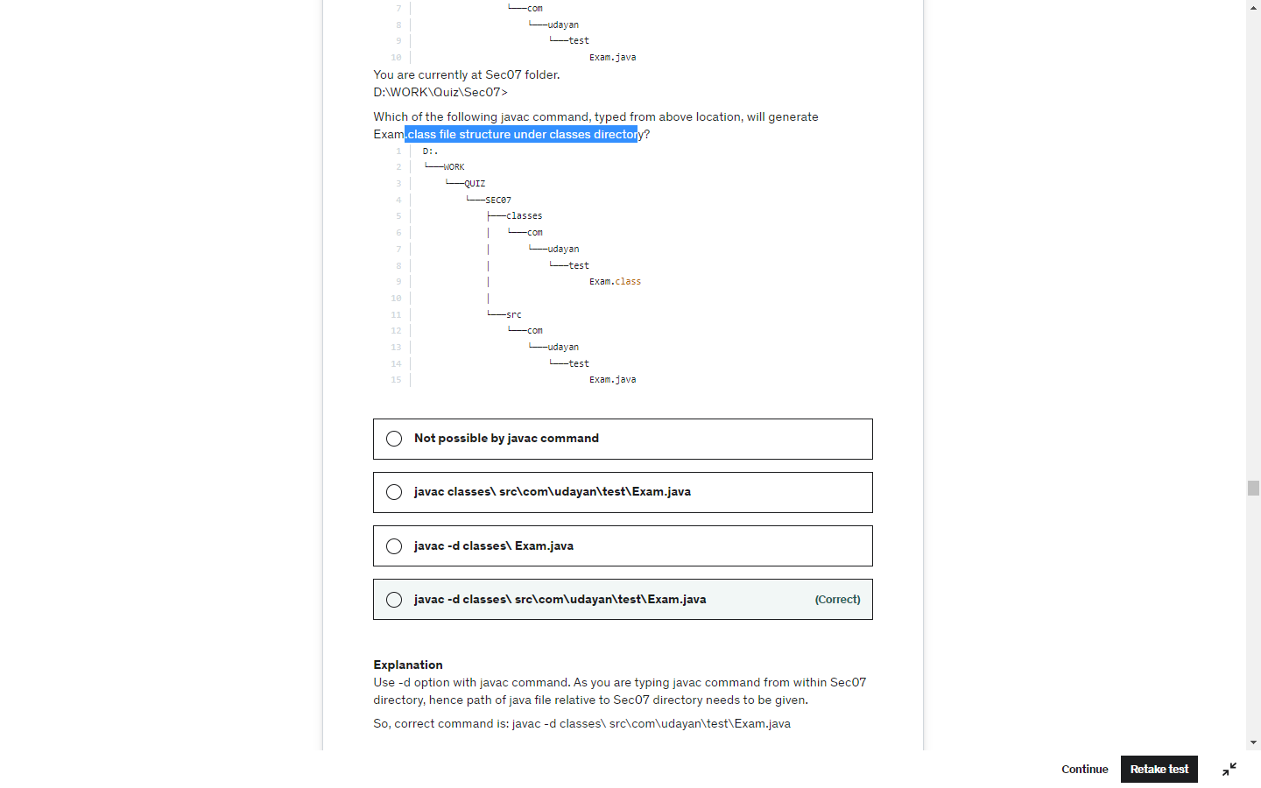

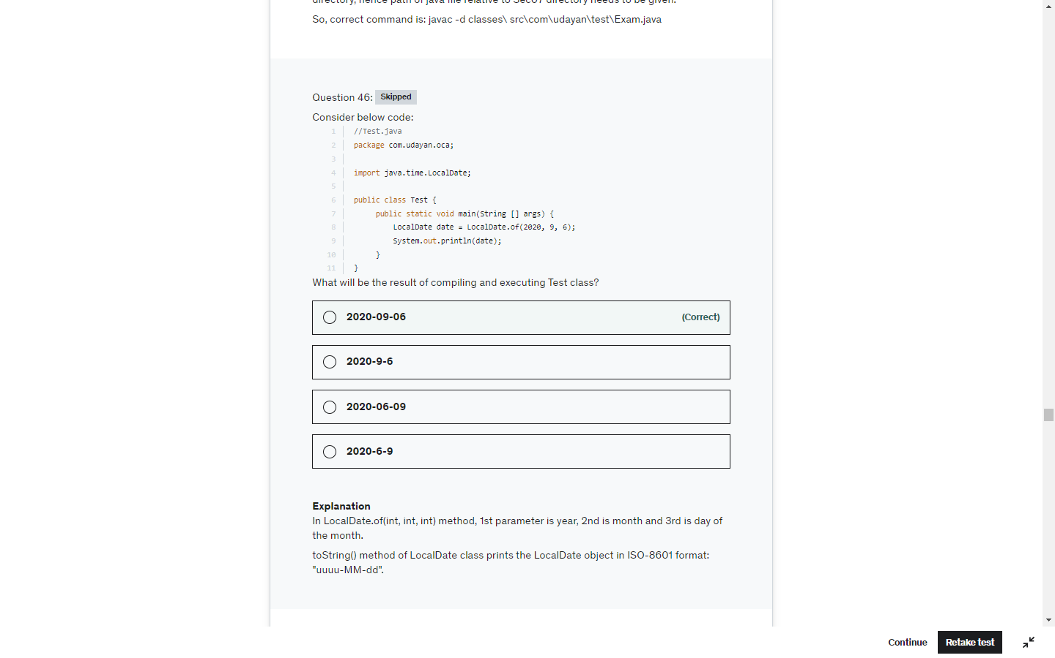

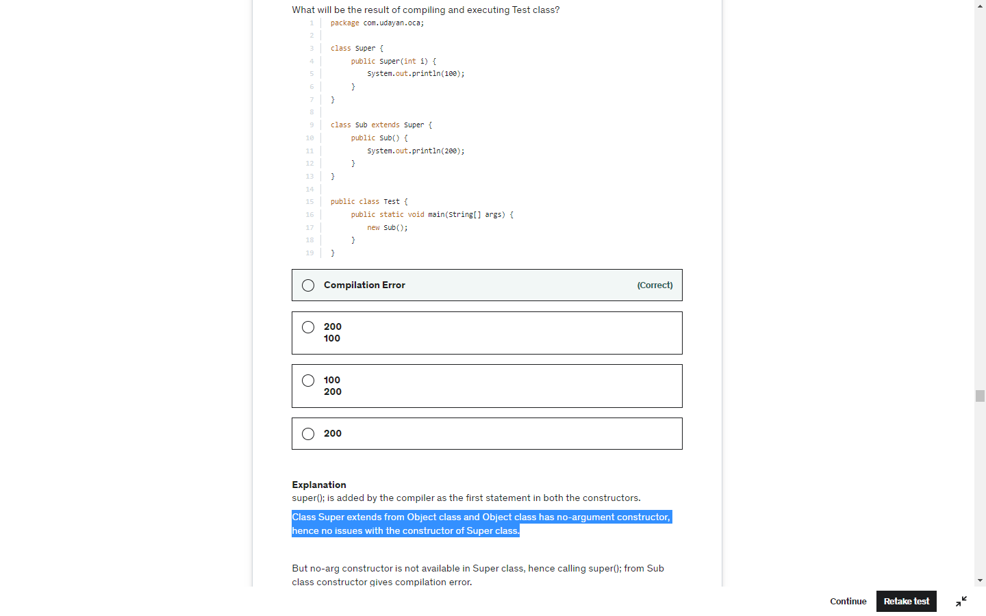

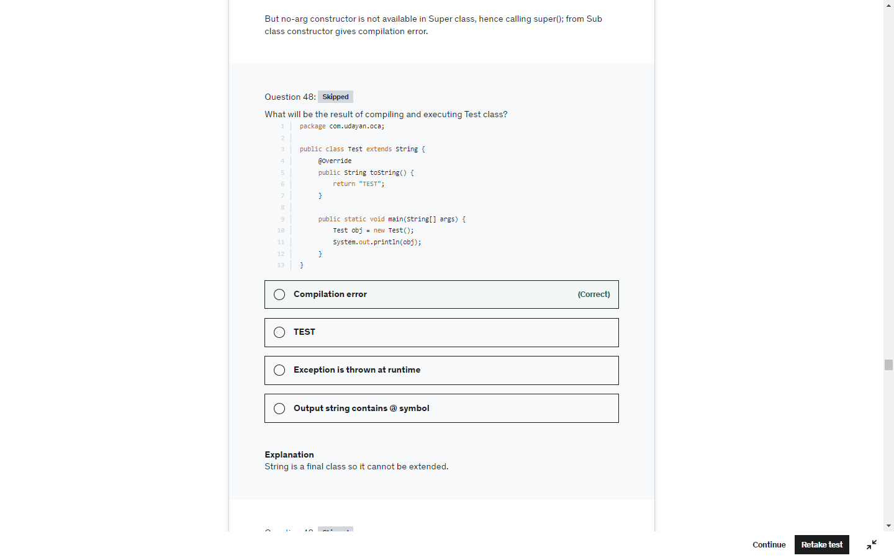

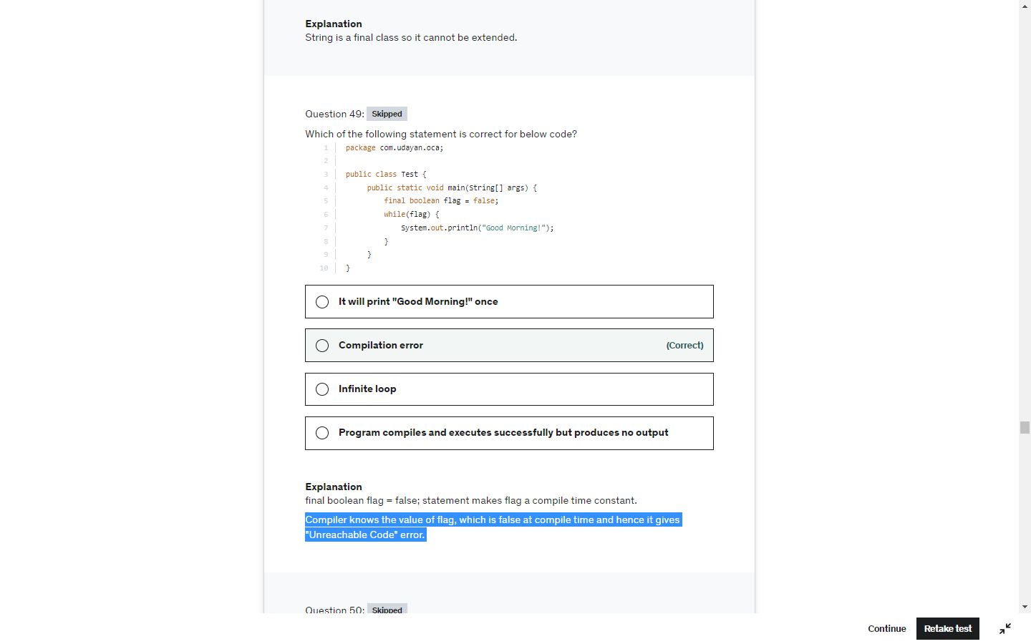

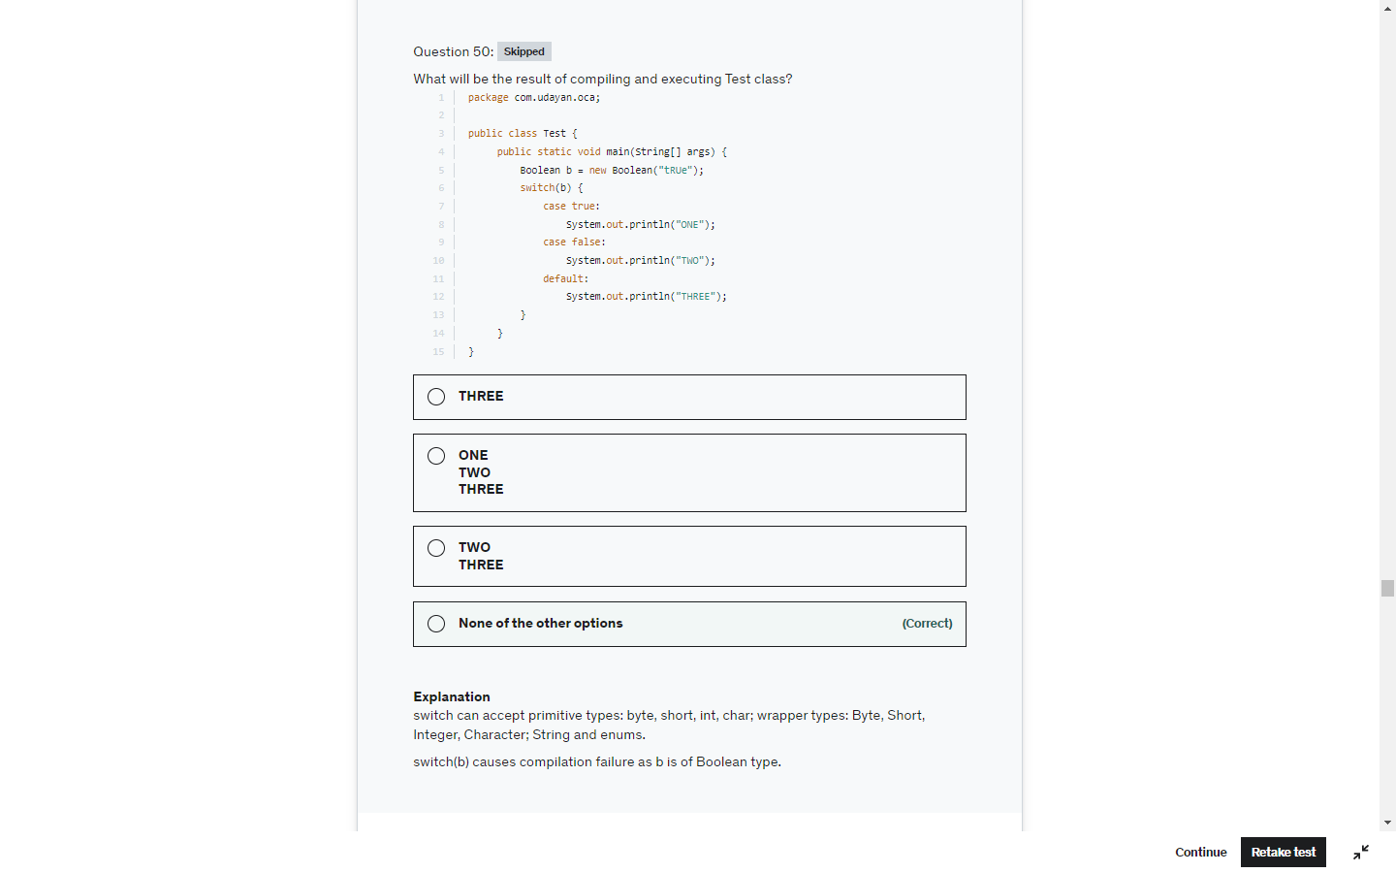

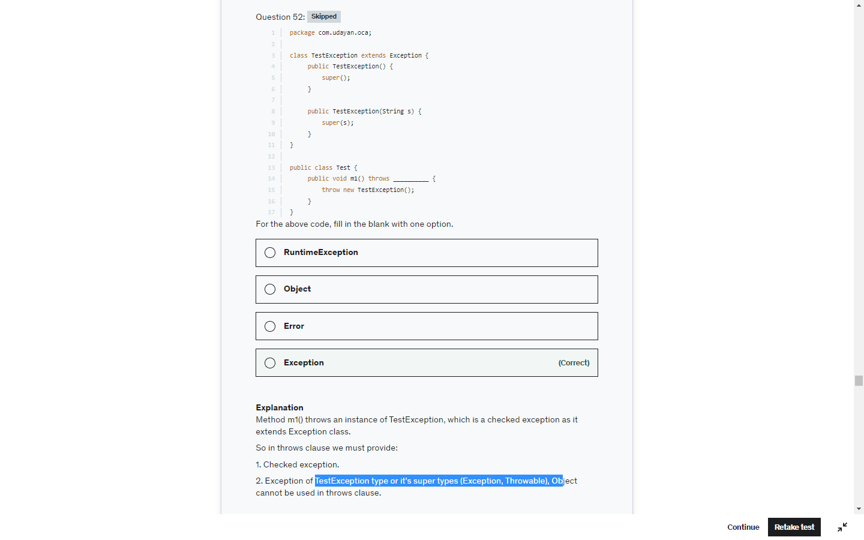

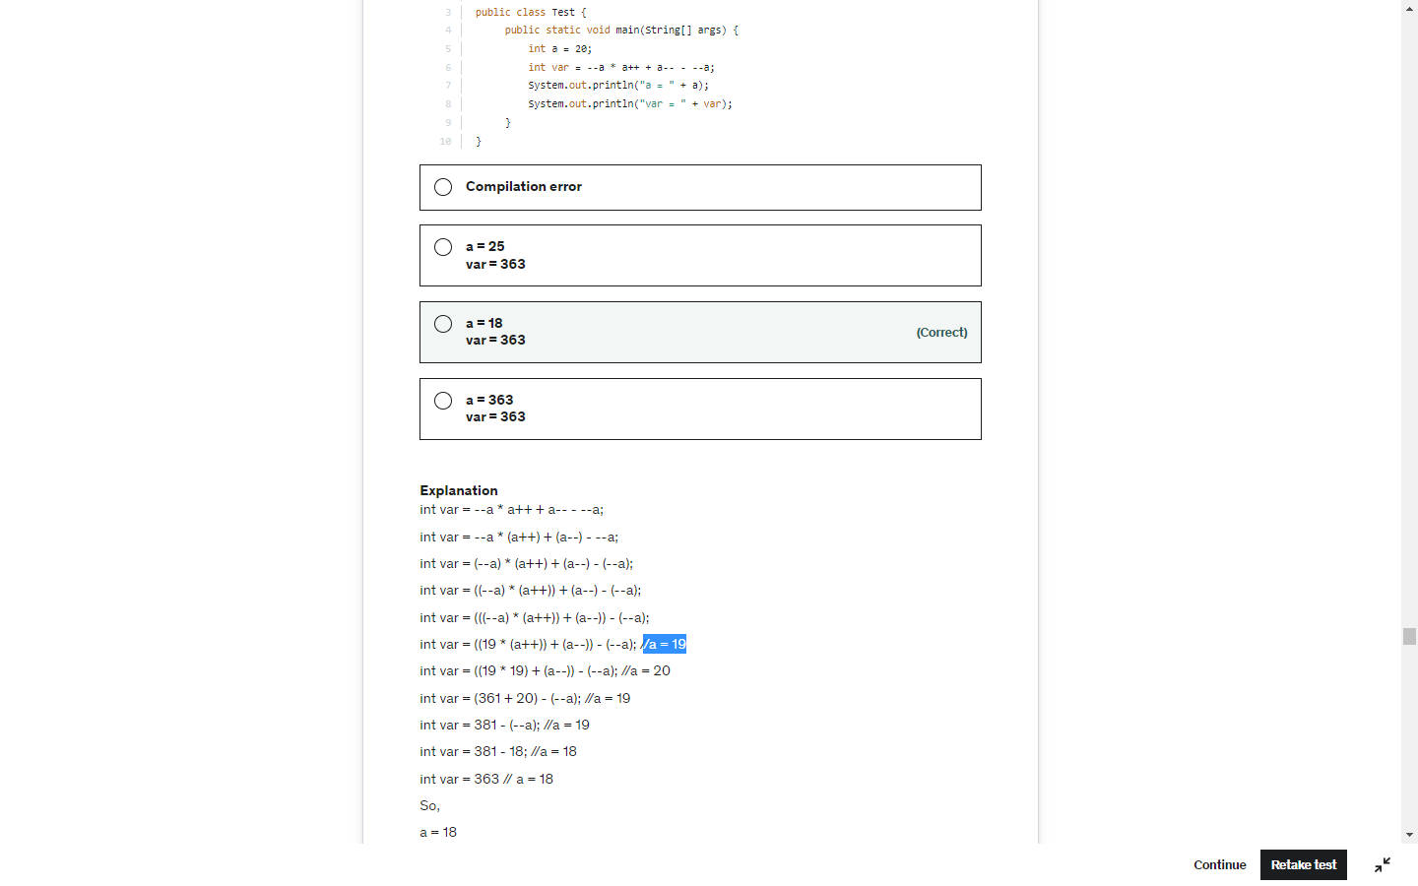

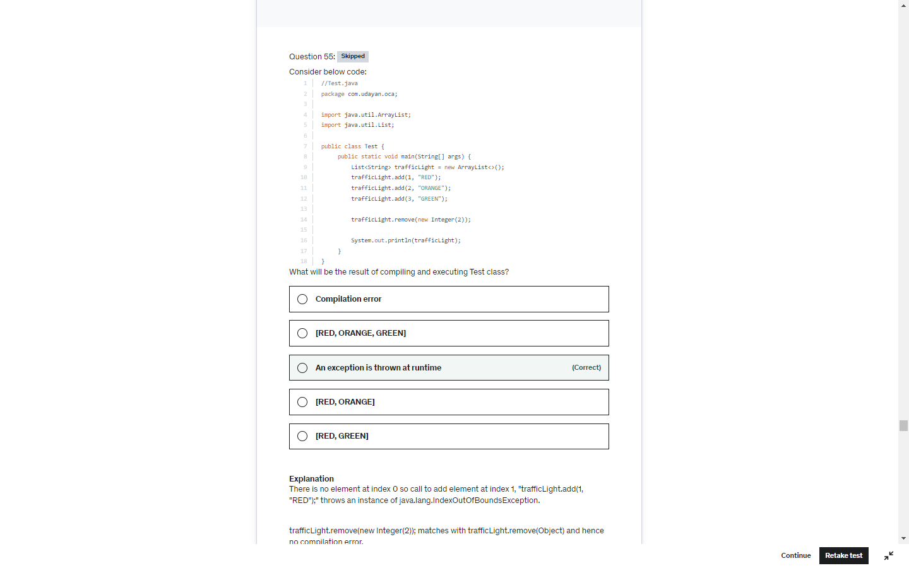

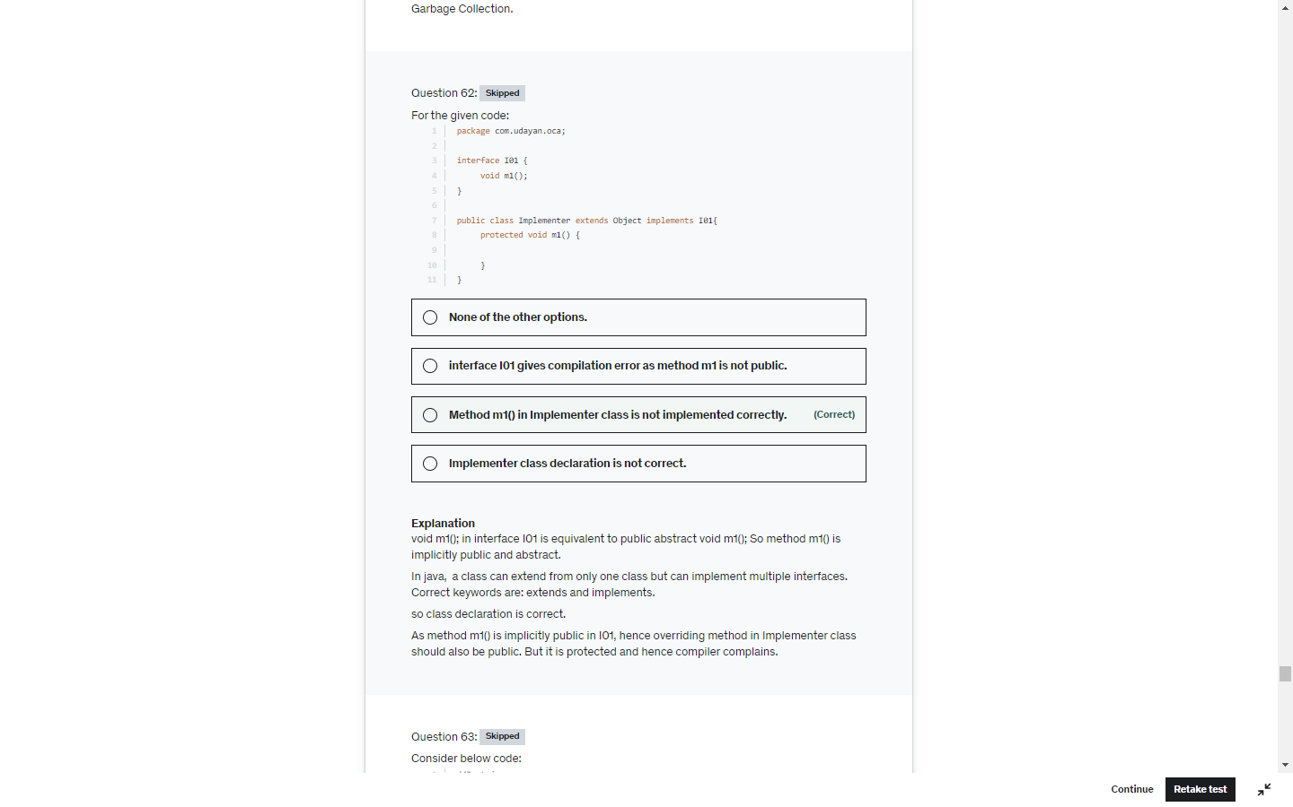

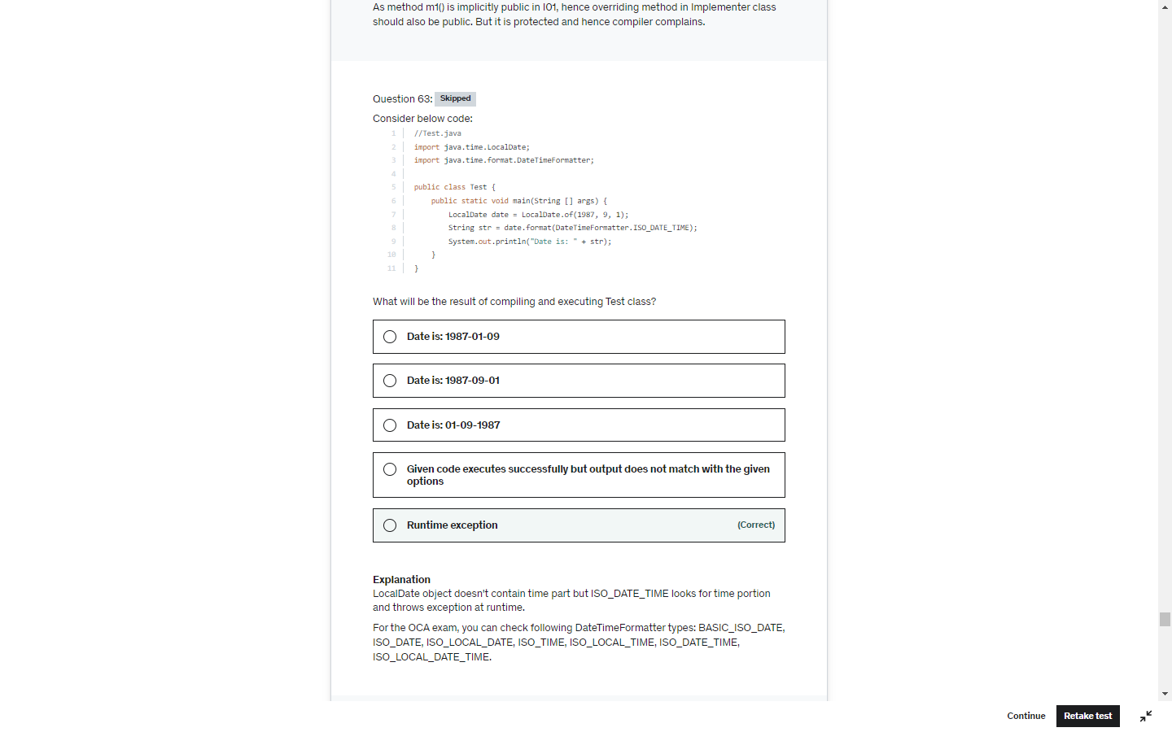

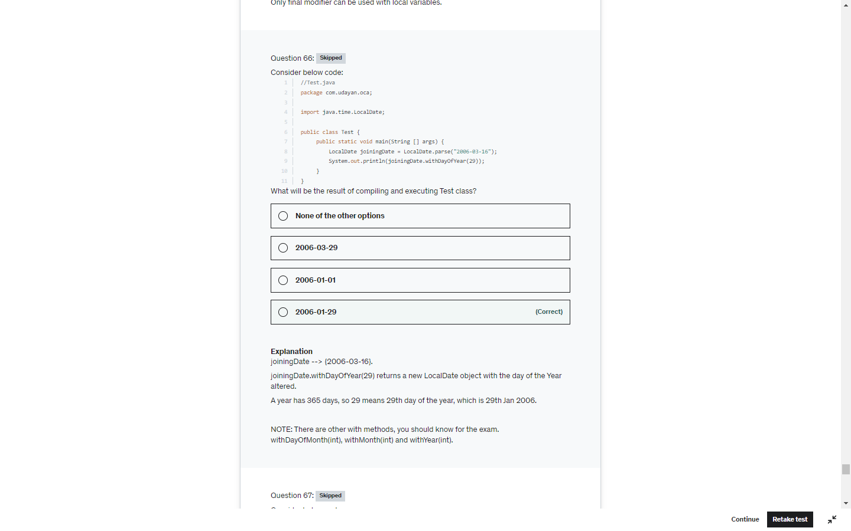

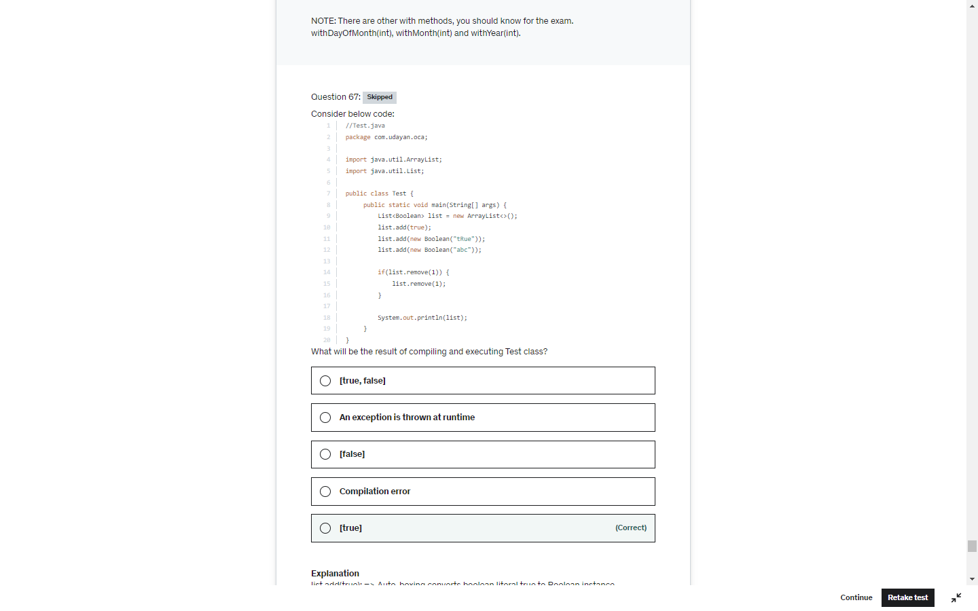

instanceOf should be a relation between two operand . parent child else below error at CE

object instanceof type

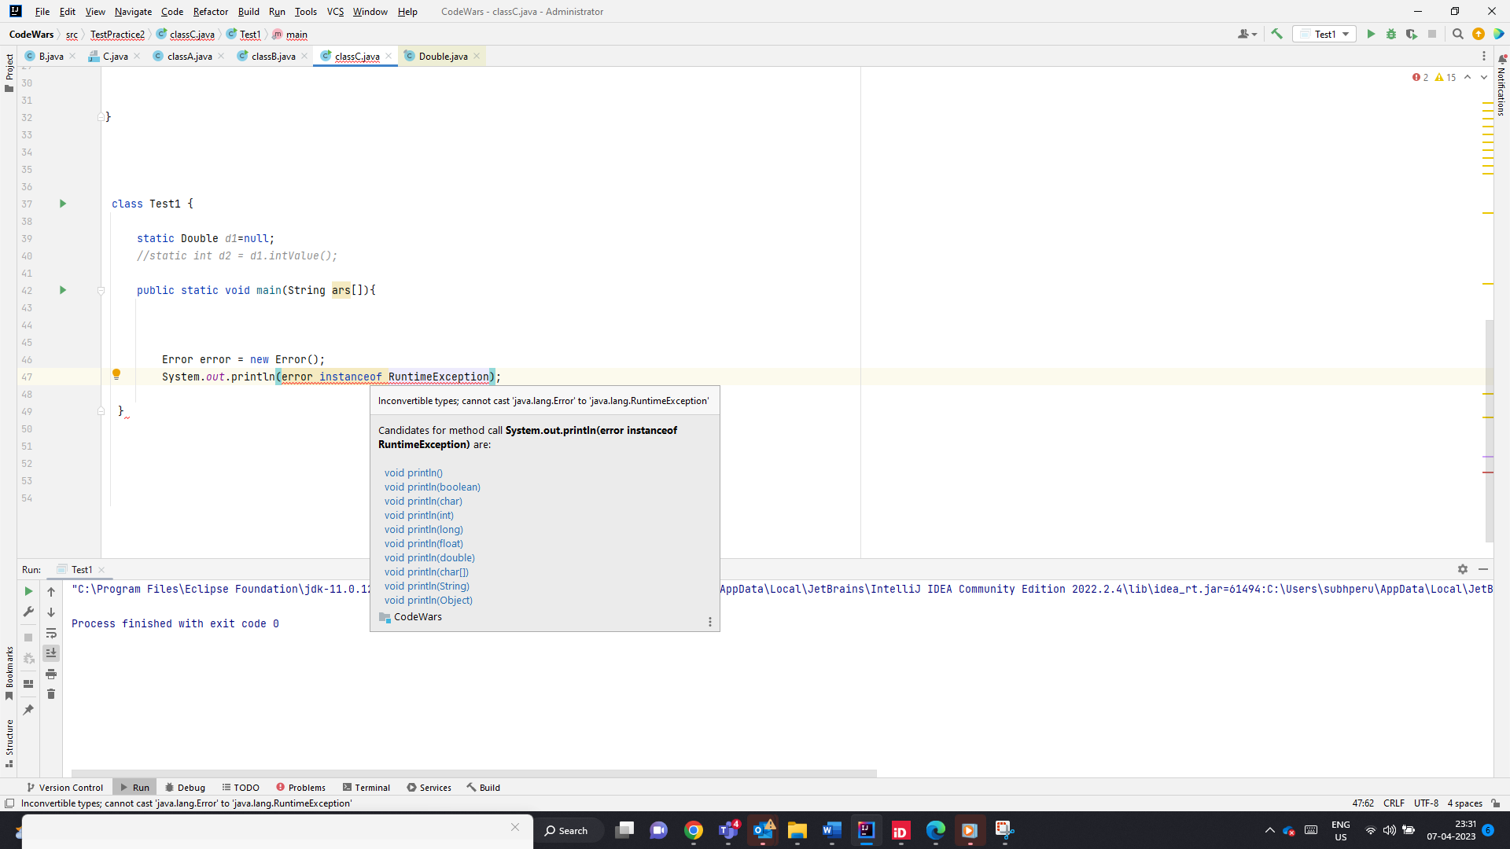

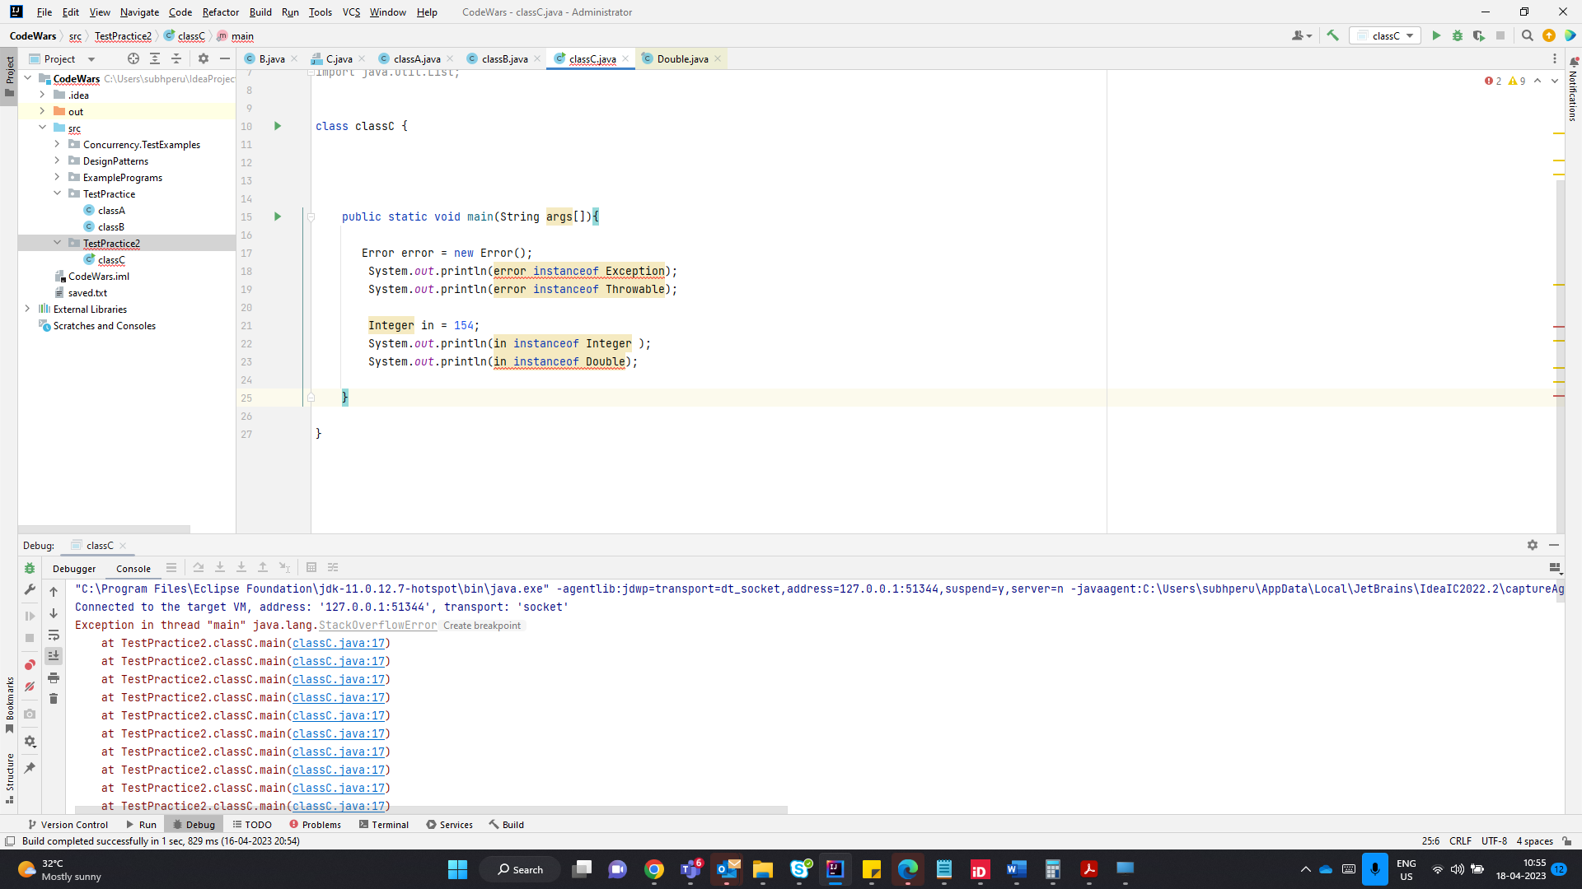

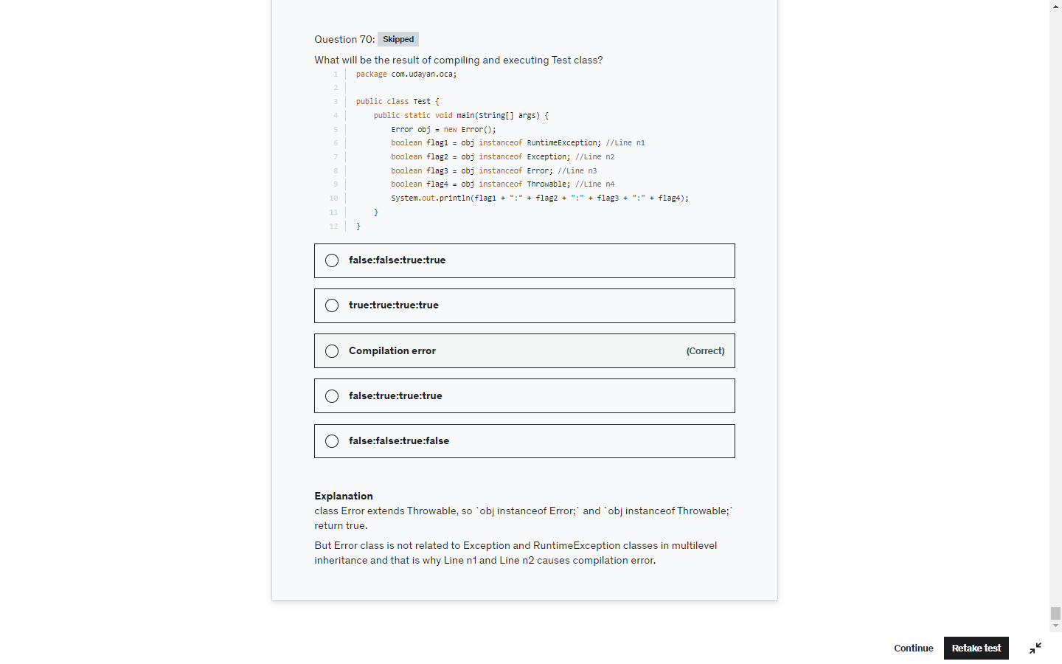

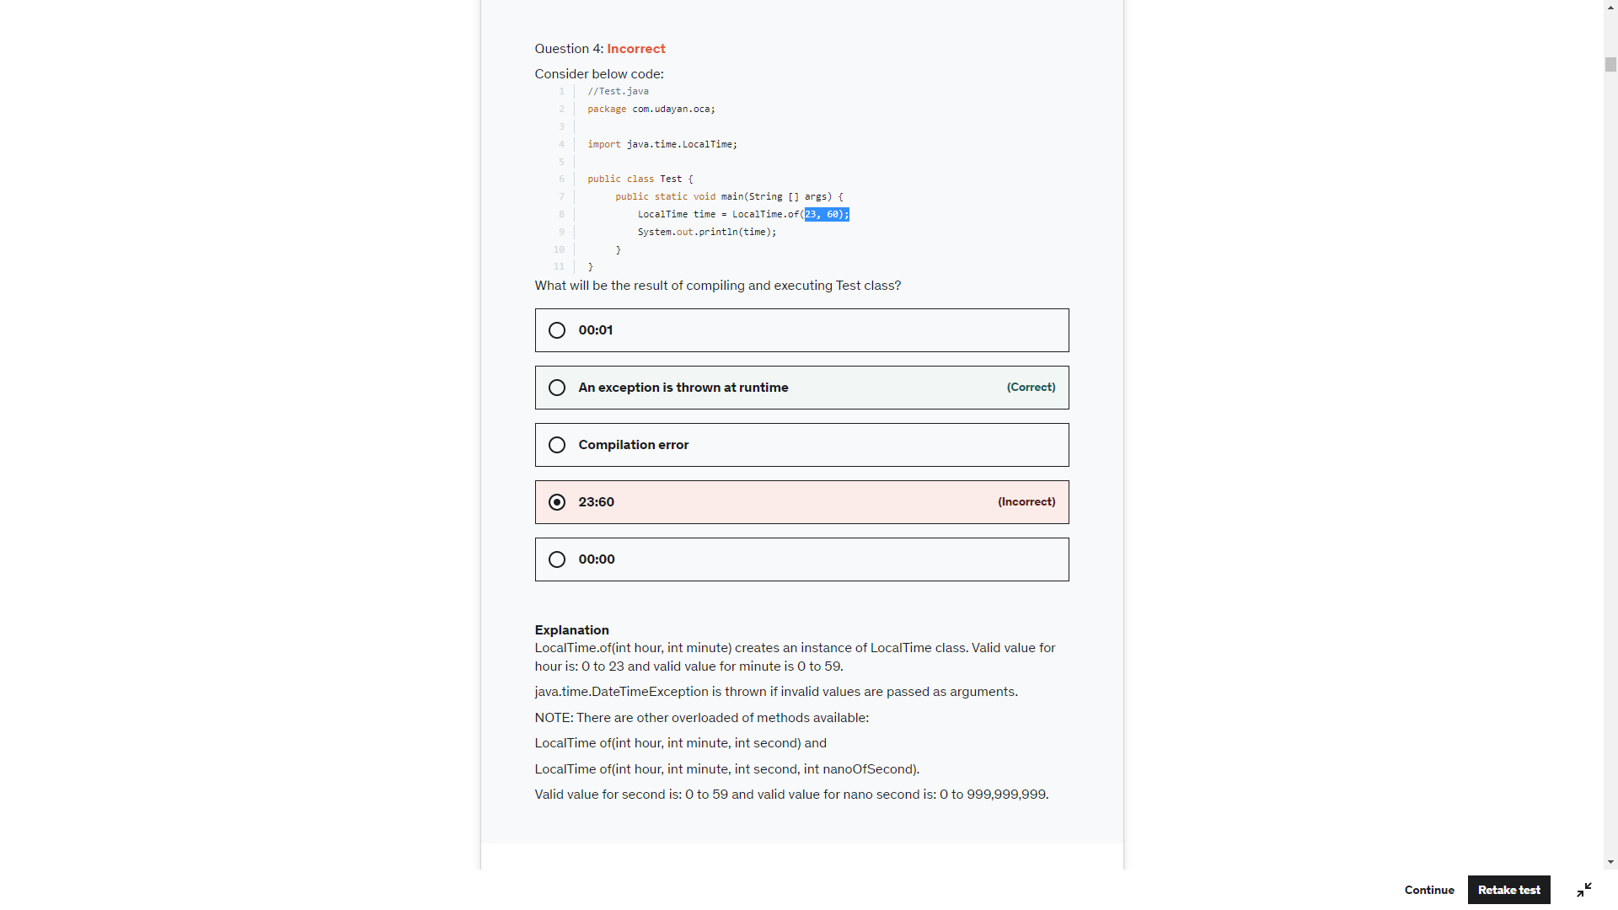

Sout(LocalTime.of(23,59)); -> 23:59

String name= null;

Sop(name)-> null

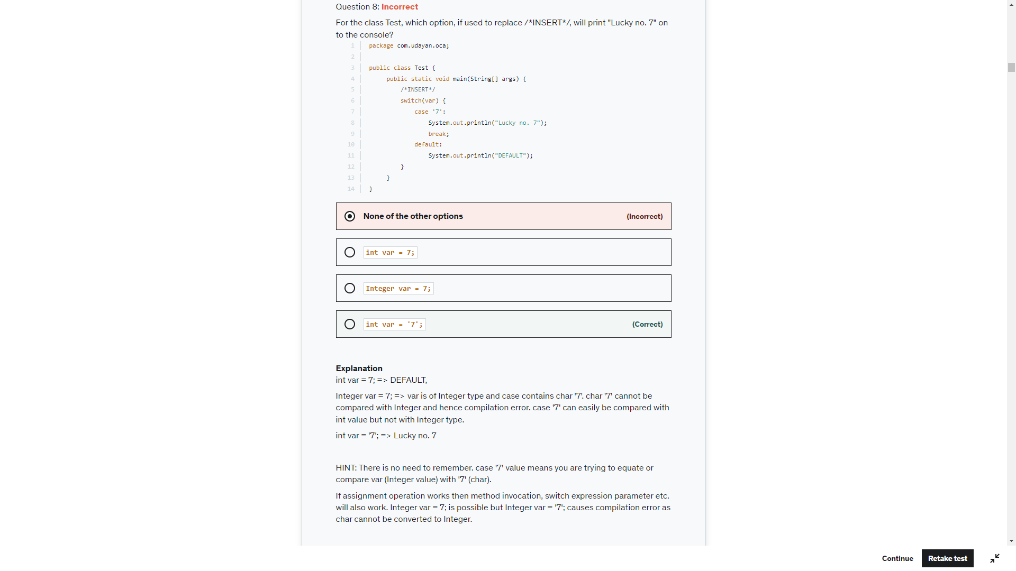

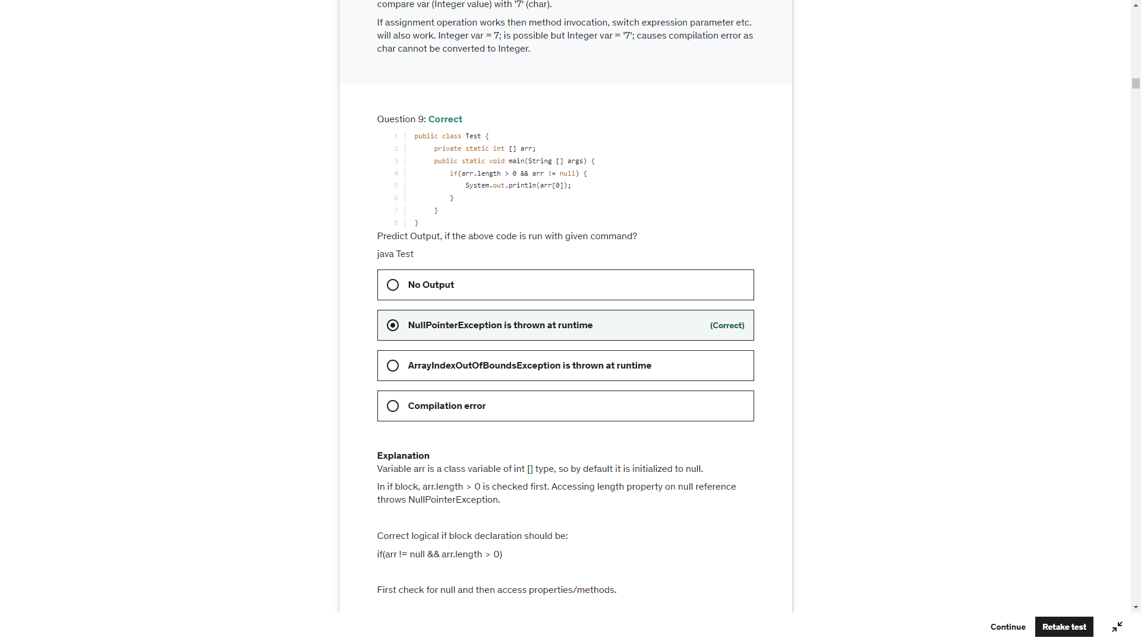

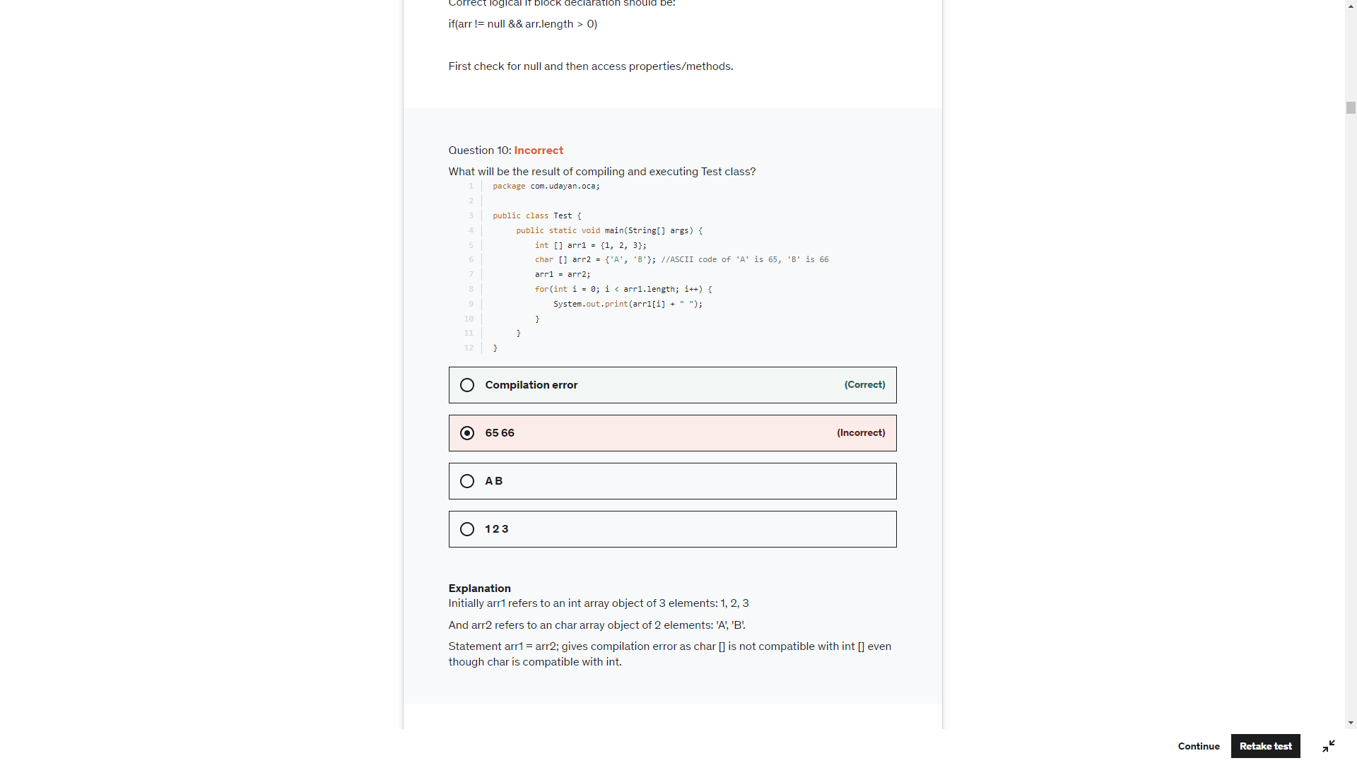

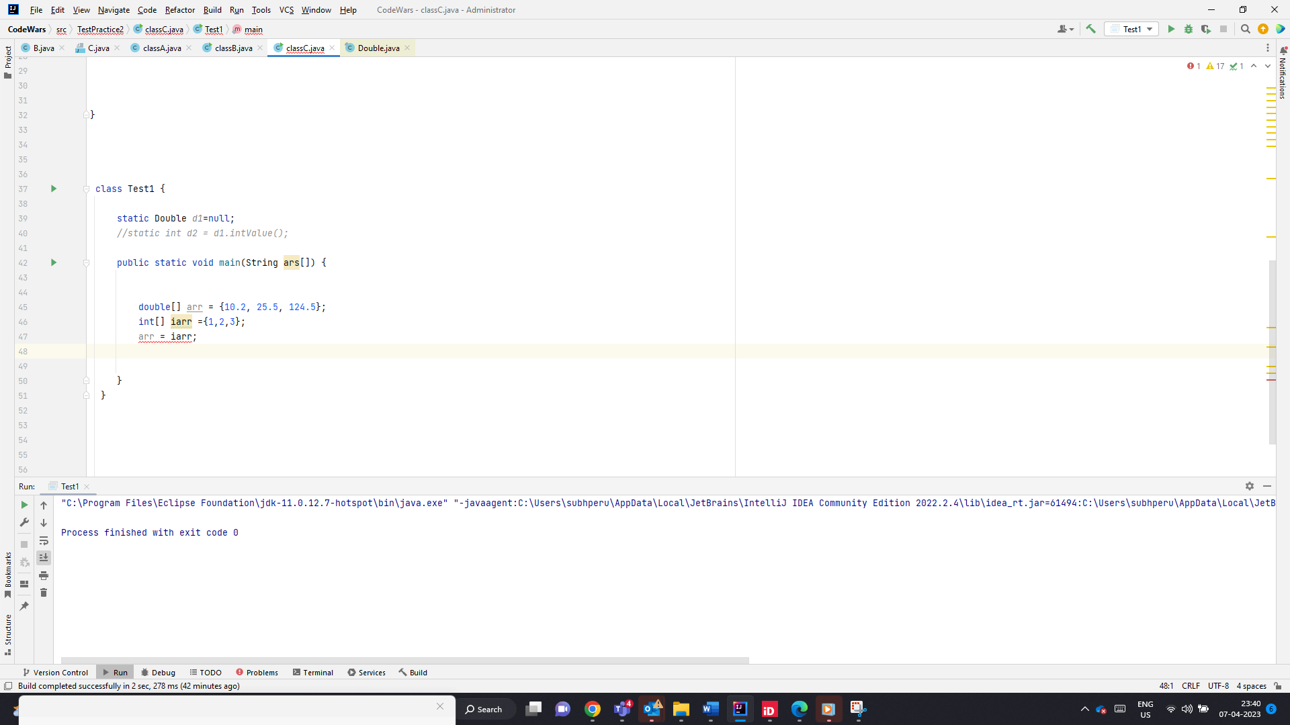

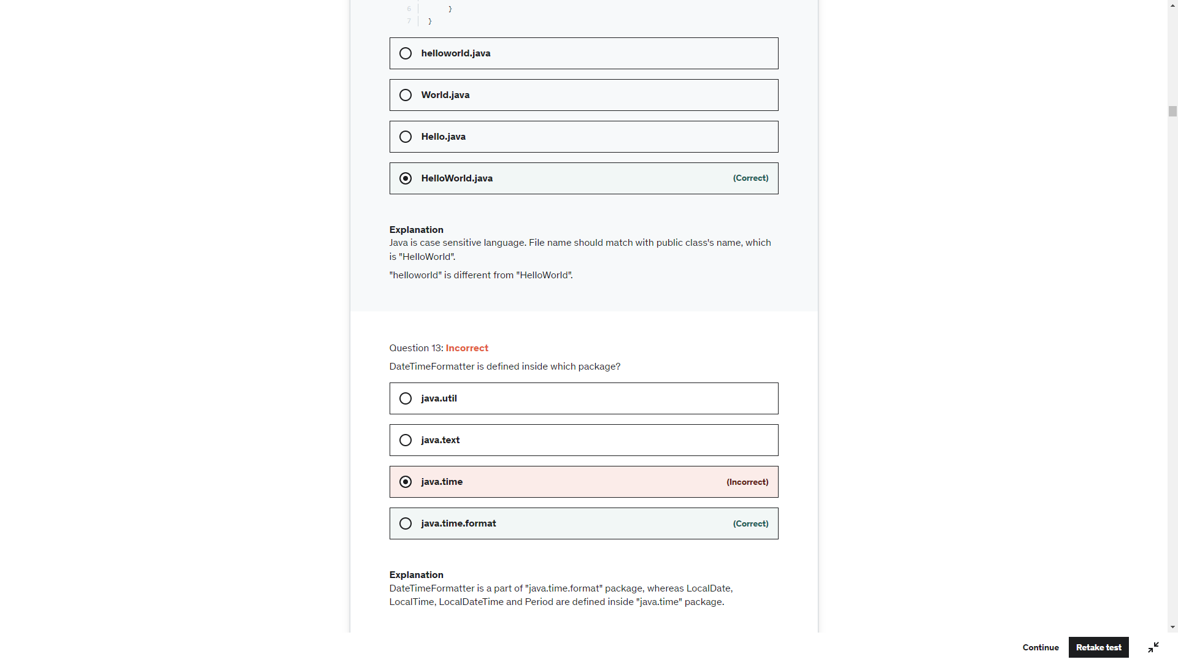

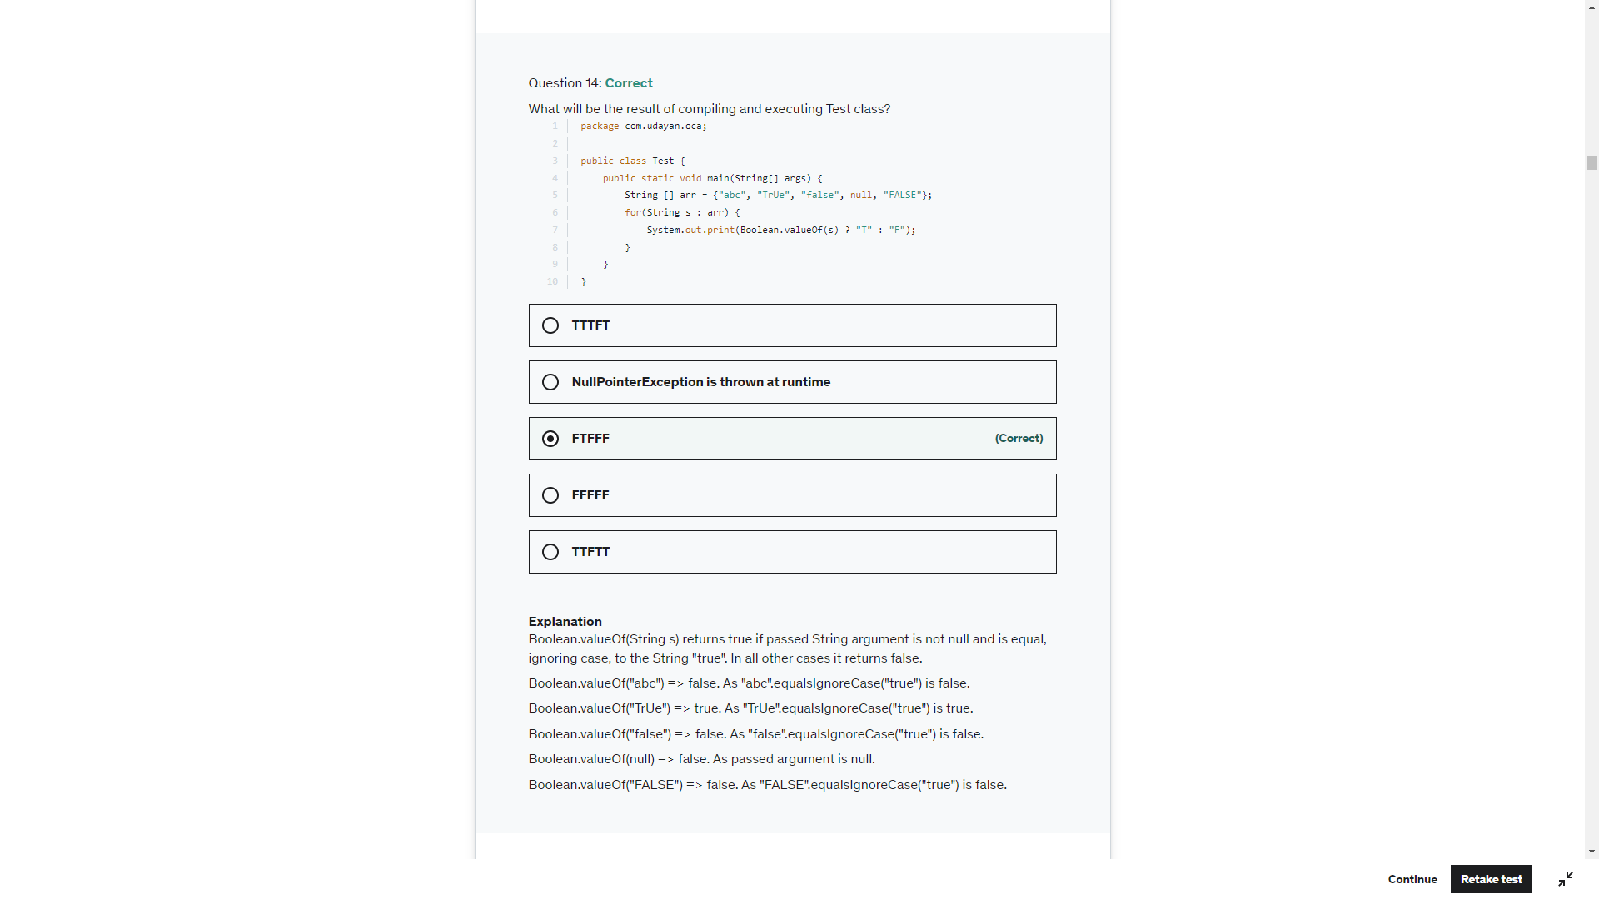

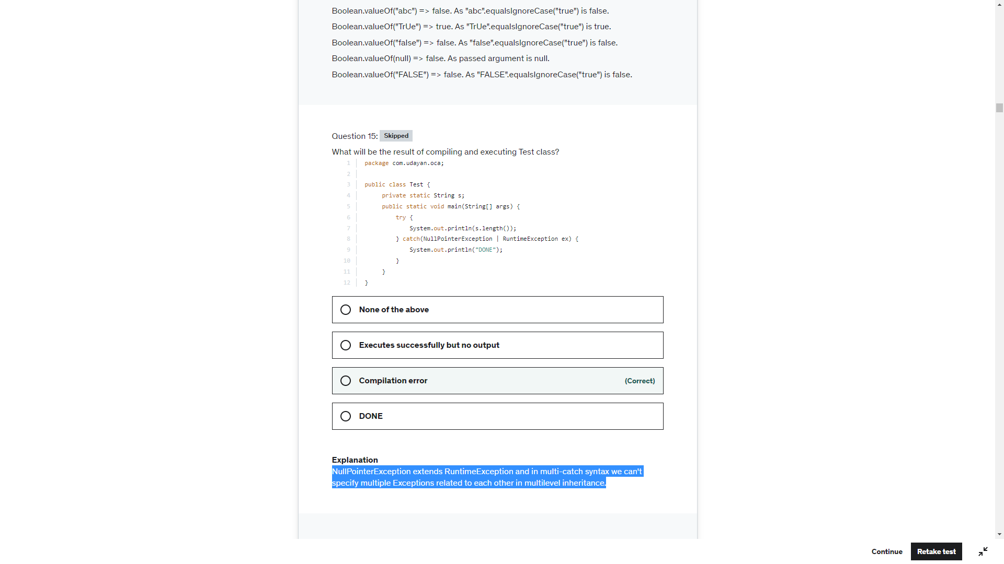

Sb.append(“”).length()->0

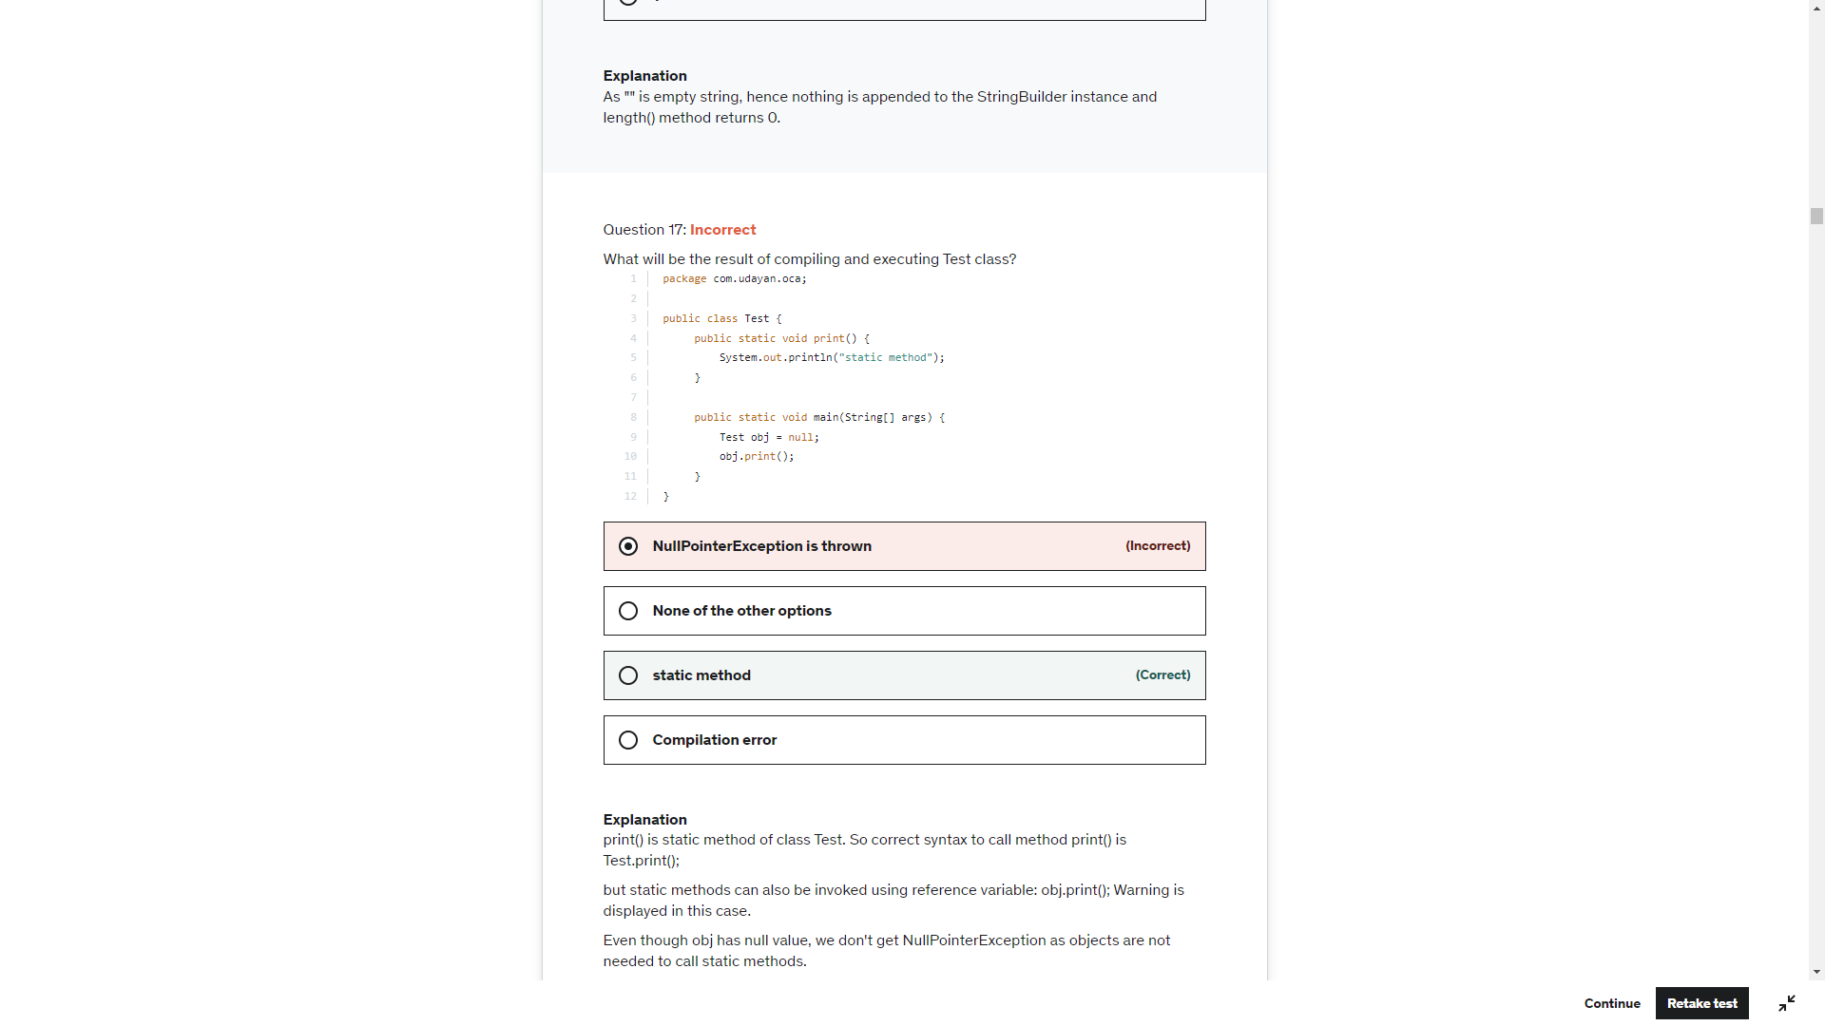

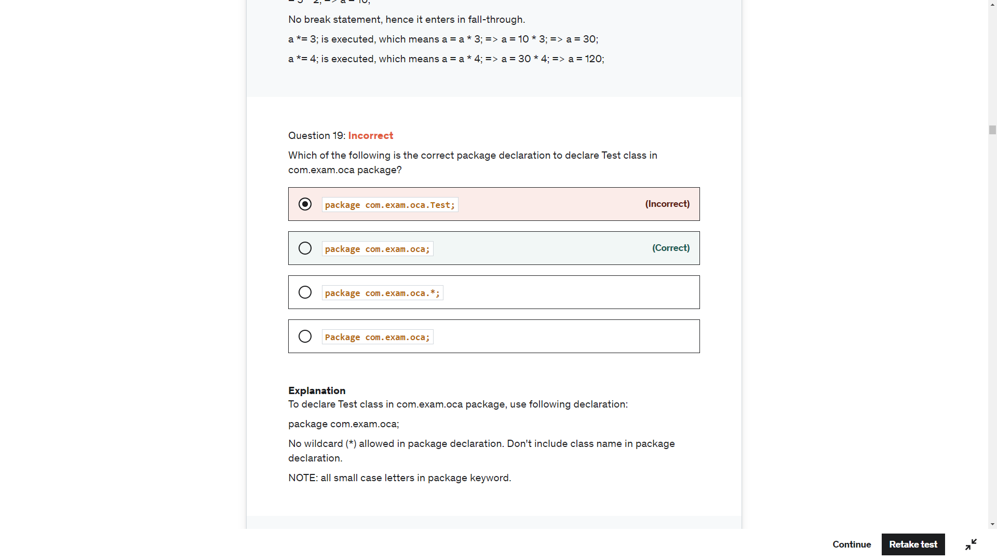

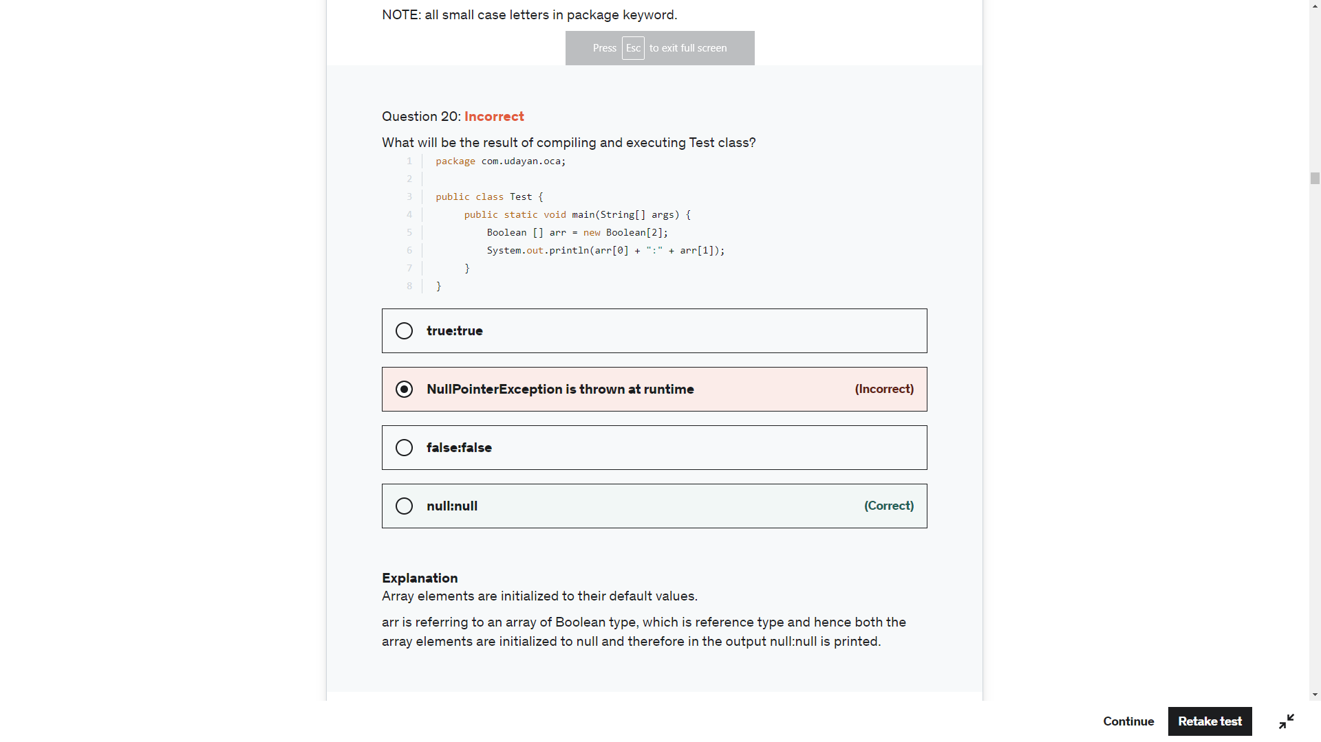

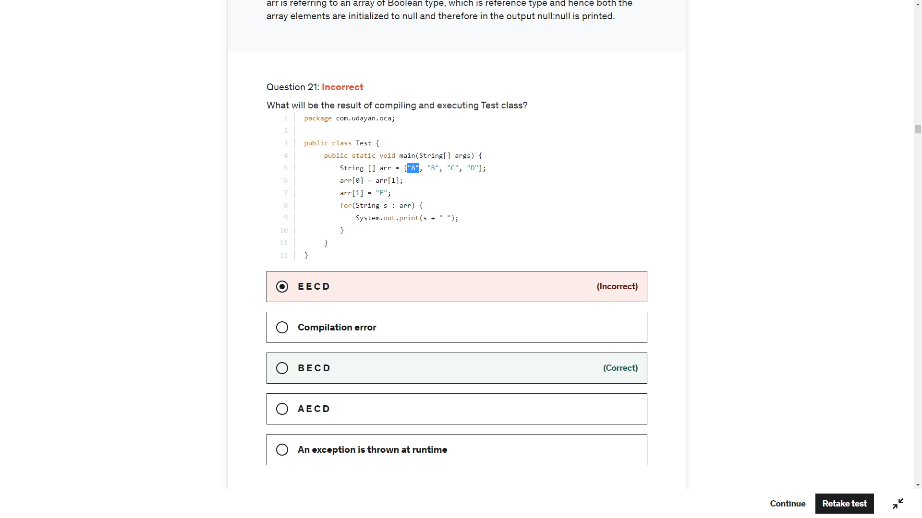

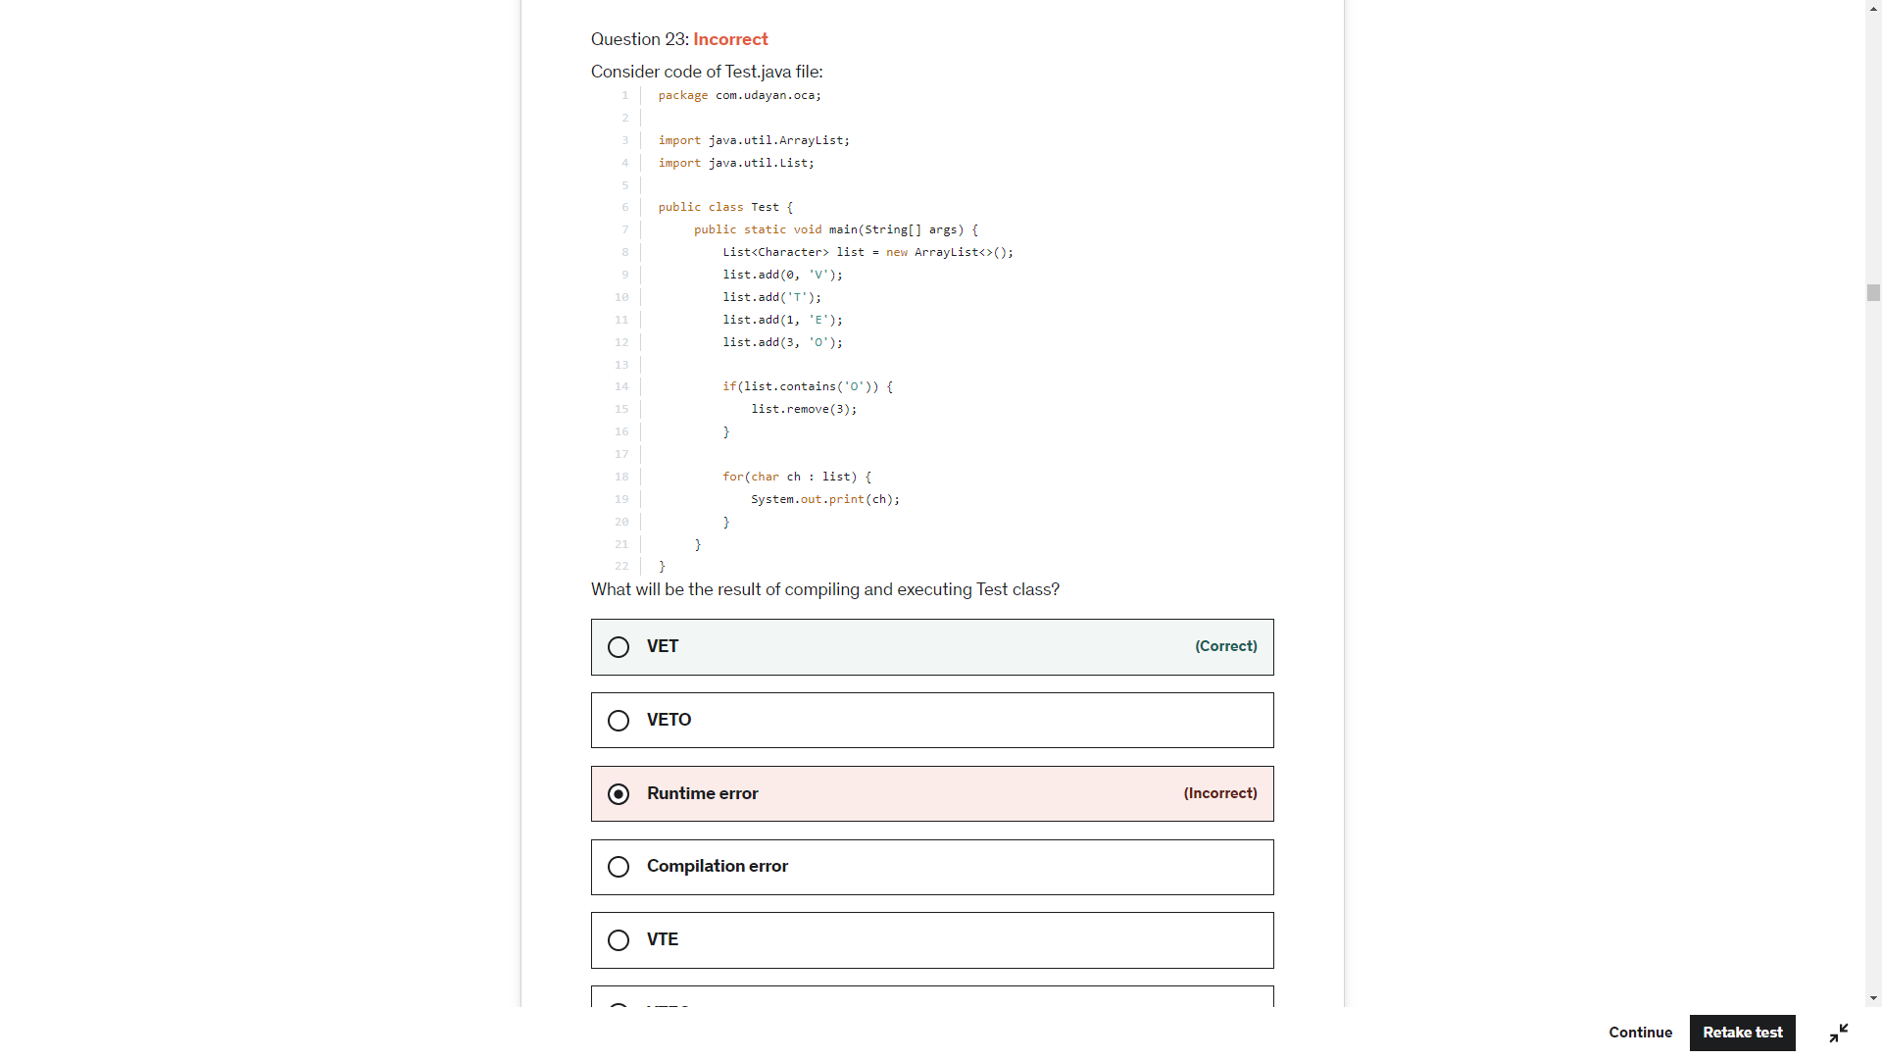

list.contains('O') => char 'O' is auto-boxed to Character object and as Character class overrides equals(String) method this expression returns true. Control goes inside if-block and executes: list.remove(3);.

list.remove(3); => Removes last element of the list. list --> [V,E,T].

for(char ch : list) => First list item is Character object, which is auto-unboxed and assigned to ch. This means in first iteration ch = 'V'; And after this it is simple enhanced for loop. Output is VET.

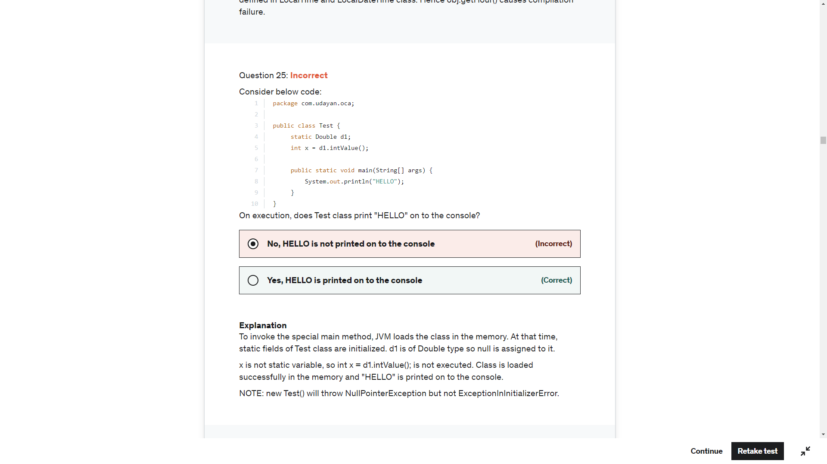

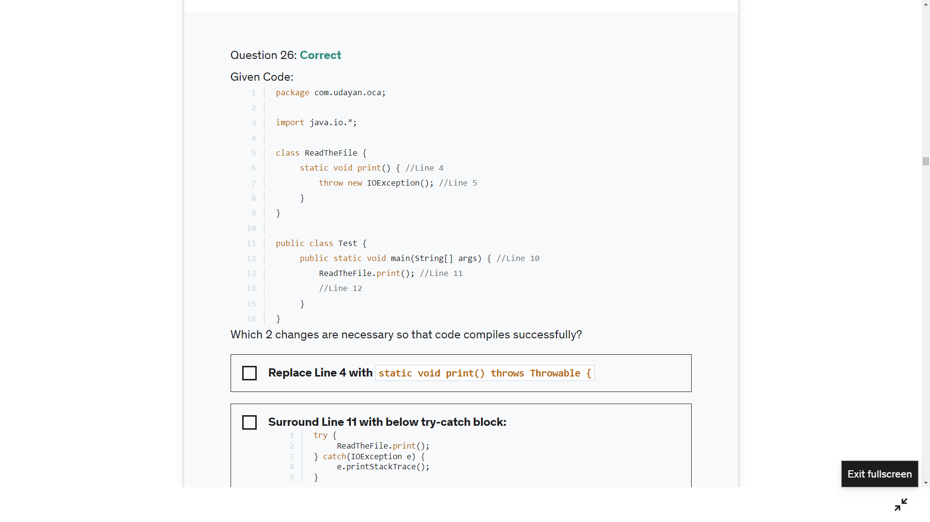

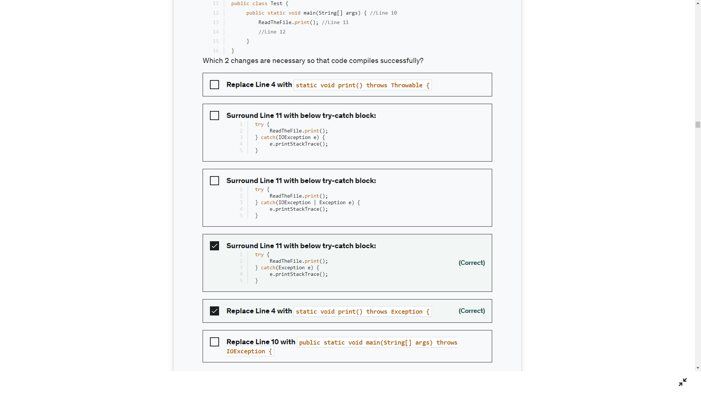

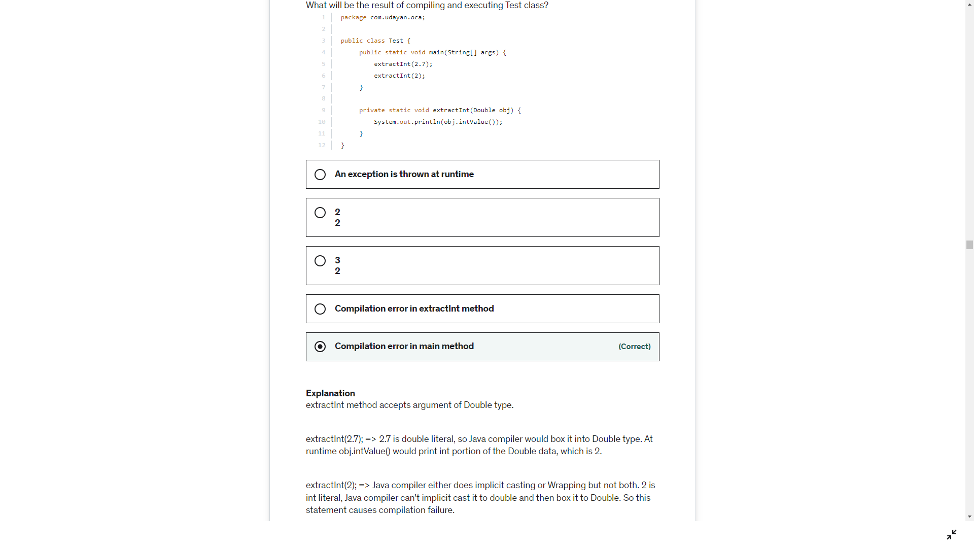

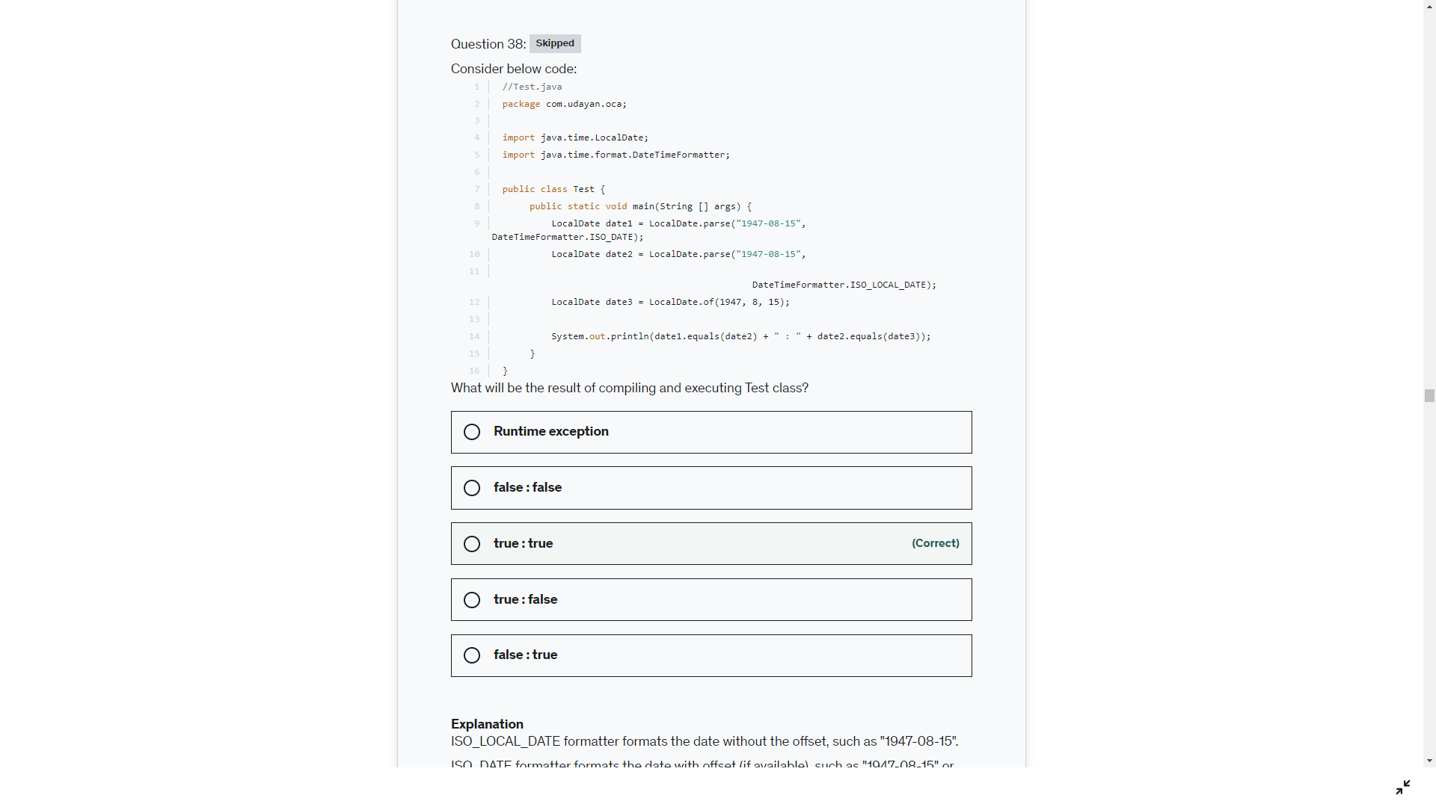

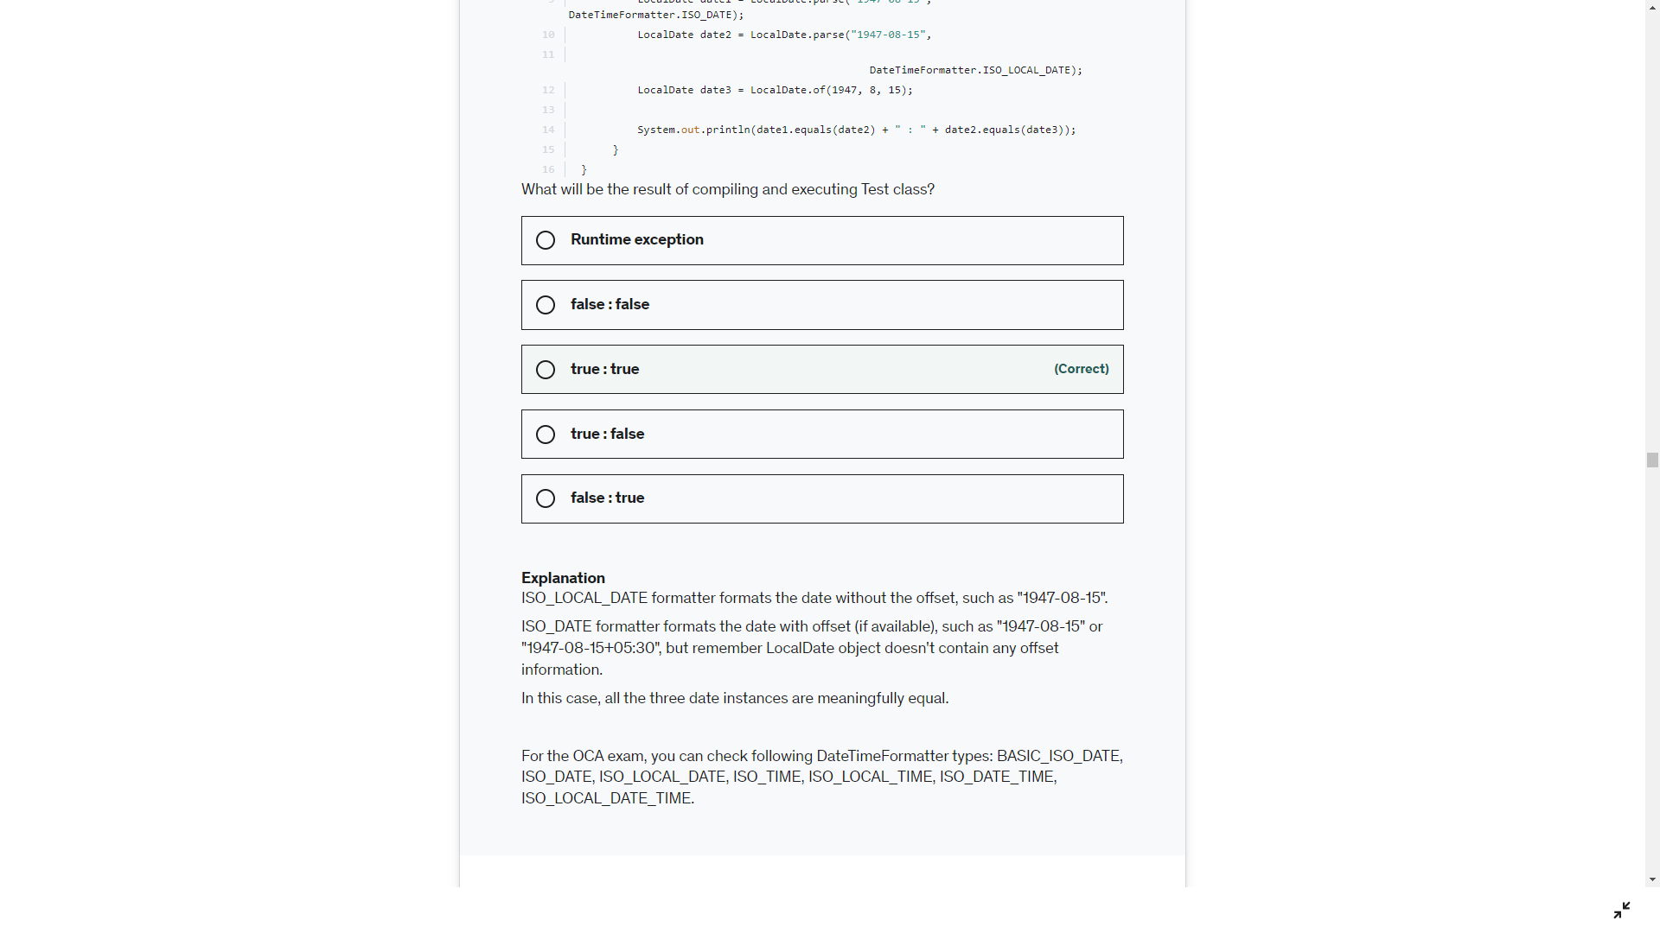

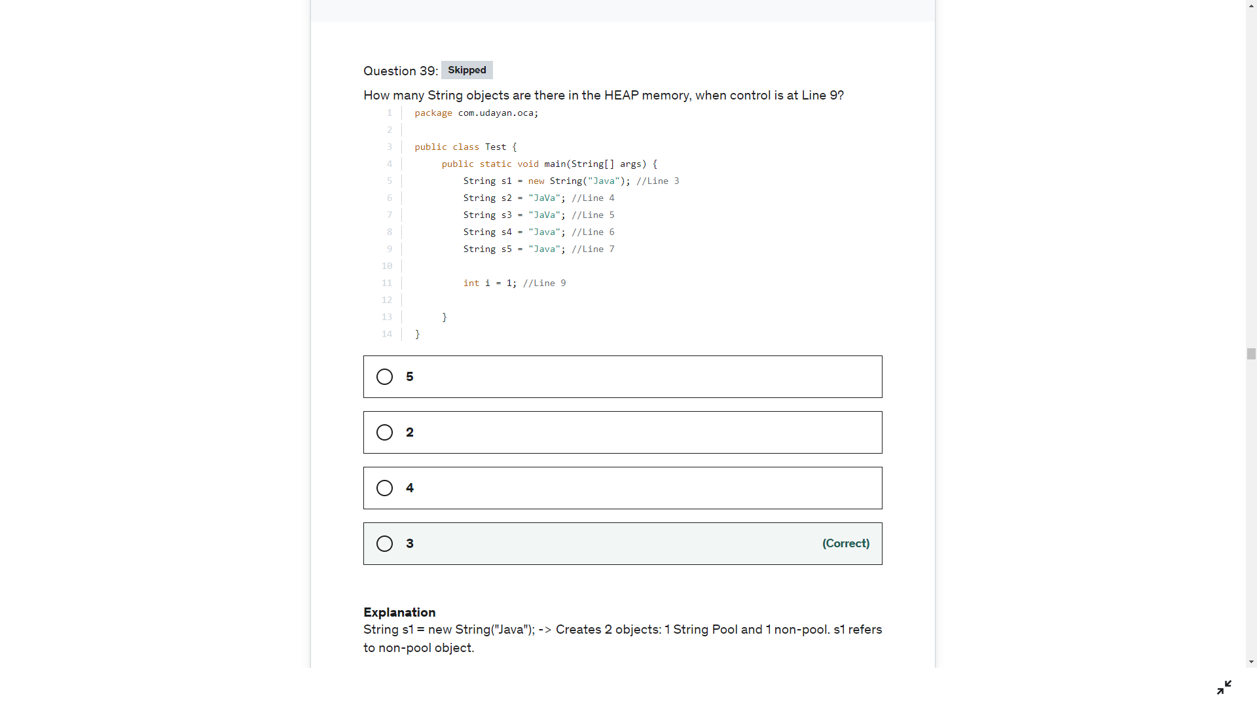

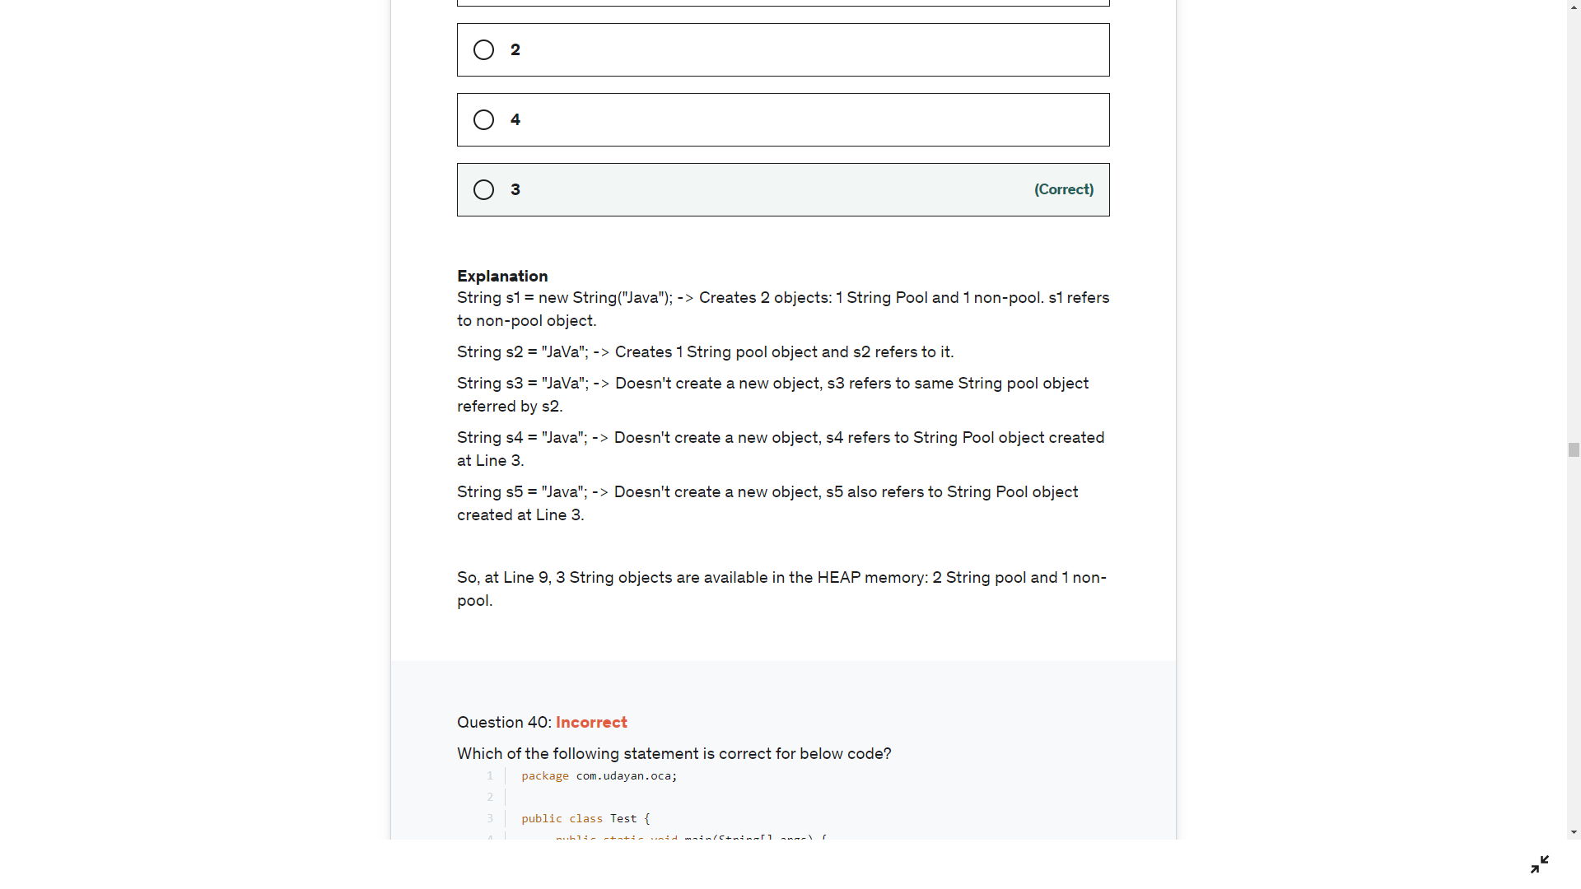

The Java string constant pool is an area in heap memory where Java stores literal string values. The heap is an area of memory used for run-time operations. When a new variable is created and given a value, Java checks to see if that exact value exists in the pool.

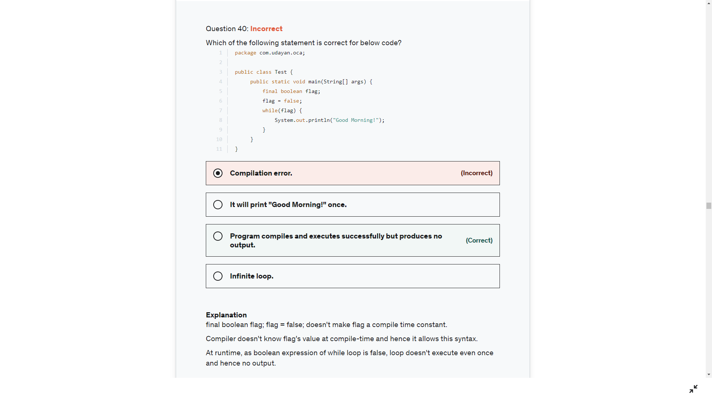

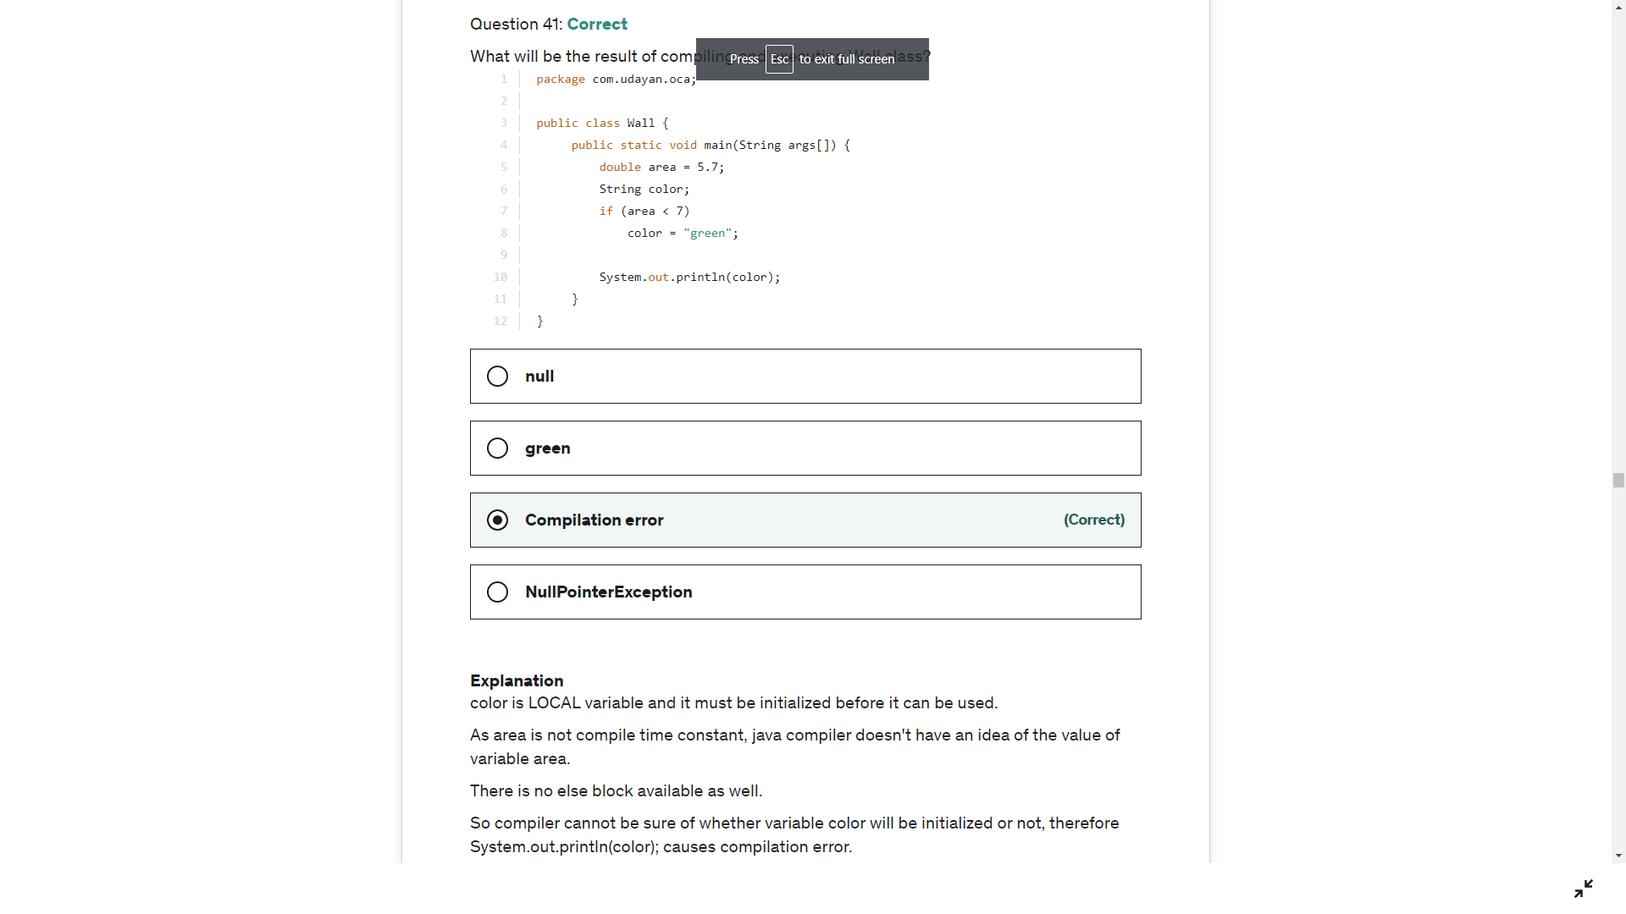

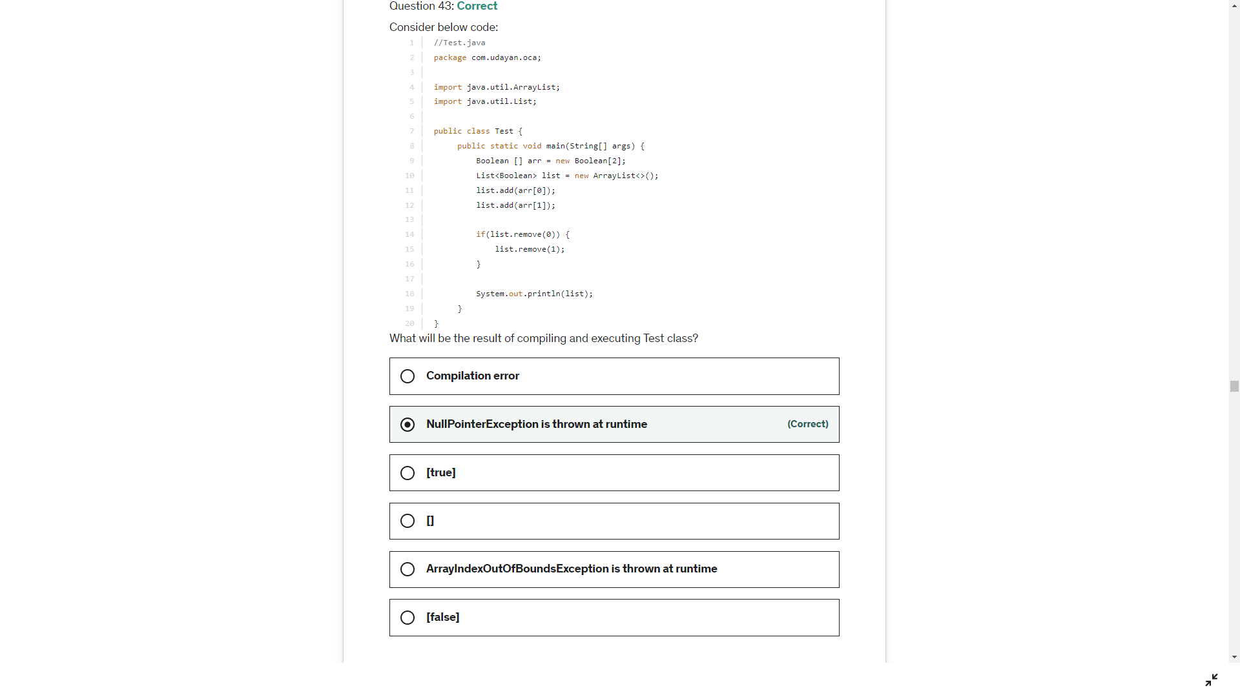

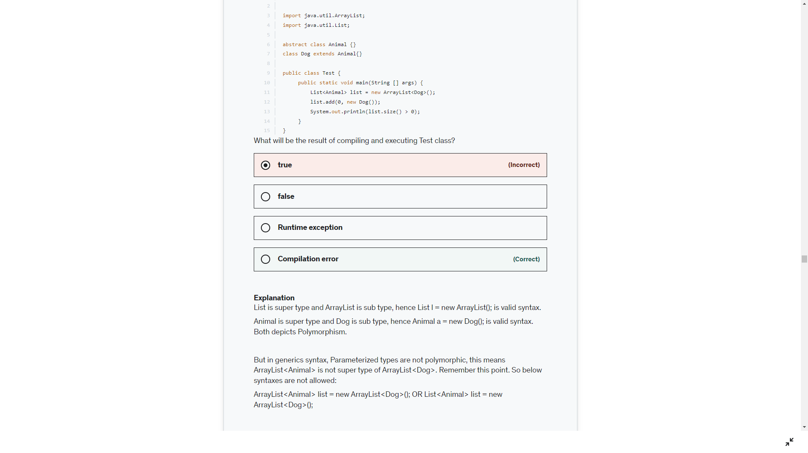

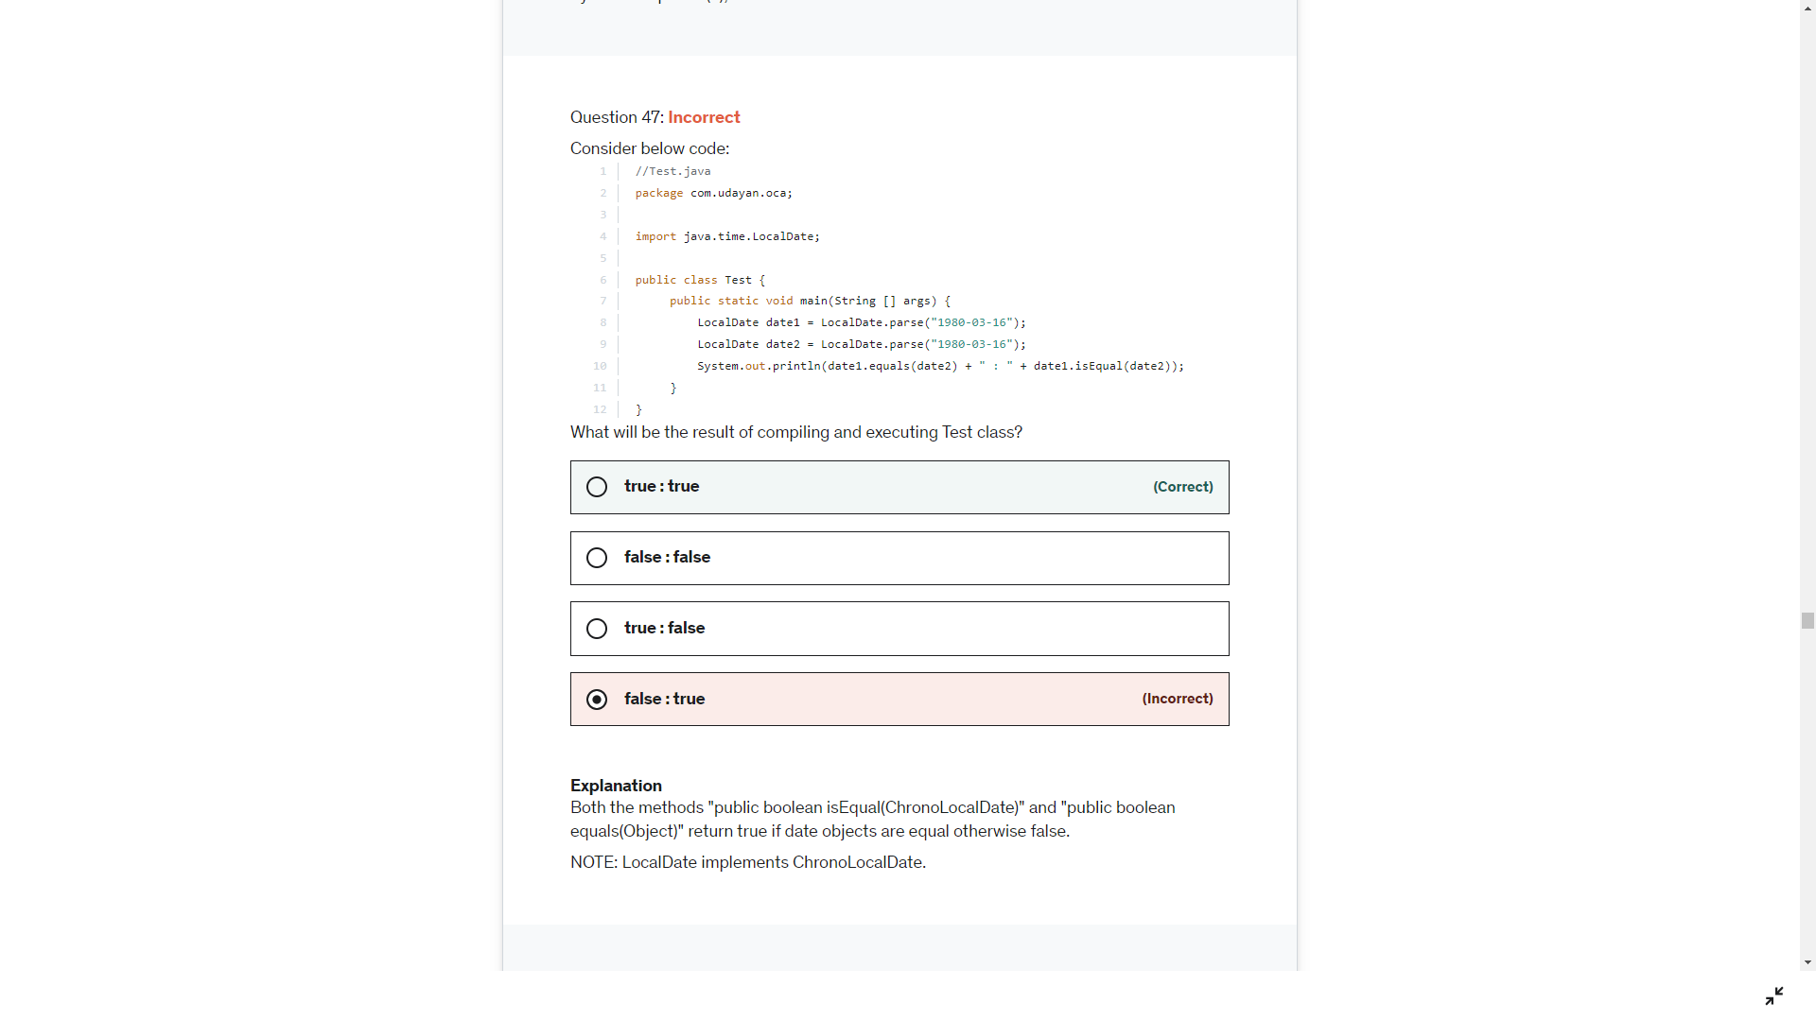

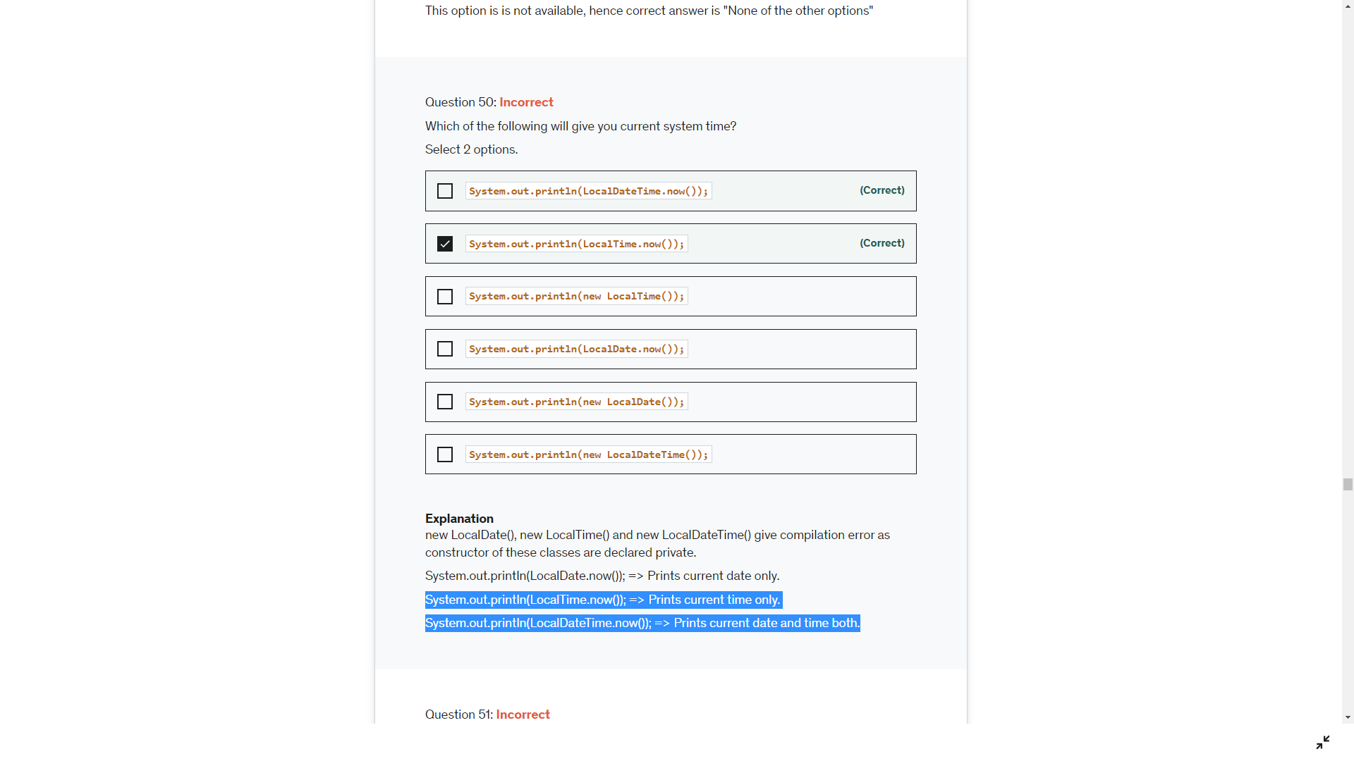

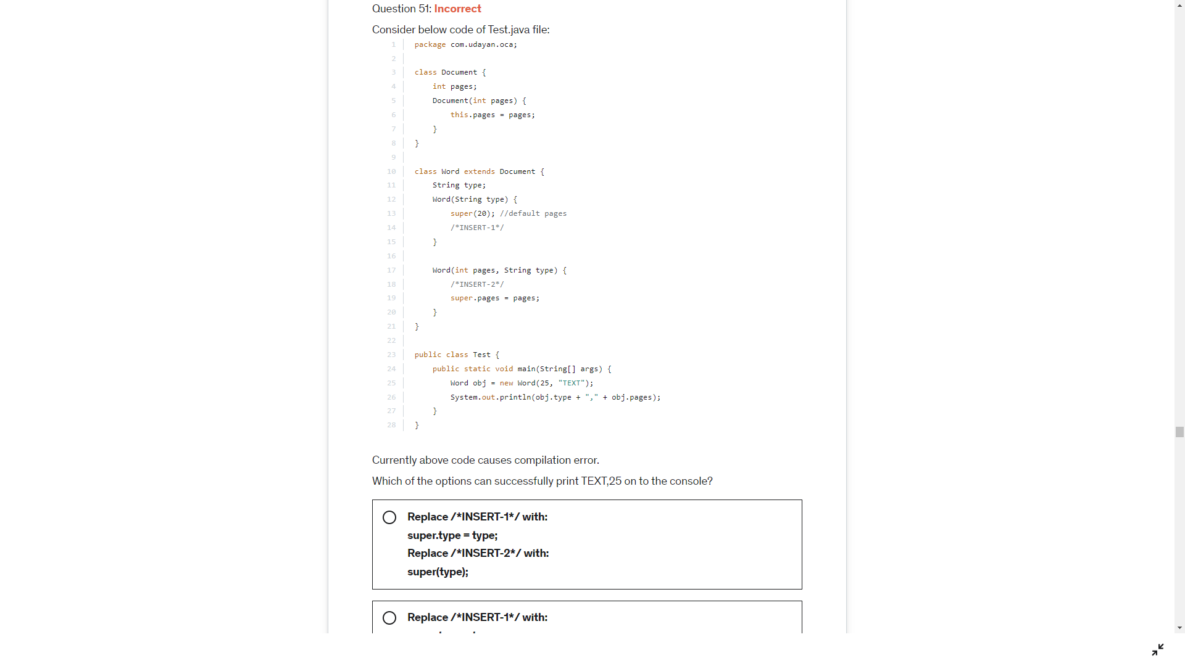

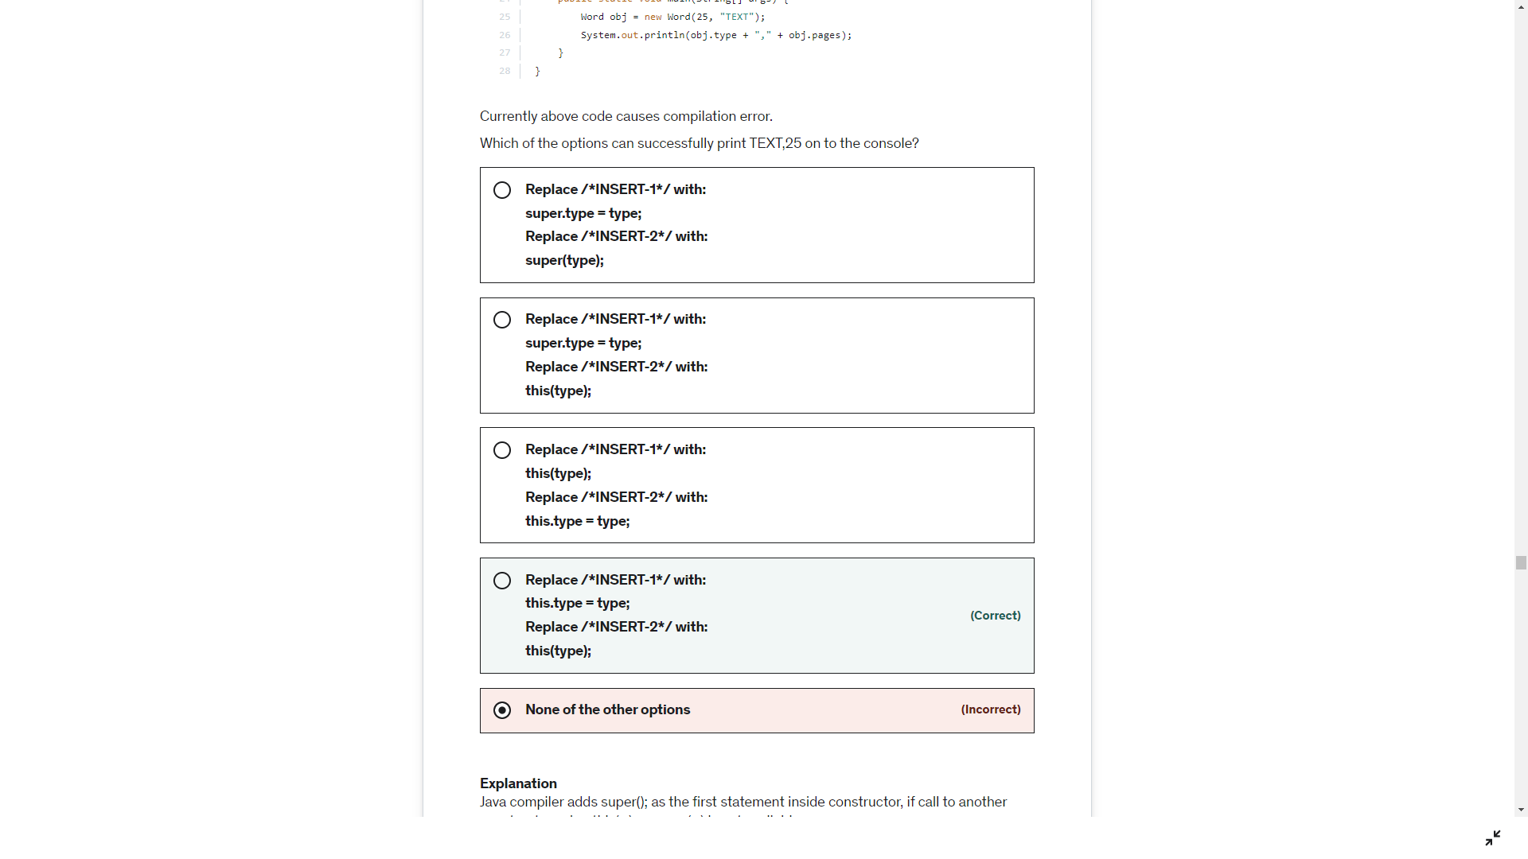

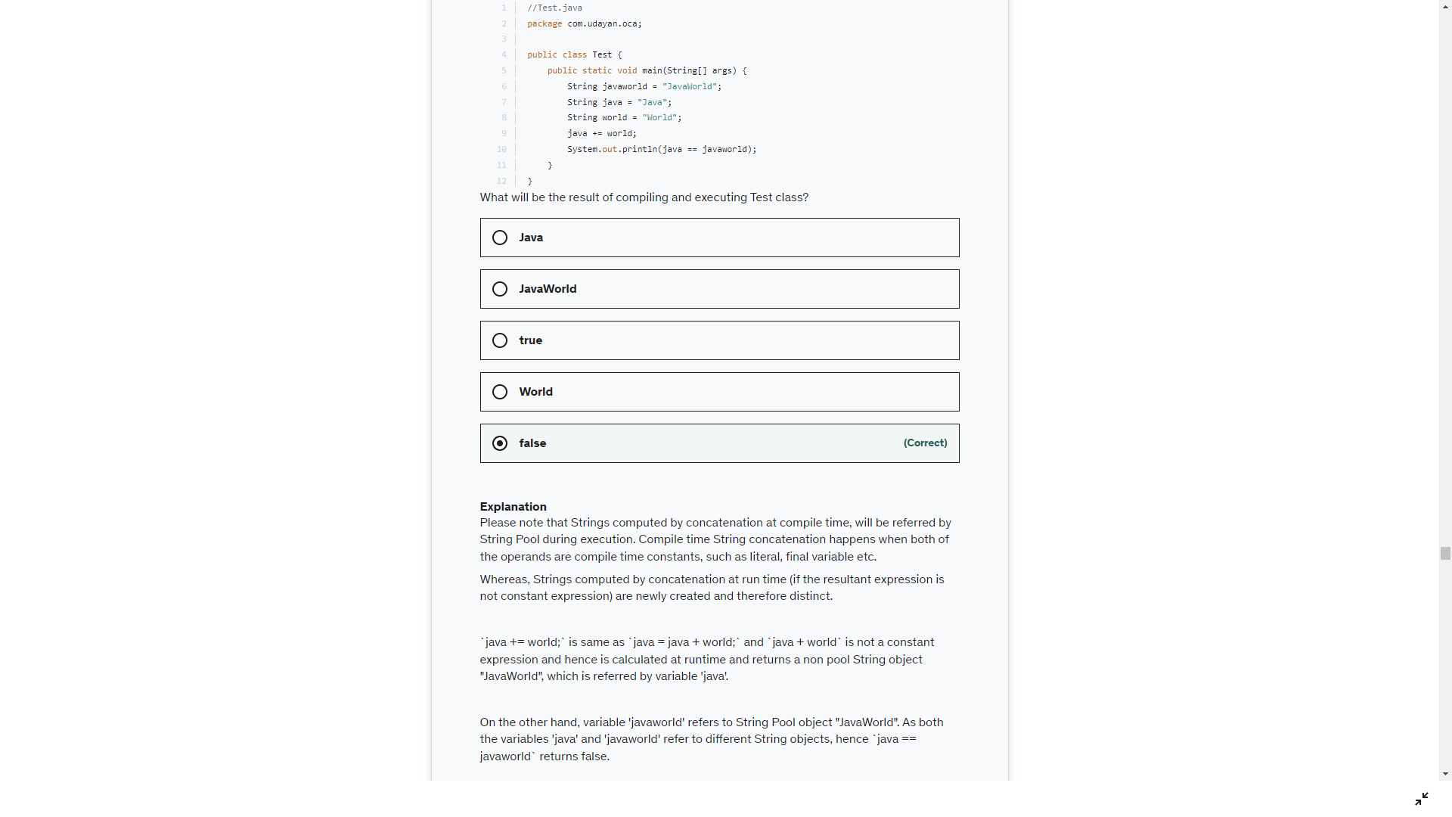

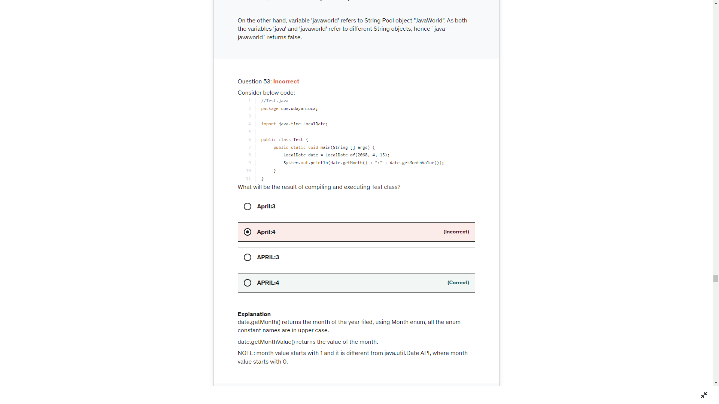

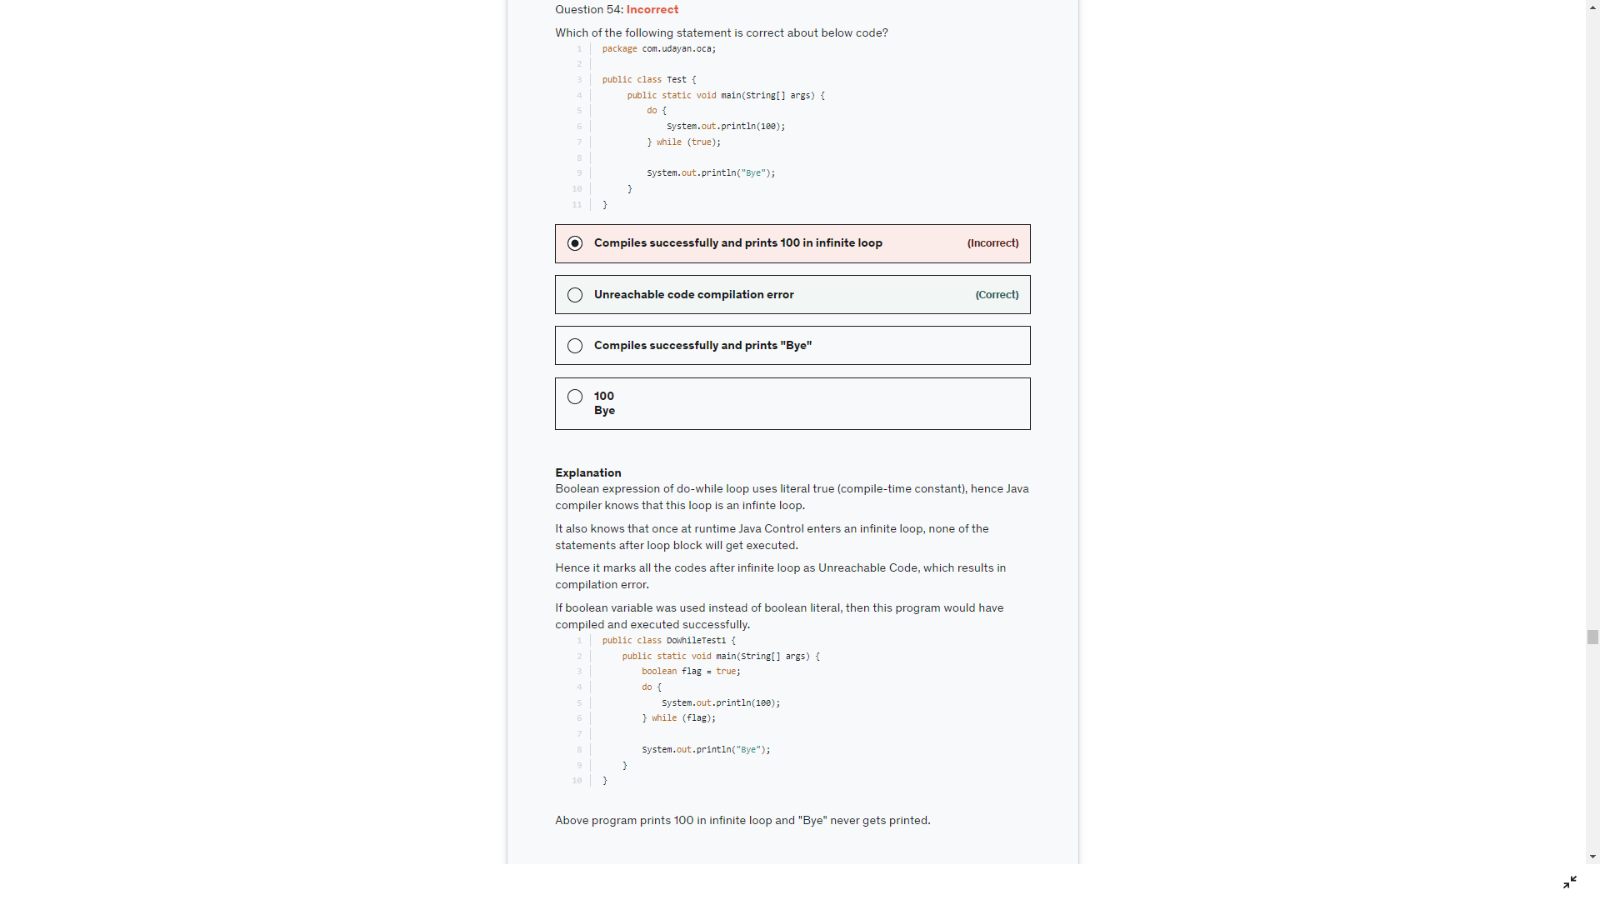

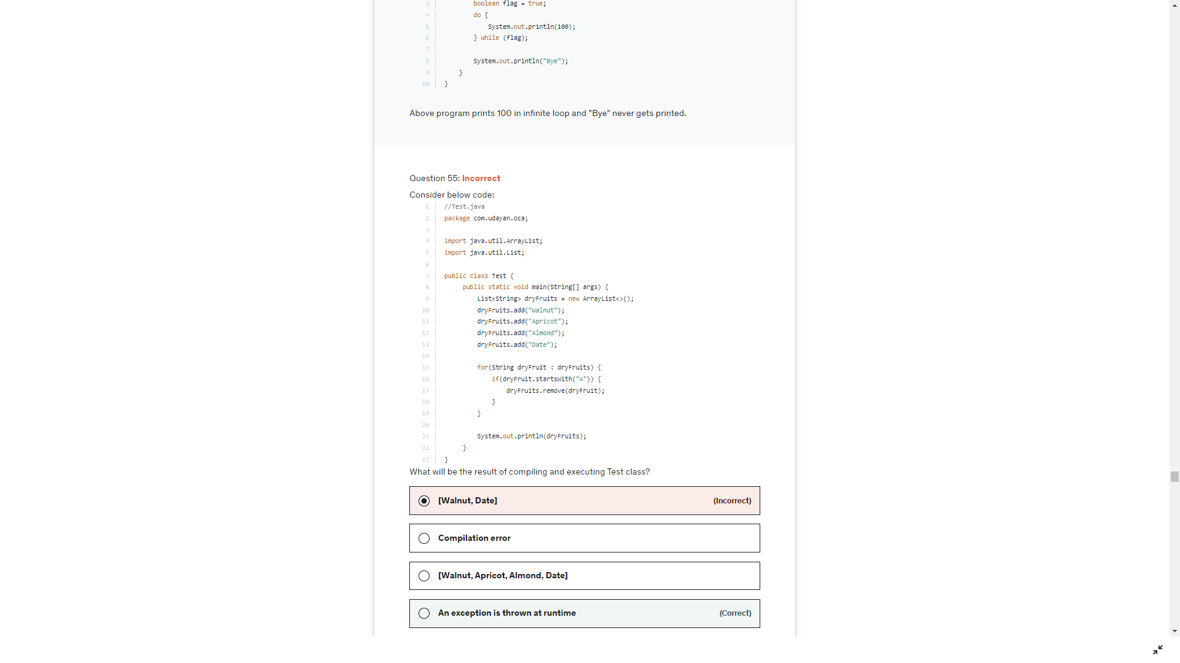

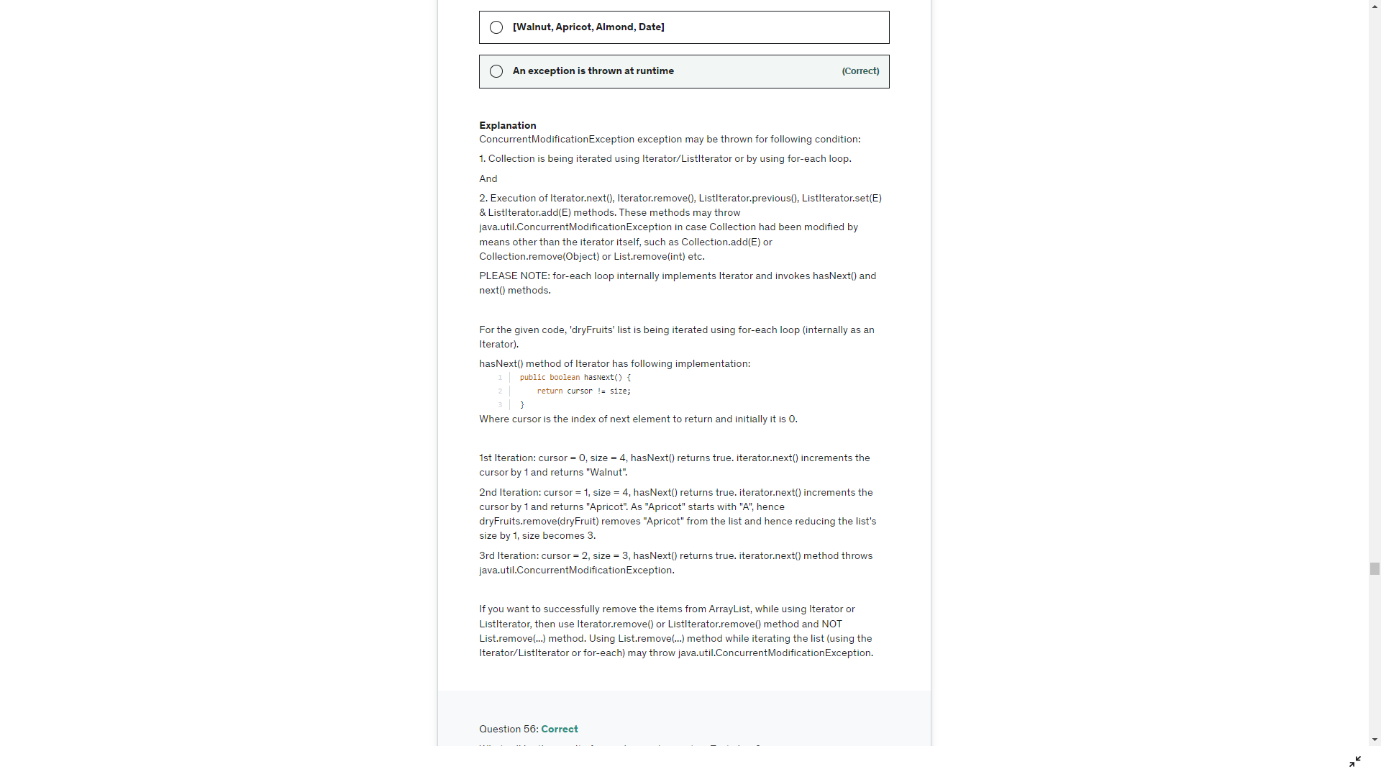

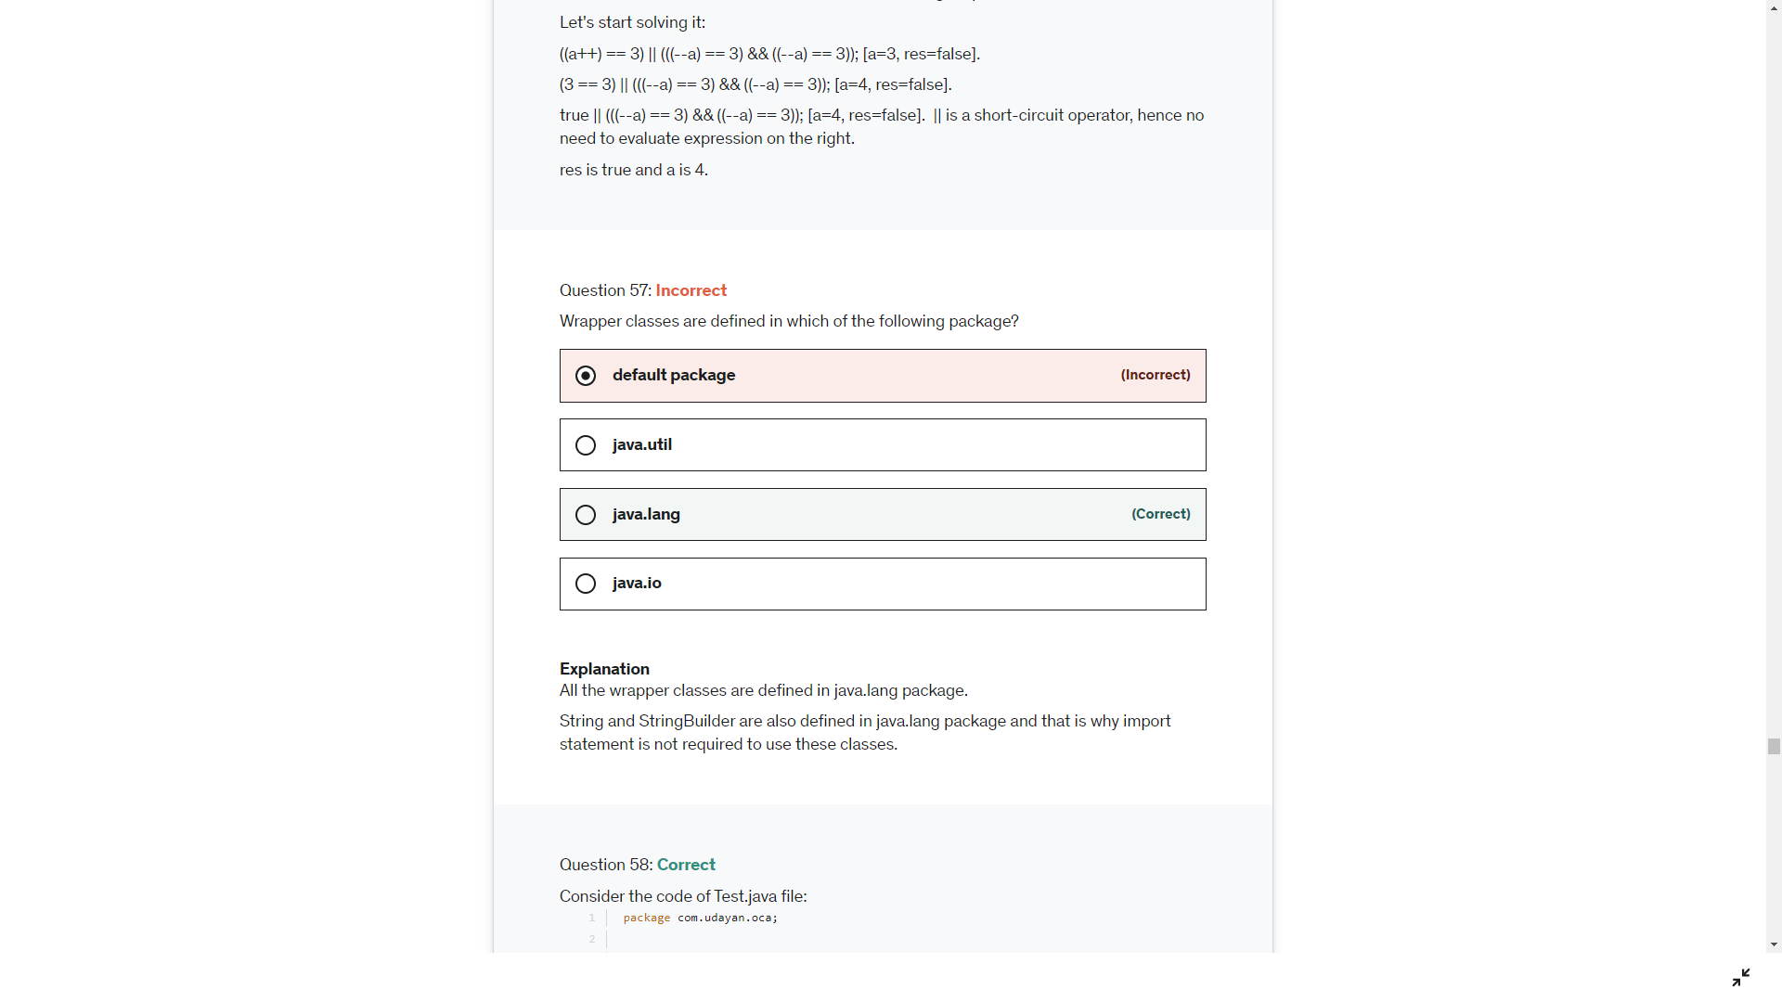

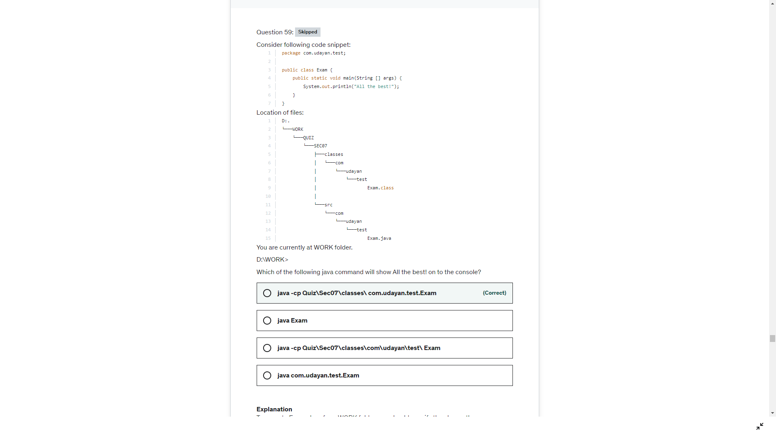

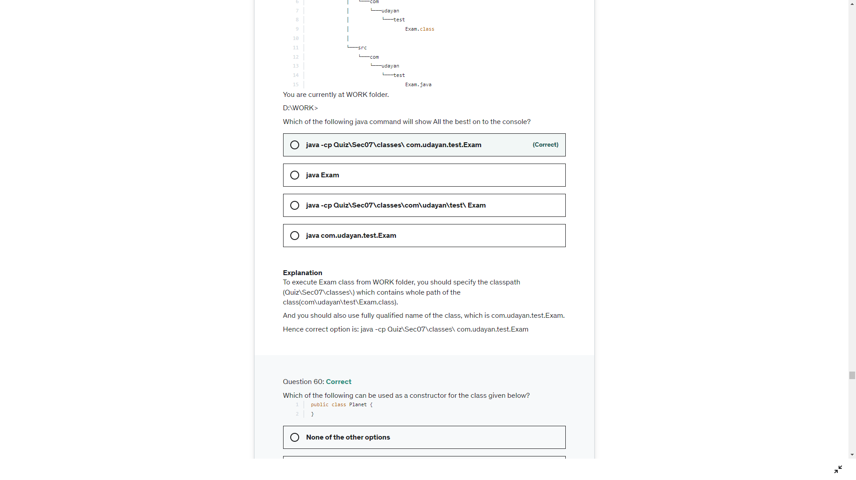

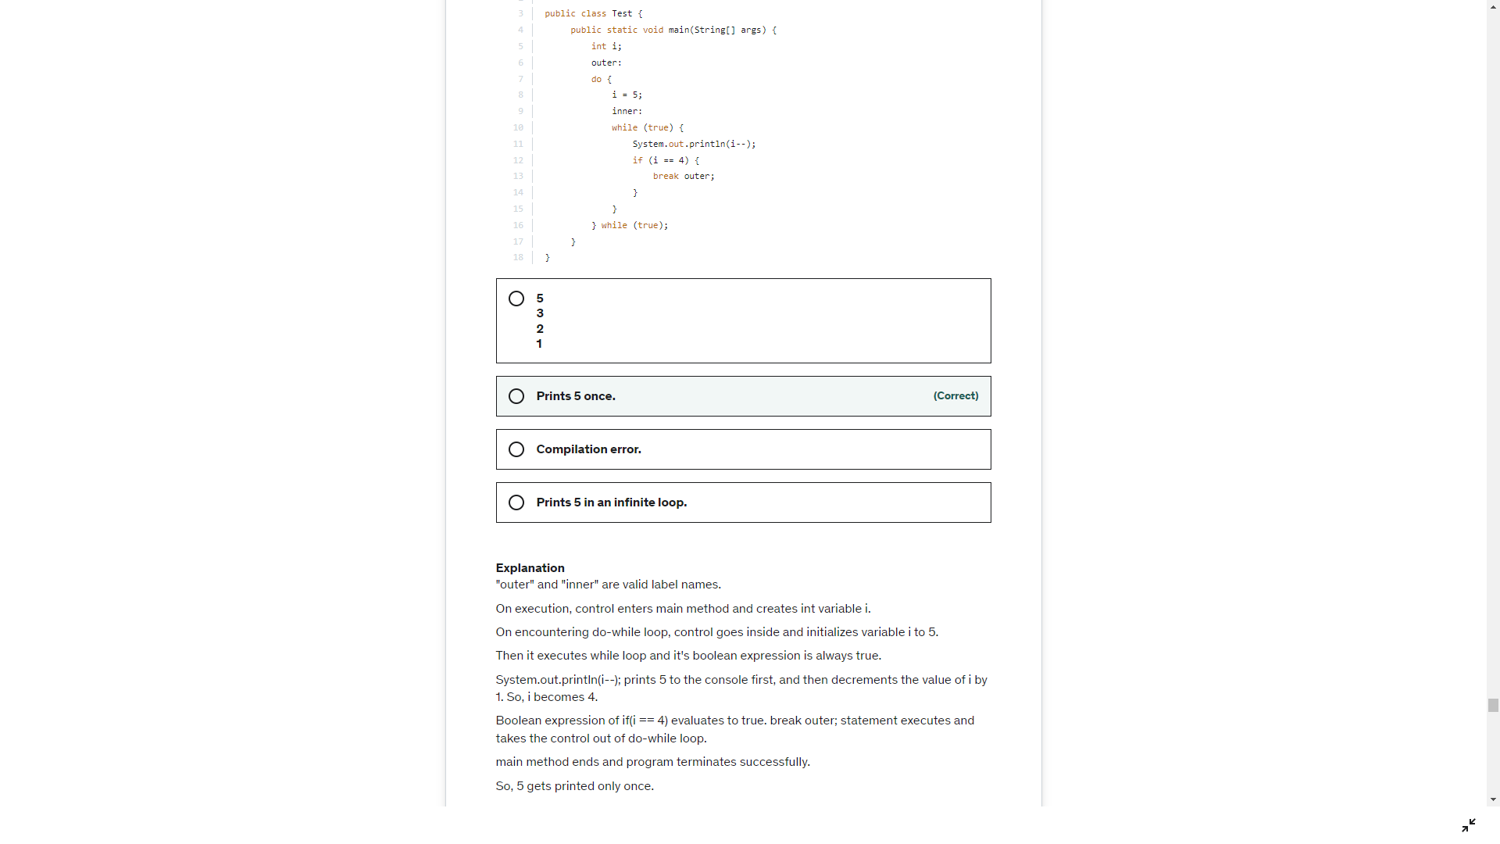

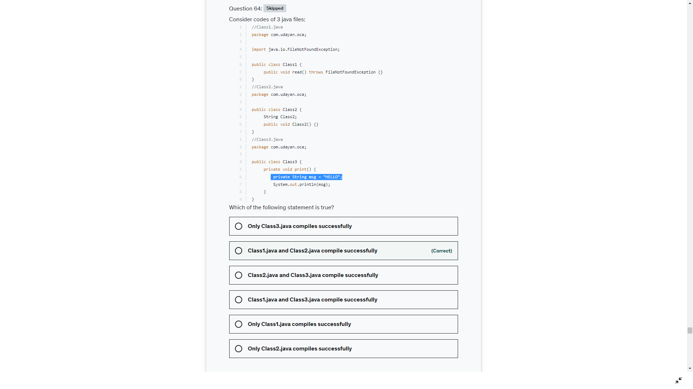

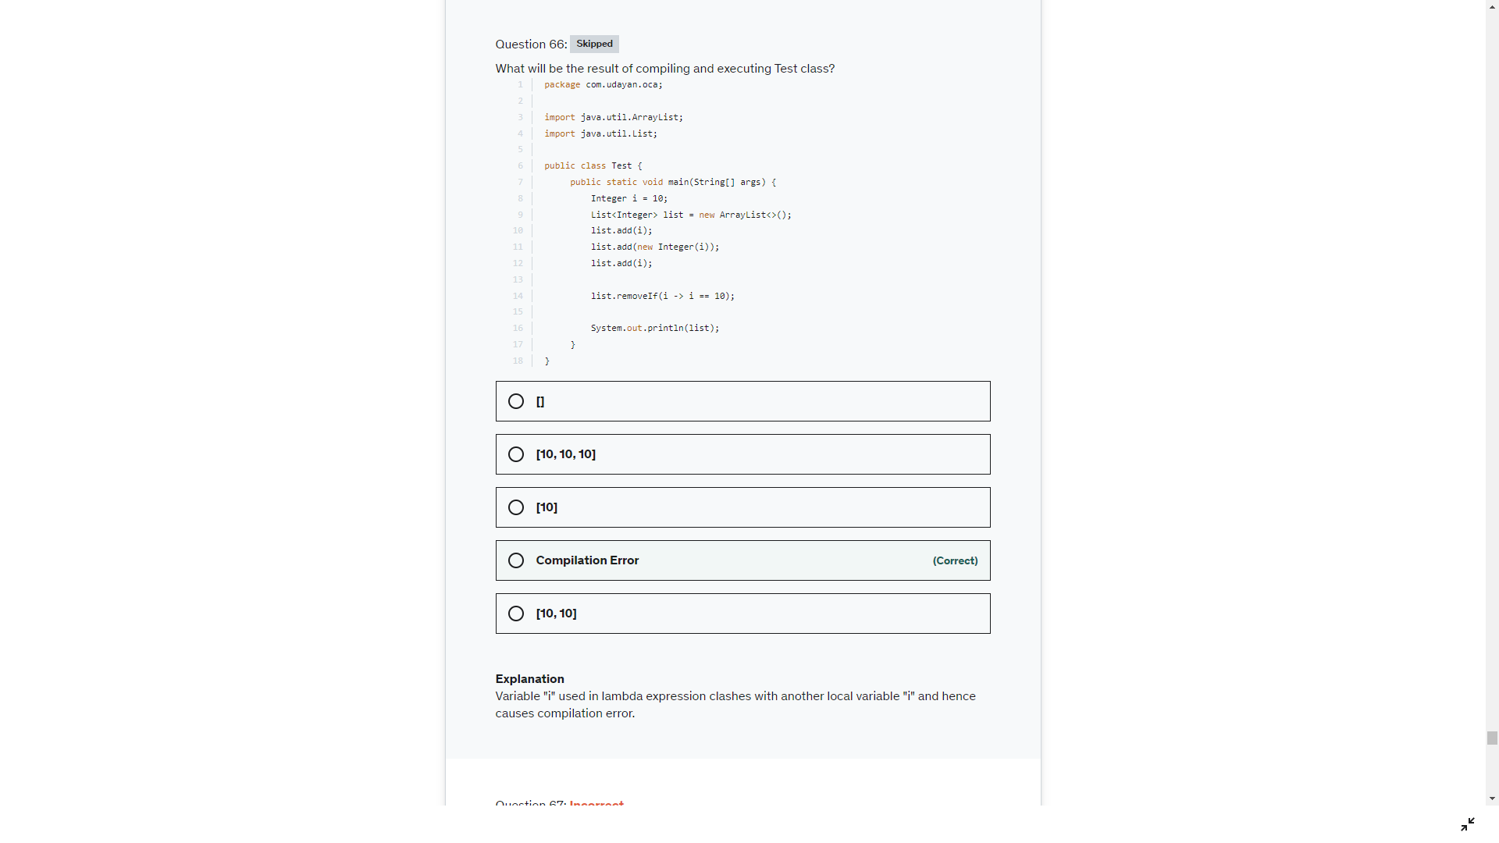

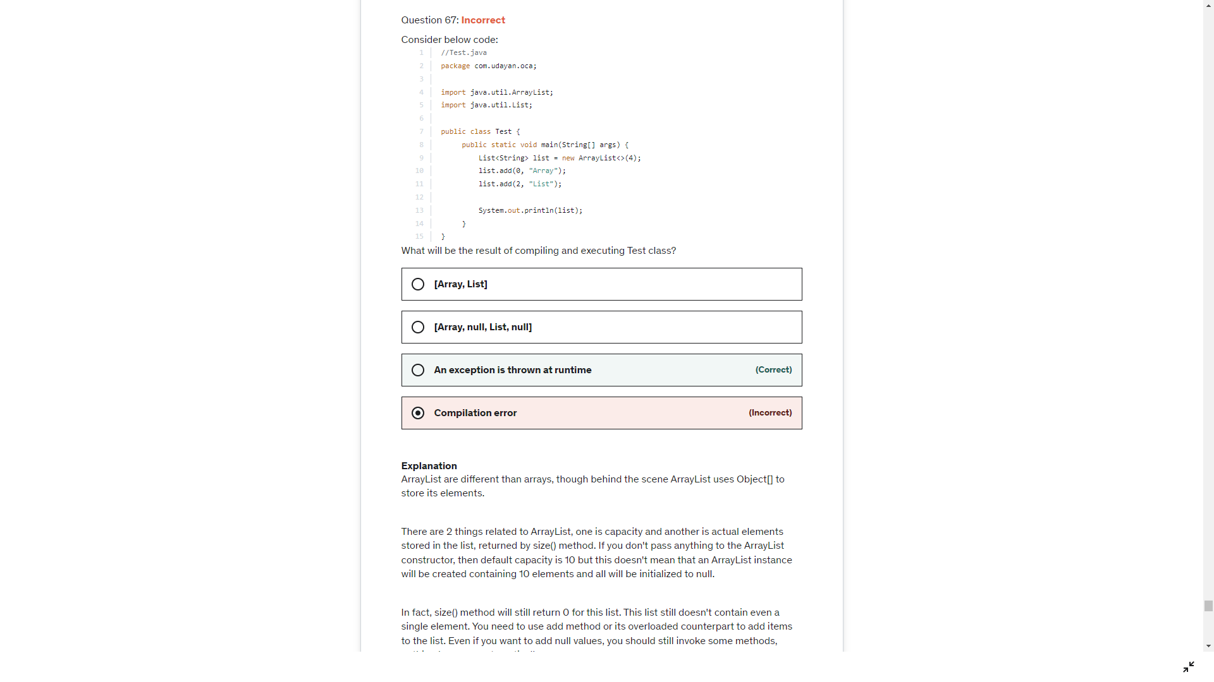

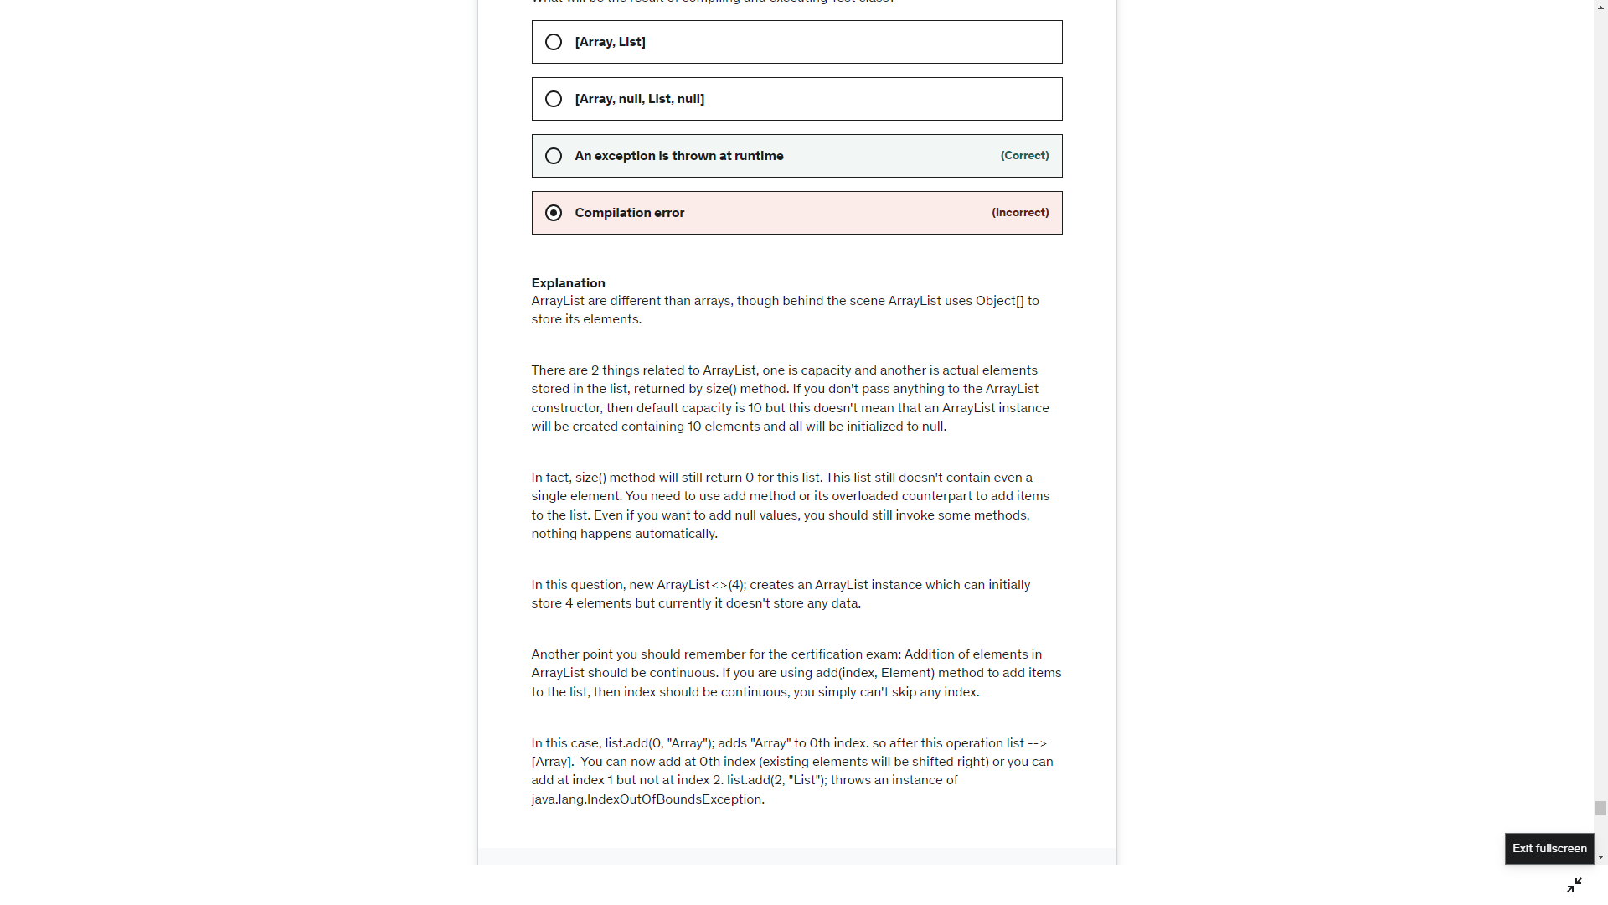

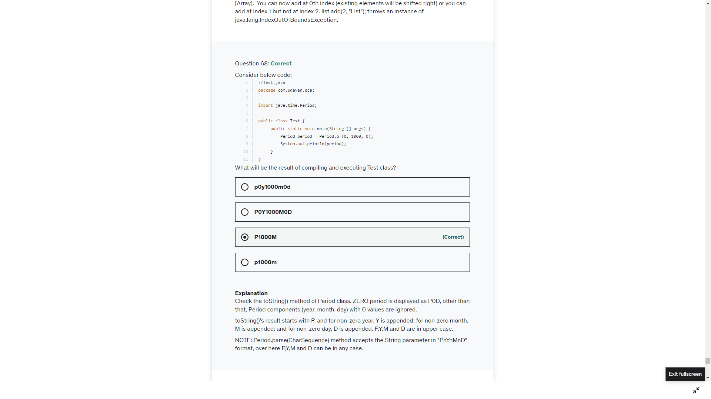

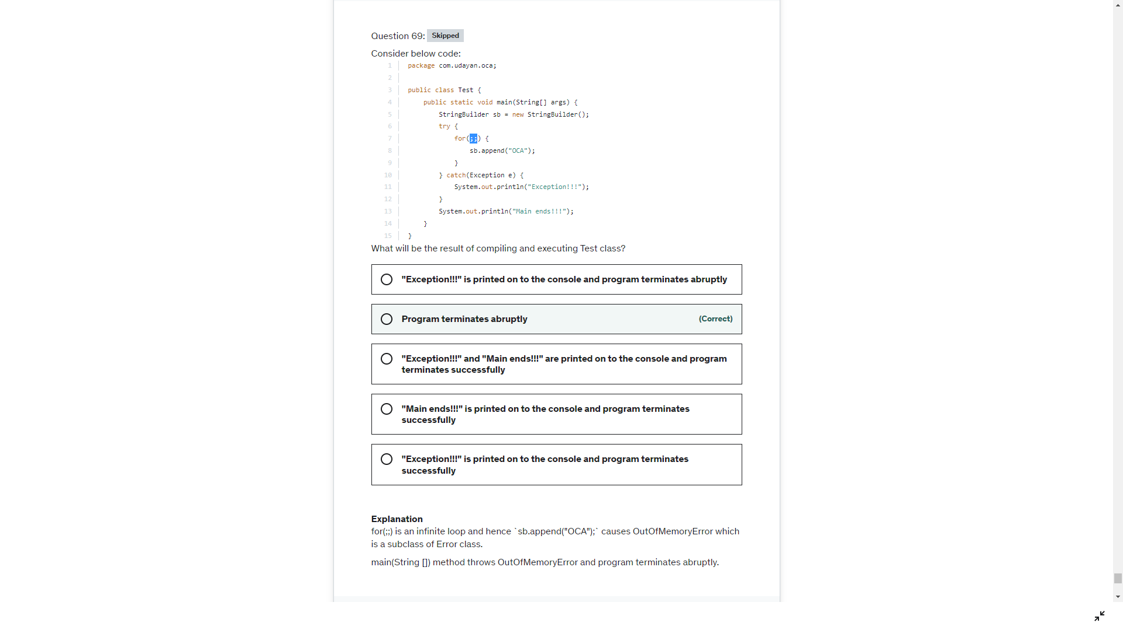

he [String#equals()](https://docs.oracle.com/en/java/javase/17/docs/api/java.base/java/lang/String.html#equals(java.lang.Object)) not only compares the String's contents, but also checks if the other object is also an instance of a String. The [String#contentEquals()](https://docs.oracle.com/en/java/javase/17/docs/api/java.base/java/lang/String.html#contentEquals(java.lang.CharSequence)) only compares the contents (the character sequence) and does **not** check if the other object is also an instance of String. It can be anything as long as it is an implementation of [CharSequence](https://docs.oracle.com/en/java/javase/17/docs/api/java.base/java/lang/CharSequence.html) which covers a.o. [String](https://docs.oracle.com/en/java/javase/17/docs/api/java.base/java/lang/String.html), [StringBuilder](https://docs.oracle.com/en/java/javase/17/docs/api/java.base/java/lang/StringBuilder.html), [StringBuffer](https://docs.oracle.com/en/java/javase/17/docs/api/java.base/java/lang/StringBuffer.html), [CharBuffer](https://docs.oracle.com/en/java/javase/17/docs/api/java.base/java/nio/CharBuffer.html), etc.s

* The equals method has to be reflexive. That means that: x.equals(y) == y.equals(x). This implies that aString.equals(aStringBuffer) would have to be the same as aStringBuffer.equals(aString). This would require the Java API developers to make some special implementation for Strings in the equals() method of StringBuffer, StringBuilder and CharSequence as well. This would be a mess.
* String#contentEquals will throw NPE if the argument supplied is null but String#equals will return false
* String#equals compares the content only when the argument supplied is instance of String otherwise it will return false in all other cases but on the other hand String#contentEquals checks the content of all the objects which implement interface [CharSequence](http://docs.oracle.com/javase/7/docs/api/java/lang/CharSequence.html).



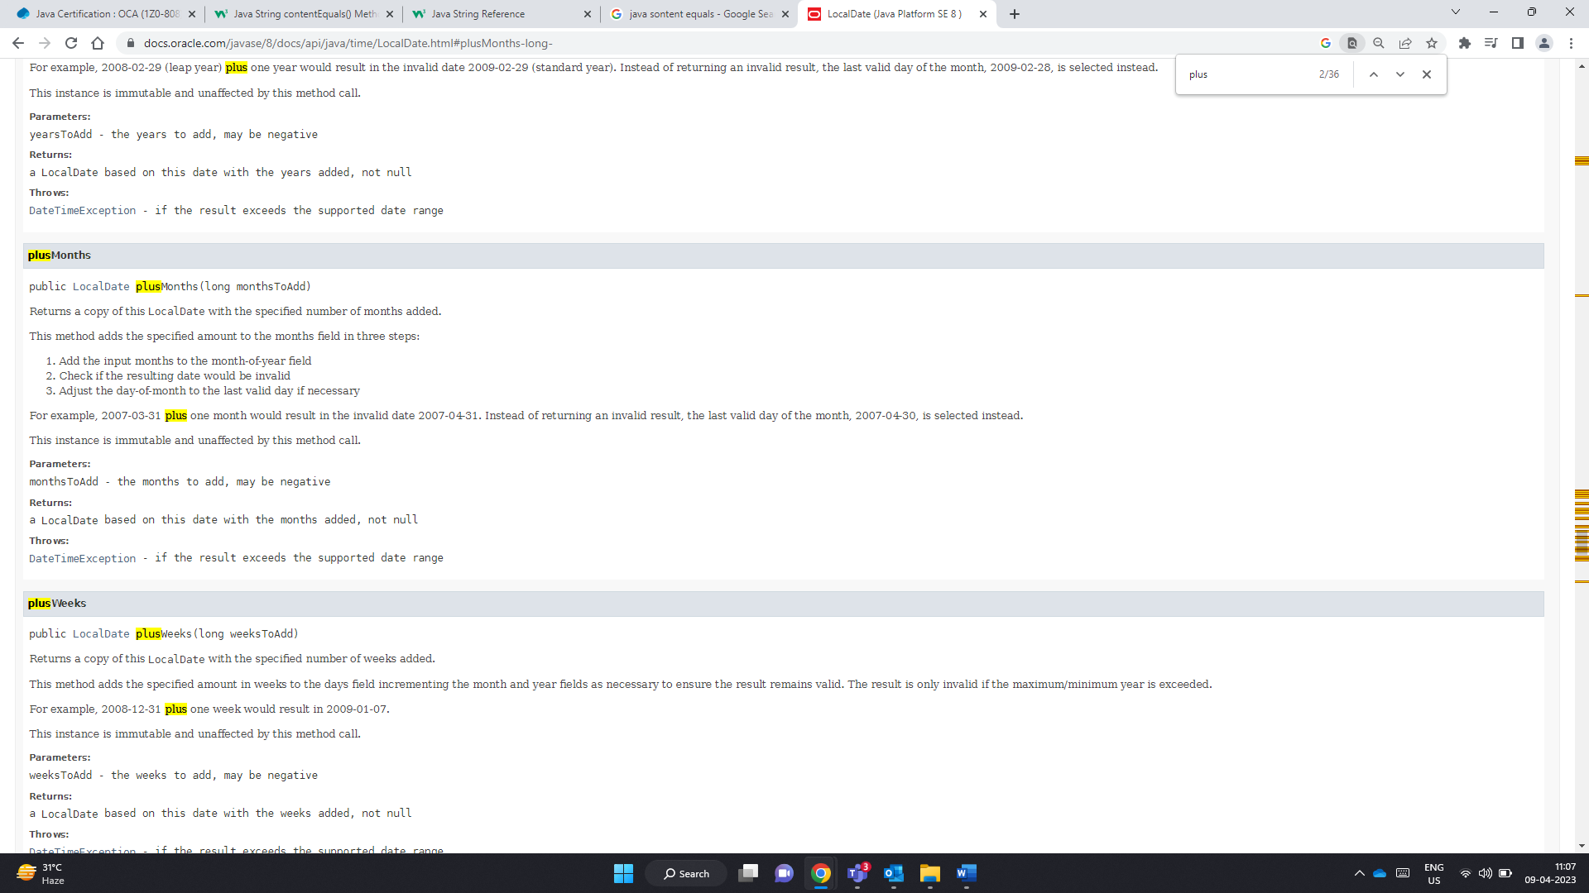

James Gosling – args[0]

Bill Jou - args[1]

Welcome JamesGosling!

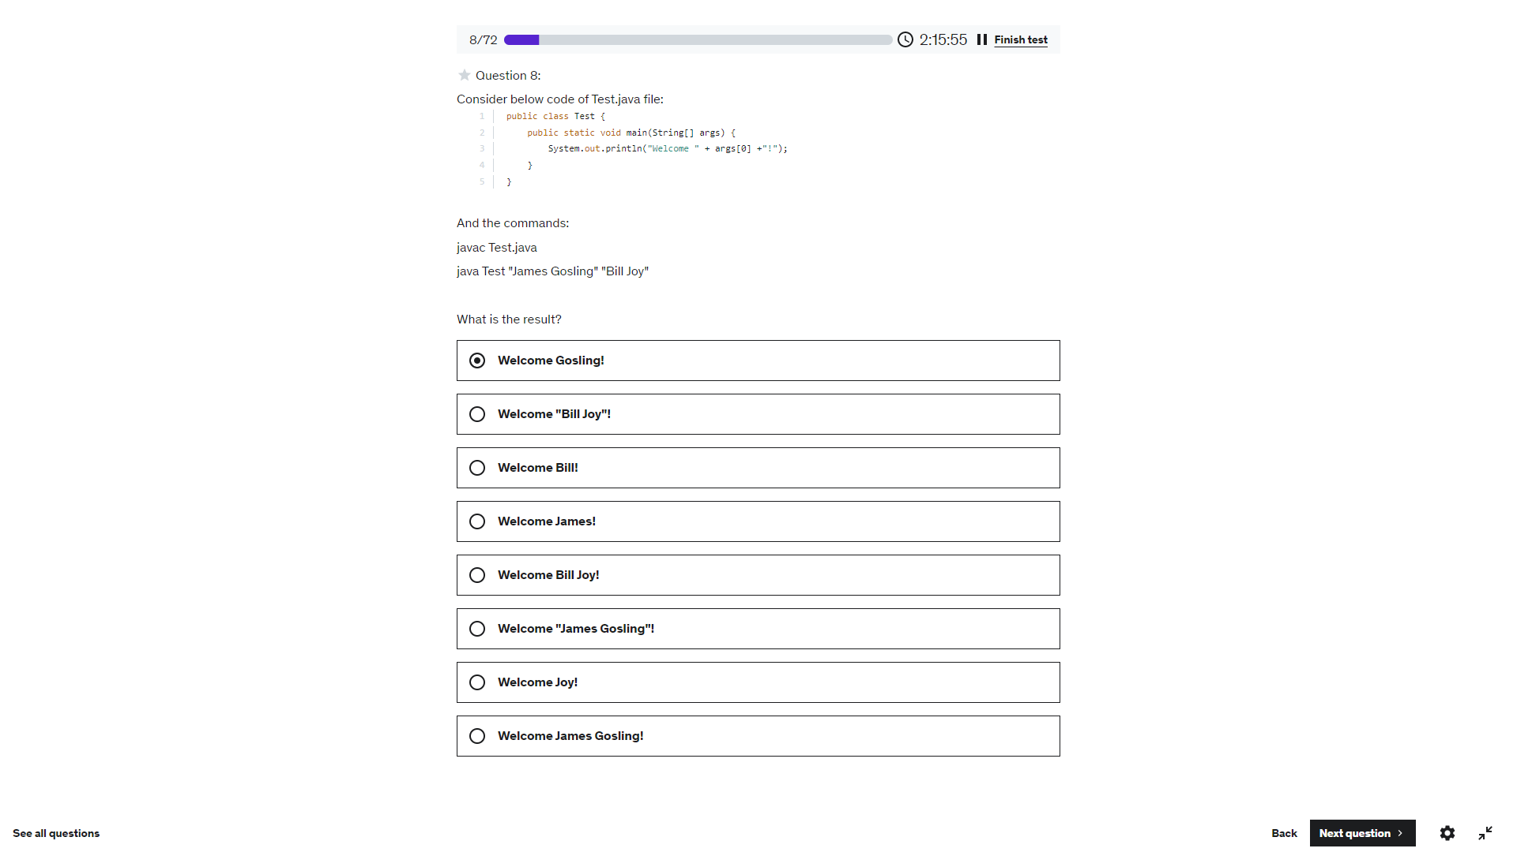

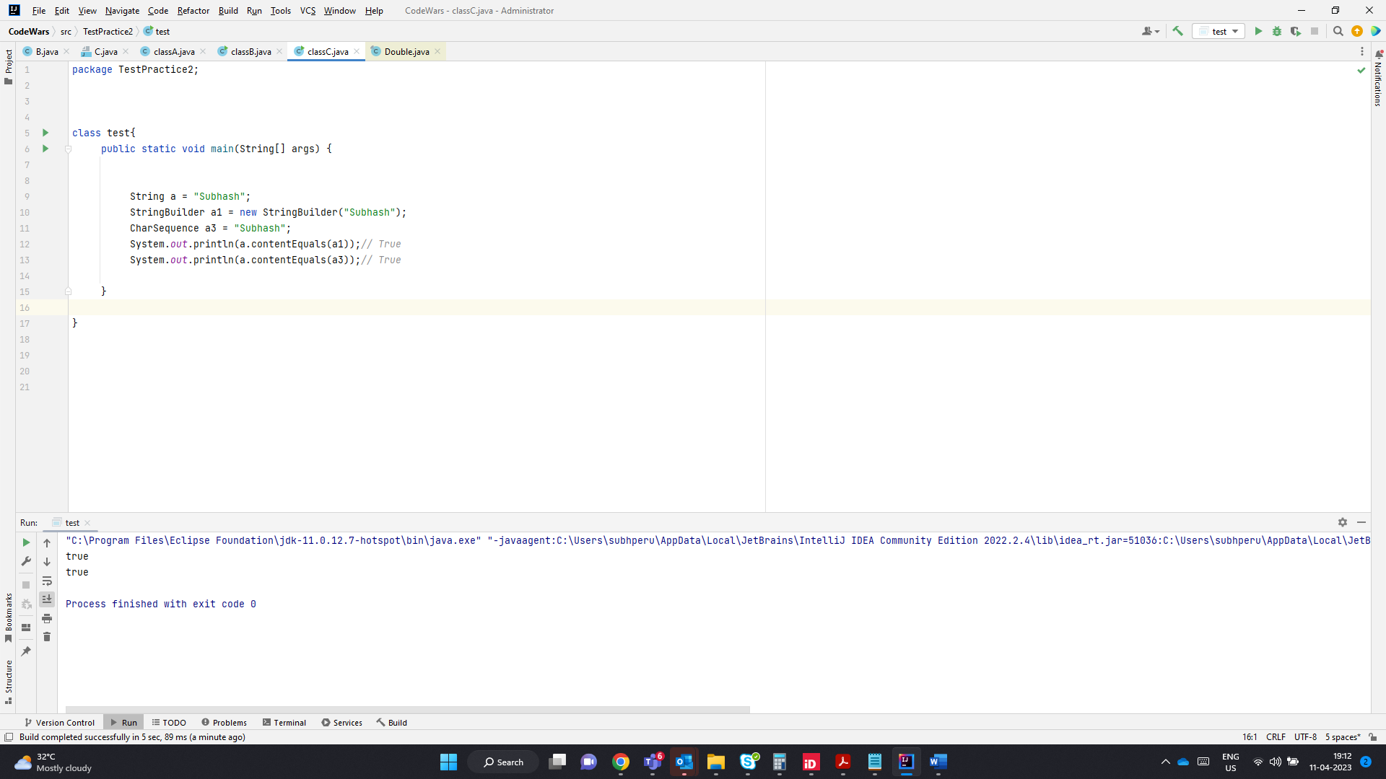

s1.contentEquals(s2): String class contains two methods: contentEquals(StringBuffer) and contentEquals(CharSequence). Please note that String, StringBuilder and StringBuffer classes implement CharSequence interface, hence contentEquals(CharSequence) method defined in String class can be invoked with the argument of either String or StringBuilder or StringBuffer. In this case, it is invoked with String argument and hence it is comparing the contents of two String objects. This method also takes character's case into account while matching. As String objects referred by s1 and s2 have different cases, hence output is false.

Look at the upper() method- should be toLowerCase() toUpperCase()

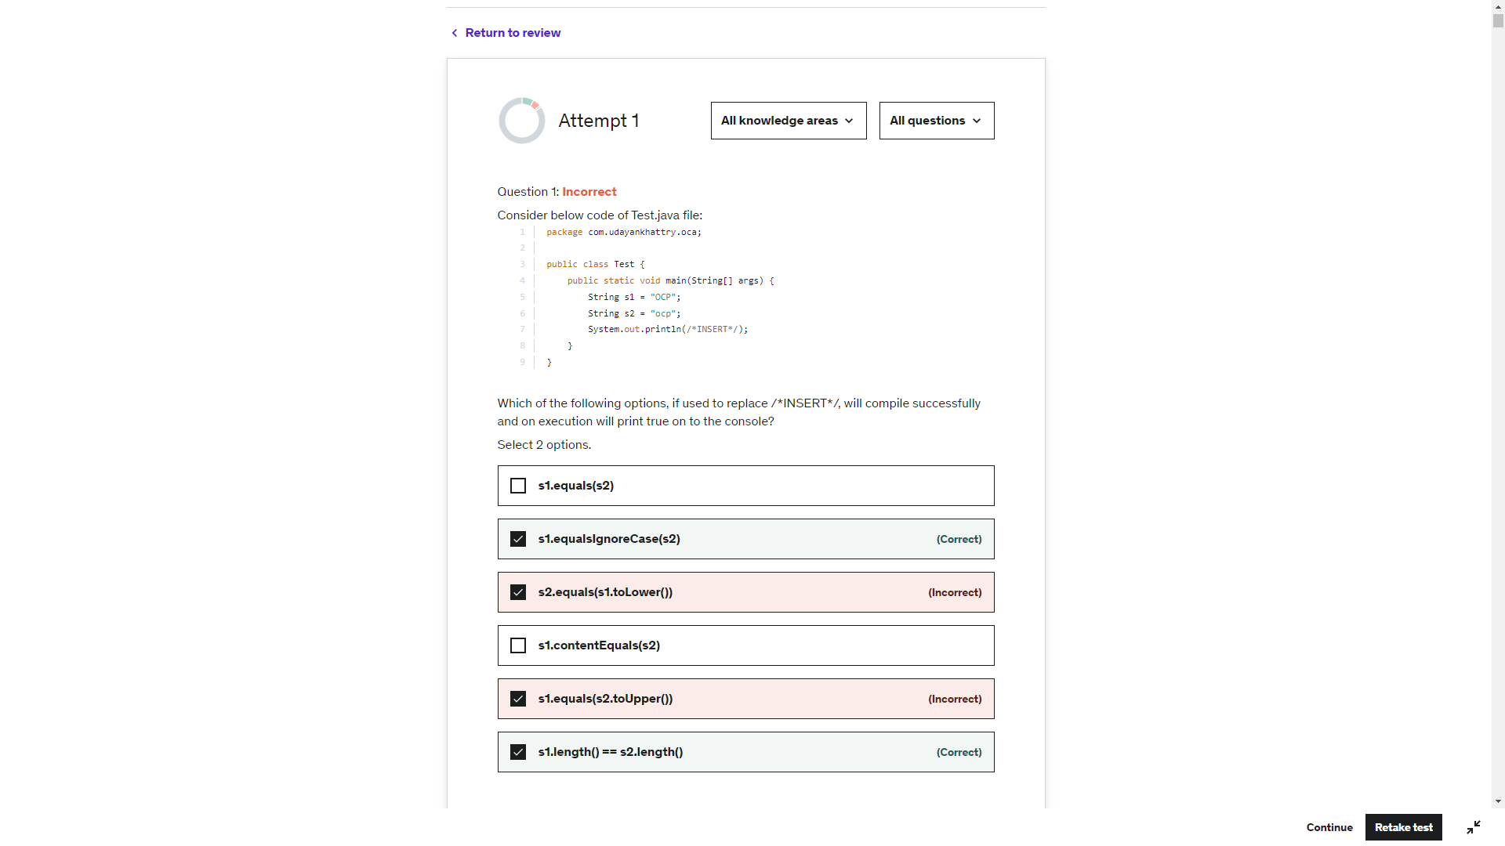

The default constructor is a **public** no arguments constructor. To be more specific it has the same access level as the class, so public in a public class, private in a private class, etc.

In your second example you are creating a package access level constructor.

This means that anyone outside of the same package will be able to see and use instances of the class (since it is a public class) but not create new ones.

Because you have defined a constructor the default constructor will not be created.

Just having no arguments does not make something a default constructor. A default constructor is added automatically by the compiler, you have no code at all for it.

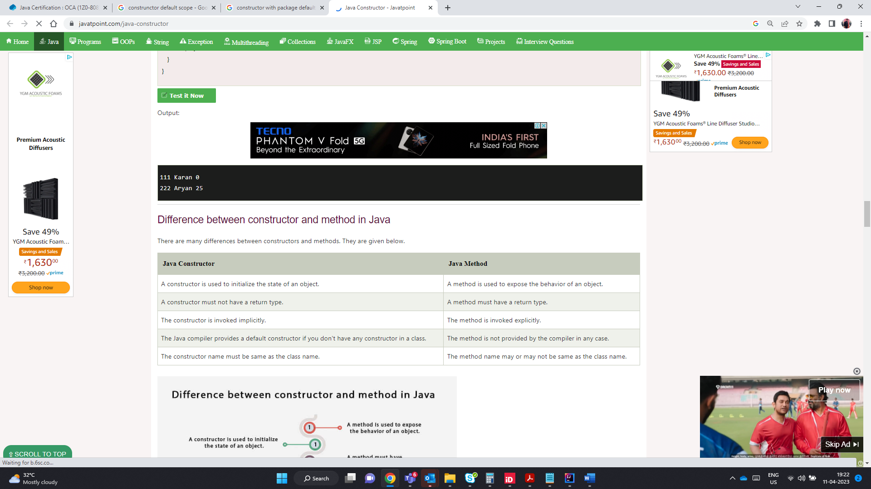

A public class is visible outside the package. A default constructor has a public access and is visible outside the package

If the class is public and the user defined constructors are default,then its not visible to the classes outside the package. Even using super keyword.

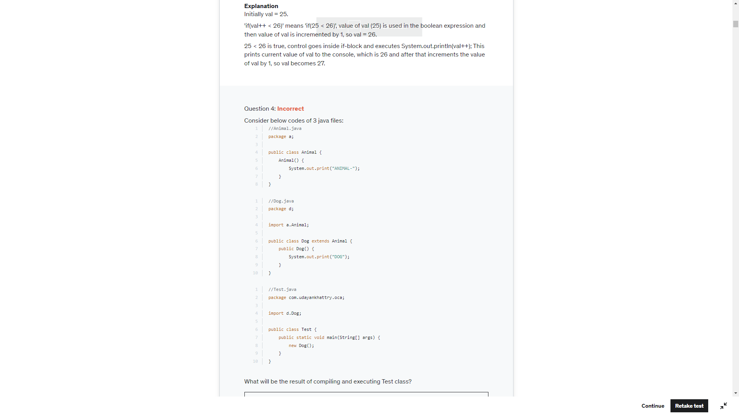

super(); is added by the compiler as the first statement in both the constructors:

Animal() {

    super();

    System.out.print("ANIMAL-");

}

public Dog() {

    super();

    System.out.print("DOG");

}

Class Animal extends from Object class and Object class has no-argument constructor, hence no issues with the constructor of Animal class.

Animal class's constructor has package scope, which means it is accessible to all the classes declared in package 'a'. But Dog class is declared in package 'b' and hence `super();` statement inside Dog class's constructor causes compilation error as no-argument constructor of Animal class is not visible.

There is no compilation error in Test.java file as Dog class's constructor is public and therefore `new Dog();` compiles successfully

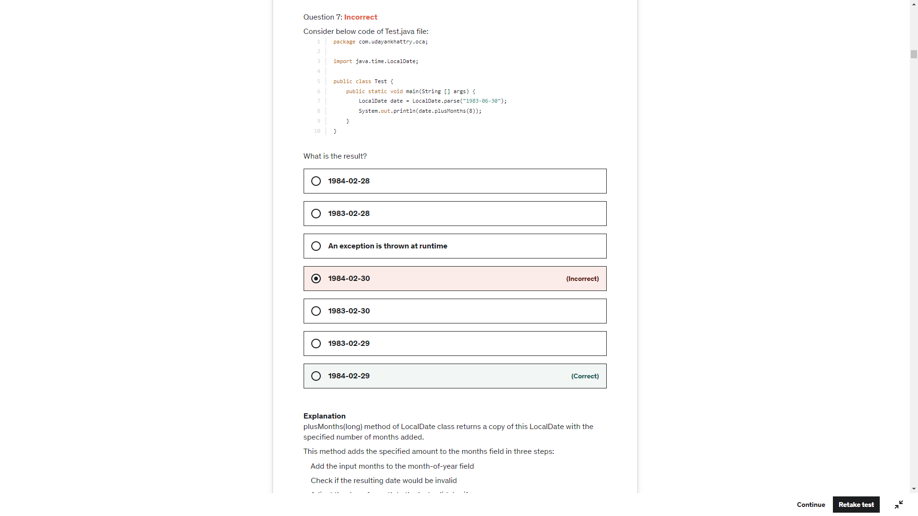

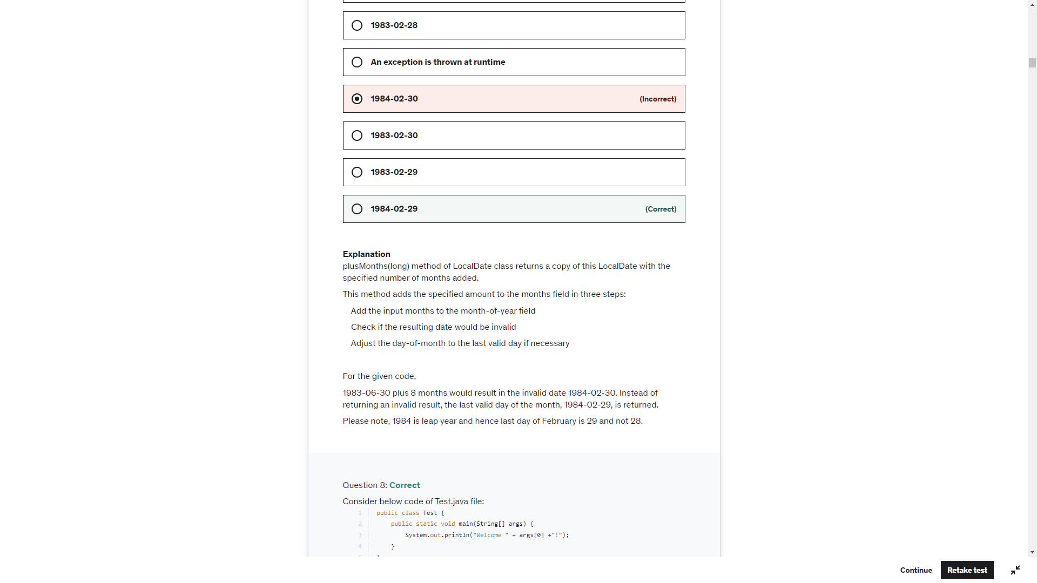

Sout(args[0]))-> Array Index out of Bound Exception

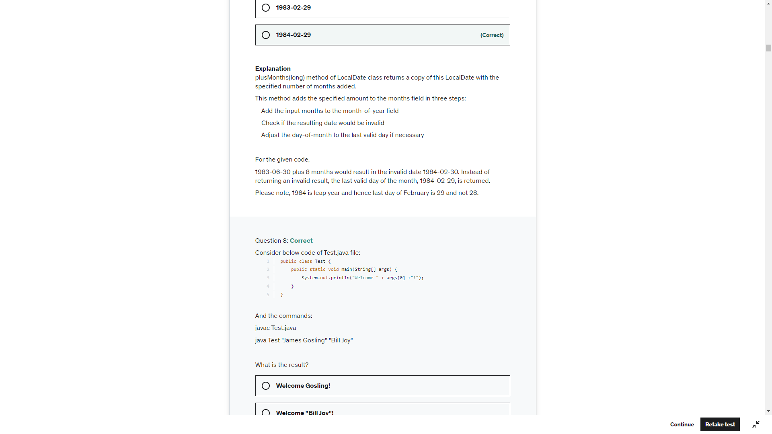

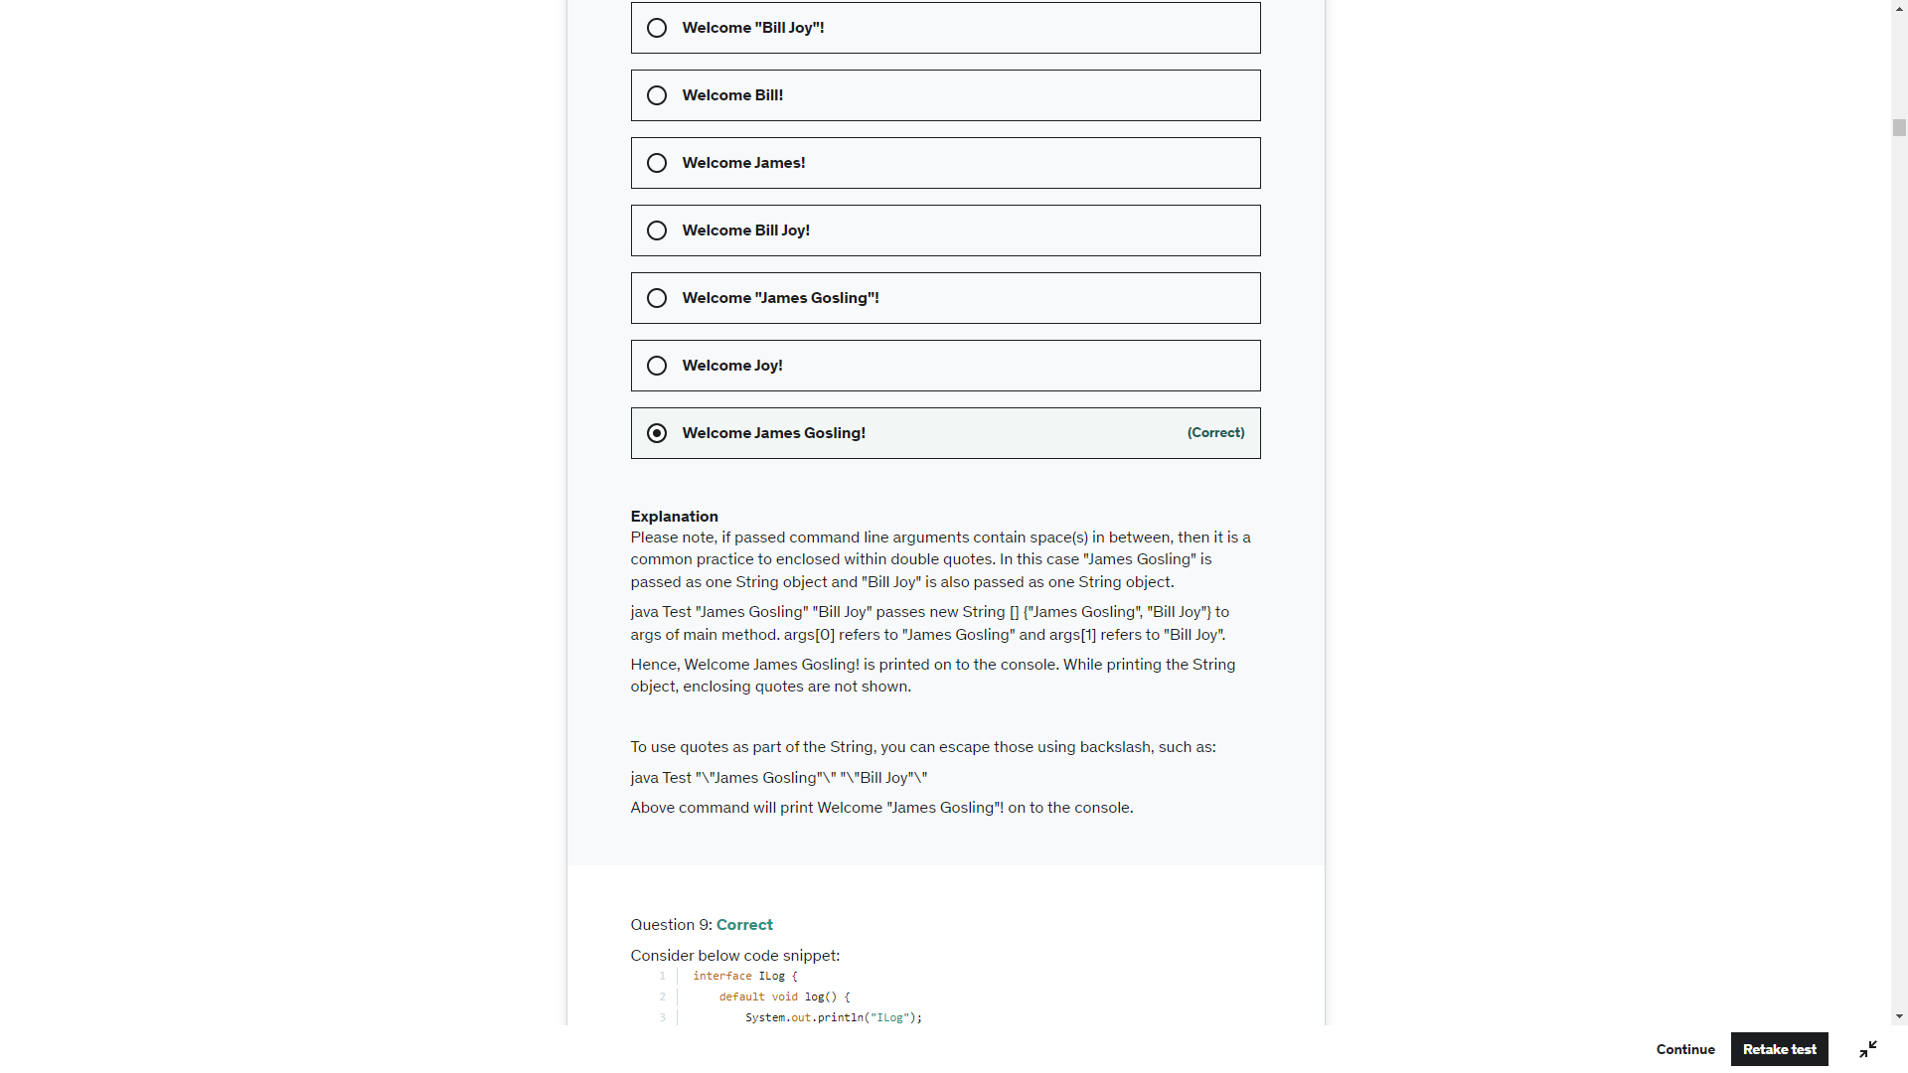

Static and Non-Static methods are not allowed in 1 scope. So, line 12 throws CE

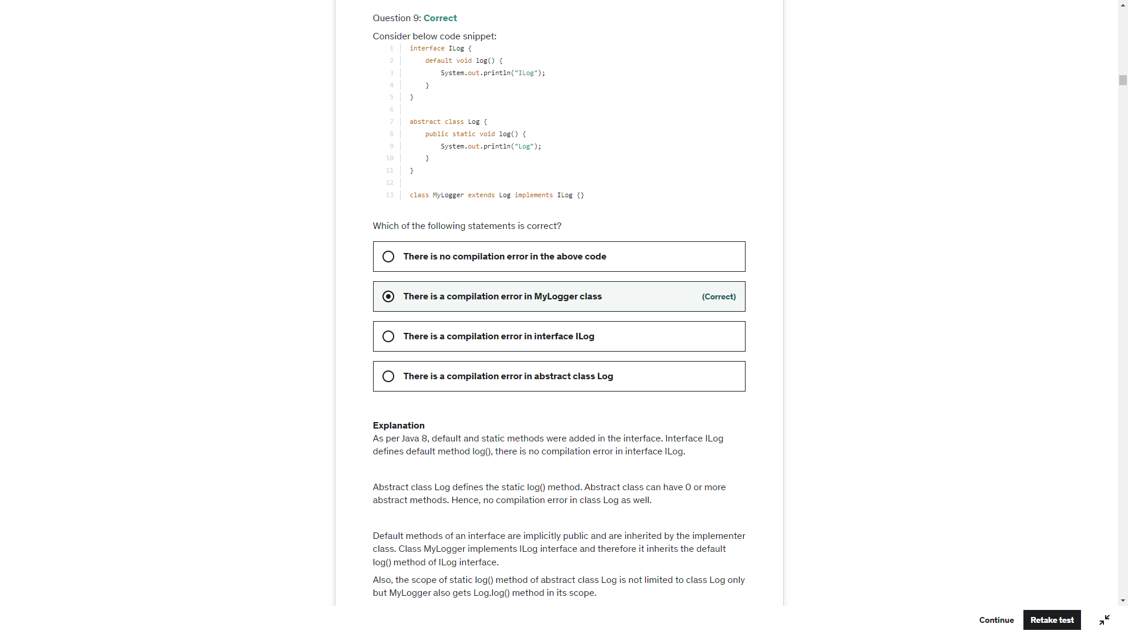

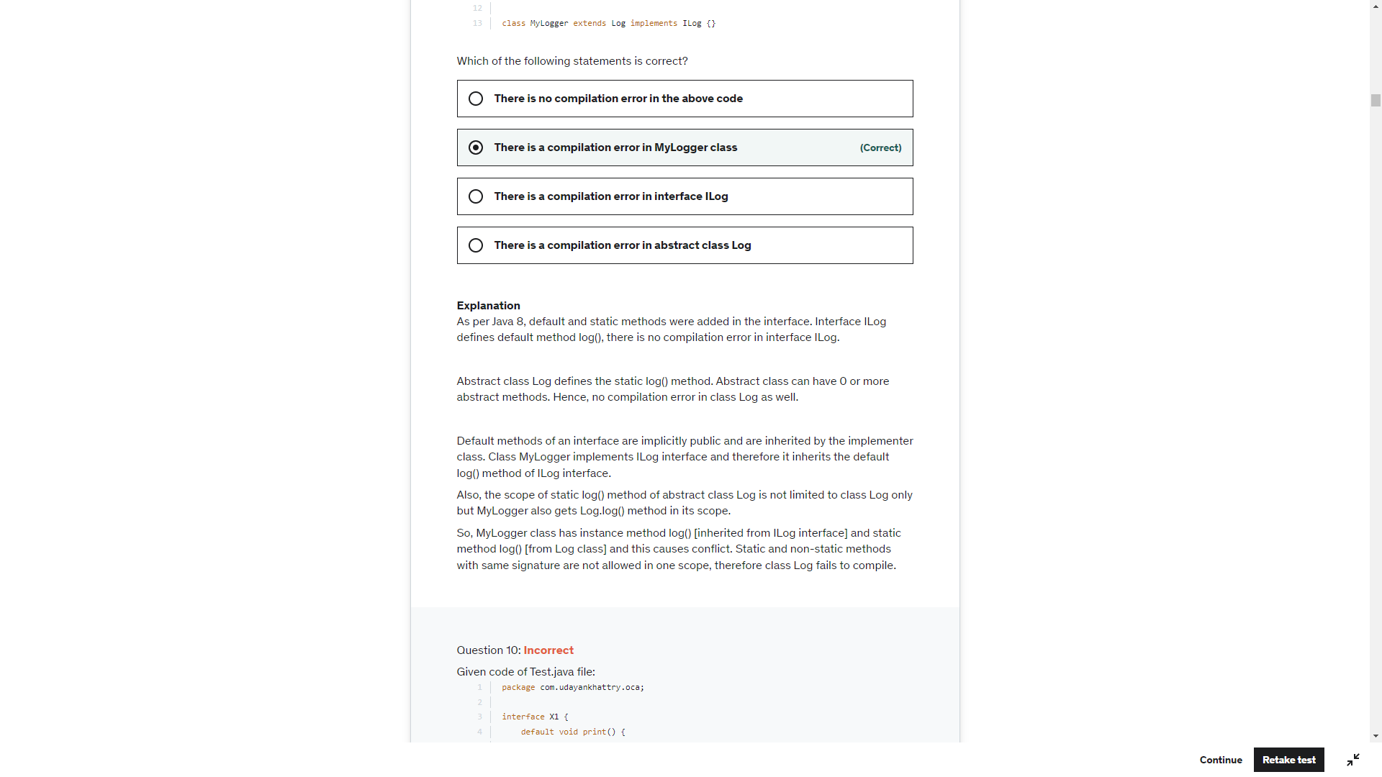



### **Can we override a static method?**

**No,** we cannot override static methods because method overriding is based on dynamic binding at runtime and the static methods are bonded using static binding at compile time. So, we cannot override static methods.

The calling of method depends upon the type of object that calls the static method. It means:

* If we call a static method by using the parent class object, the original static method will be called from the parent class.
* If we call a static method by using the child class object, the static method of the child class will be called.

In the following example, the ParentClass has a static method named display() and the ChildClass also has the same method signature. The method in the derived class (ChildClass) hides the method in the base class. let's see an example.



Static method is resolved during compilation and not at run time so Parent method is called

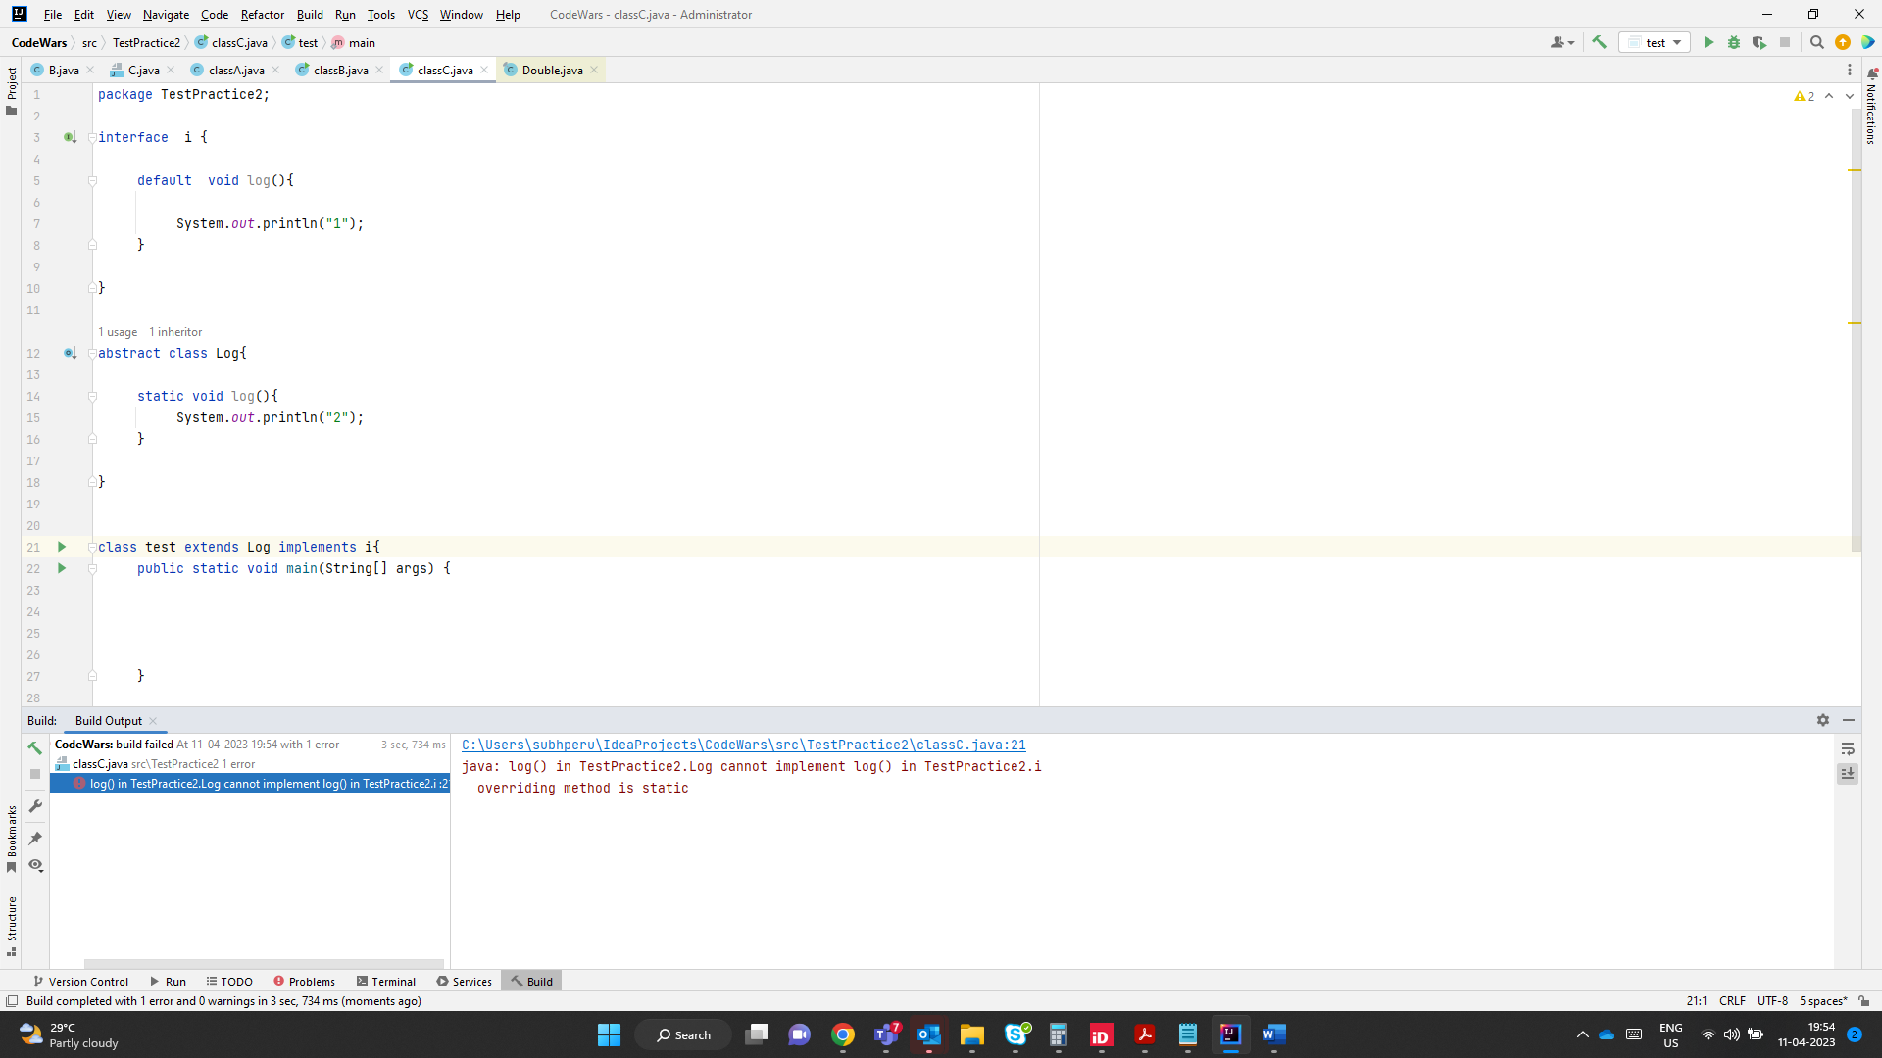

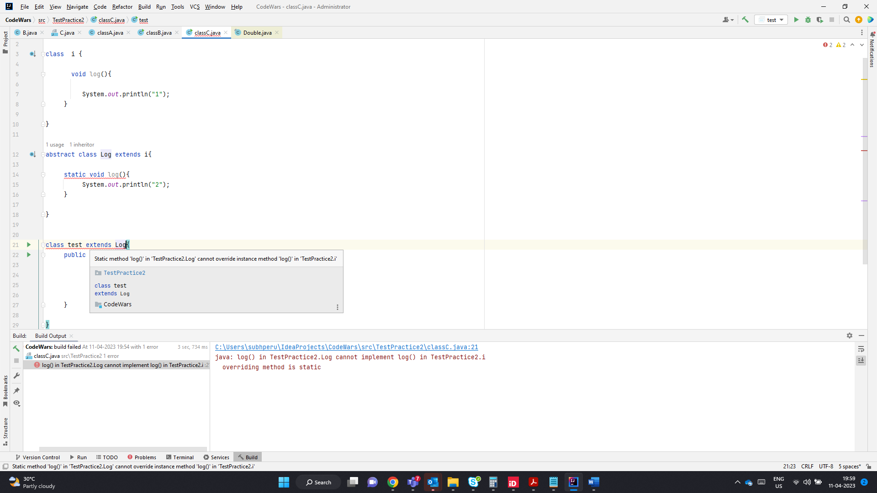

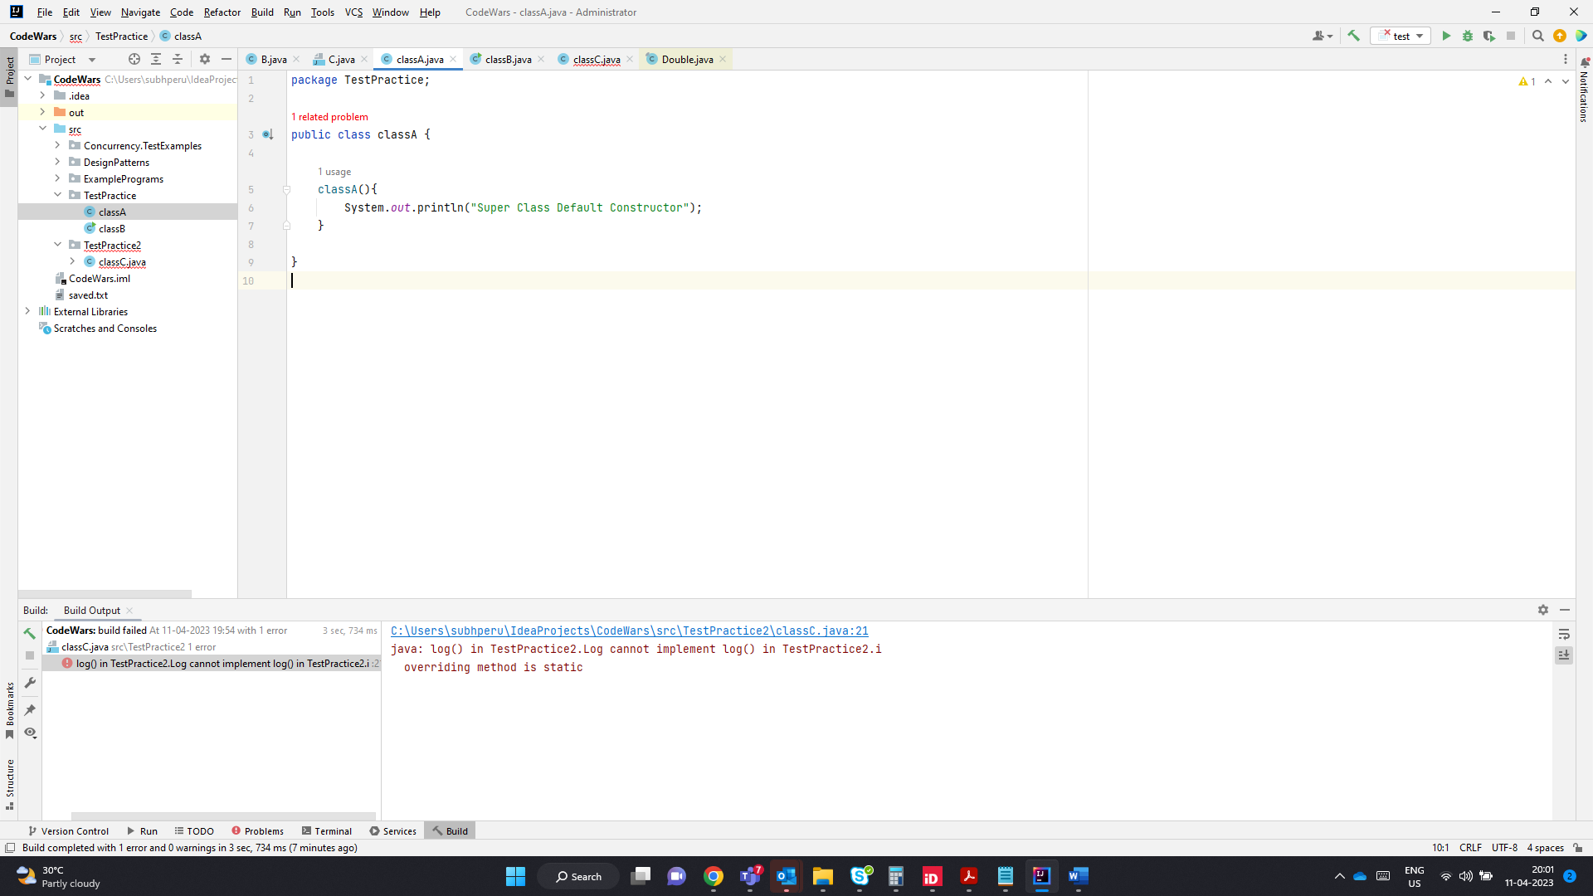

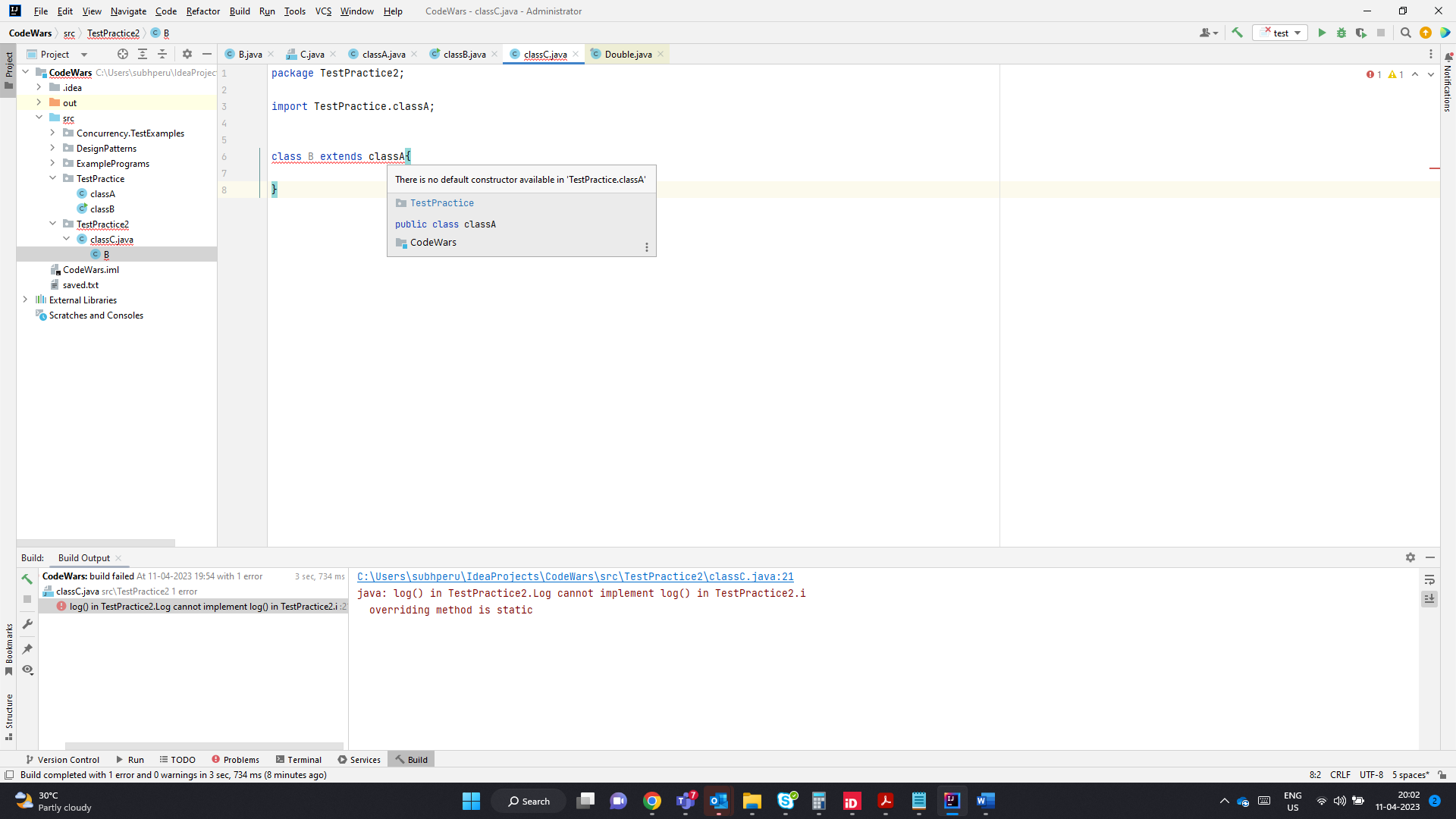

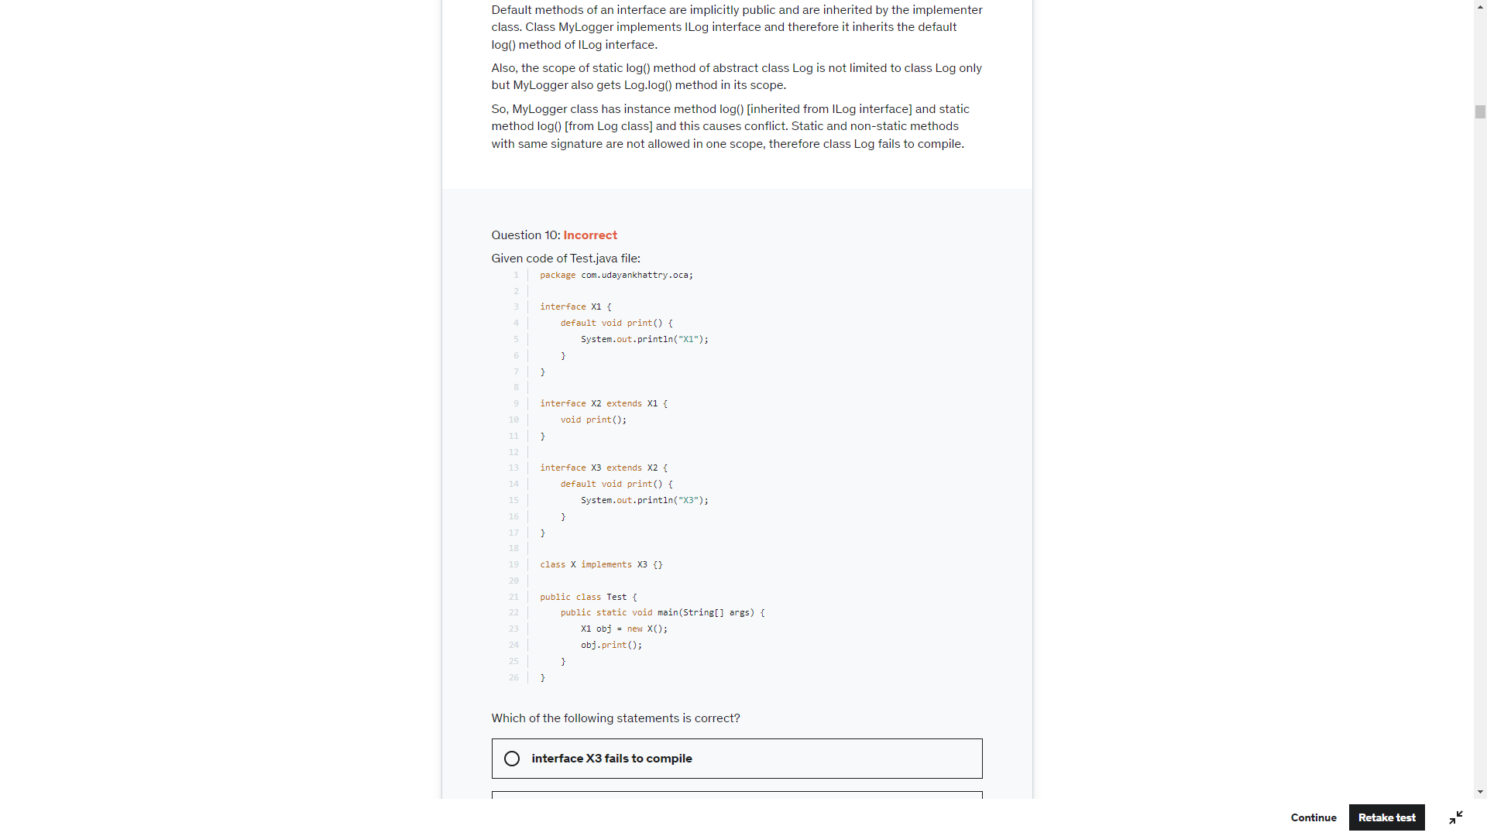

An interface in java can override default method of super type with abstract modifier.

X2 has an implicit public abstract modifier which is valid

An interface in java can override an Abstract method with default modifier. So X3 is proper overriding

Class X implements X3 and it does not have any abstract method to be implemented so X is also right

X1 obj = new X();

Obj.print() calls the default method in X3 and prints X3

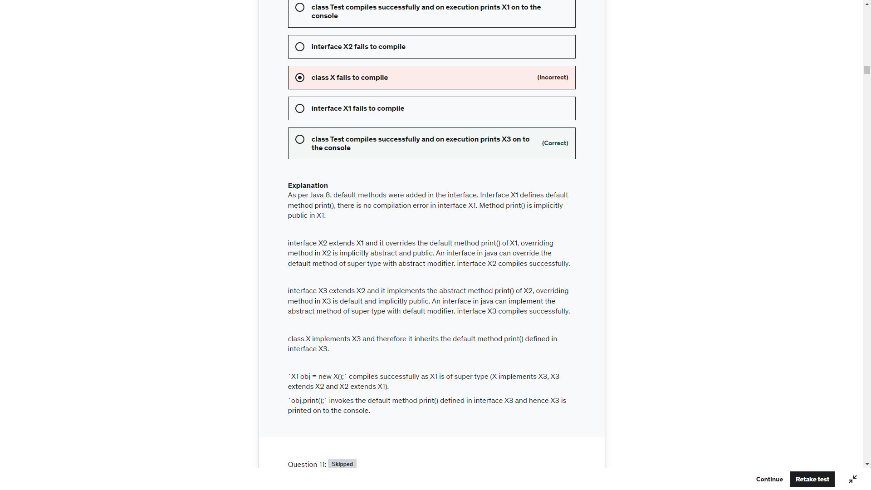

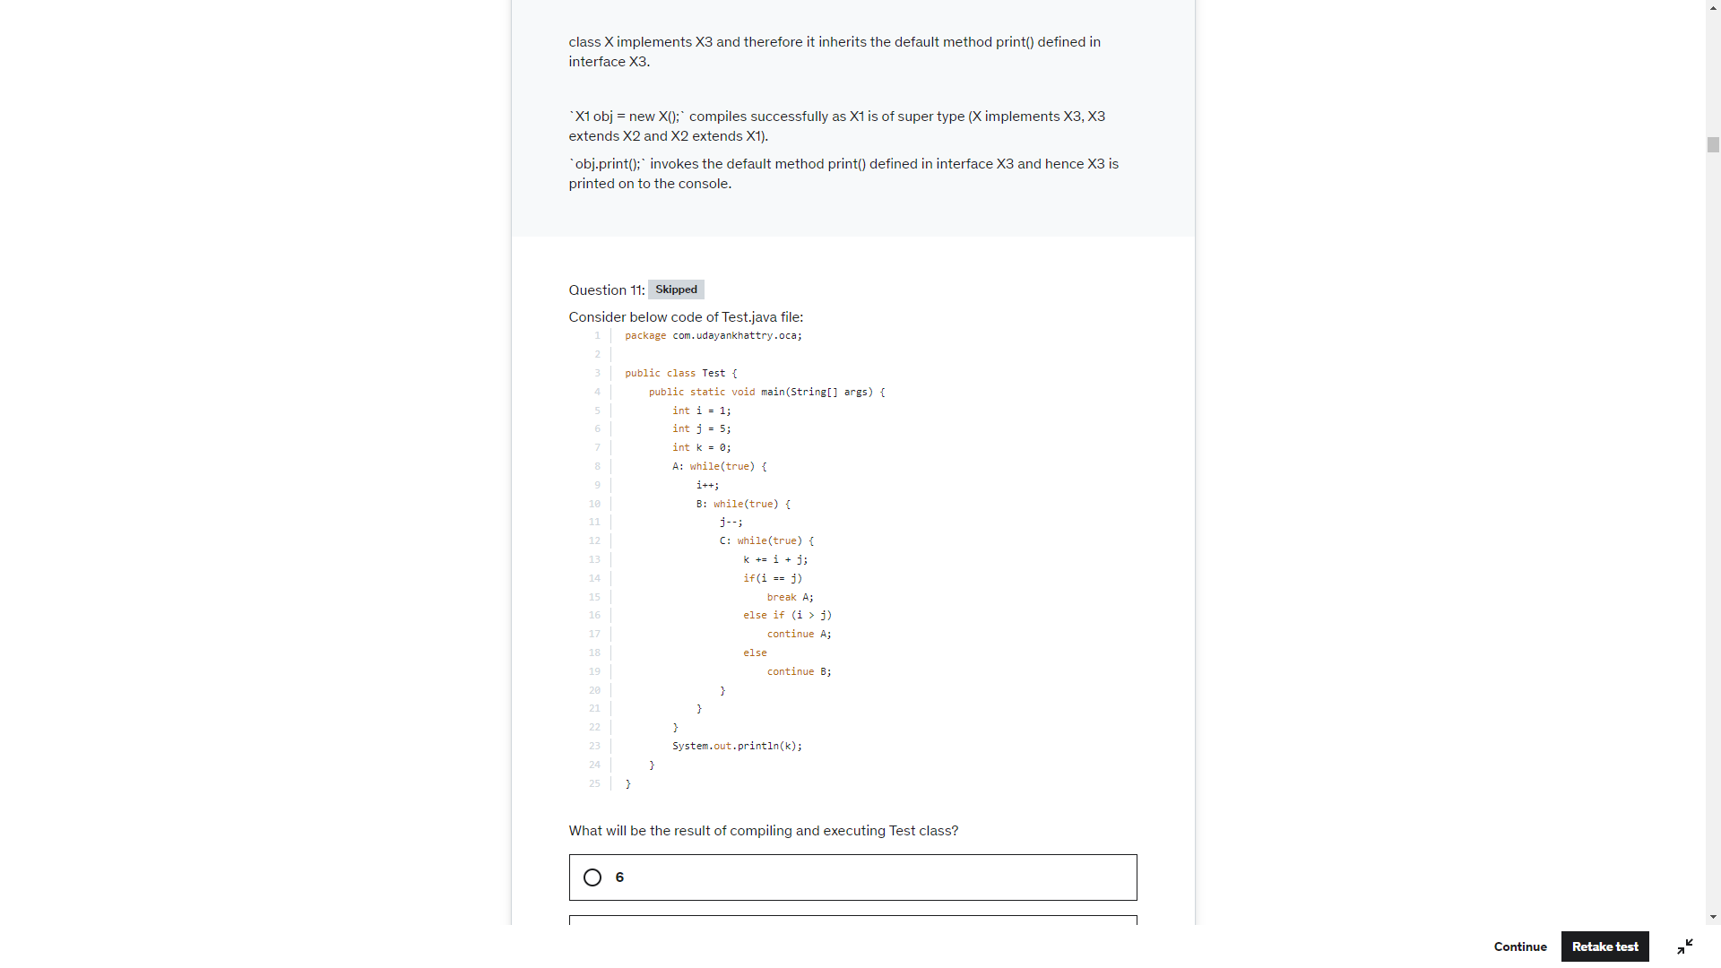

15

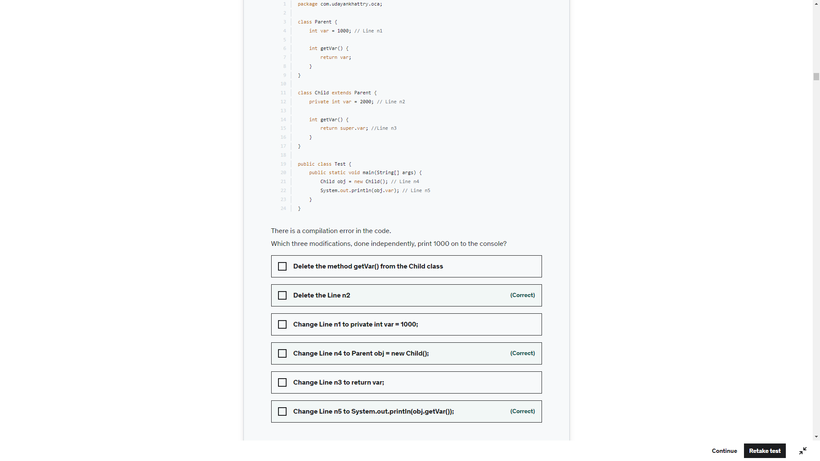

Change line n3 to return var. will have no impact because getvar() is not called in print statement. Variable resolution is performed during compilation not at run time. Variable overloading is performed using object ref

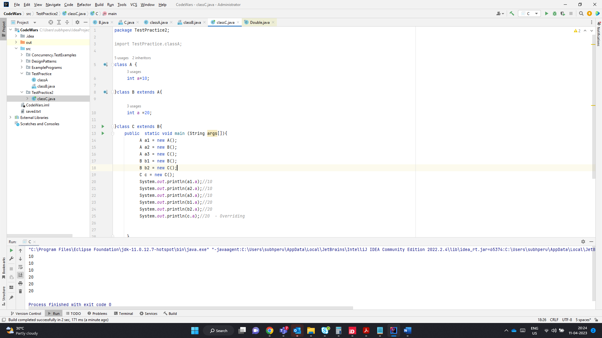

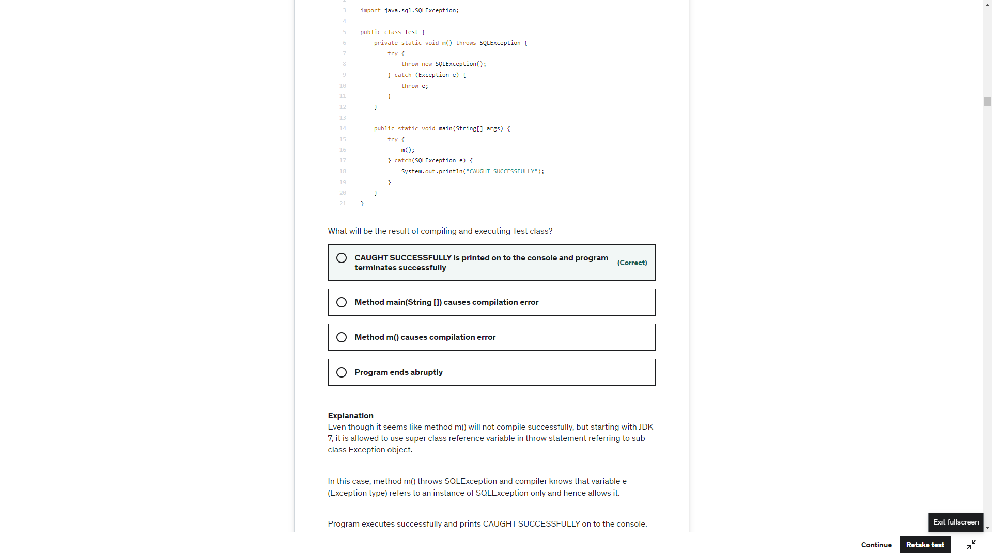

.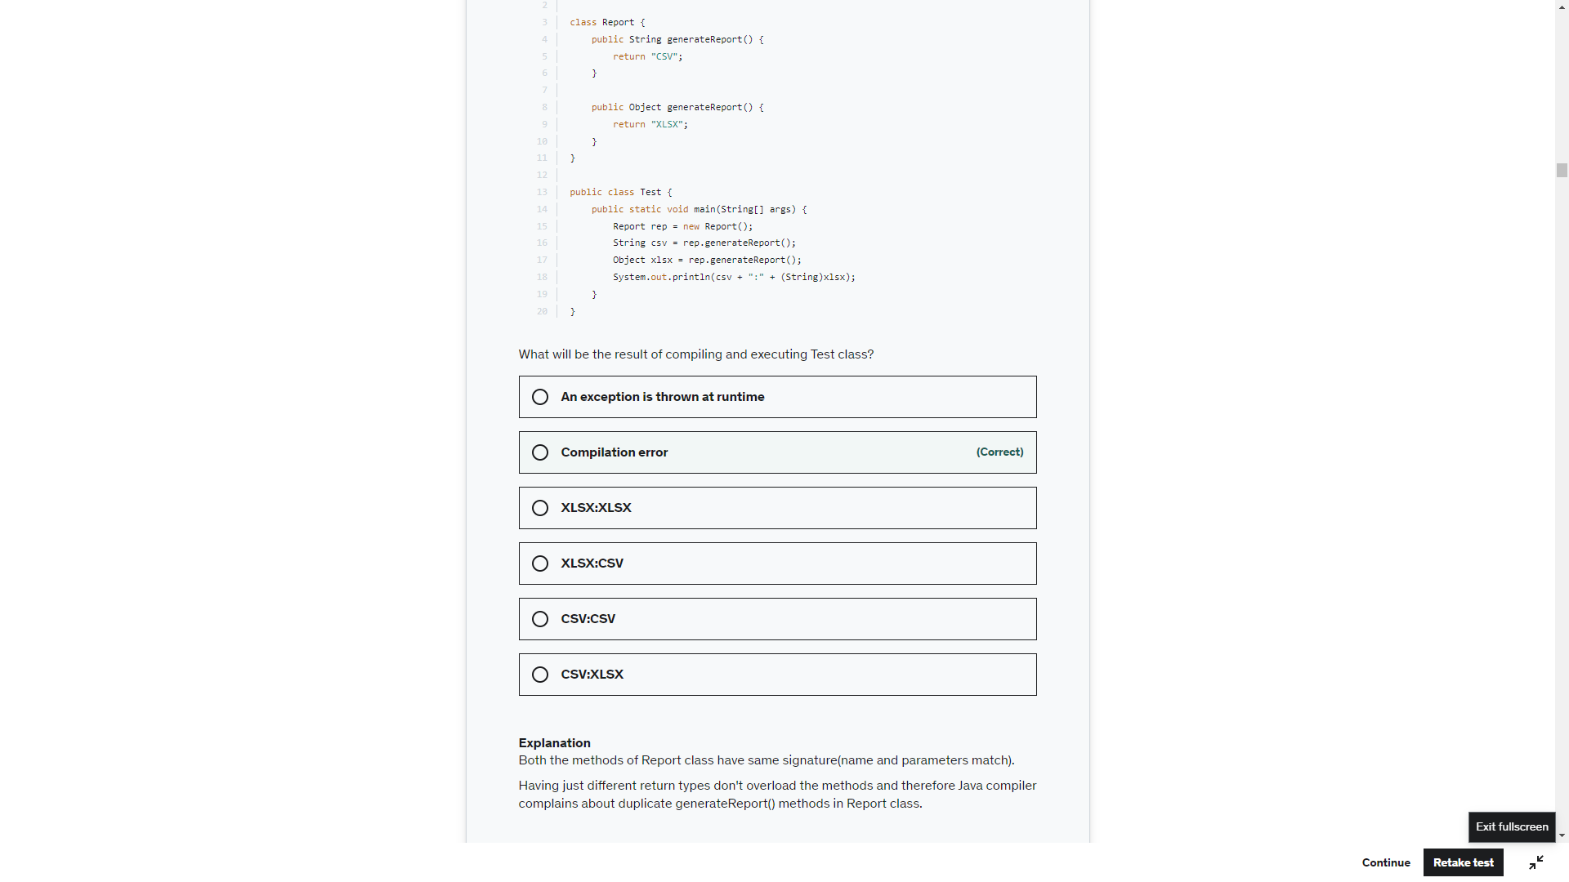

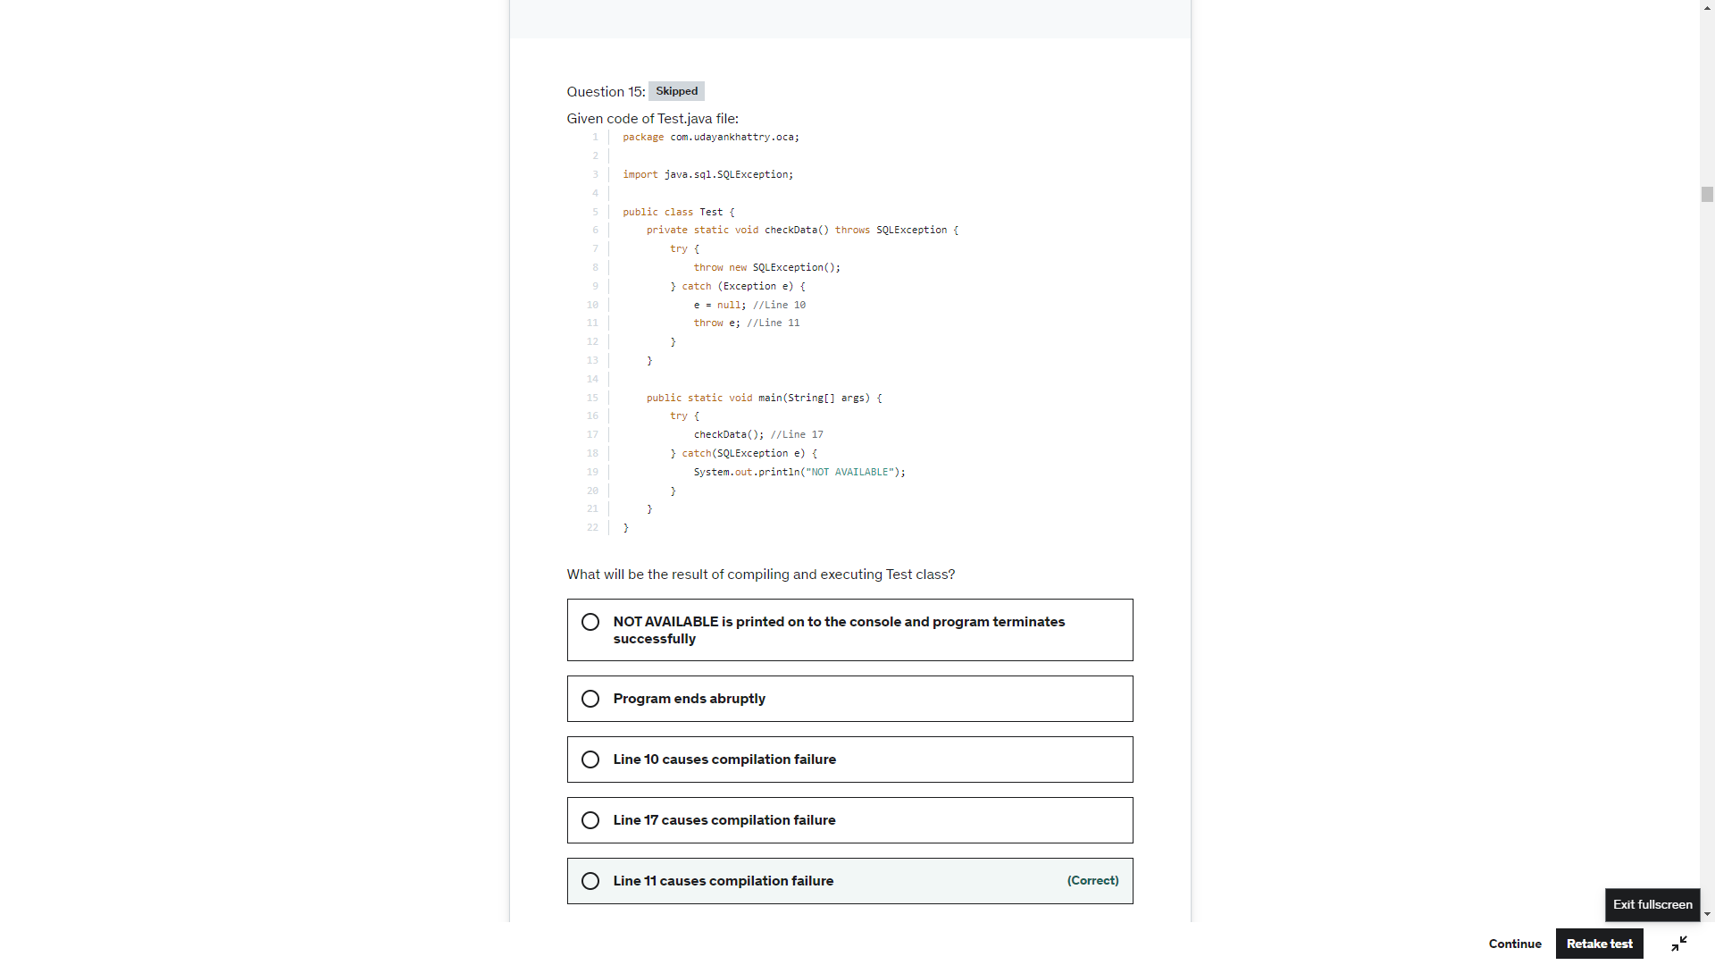

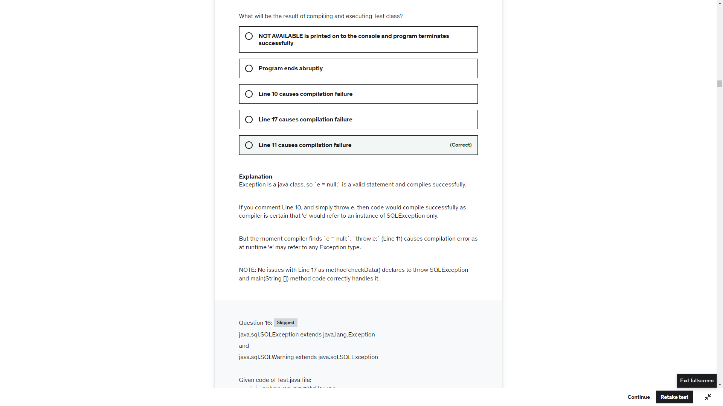

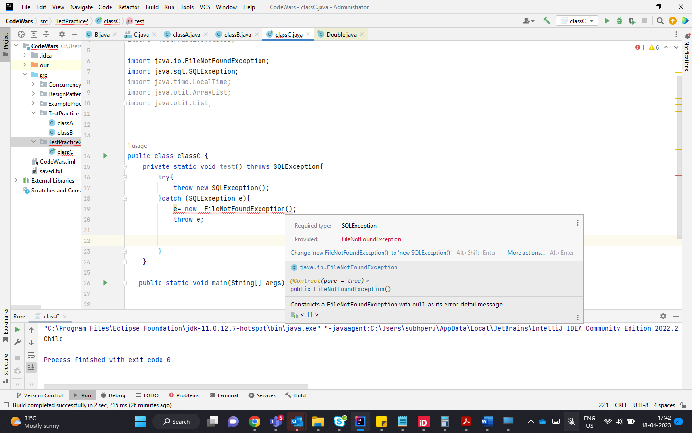

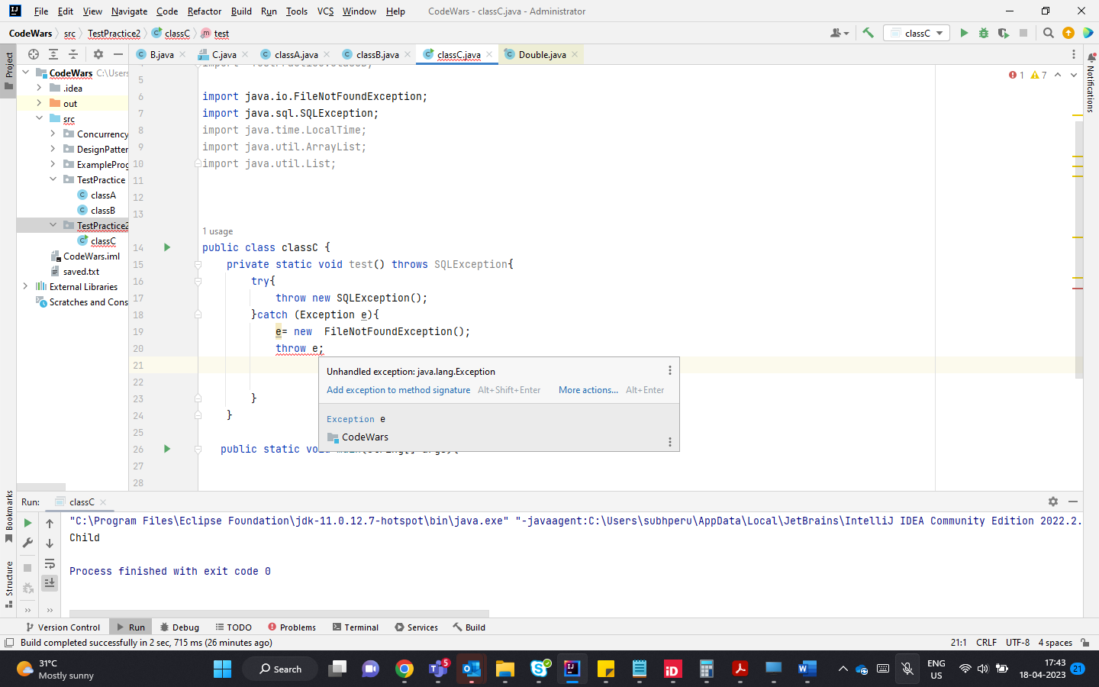

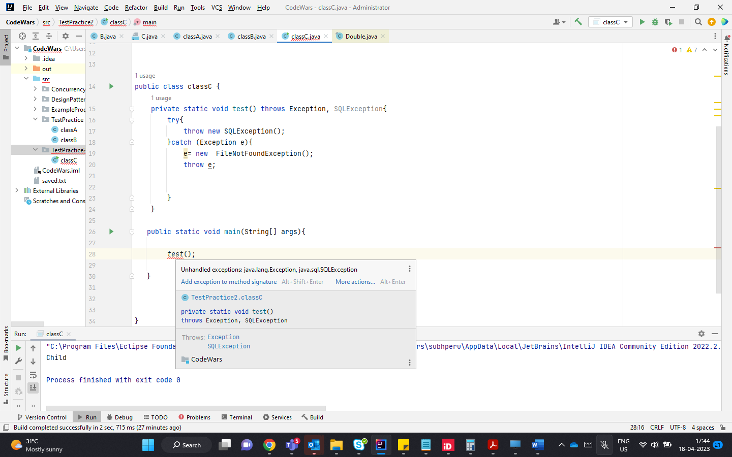

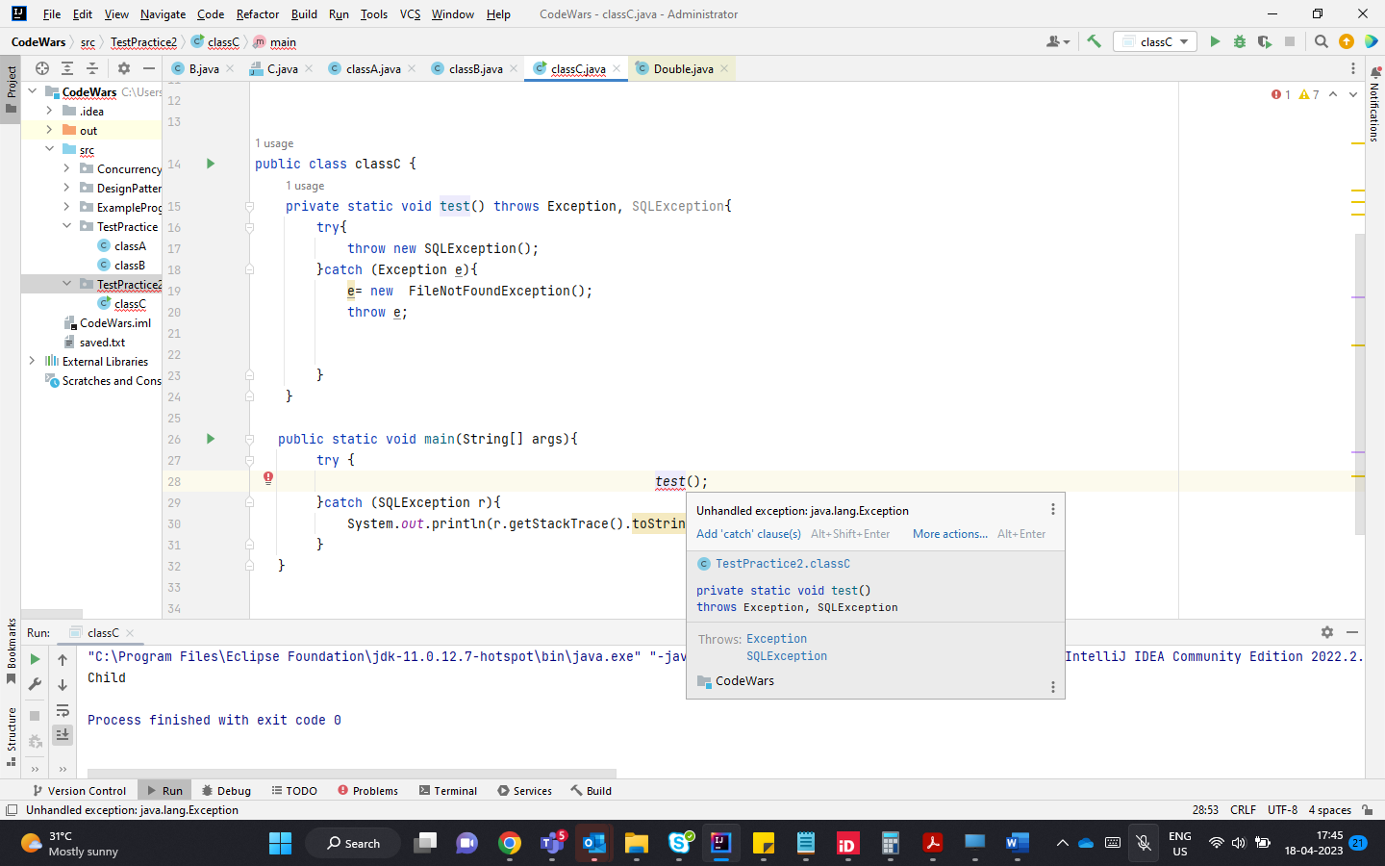

The type of e = null at compile time. But compiler does not know what is the type of exception e is and throws CE

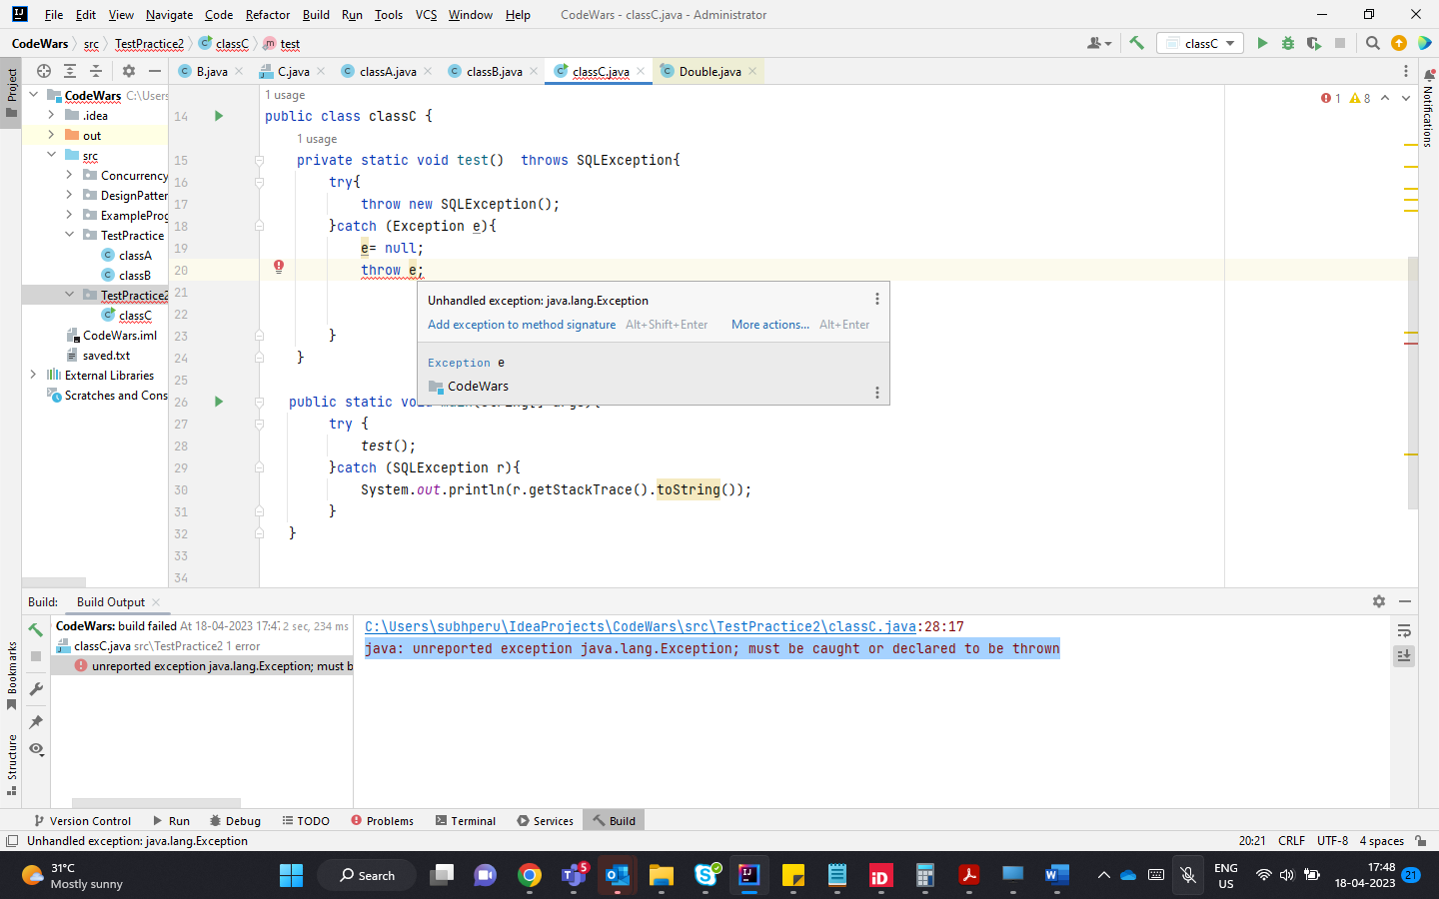

Though there is no CE error as it handled by using throws Exception.e=null triggers null pointer exception

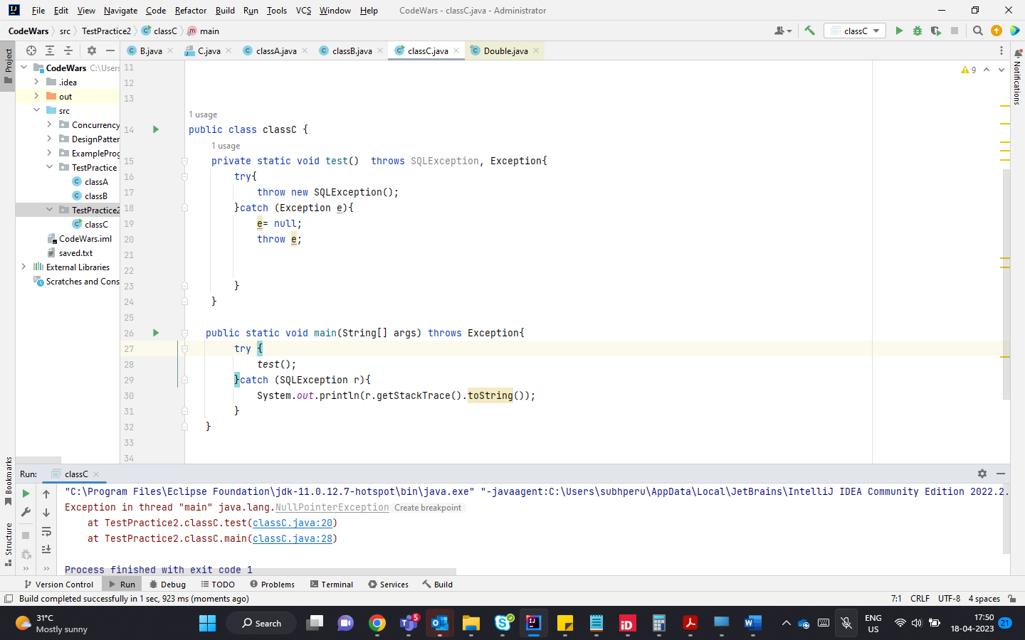

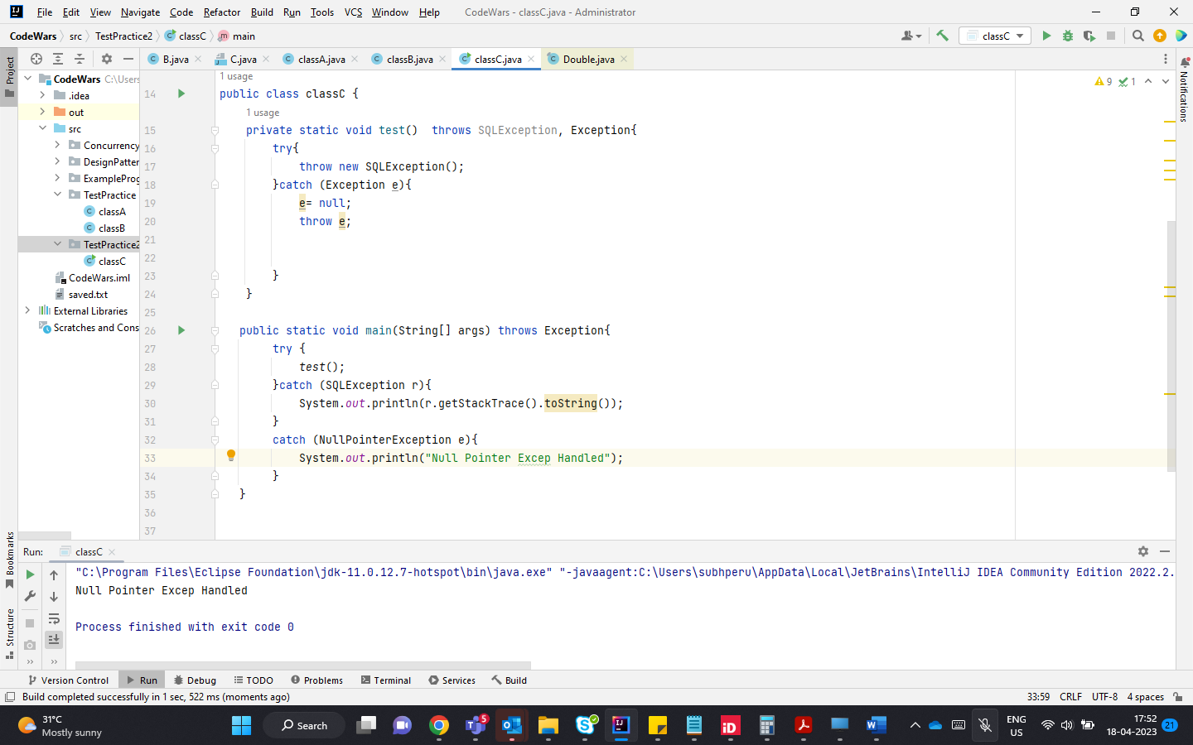

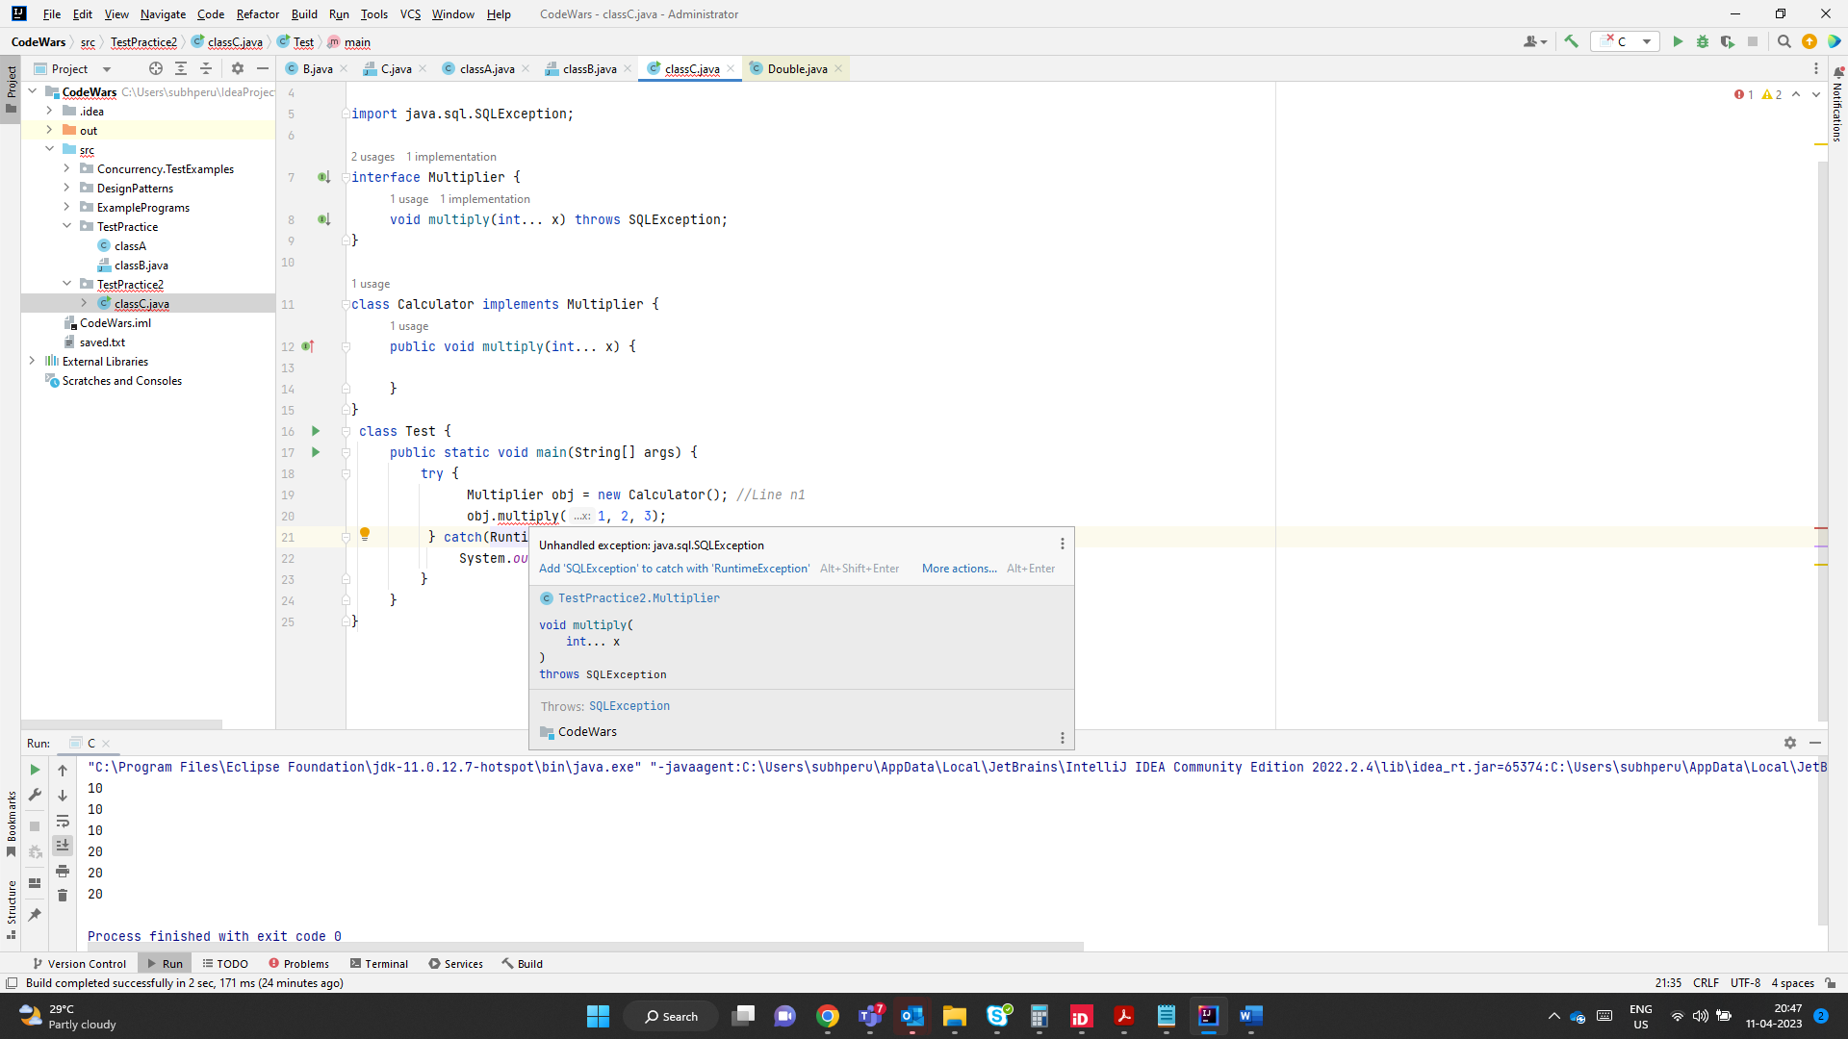

Here the ref variable is of Multiplier type , since its declared to throw SQL exception, Test class has to handle it , the try catch can either contain SQL Exception or its parent type. Or can be declared to throws the Exception or its parenttype

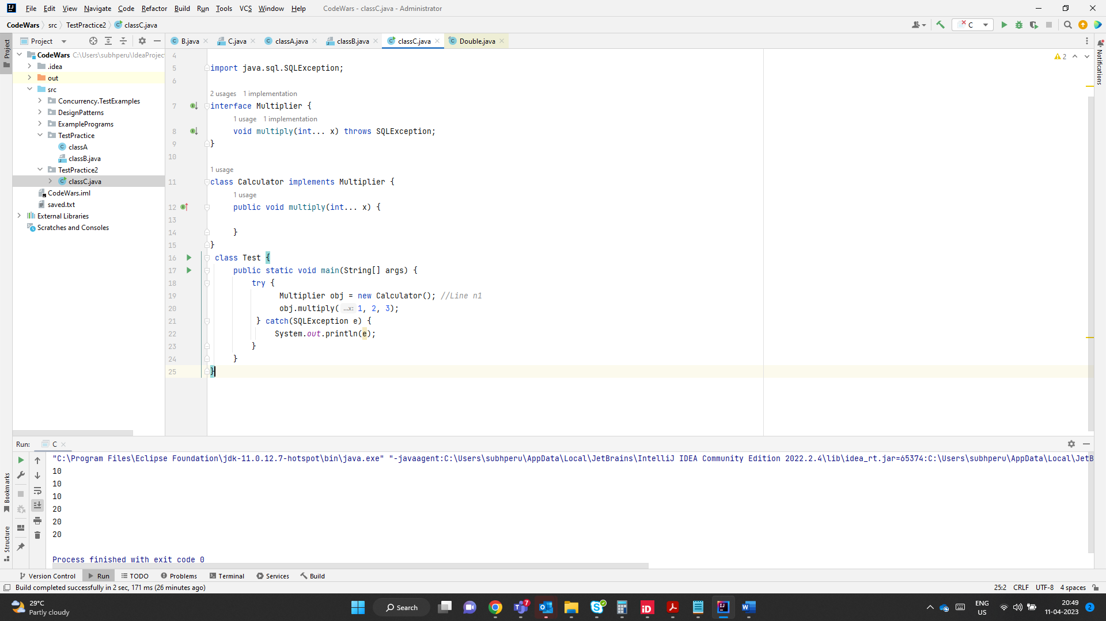

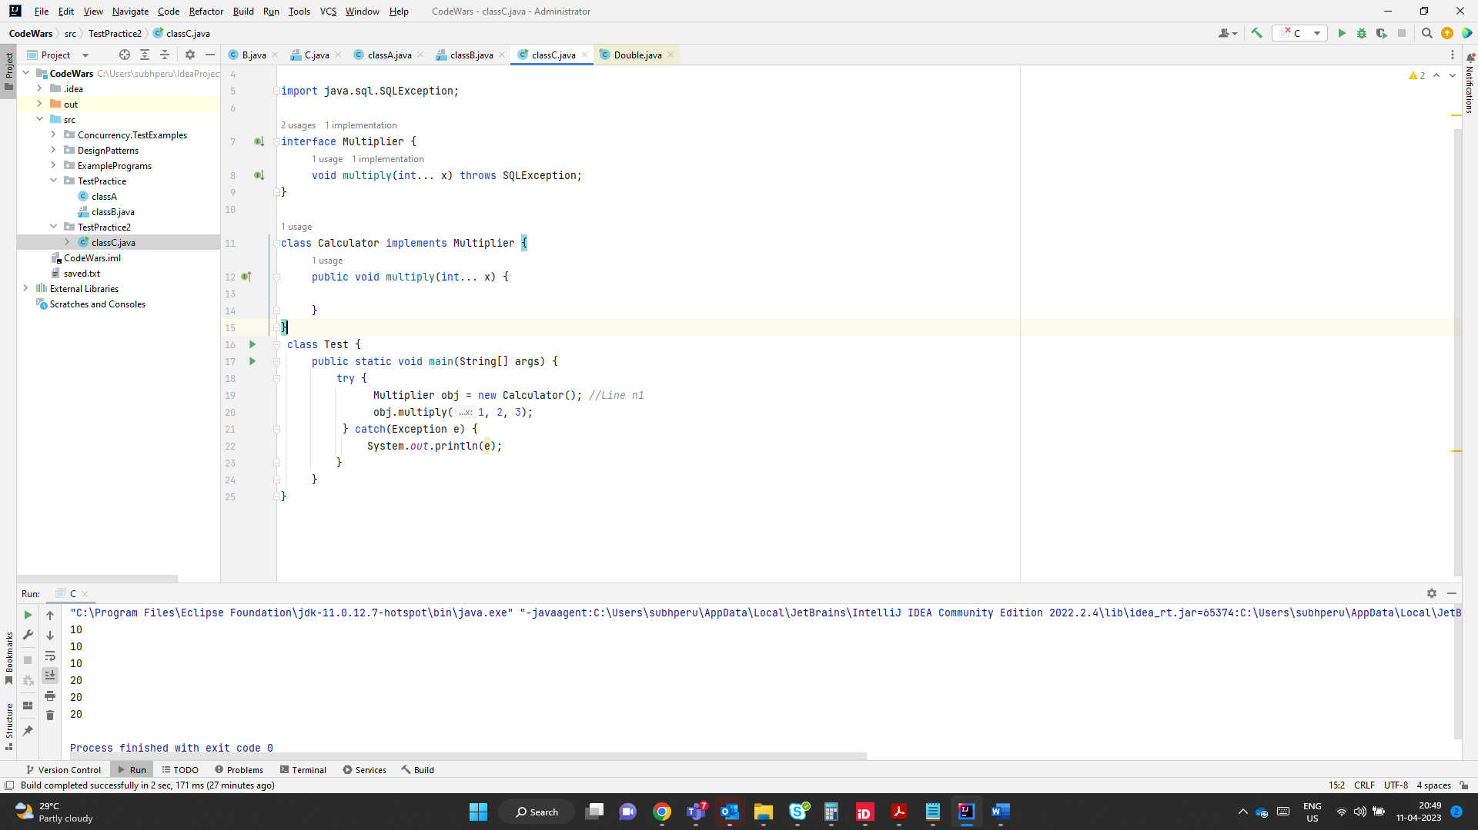

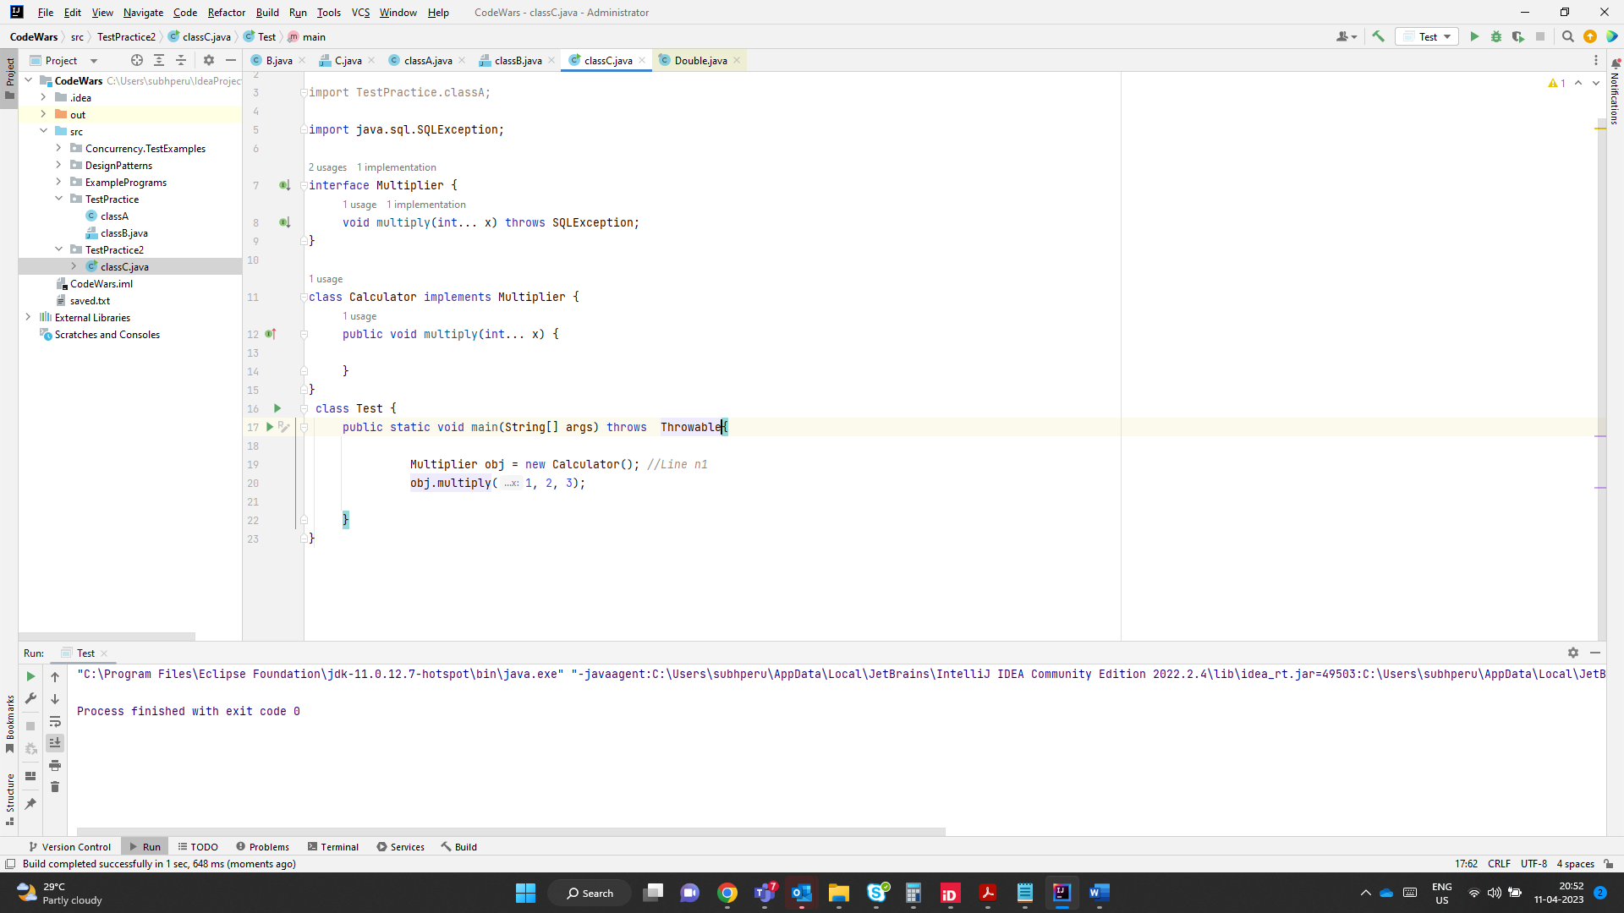

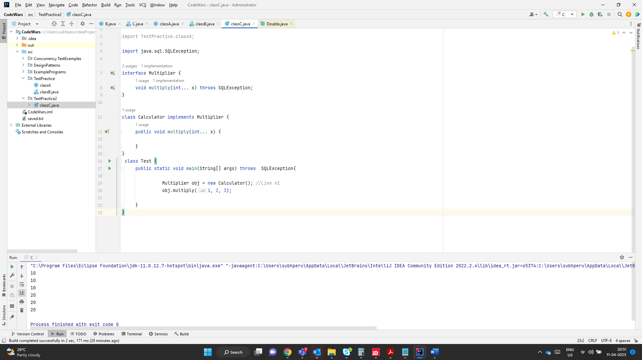

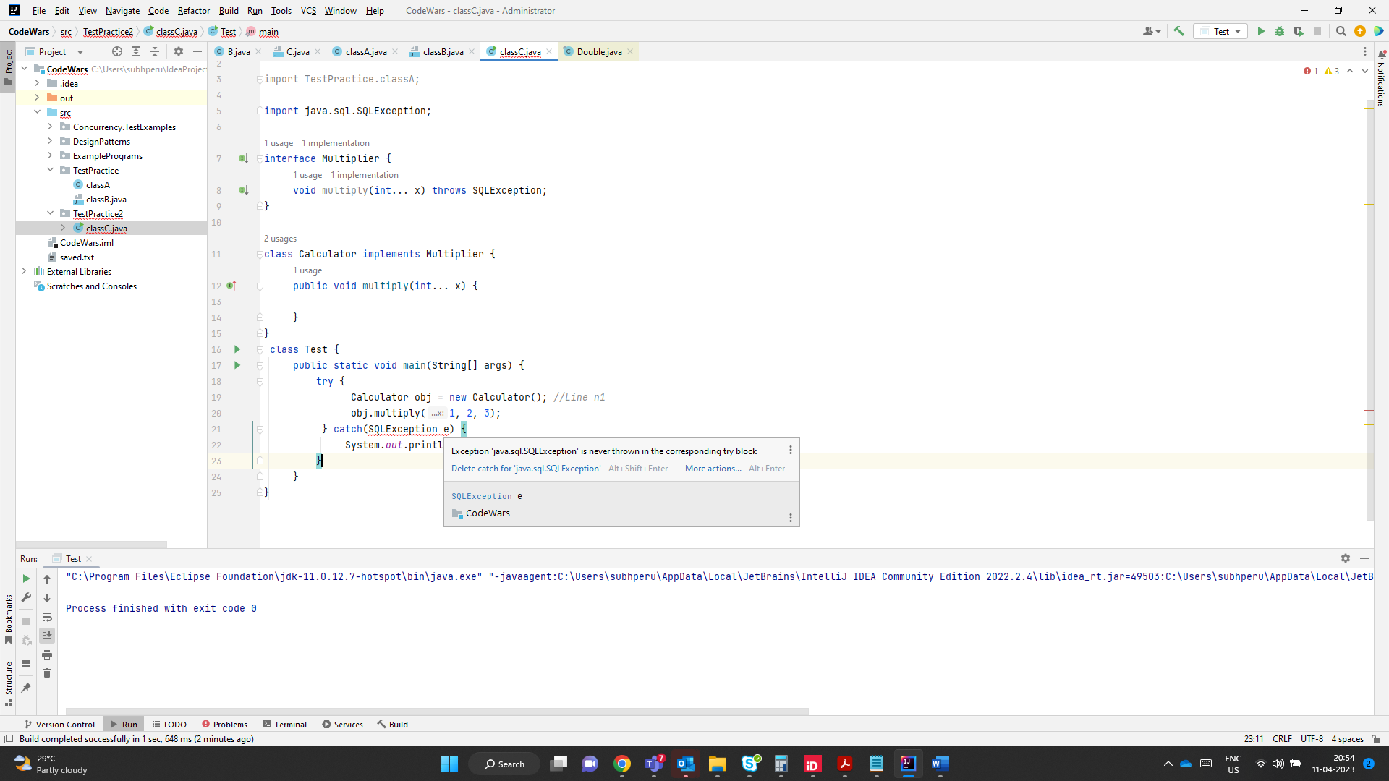

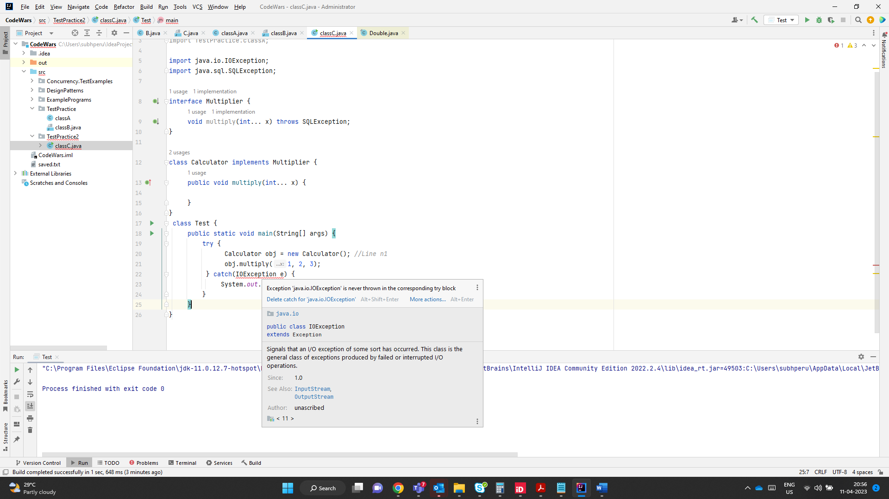

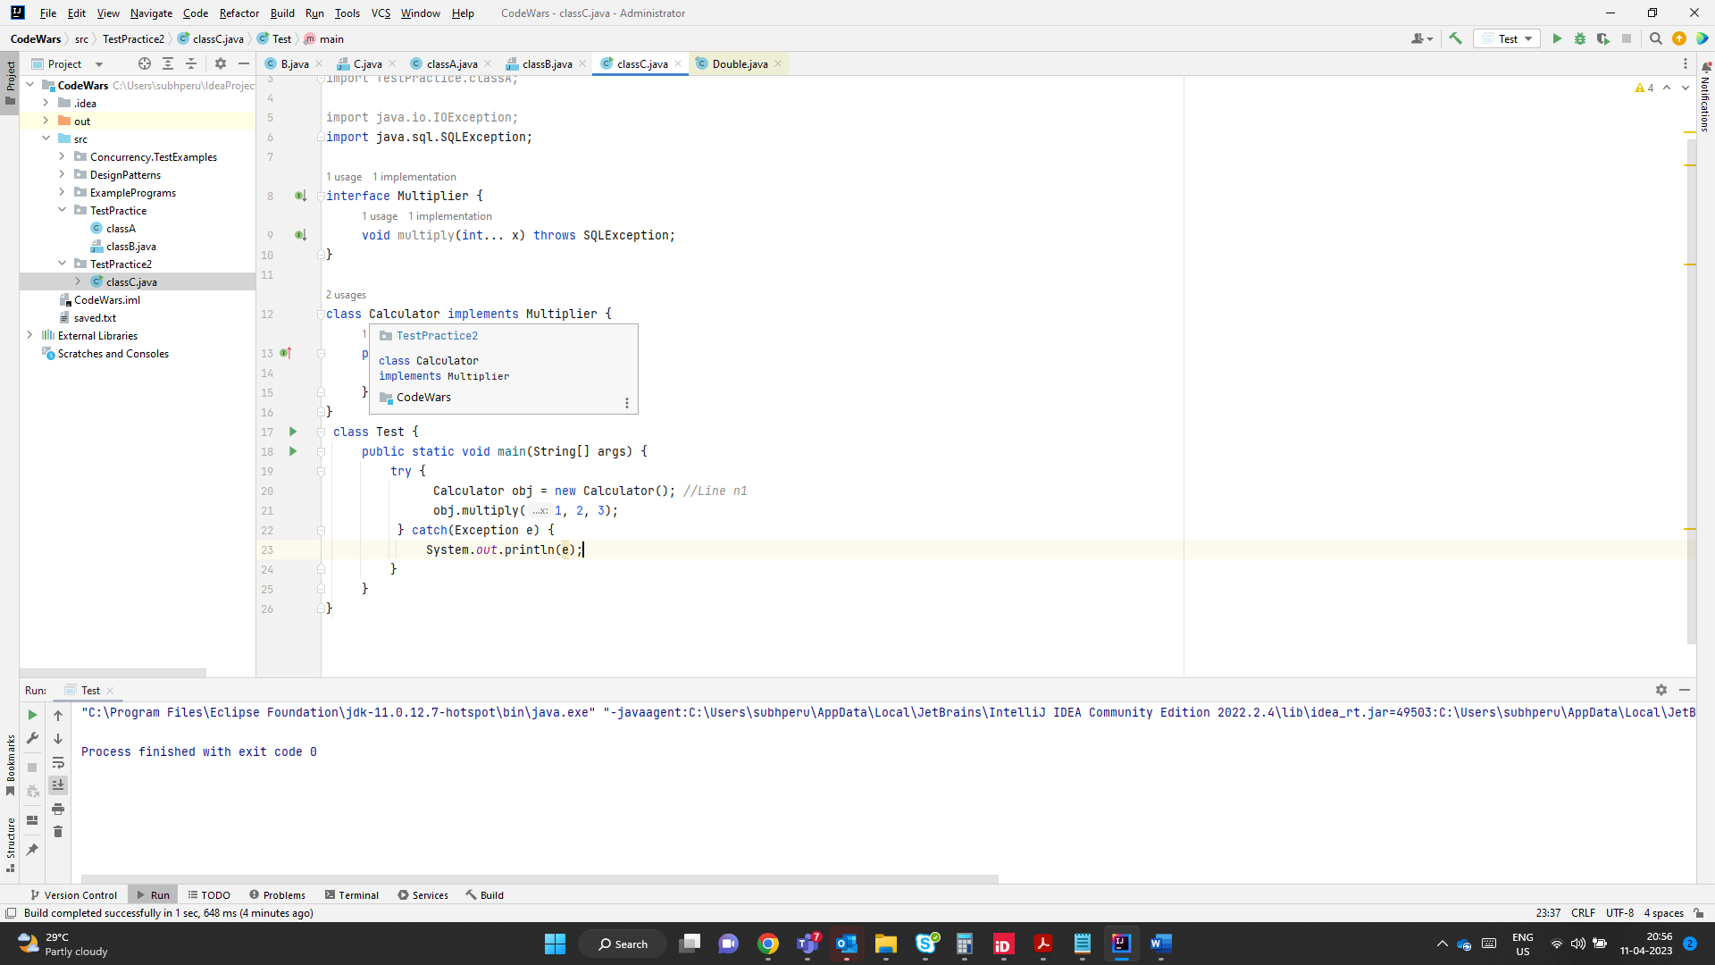

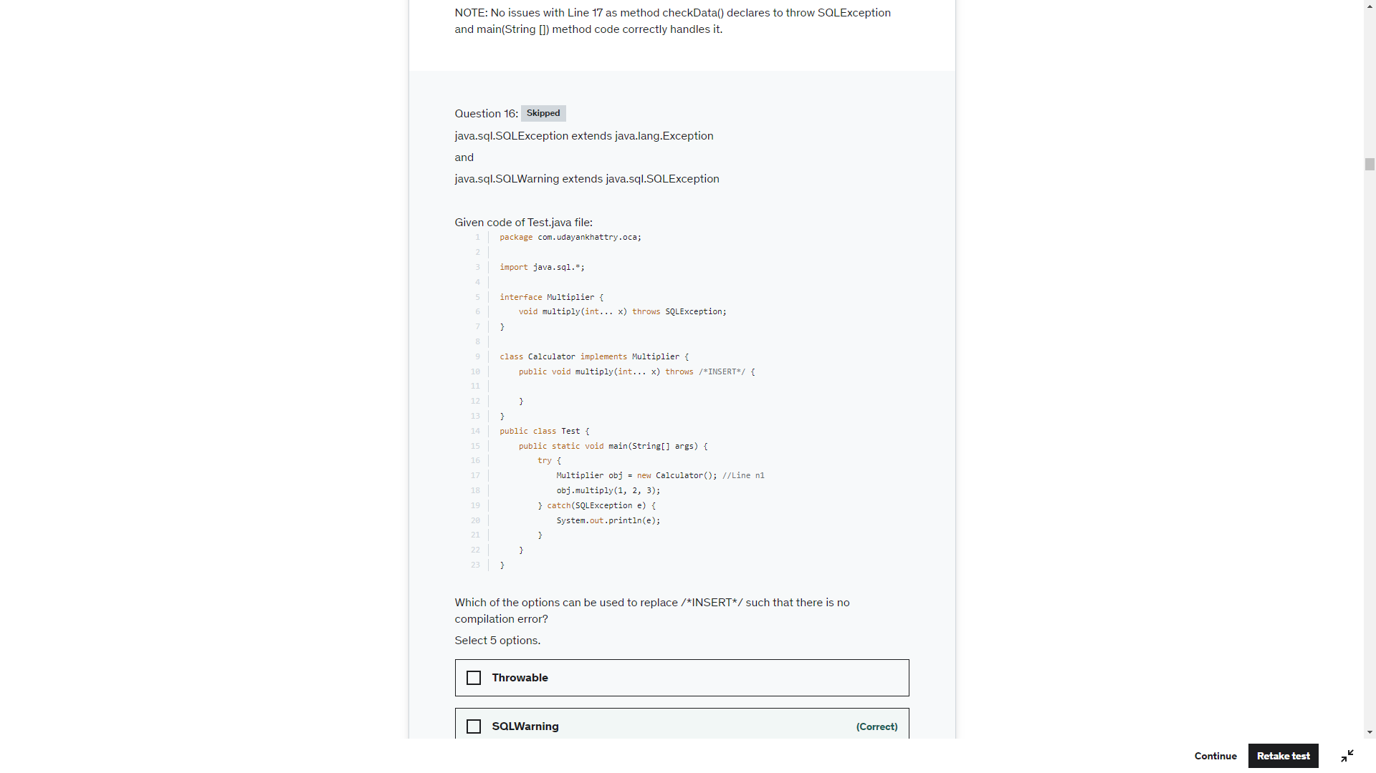

At Line n1, reference variable 'obj' is of Multiplier type (supertype) and it refers to an instance of Calculator class (subtype). This is polymorphism and allowed in Java.

multiply(int...) method declared in Multiplier interface declares to throw SQLException, hence the catch handler for Line n1 should provide handler for SQLException or its supertype. As catch-handler for SQLException is available, therefore Test class compiles successfully.

According to overriding rules, if super class / interface method declares to throw a checked exception, then overriding method of sub class / implementer class has following options:

1. May not declare to throw any checked exception

2. May declare to throw the same checked exception thrown by super class / interface method: SQLException is a valid option.

3. May declare to throw the sub class of the exception thrown by super class / interface method: SQLWarning is a valid option.

4. Cannot declare to throw the super class of the exception thrown by super class / interface method: Exception, Throwable are not valid options.

5. Cannot declare to throw unrelated checked exception: java.io.IOException is not a v alid option as it is not related java.sql.SQLException in multi-level inheritance.

6. May declare to throw any RuntimeException or Error: RuntimeException, NullPointerException and Error are valid options.

Therefore 5 options can successfully replace /*INSERT*/: SQLException, SQLWarning, RuntimeException, Error and NullPointerException

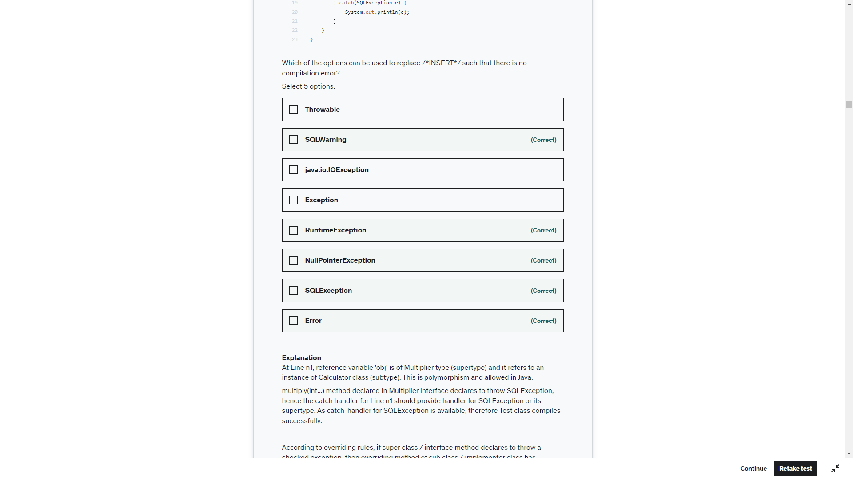



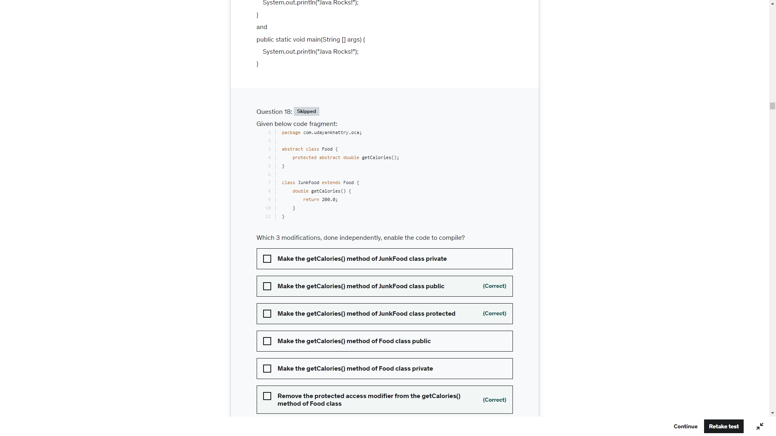

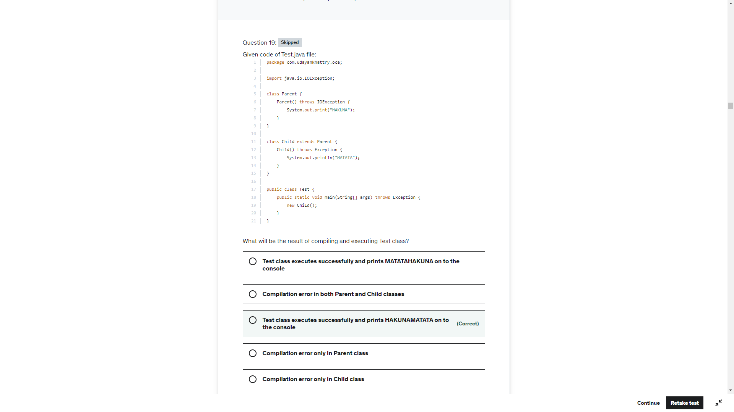

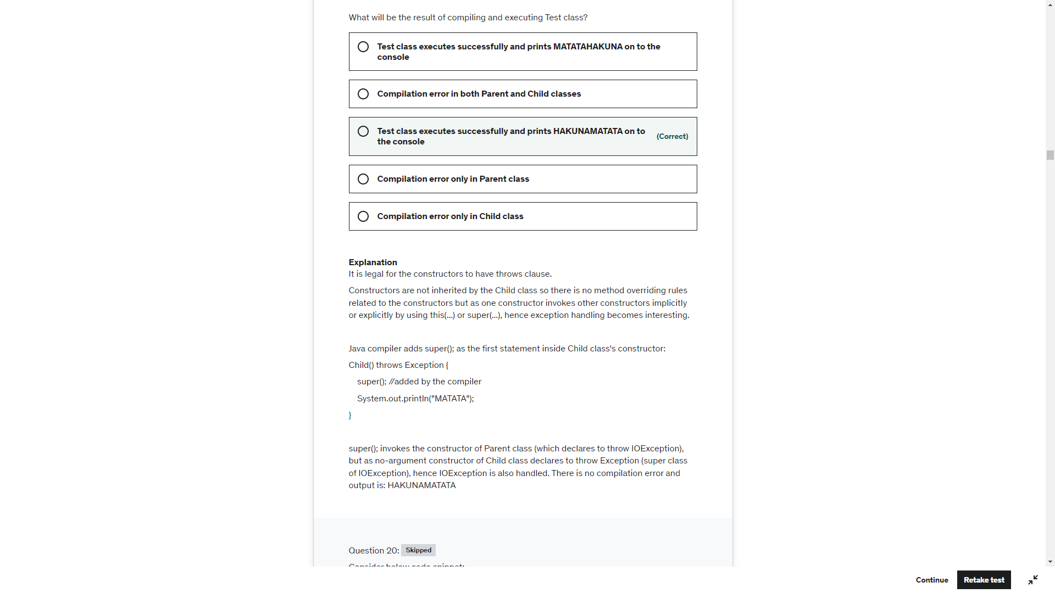

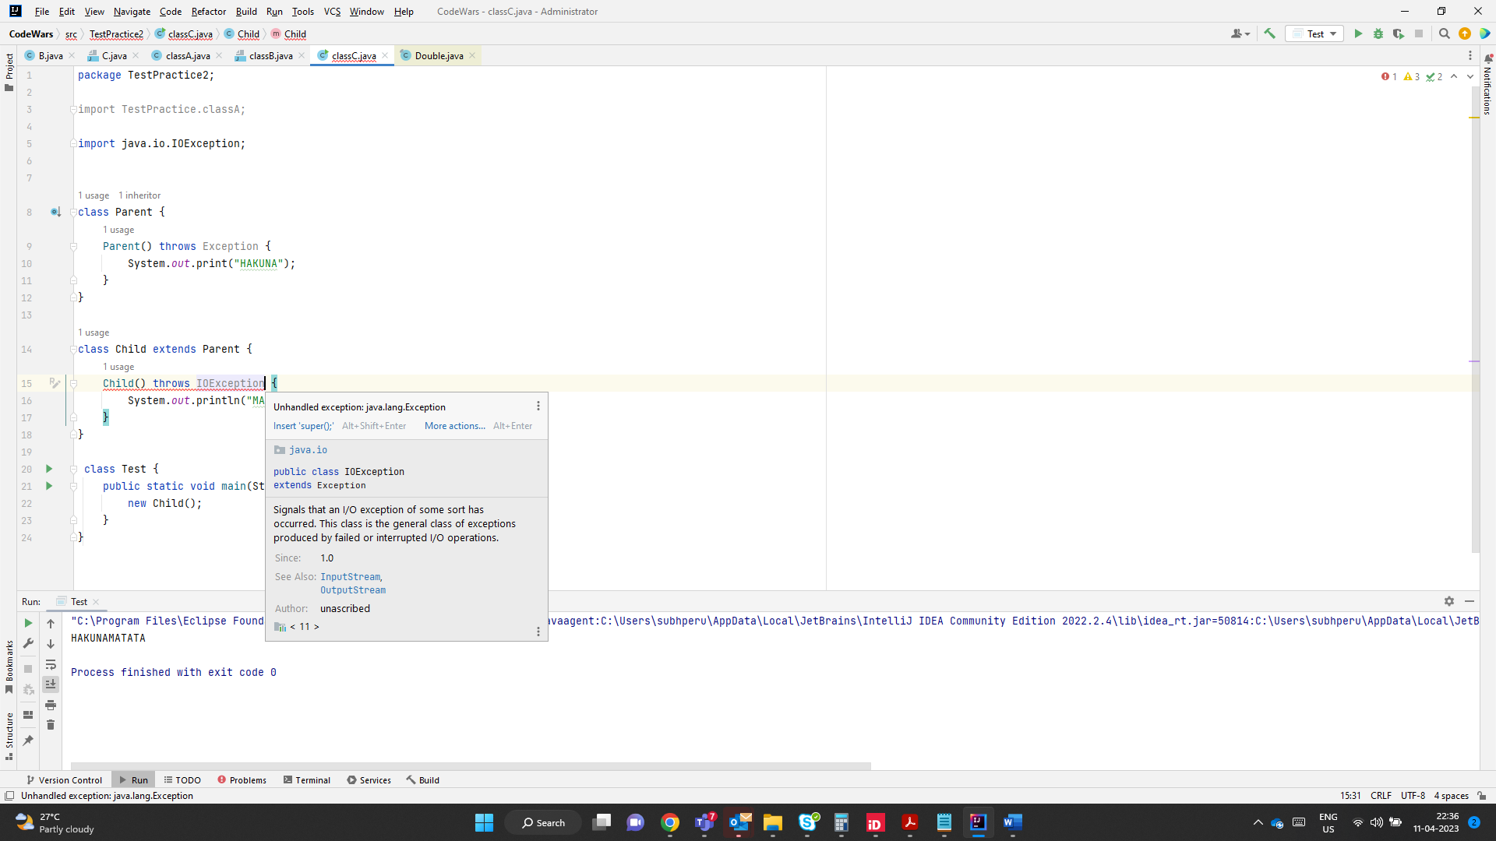s

It is legal for the constructors to have throws clause.

Constructors are not inherited by the Child class so there is no method overriding rules related to the constructors but as one constructor invokes other constructors implicitly or explicitly by using this(...) or super(...), hence exception handling becomes interesting.

java compiler adds super(); as the first statement inside Child class's constructor:

Child() throws Exception {

    super(); //added by the compiler

    System.out.println("MATATA");

}

super(); invokes the constructor of Parent class (which declares to throw IOException), but as no-argument constructor of Child class declares to throw Exception (super class of IOException), hence IOException is also handled. There is no compilation error and output is: HAKUNAMATATA

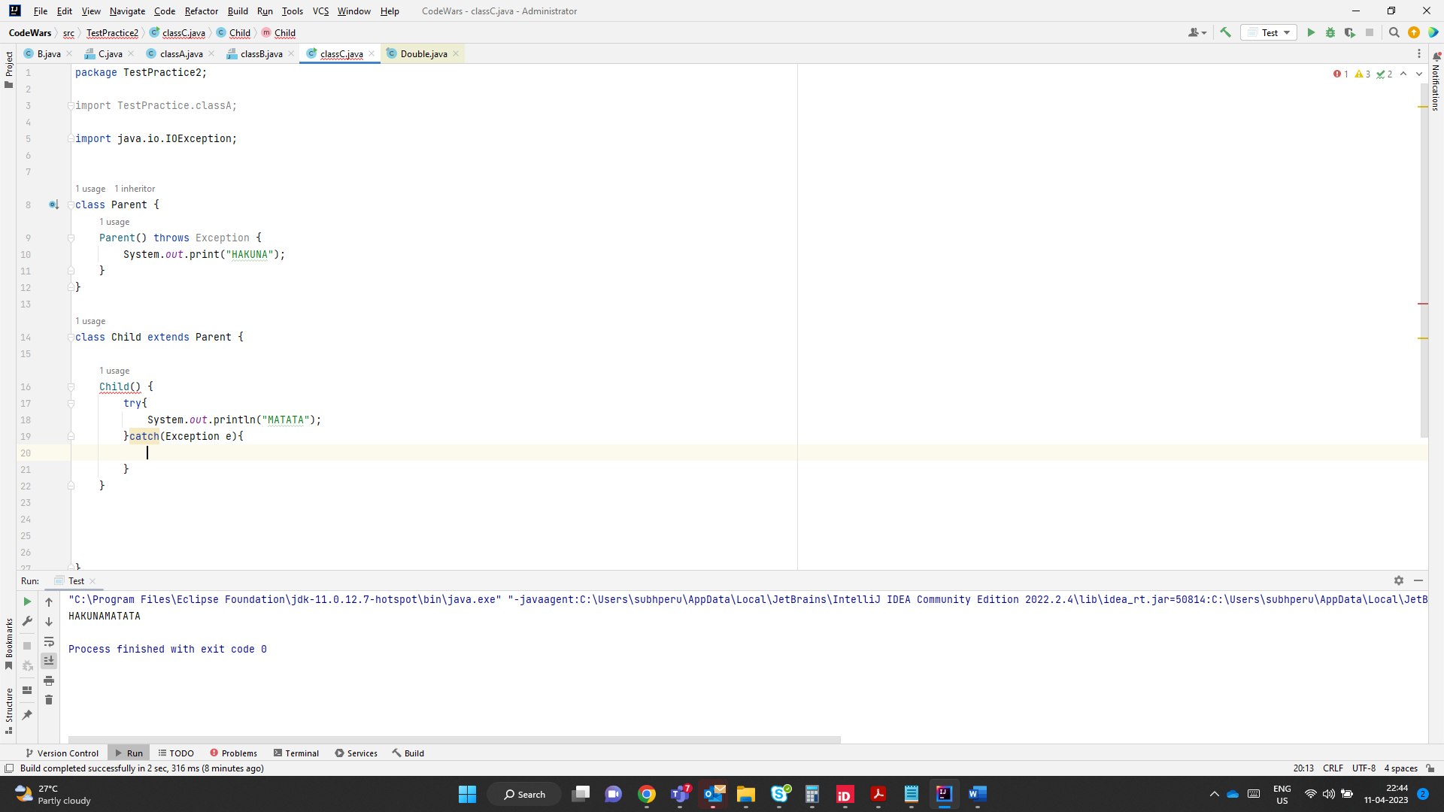

Here super() is placed by the compiler at line 17 and would not be handled by try catch block.

Define so we cant handle it this way.this has to be handed in the class where objects are created

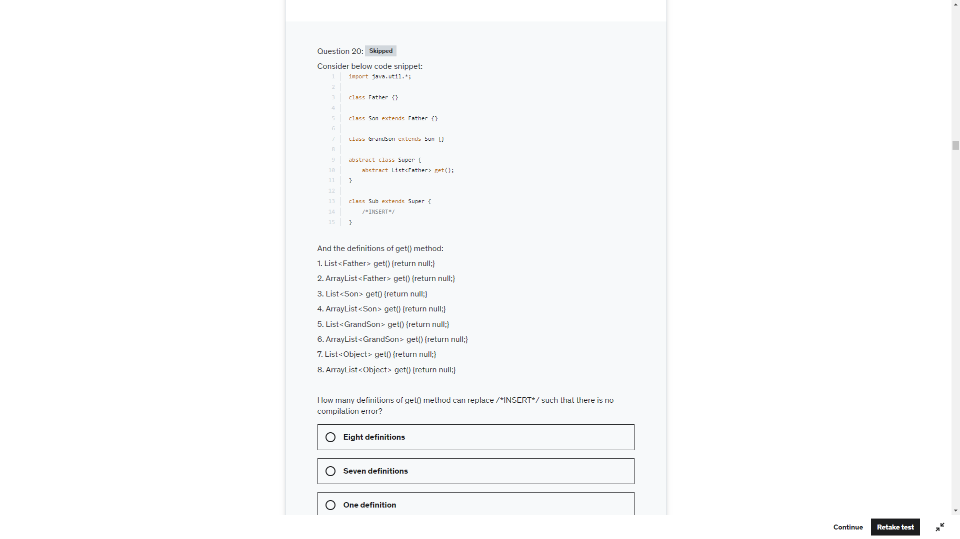

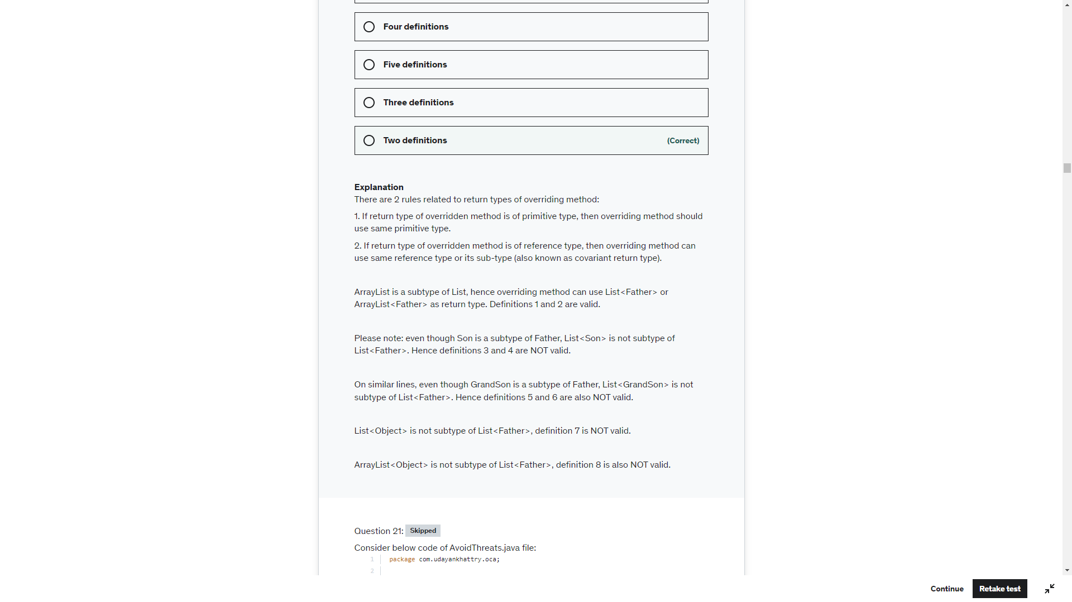

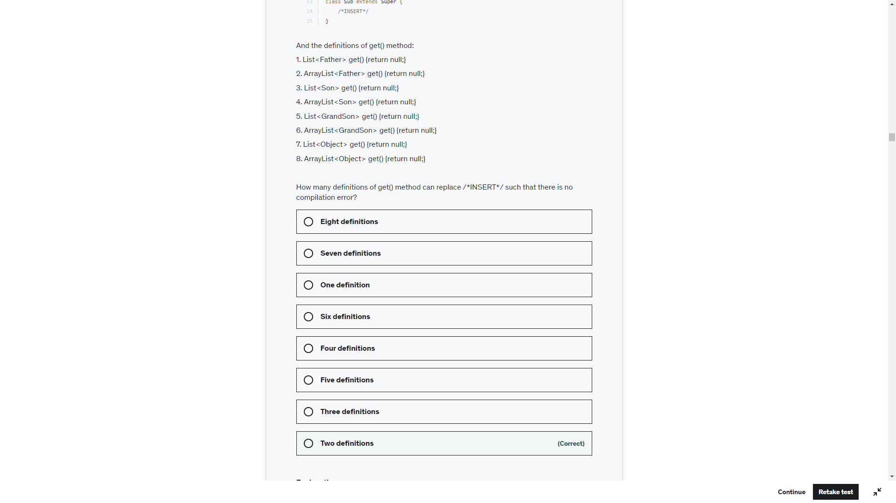

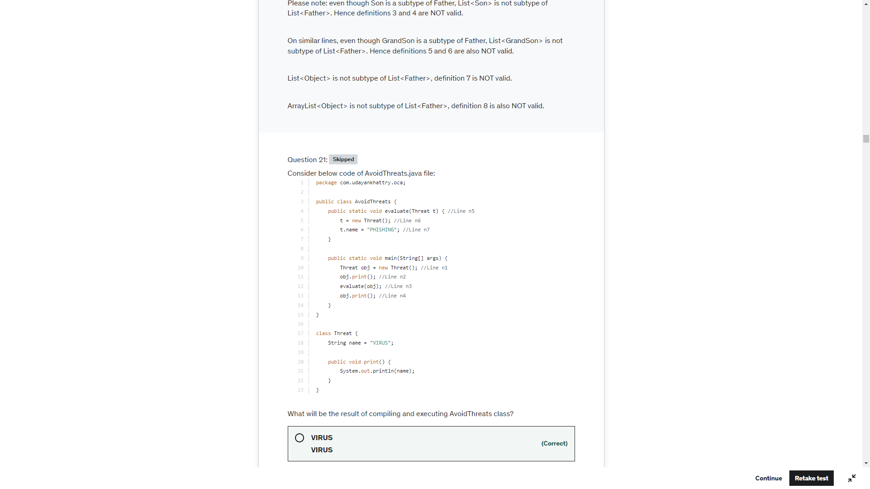

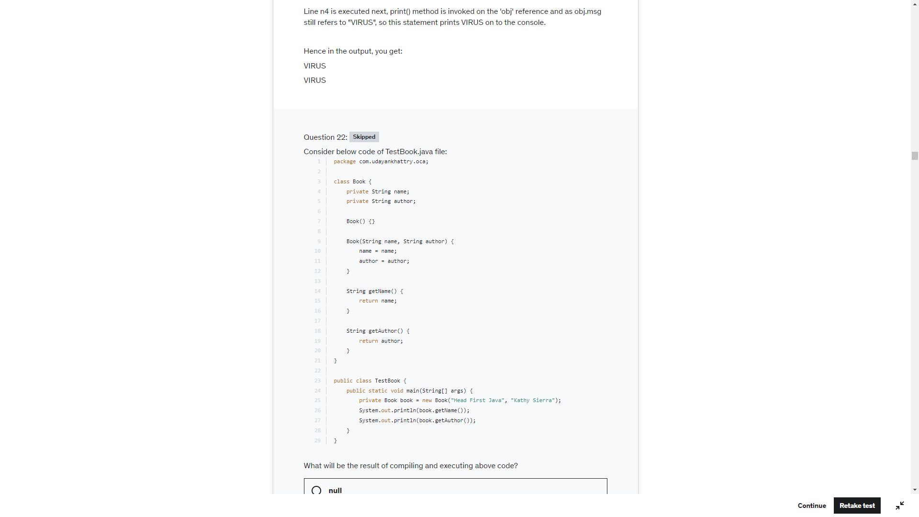

Check line 25, variable Book is declared private. You cant have access modifiers inside methods. Only final modifiers can be used for local variables.

If the variable is not declared private. Line 10 and 11 would update the local variable name and author and make no changes to instance variable. So the output in that case would be null null

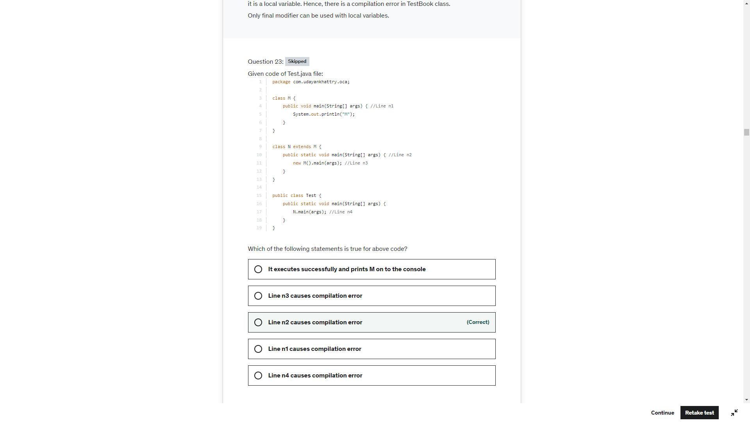

The static method of subclass cannot hide the instance method of superclass. static main(String []) method at Line n2 tries to hide the instance main(String []) method at Line n1 and hence Line n2 causes compilation error.

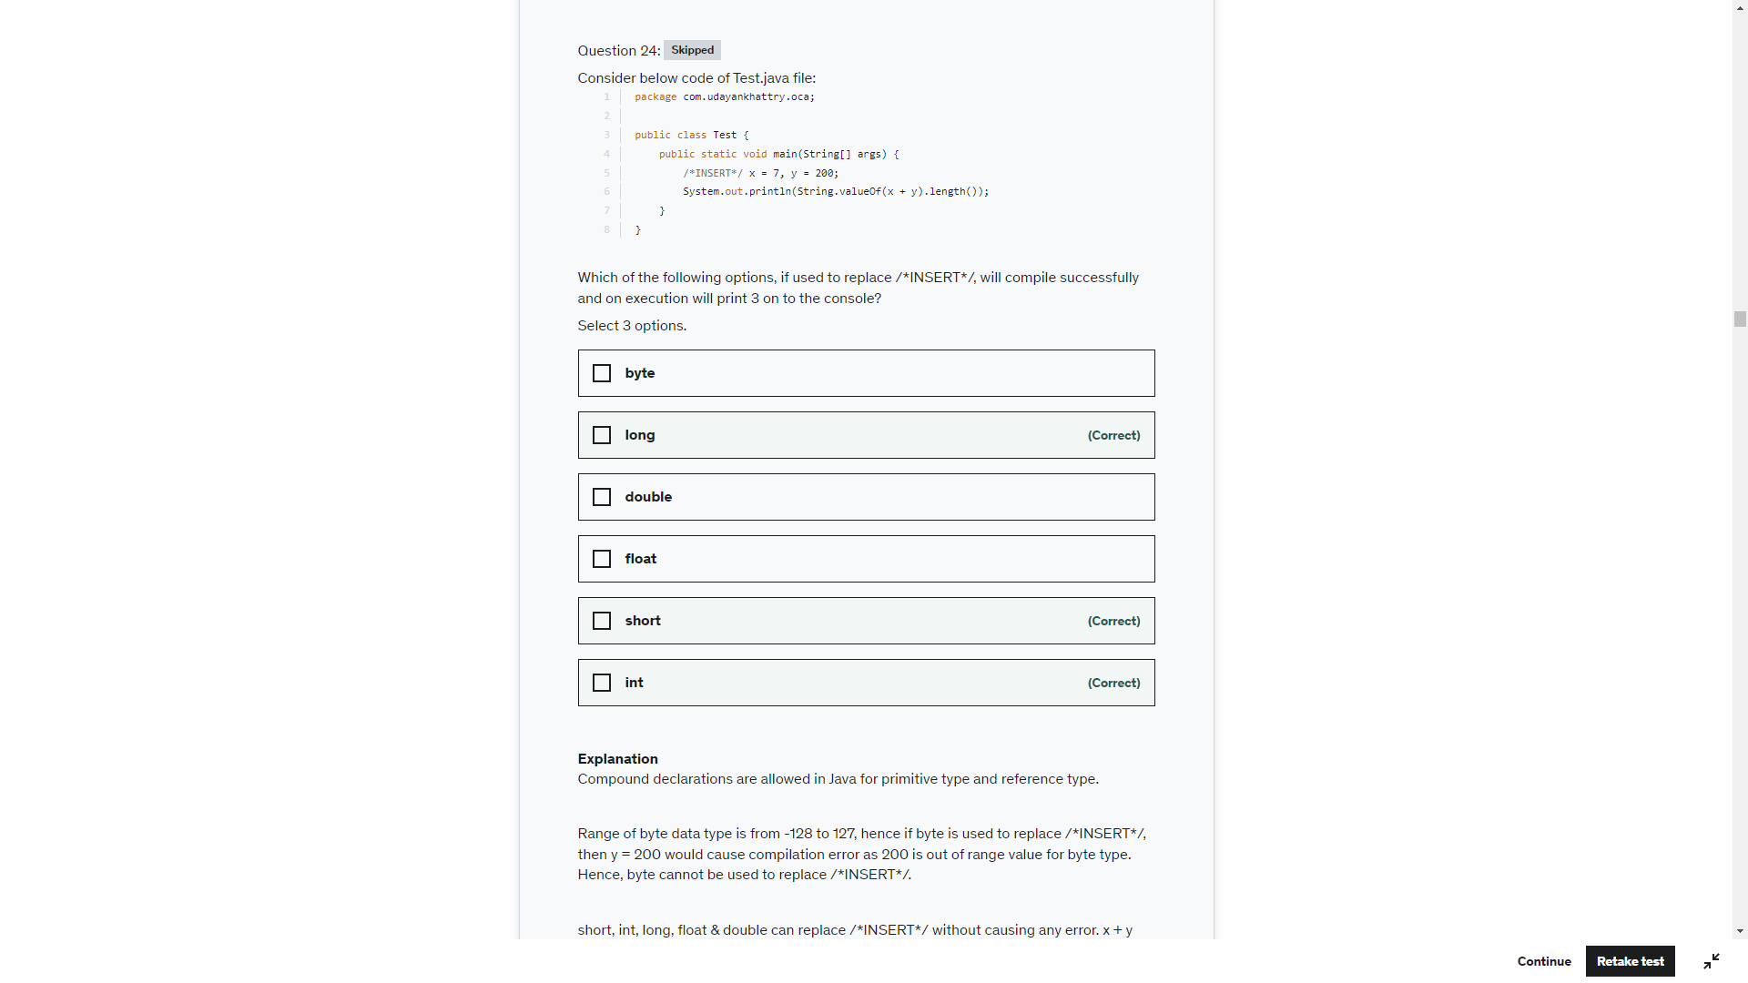

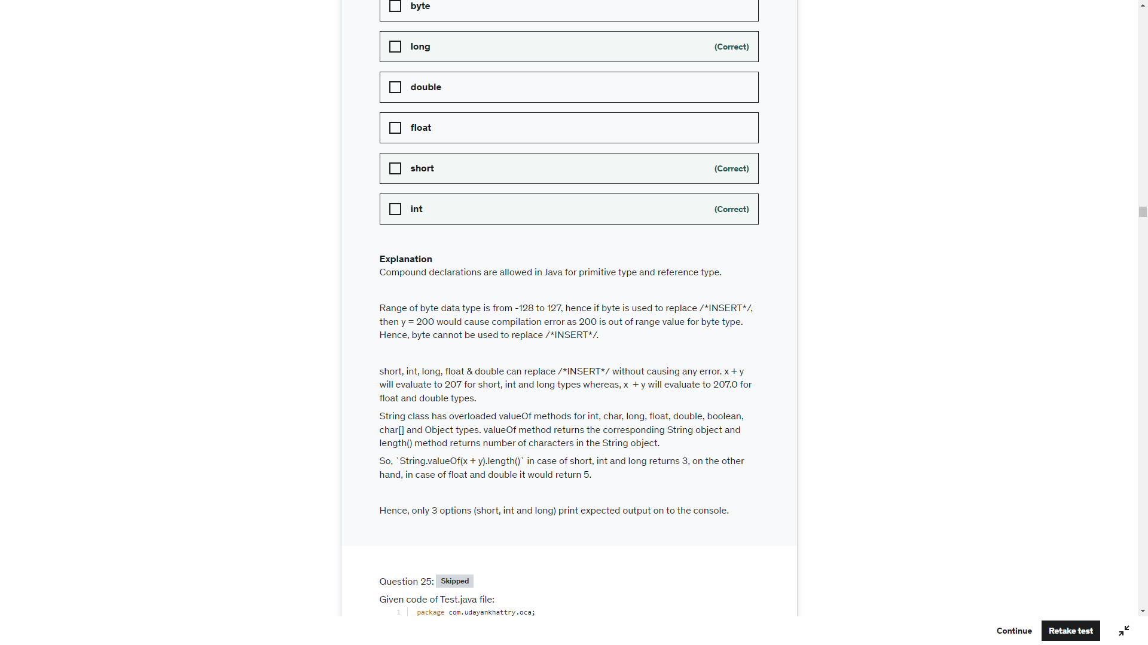

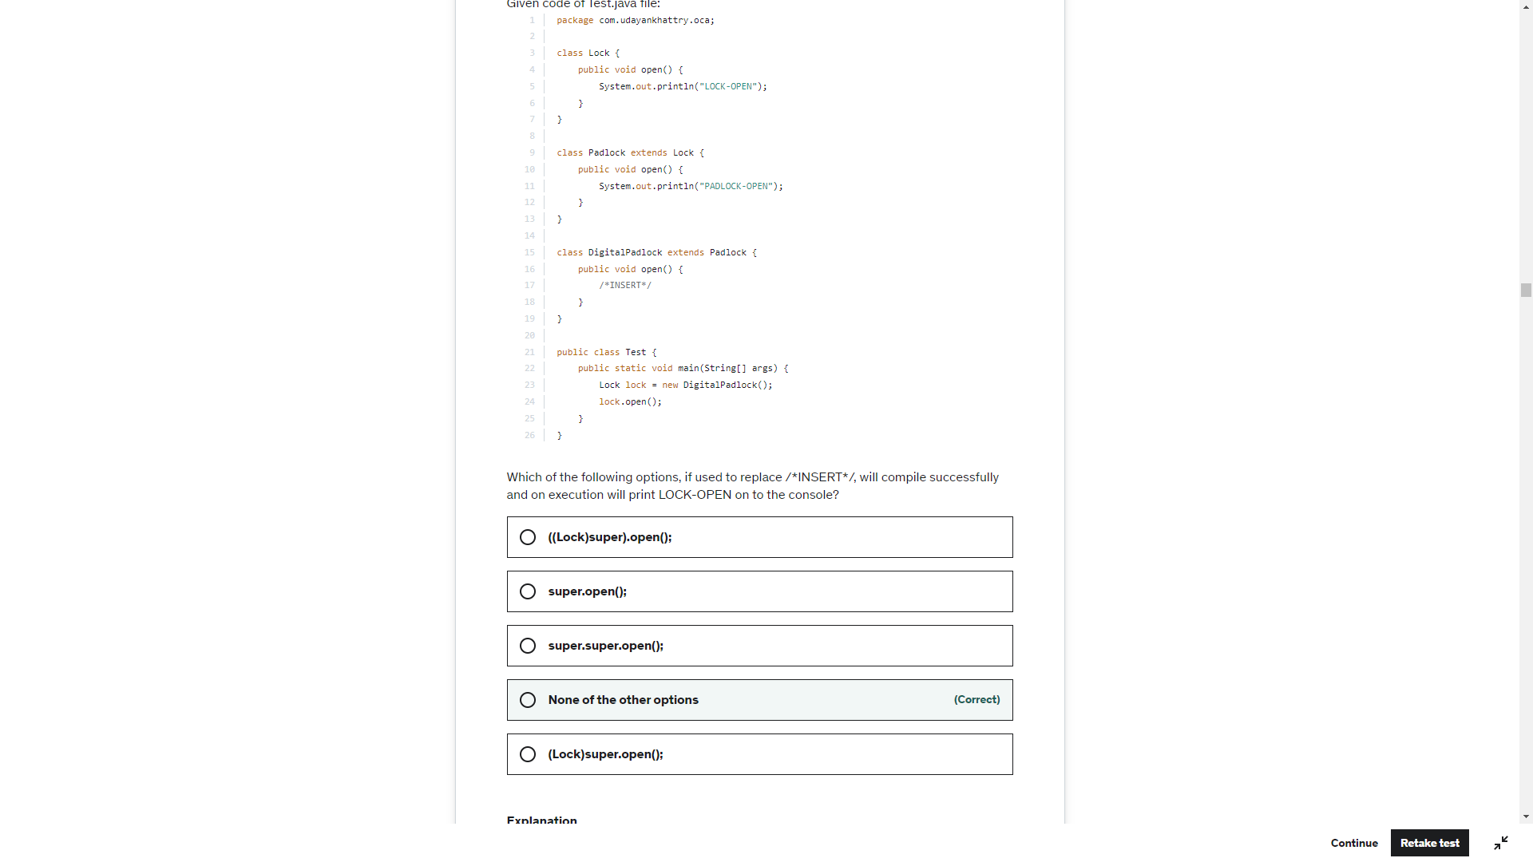

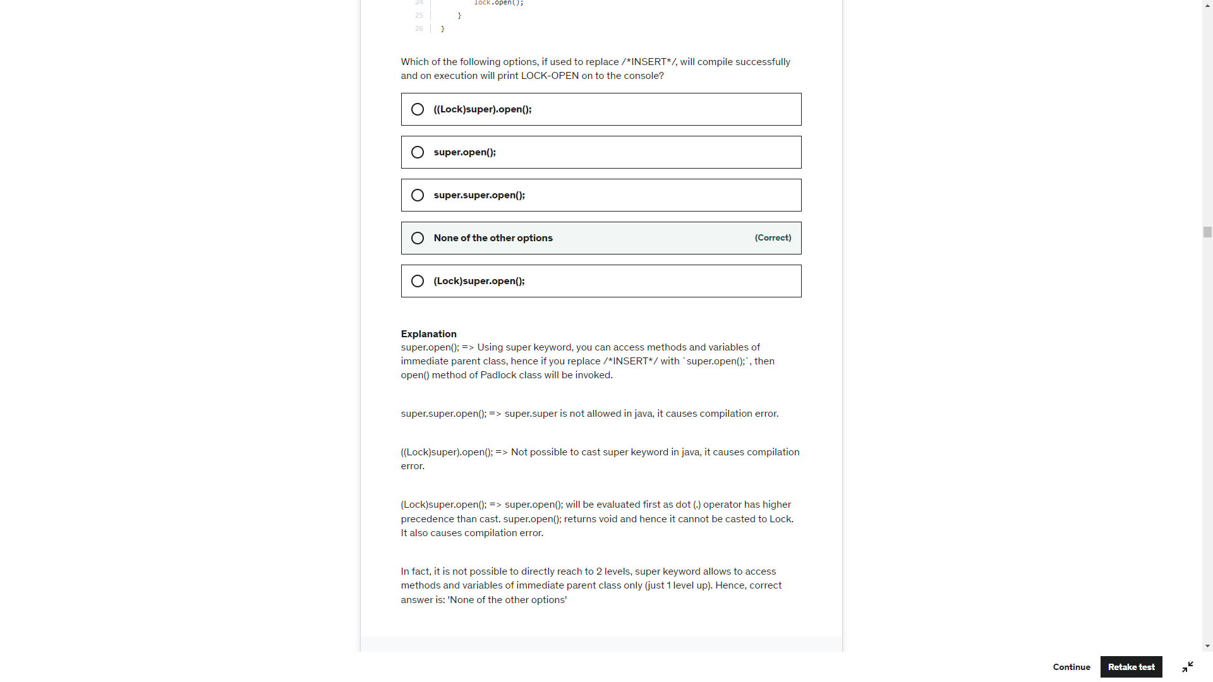

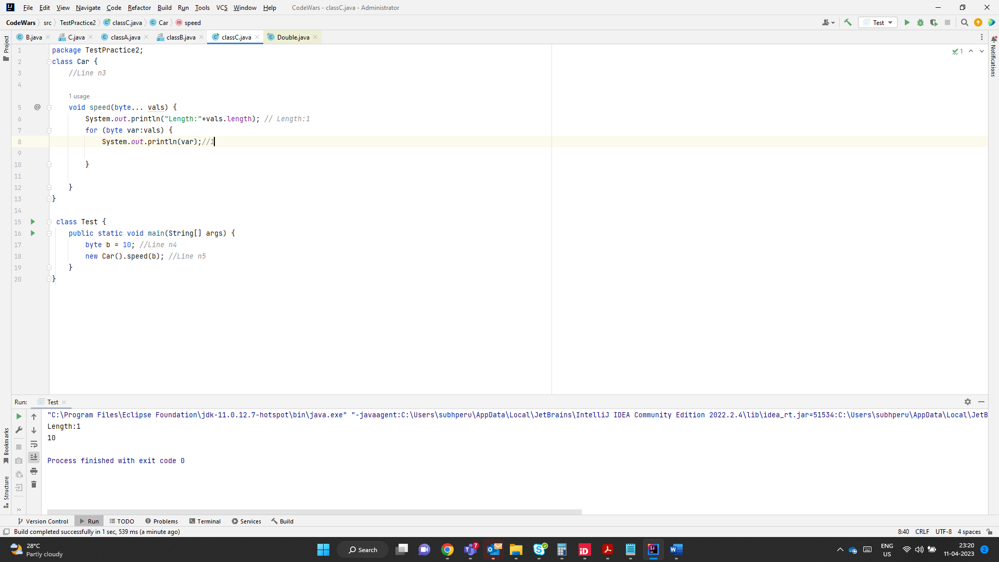

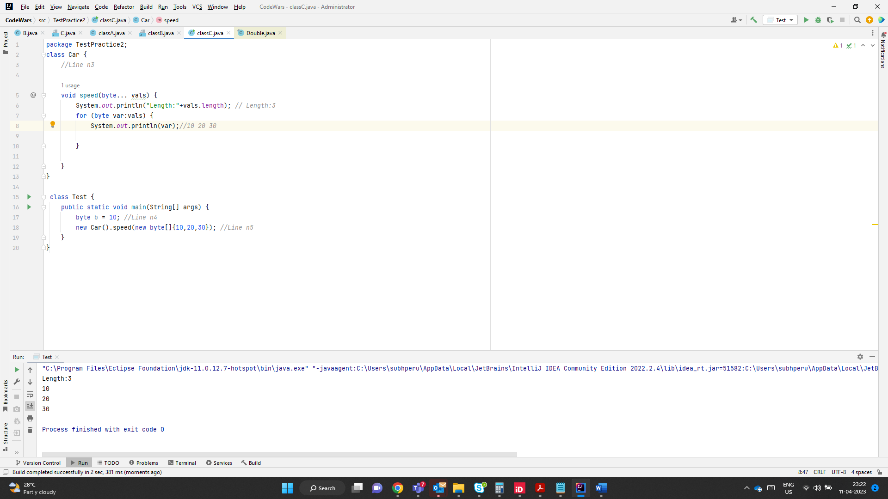

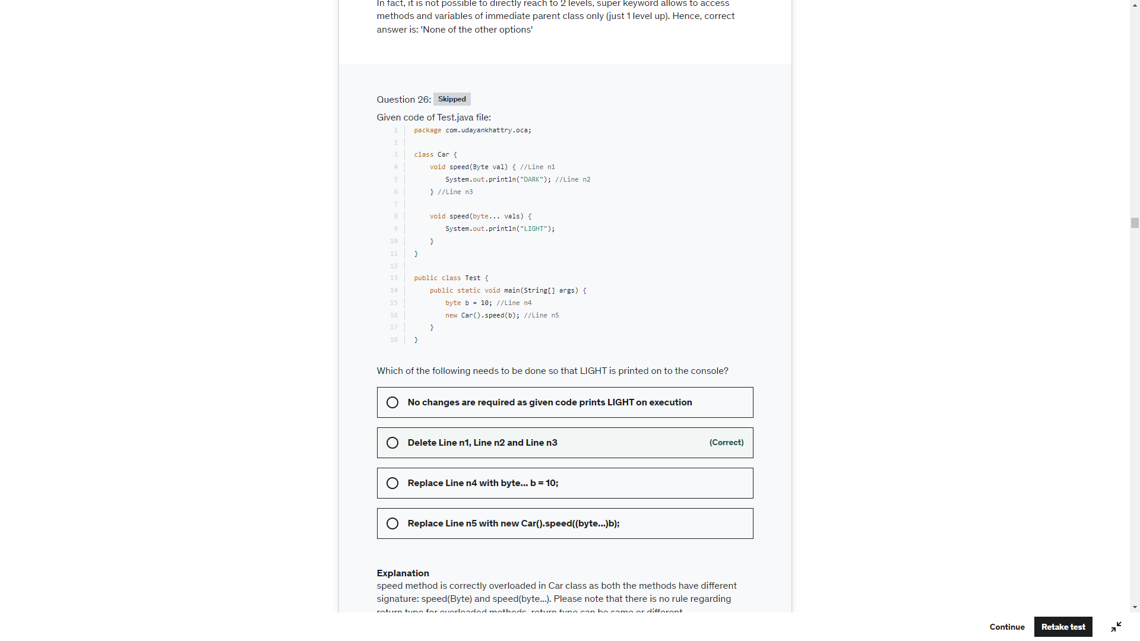

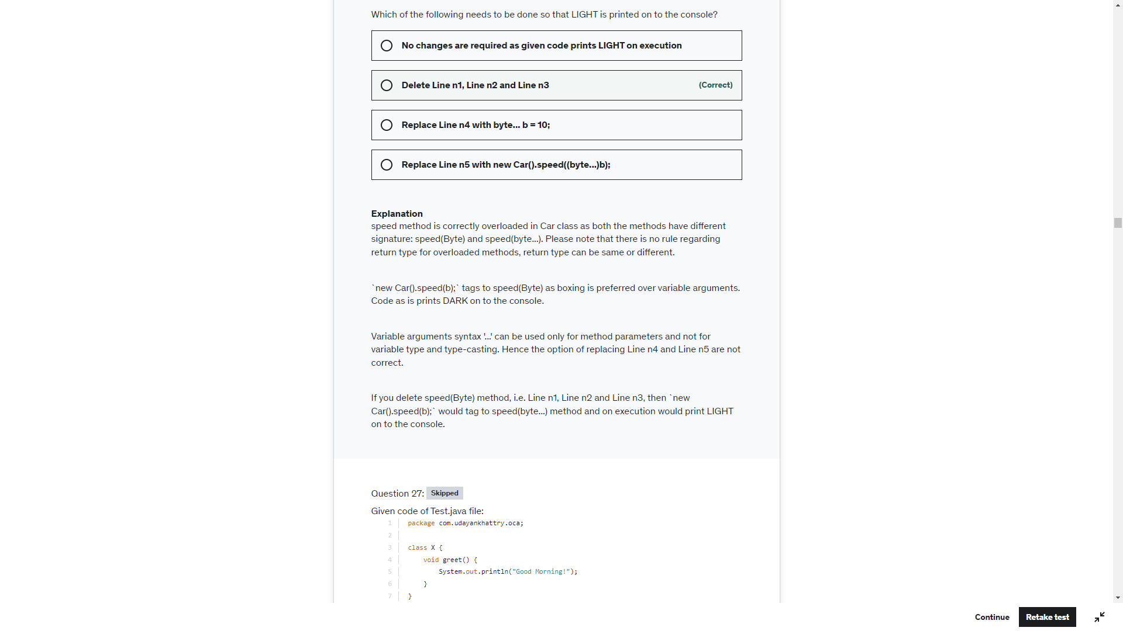

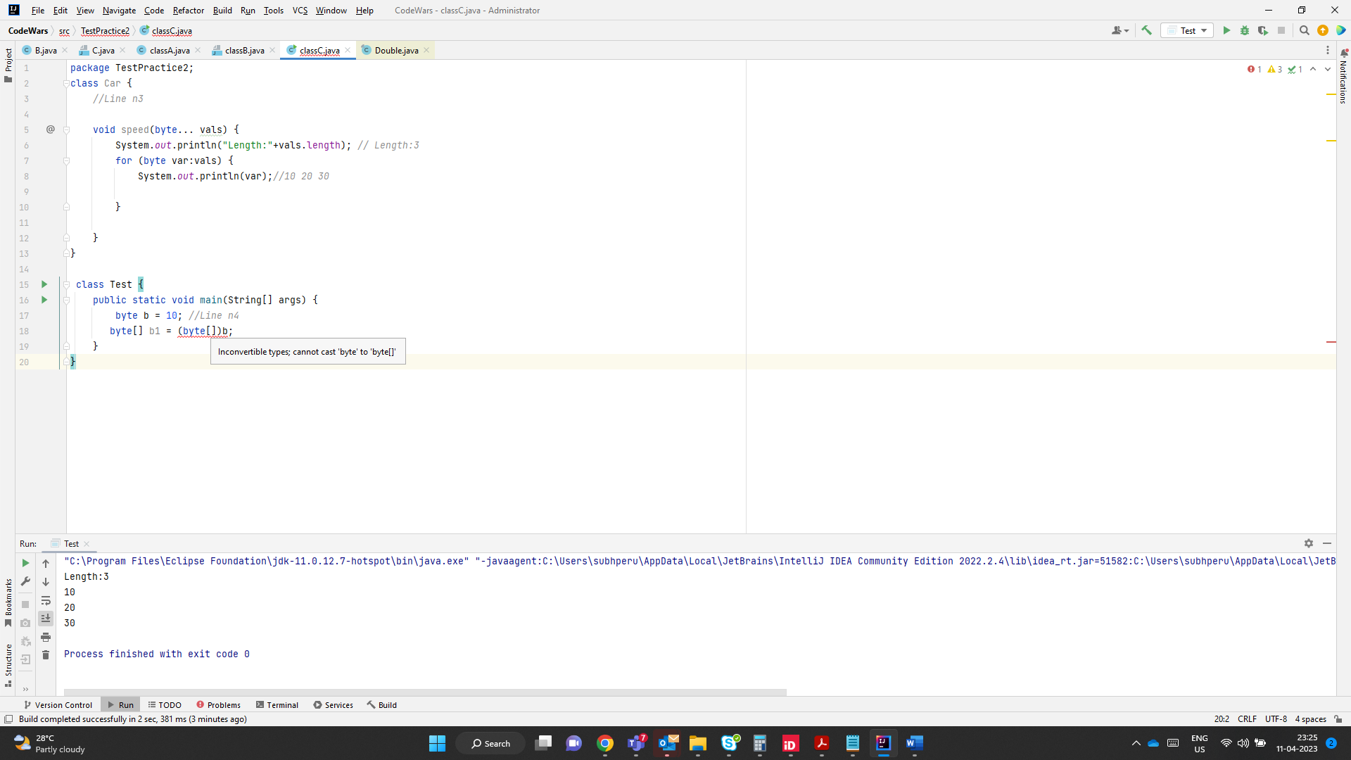

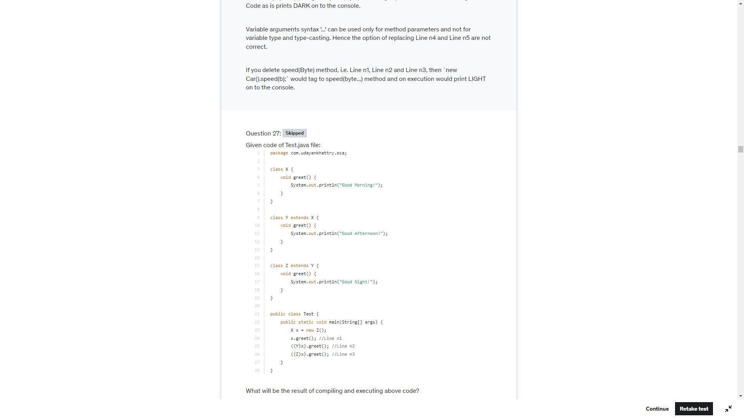

Good Night

Good Night

Good Night

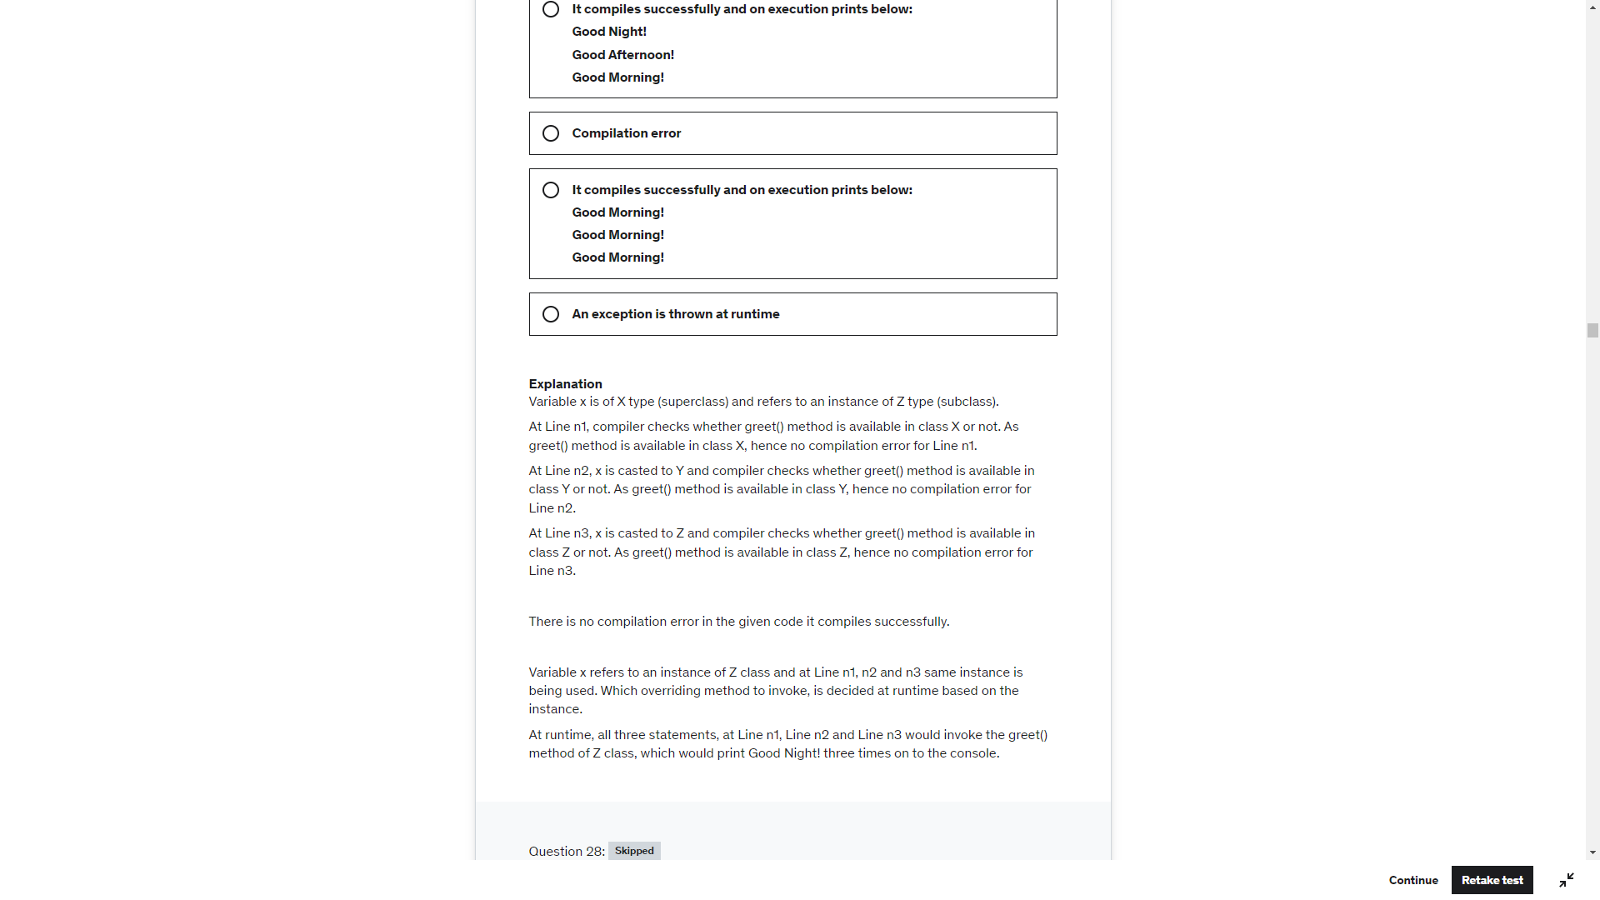

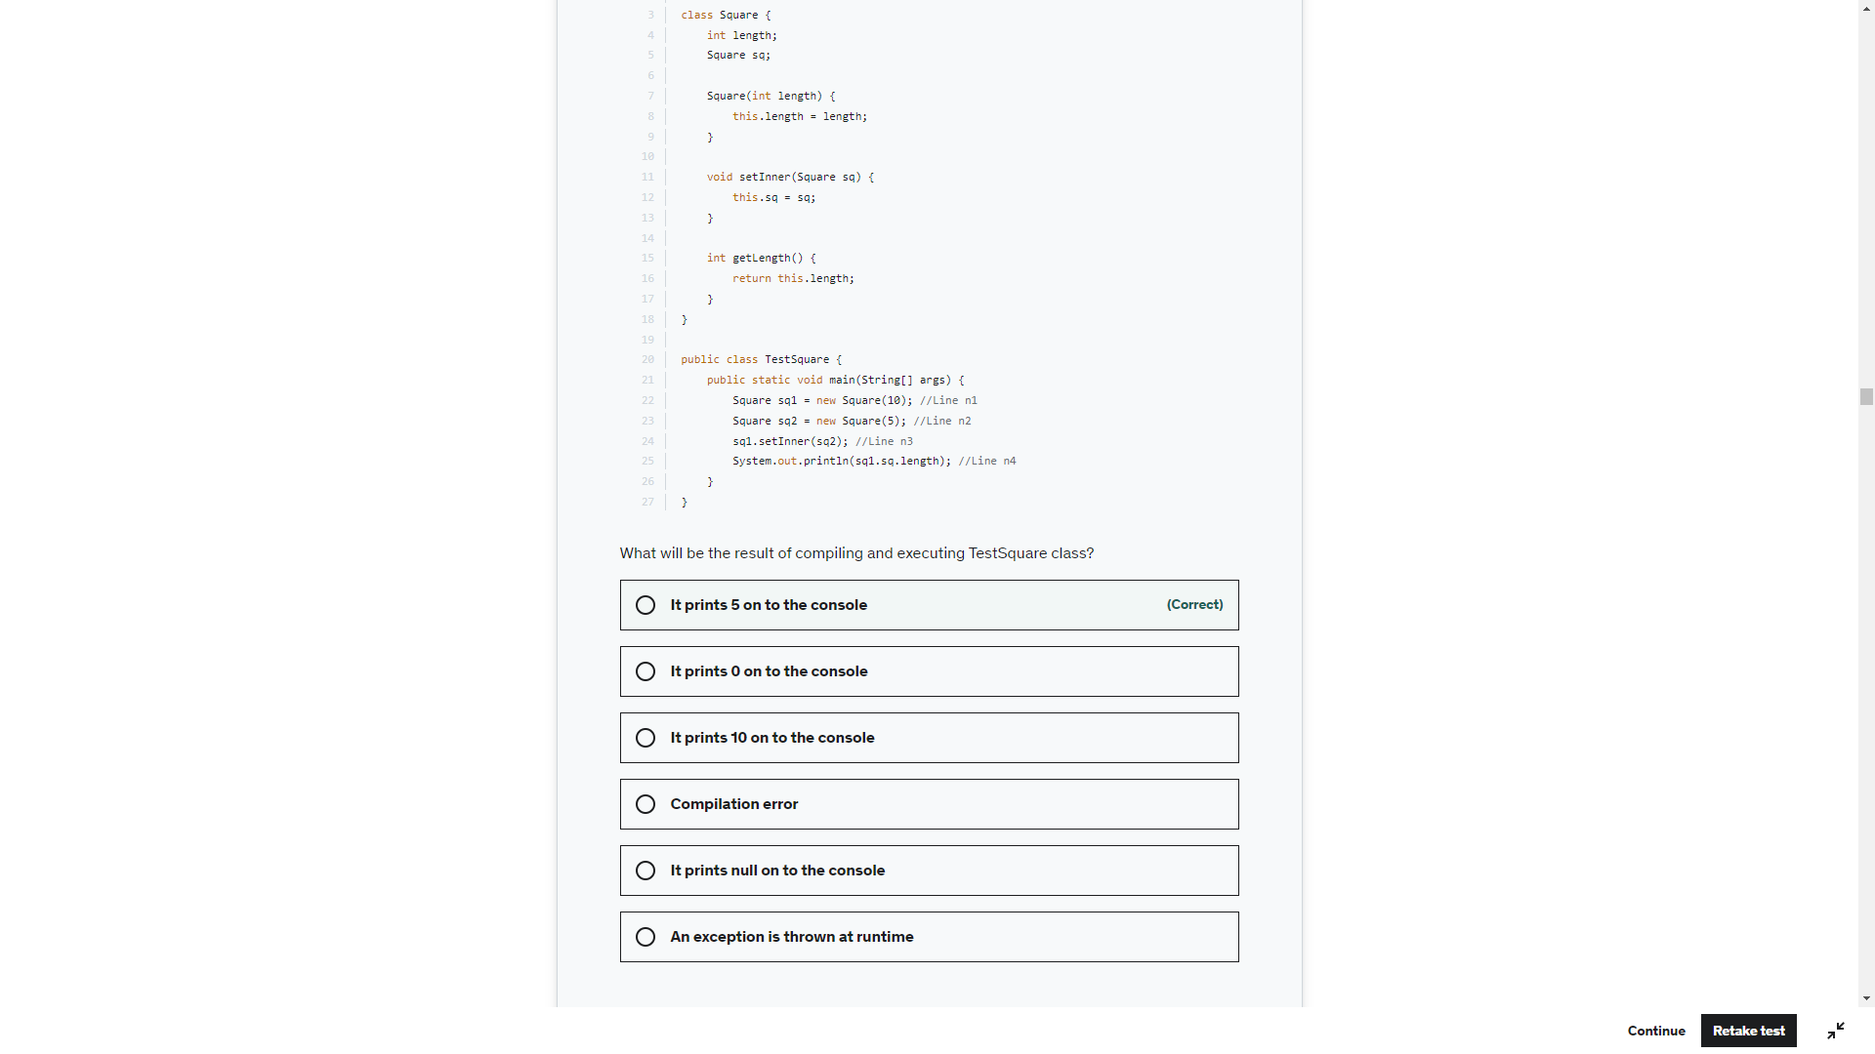

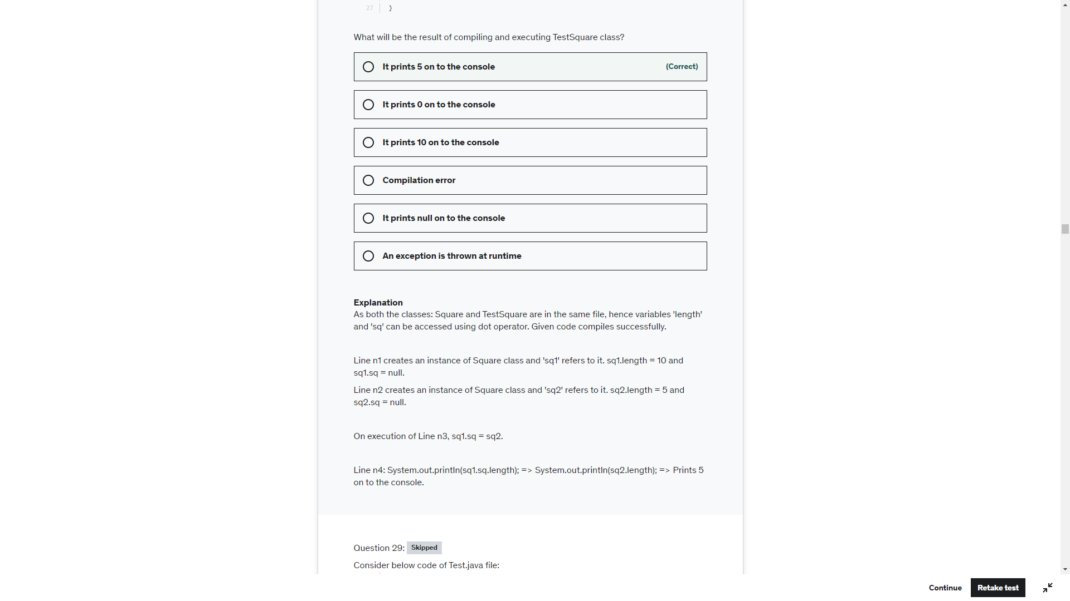

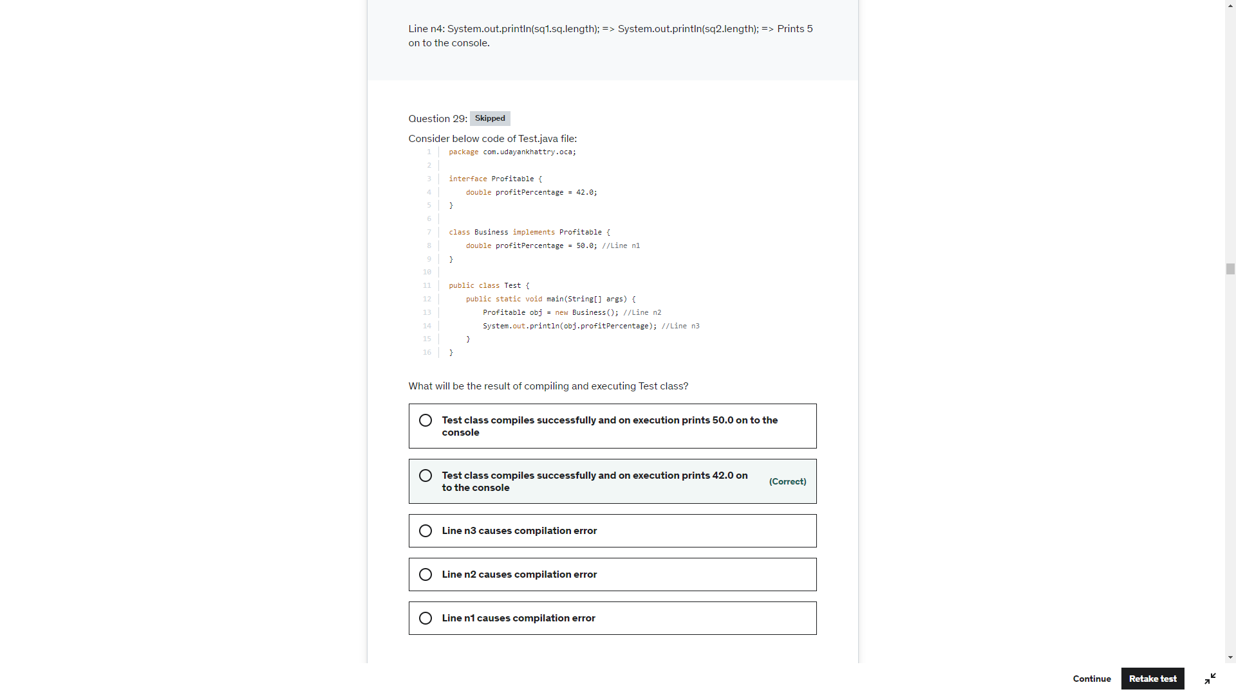

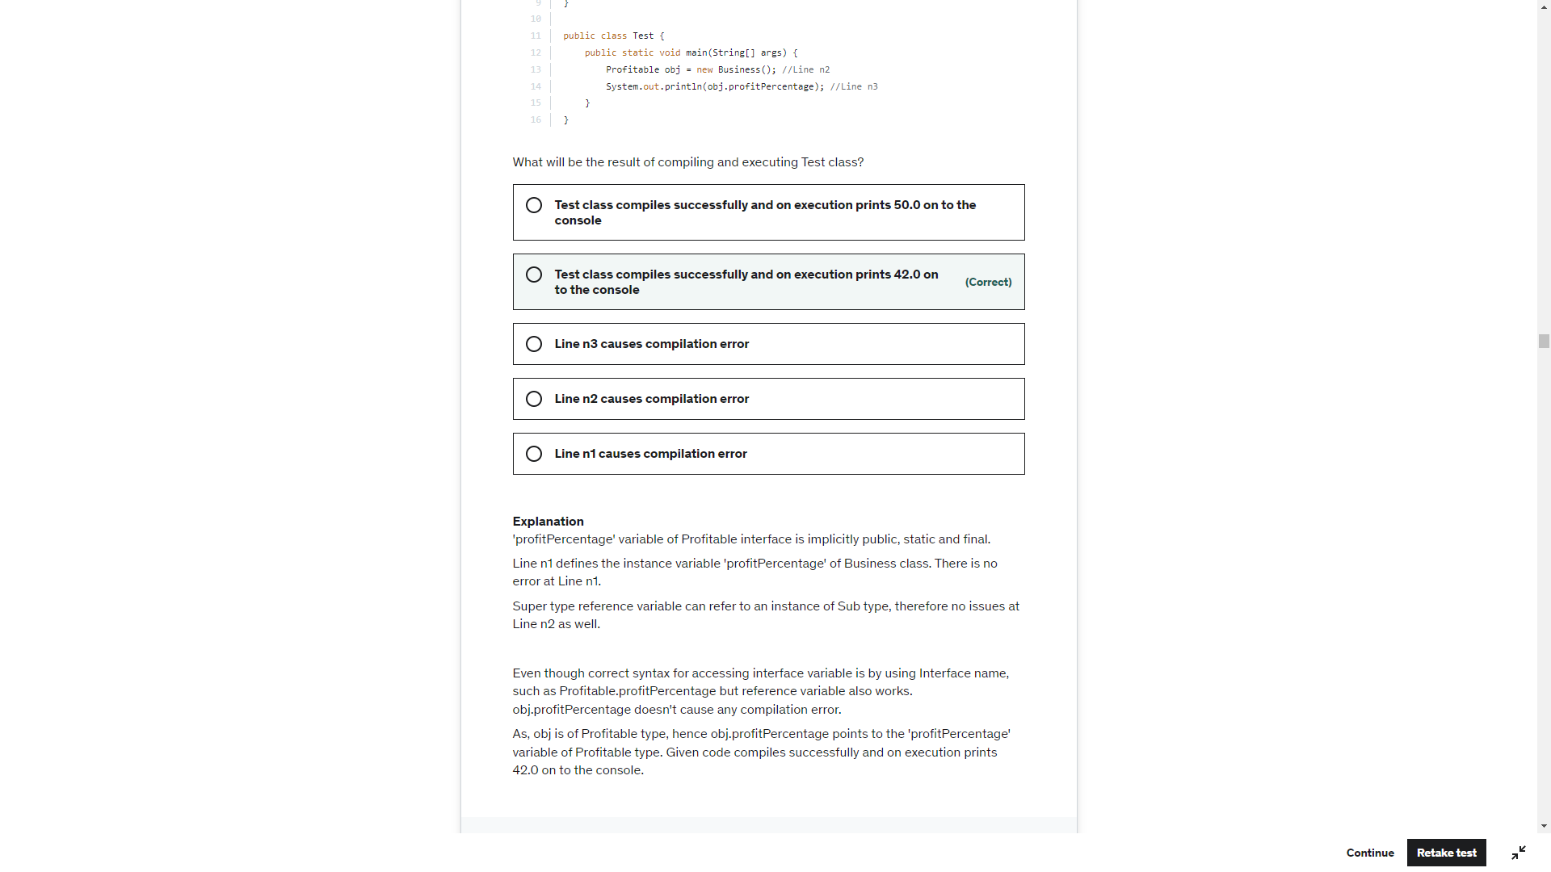

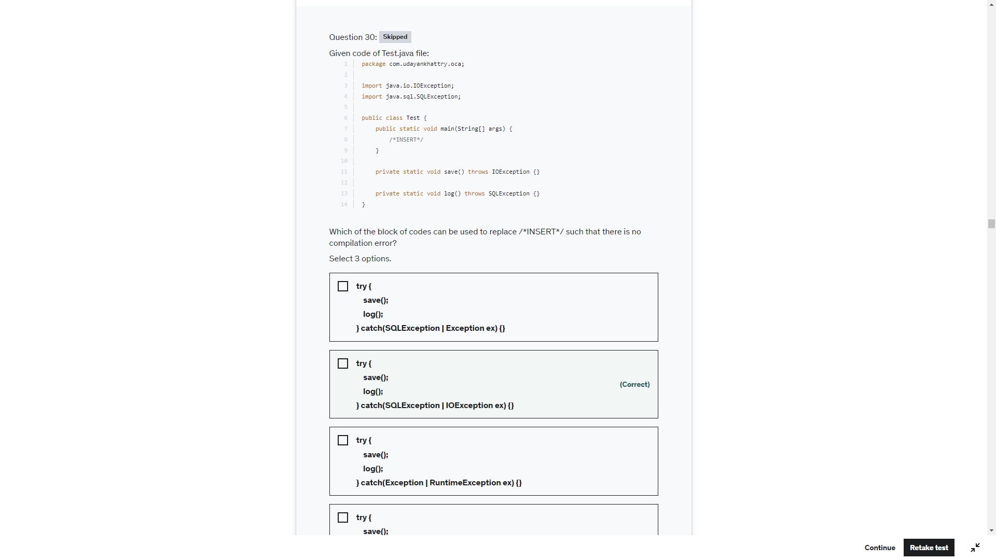

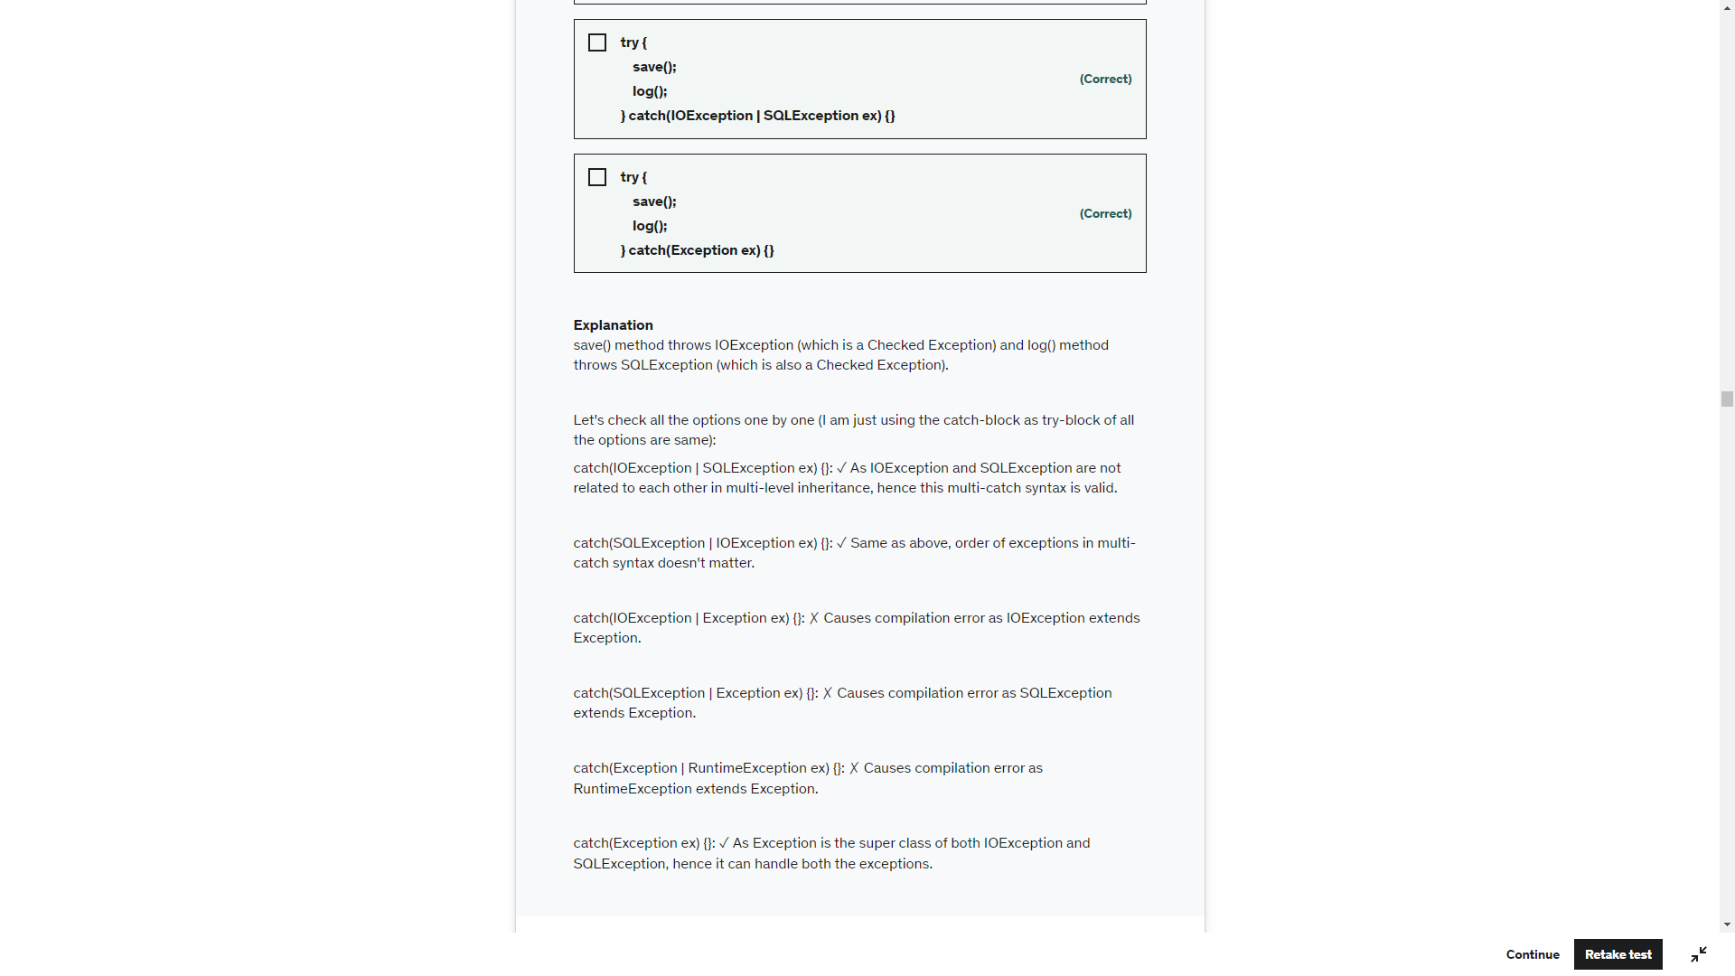

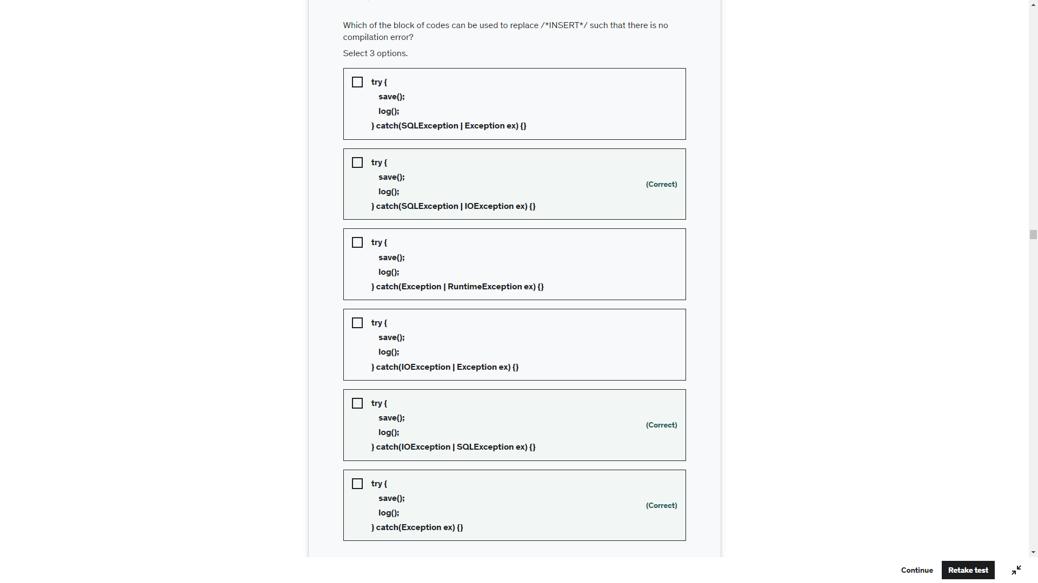

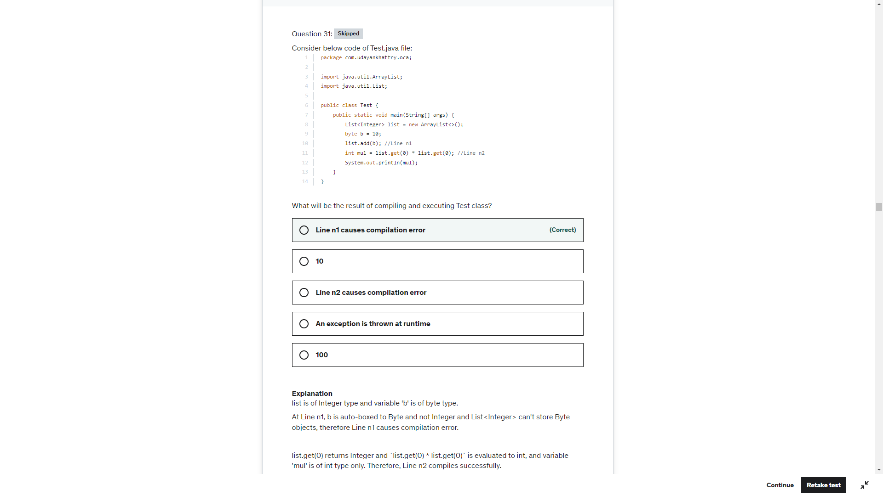

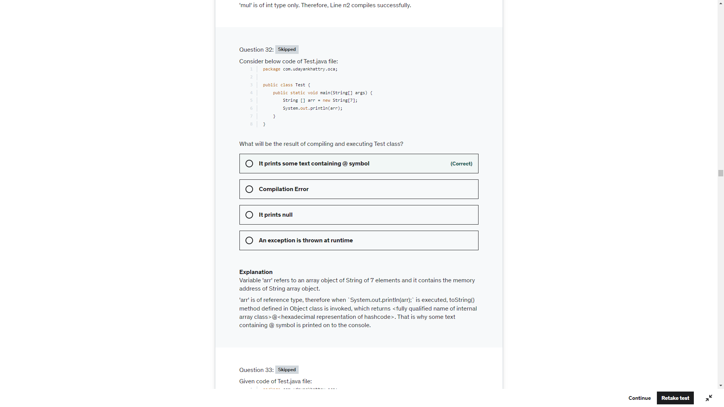

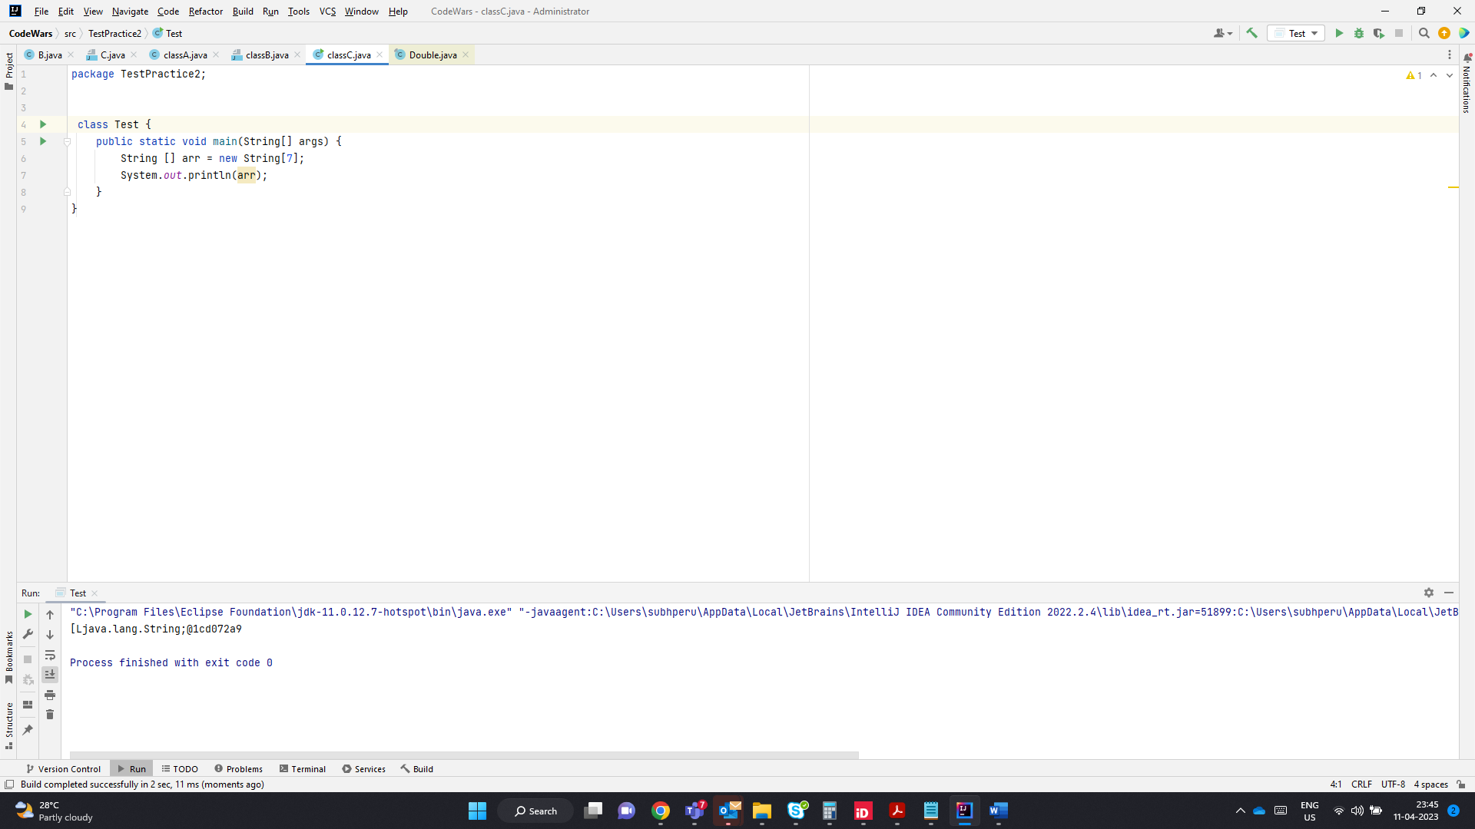

Int[] ->[I@1cd072a9

Integer[] ->[Ljava.lang.Integer;@1cd072a9

String[] ->[Ljava.lang.String;@1cd072a9s

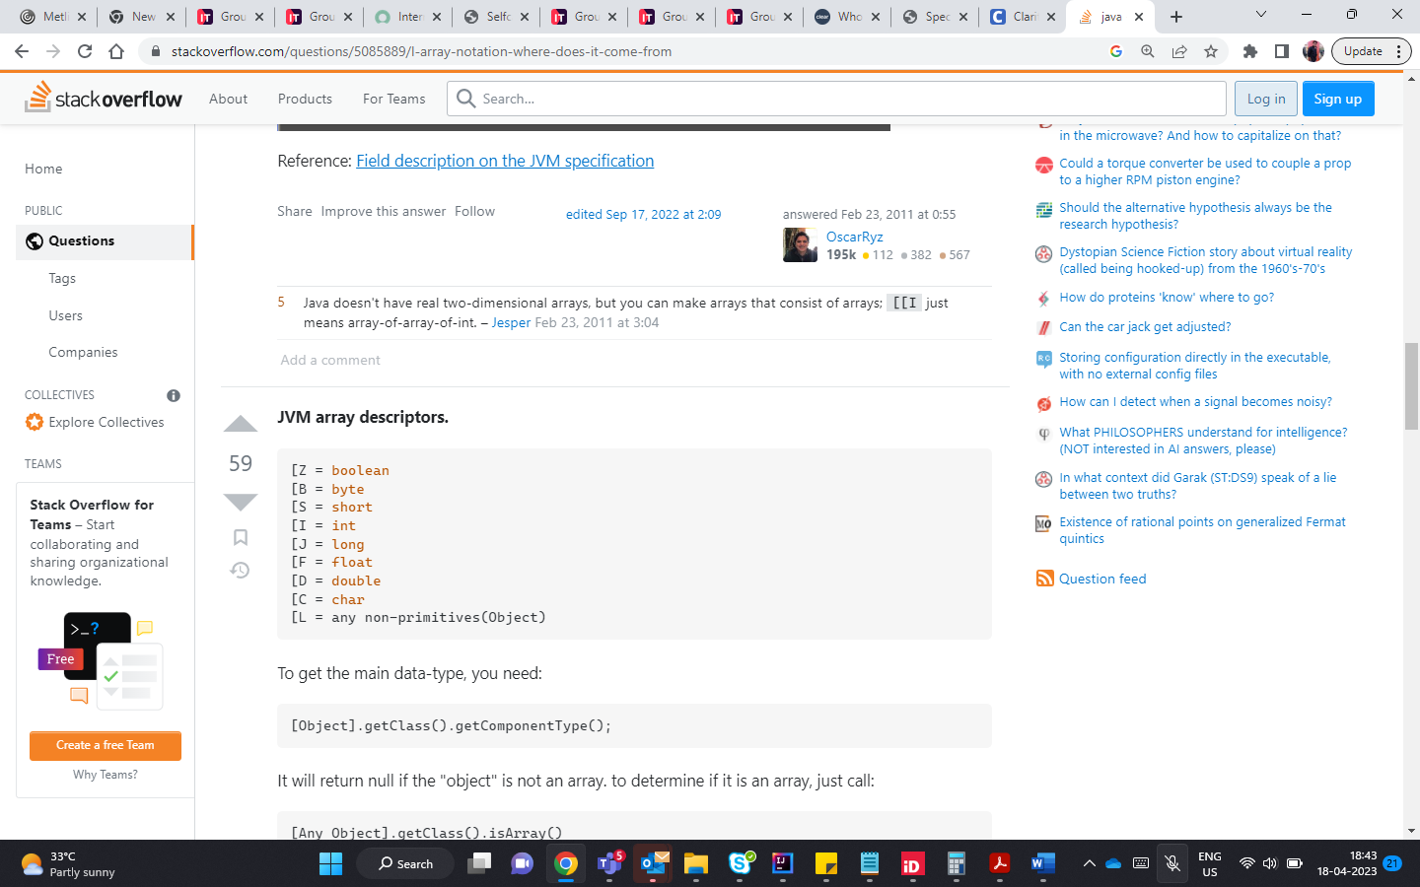

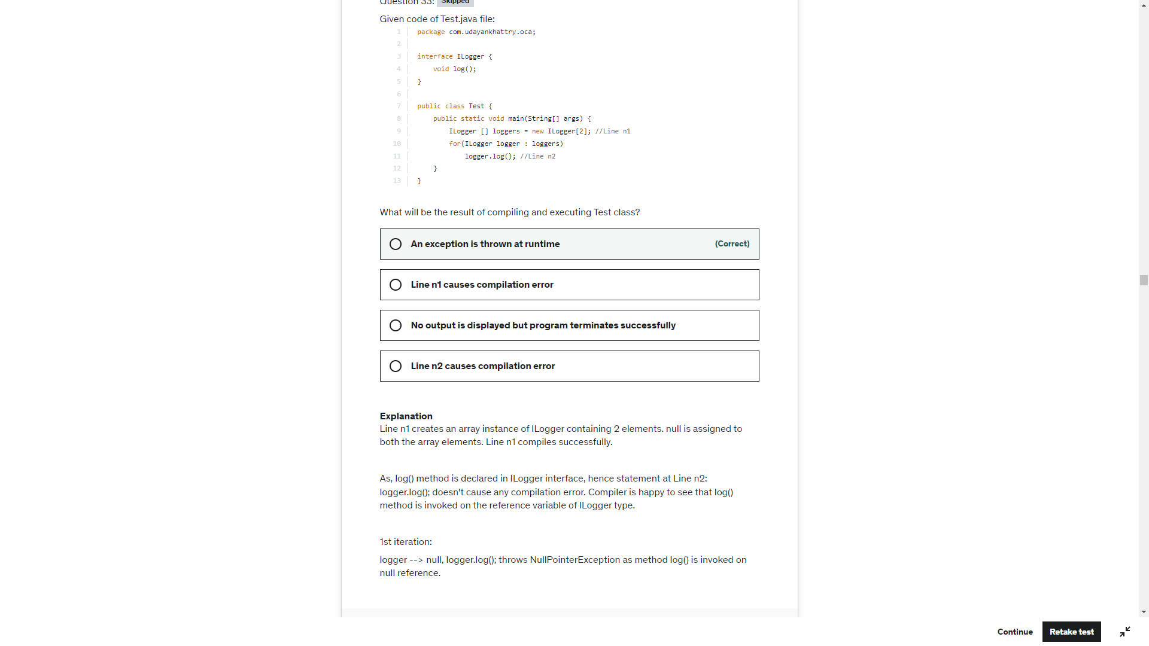

Here we are not creating new Ilogger object , we have just created an of type ILogger. There are no ILogger objects being created.

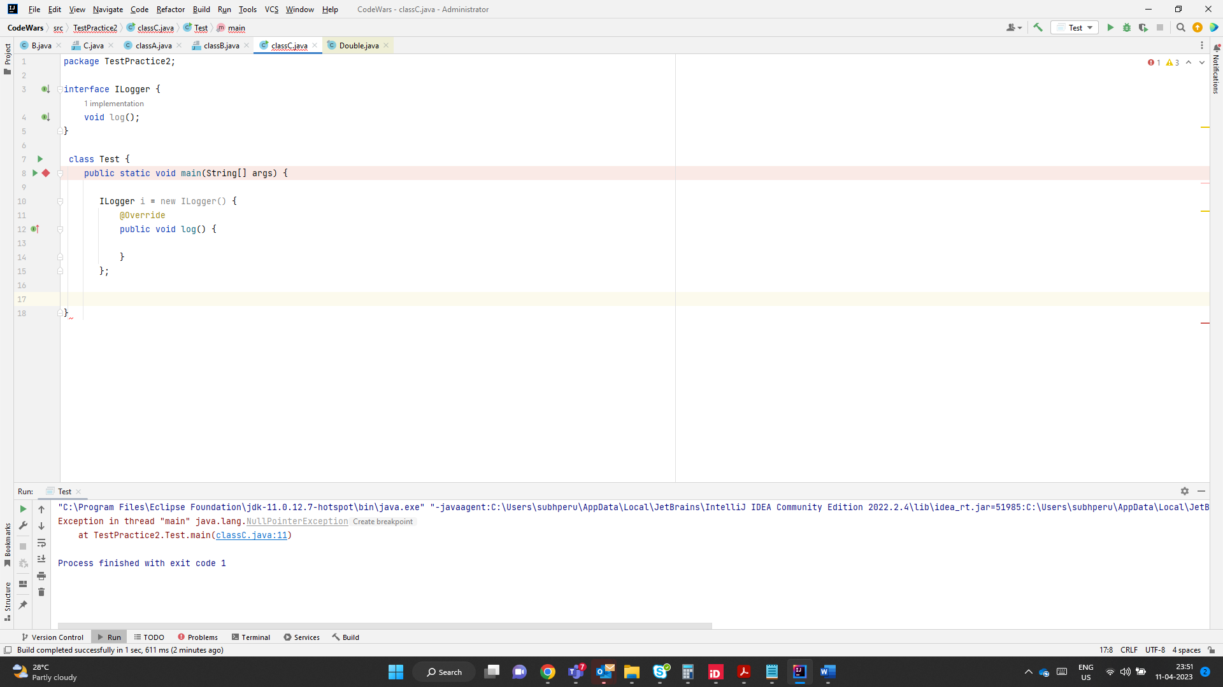

If you are creating an object of interface then you need to implement those methods

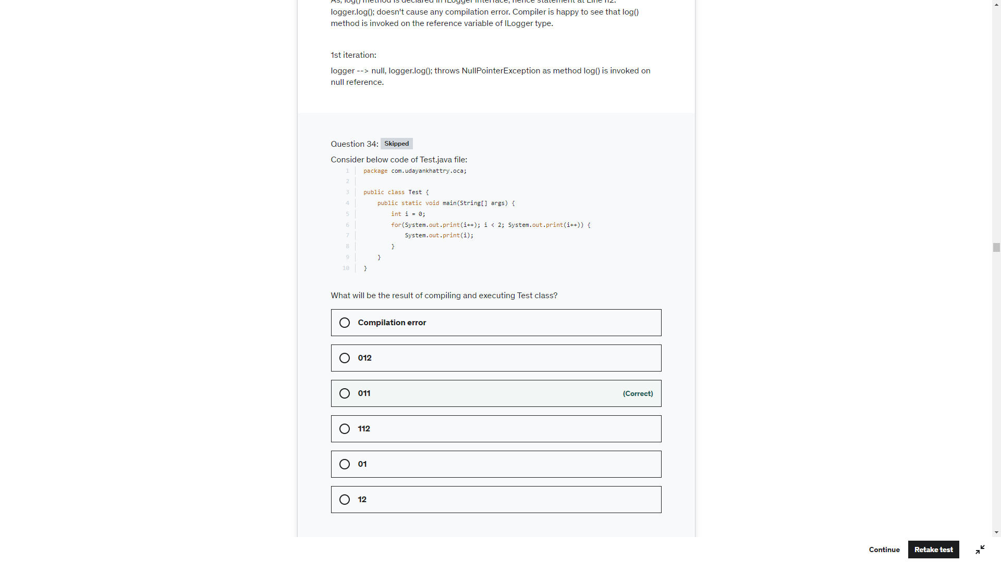

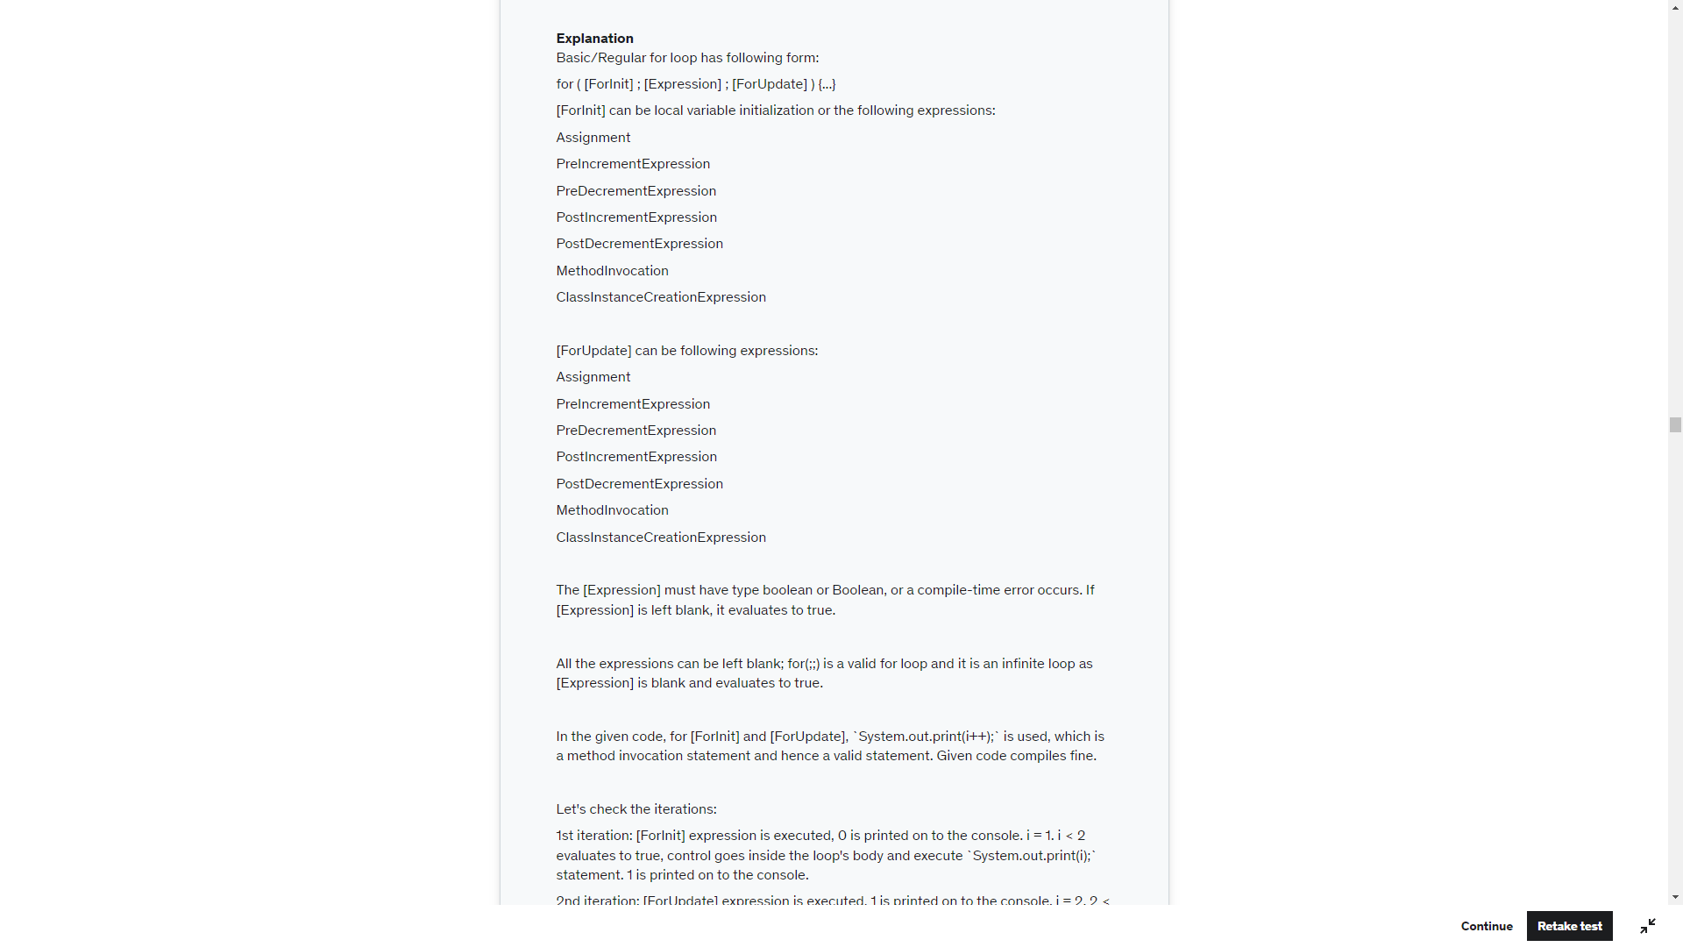

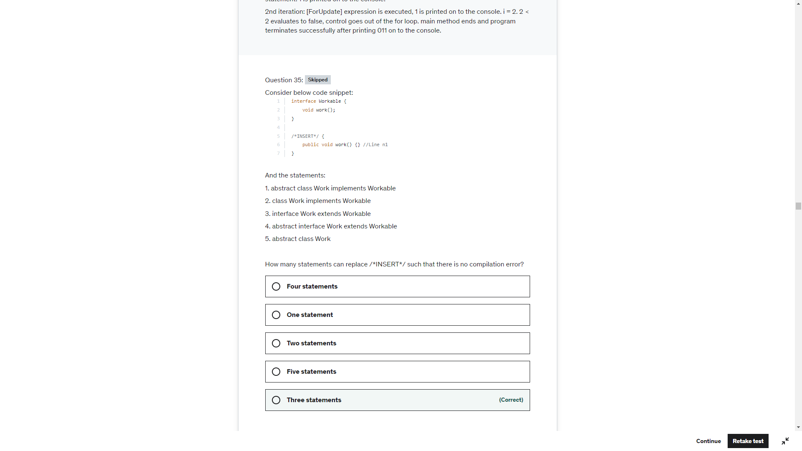

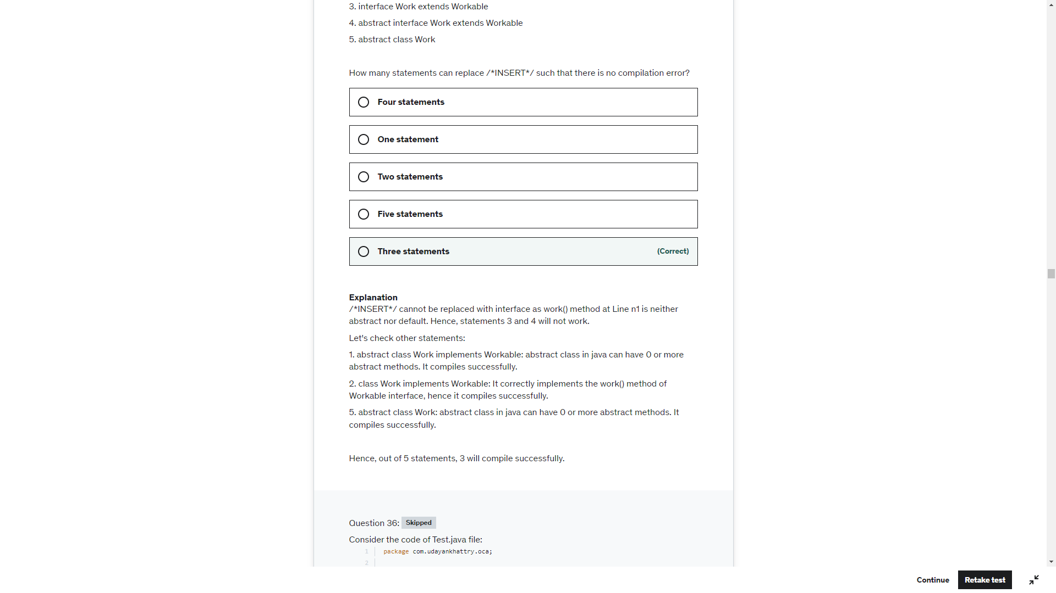

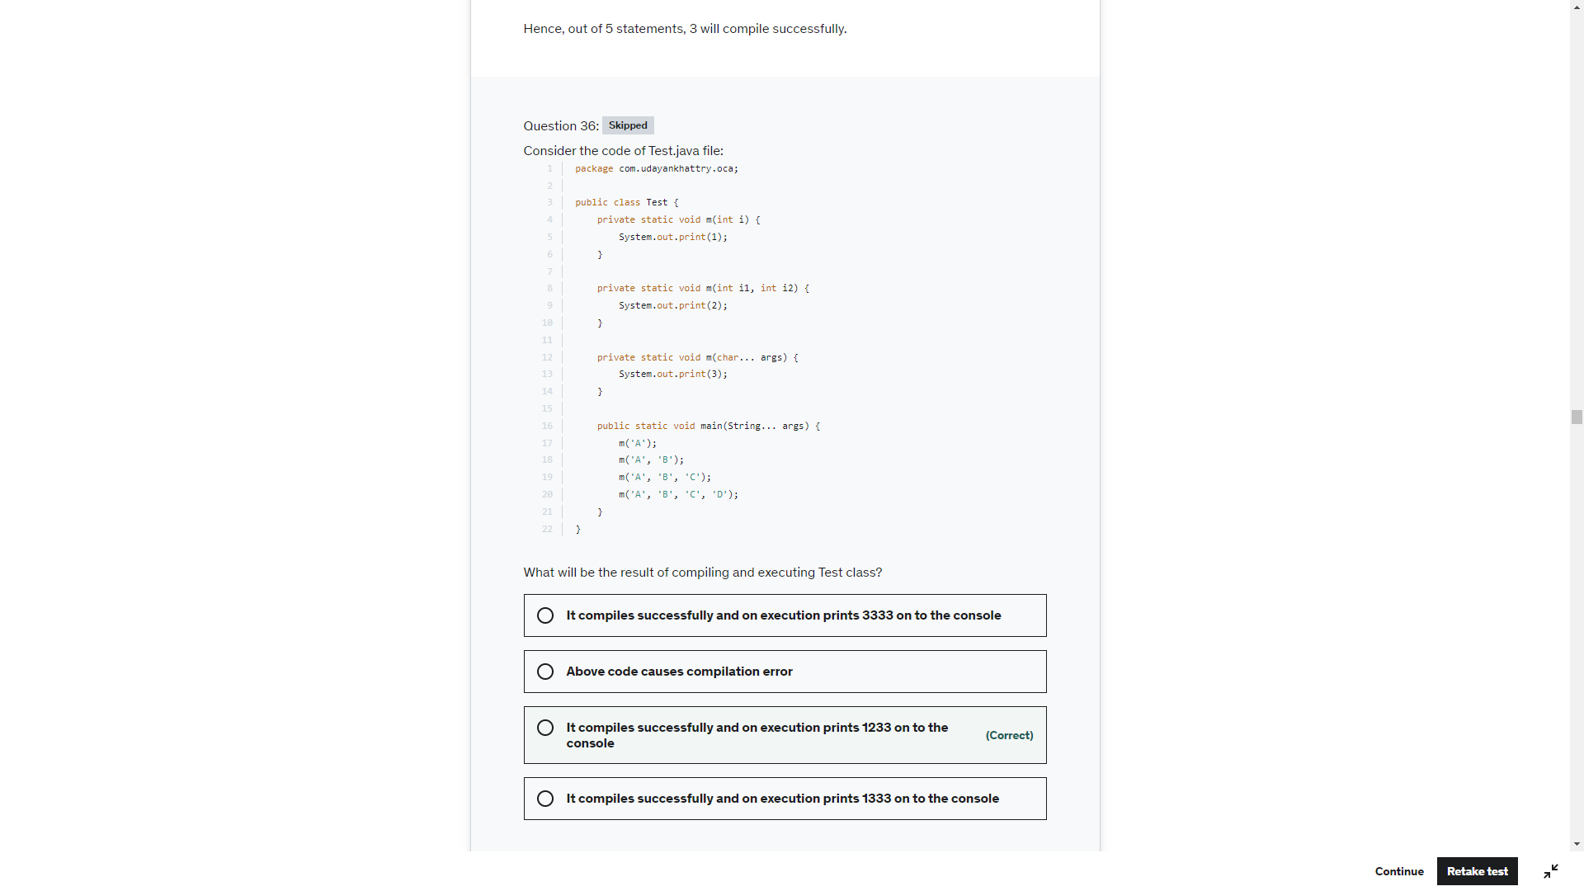

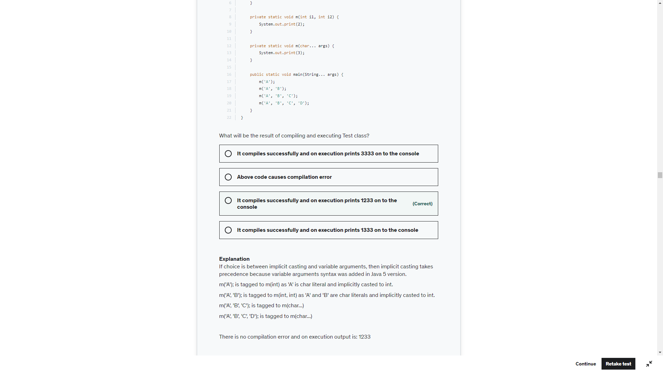

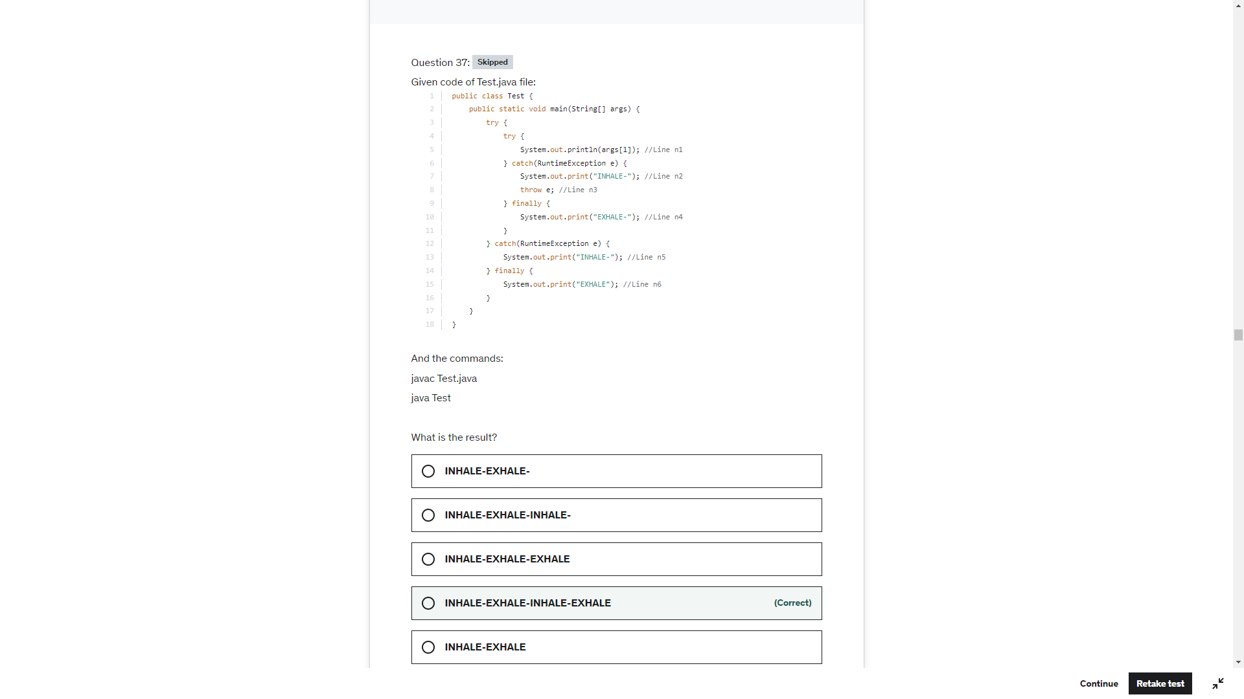

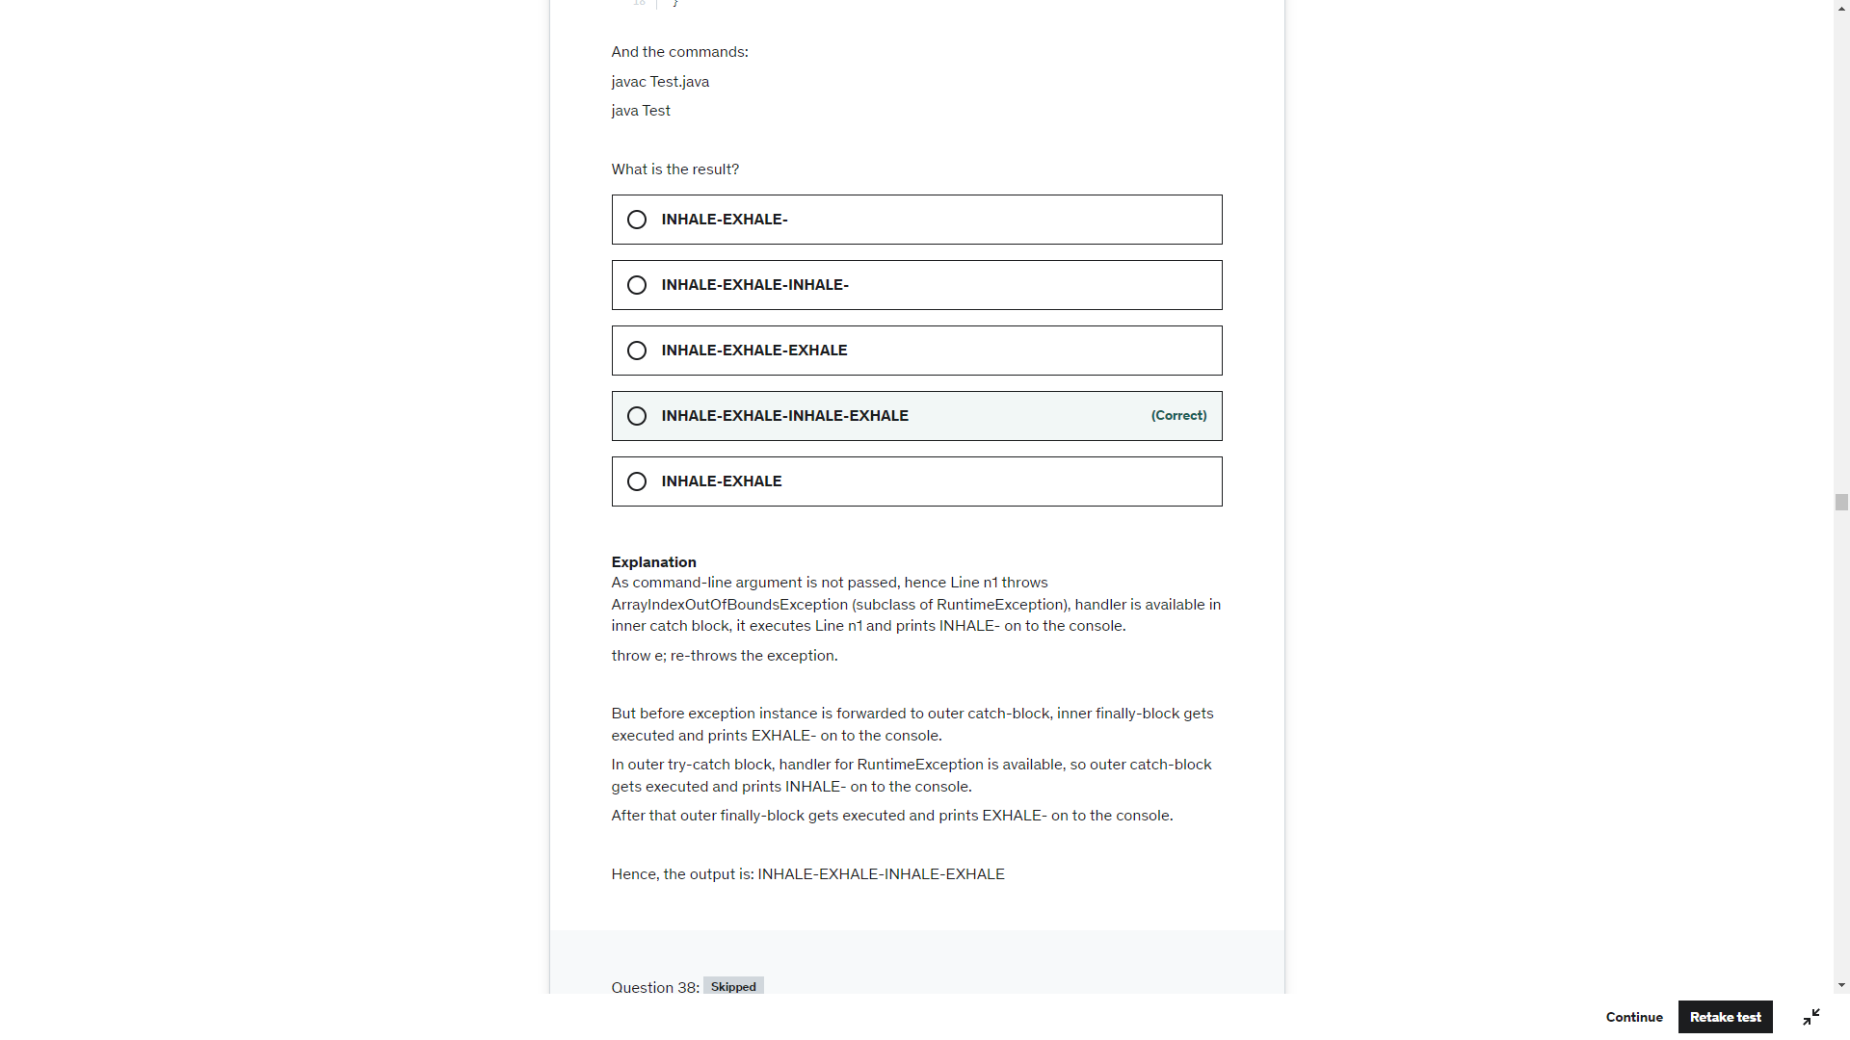

If the replcae method replace any character or character seq then new object is created else no change. Becarefull with the below explanation

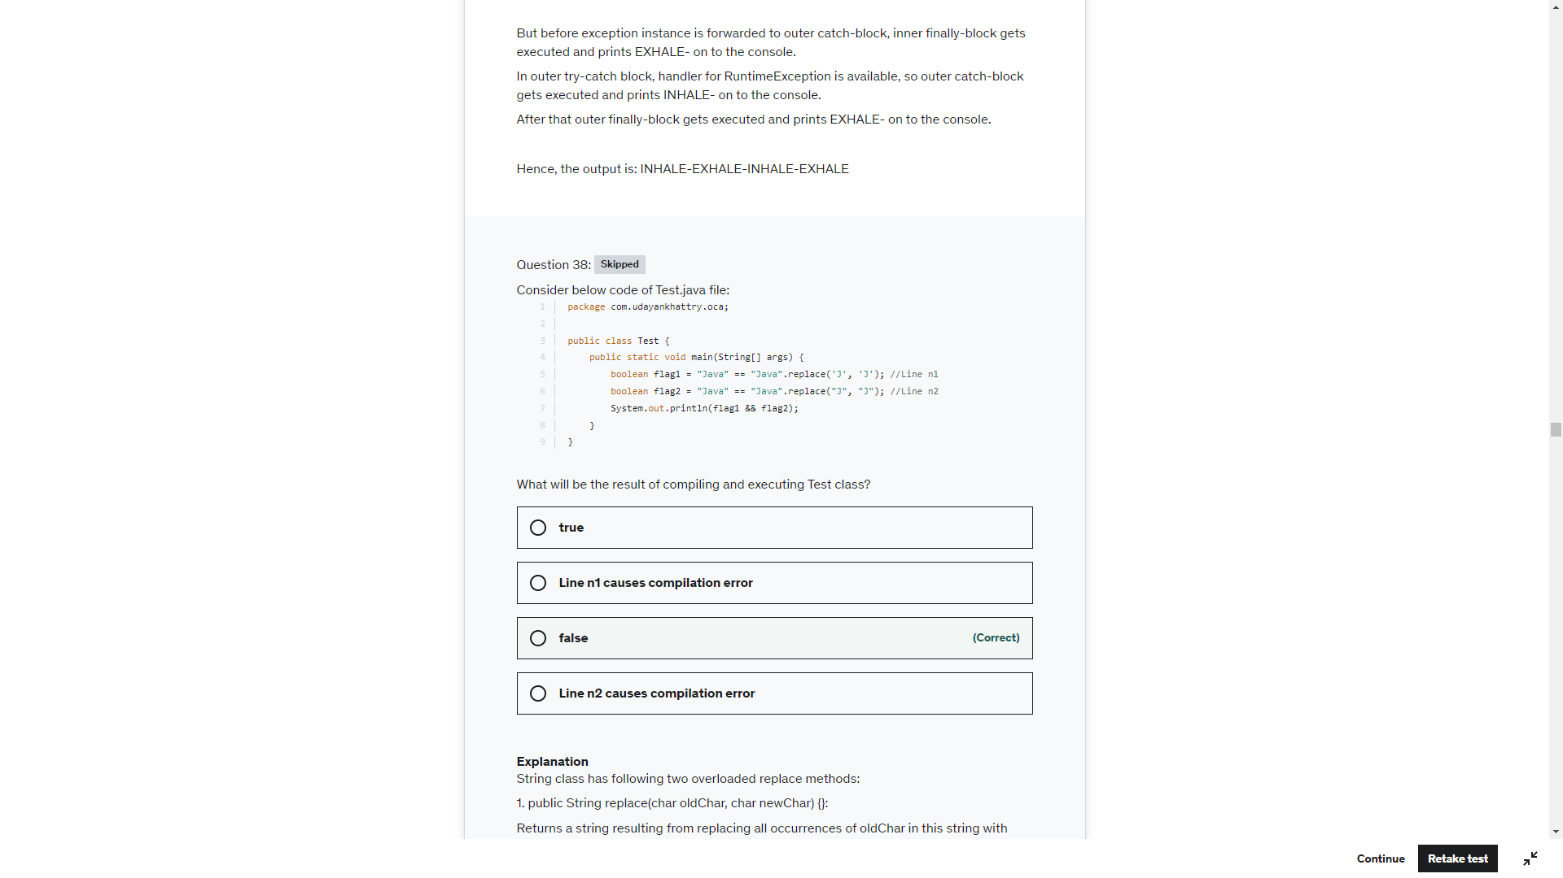

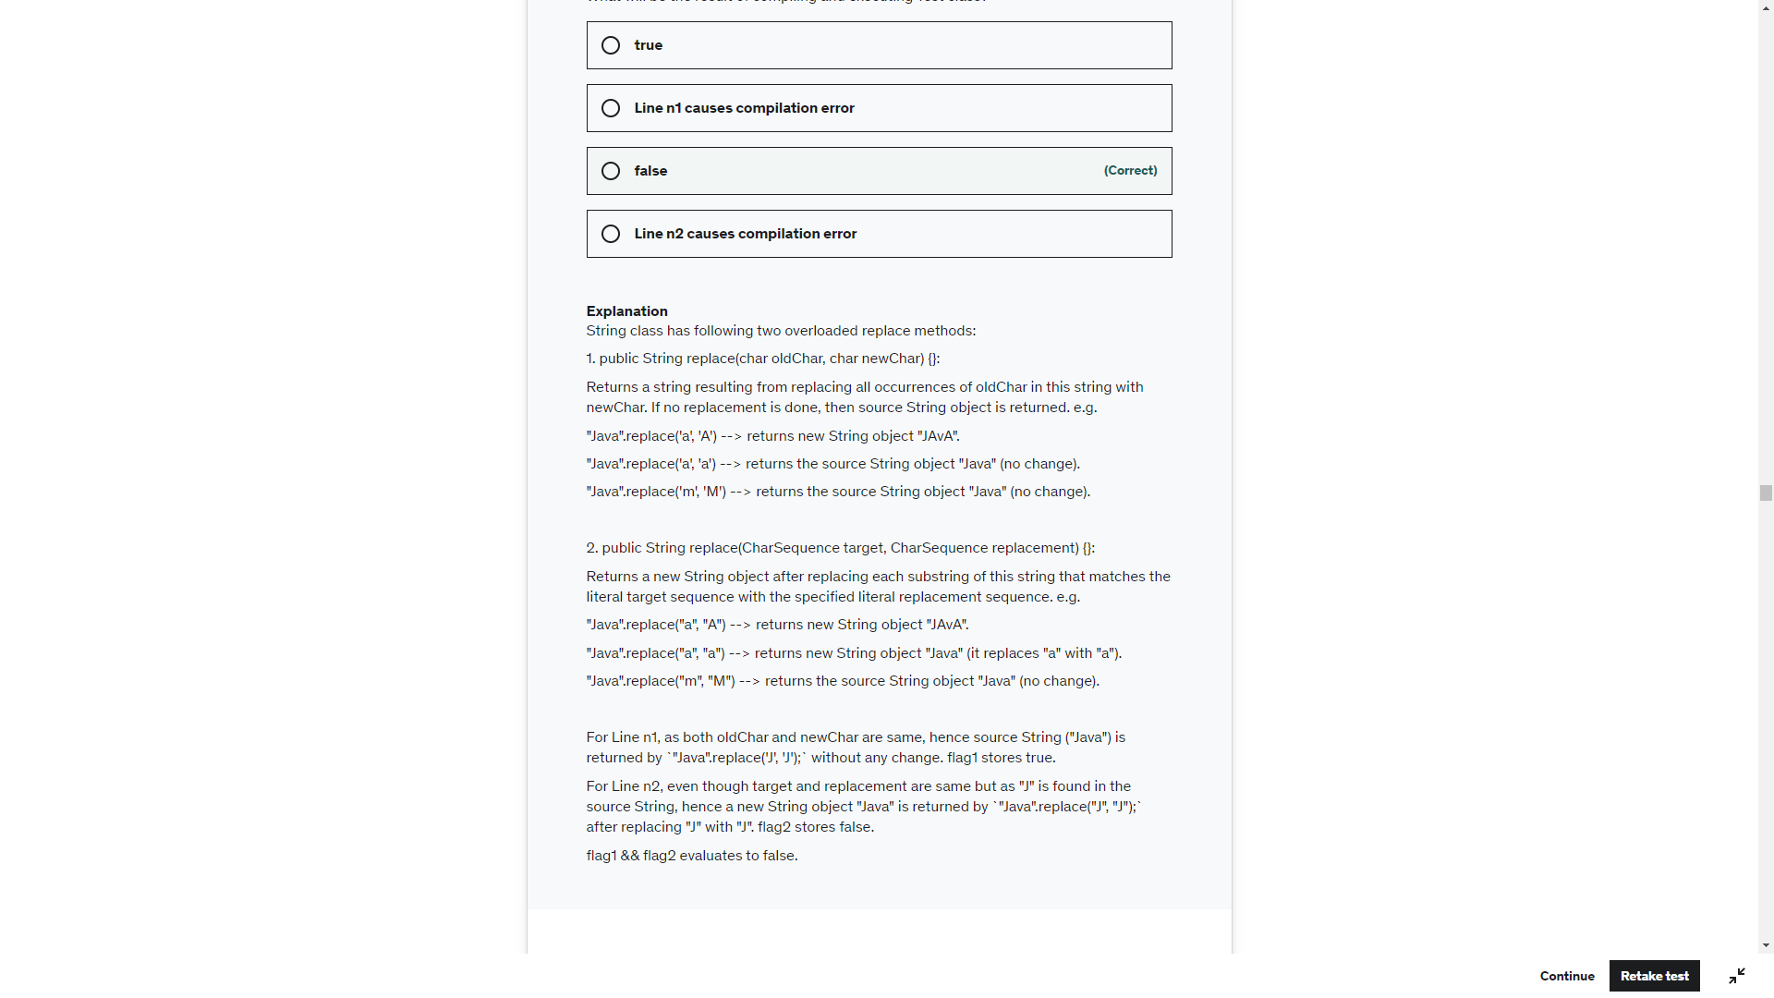

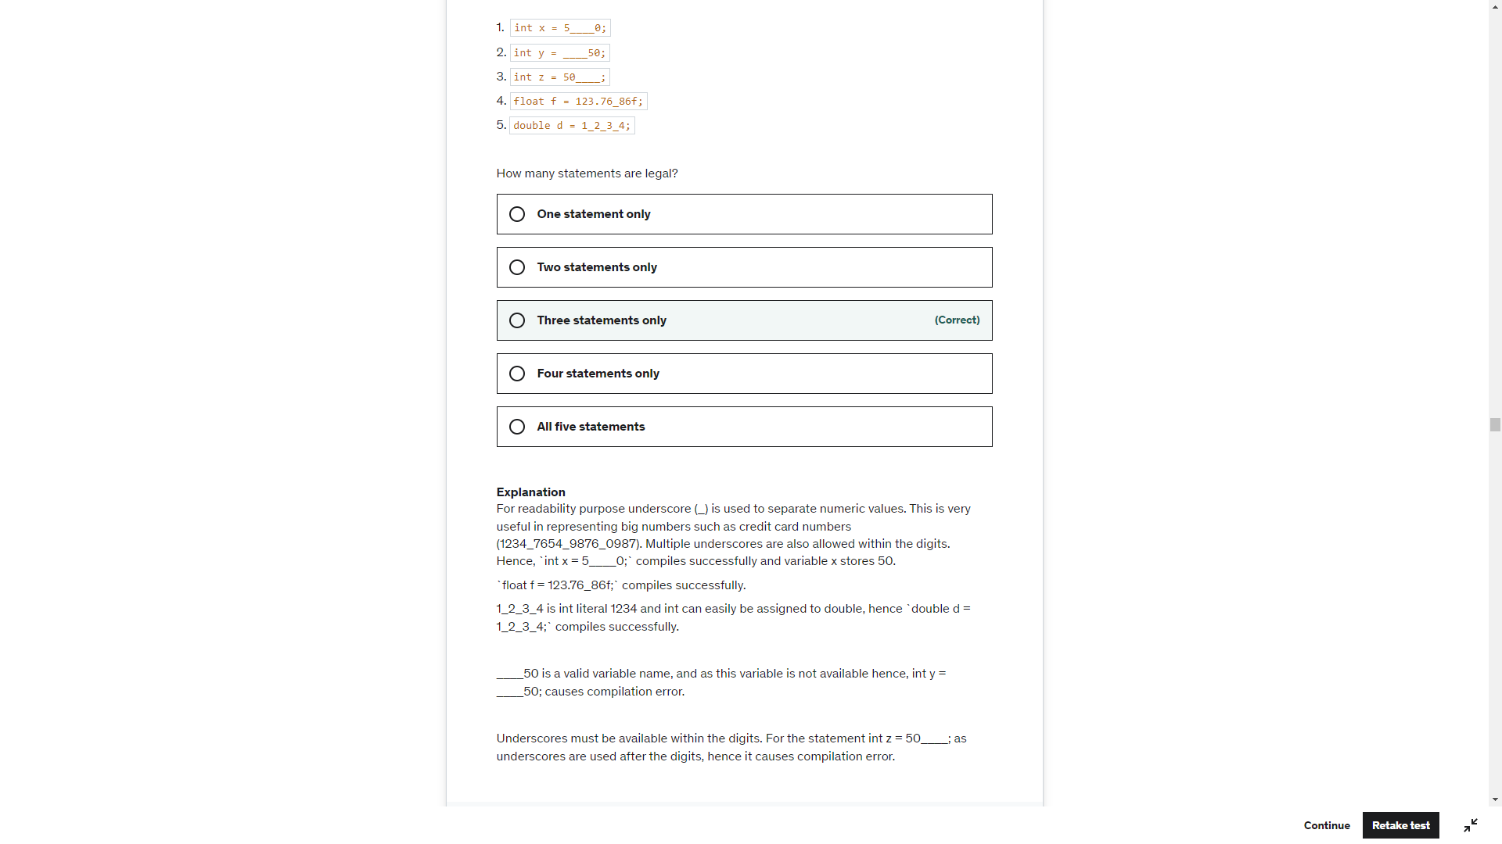

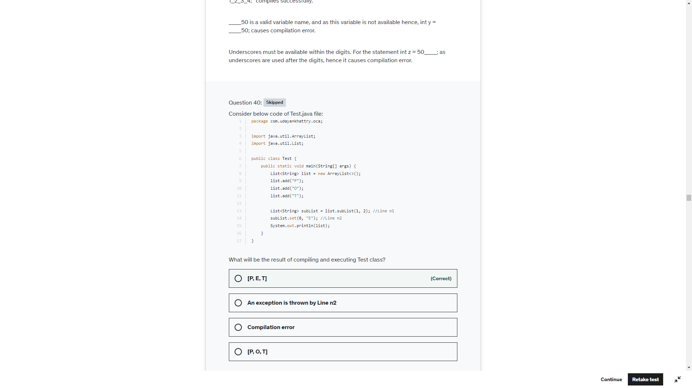

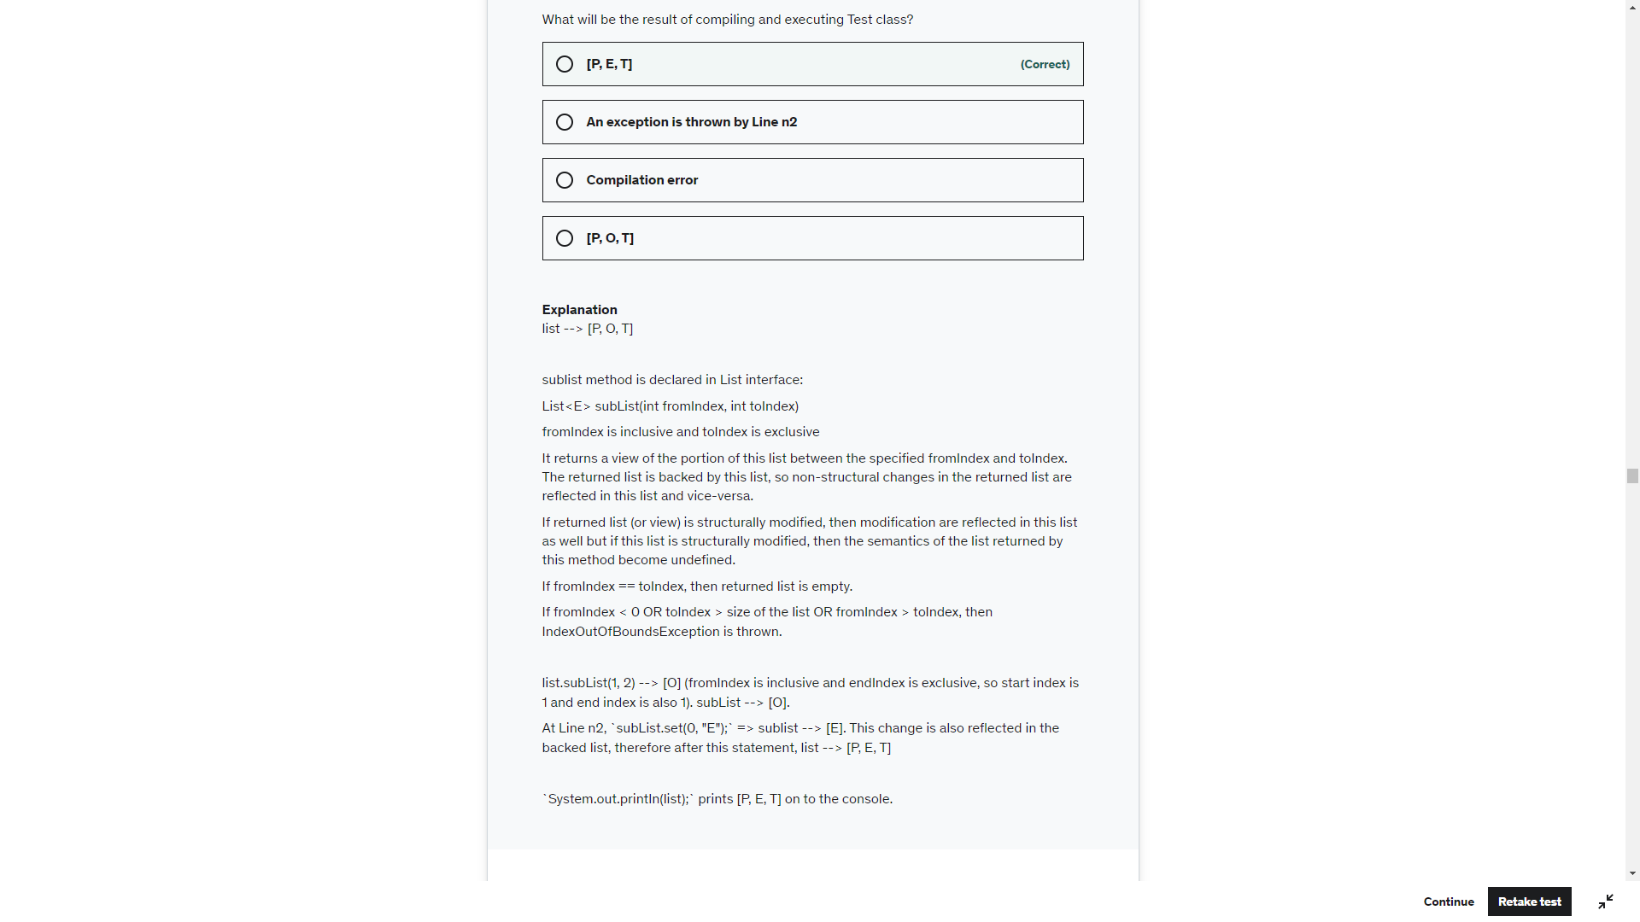

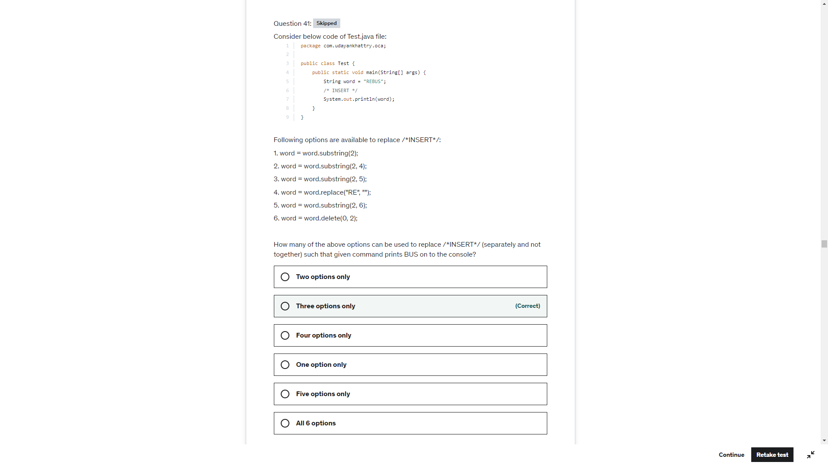

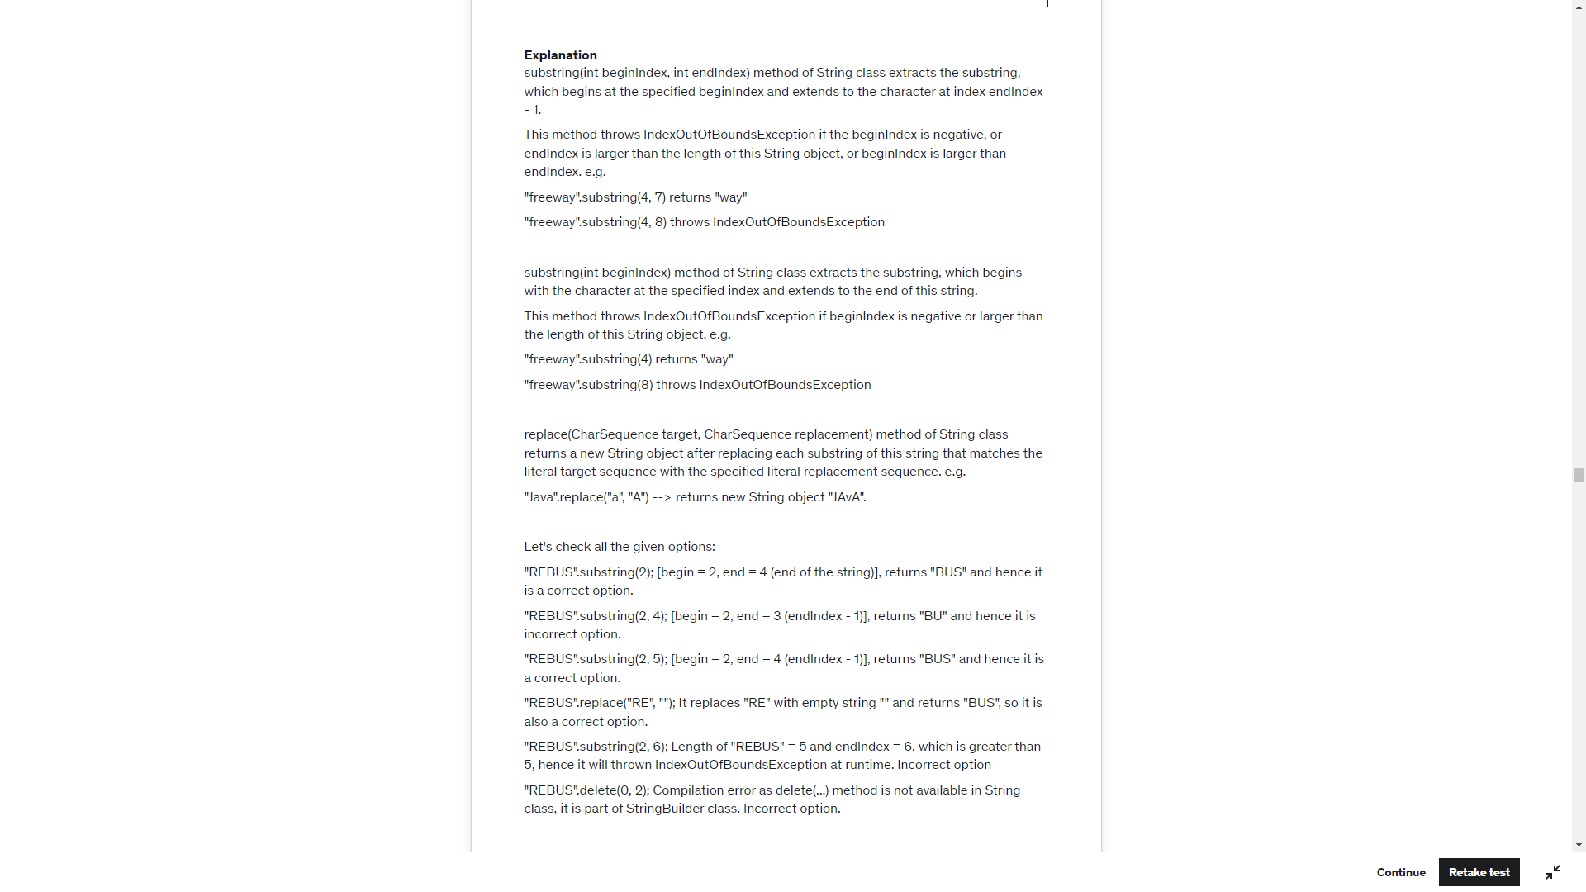

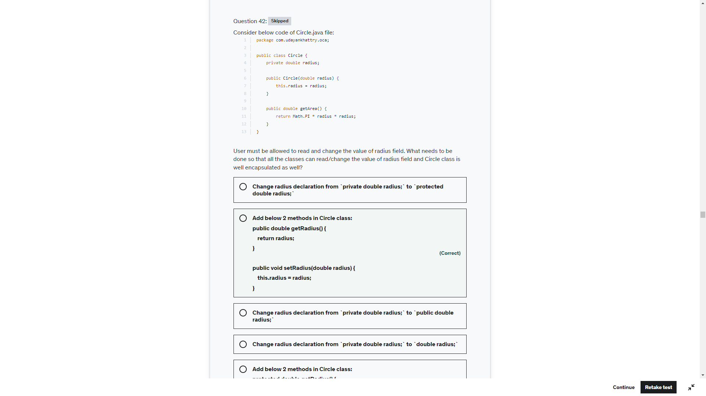

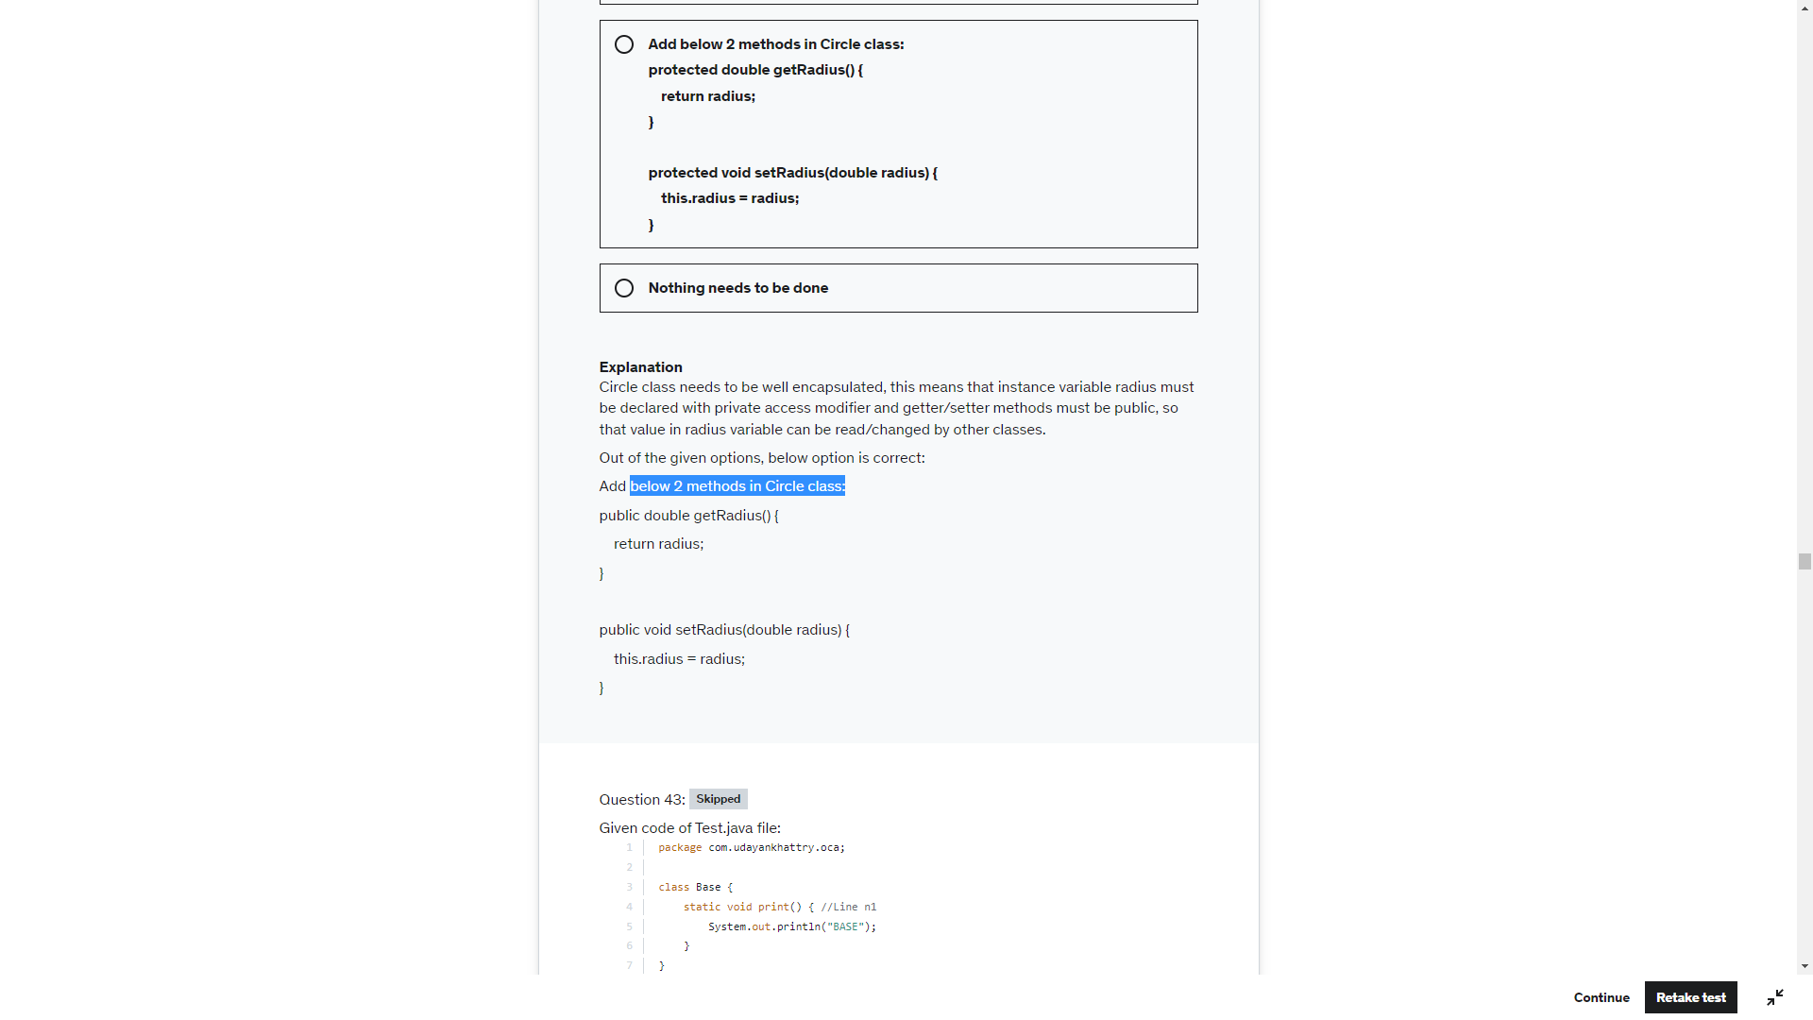

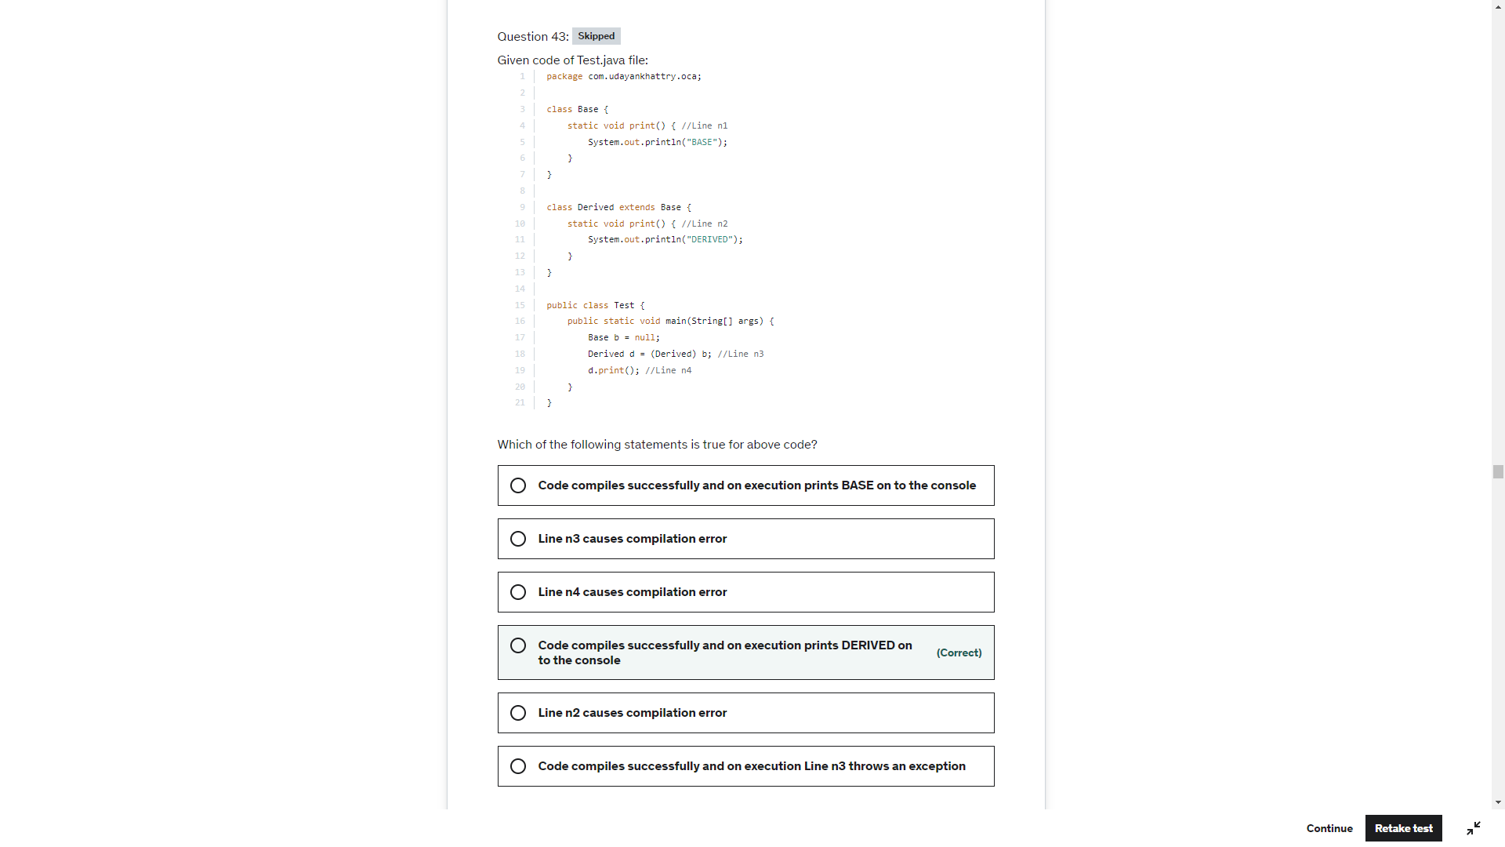

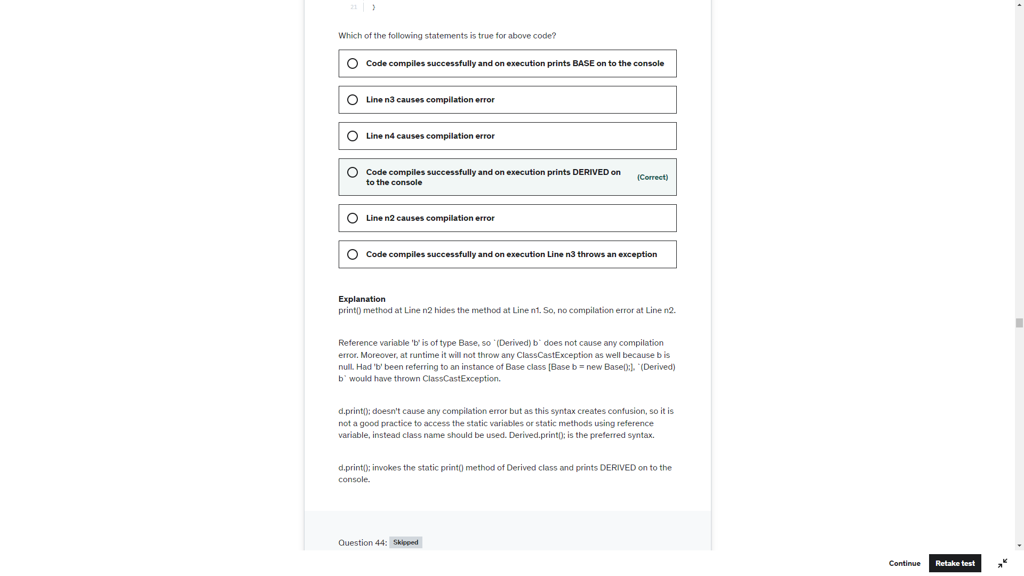

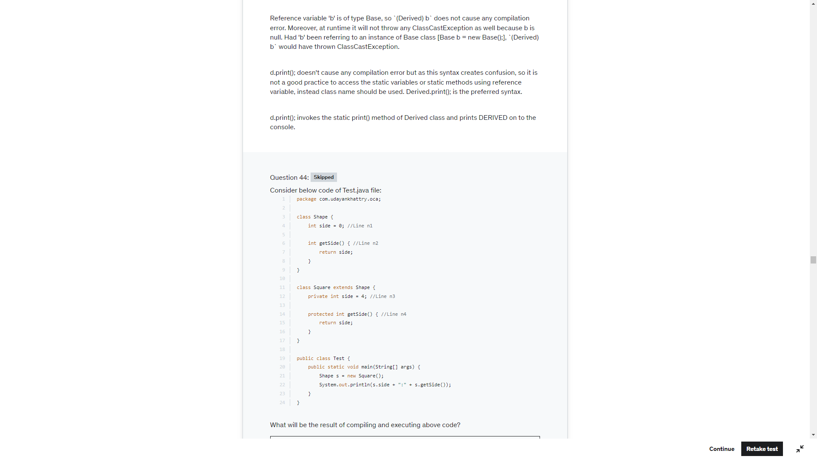

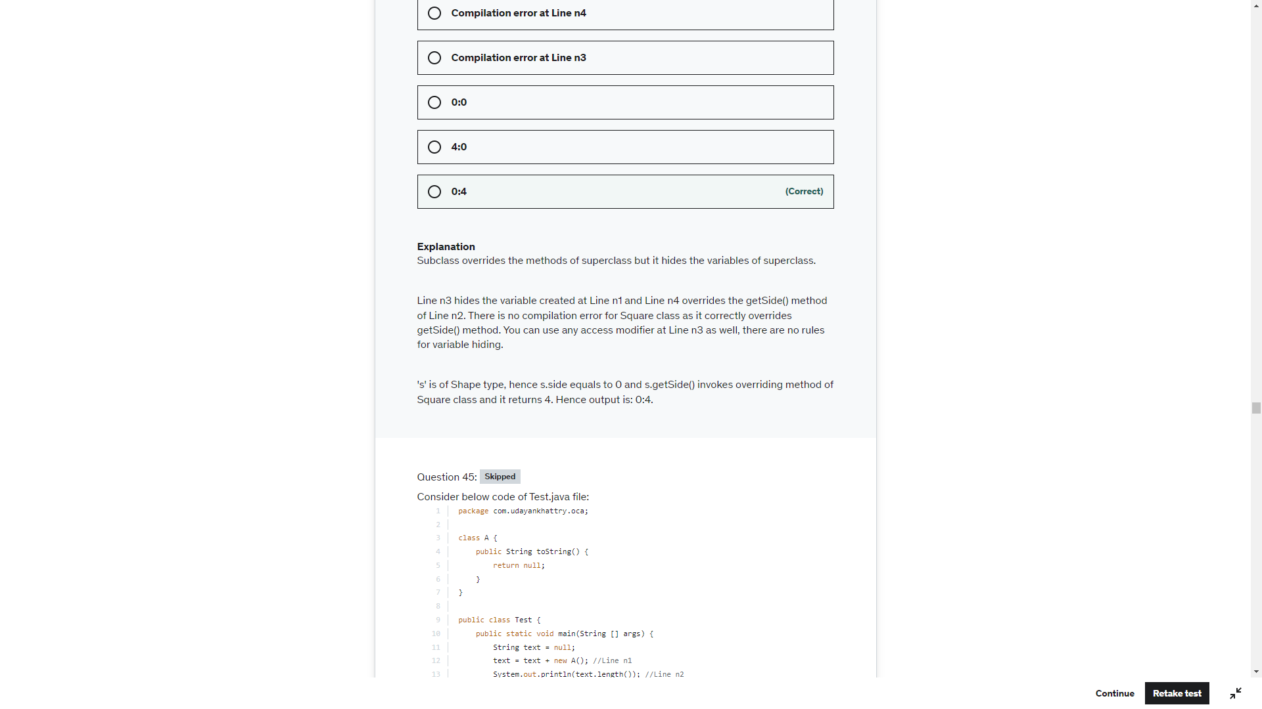

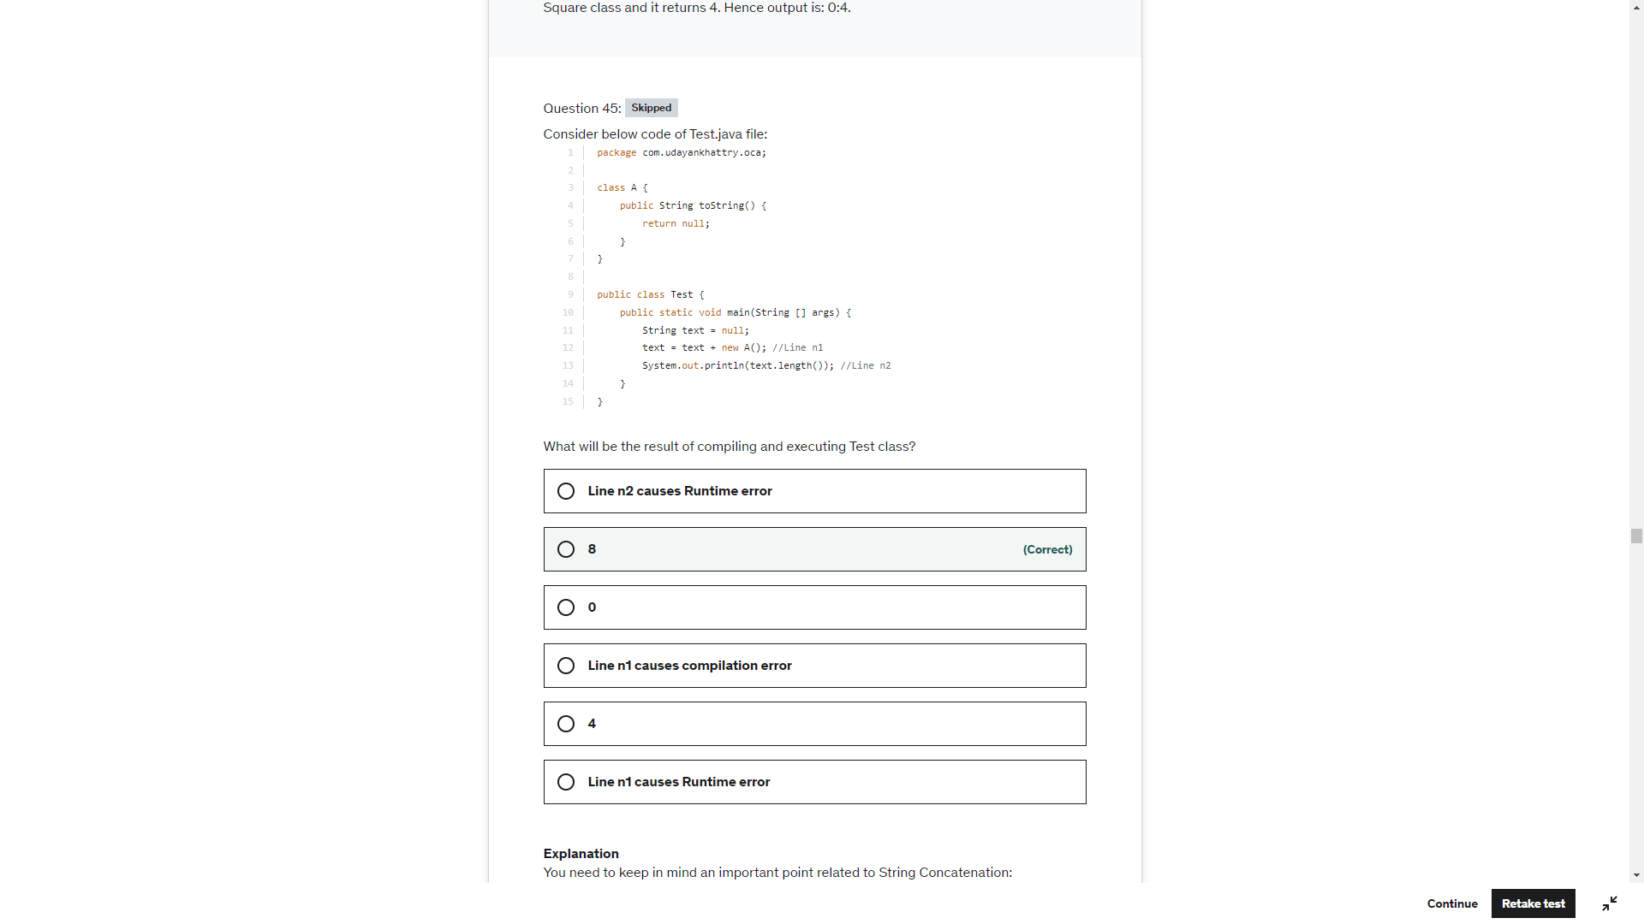

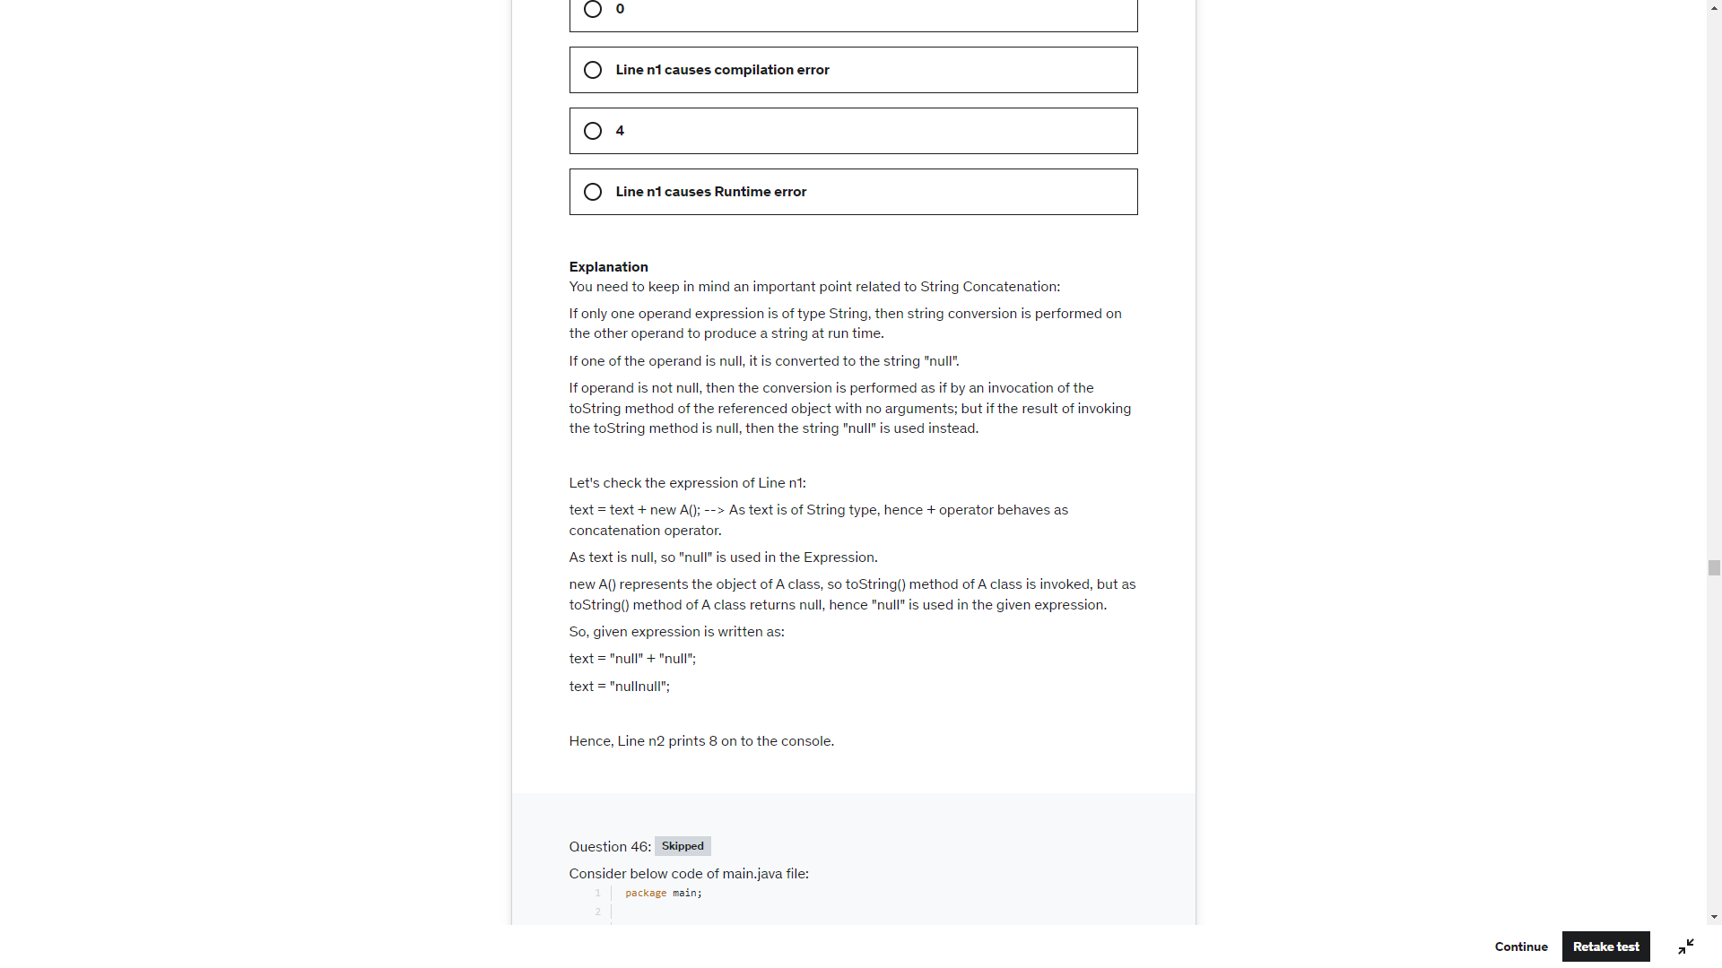

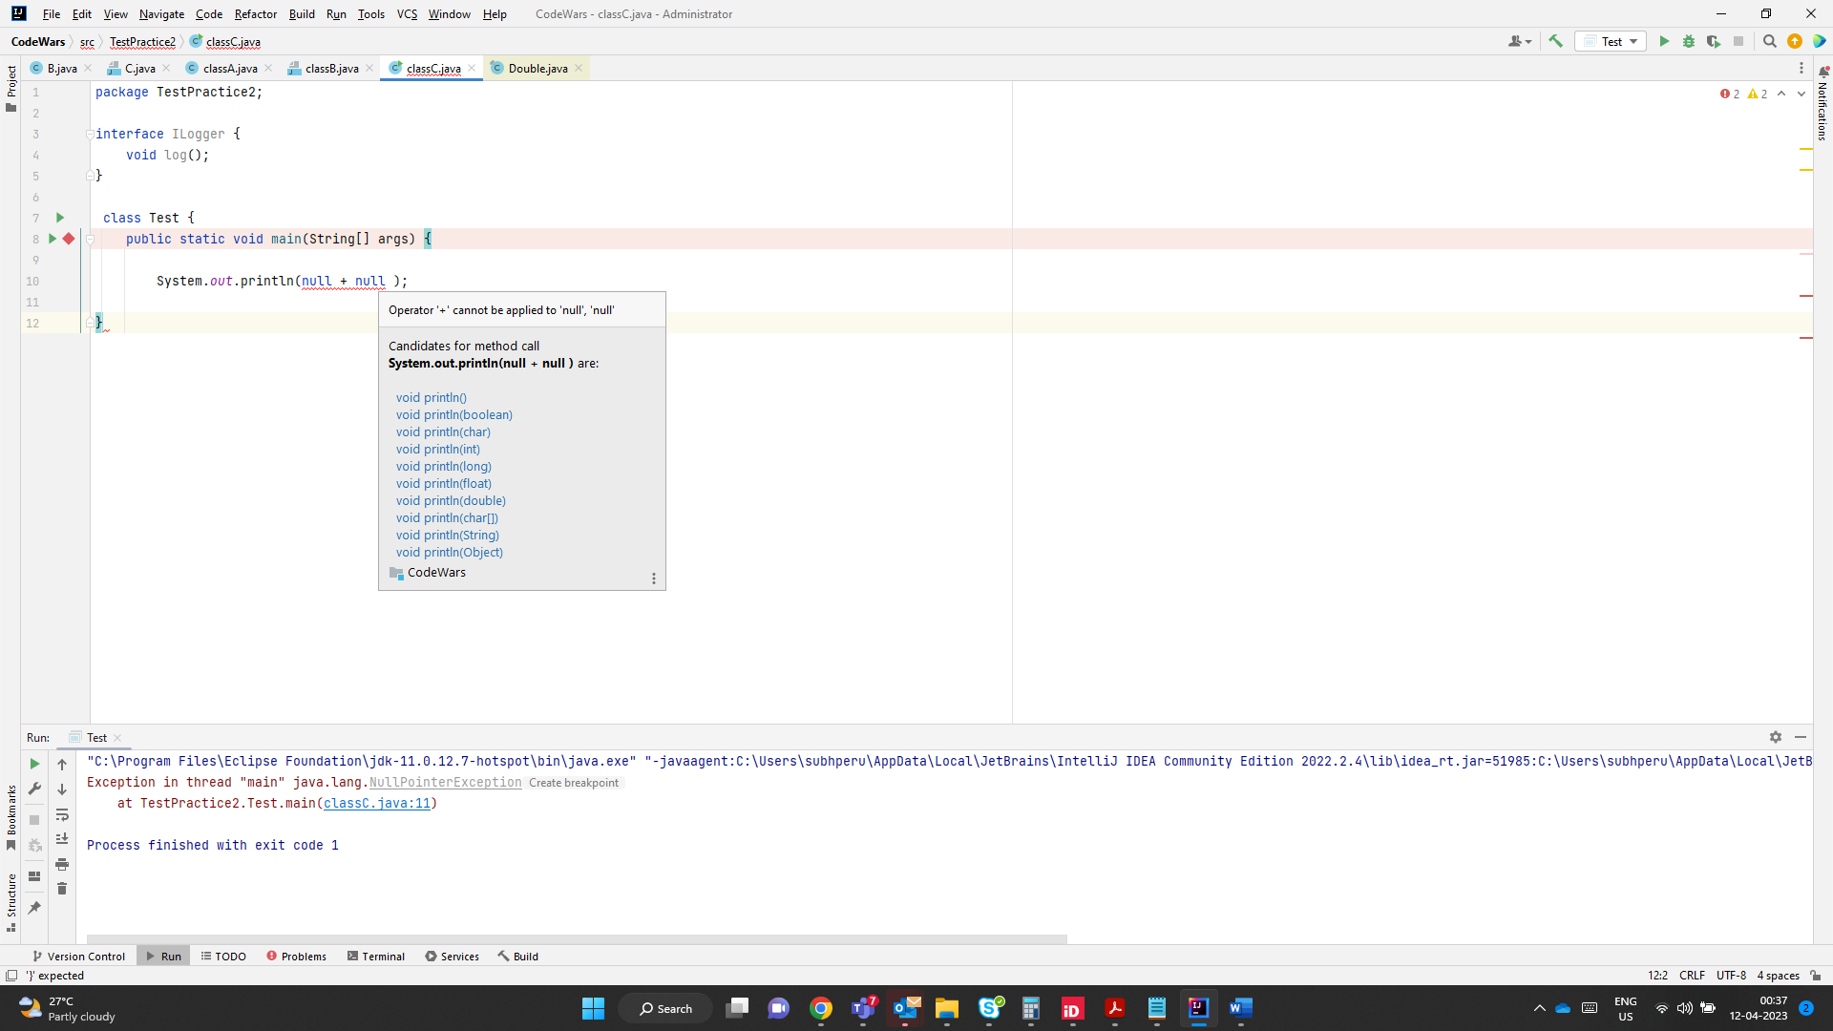

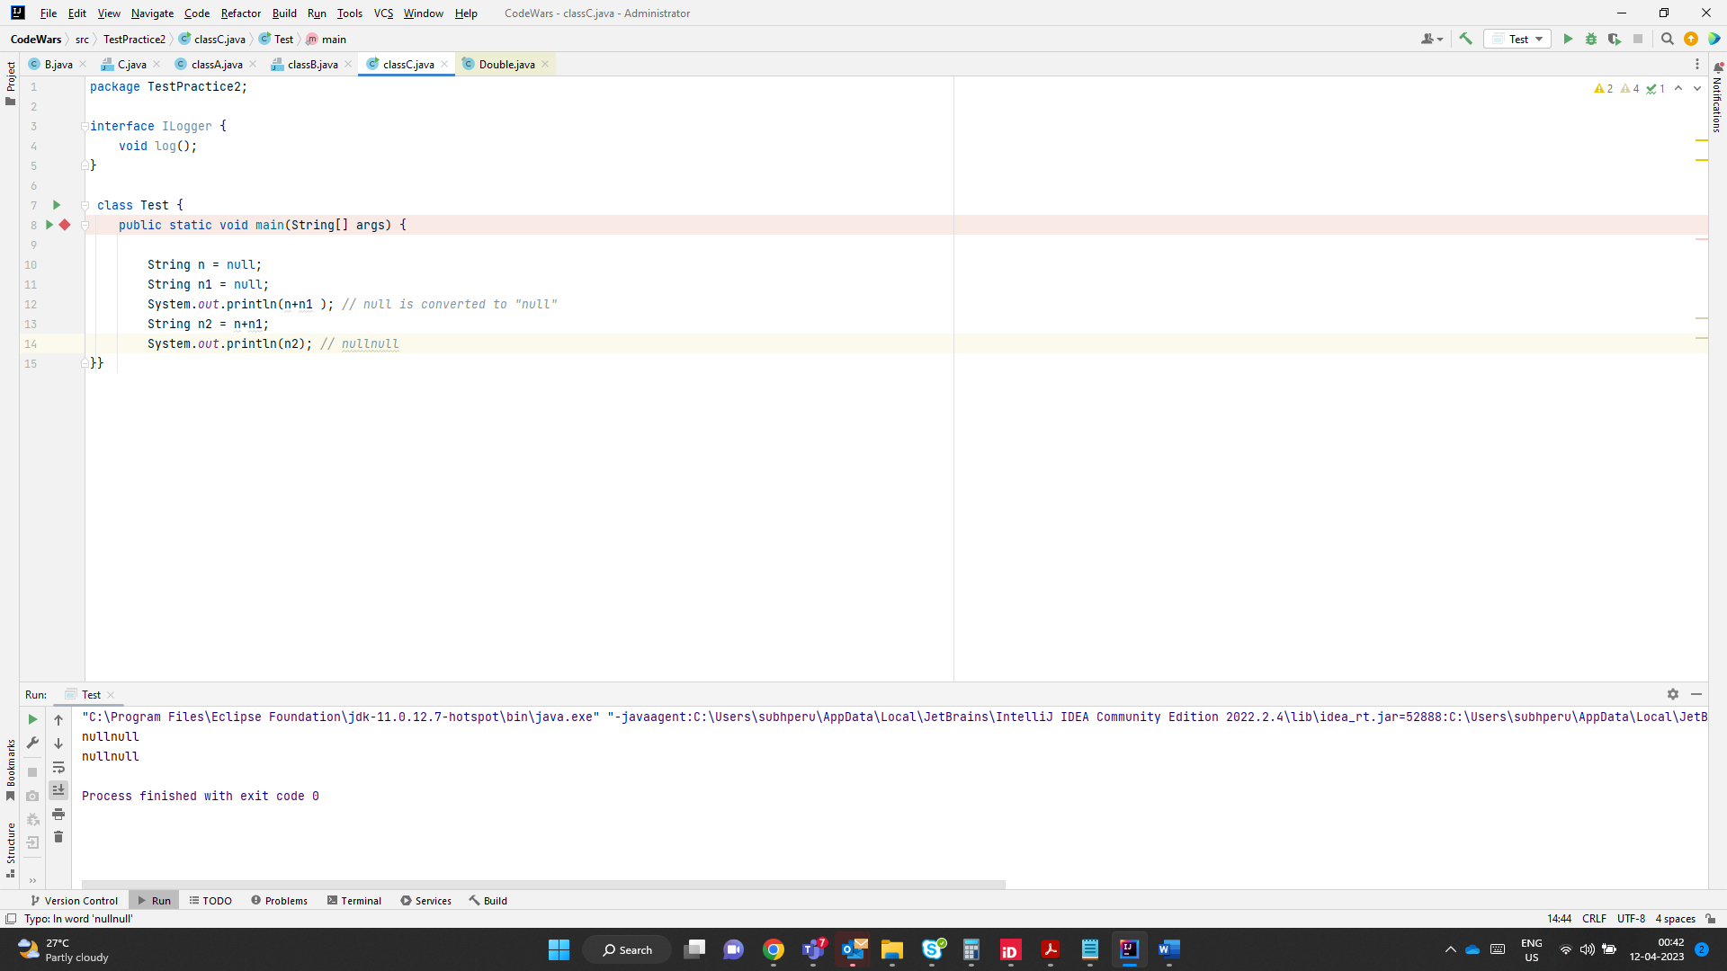

String s = null+null; -> + operator cannot be applied to null

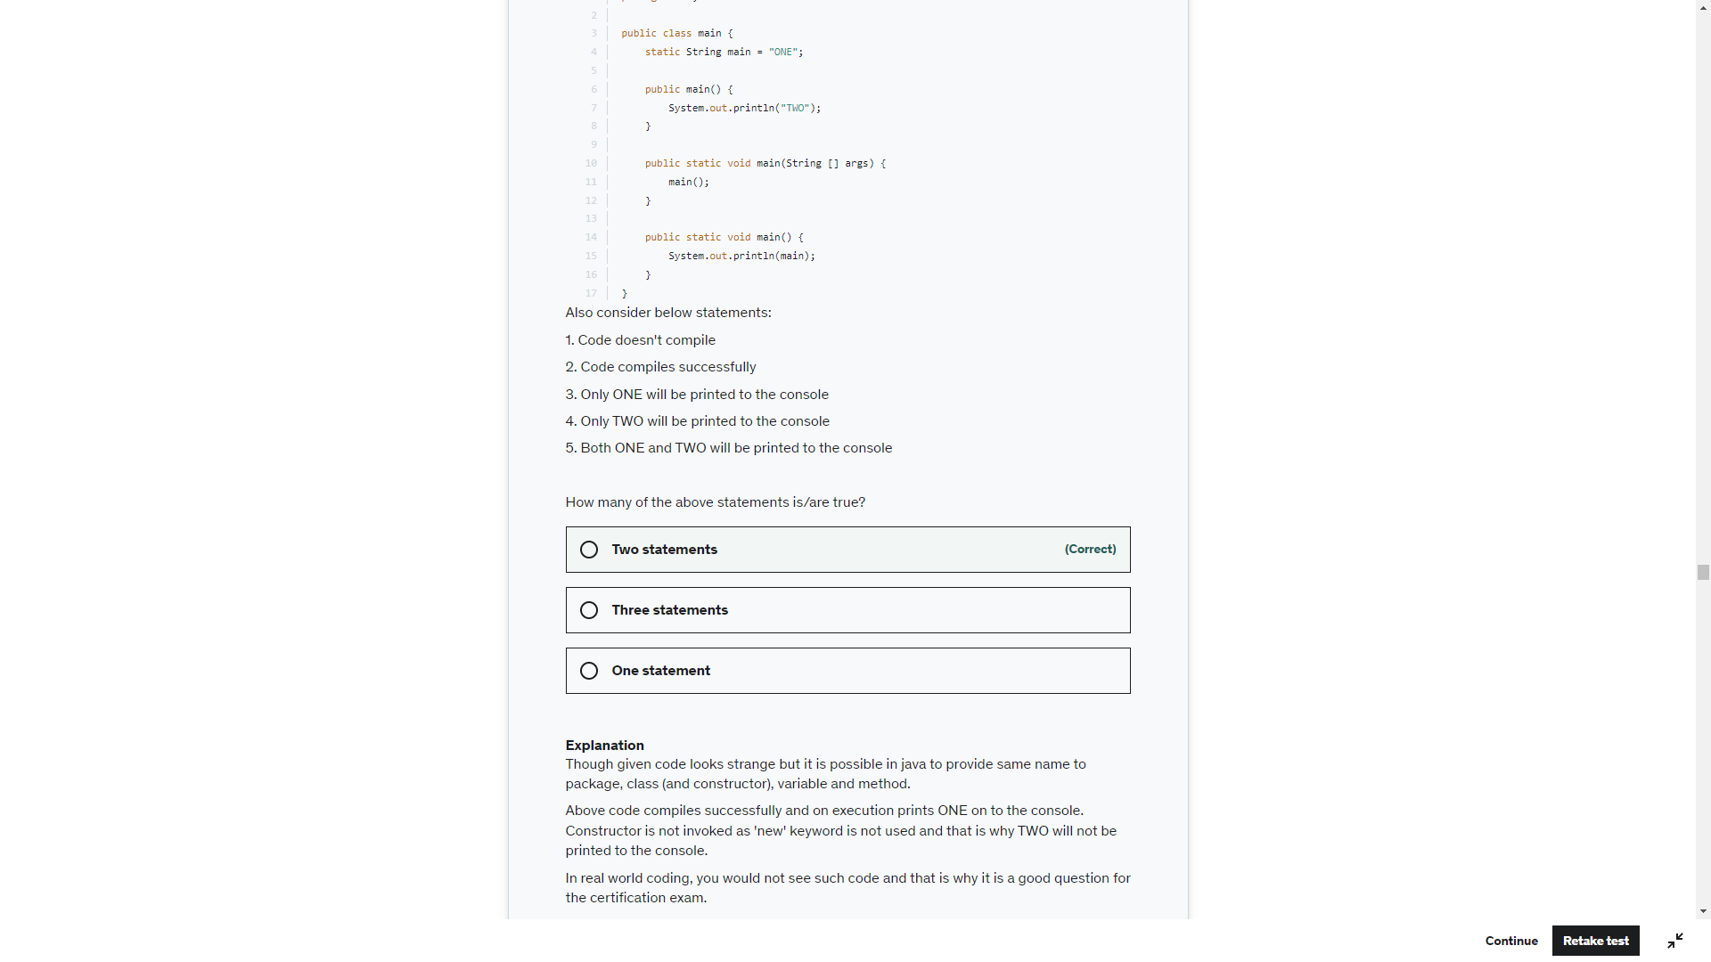

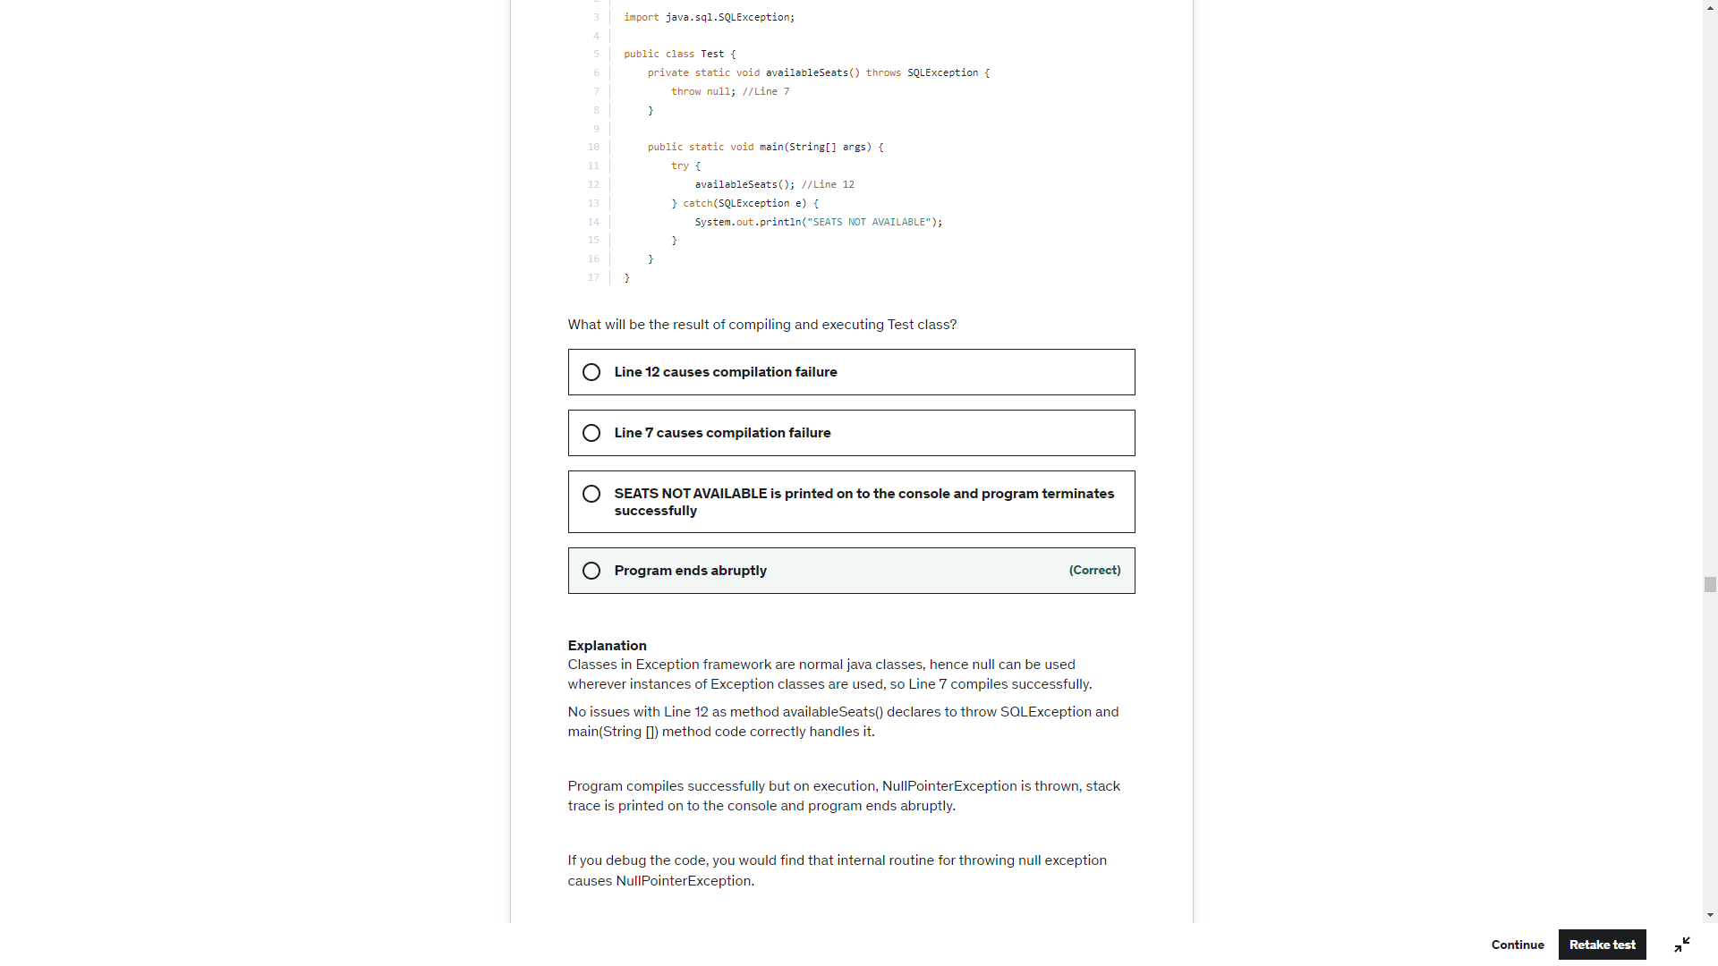

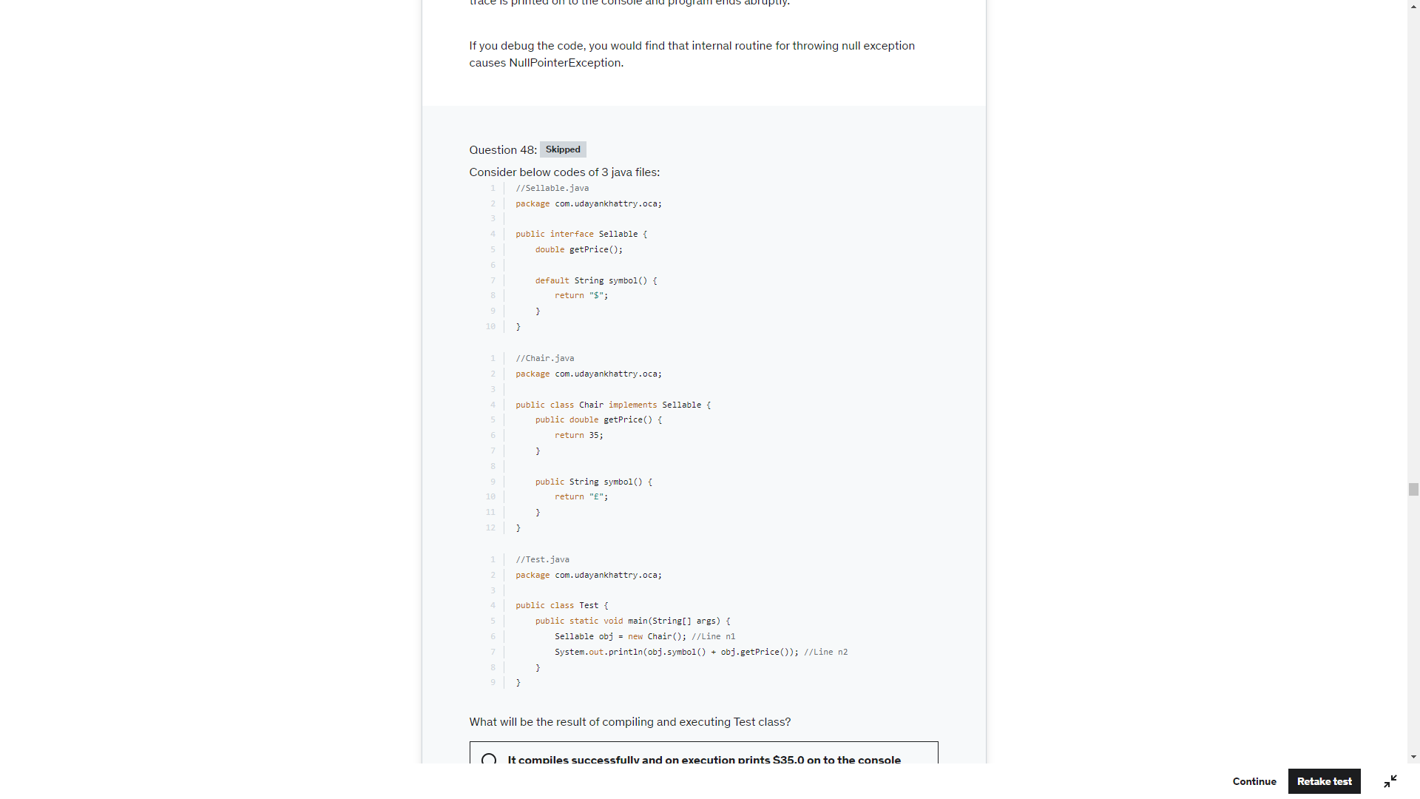

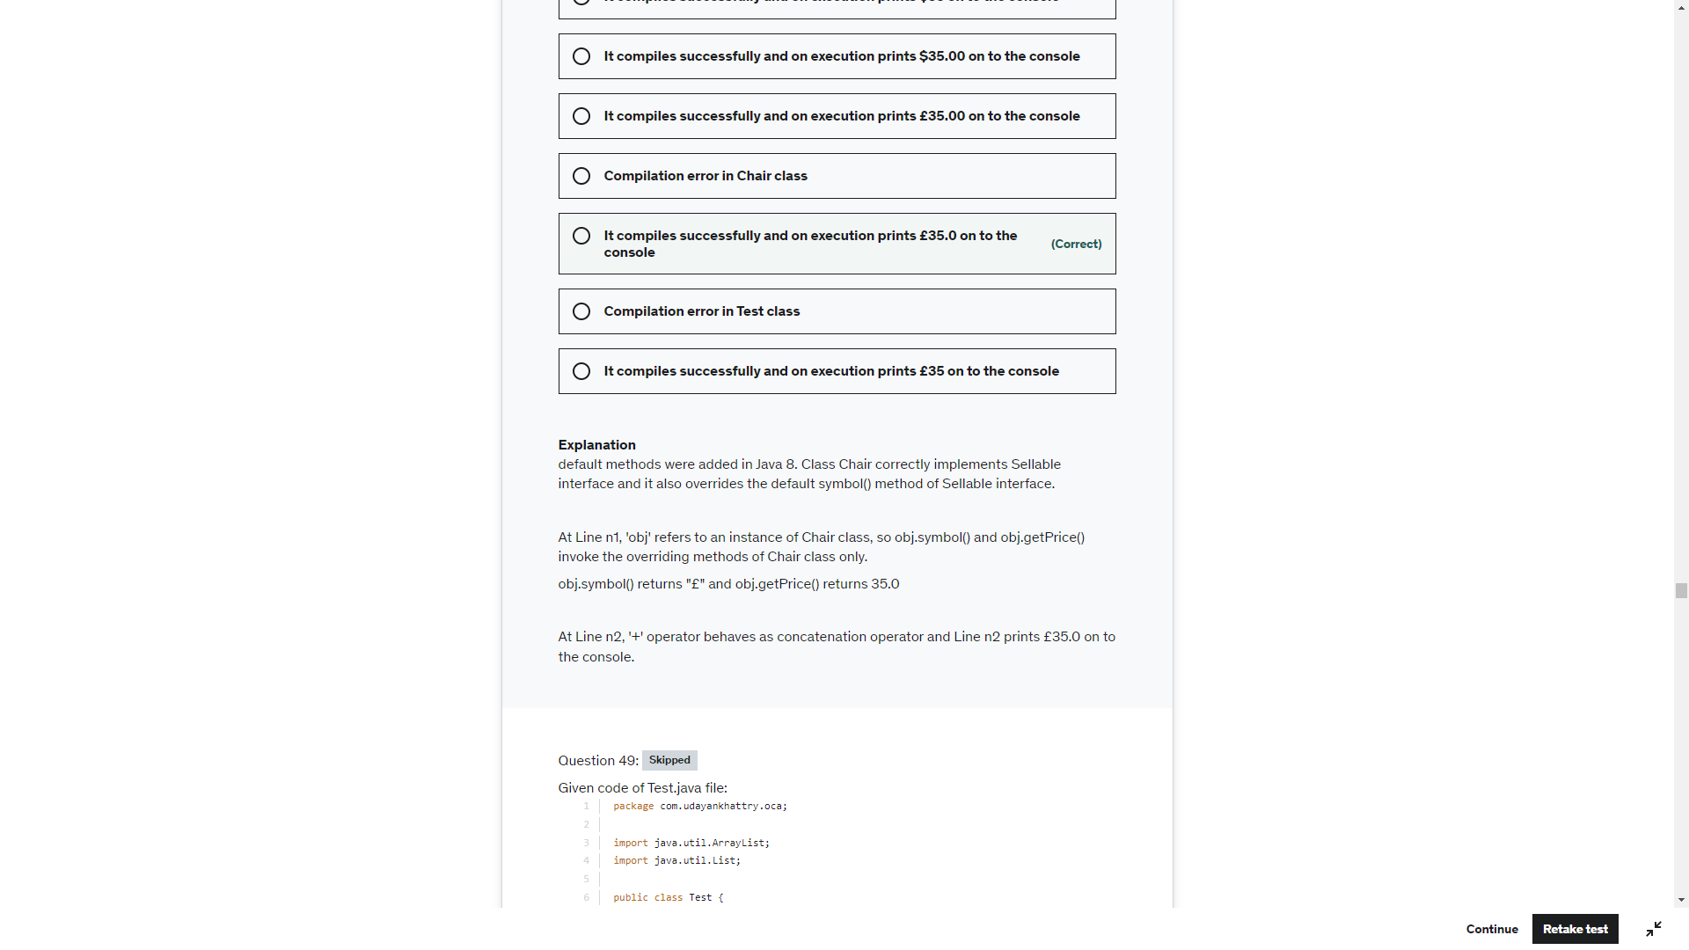

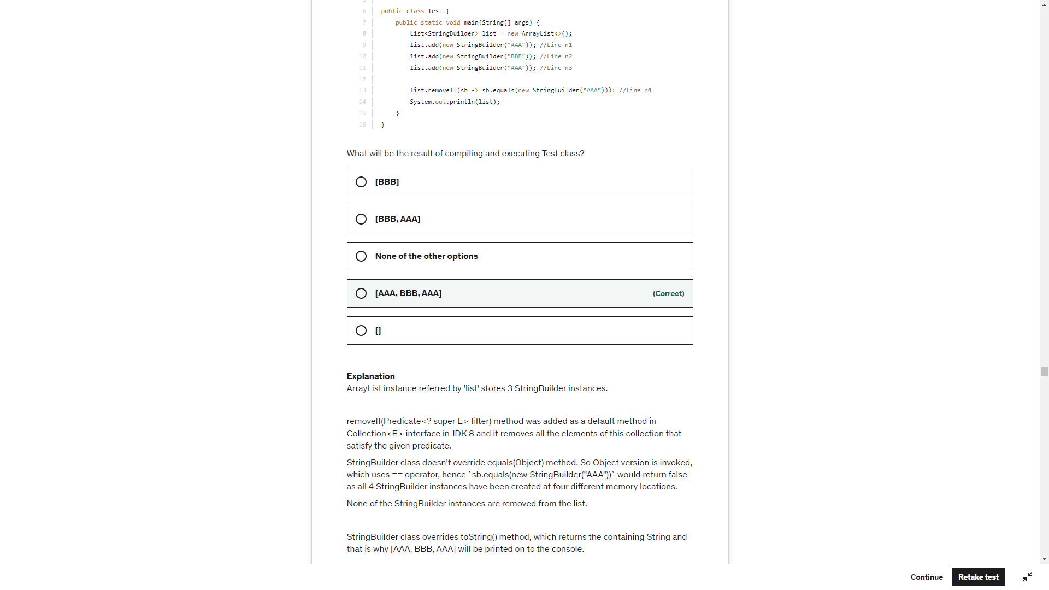

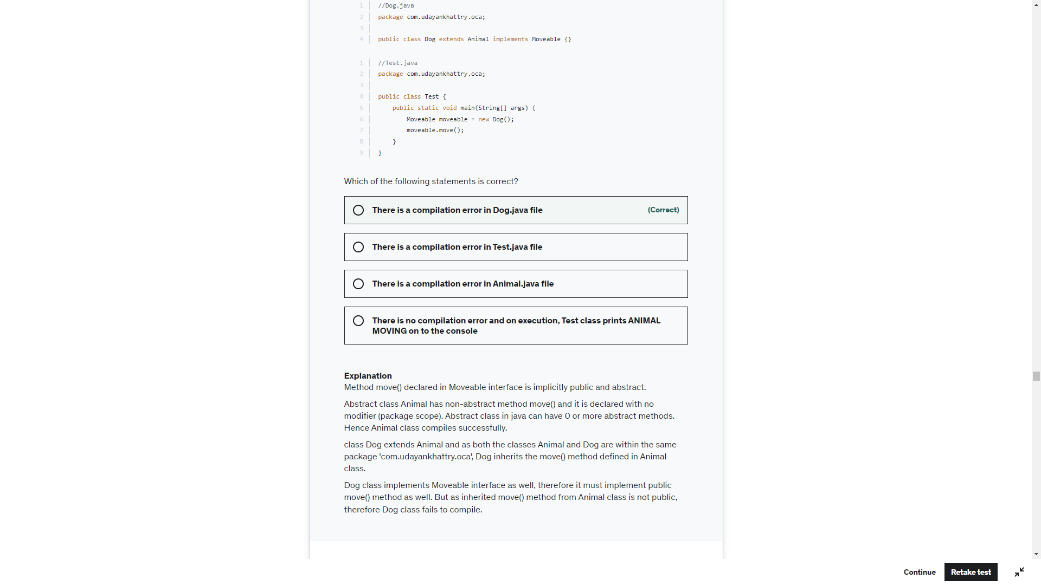

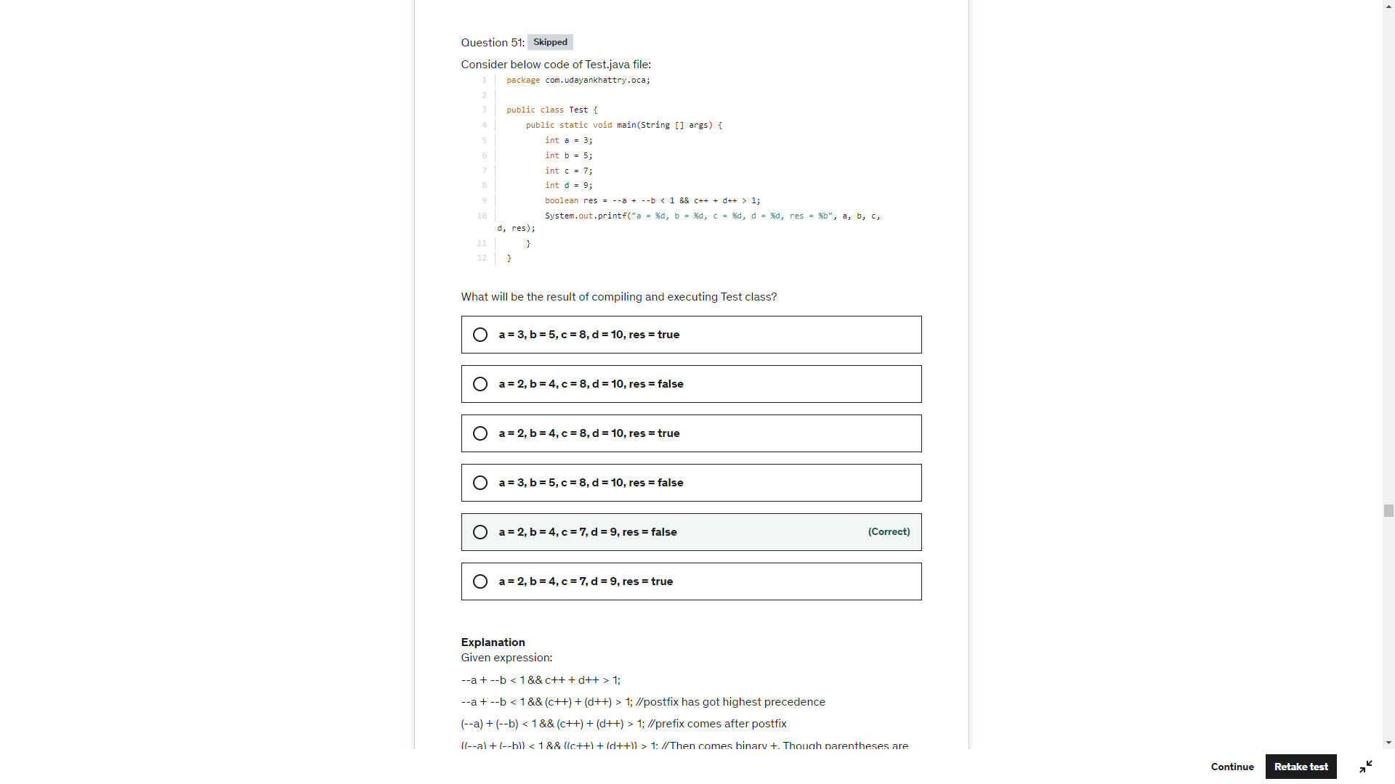

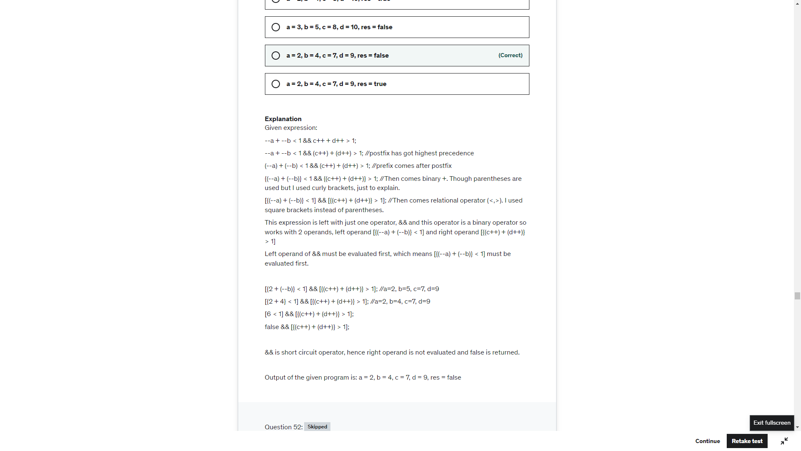

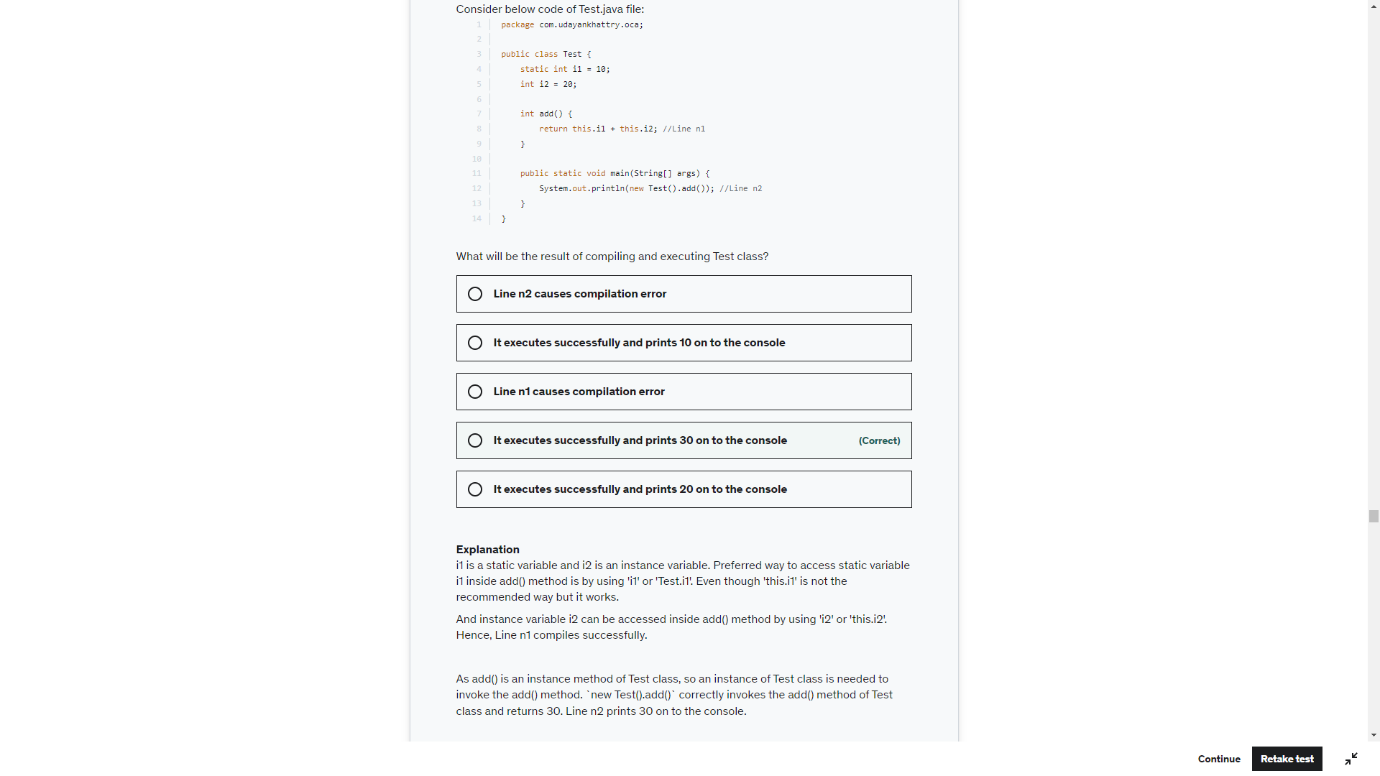

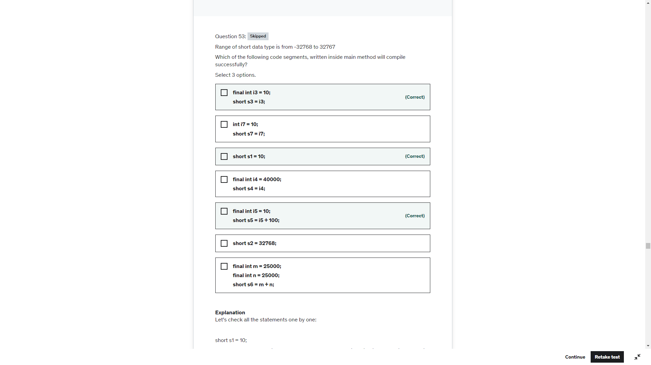

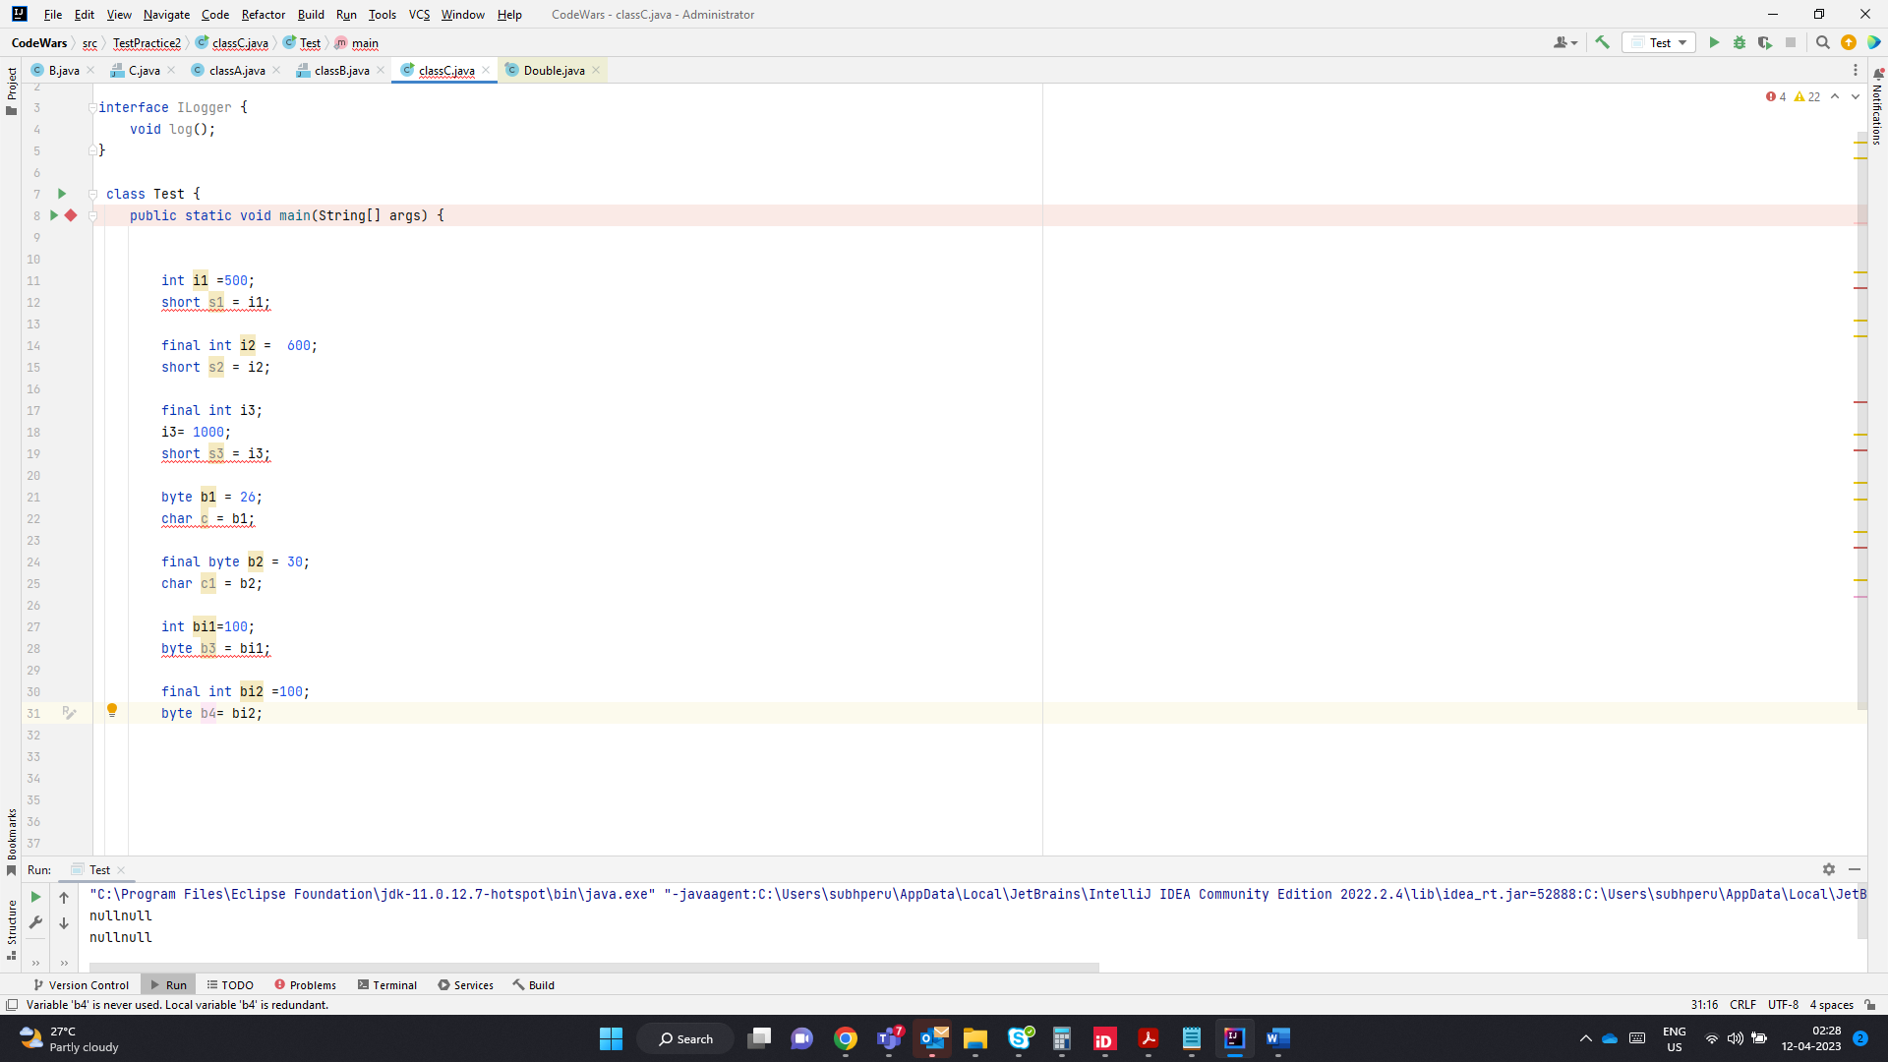

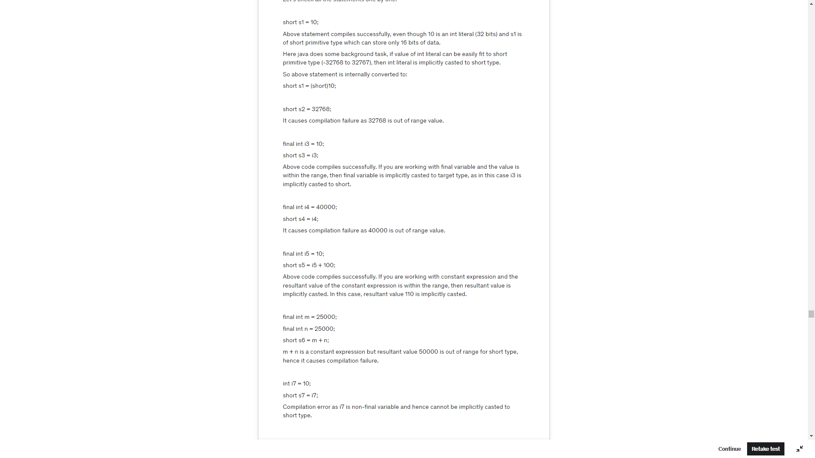

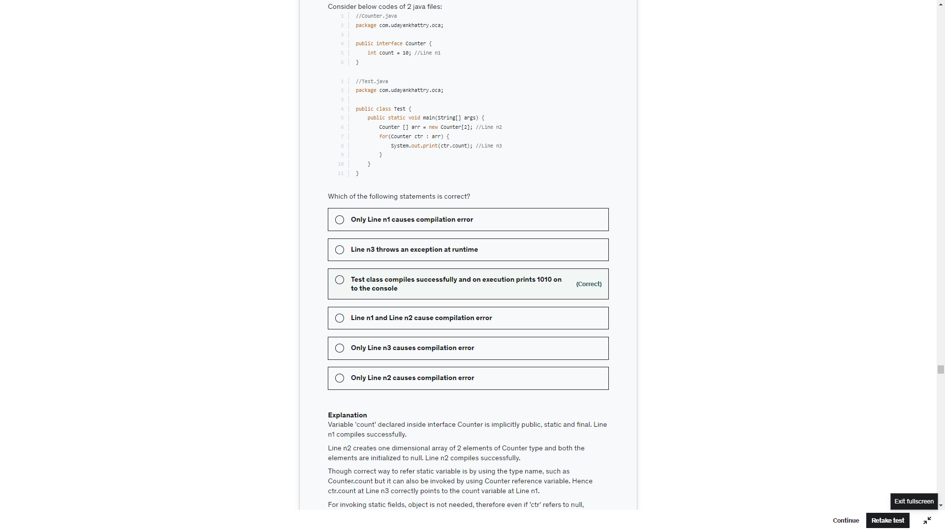

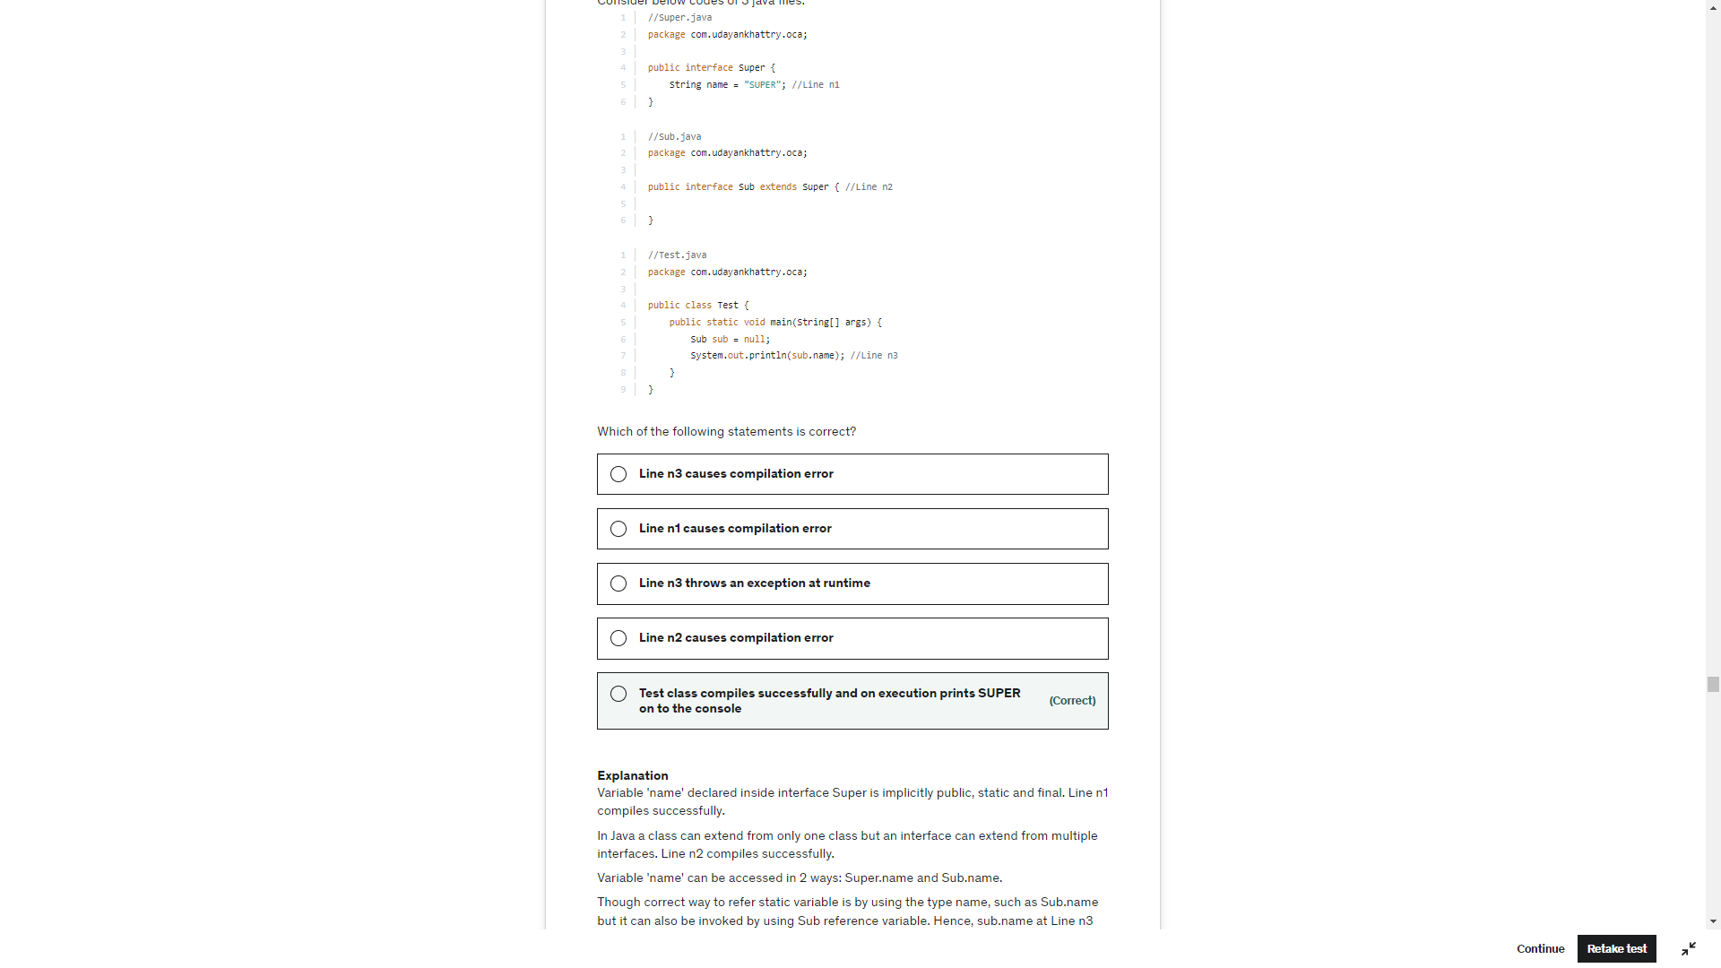

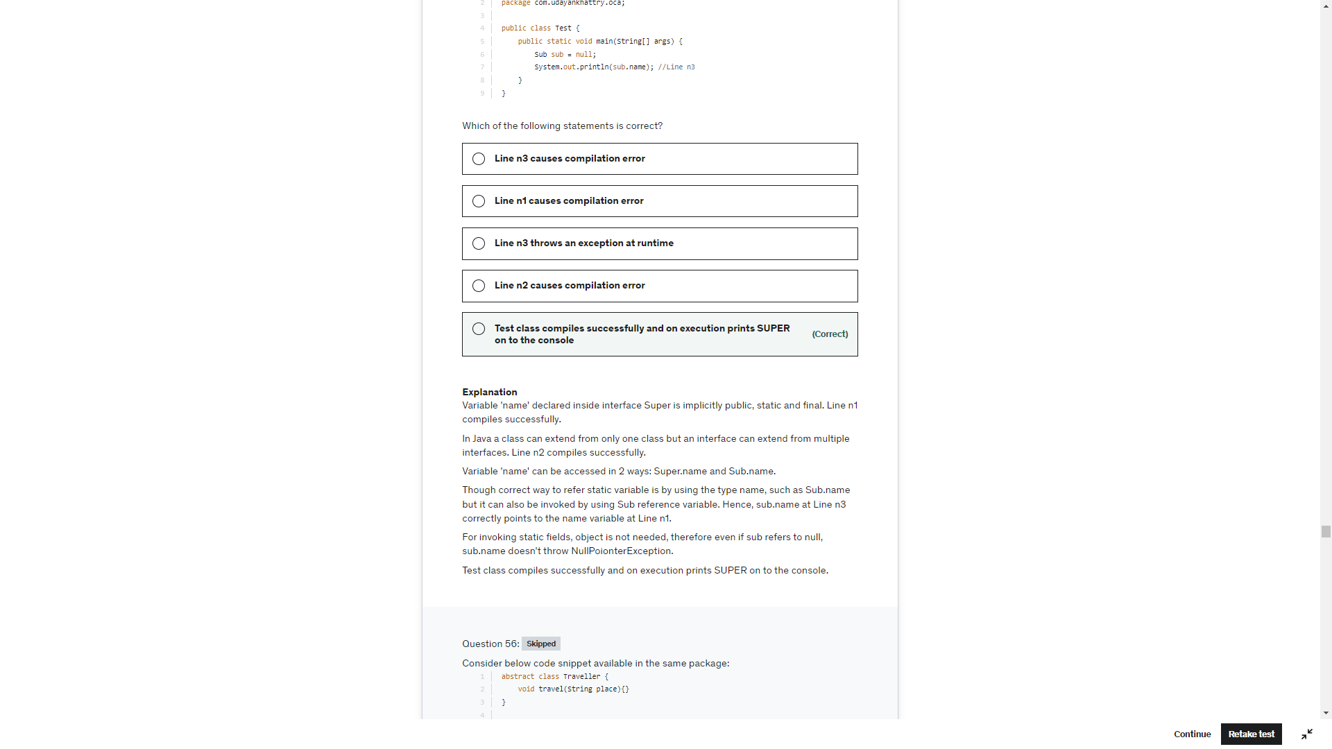

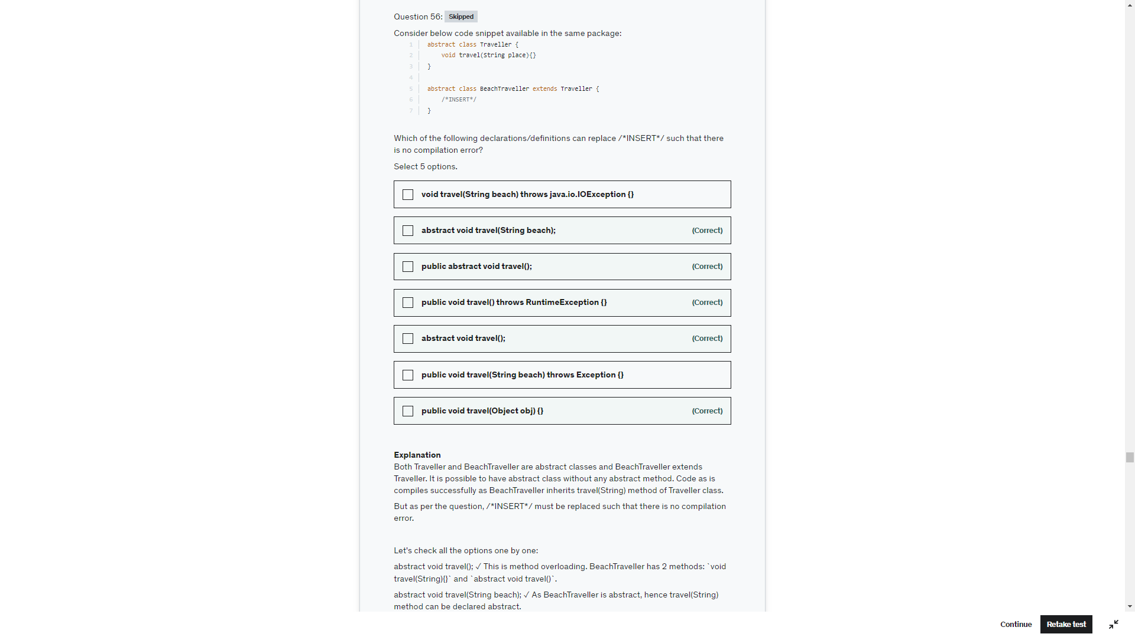

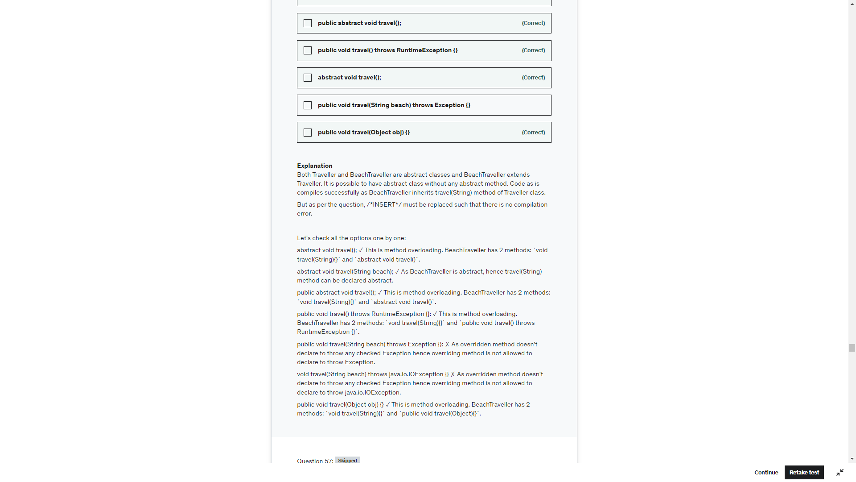

Interface static methods cannot be accessed using instance . They can be accessed only using Interface name

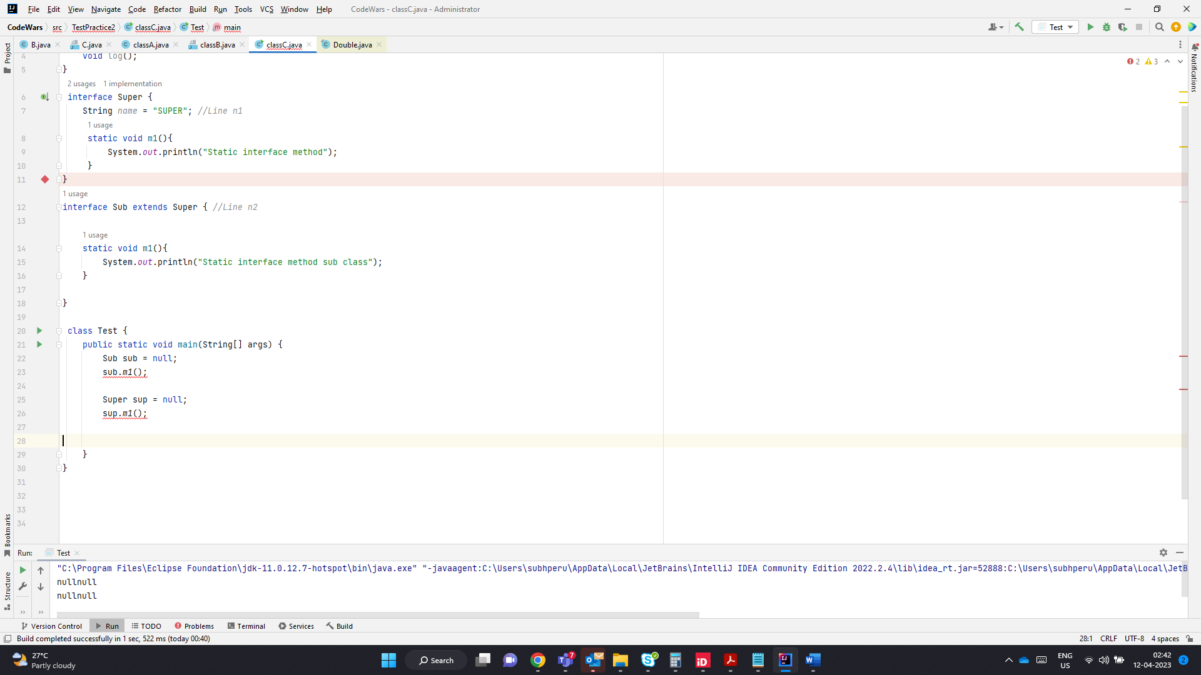

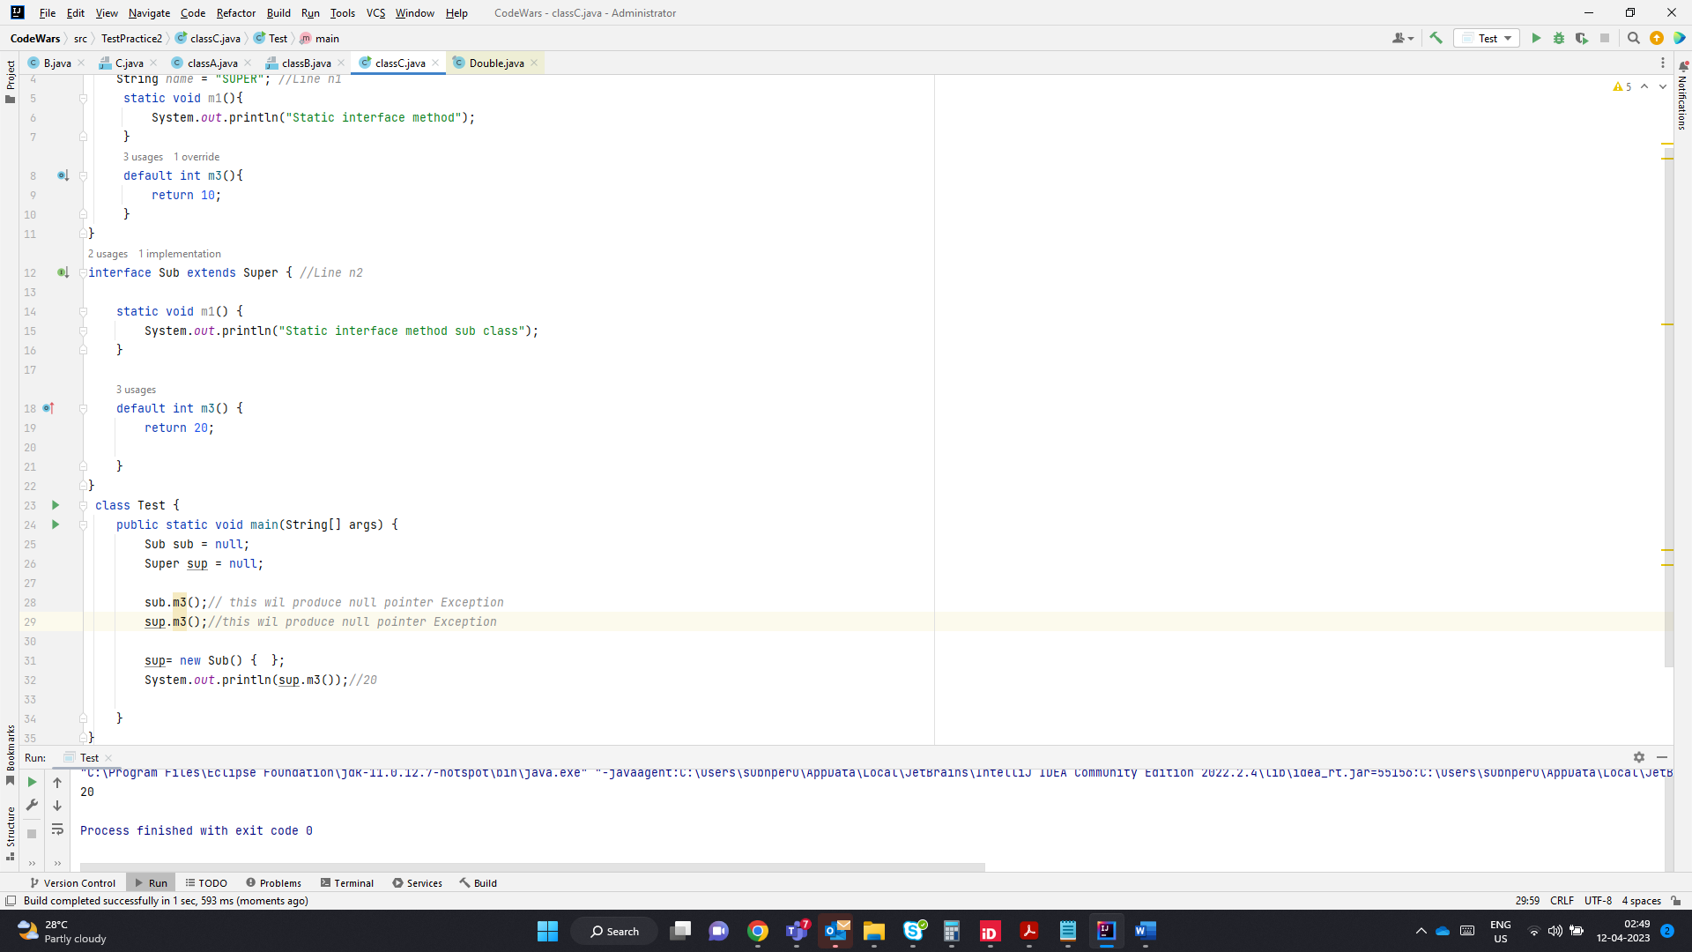

Interface variable behaves like static variable for general class

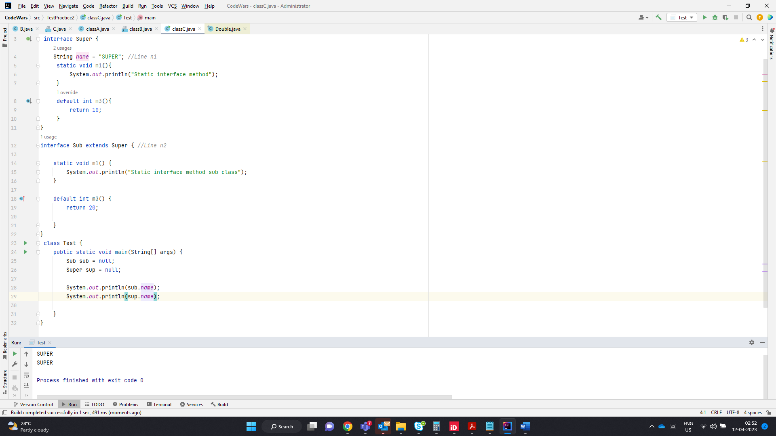

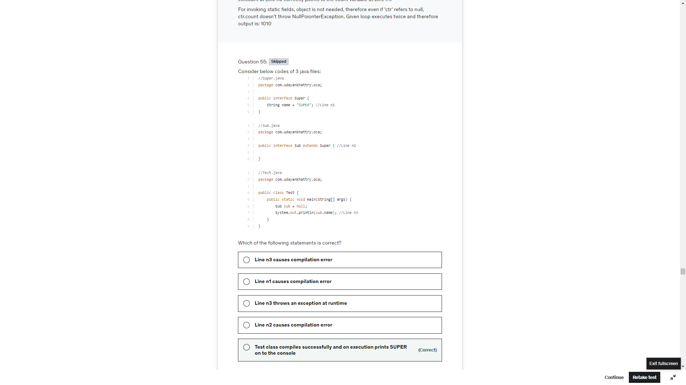

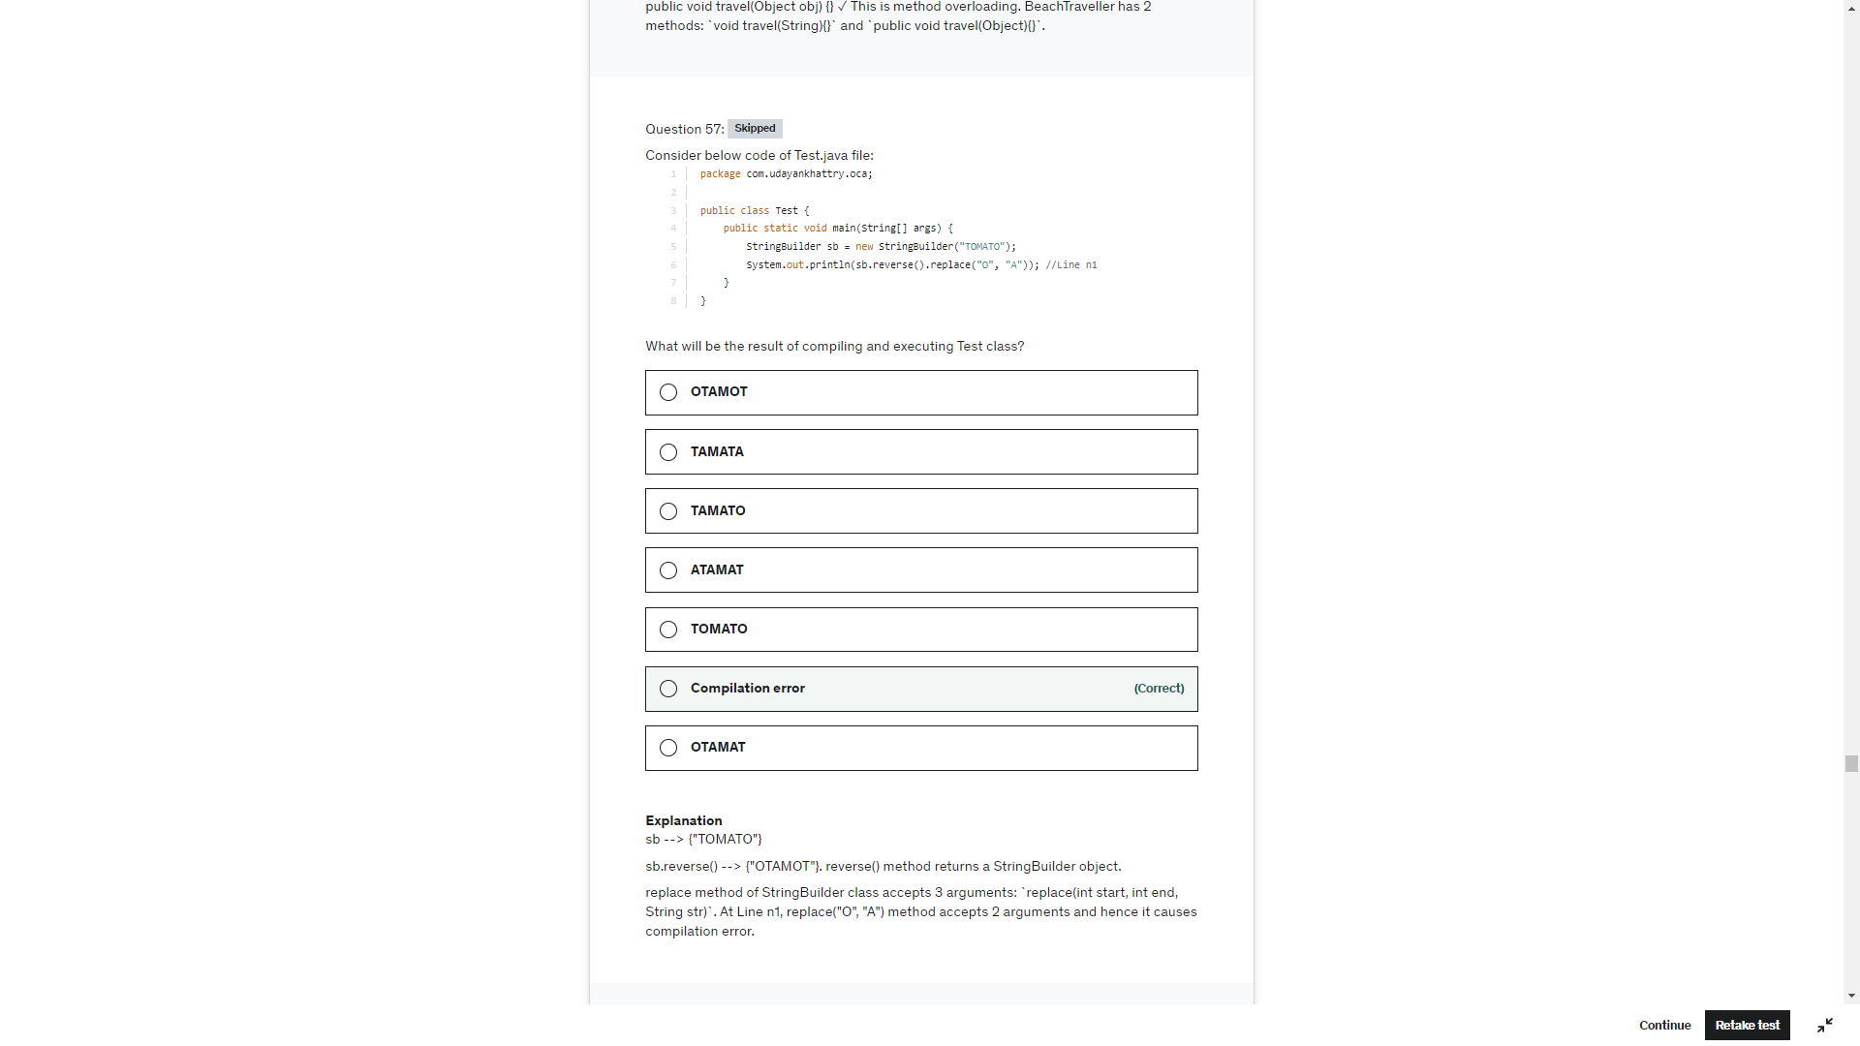

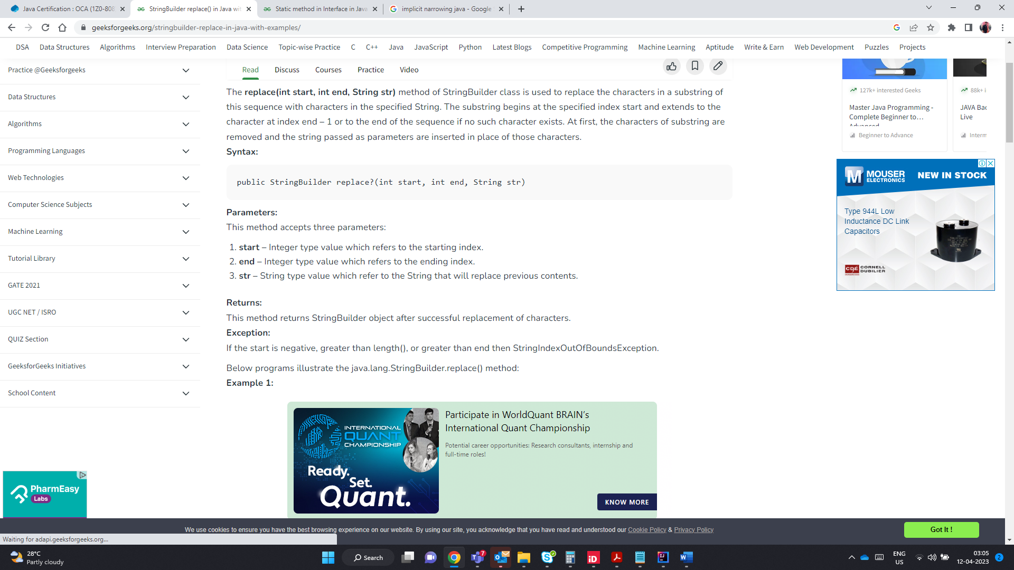s

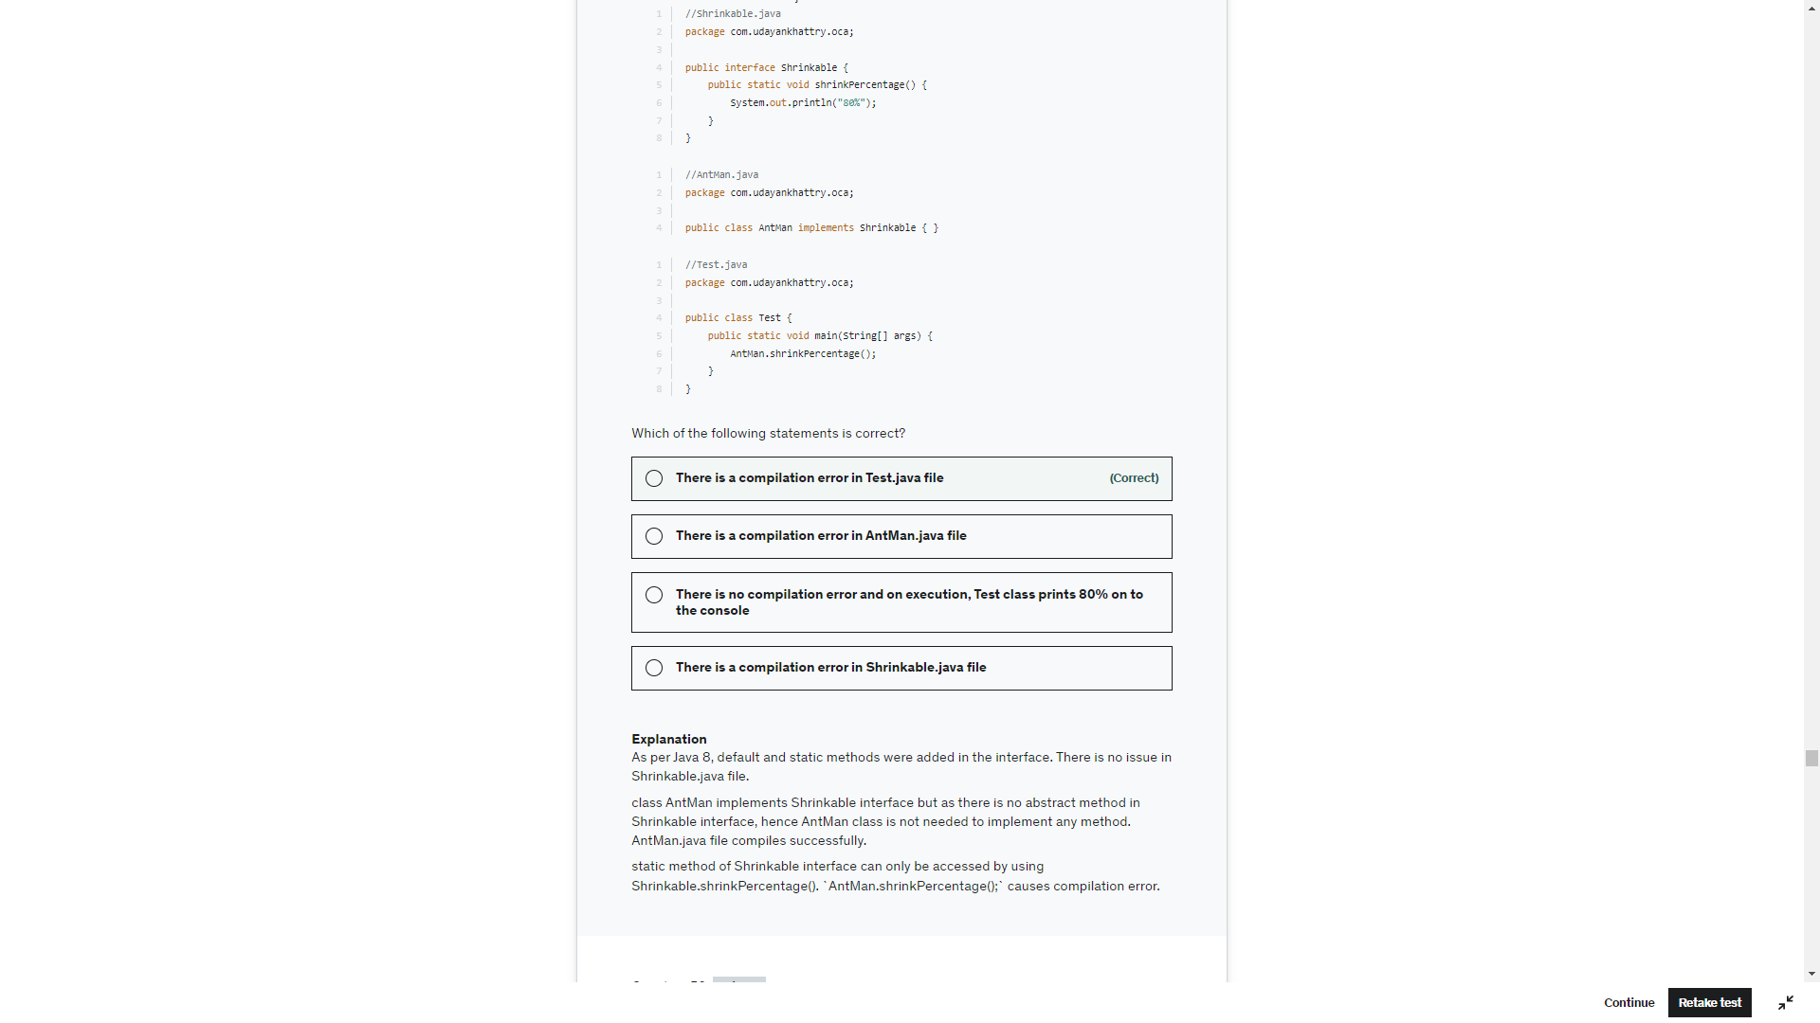

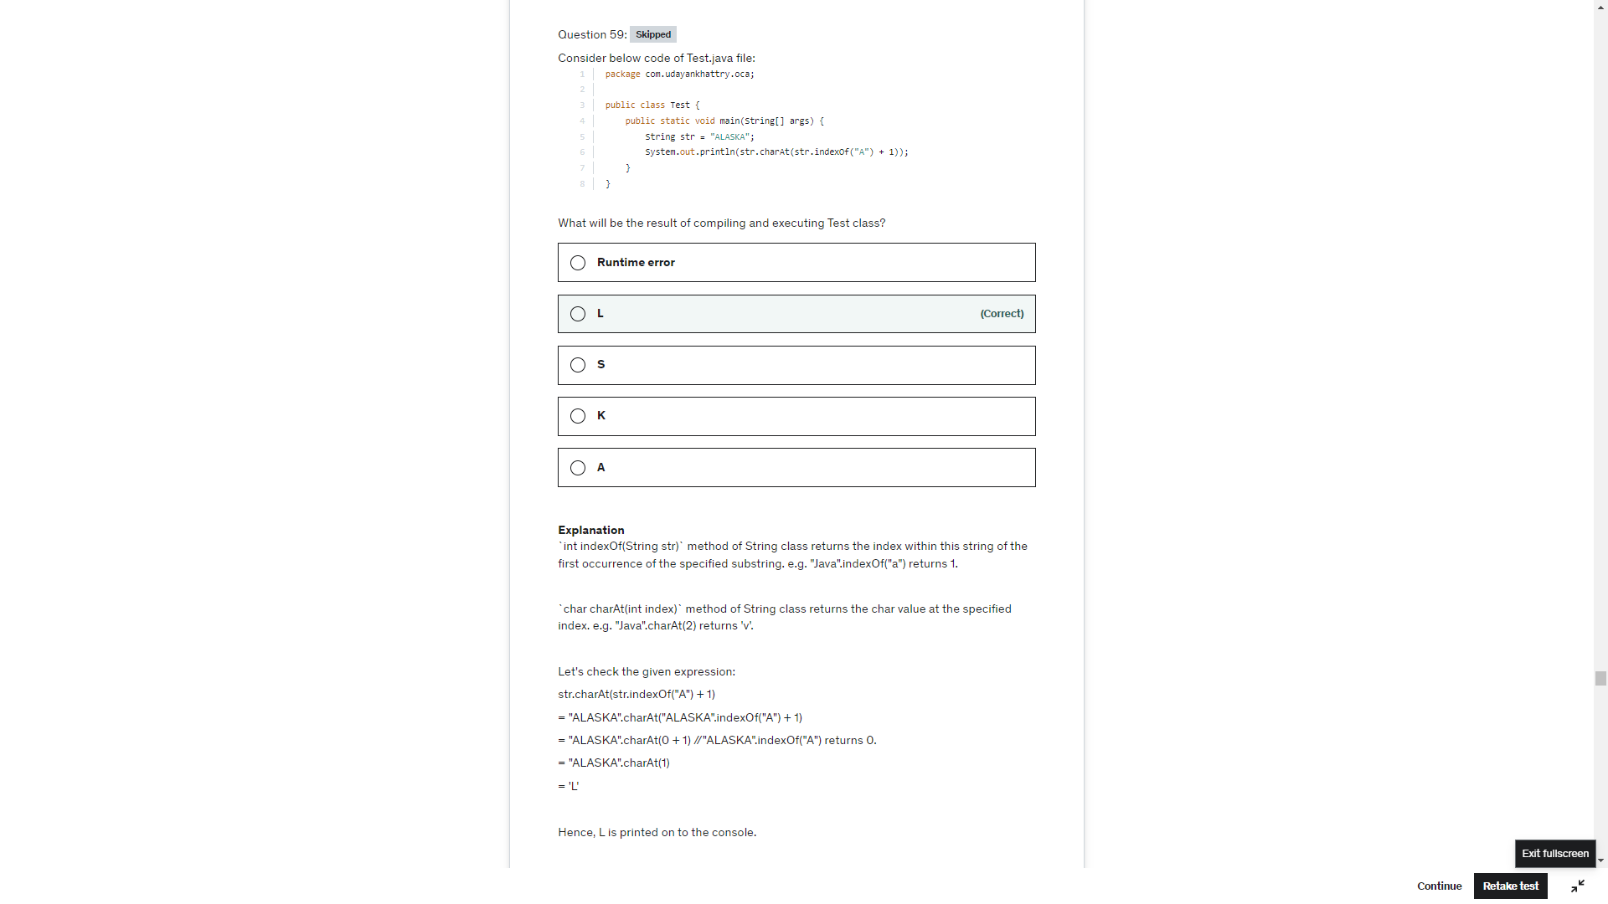

indexOf(String) returns -1 if the string is not found

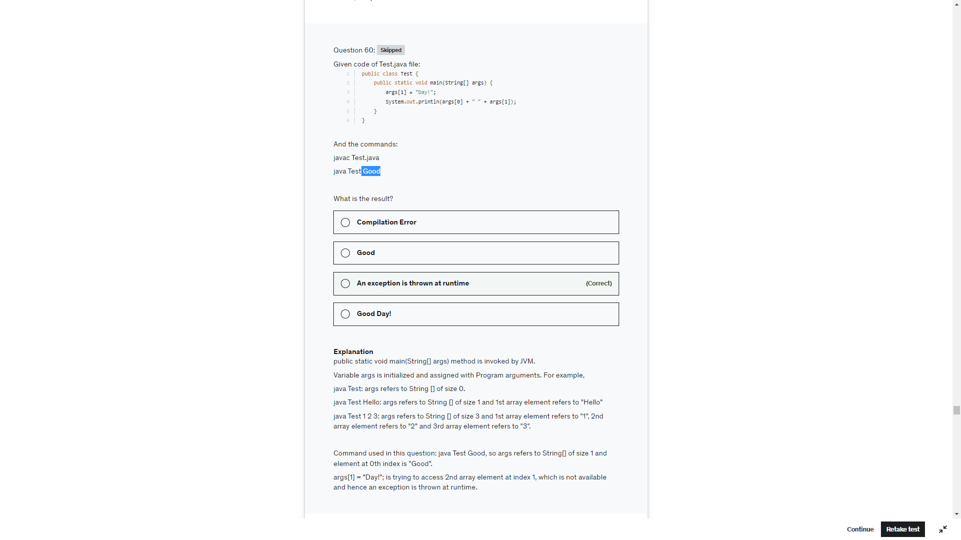

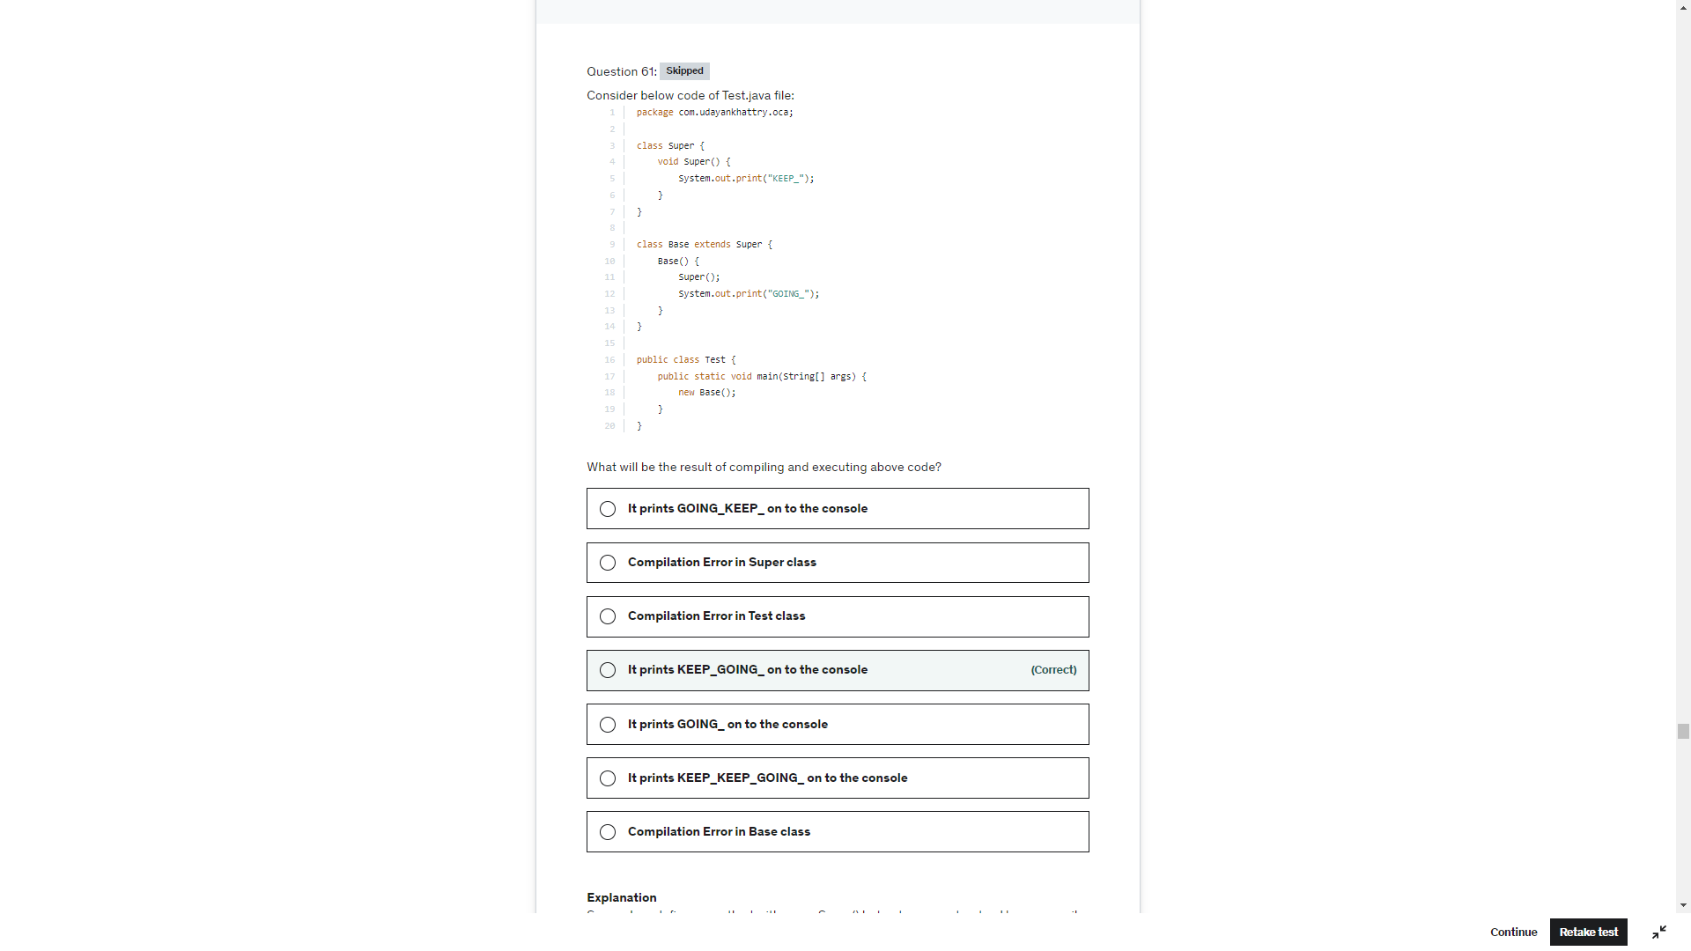

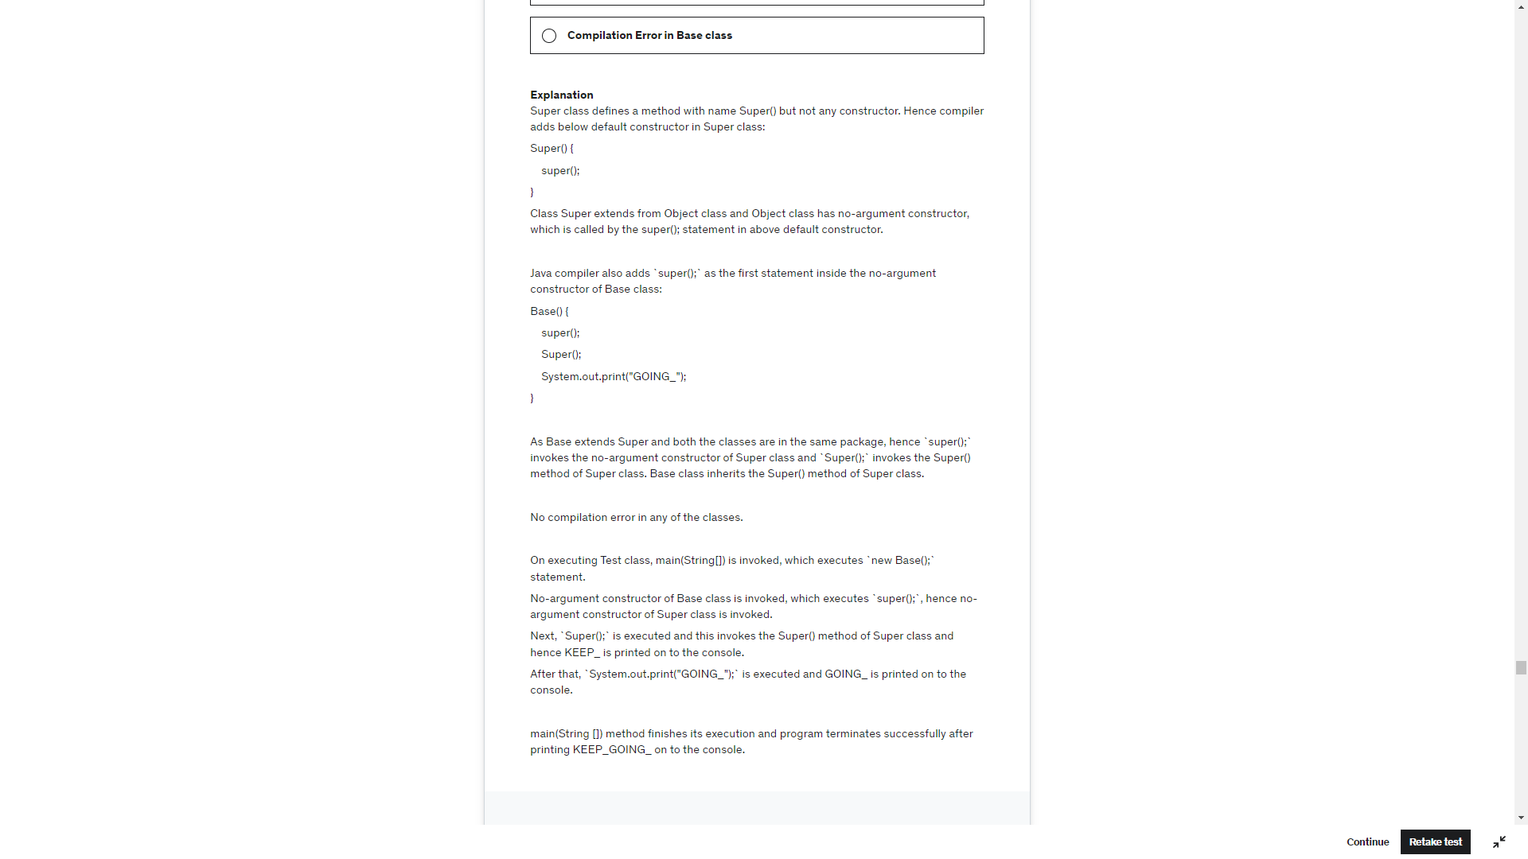

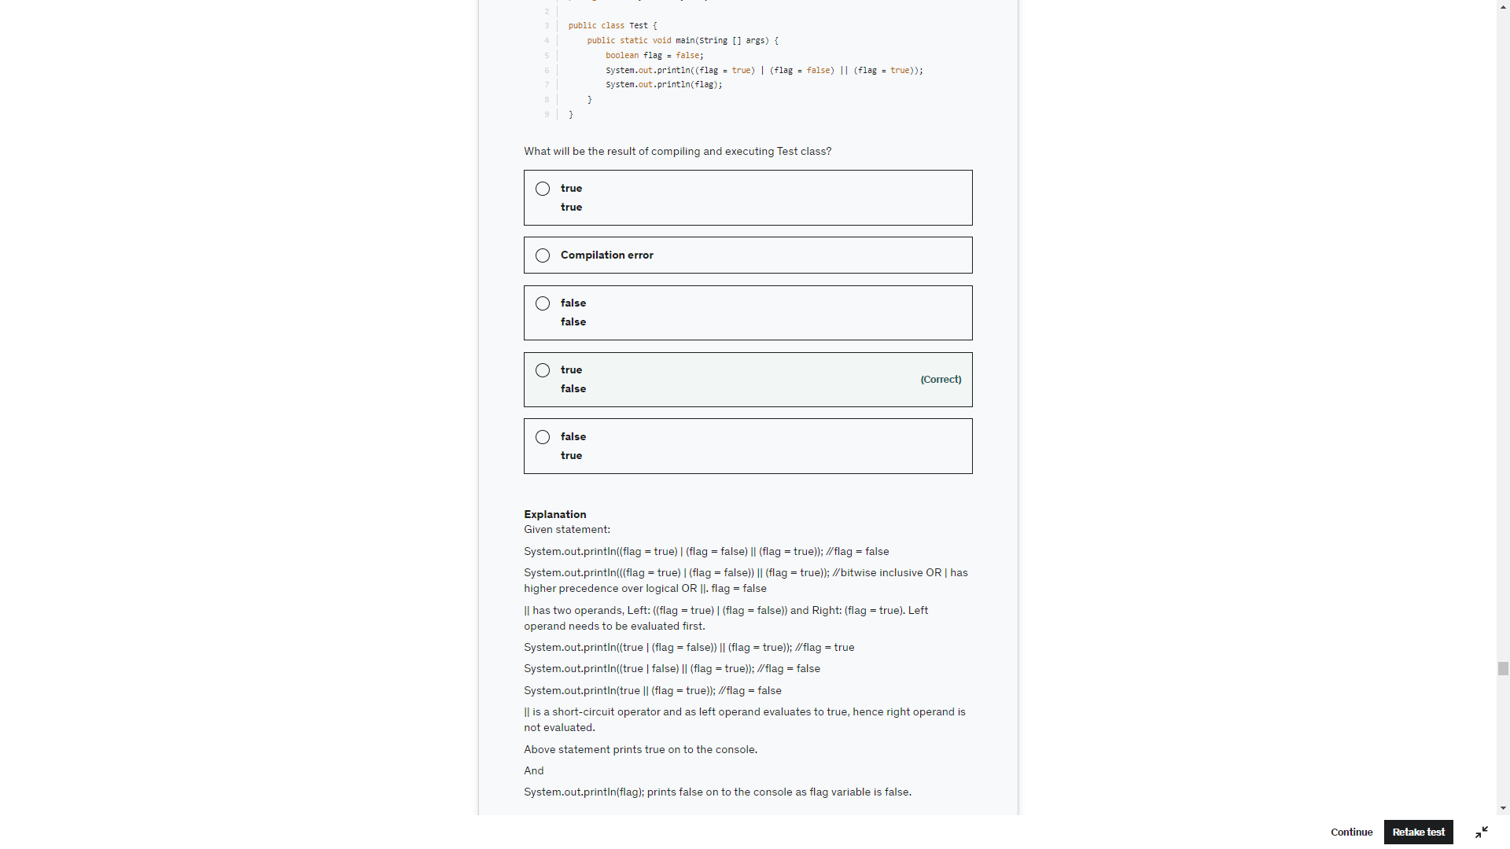

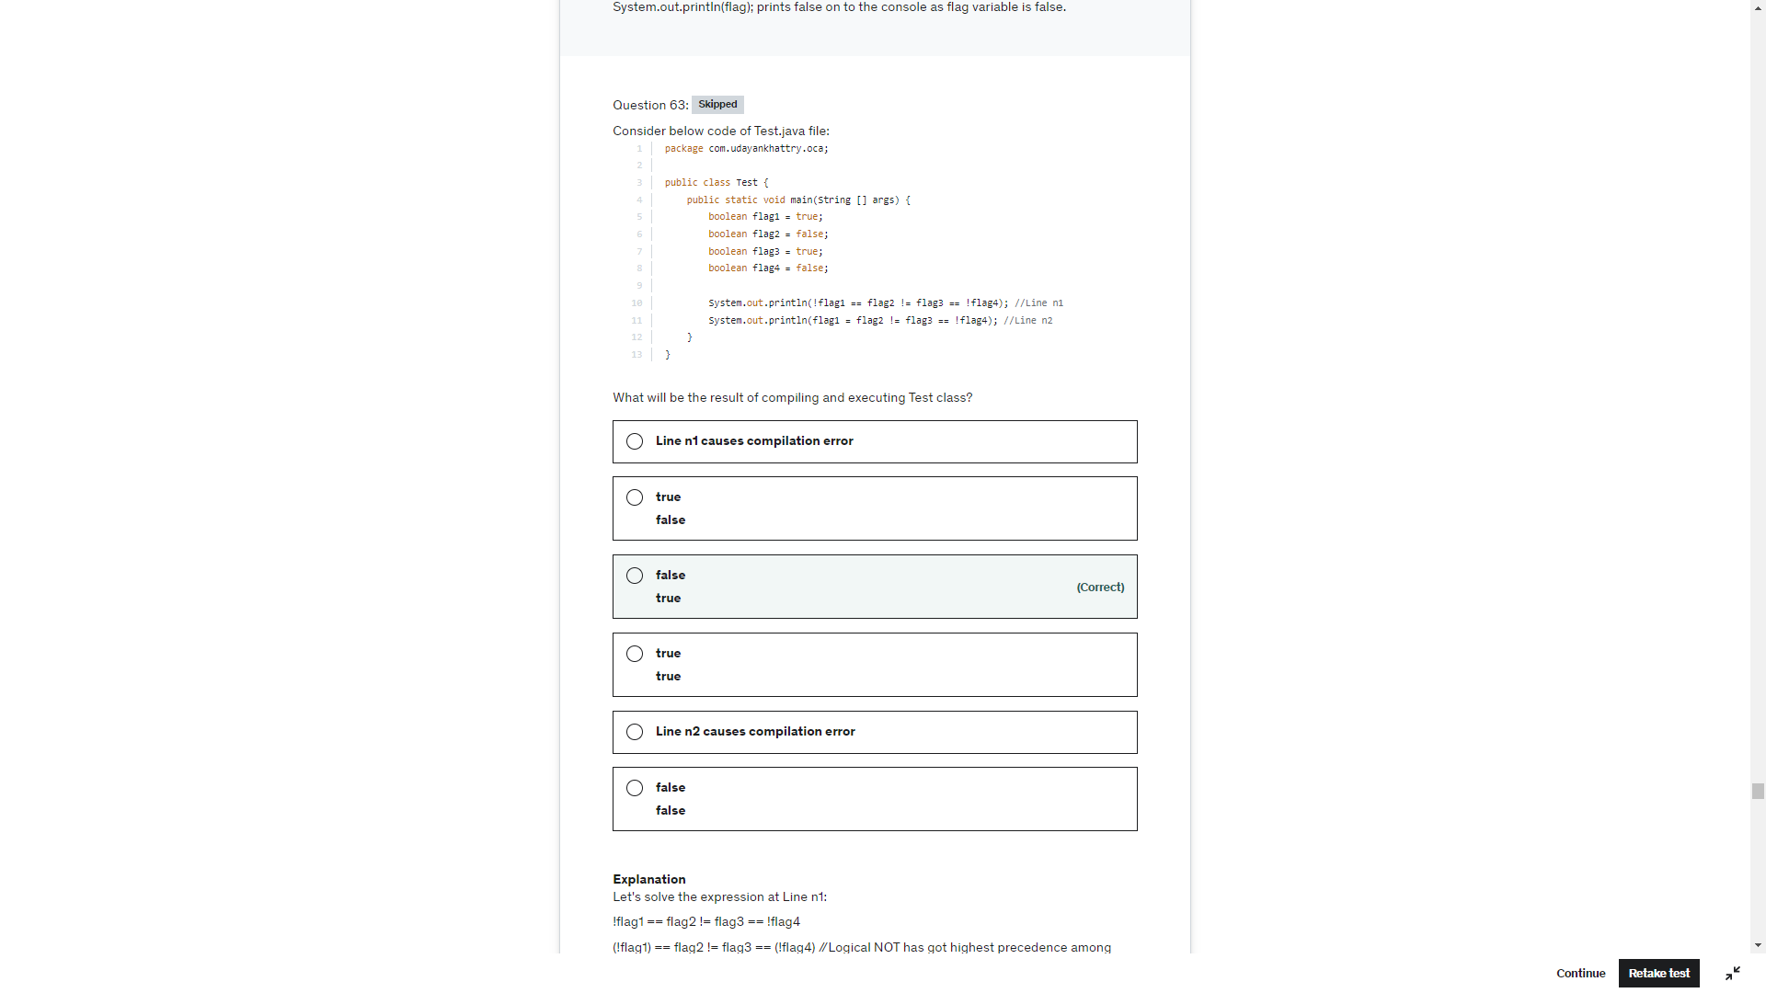

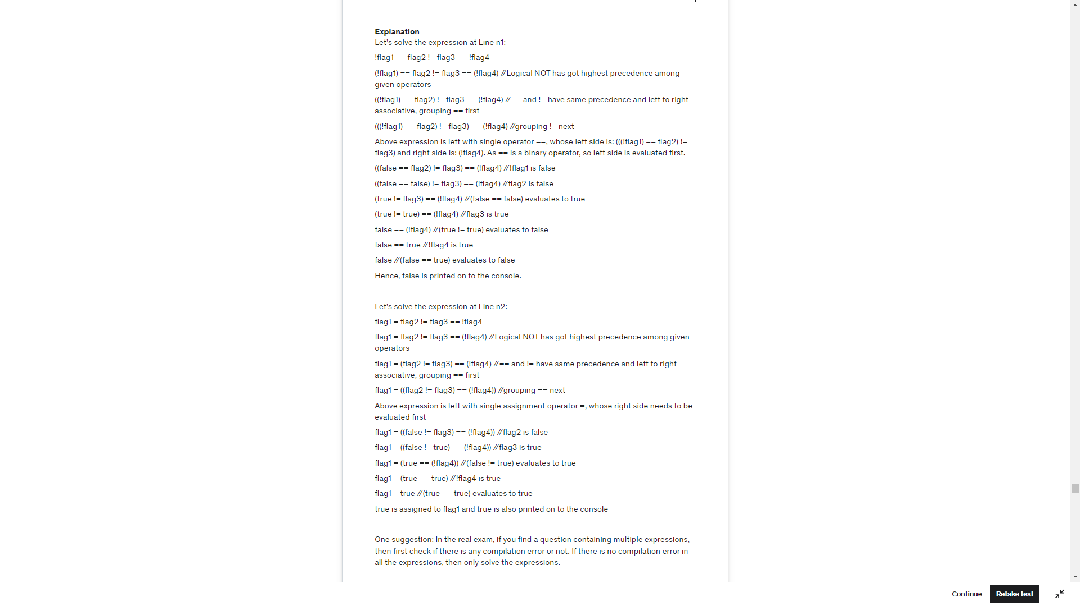

\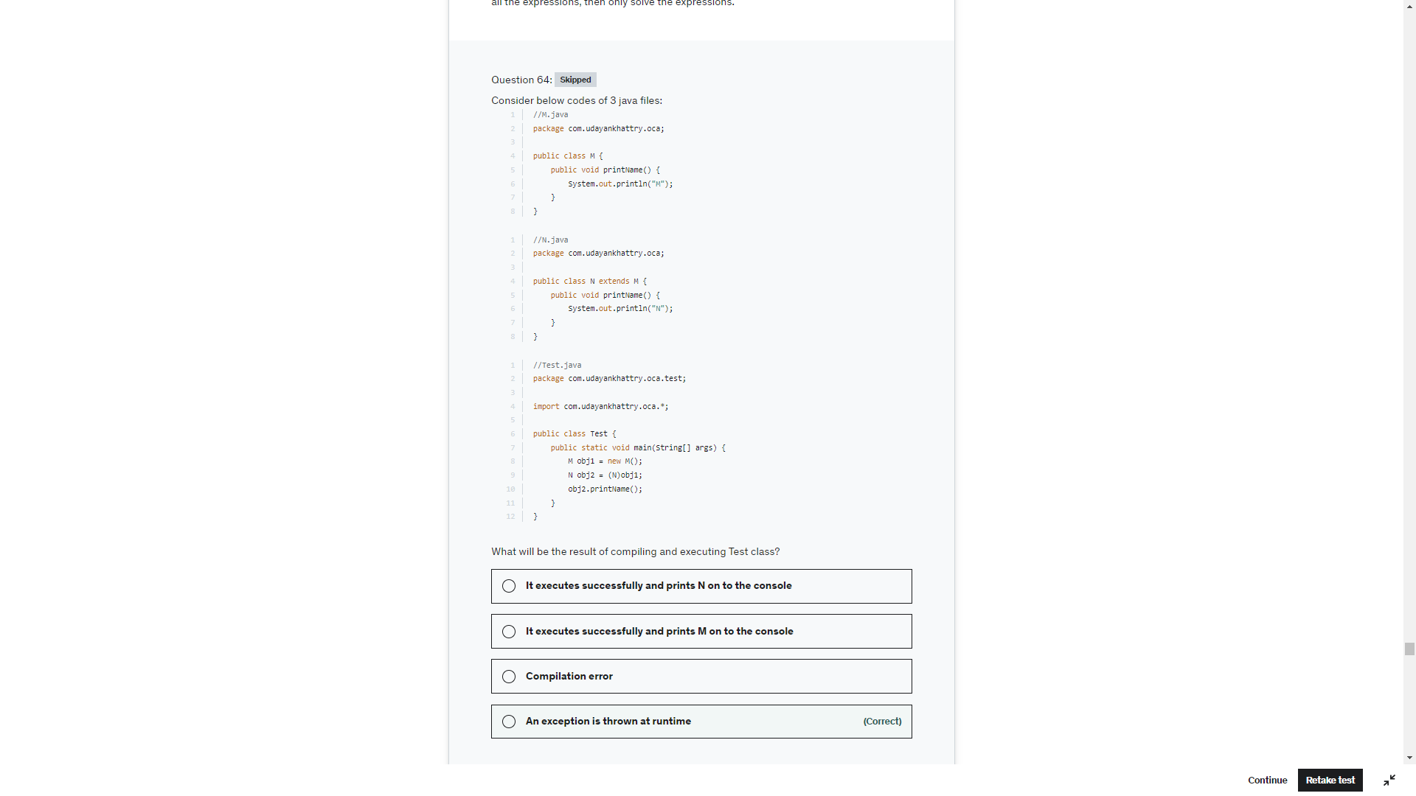

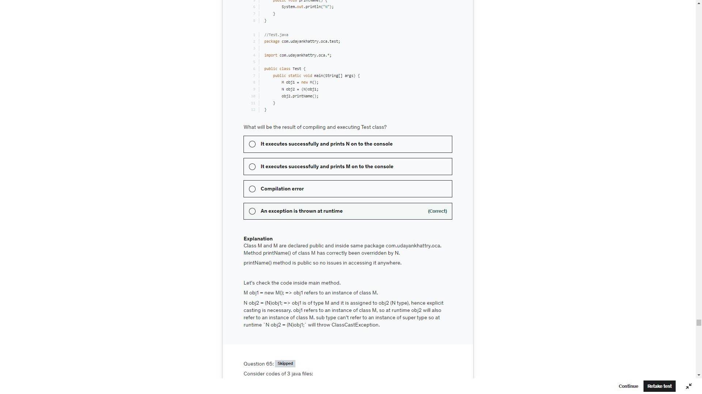

1 and 3 only

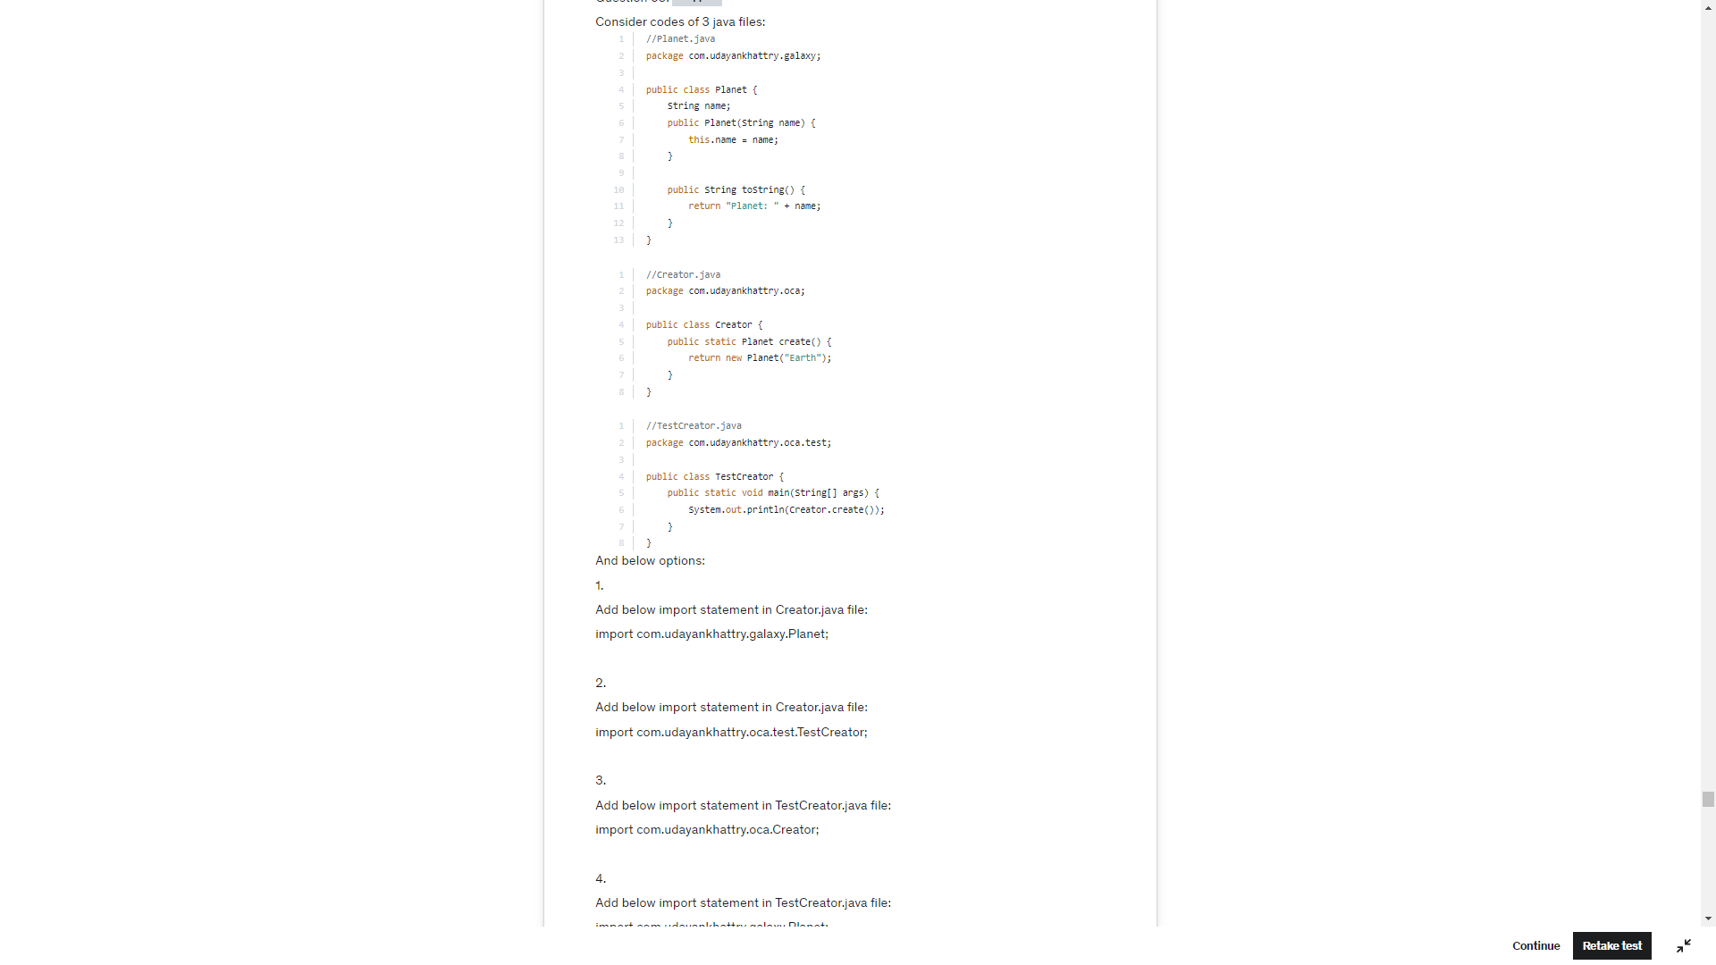

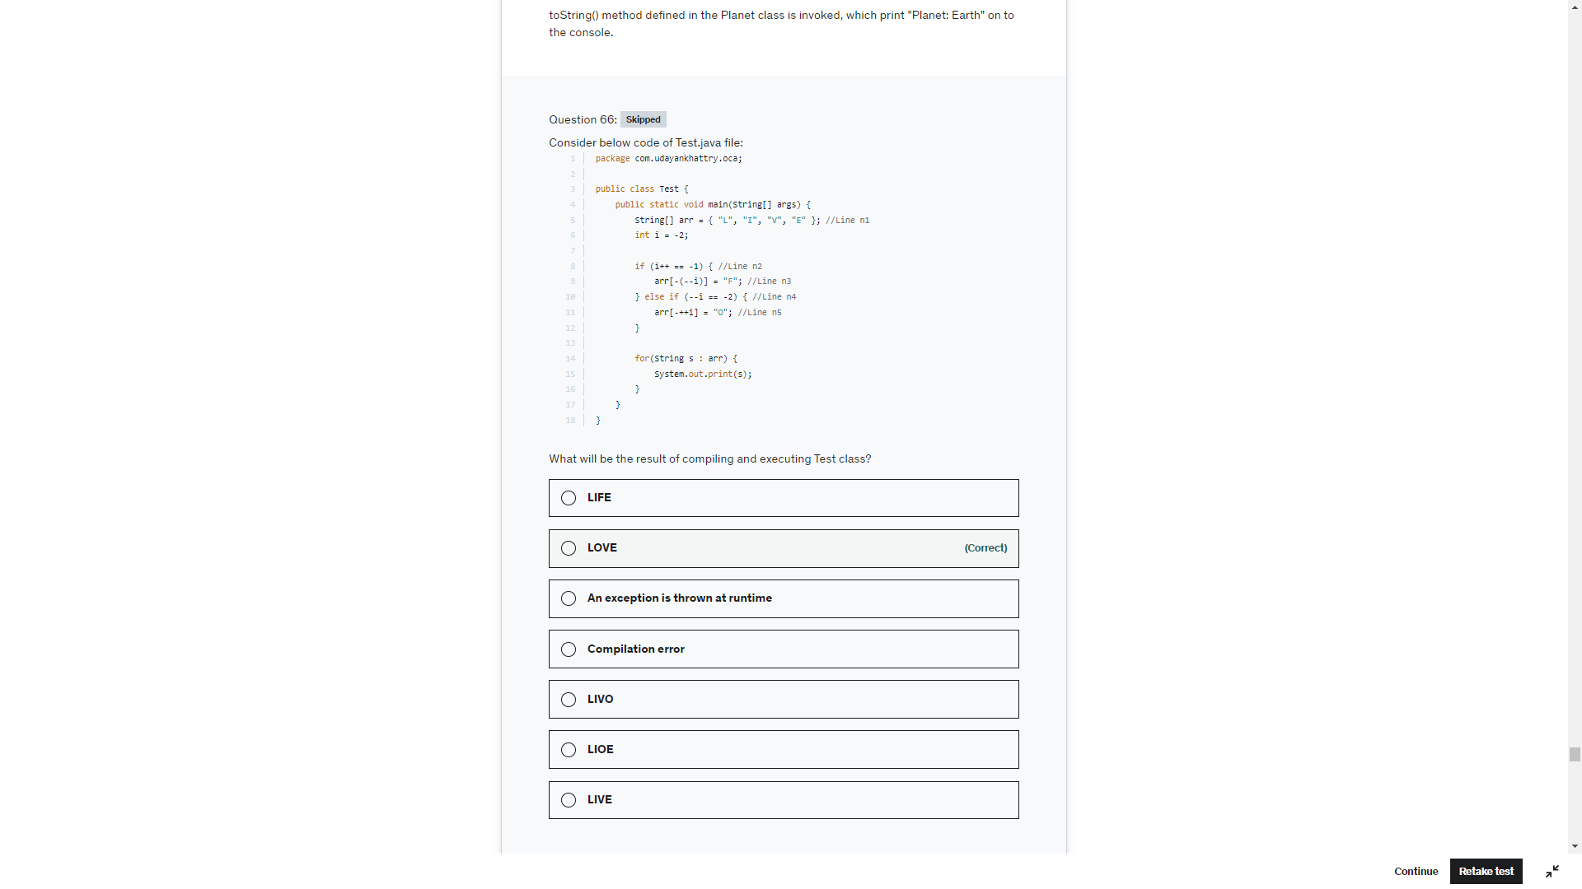

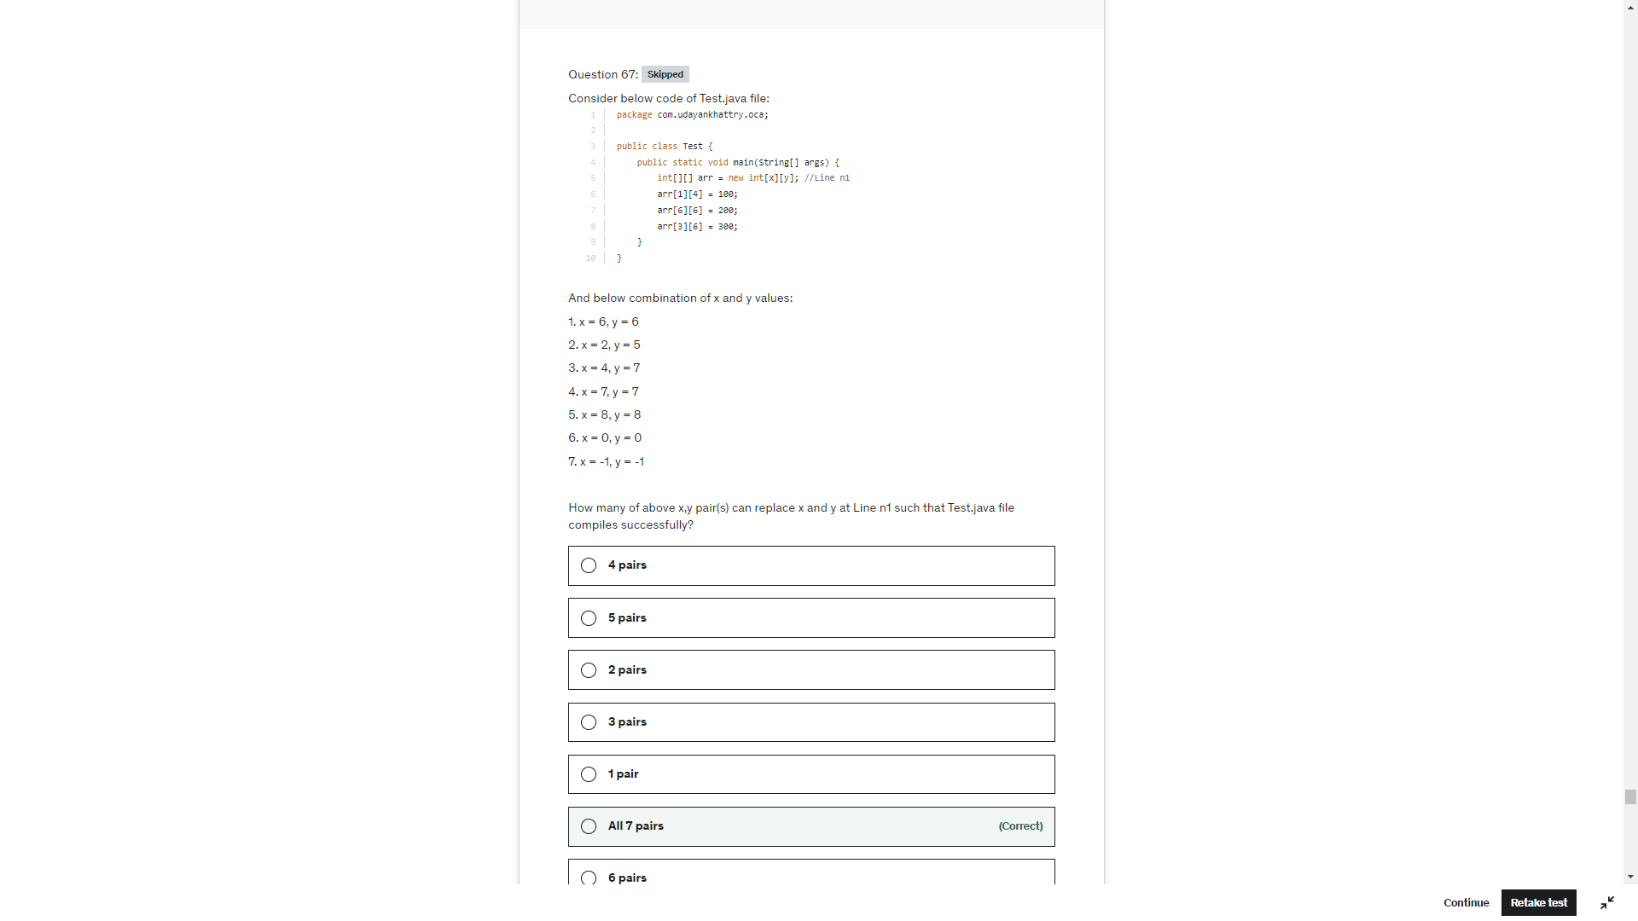

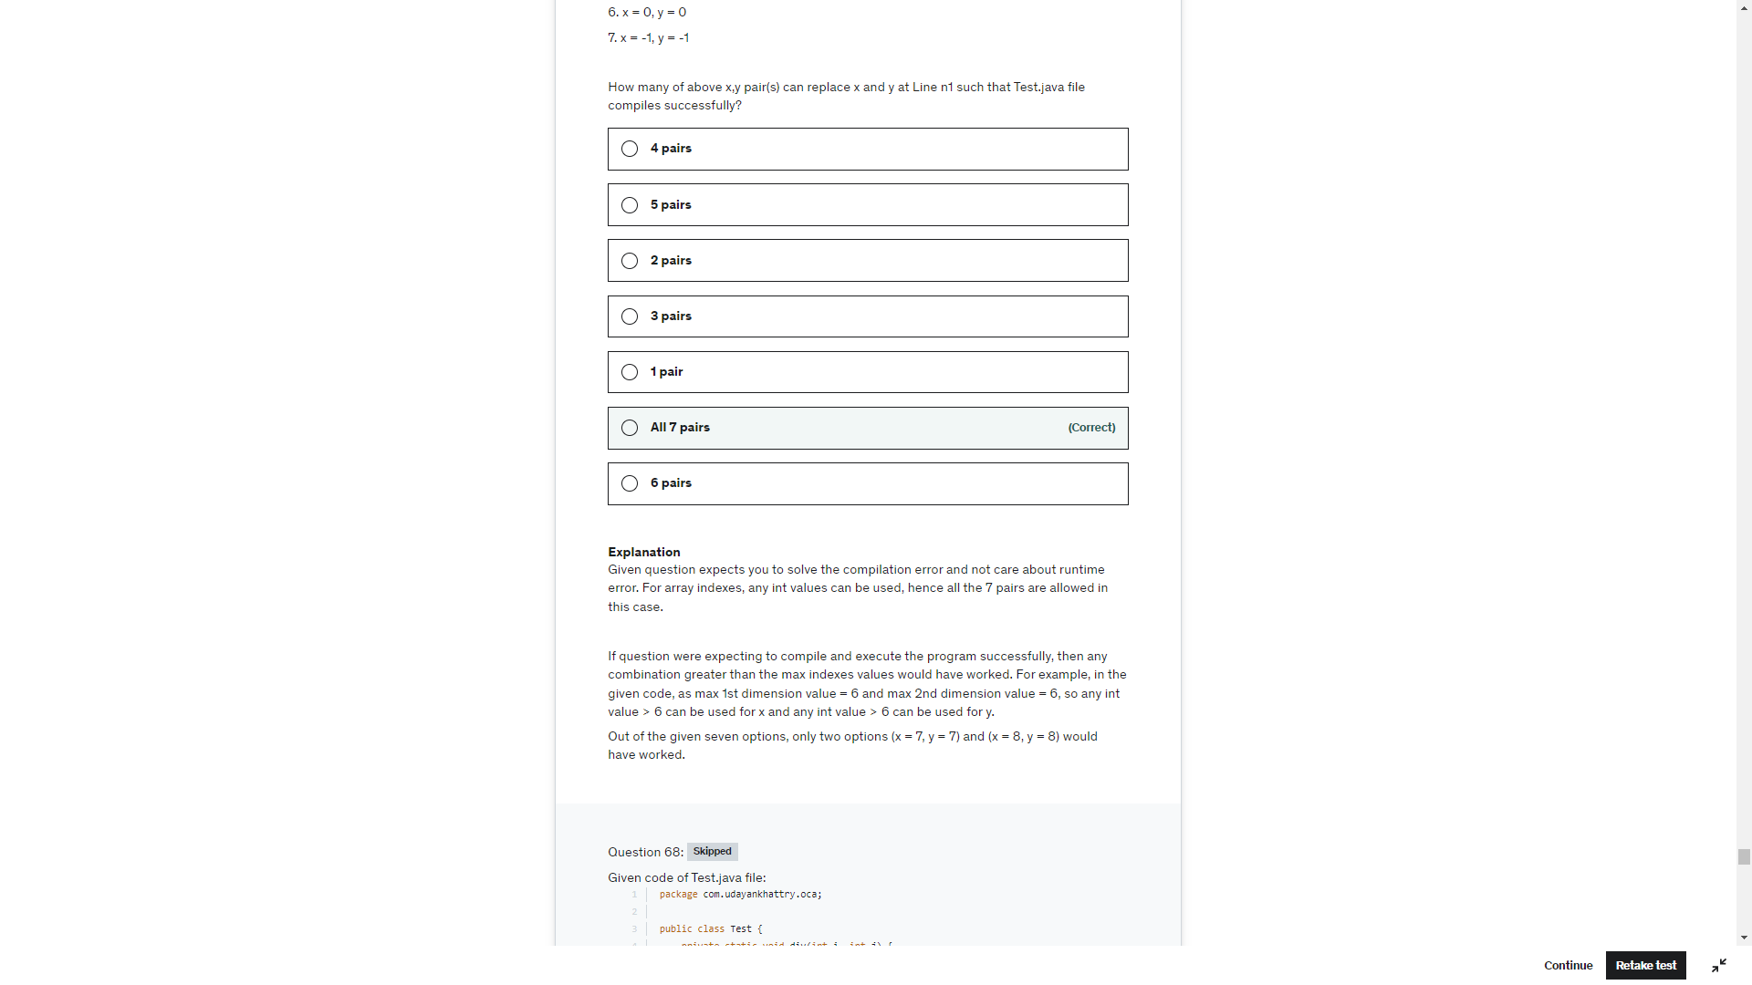

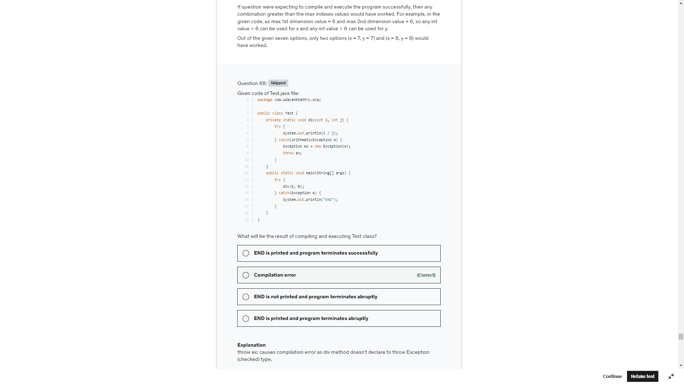

Code compiles successfully but the for loop will excute 5 times and there are only 4 books. ArrayIndexOutOfBound Excpetion wll be thrown

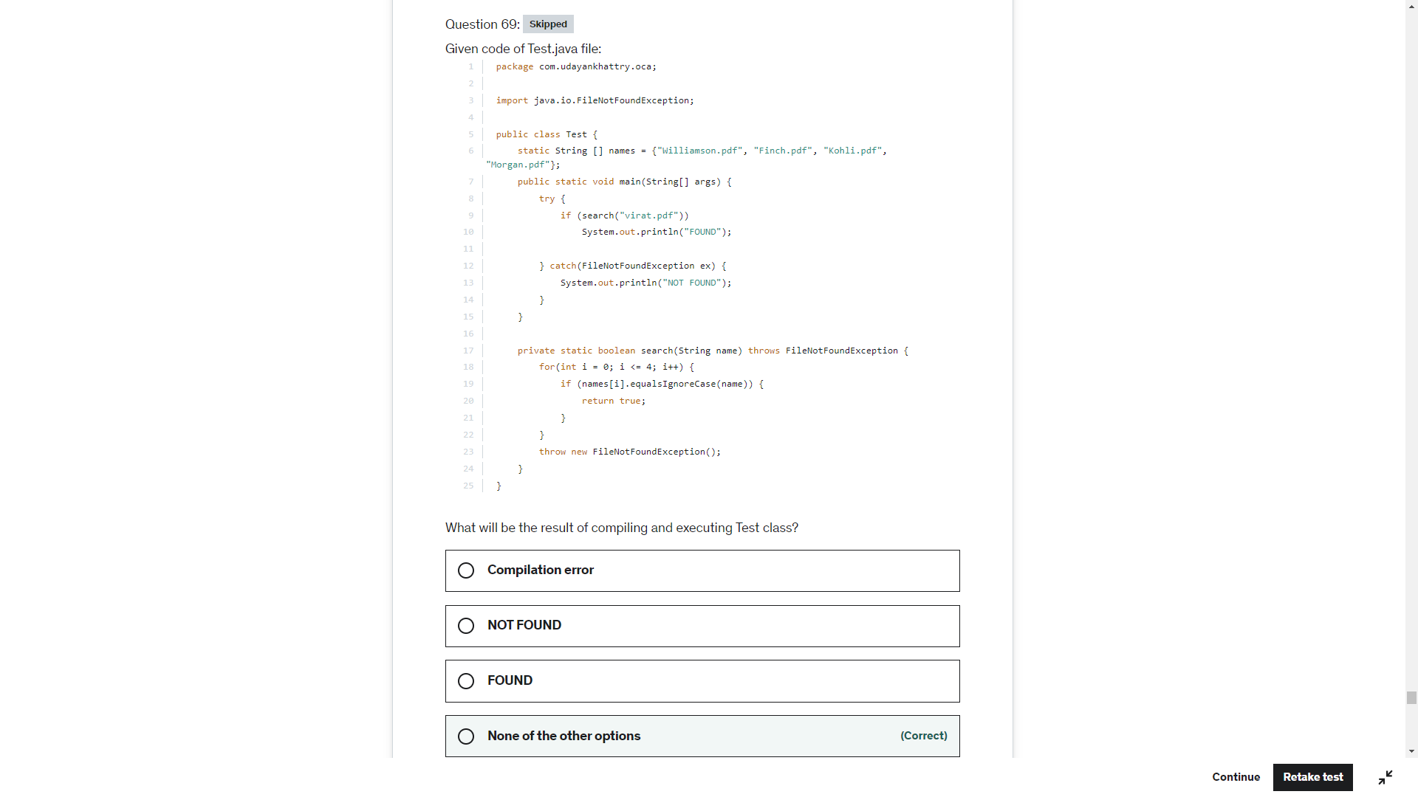

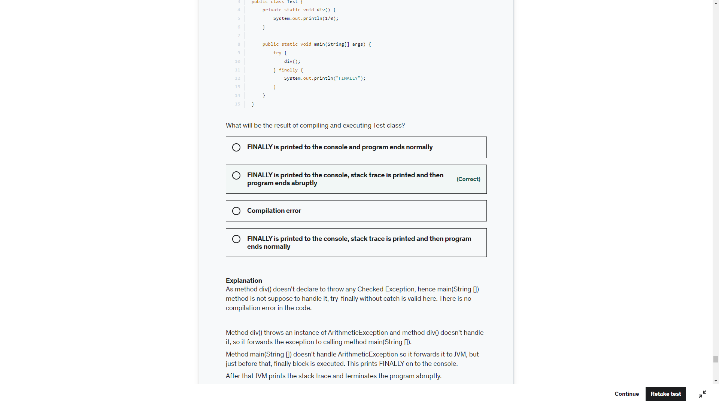

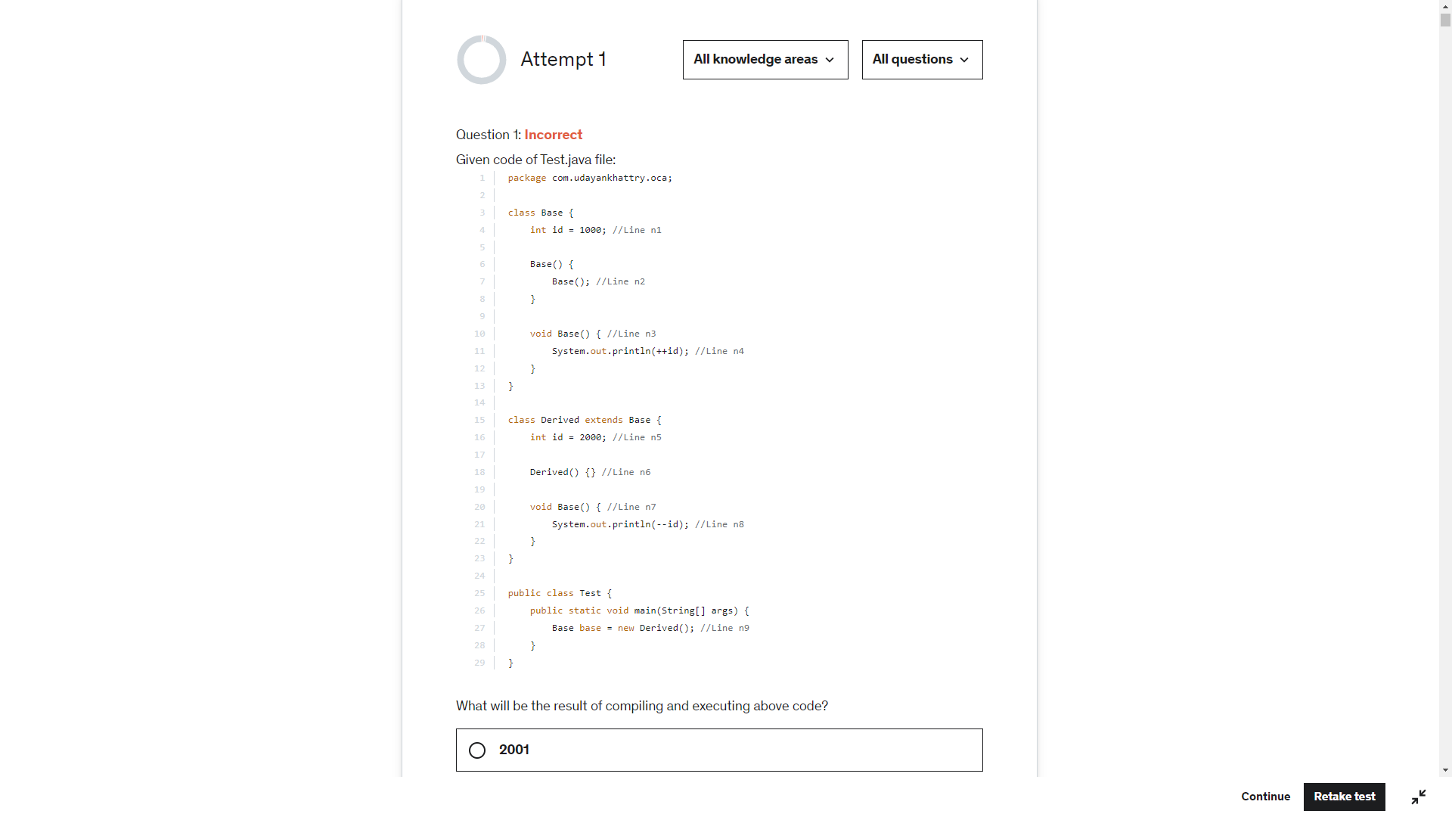

-1 is the output

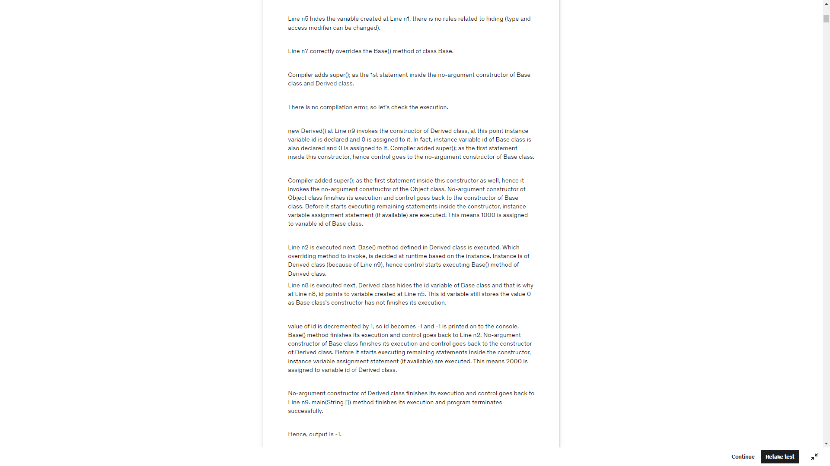

Whenever you inherit a superclass a copy of superclass’s members is created at the subclass and you using its object you can access the superclass members.

If the superclass and the subclass have instance variable of same name, if you access it using the subclass object, the instance variables of the subclass hides the instance variables of the superclass irrespective of the types. This mechanism is known as field hiding or, instance variable hiding.

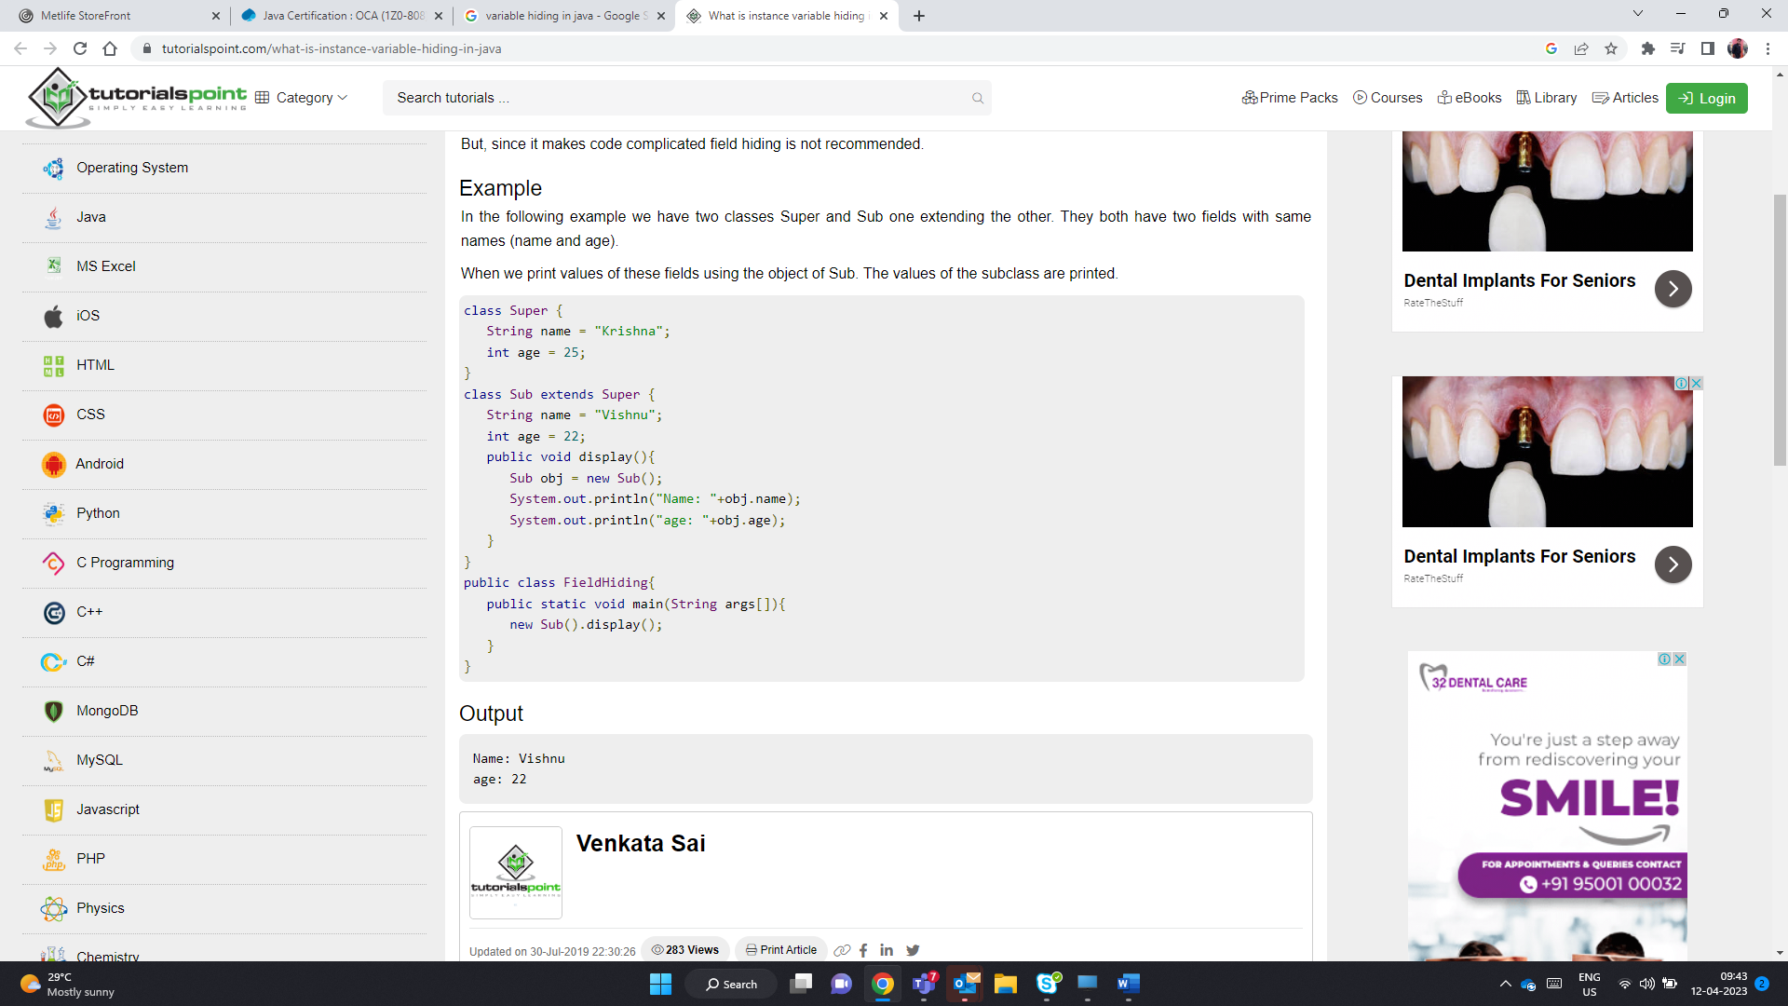

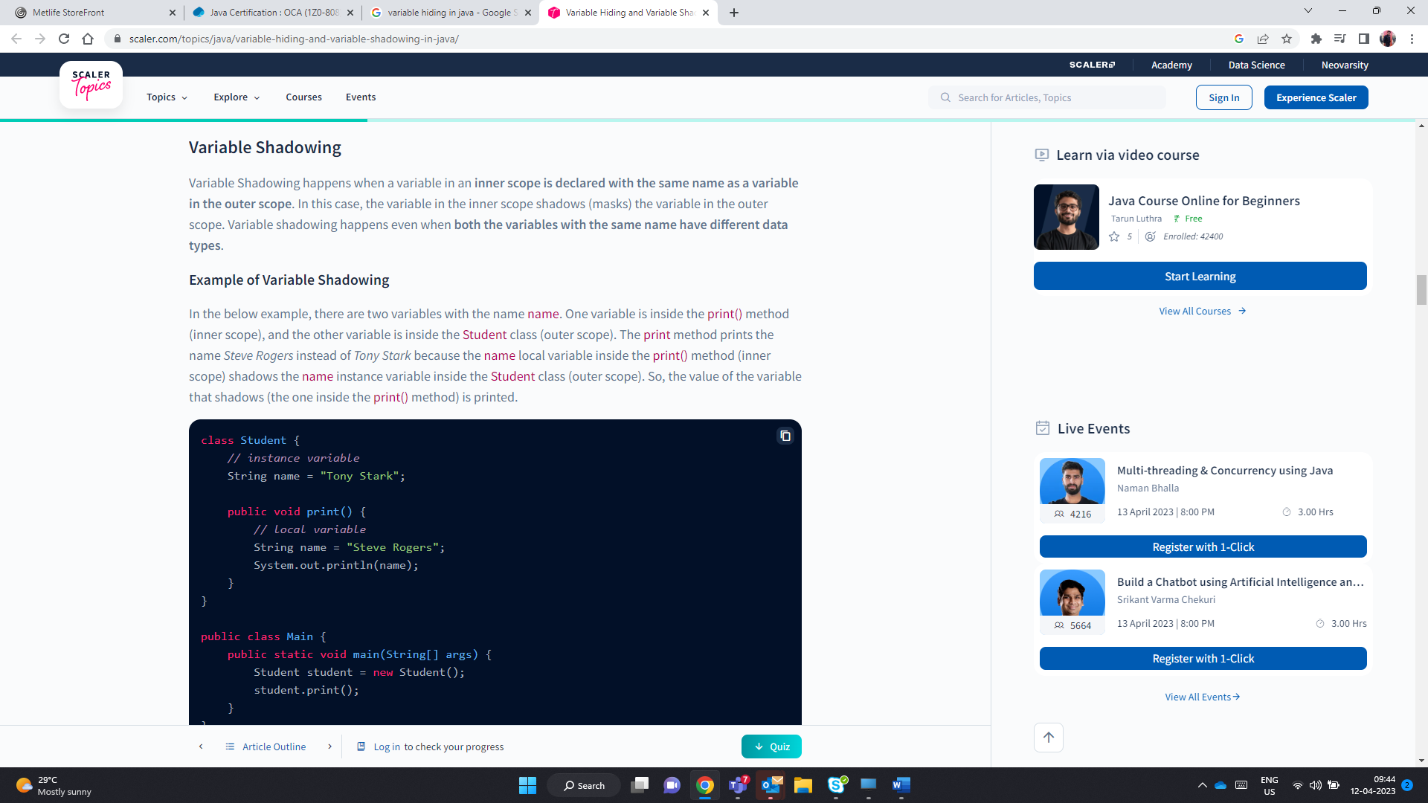

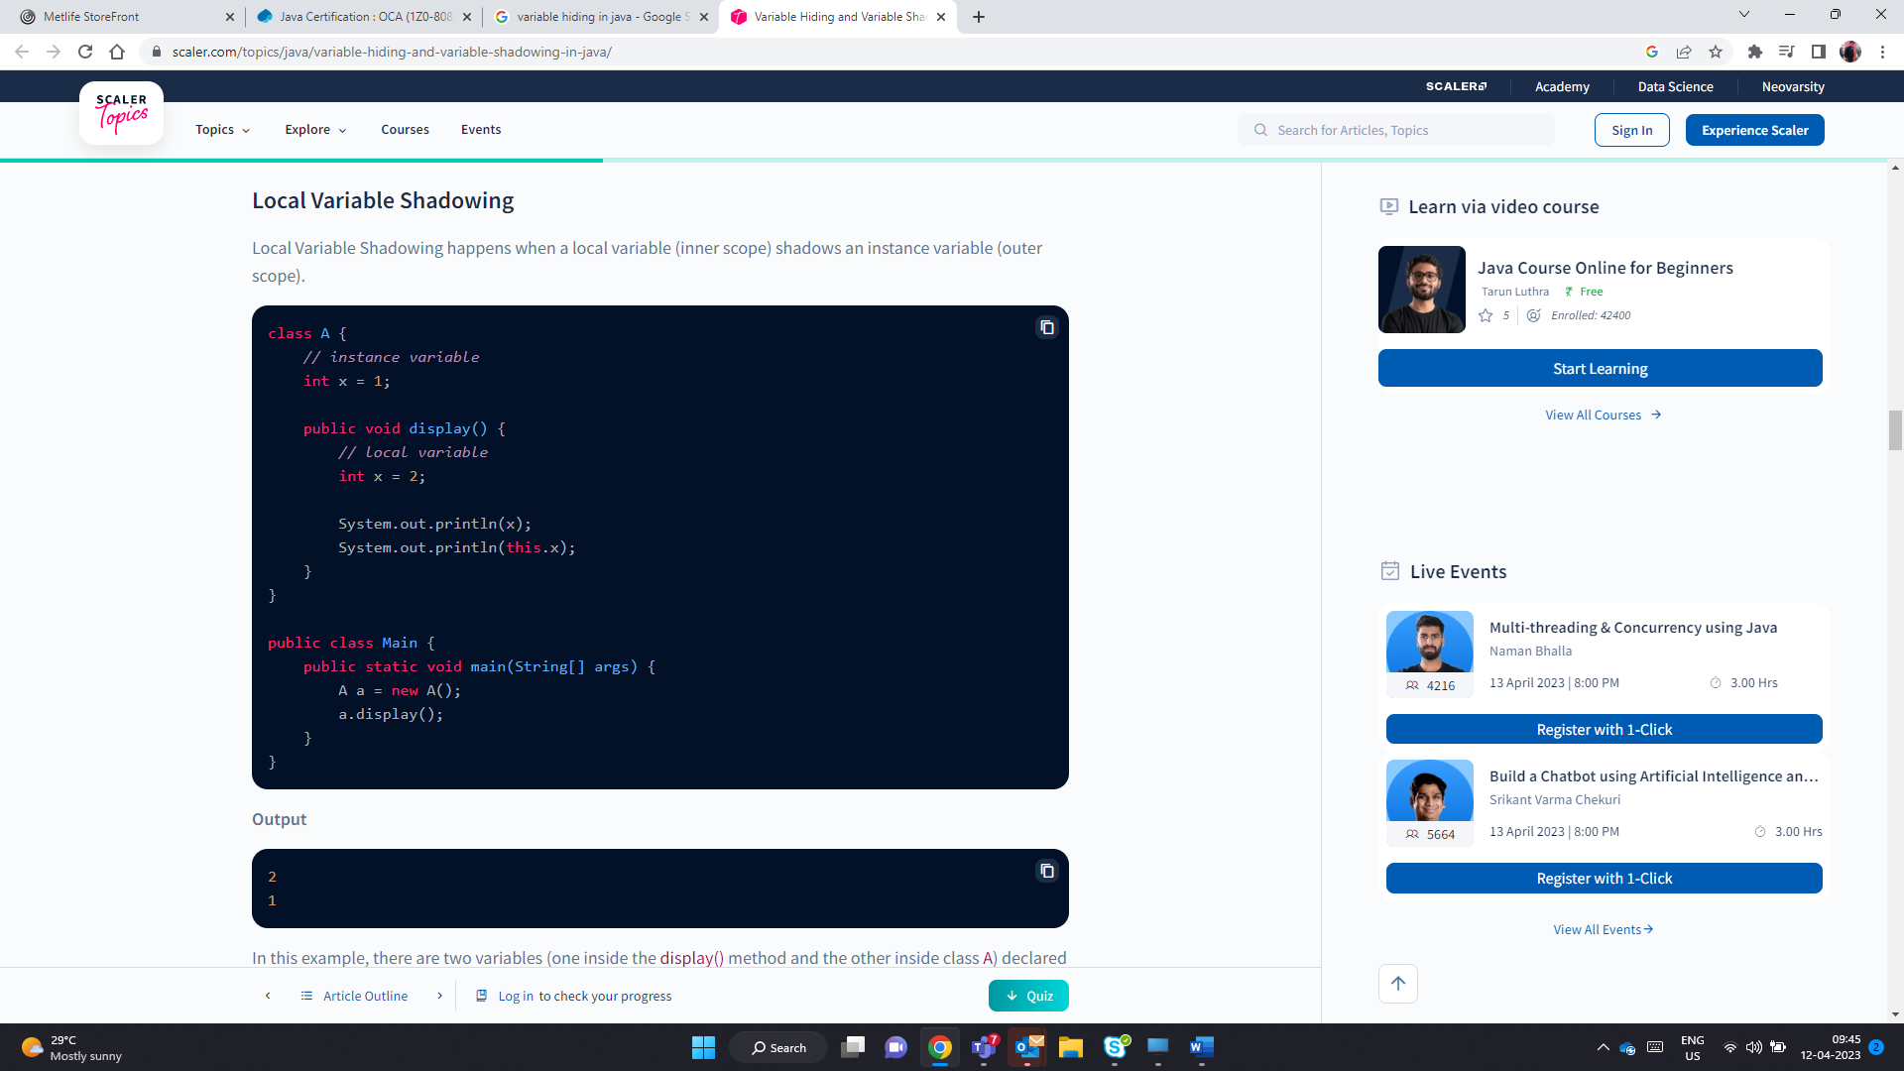

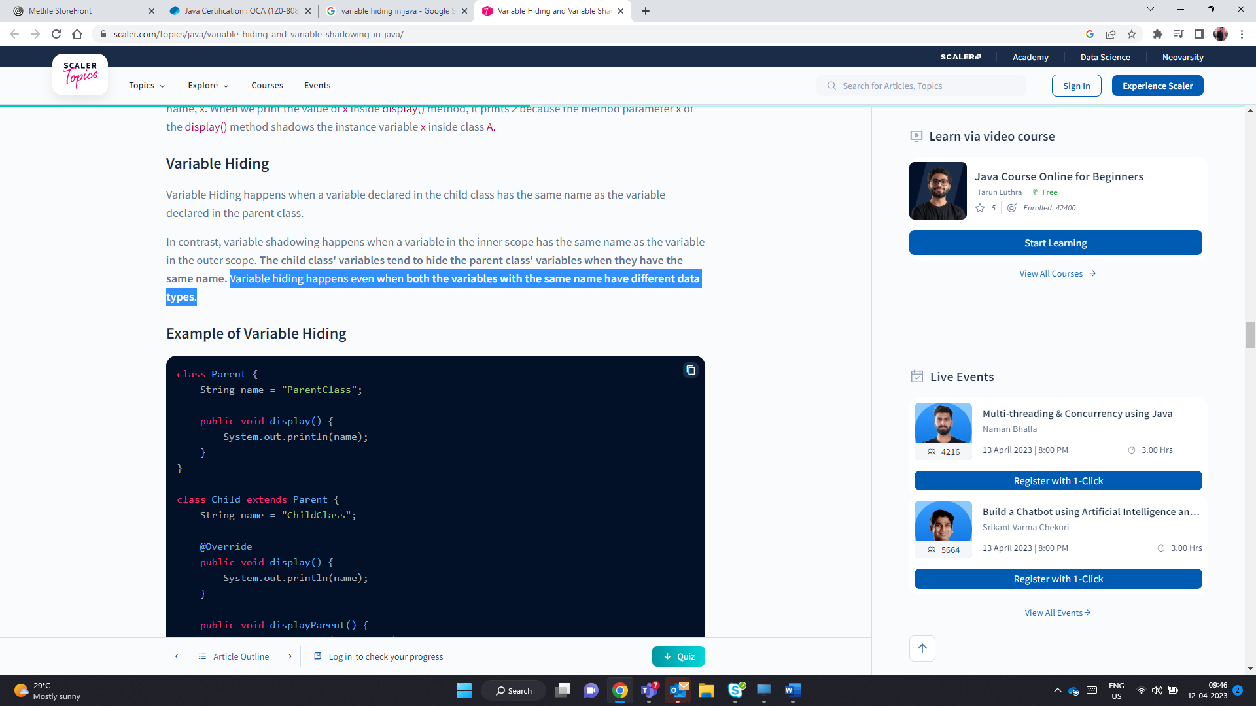

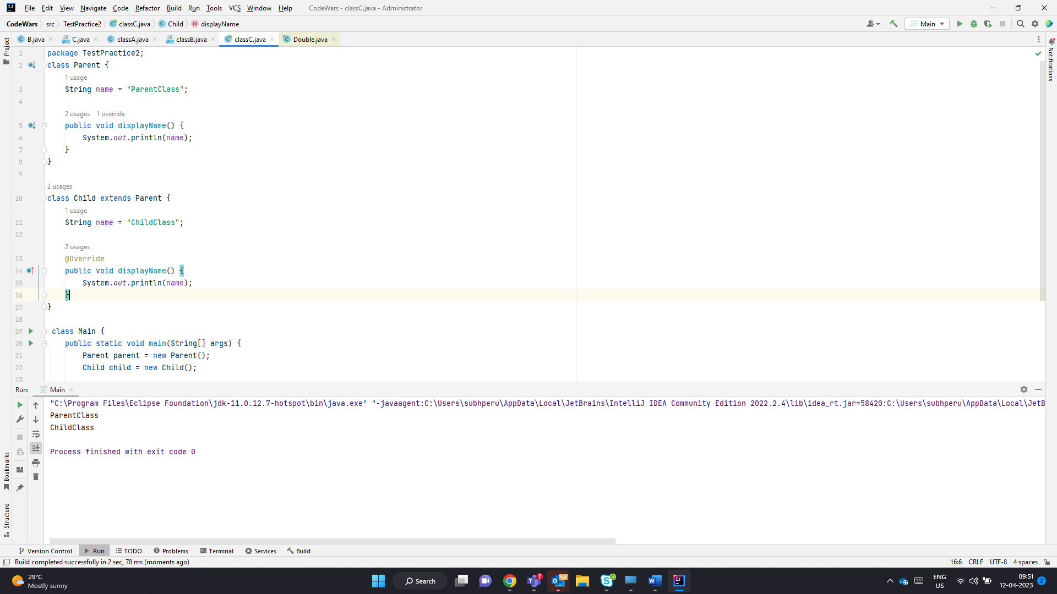

parent.name -> ParentClass

child.name -> ChildClass

to access hidden variable use super.name;

to access shadowed variable use this.name();in case of shadowing

* Variable hiding is not the same as method overriding because, in variable hiding, the child class variables only hide the parent class variables. Whereas in method overriding the methods in the child class replaces the methods in the parent class.

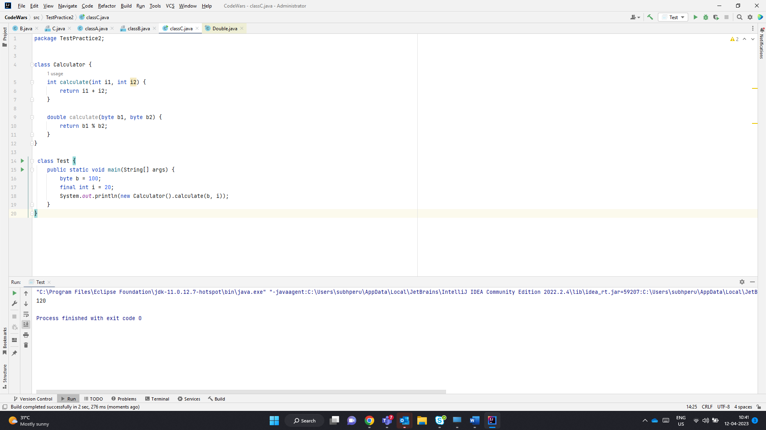

Even if i is not final it still works fine. The variable is resolved at run time .

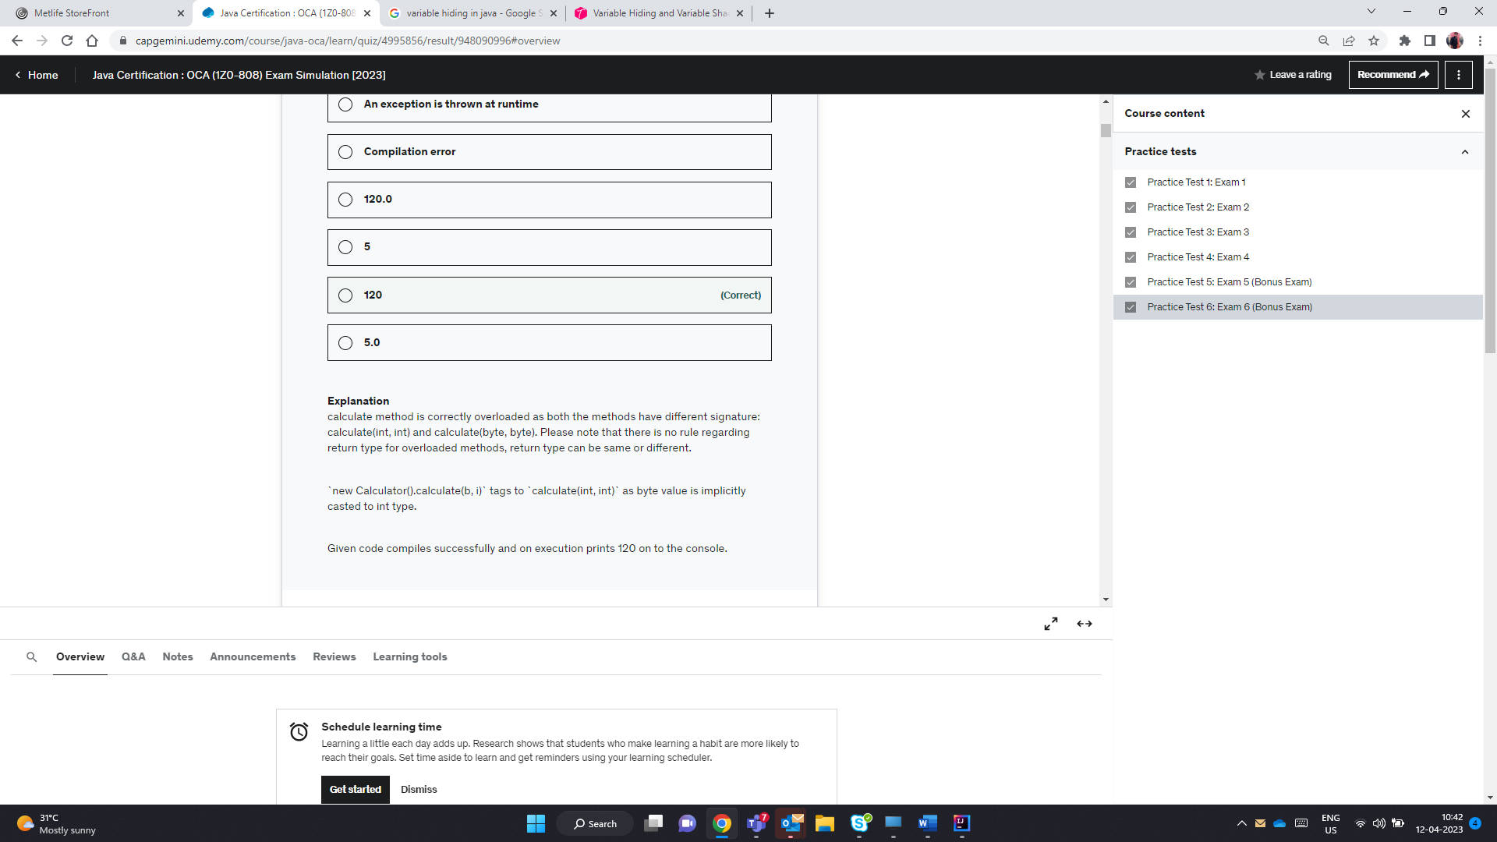

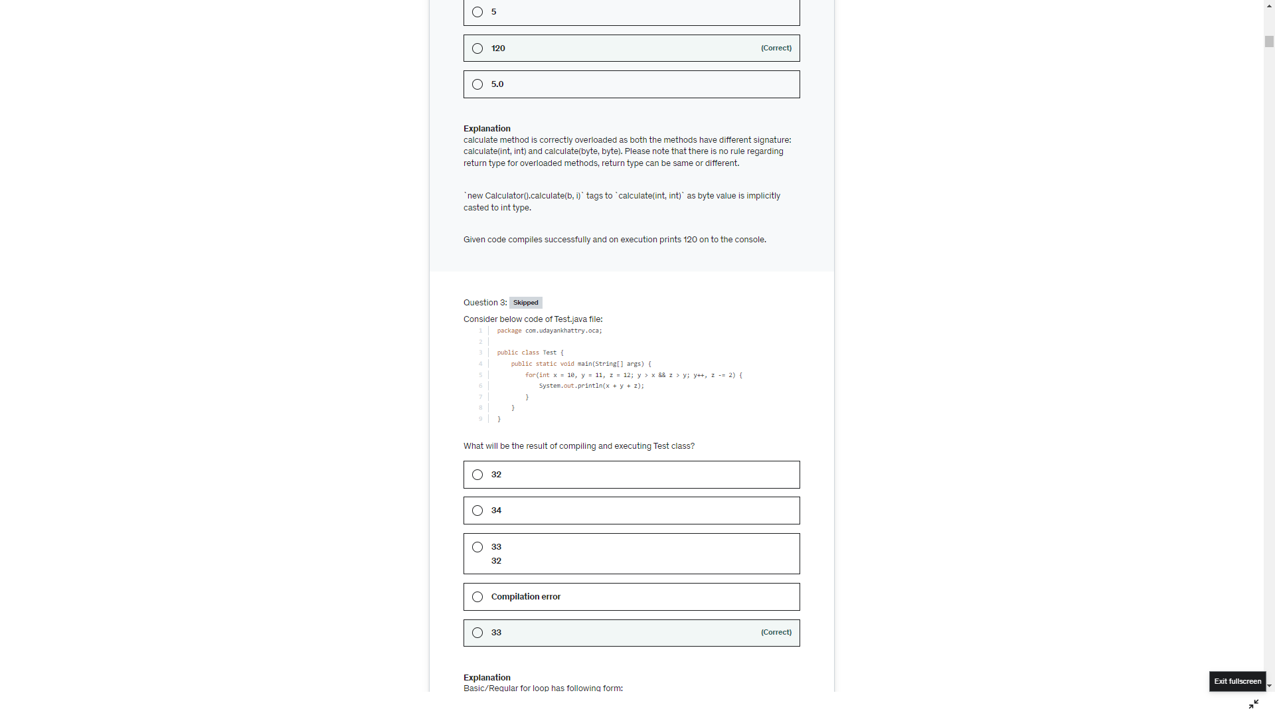

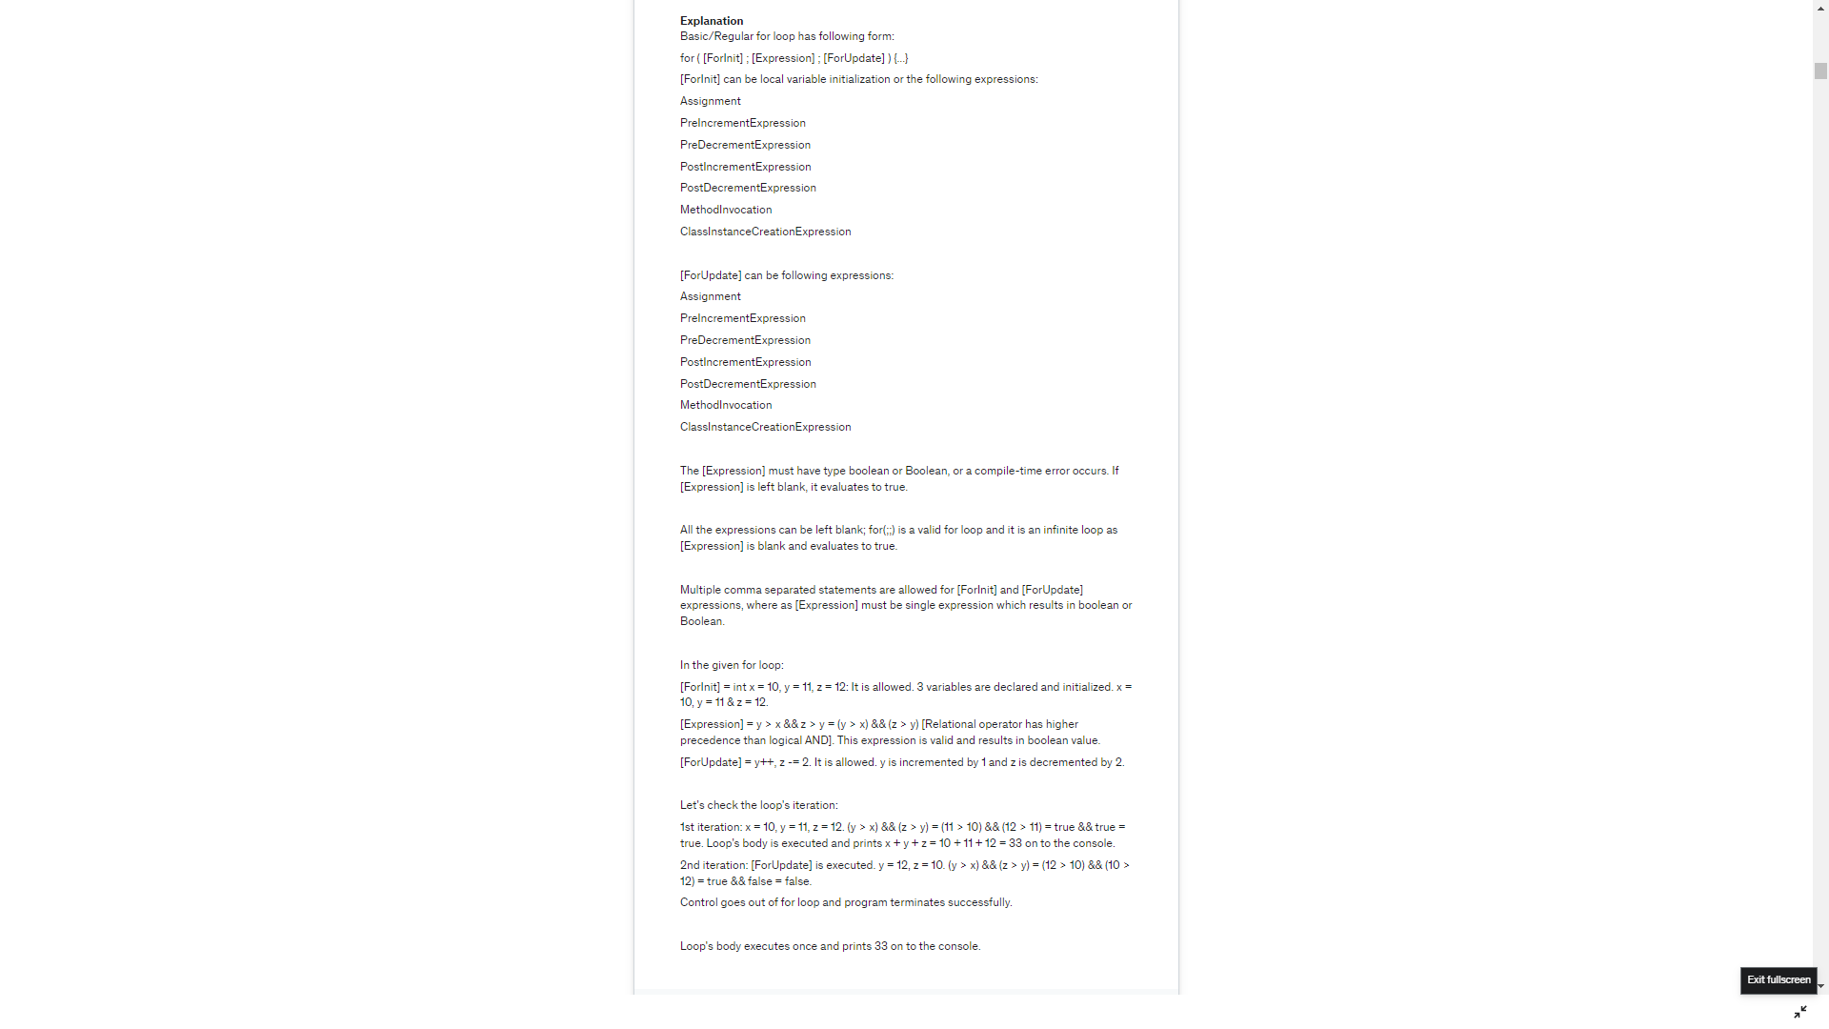

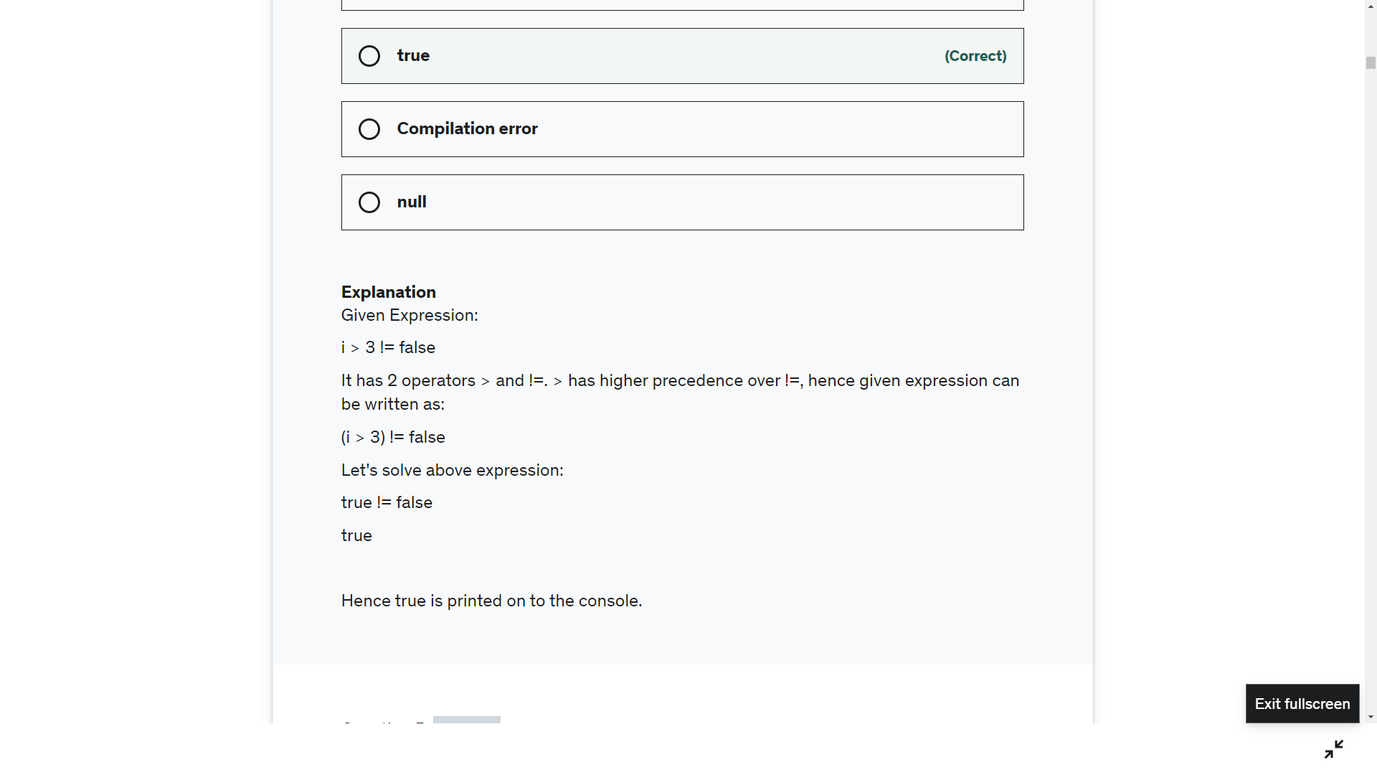

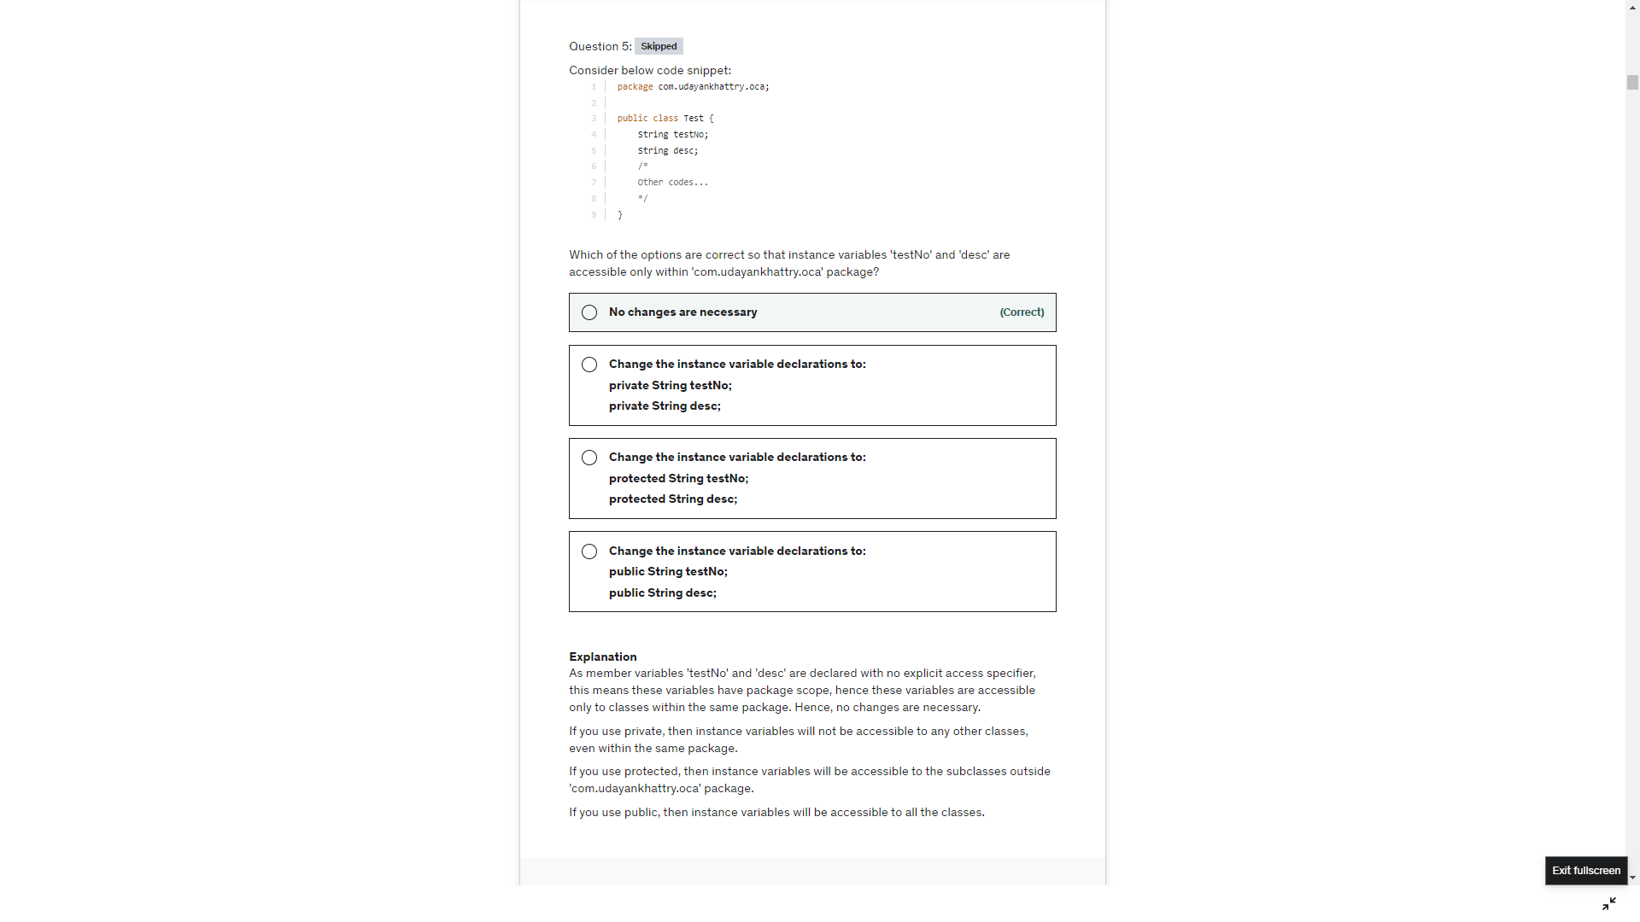



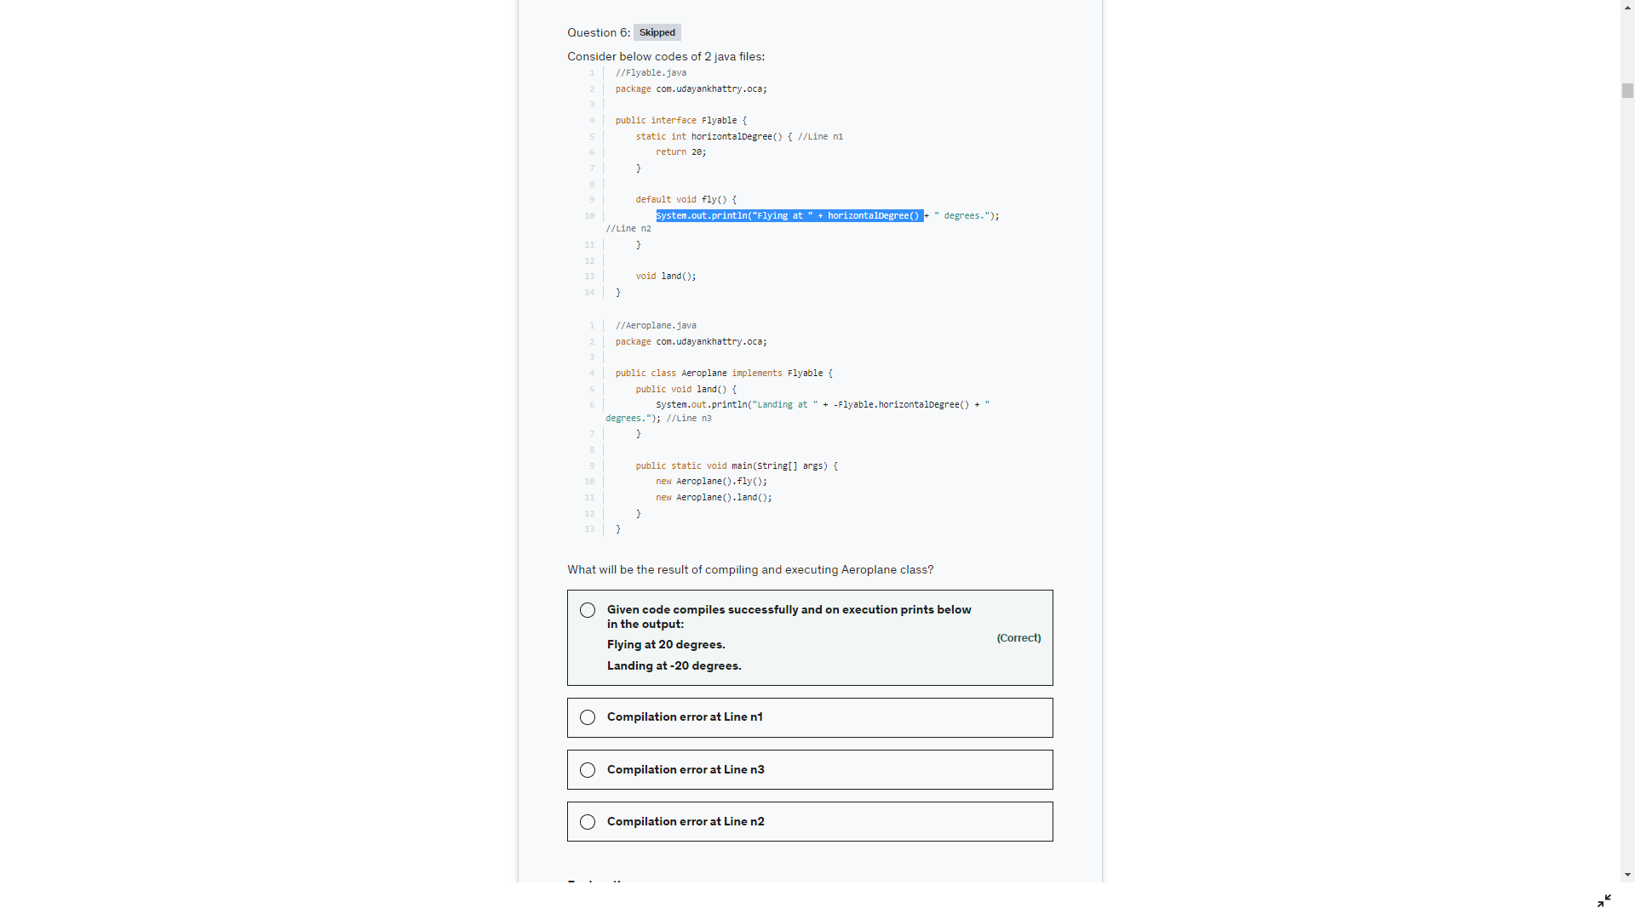

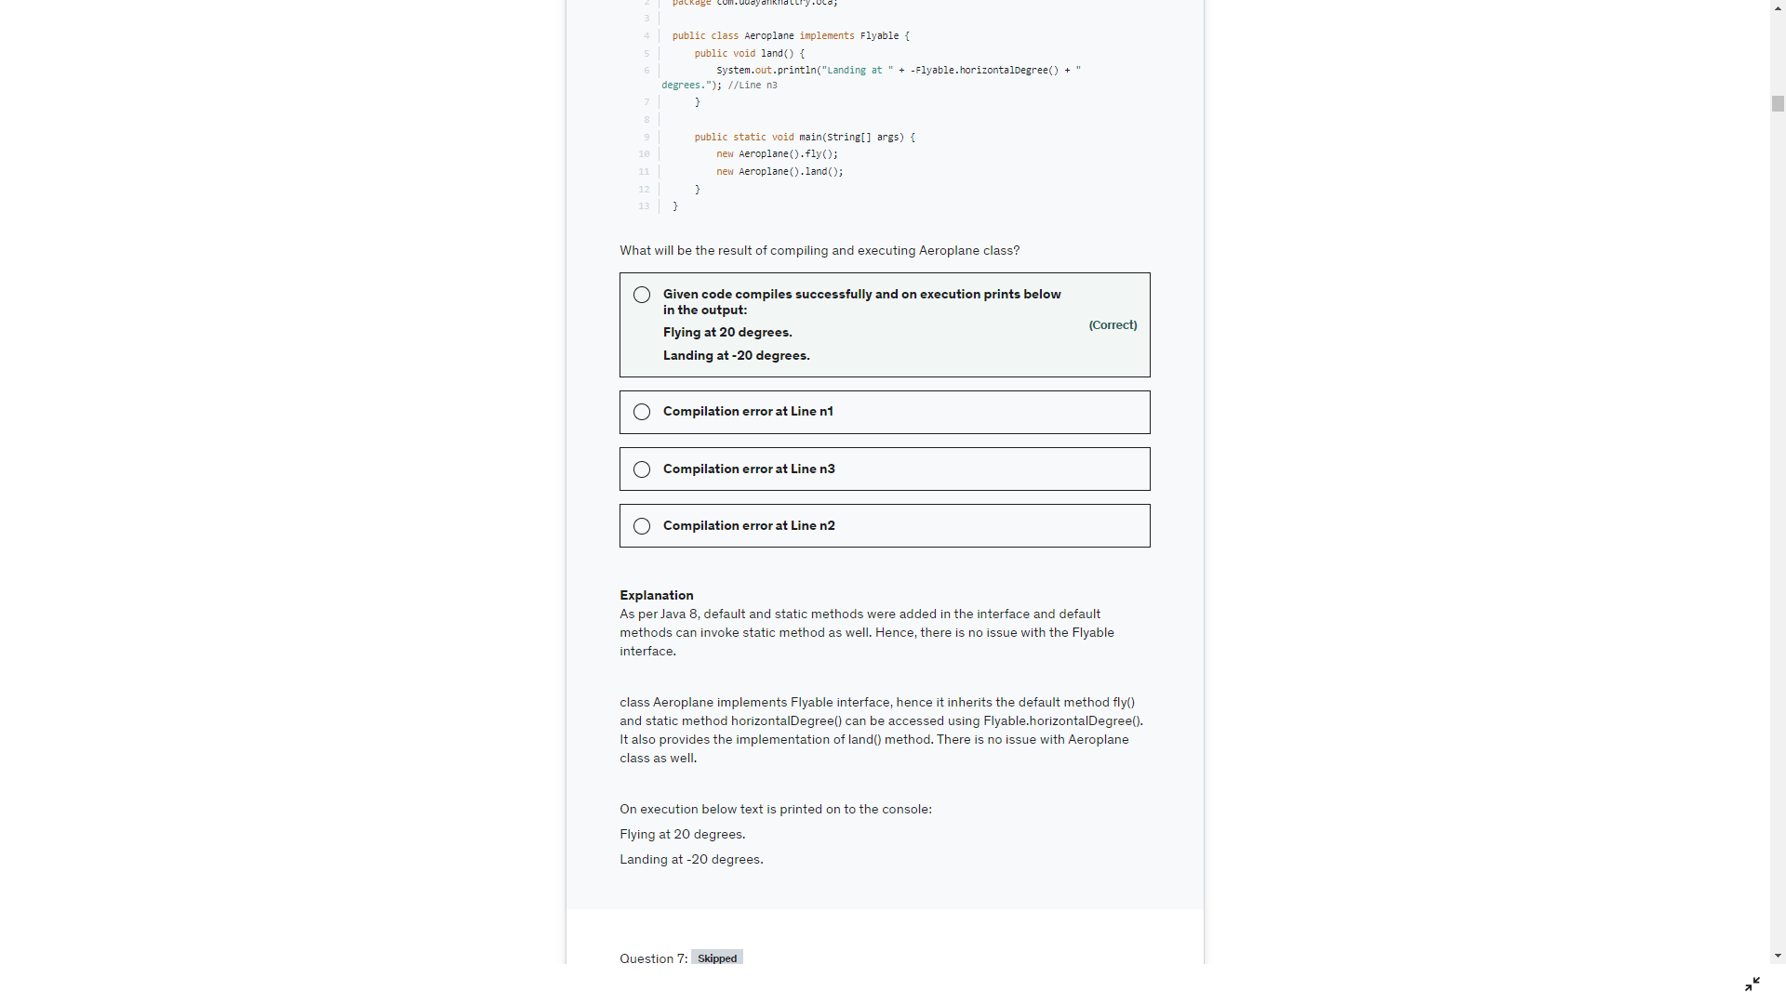

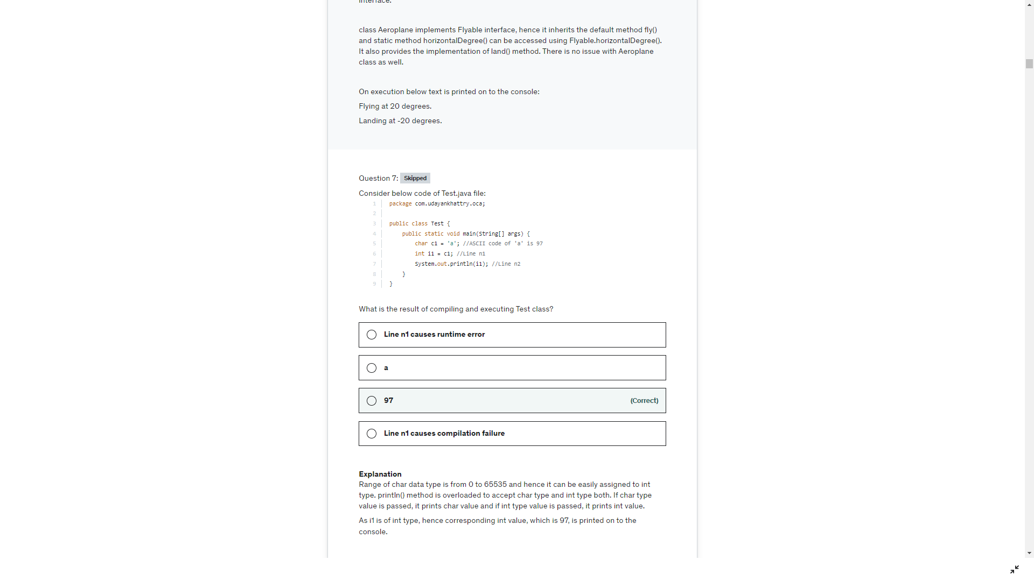

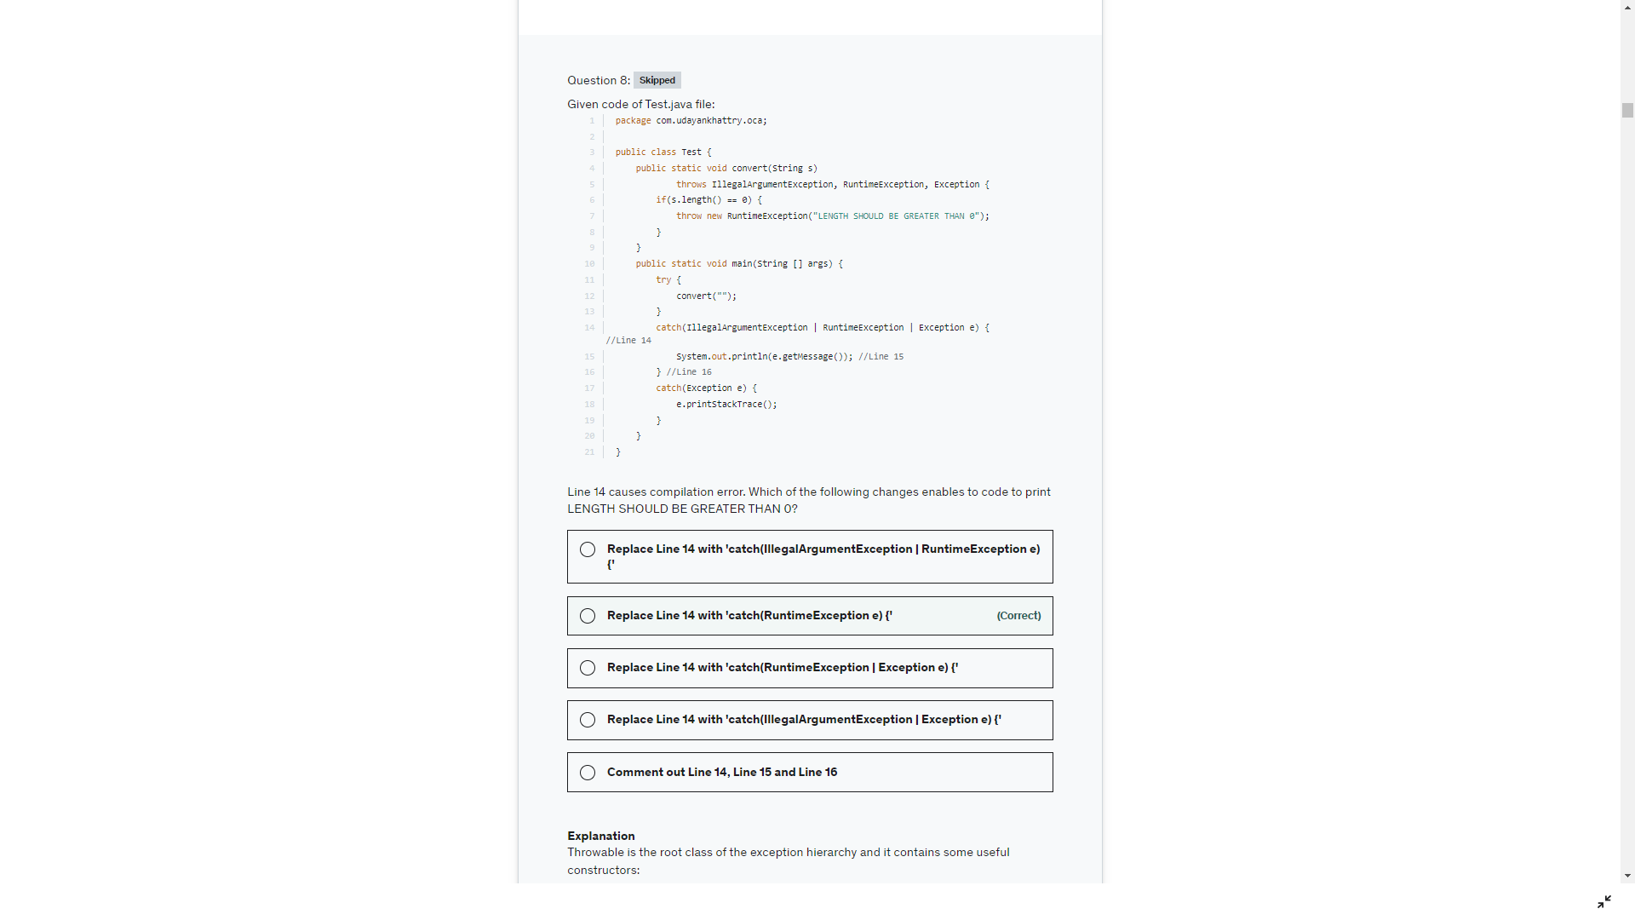

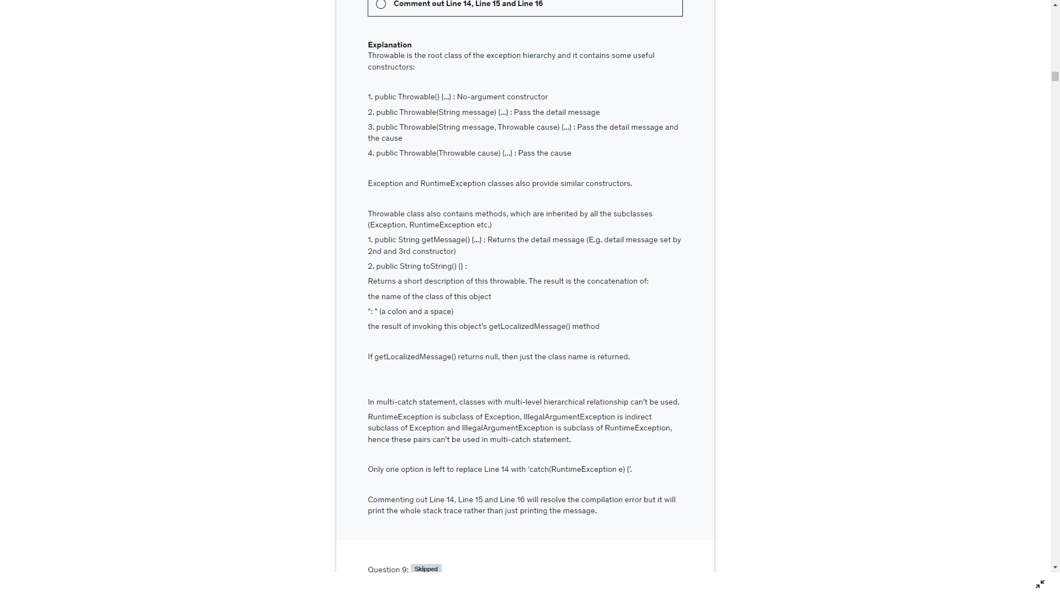

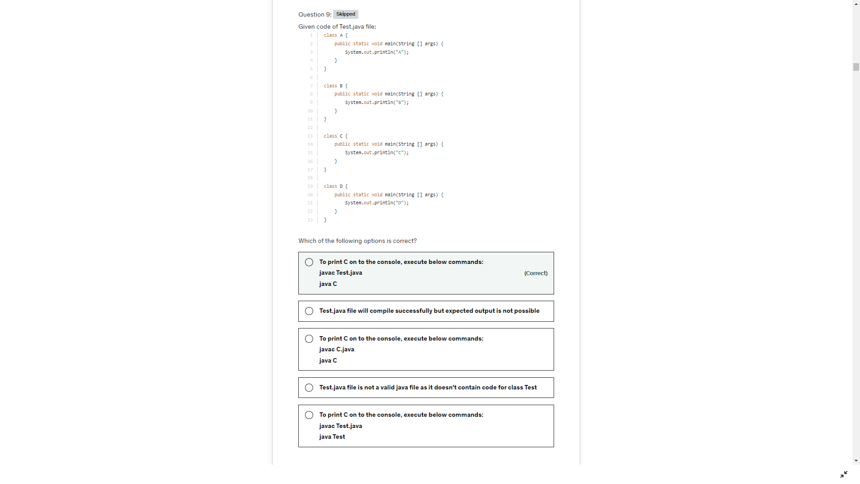

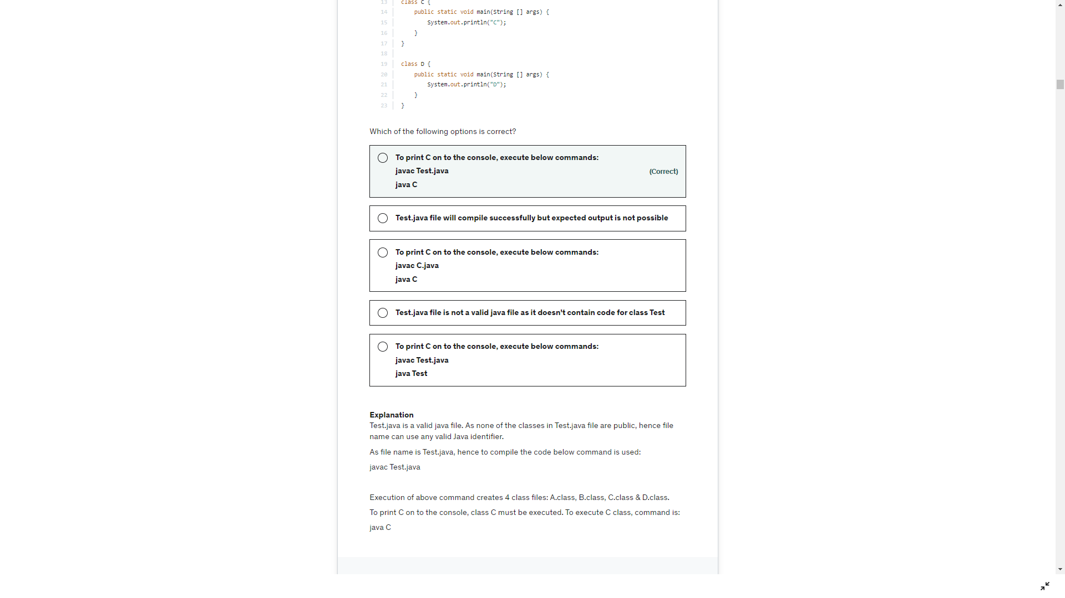

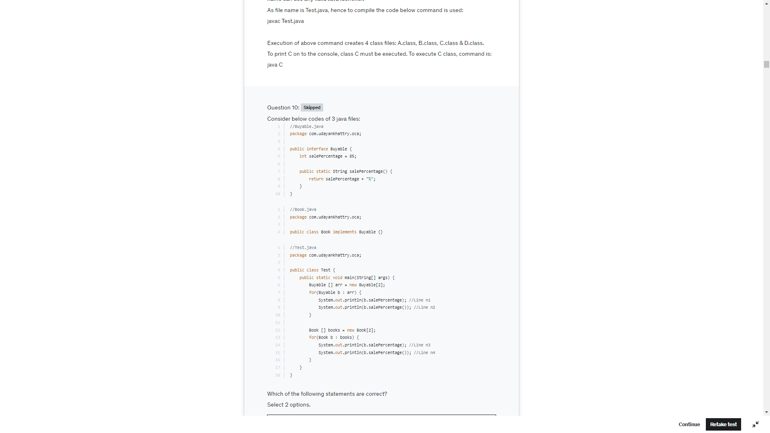

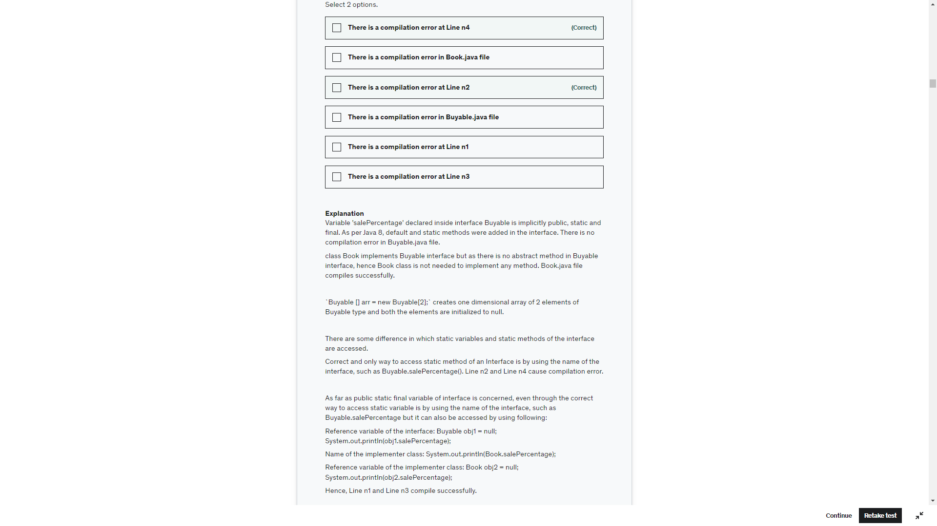

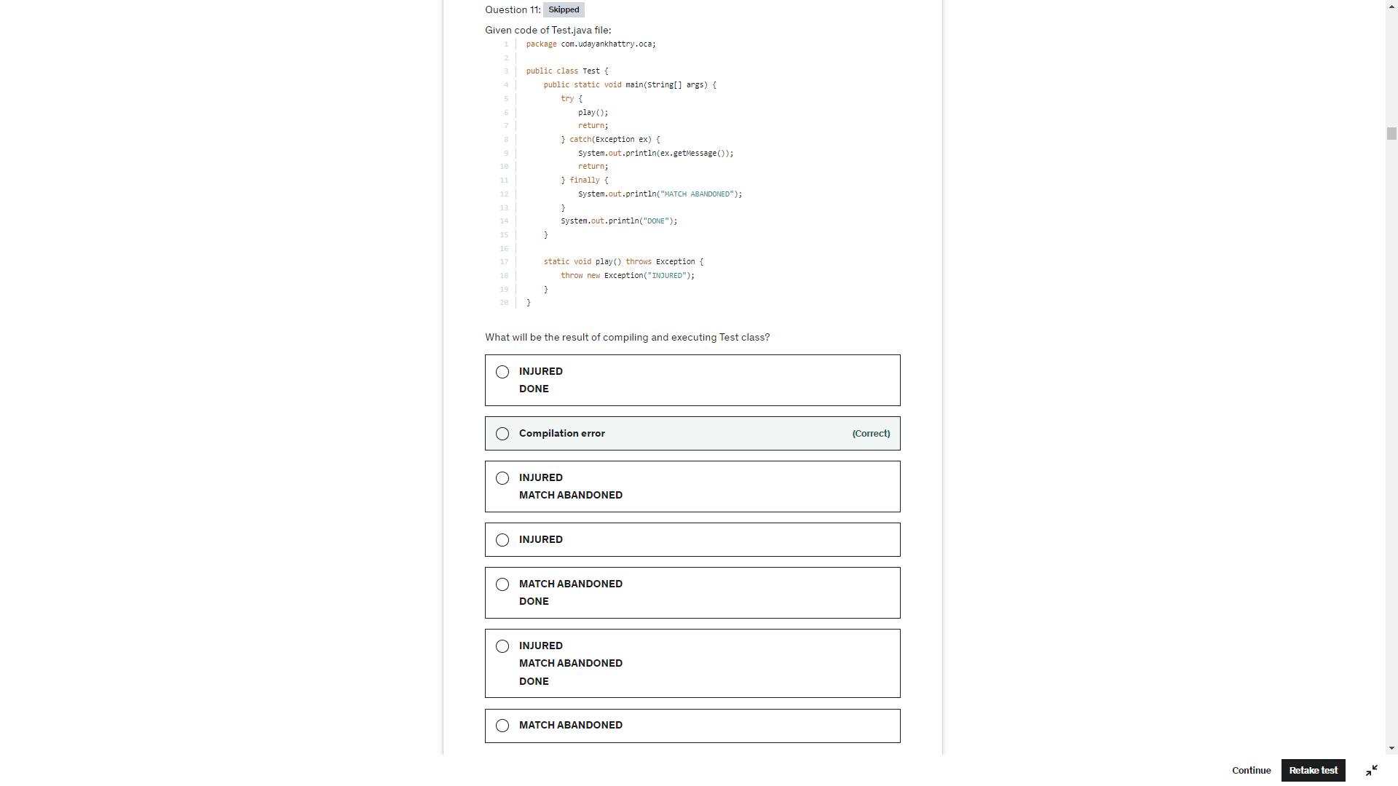

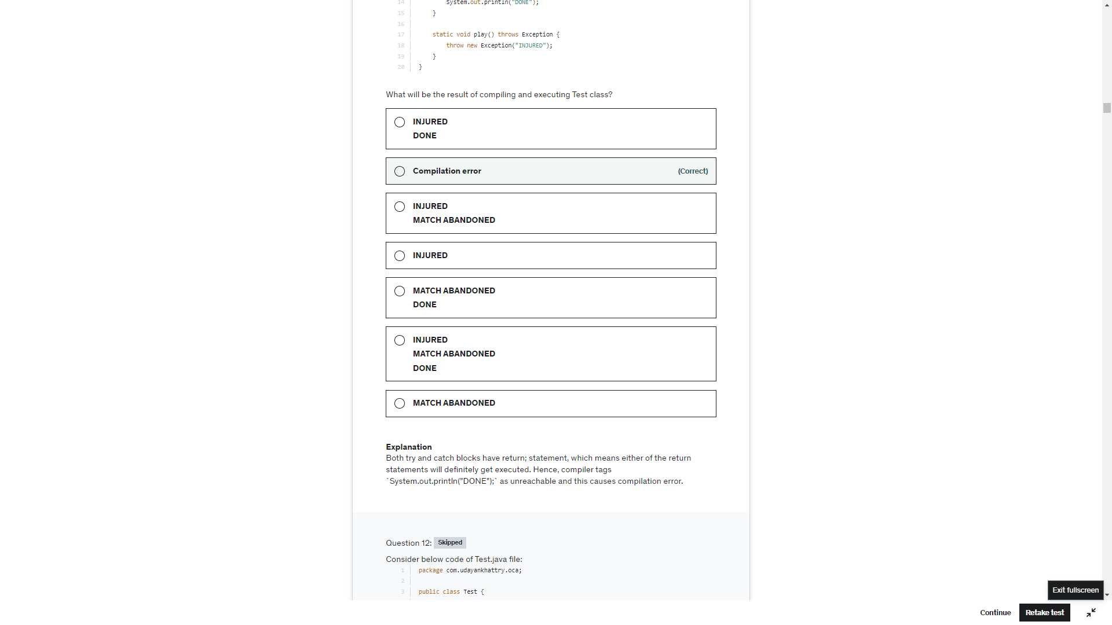

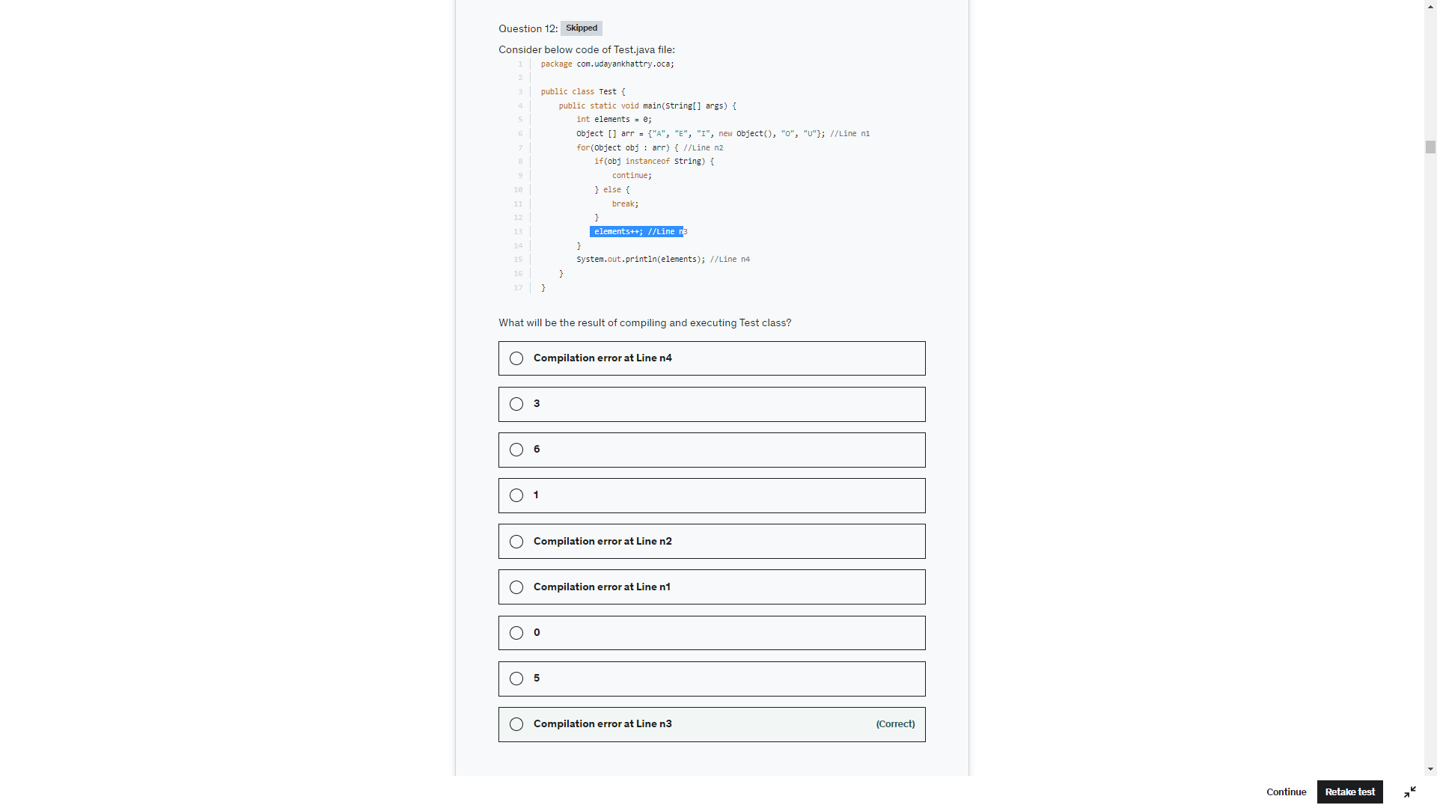

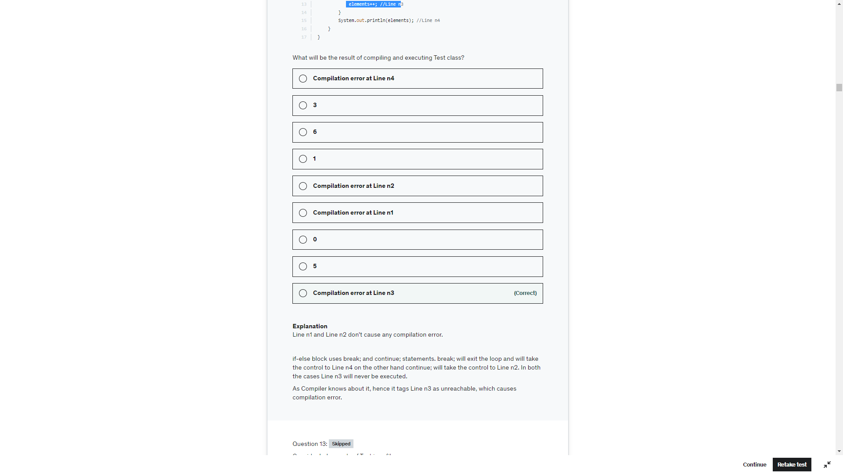

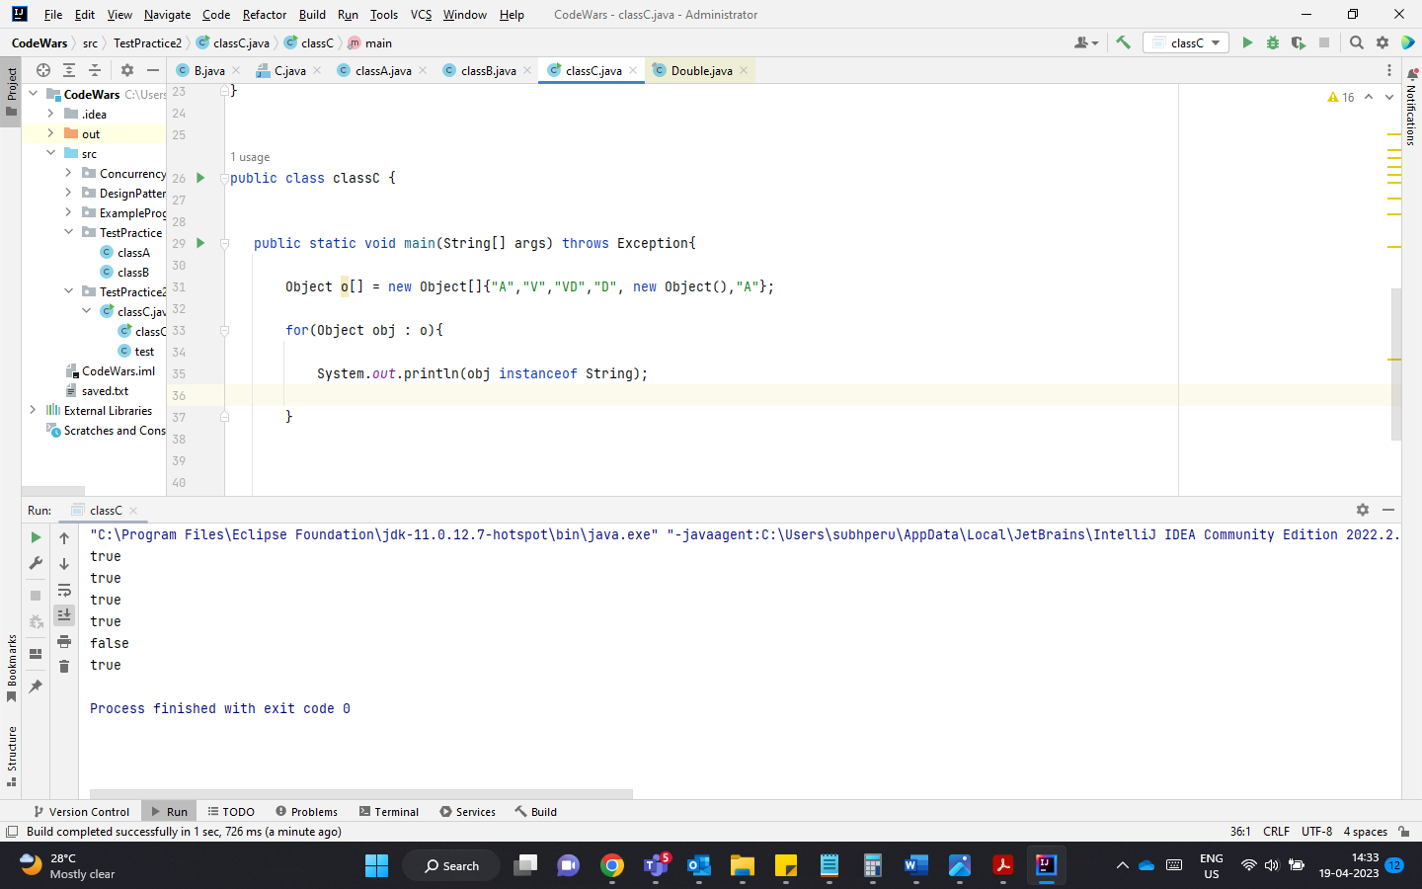

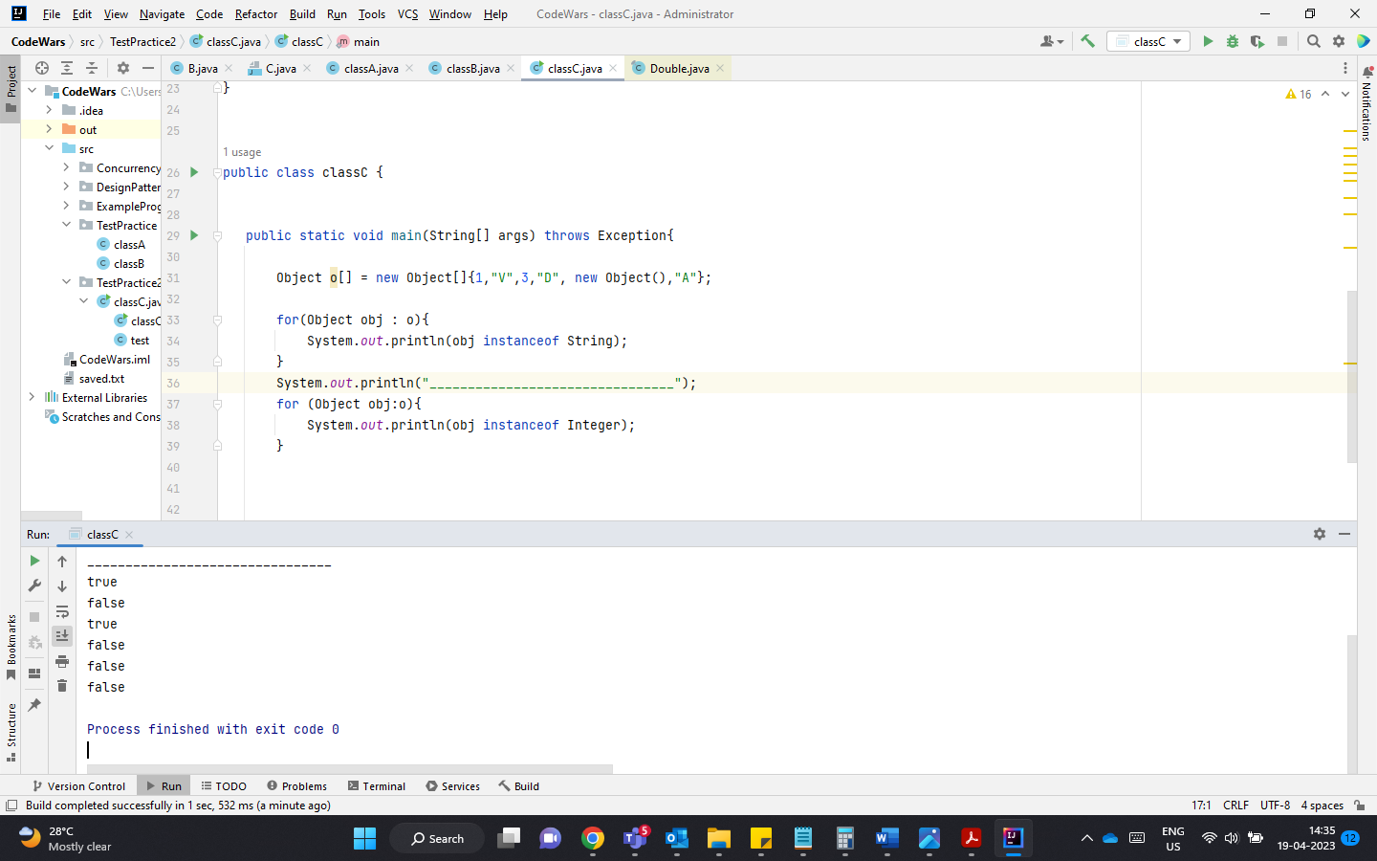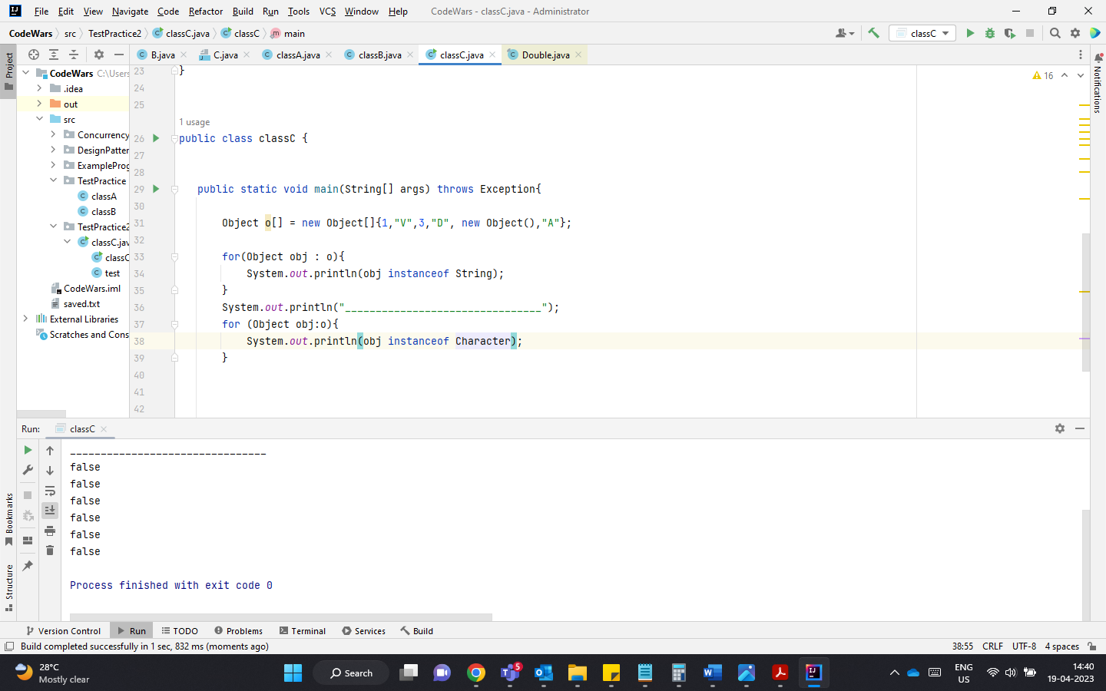

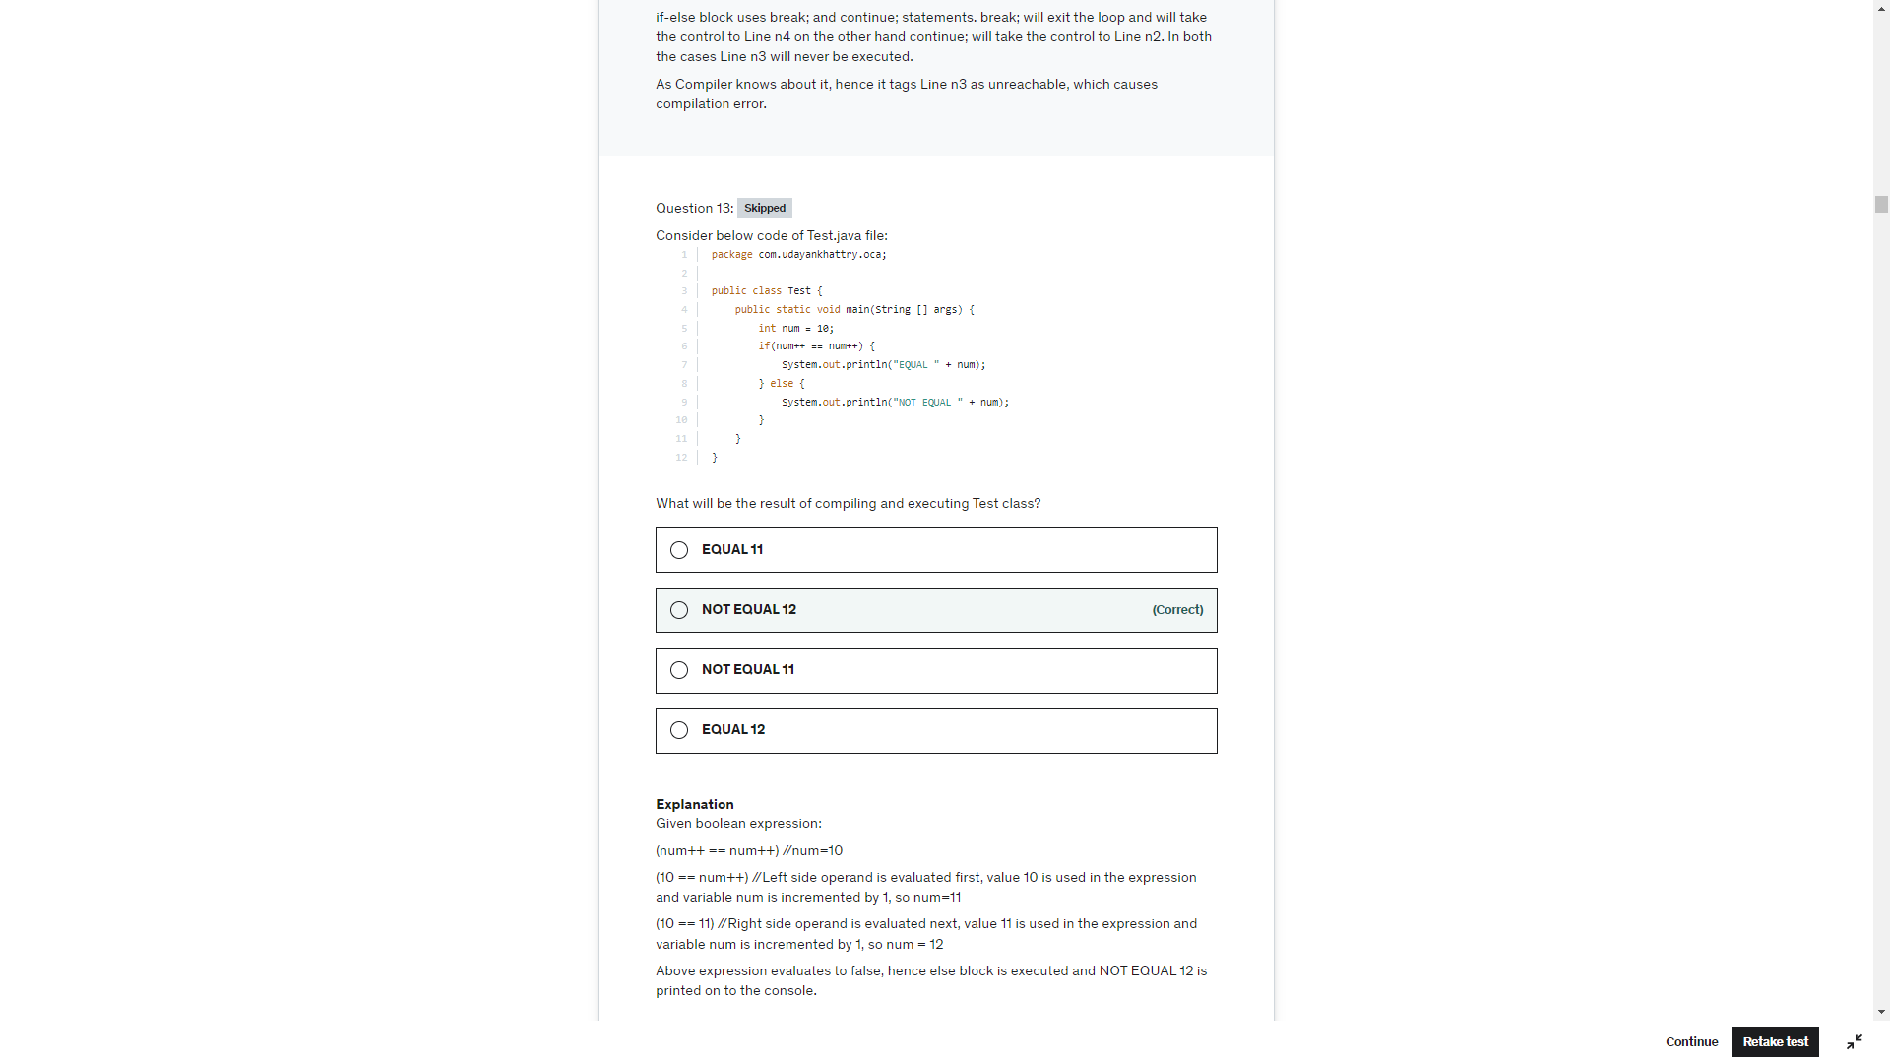

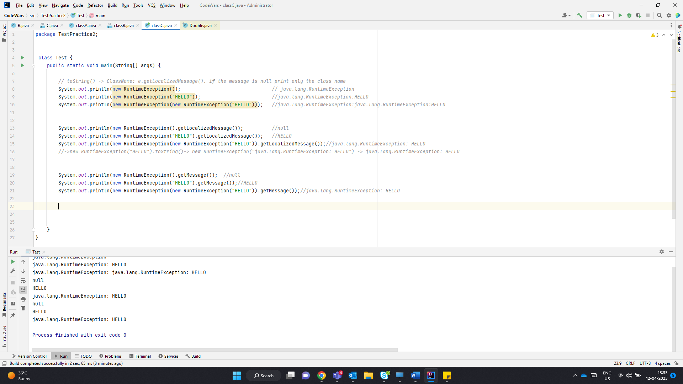

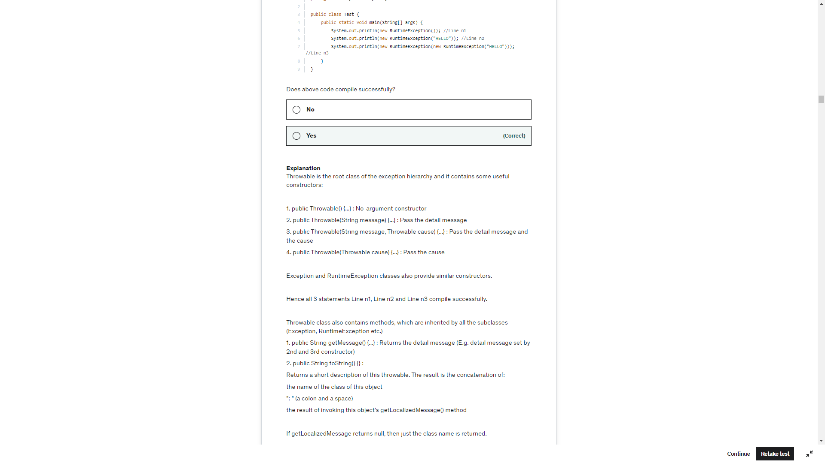

Because of the toString() method,

Line n1 prints "java.lang.RuntimeException".

Line n2 prints "java.lang.RuntimeException: HELLO"

Line n3 prints "java.lang.Exception: java.lang.RuntimeException: HELLO"

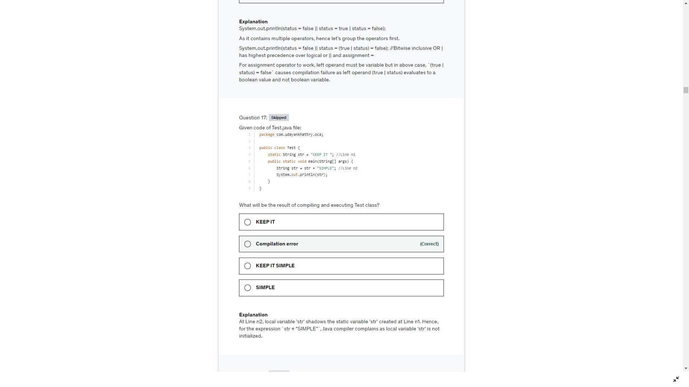

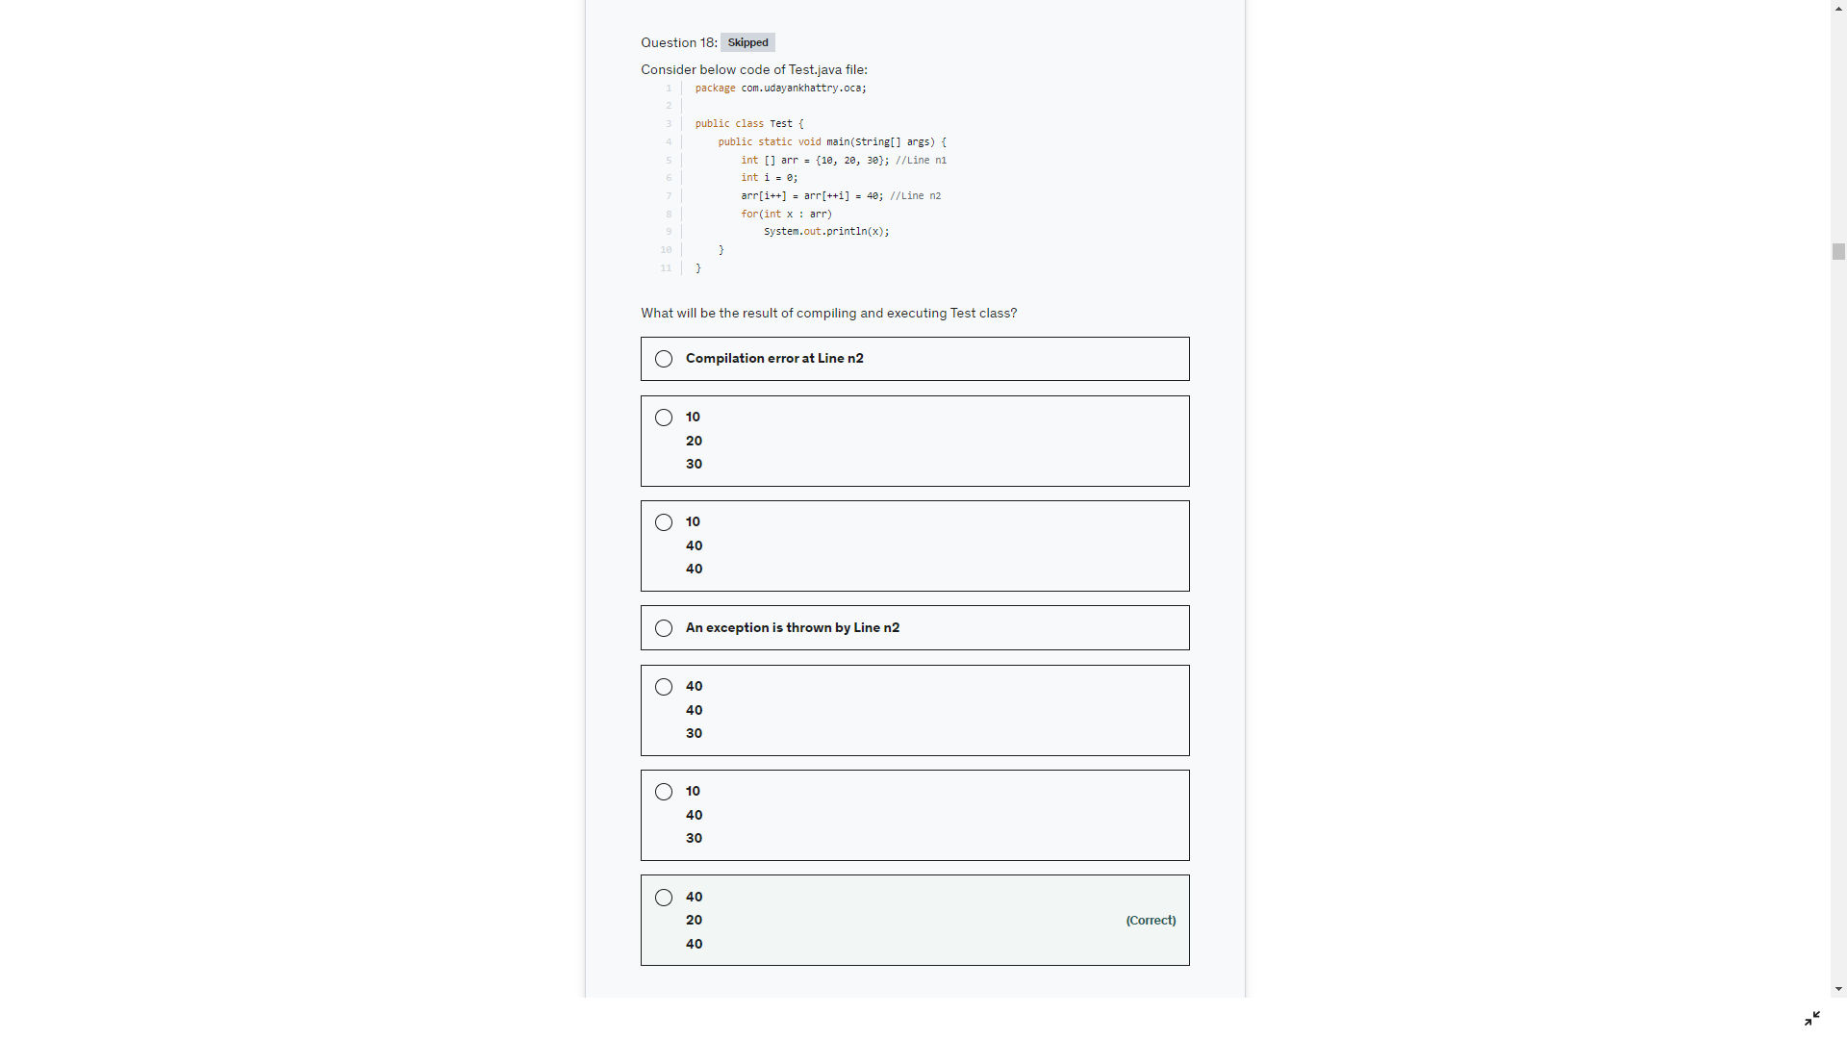

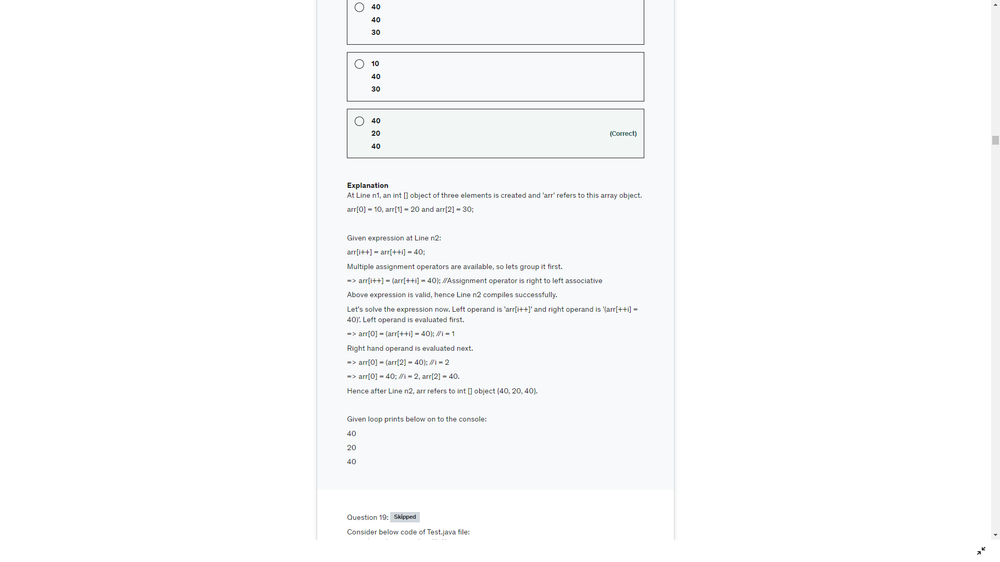

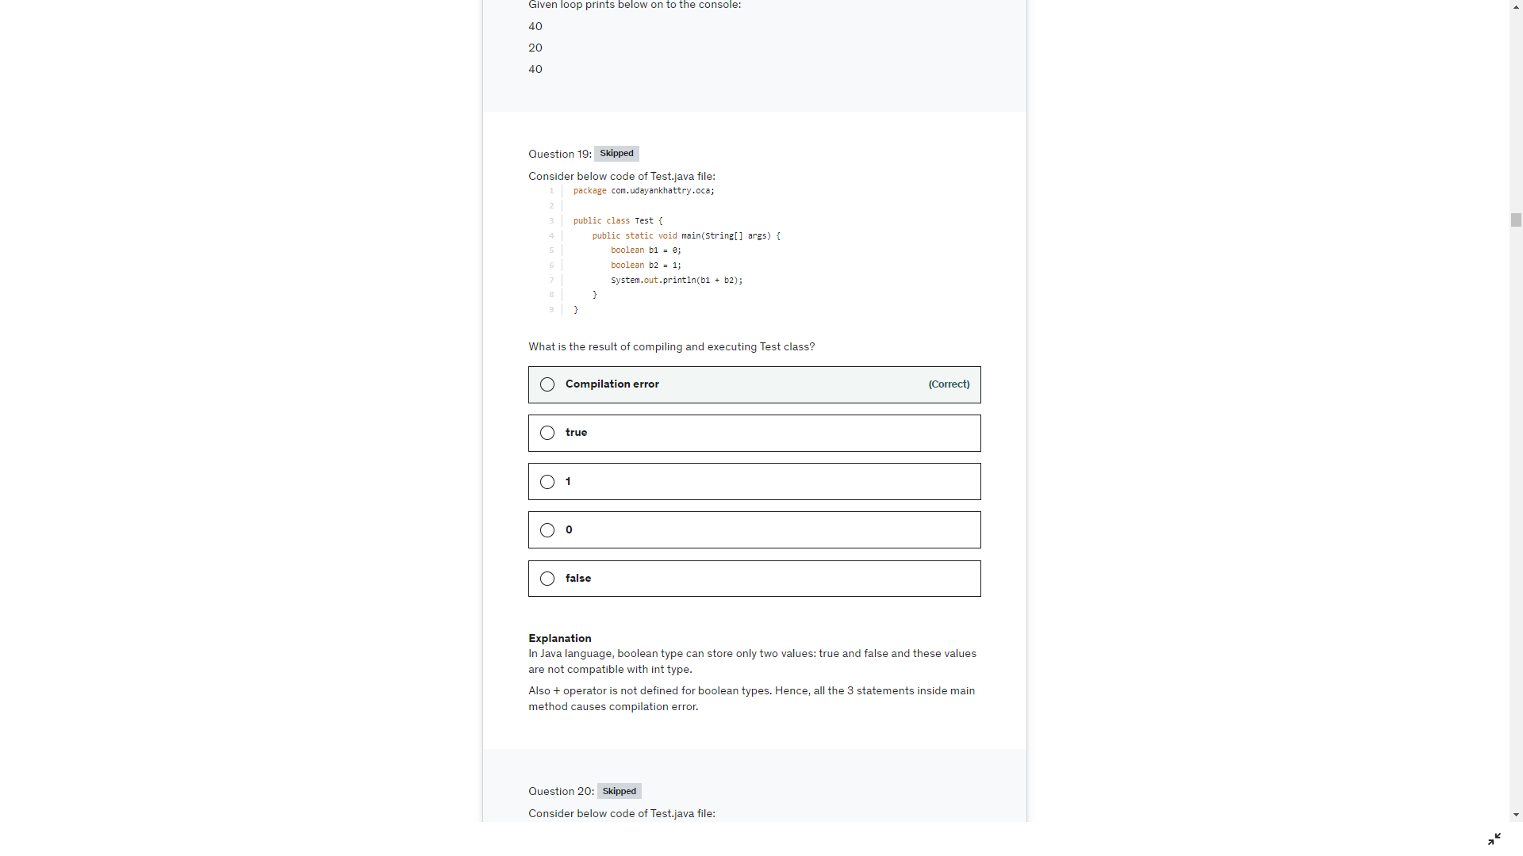

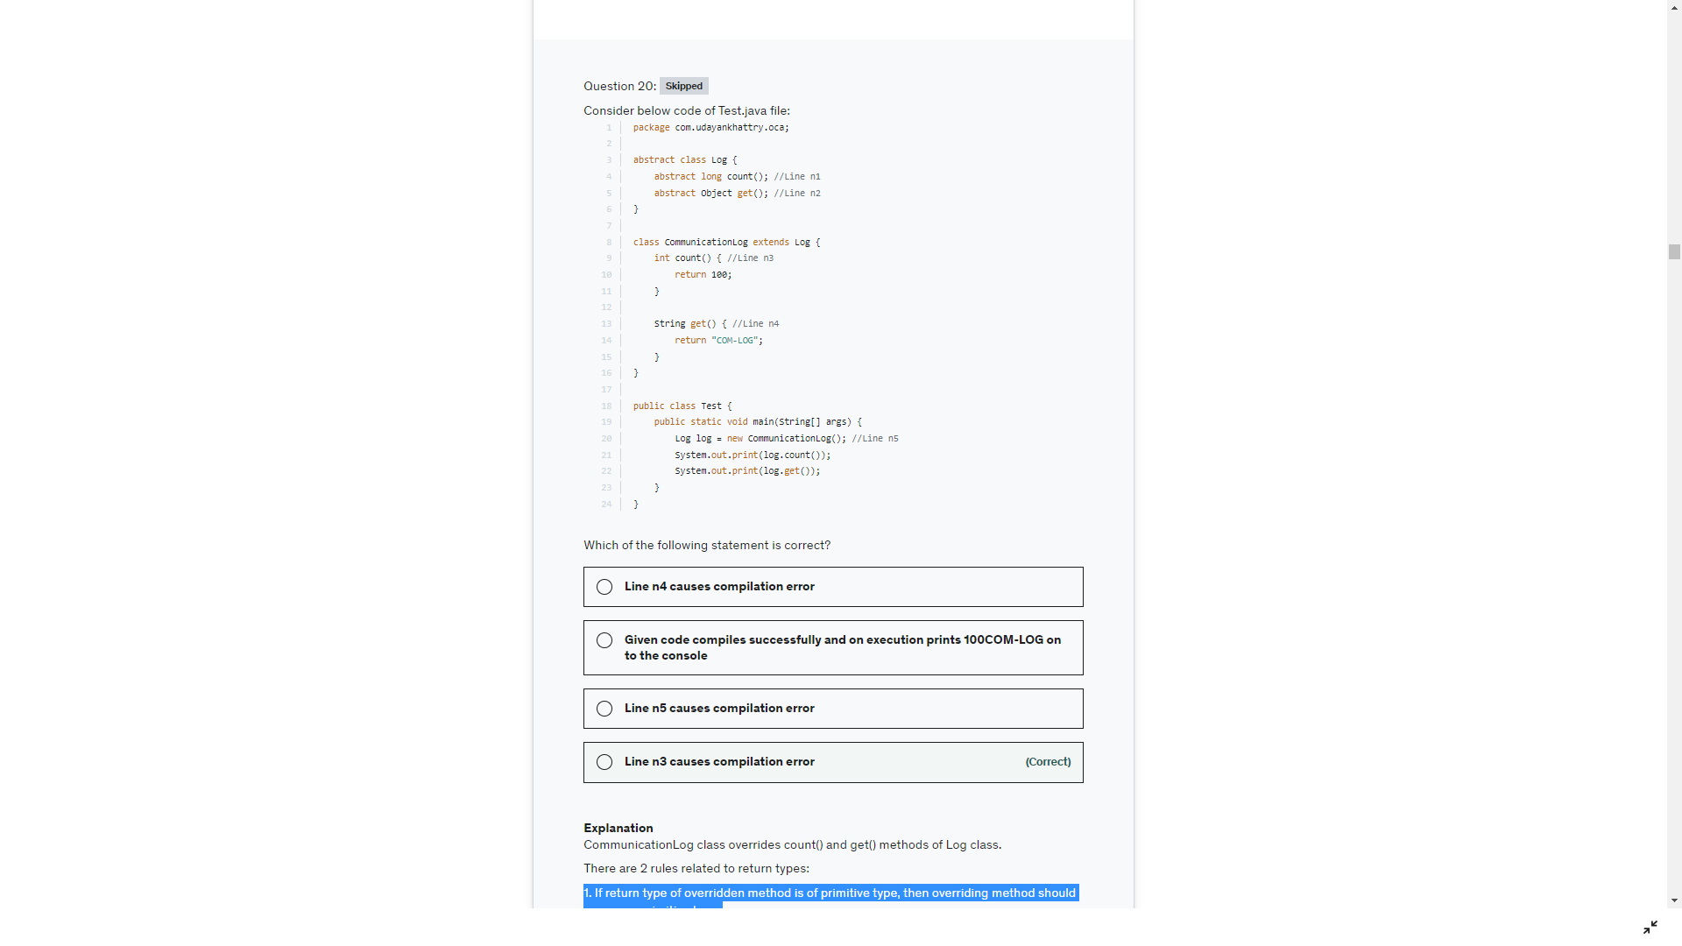

You cant declare an absrtact method private but you declare it protected

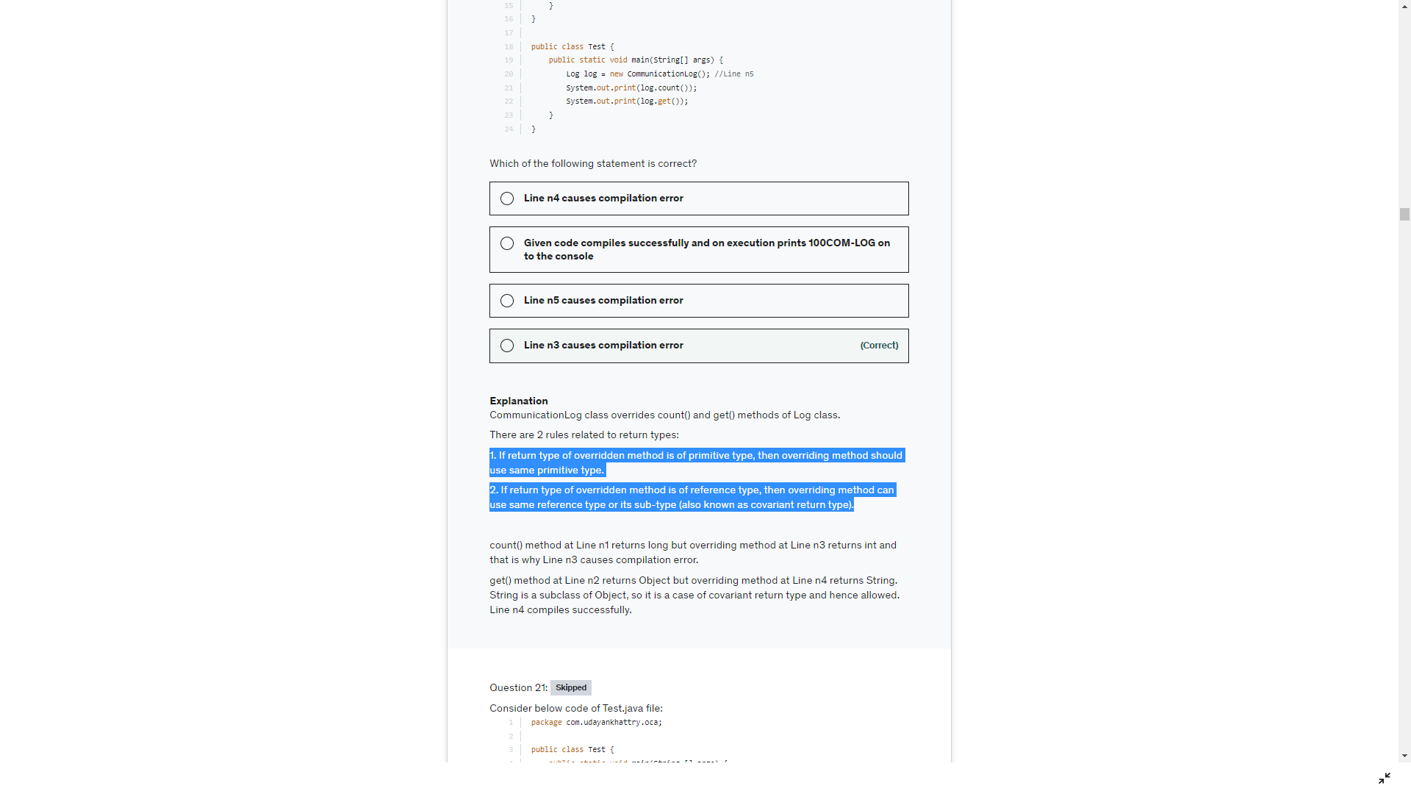

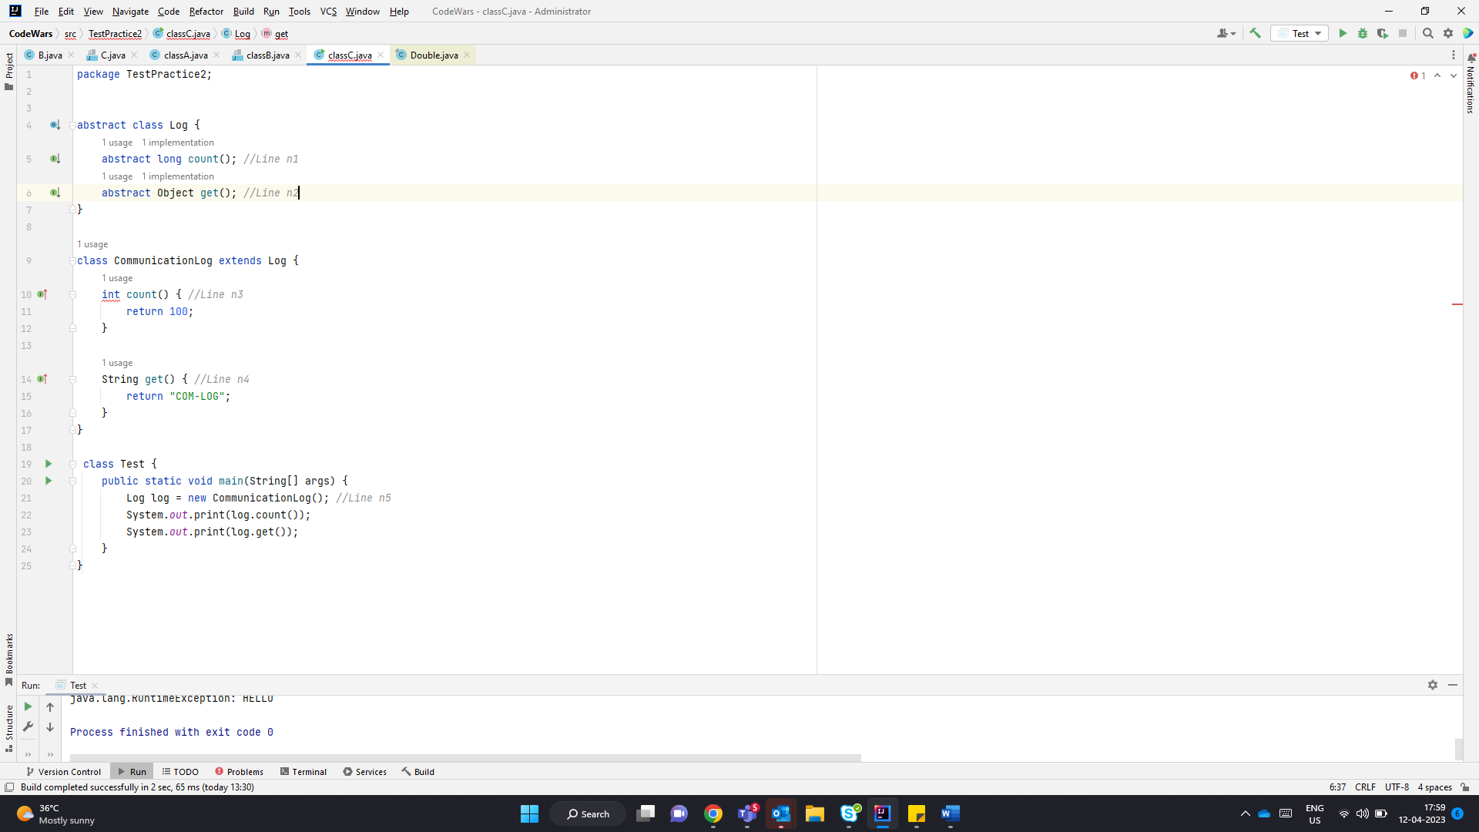

Abstract method in abstract classes are not public by default.

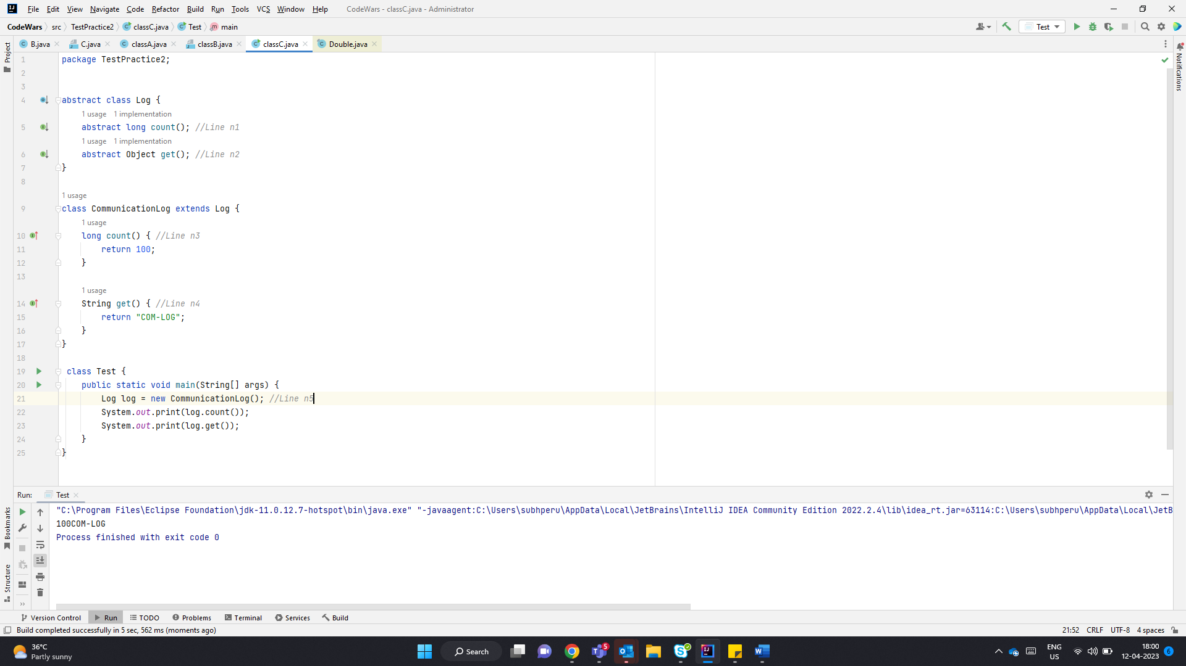

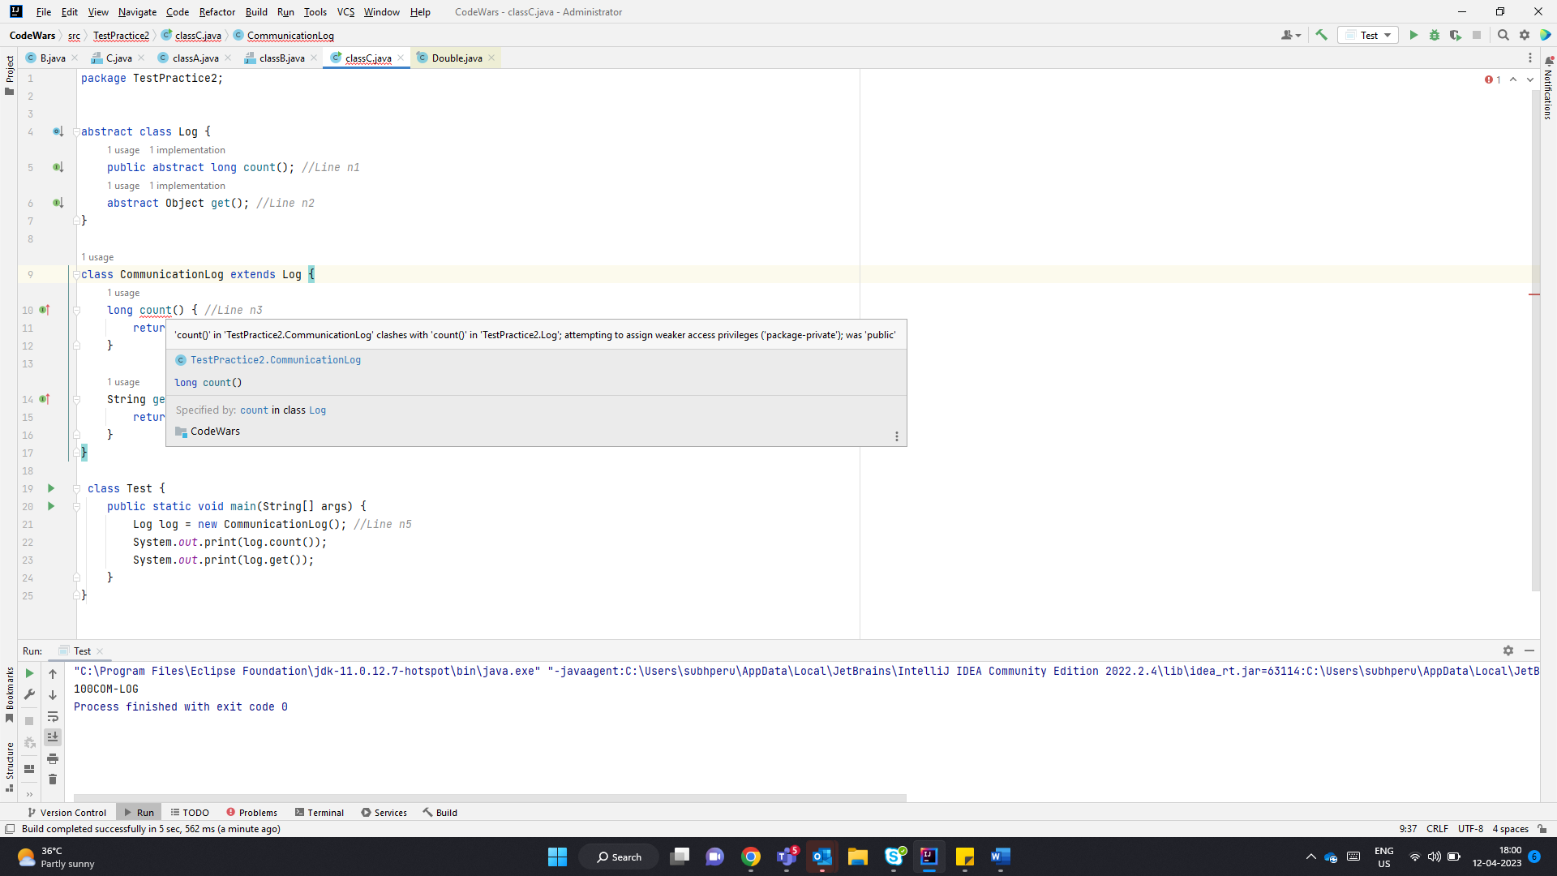

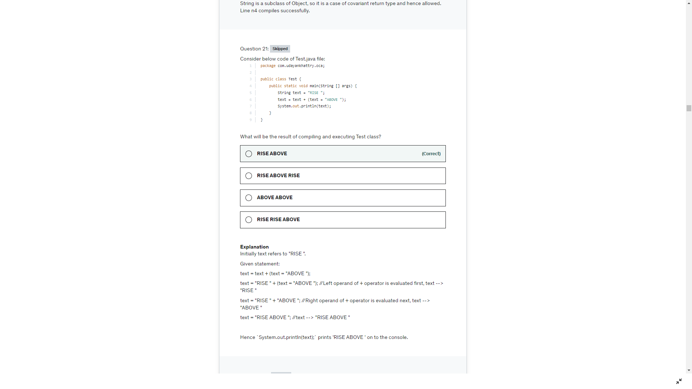

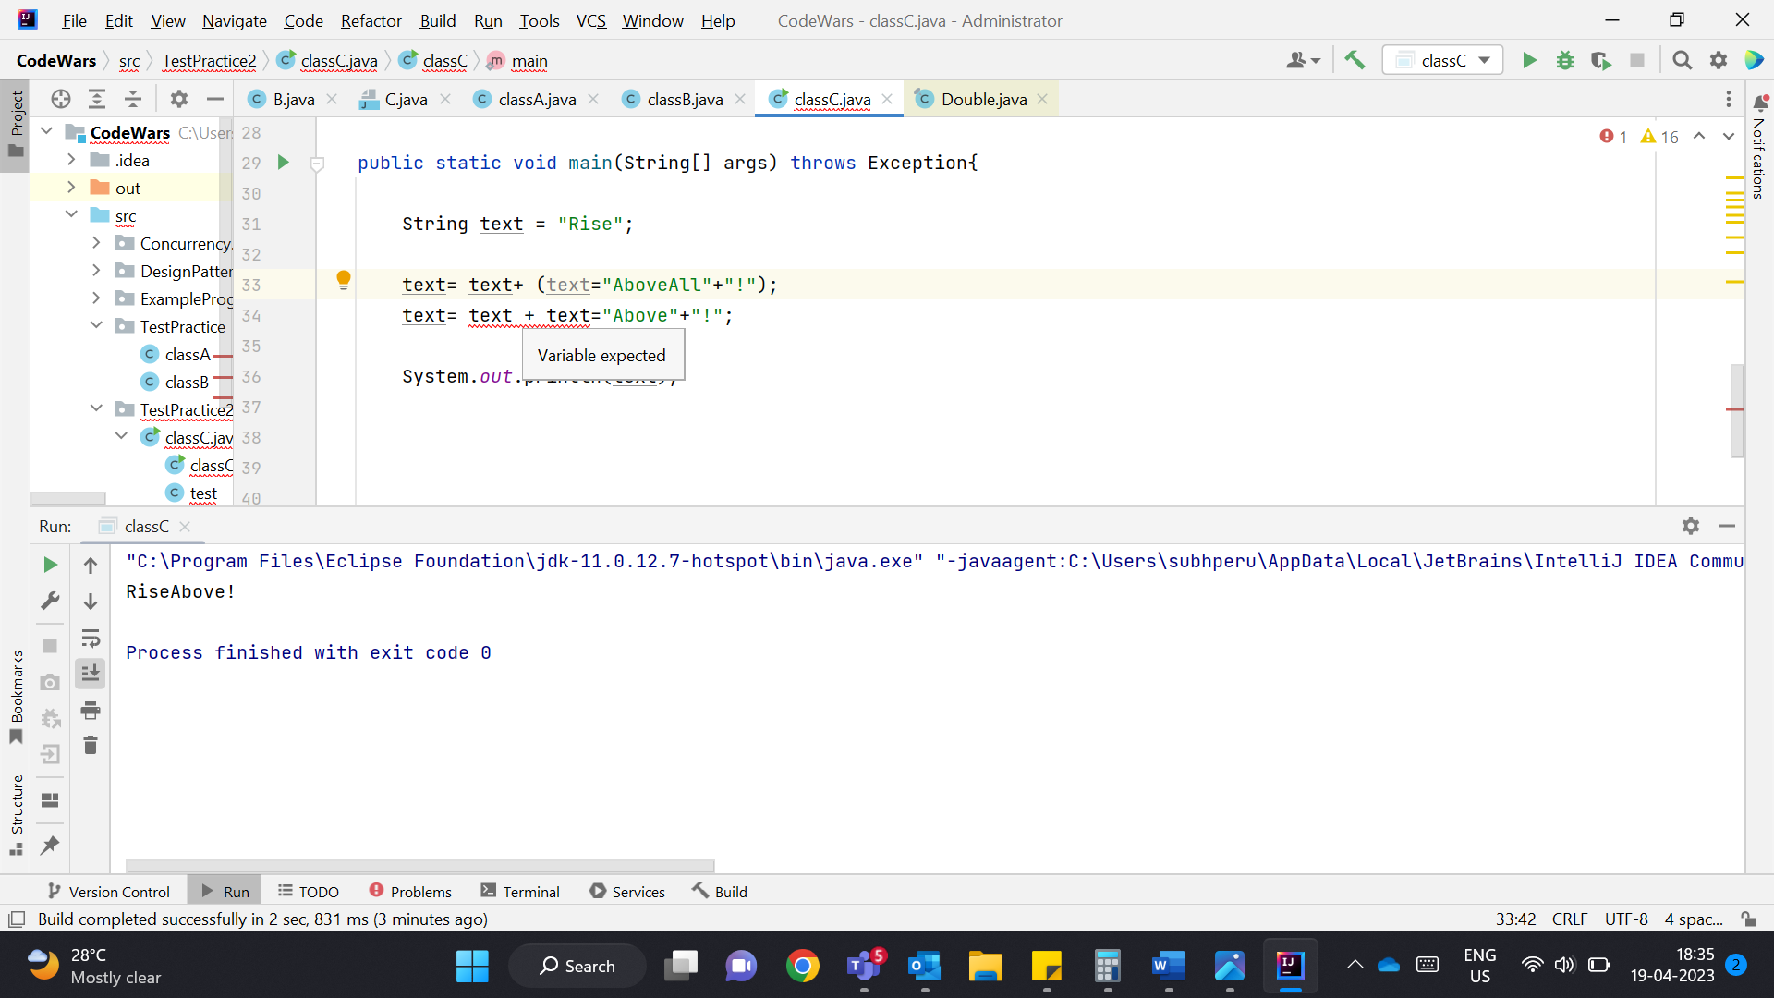

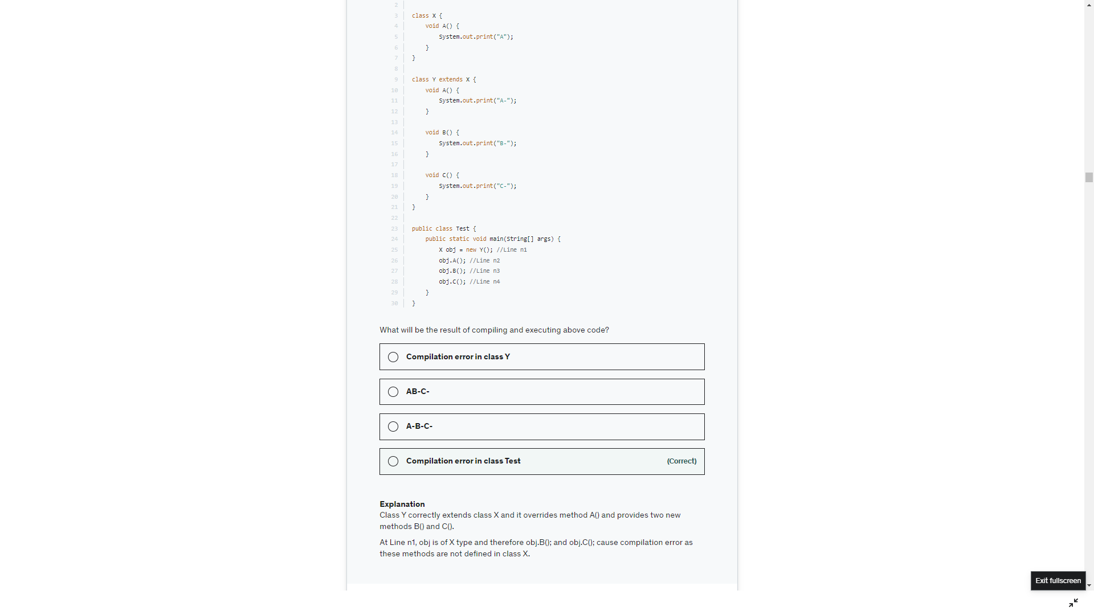

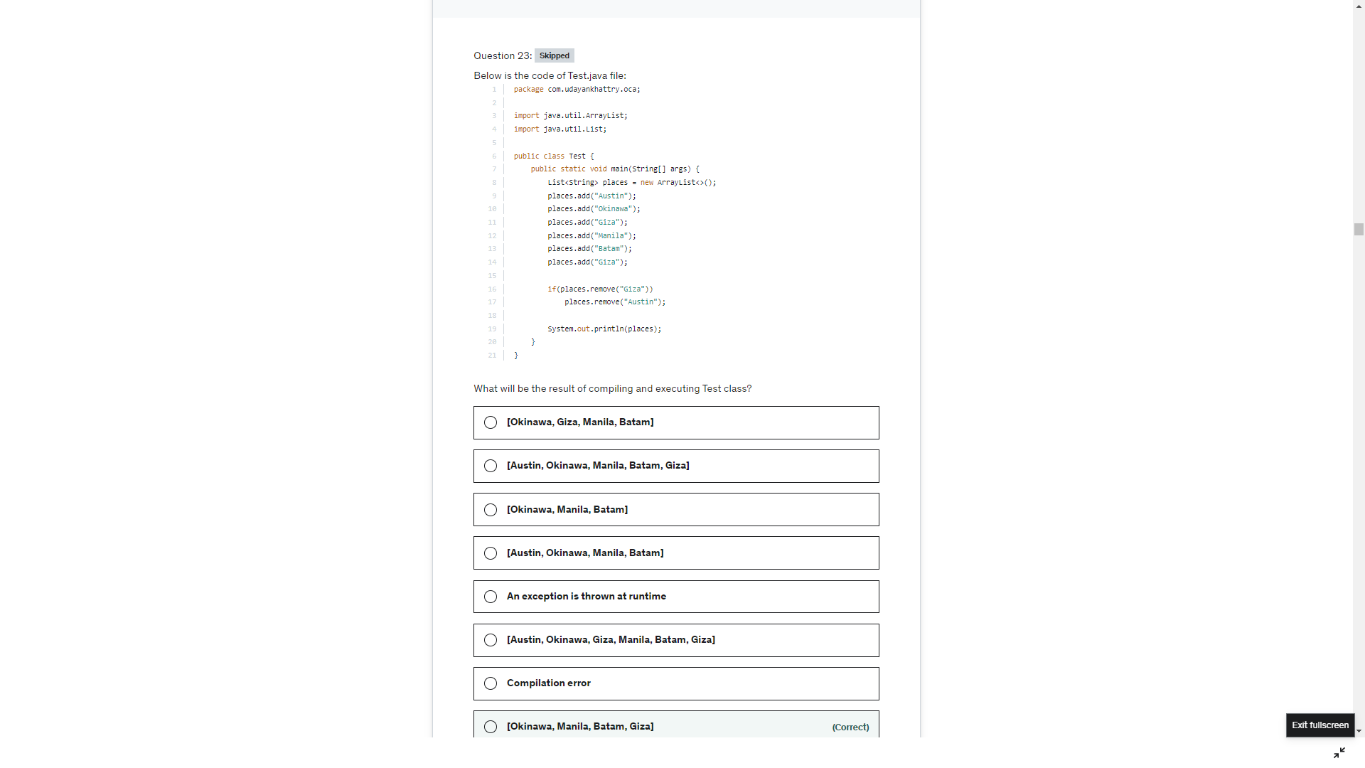

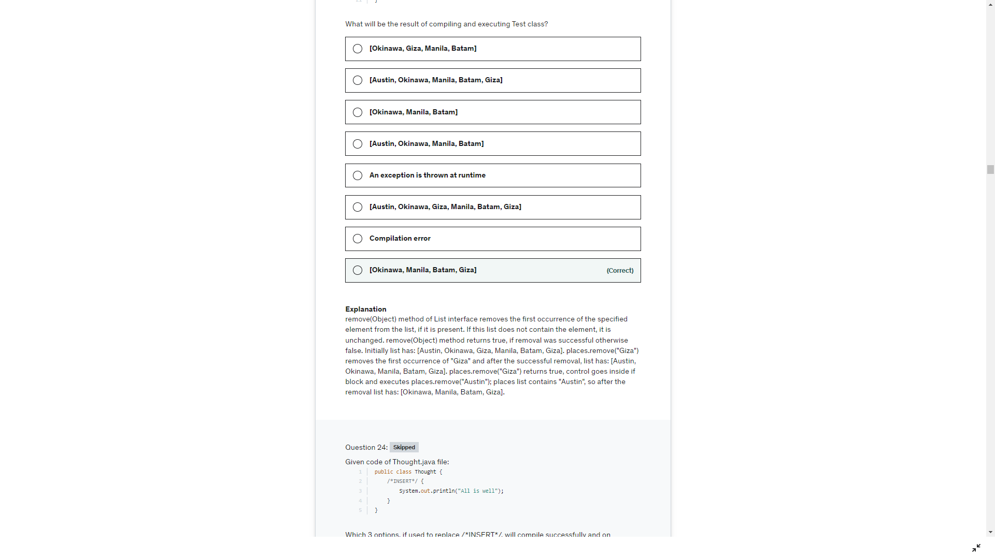

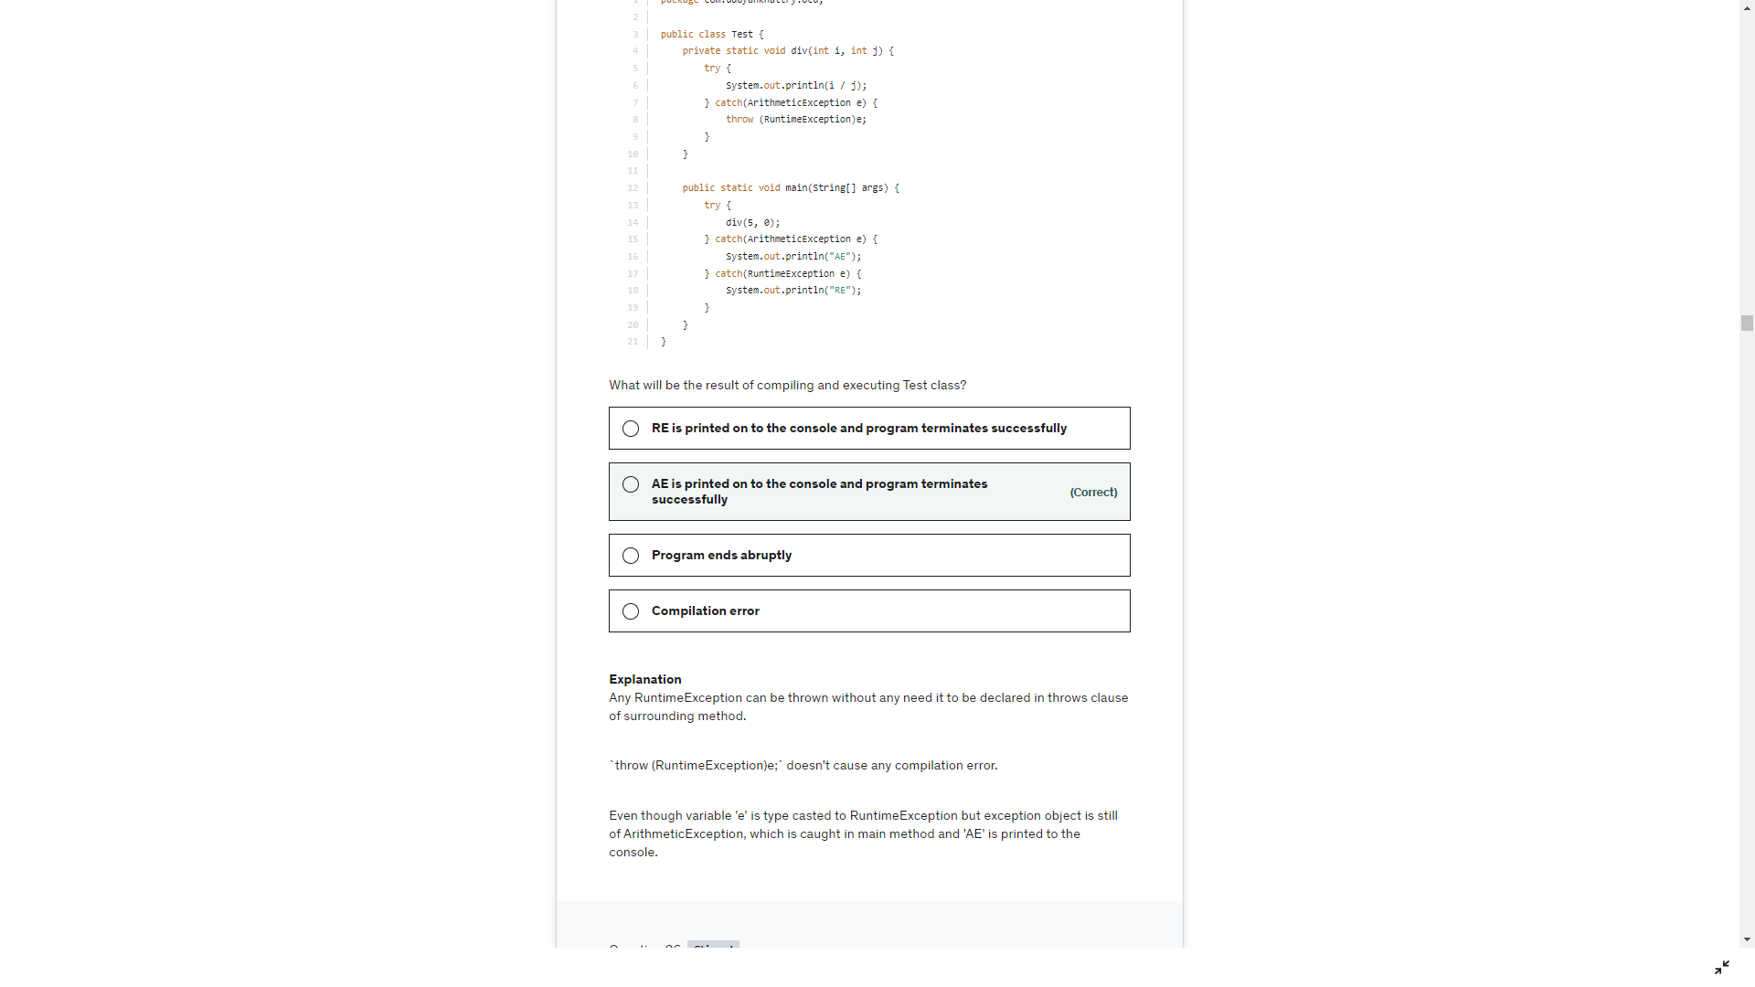

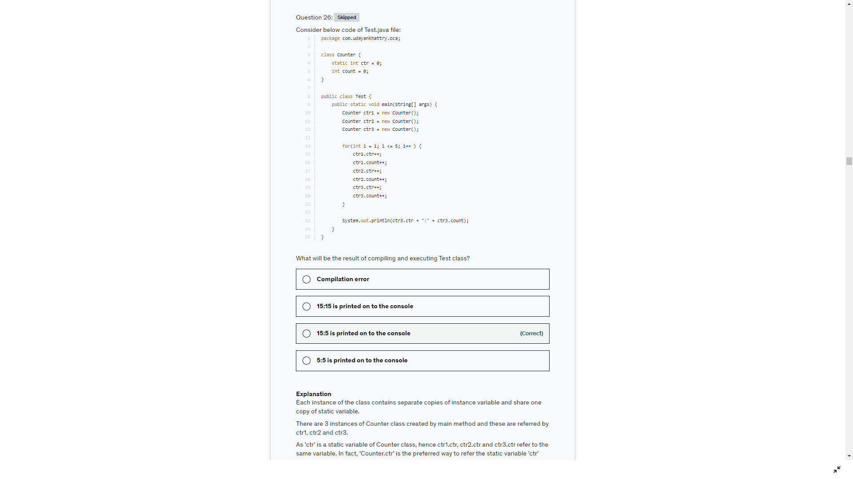

See the question properly the expected output is 200. Cant assign to double or float

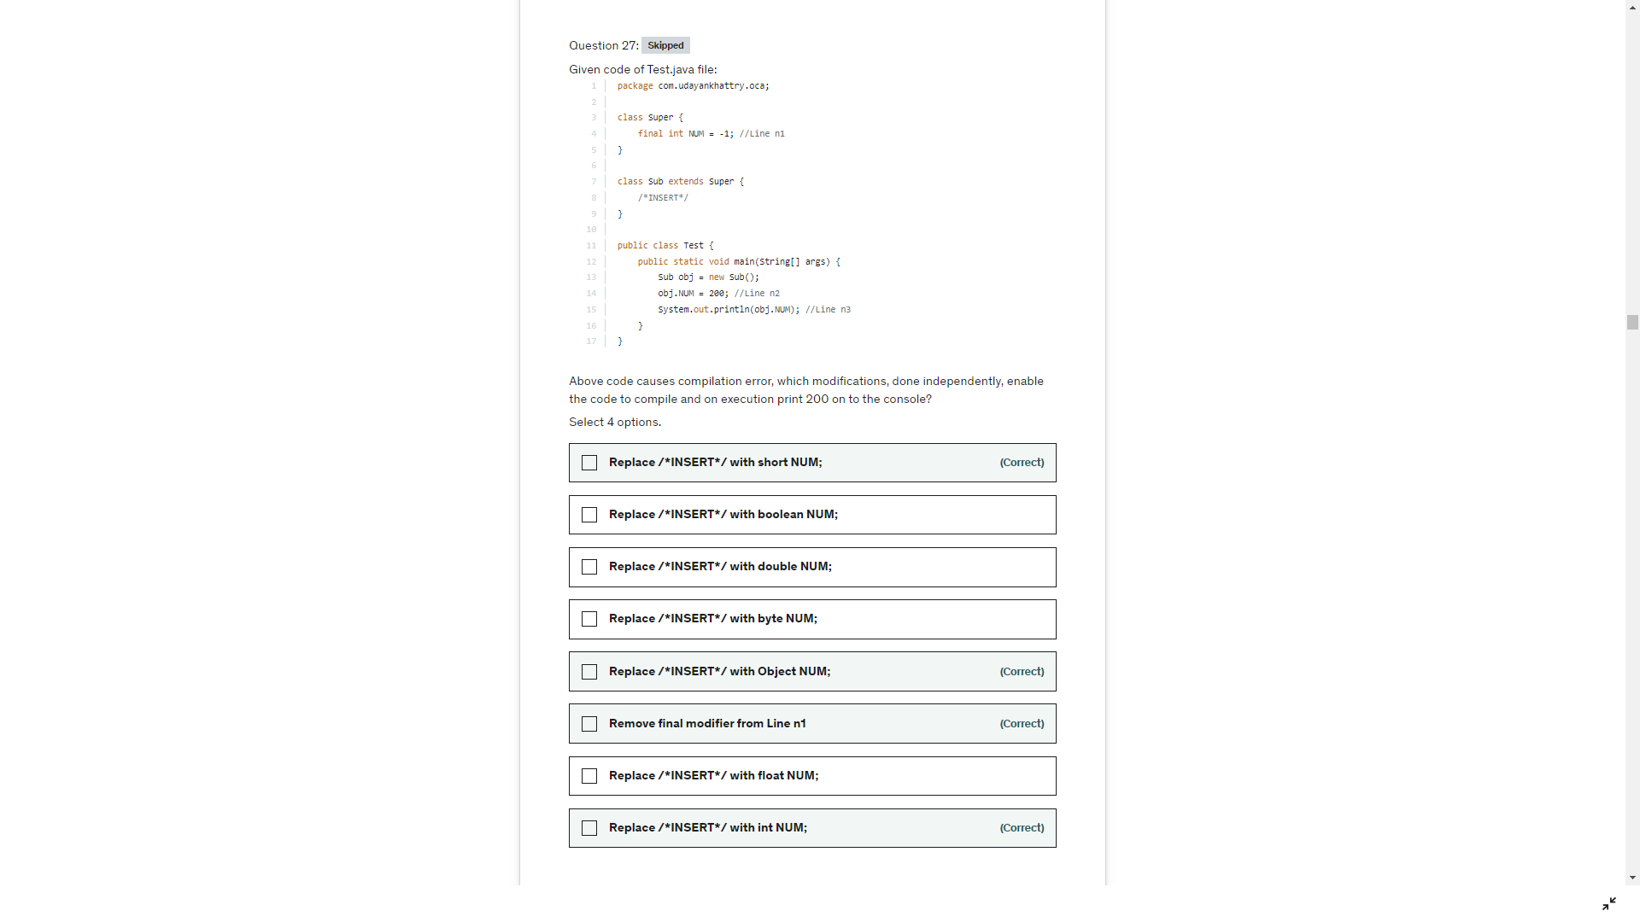

10

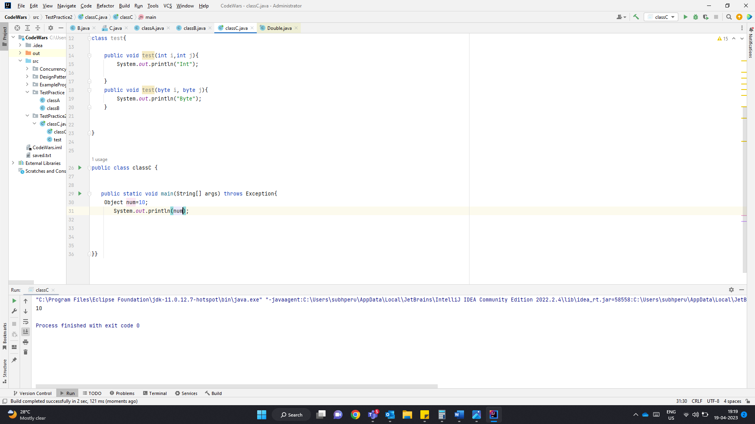

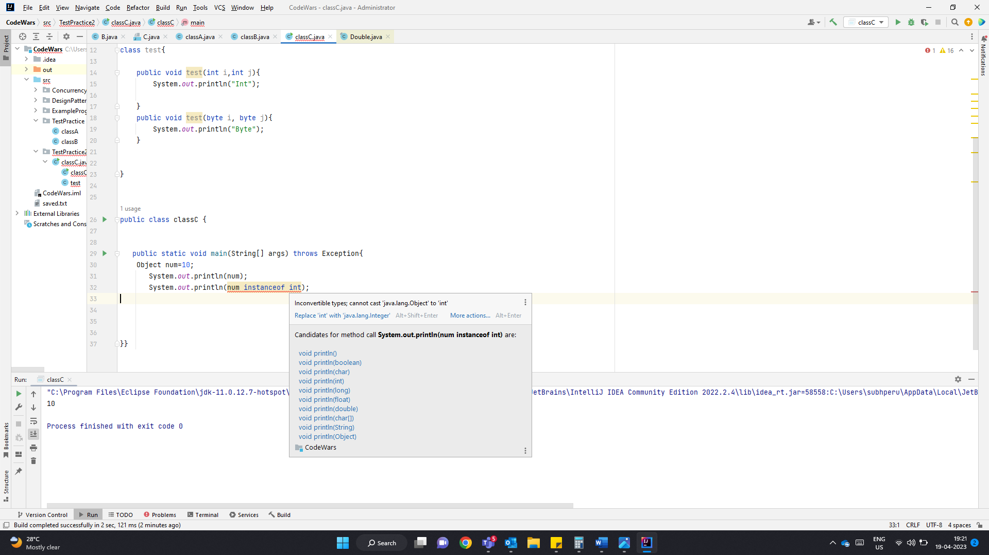

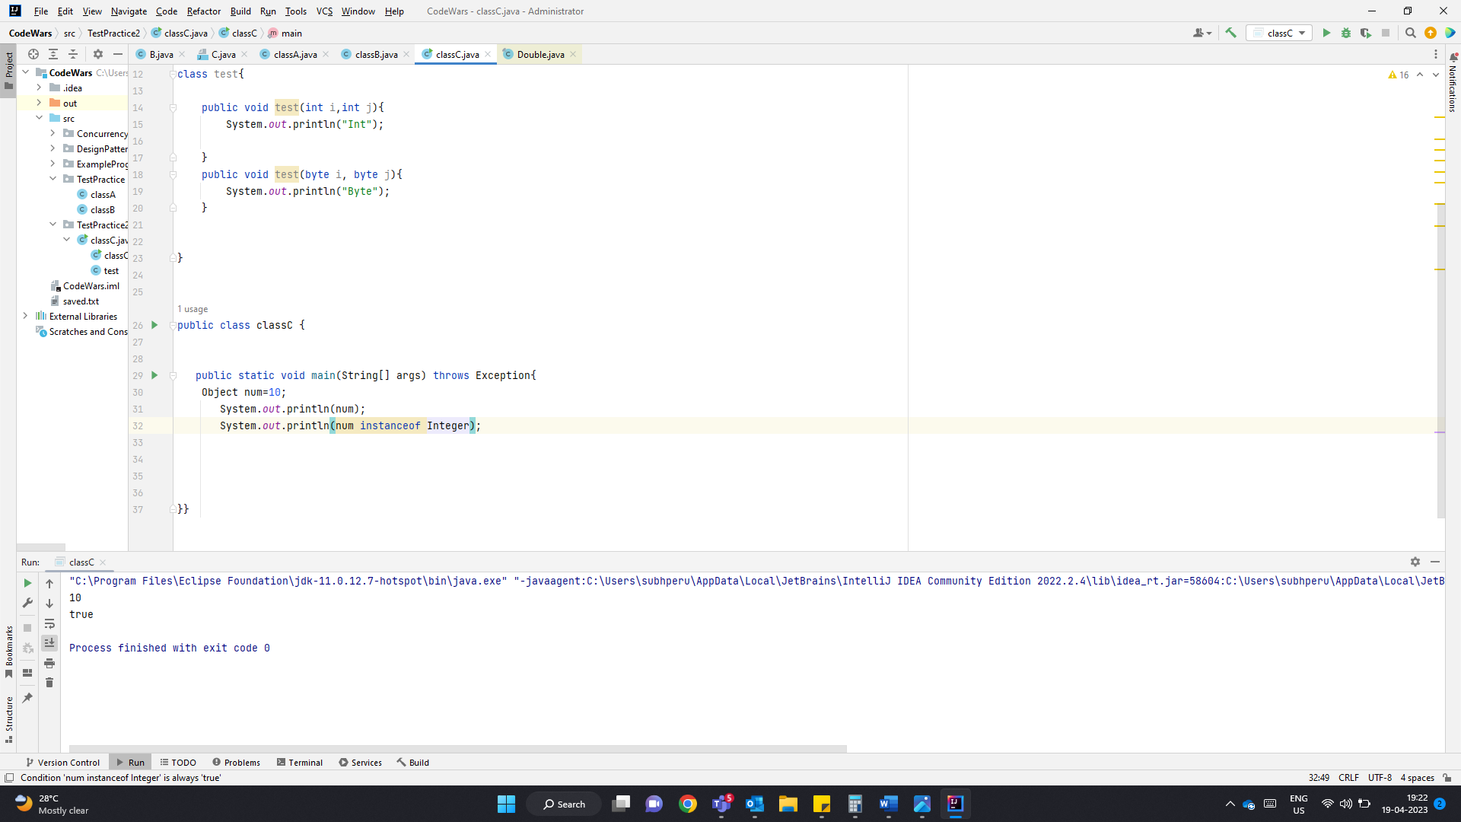

true

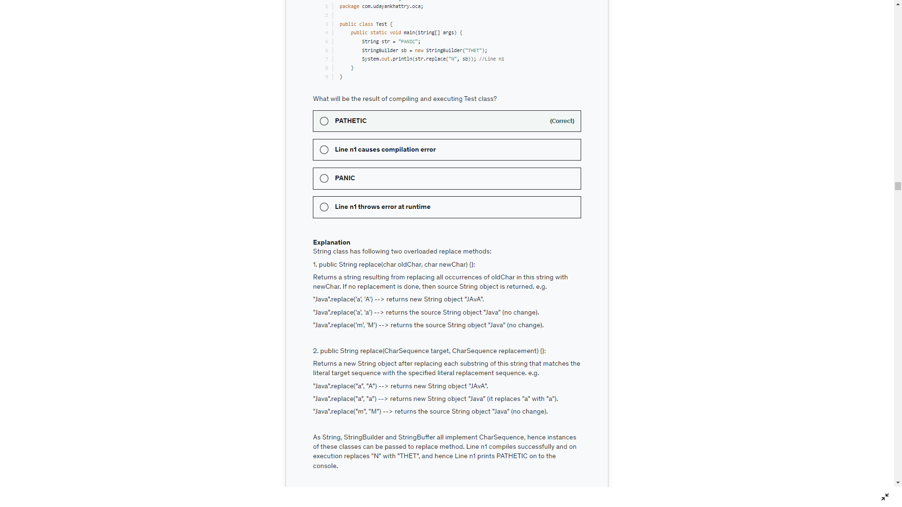

Replace(char, char)

Replace(CharSequence, CharSequence)

StringBuilder, StringBuffer and String implemens CharSequence

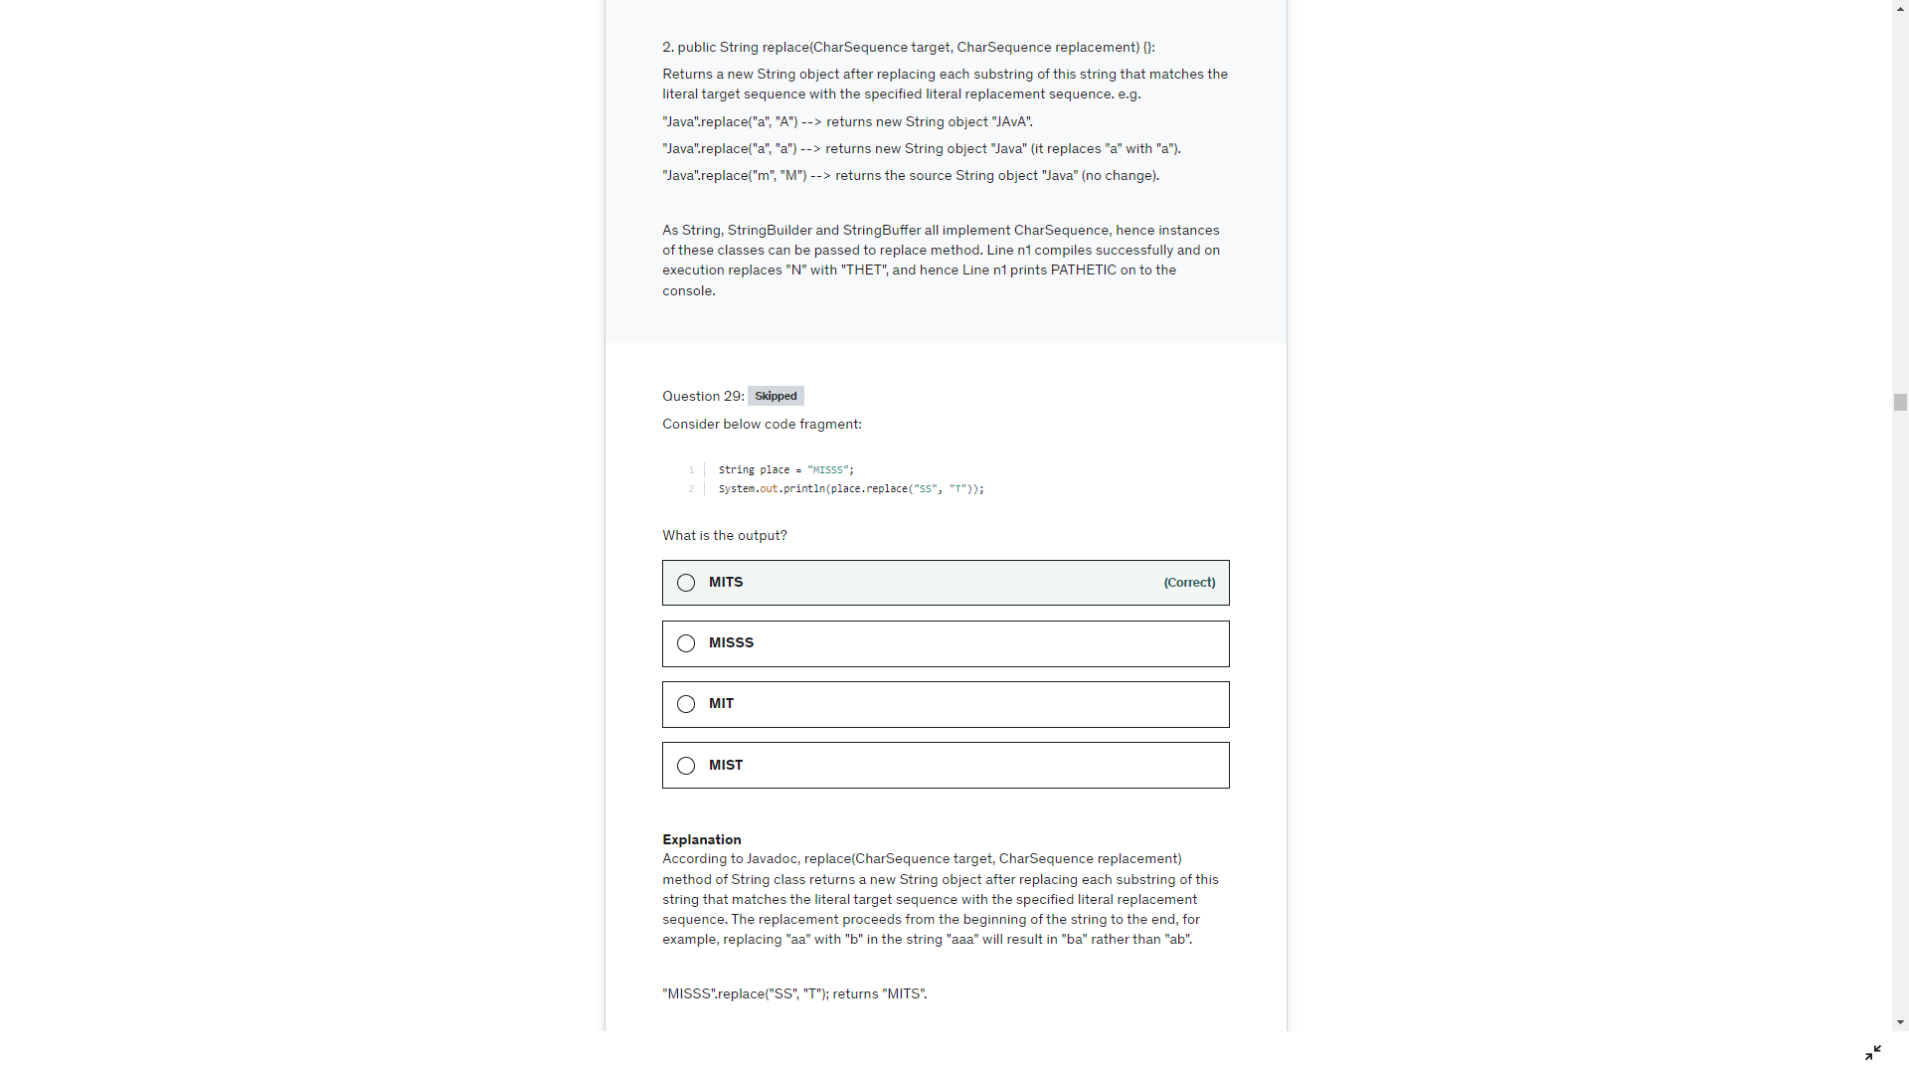

String.contentEquals(charSeq)

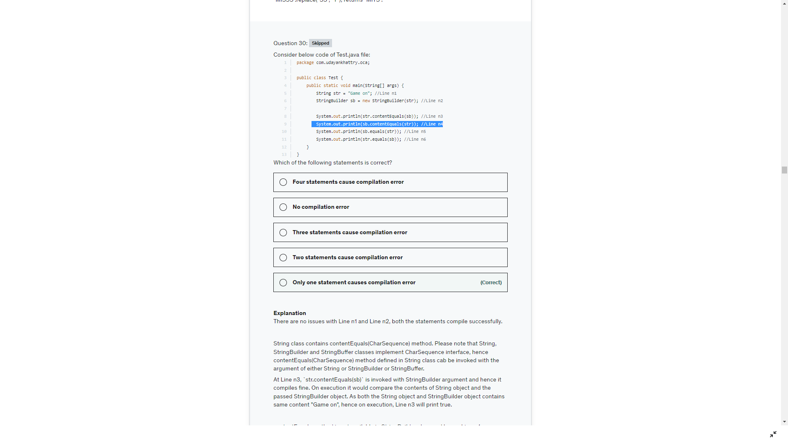

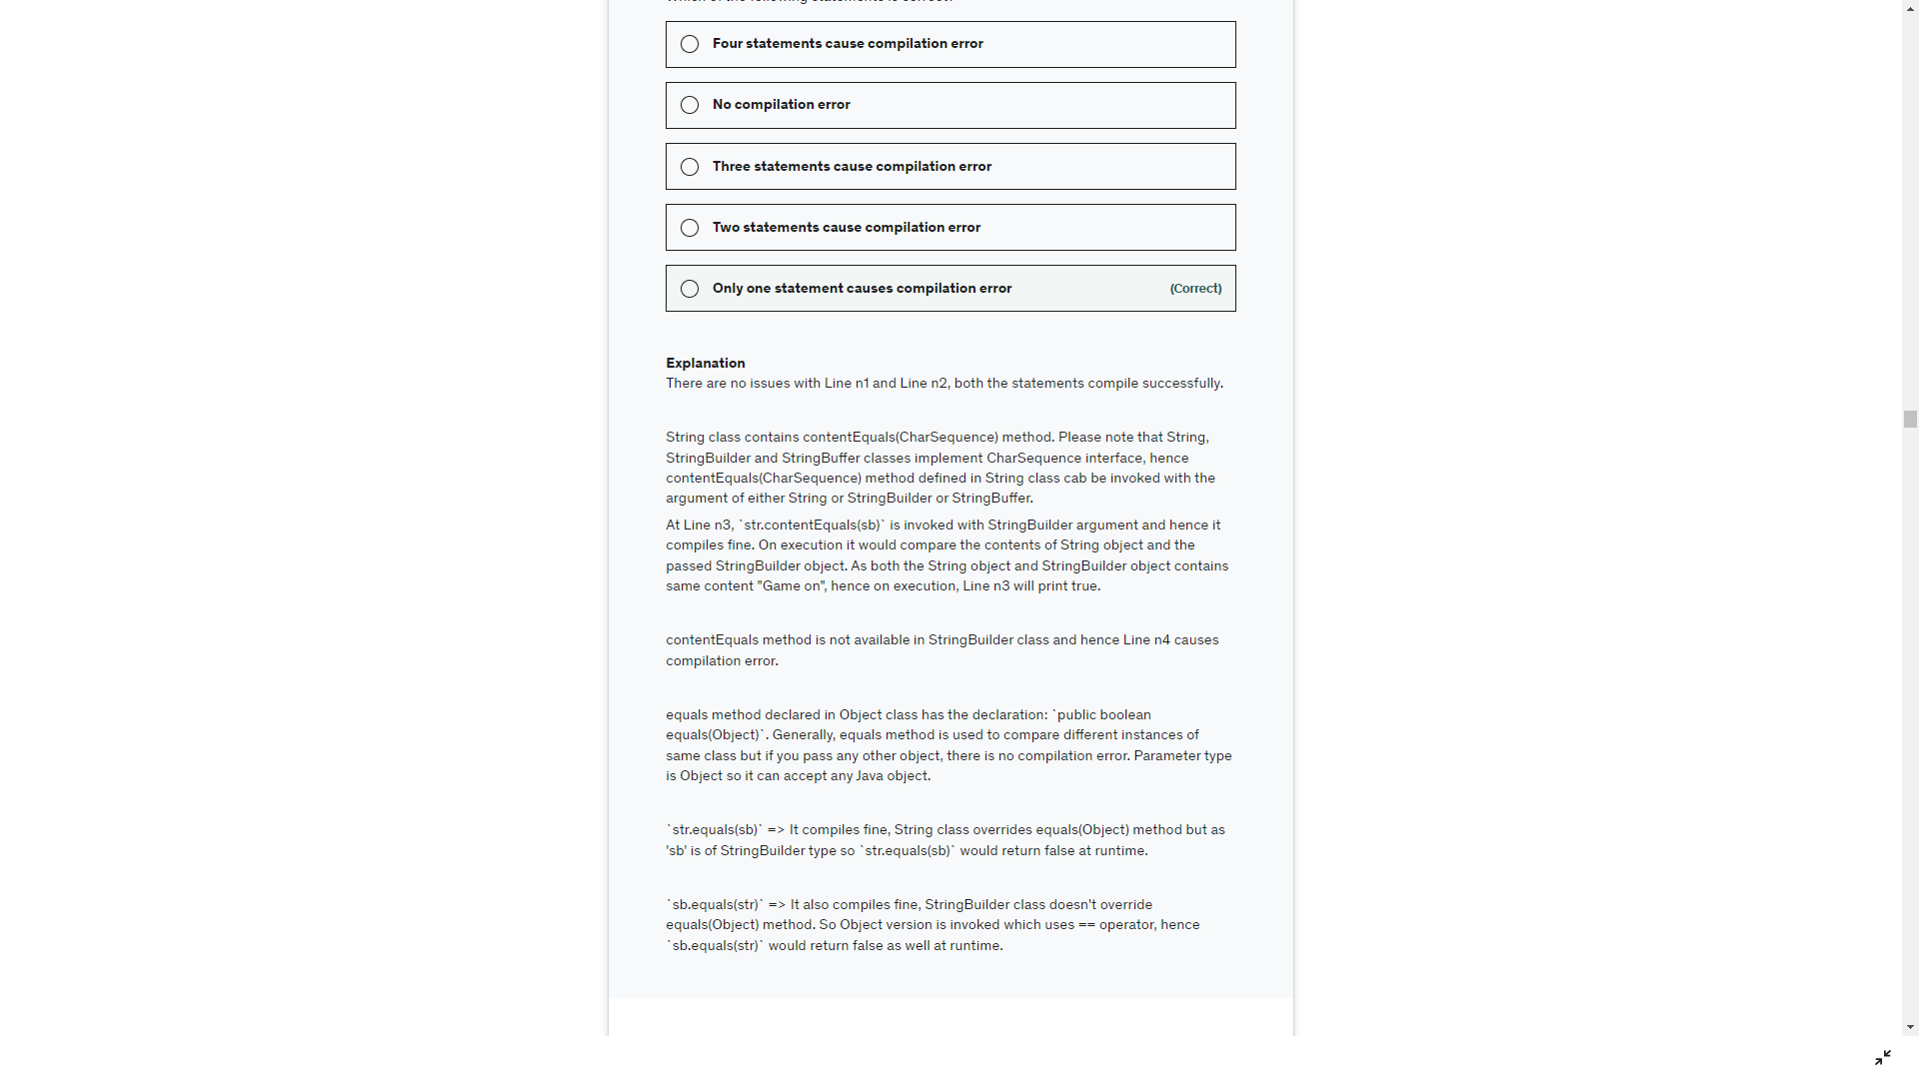

Default method in interface is public. It’s called default method.

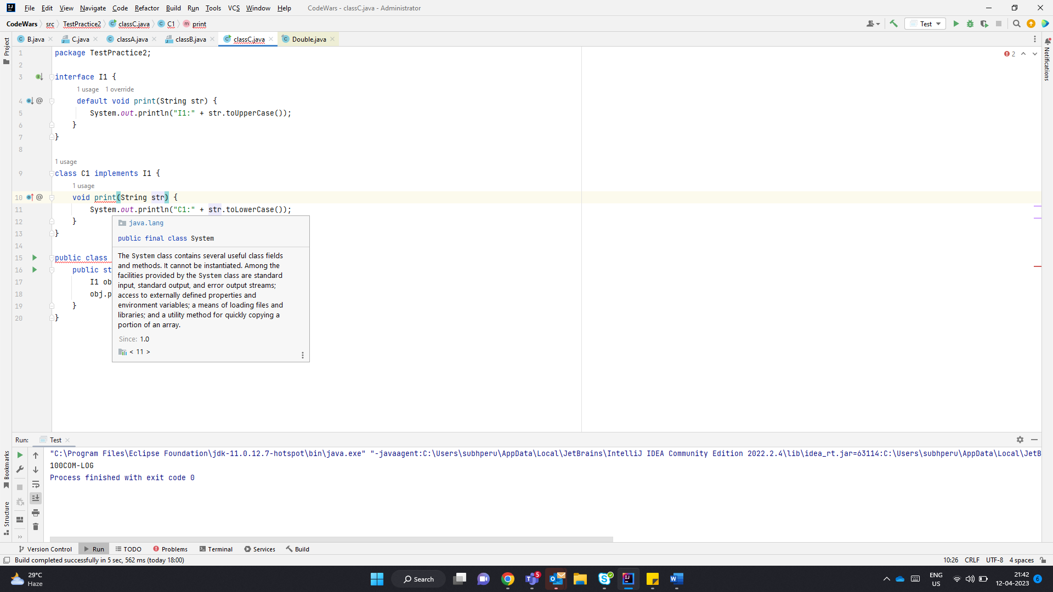

Here the static method can be accessed only using I1.print() , so it has no scope in C1 and hence C1 can define a method name print and it is not overriding print from I1 is valid. But for compiler at line 18. Obj refer to Parent I1. And the static method cant be accessed with instance name so compile time error at that line

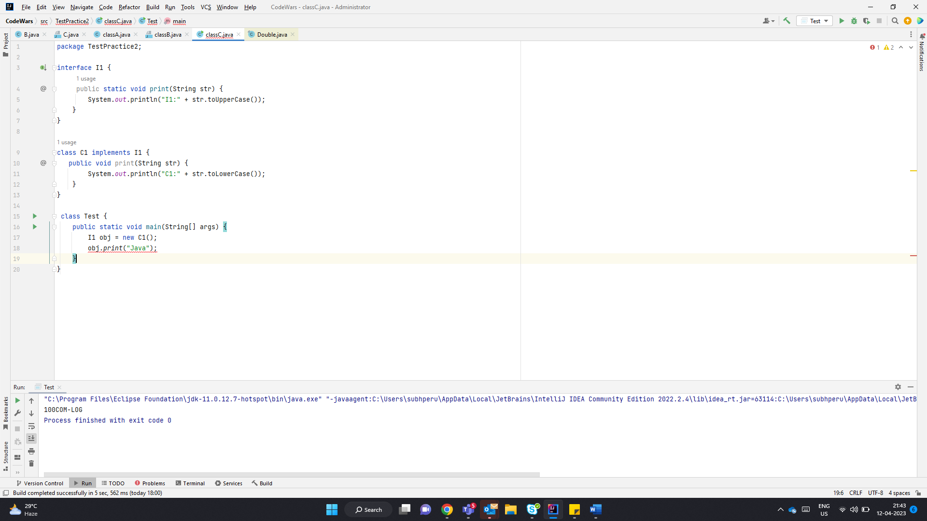

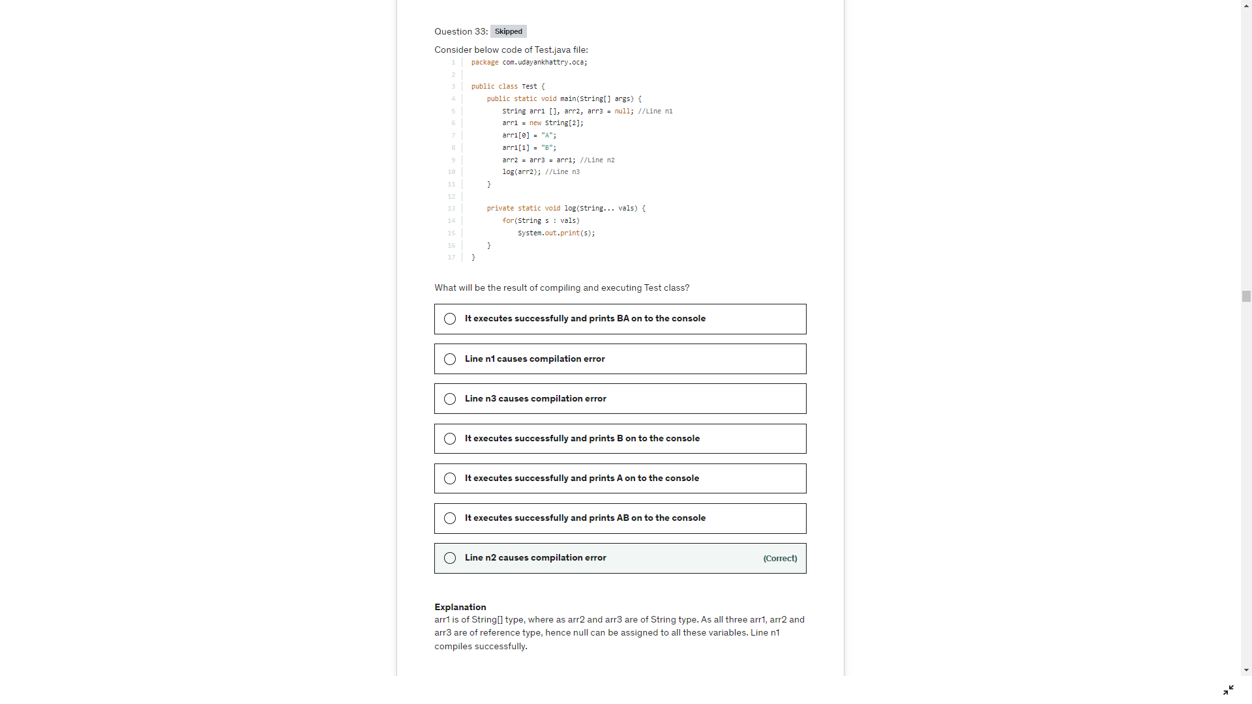

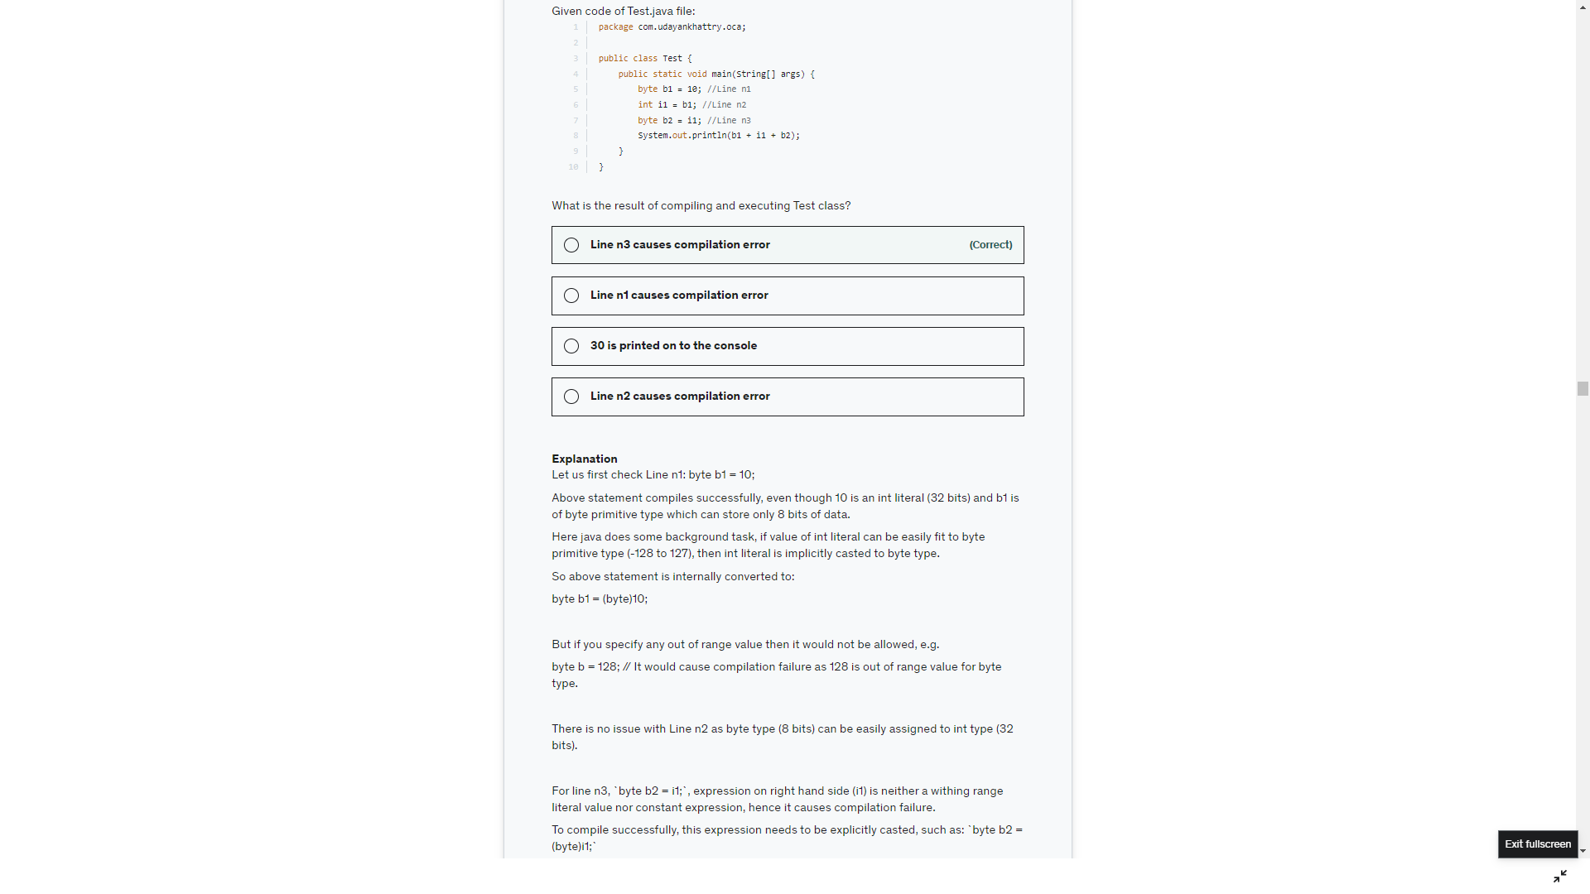

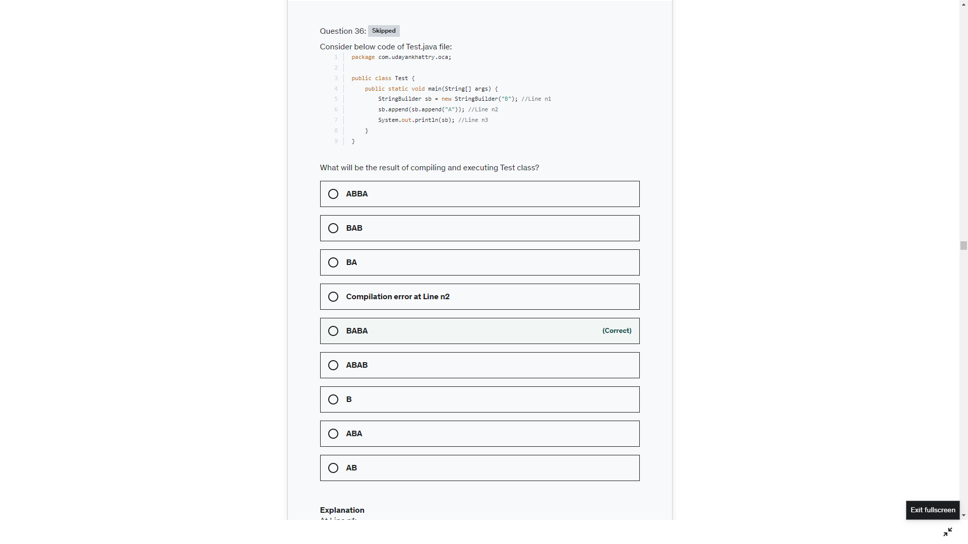

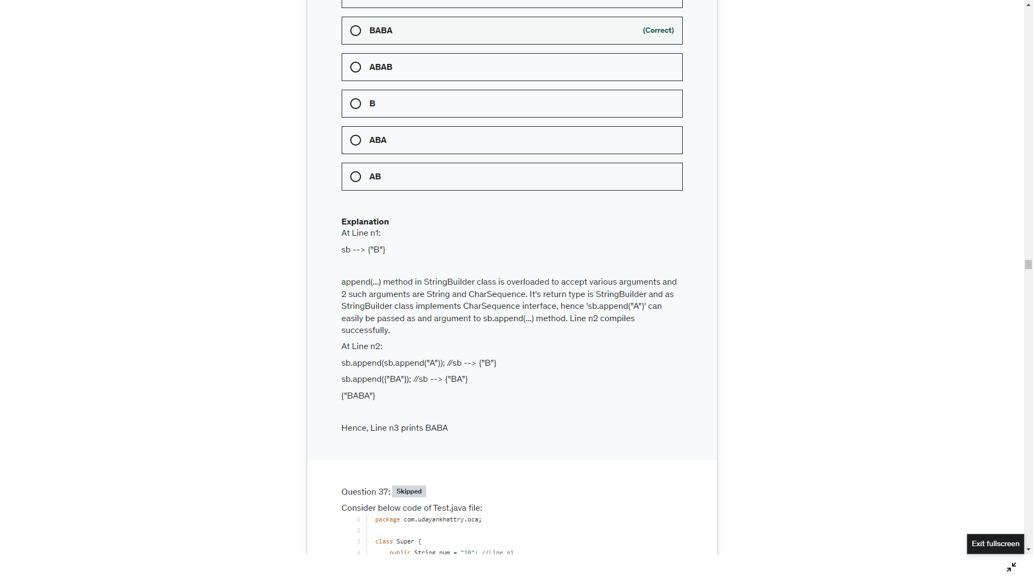

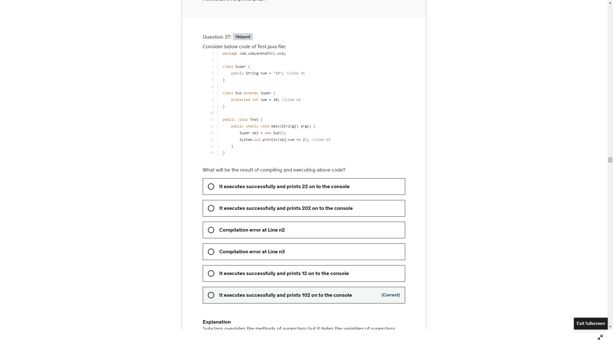

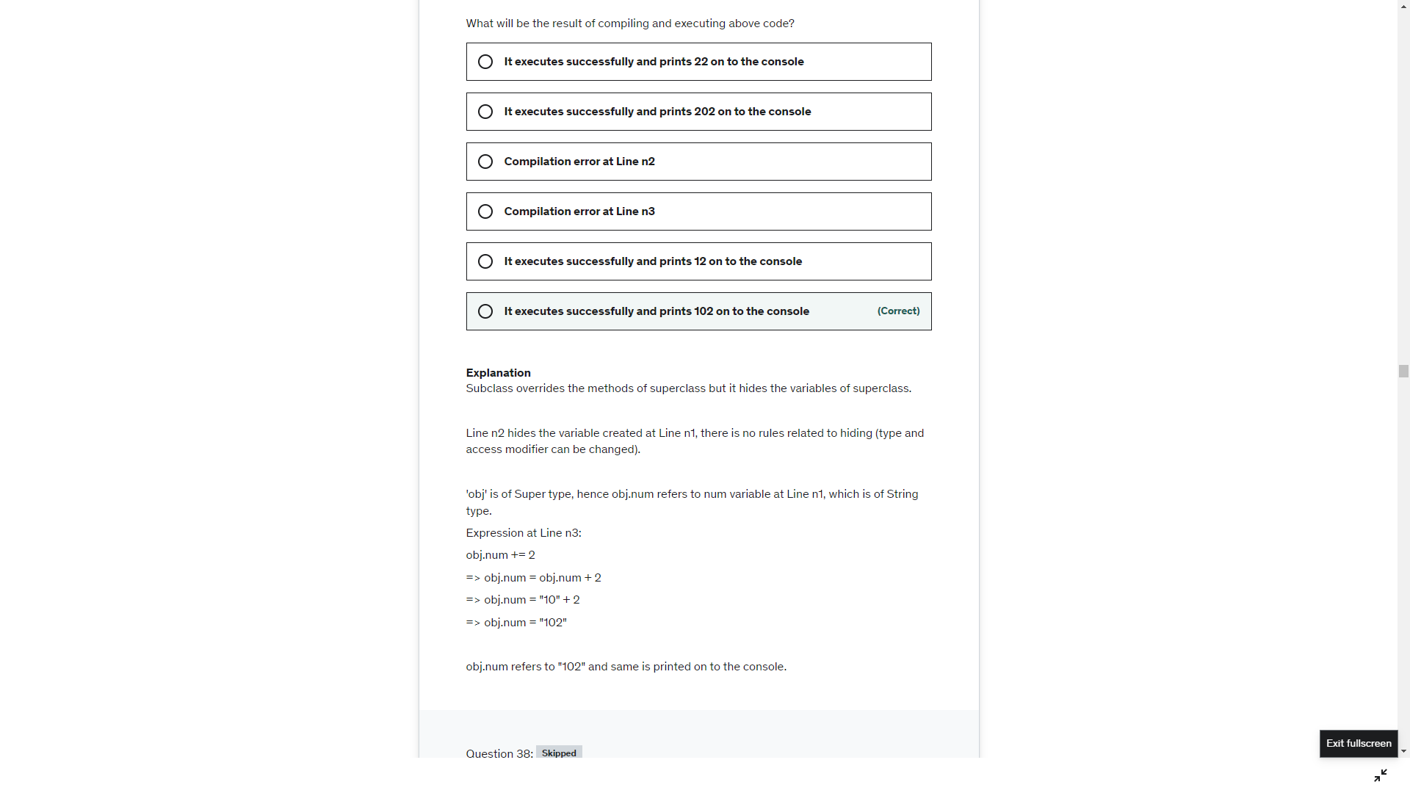

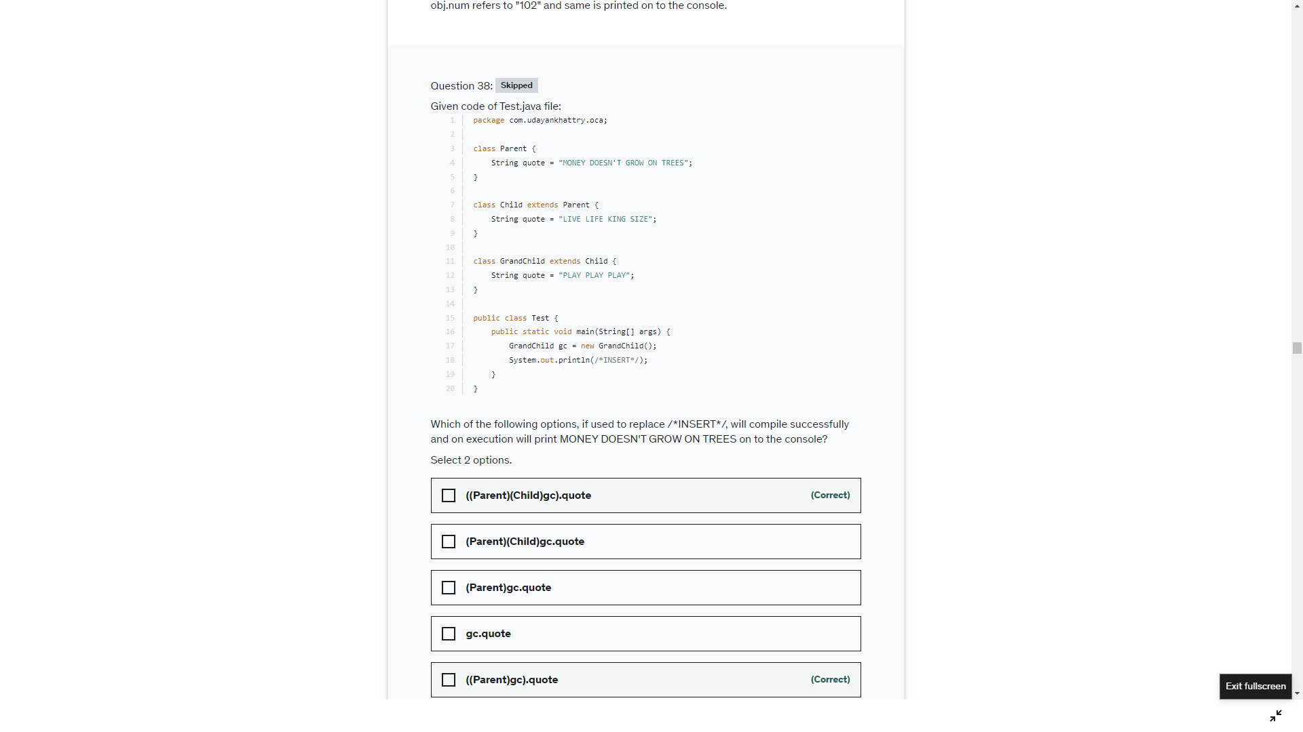

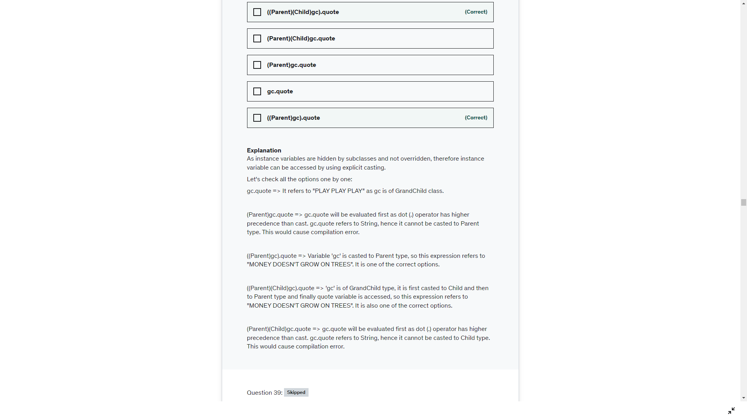

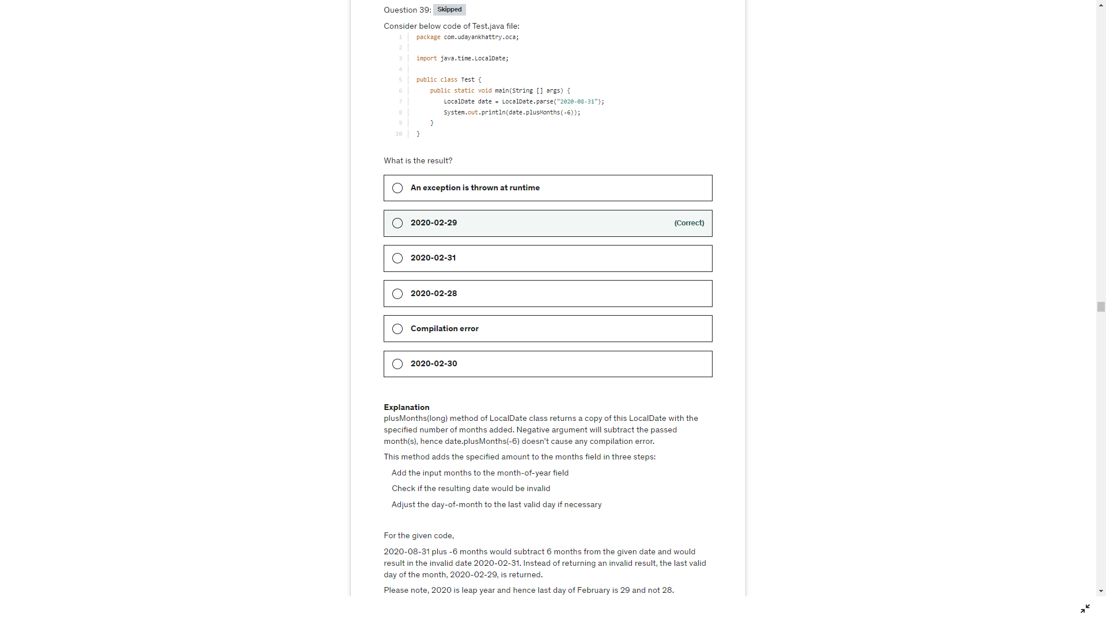

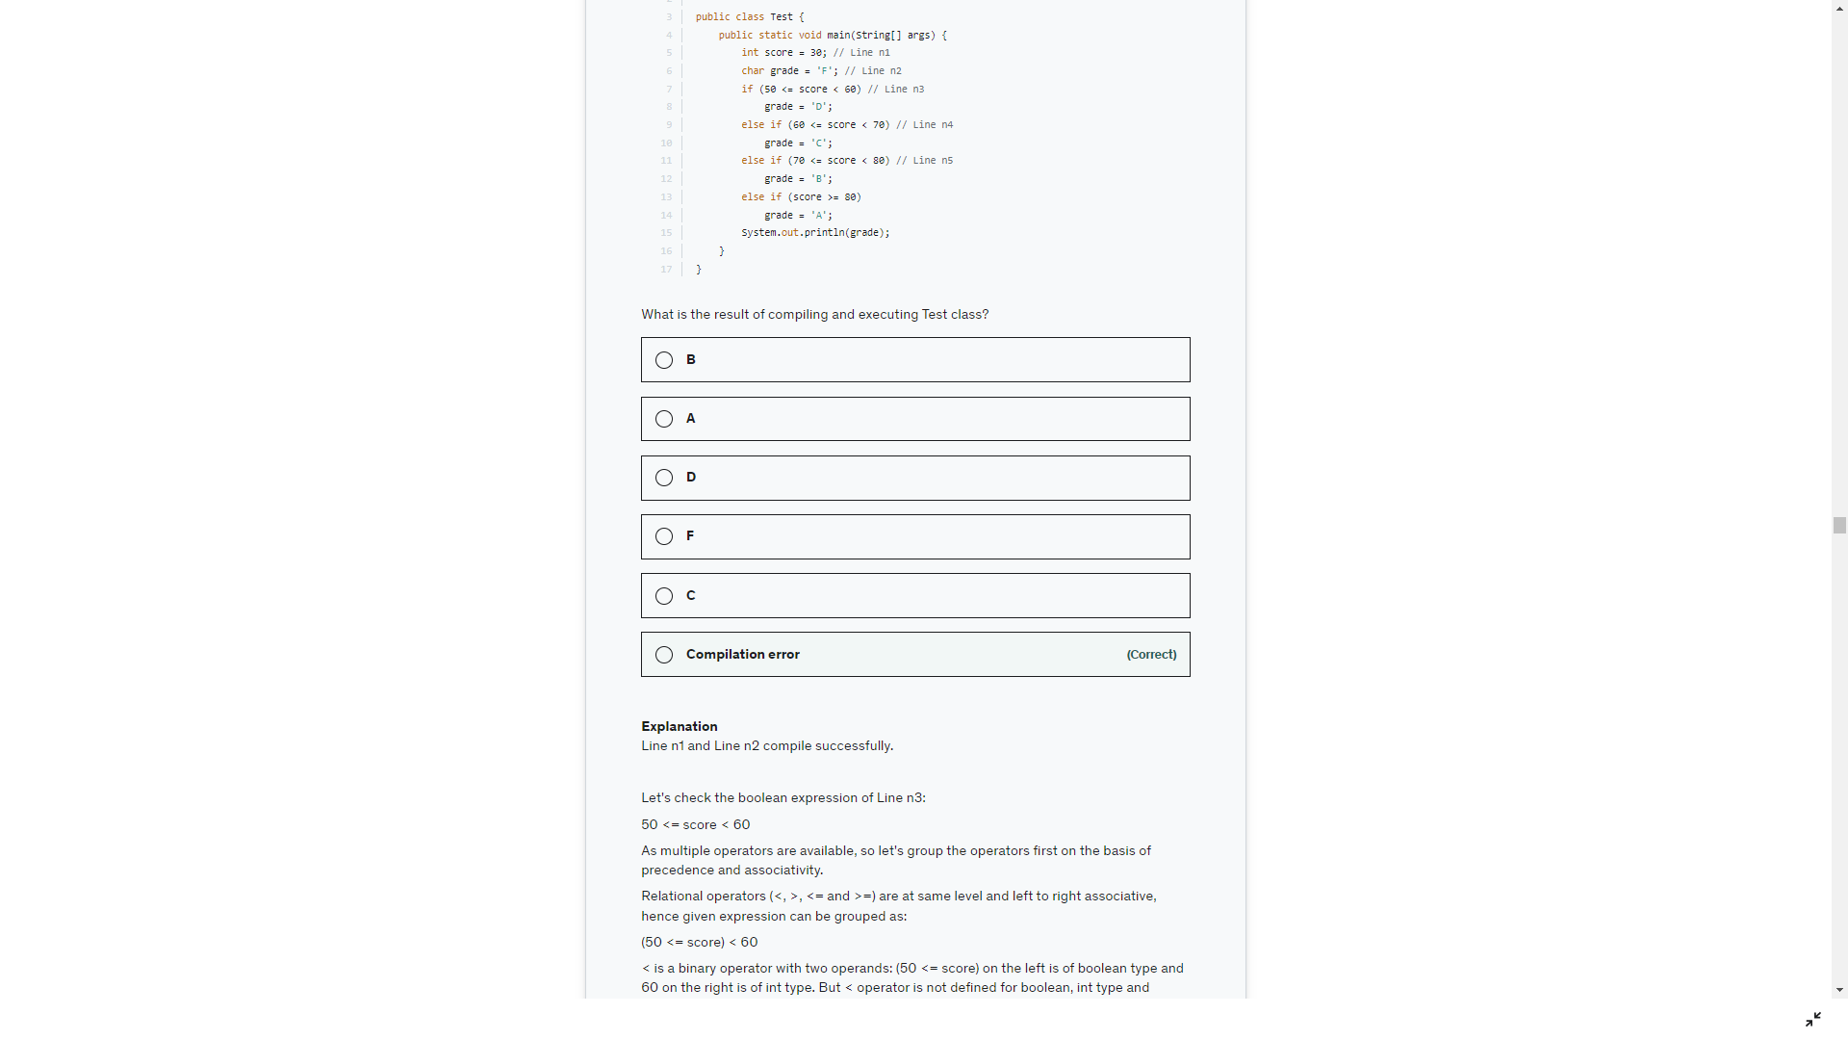

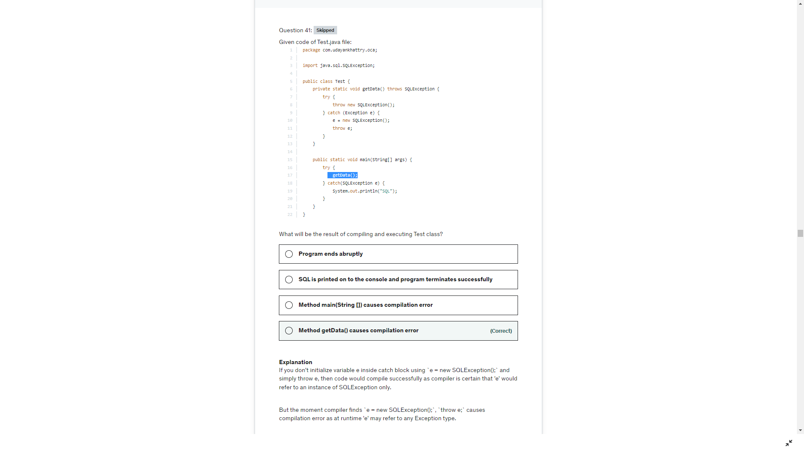

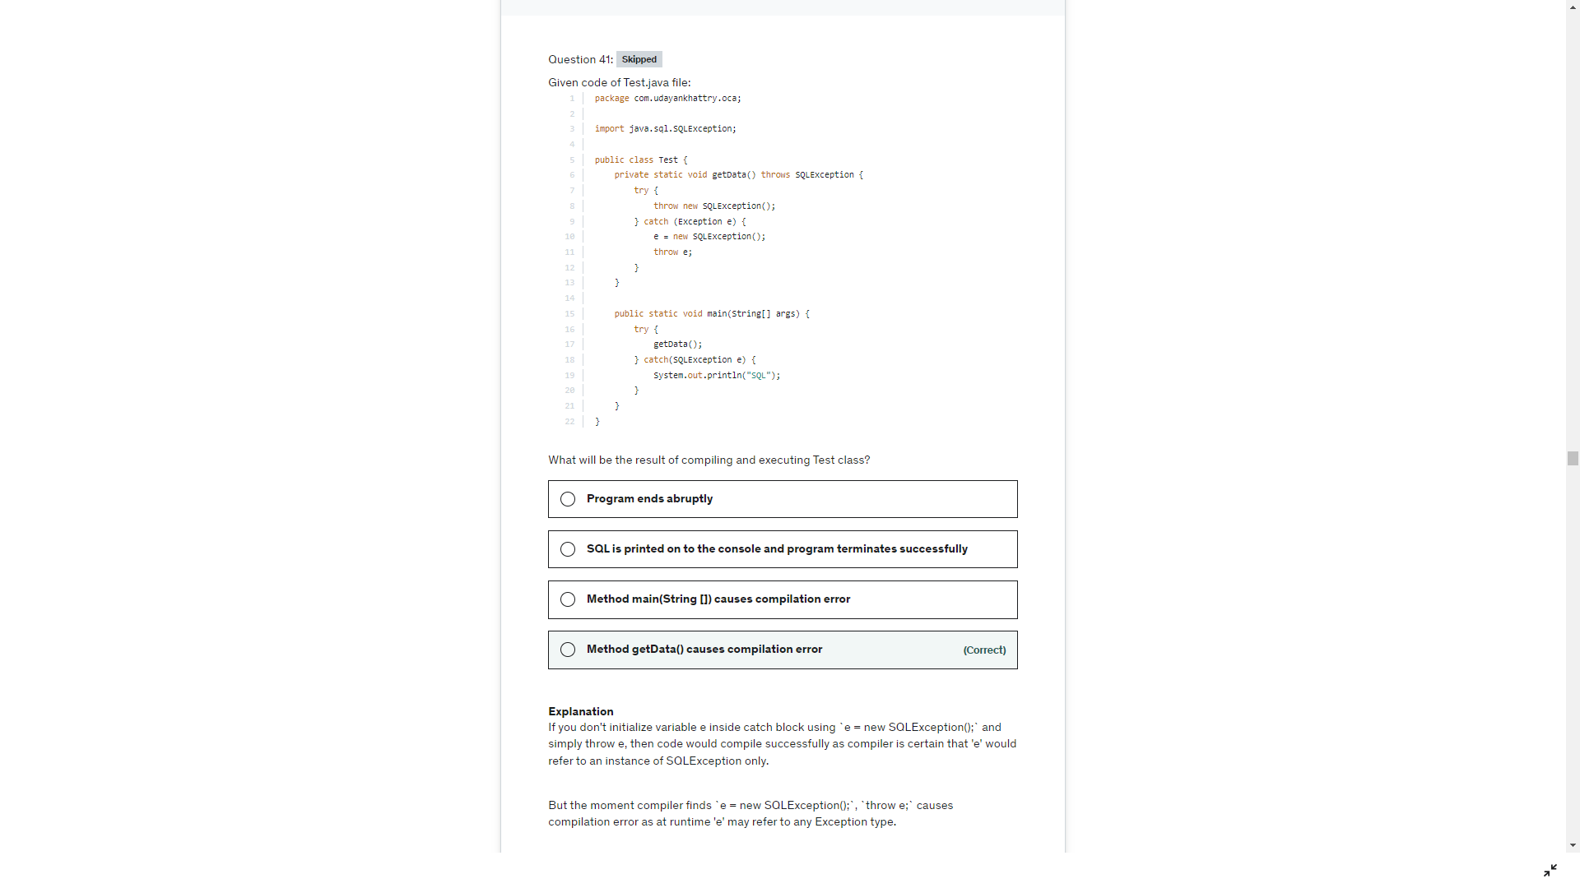

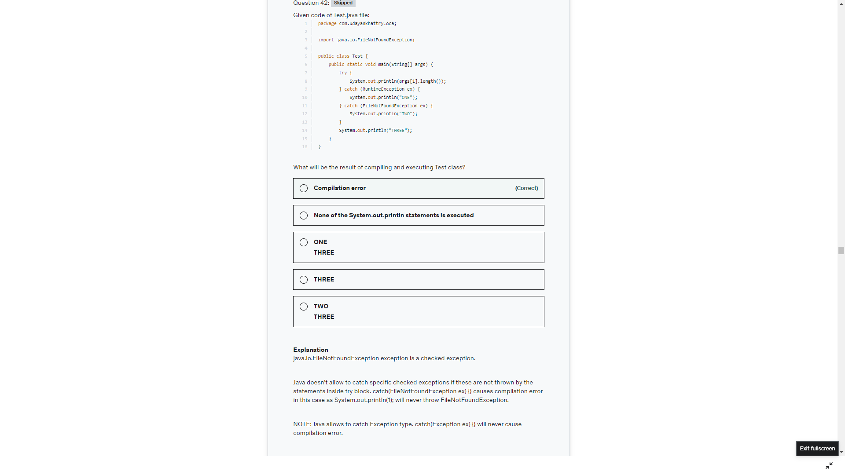

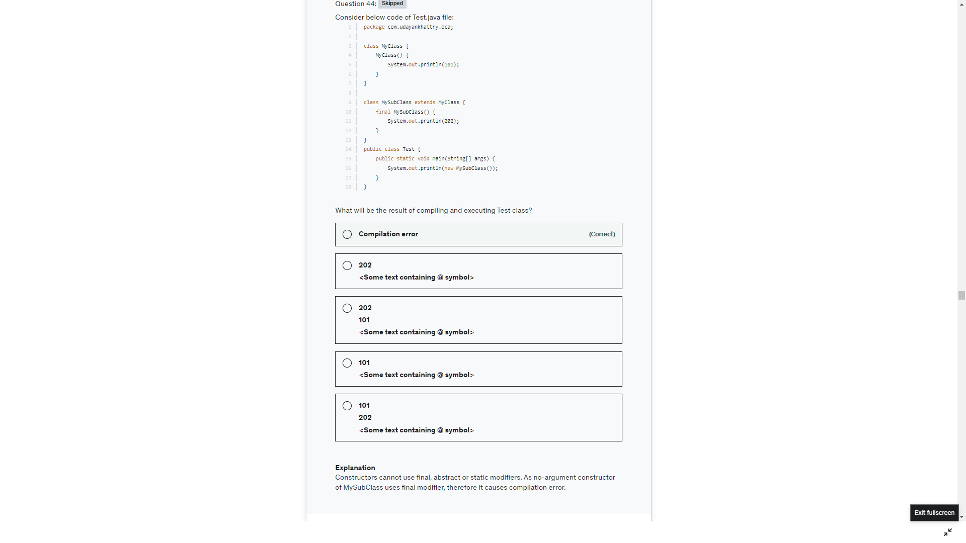

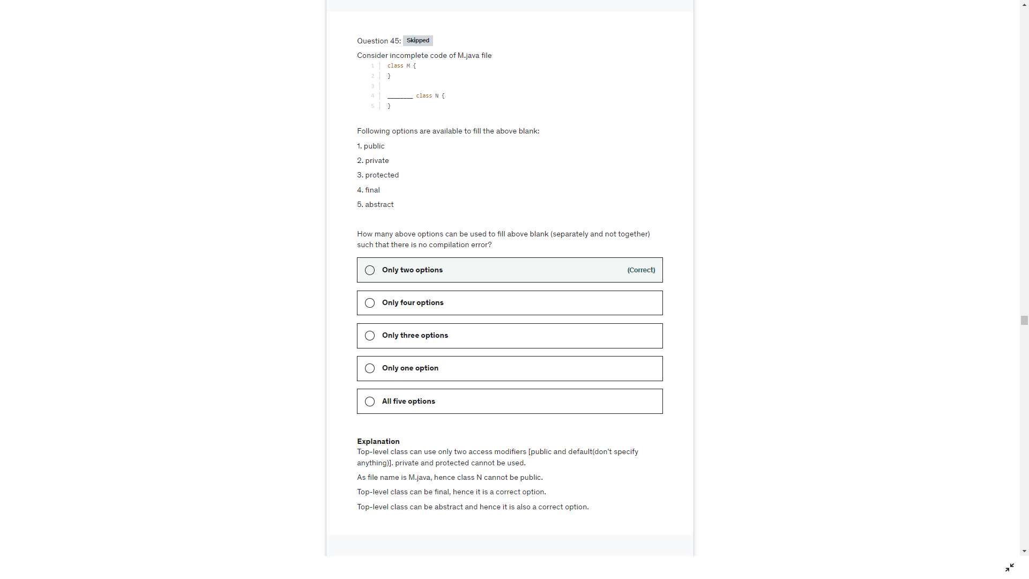

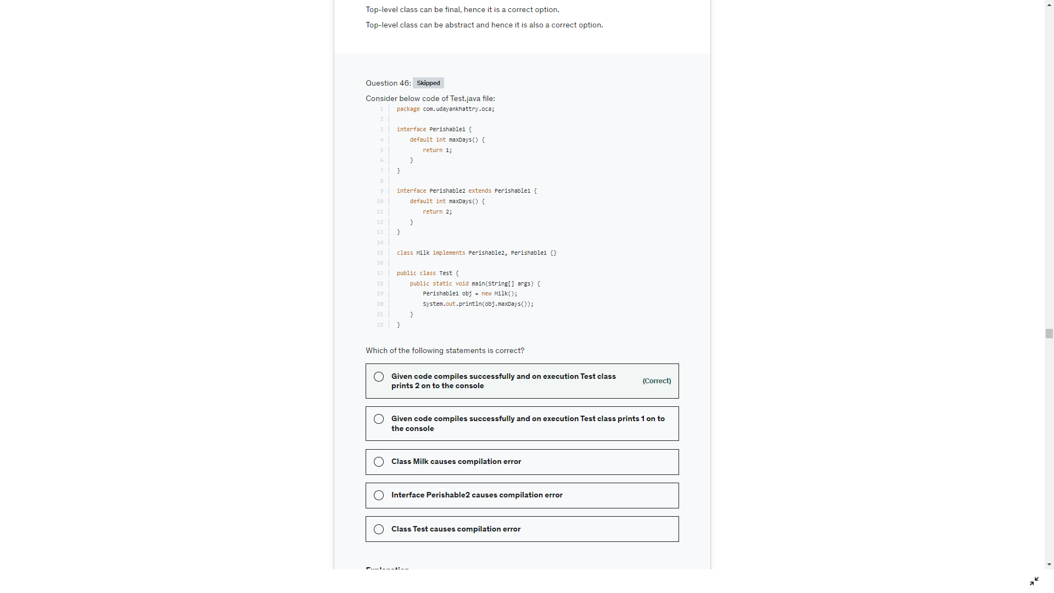

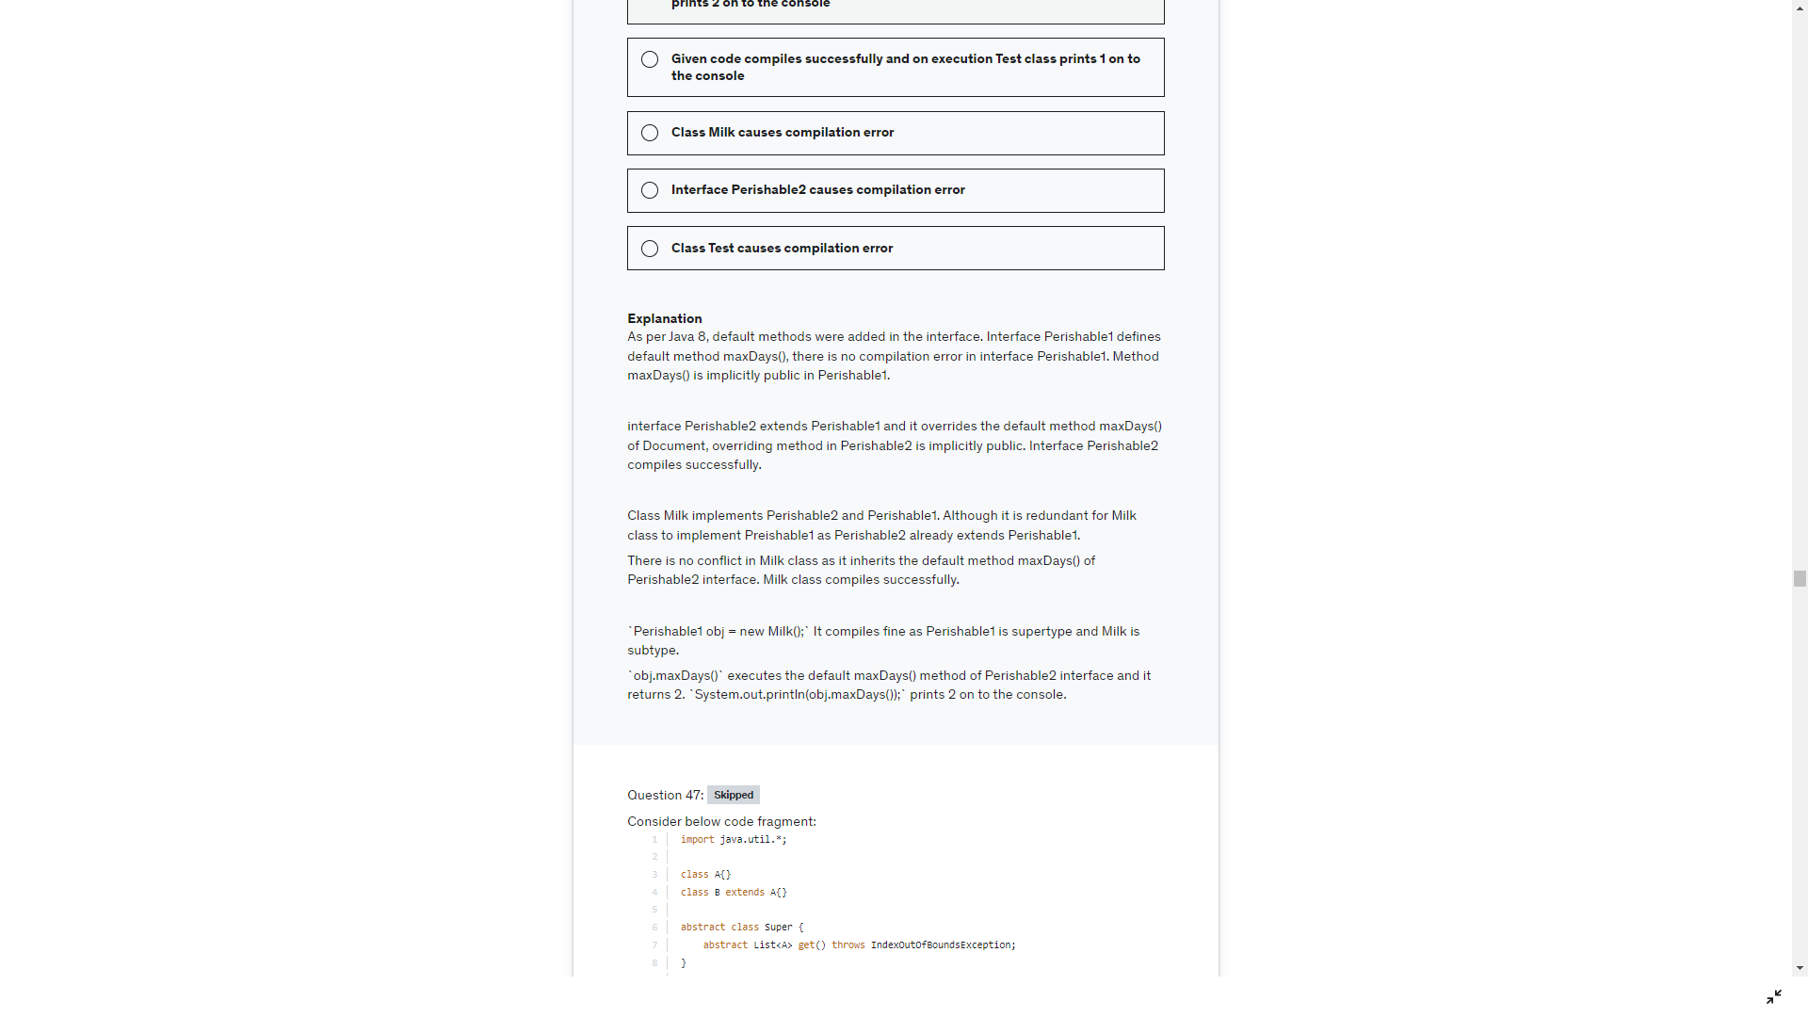

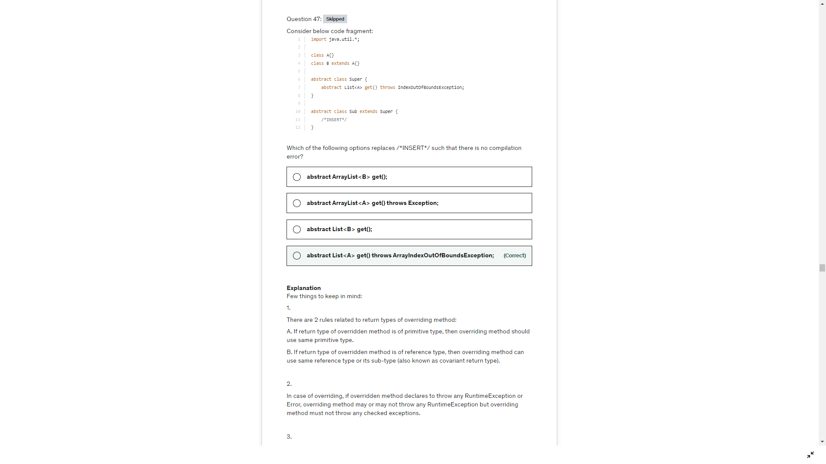

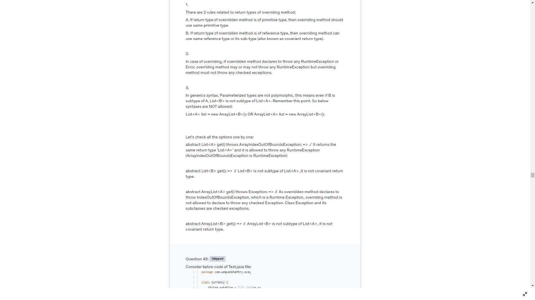

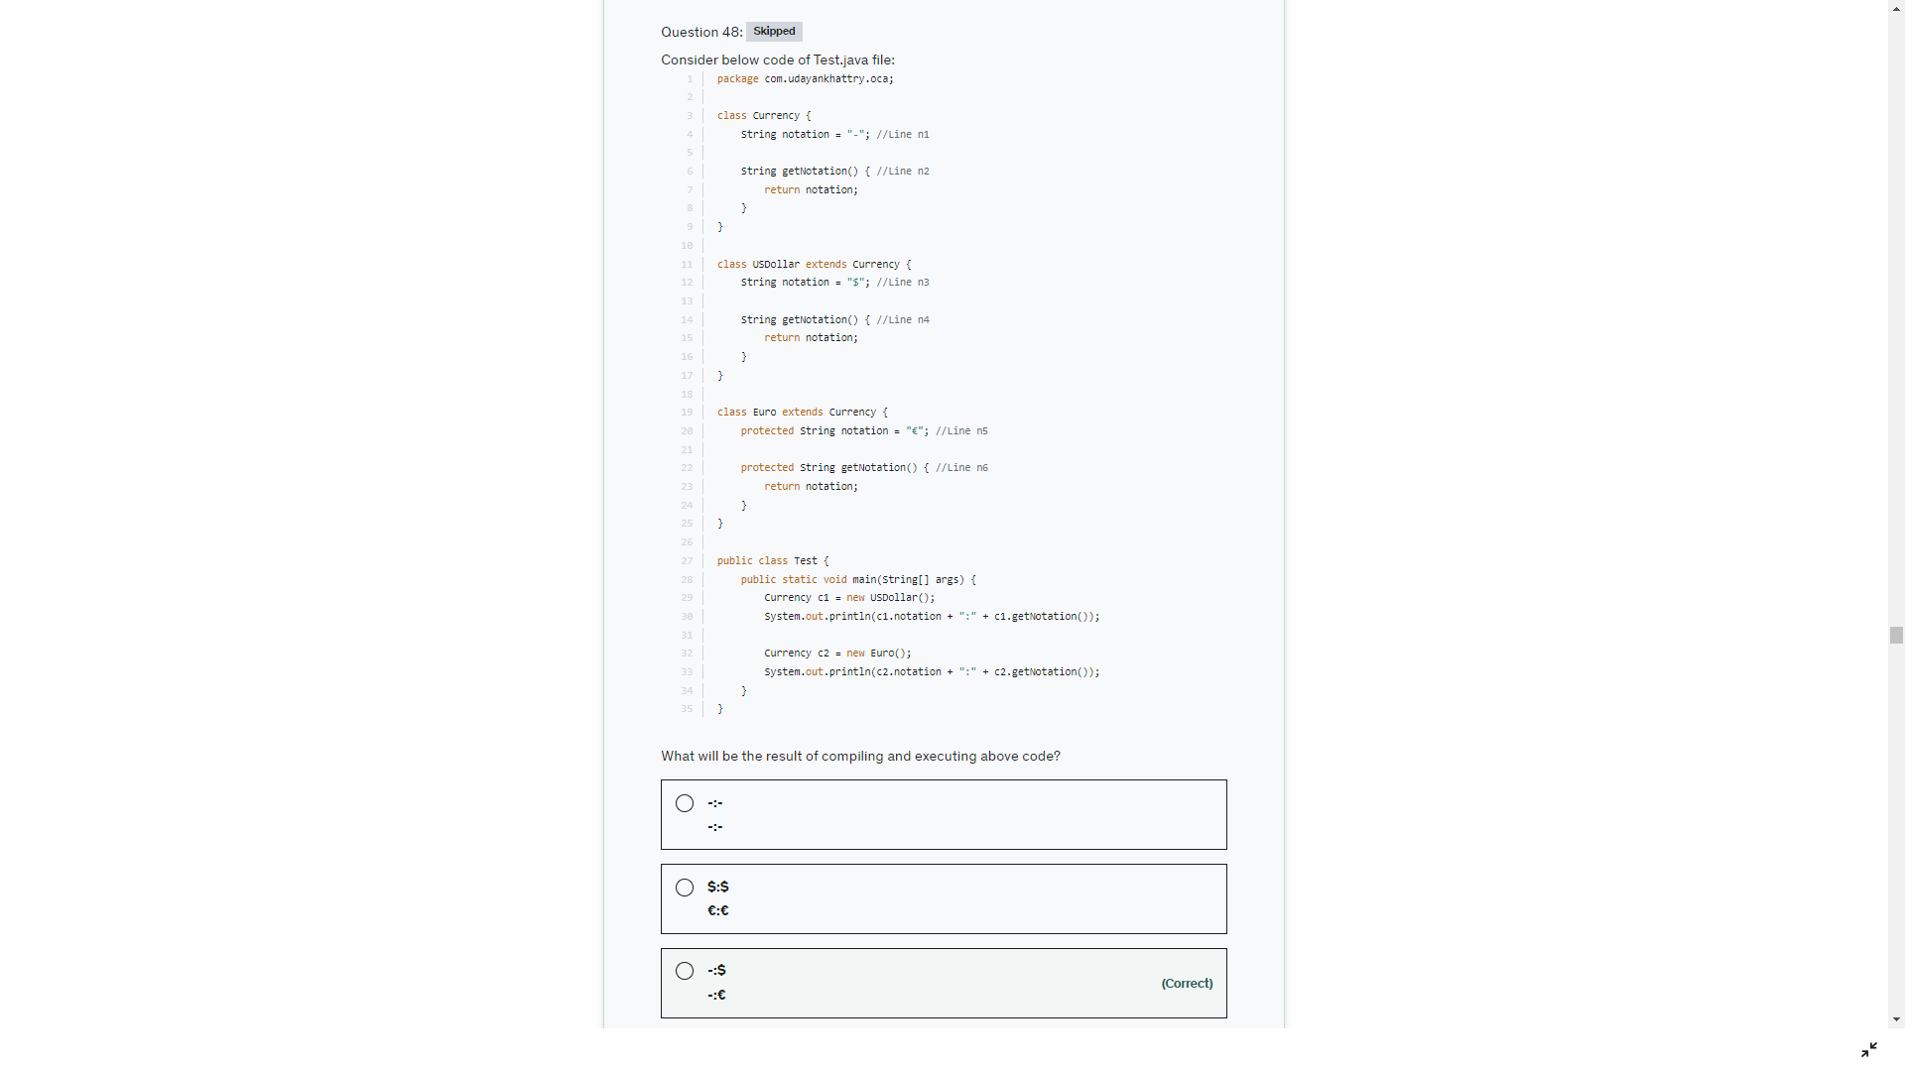

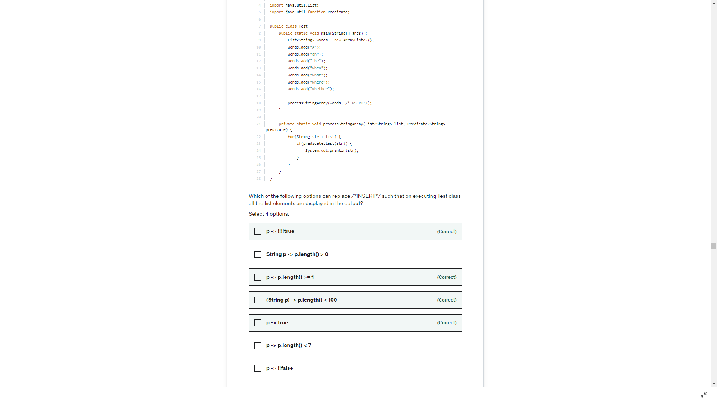

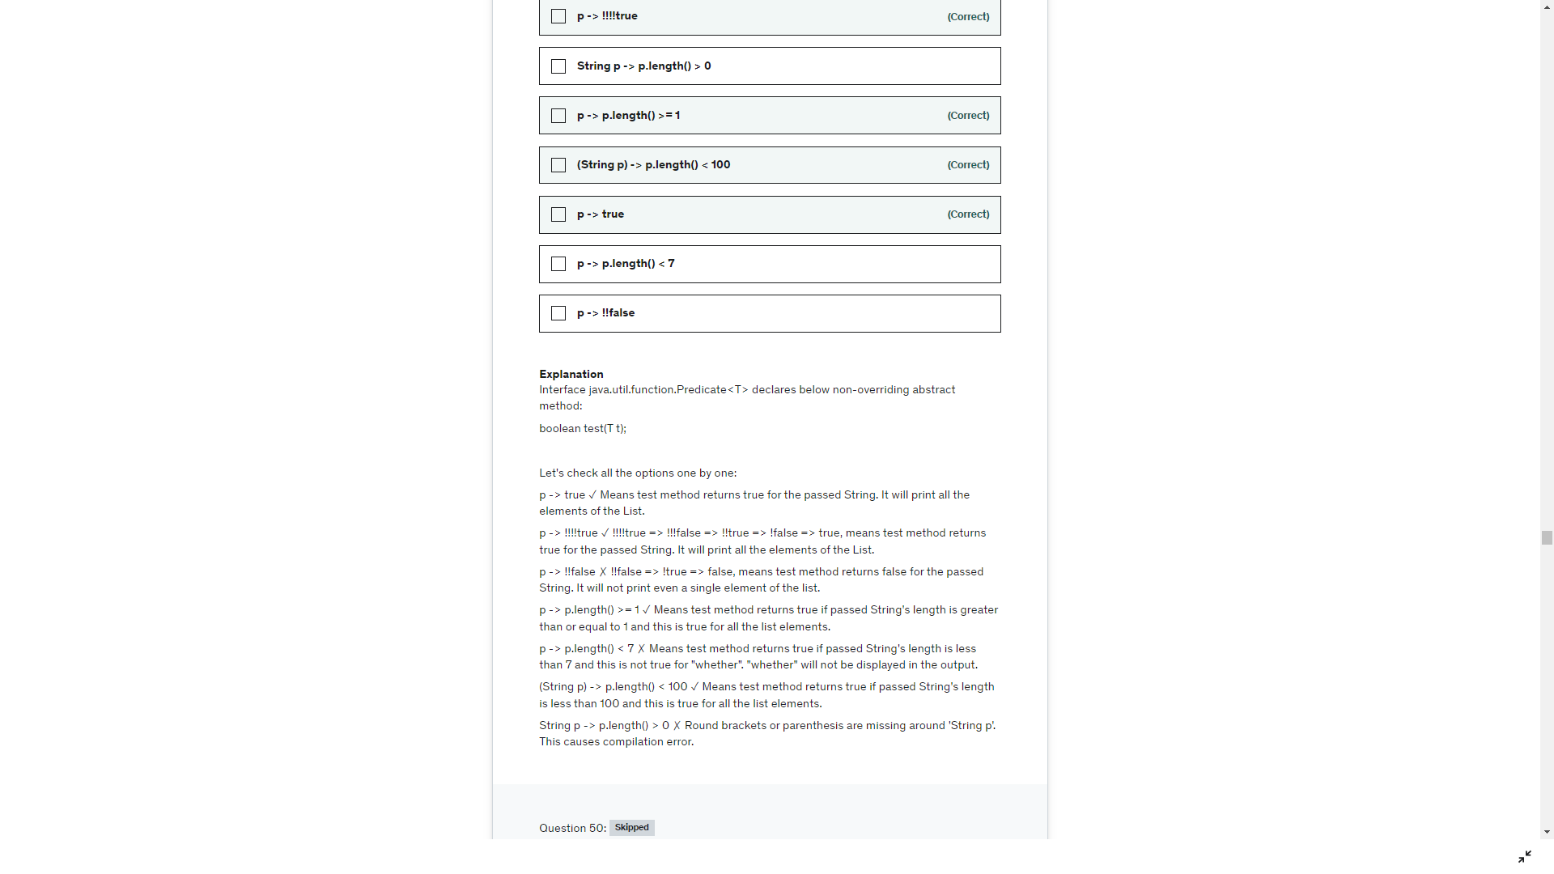

Here TravelBlogger is a class, its is overriding the default method of Blogge. Since the default method has public scope it should be defined as public in line 10

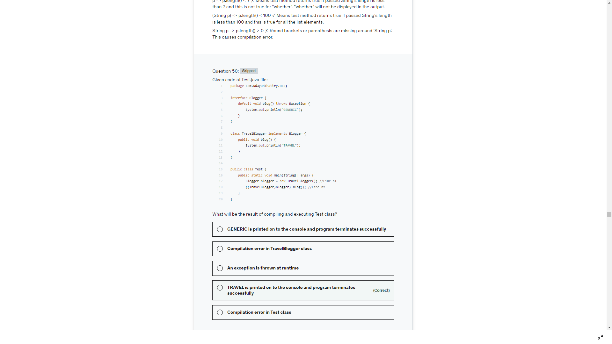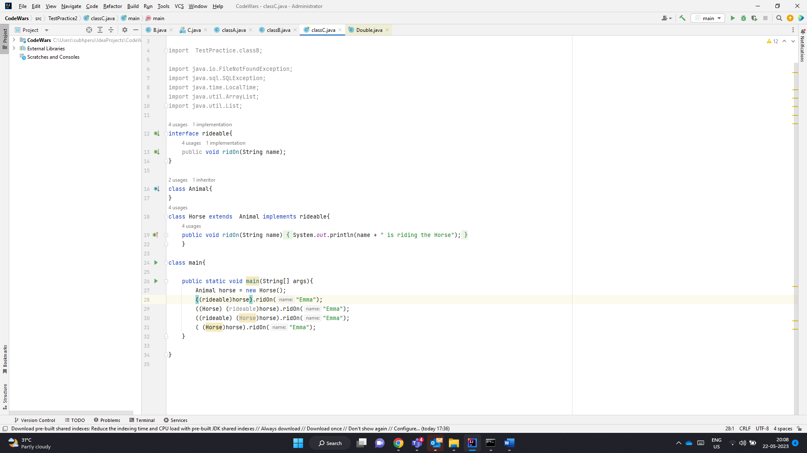

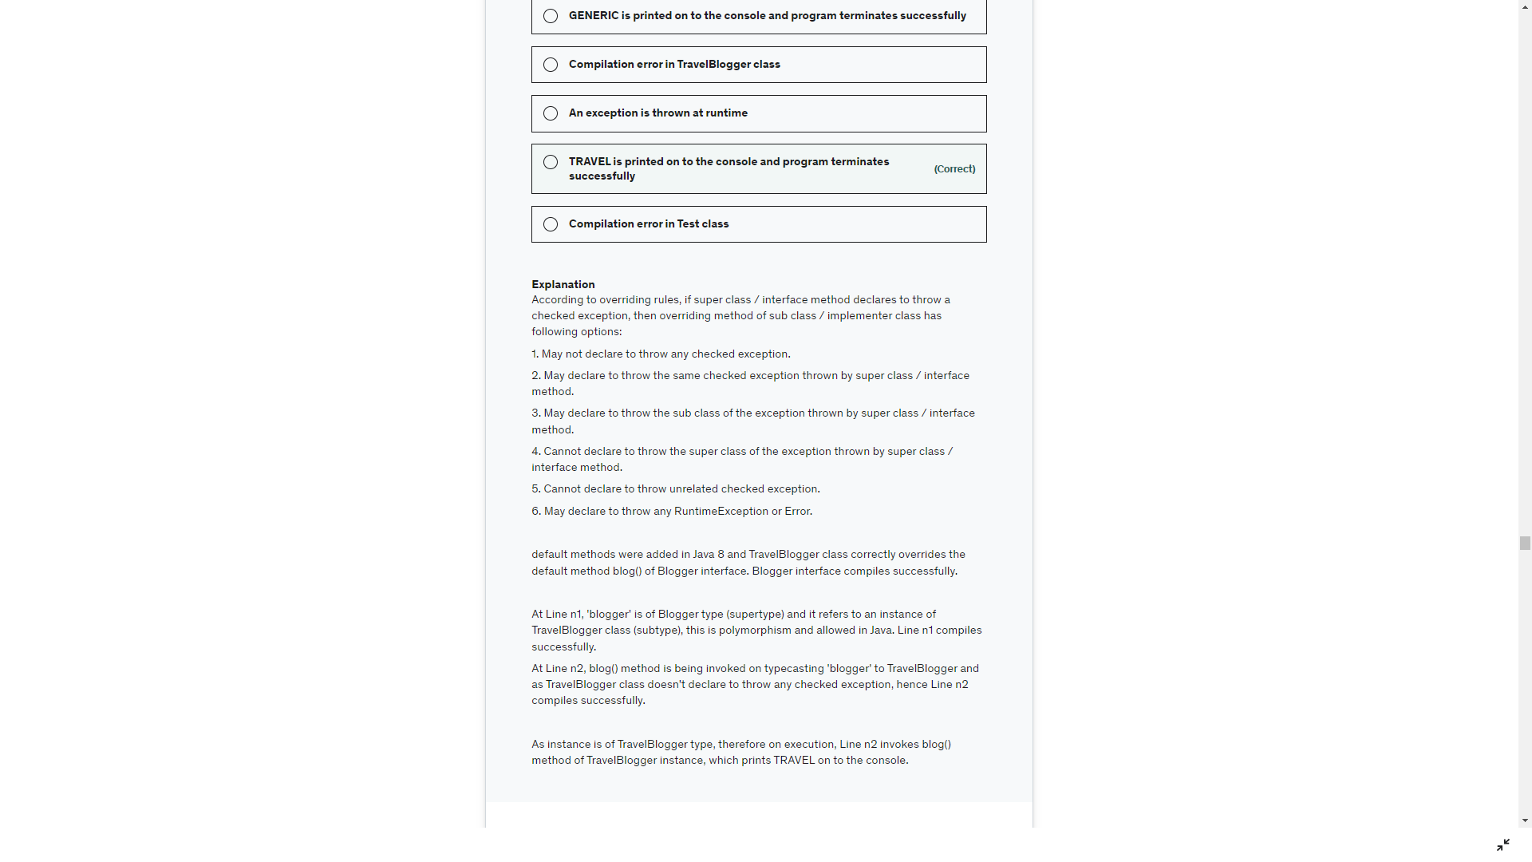

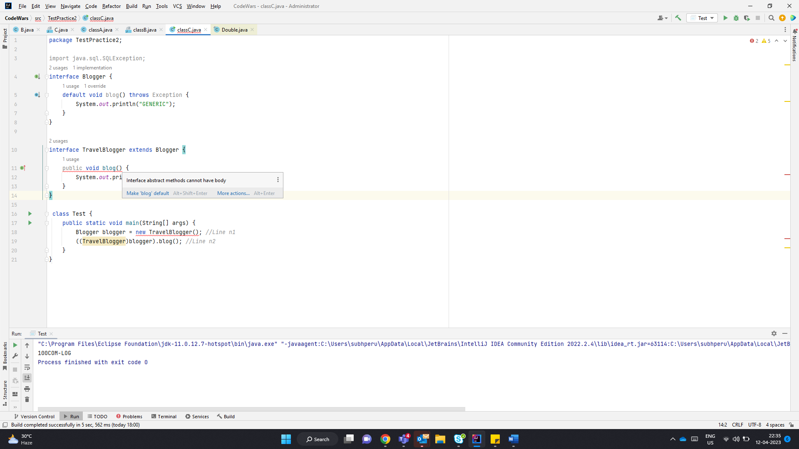

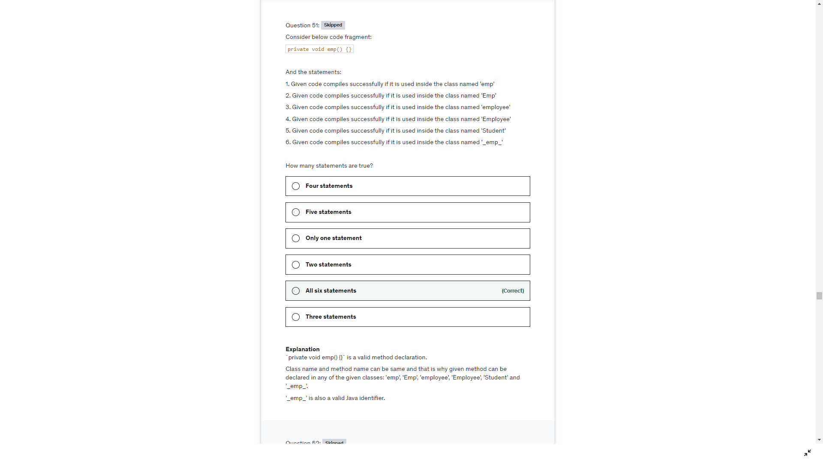

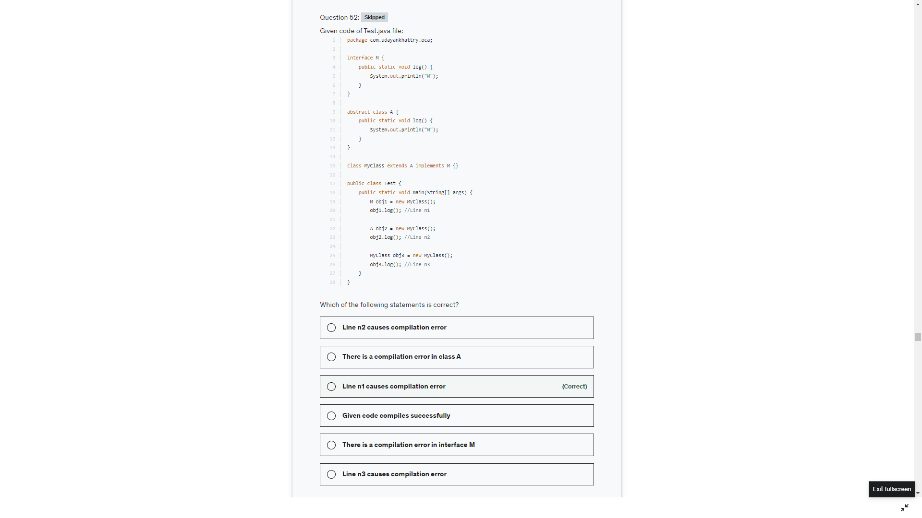

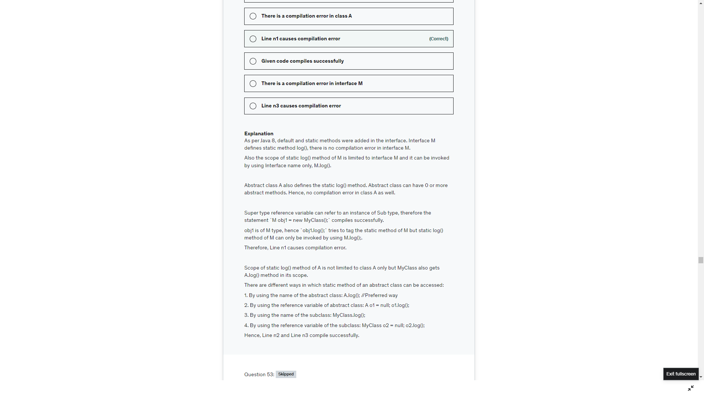

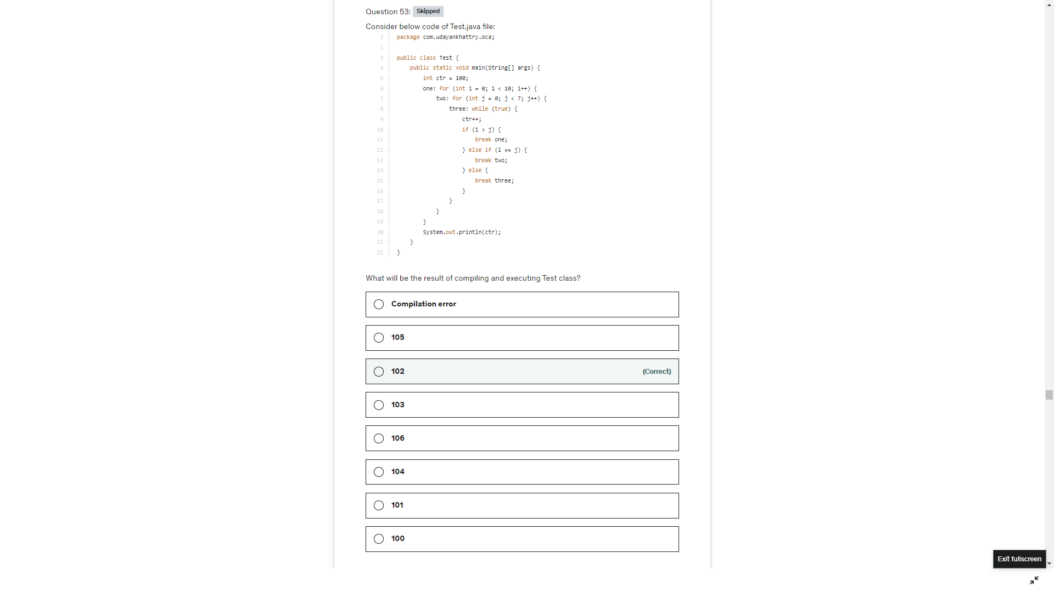

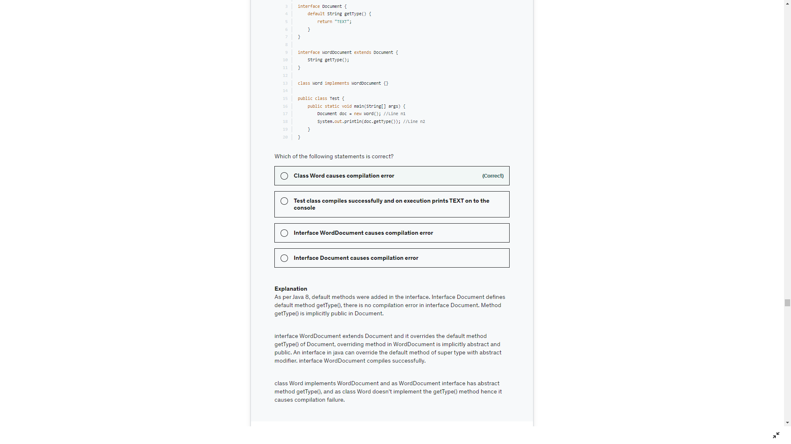

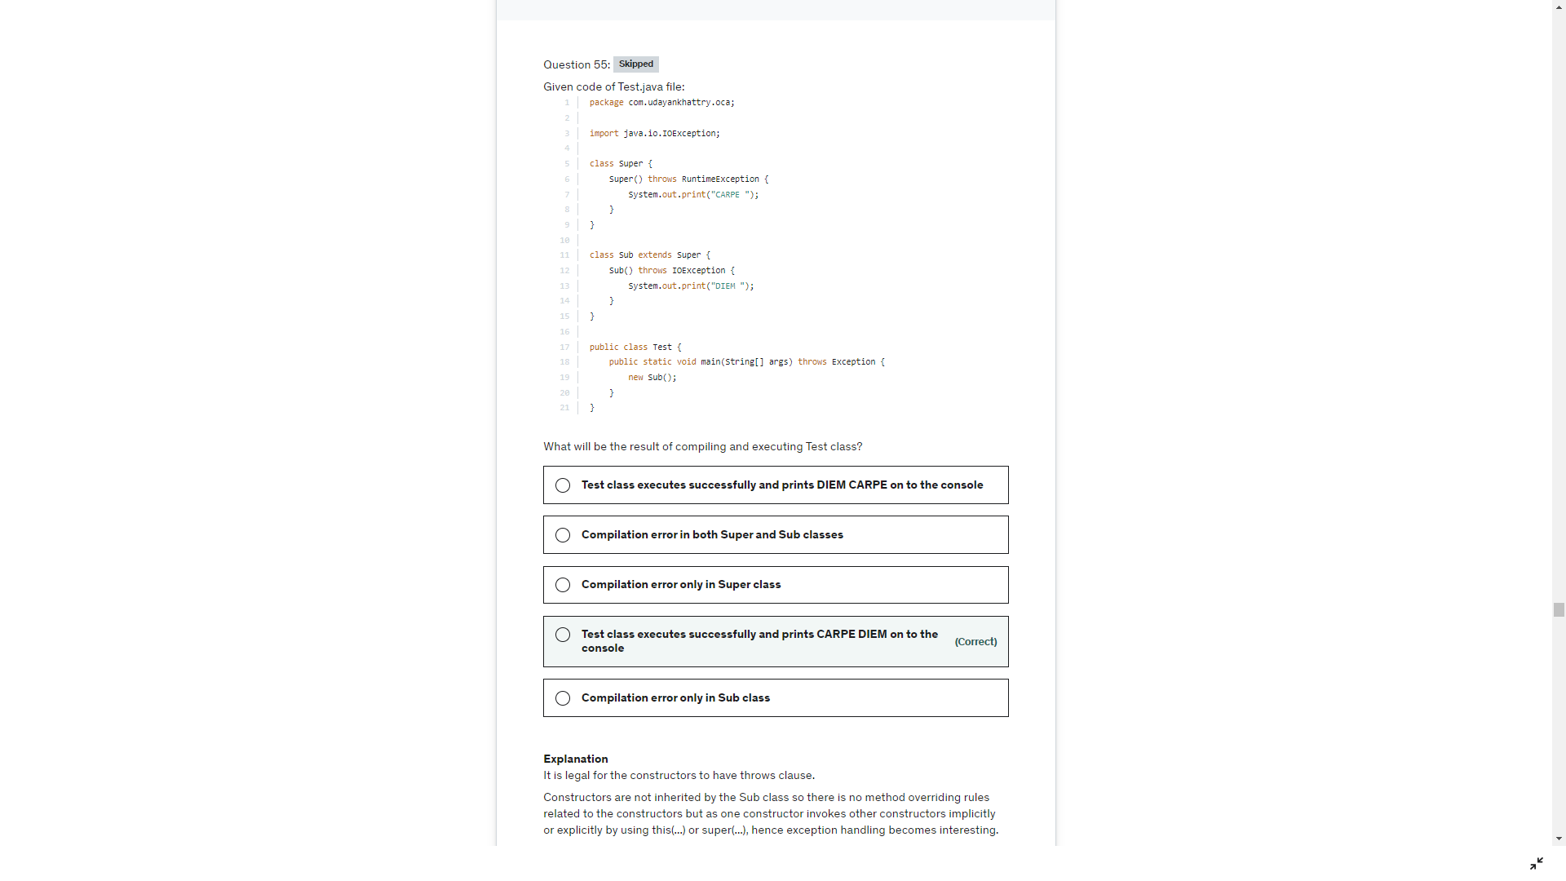

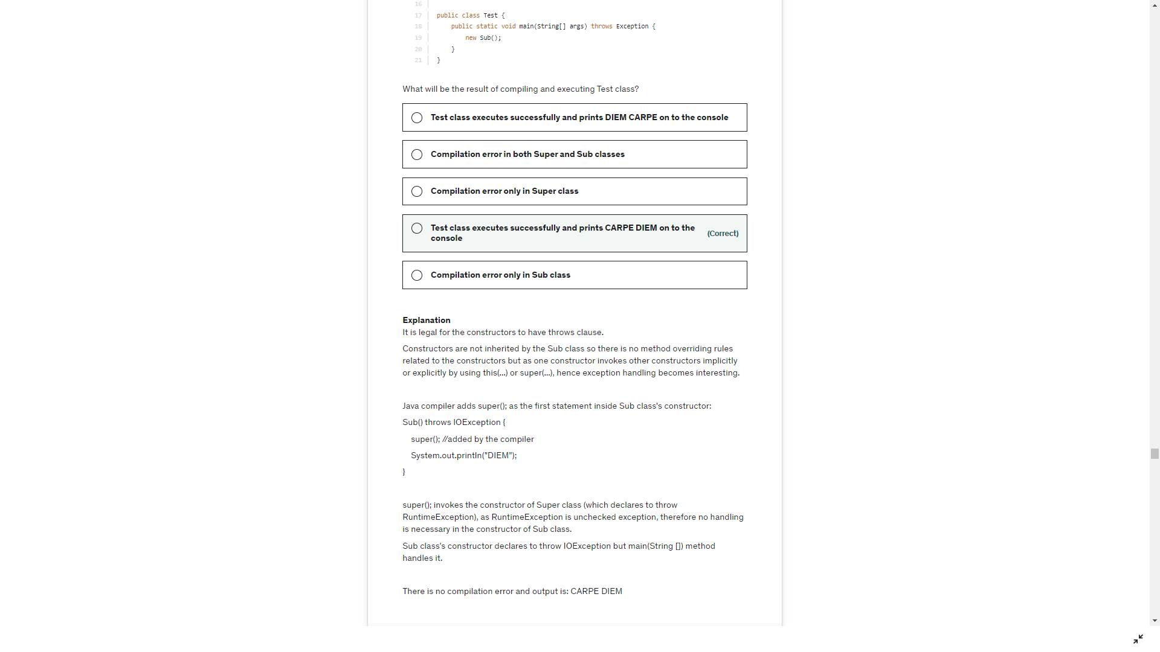

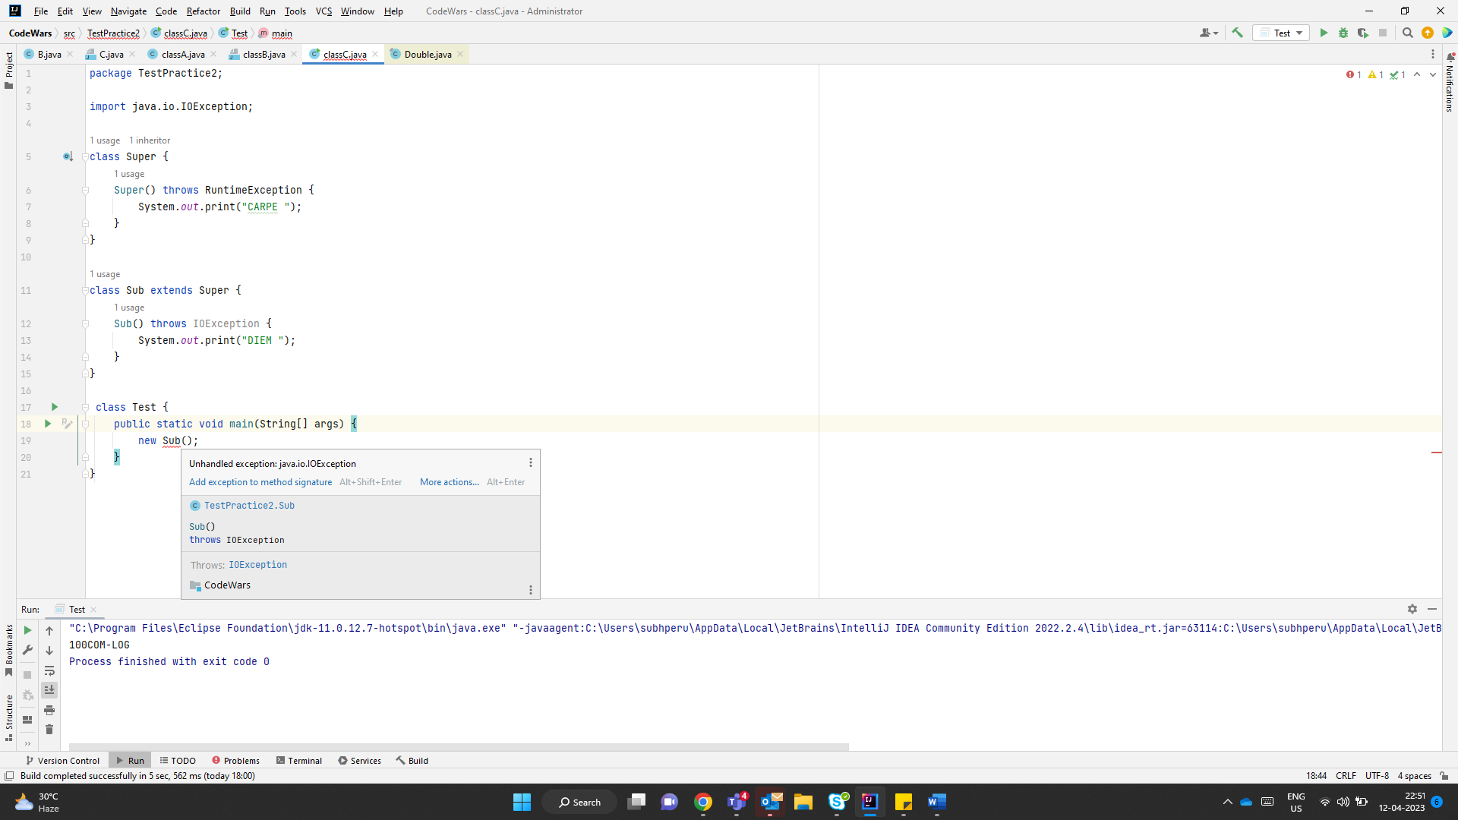

Super class const throws Exception, super() line 1 of base class const has to handle the exception thrown by super class const

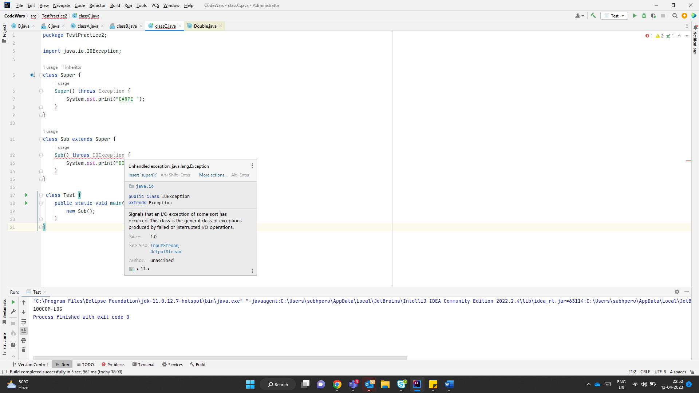

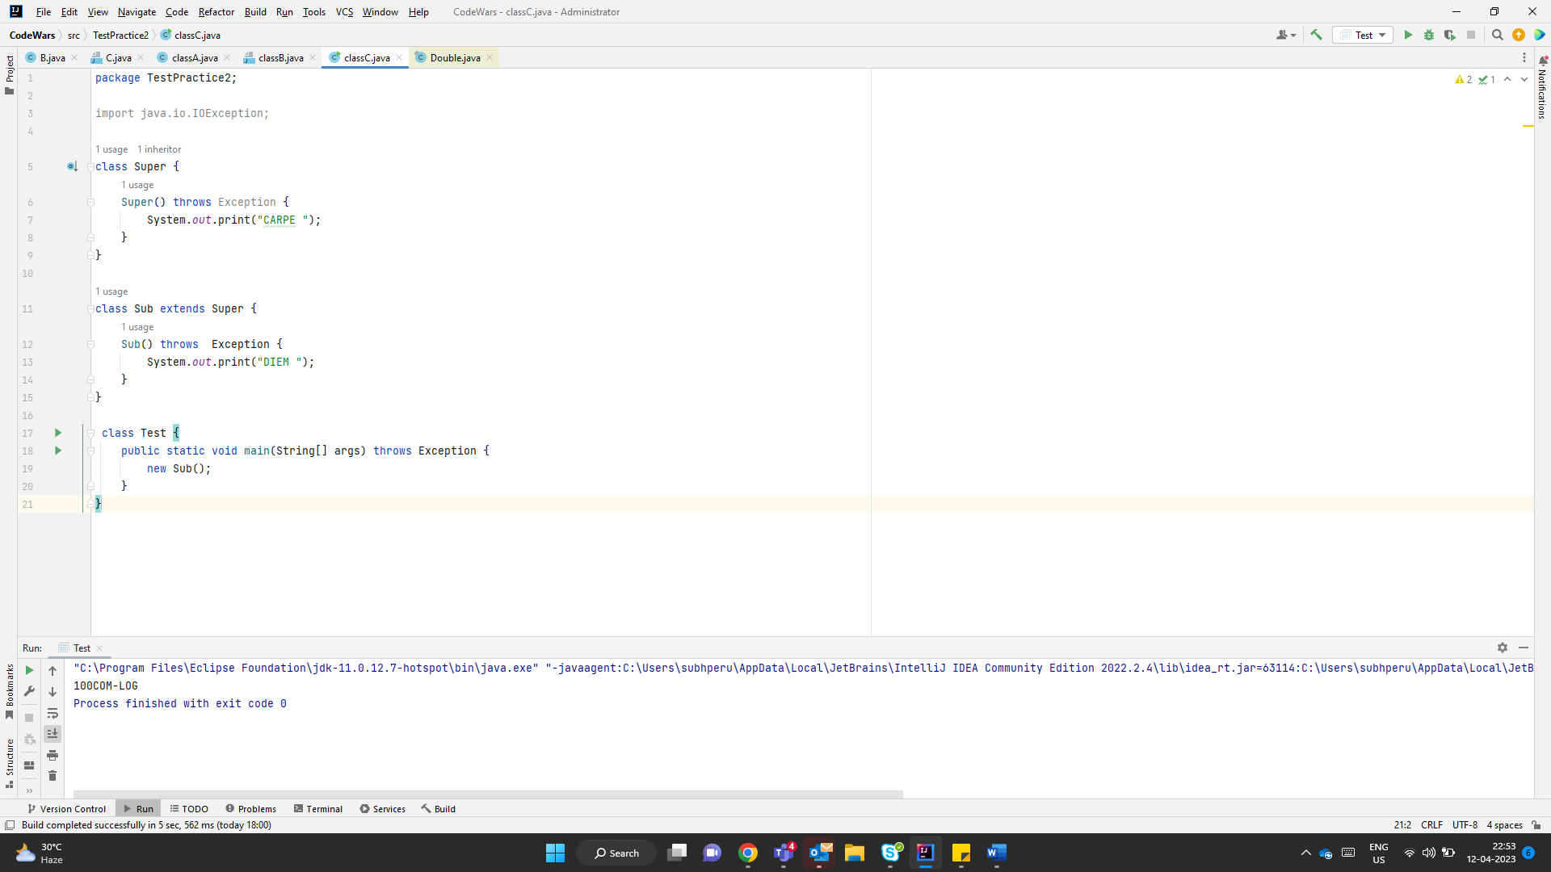

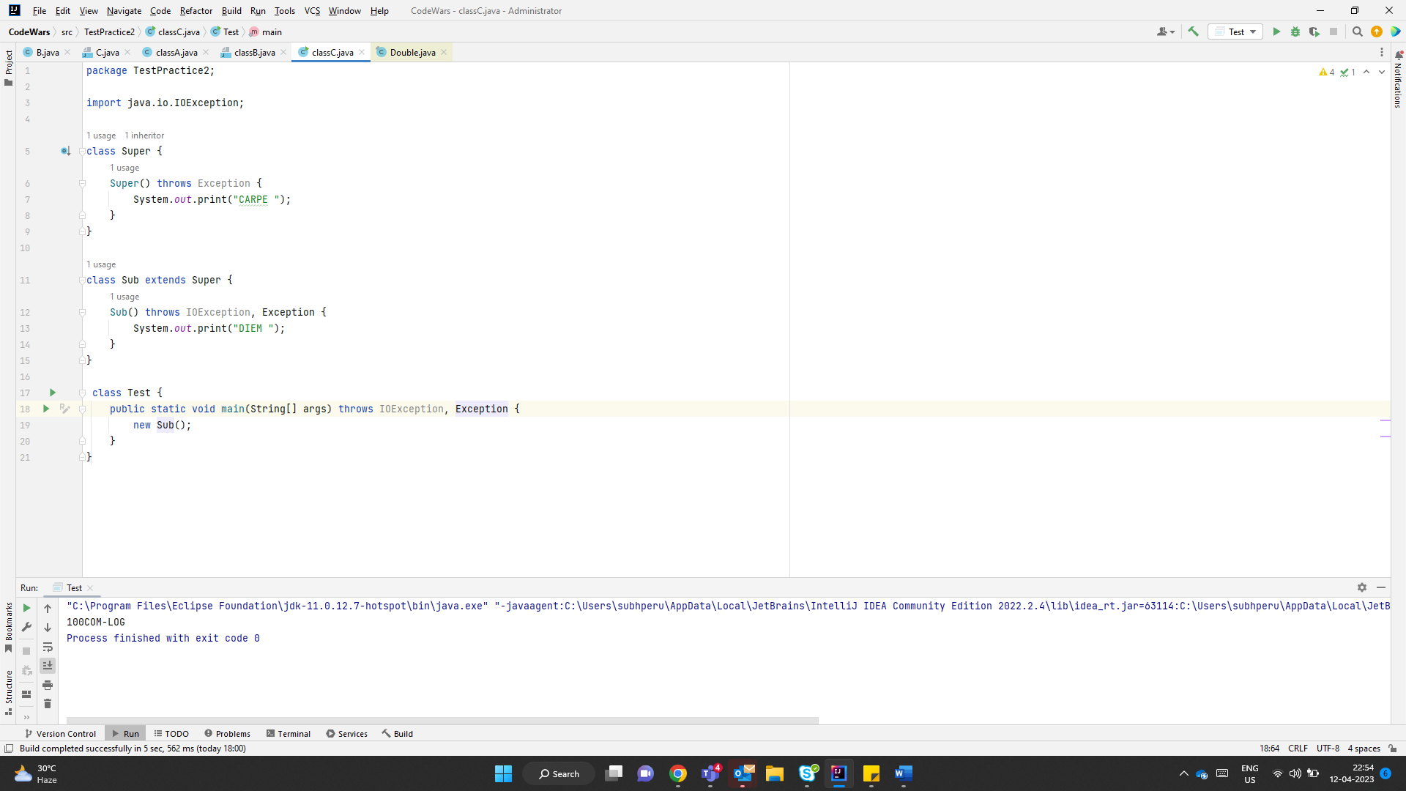

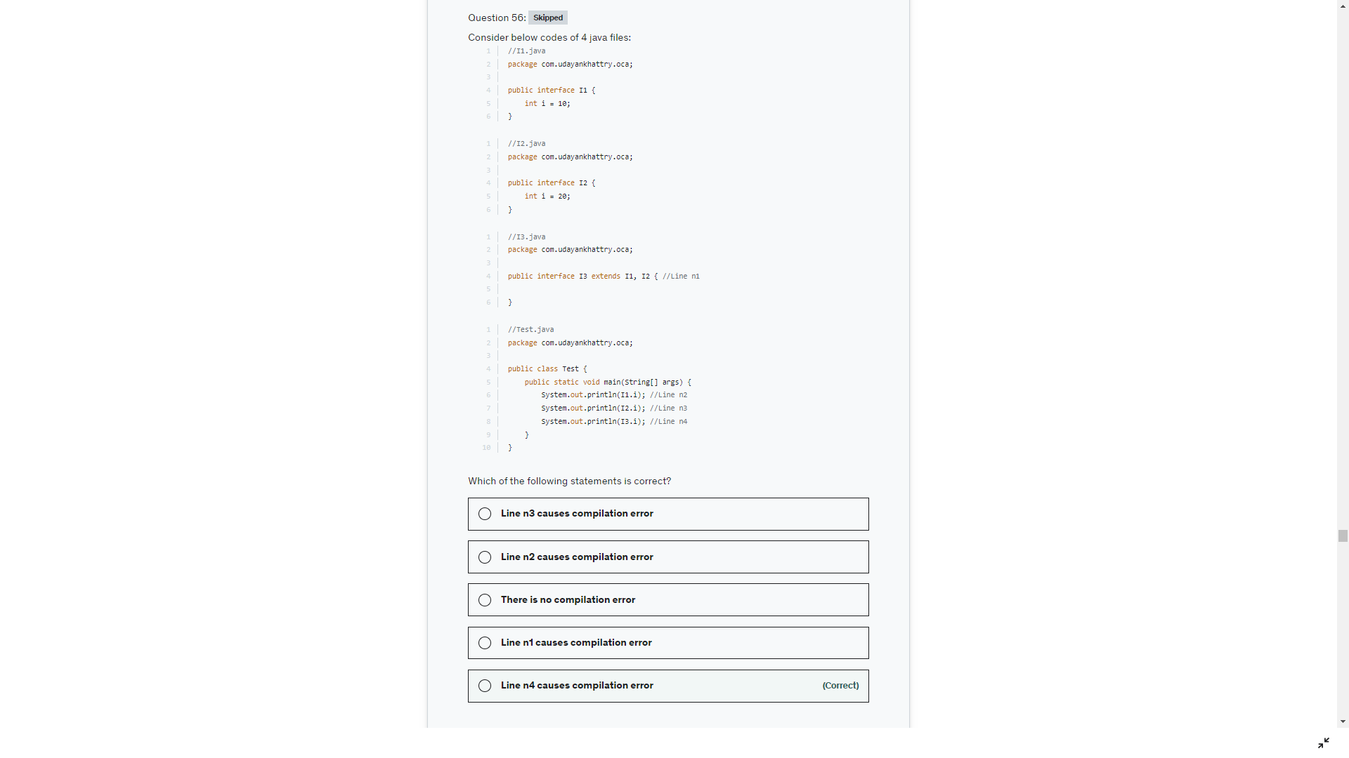

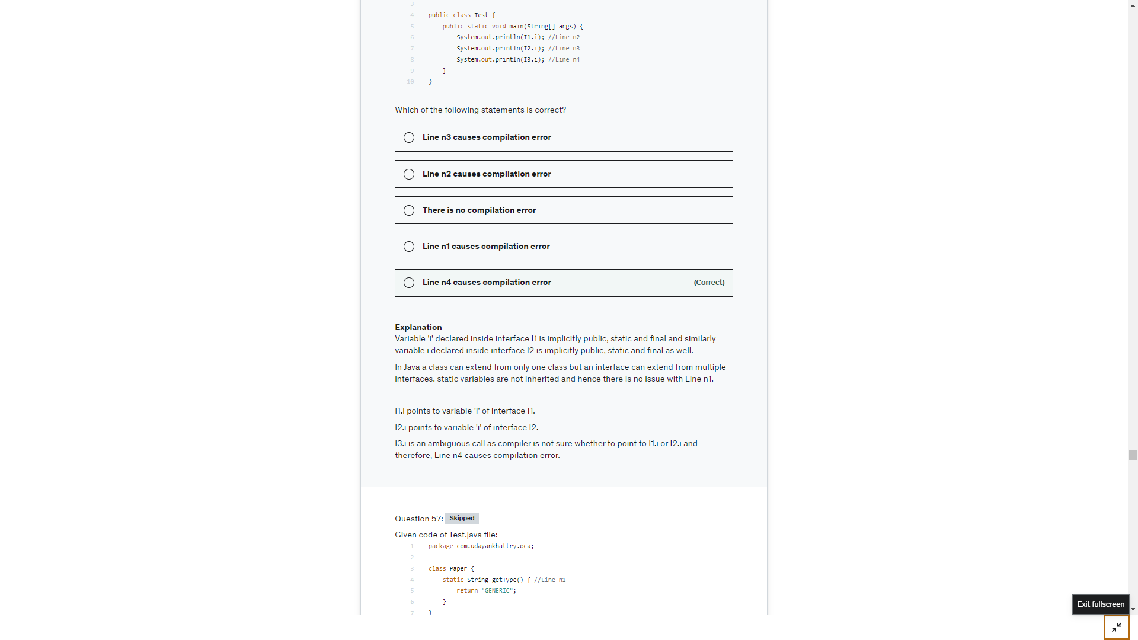

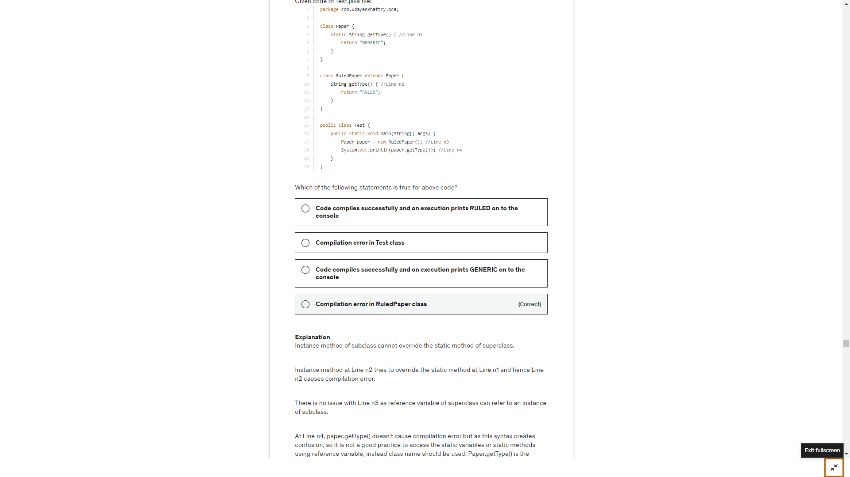

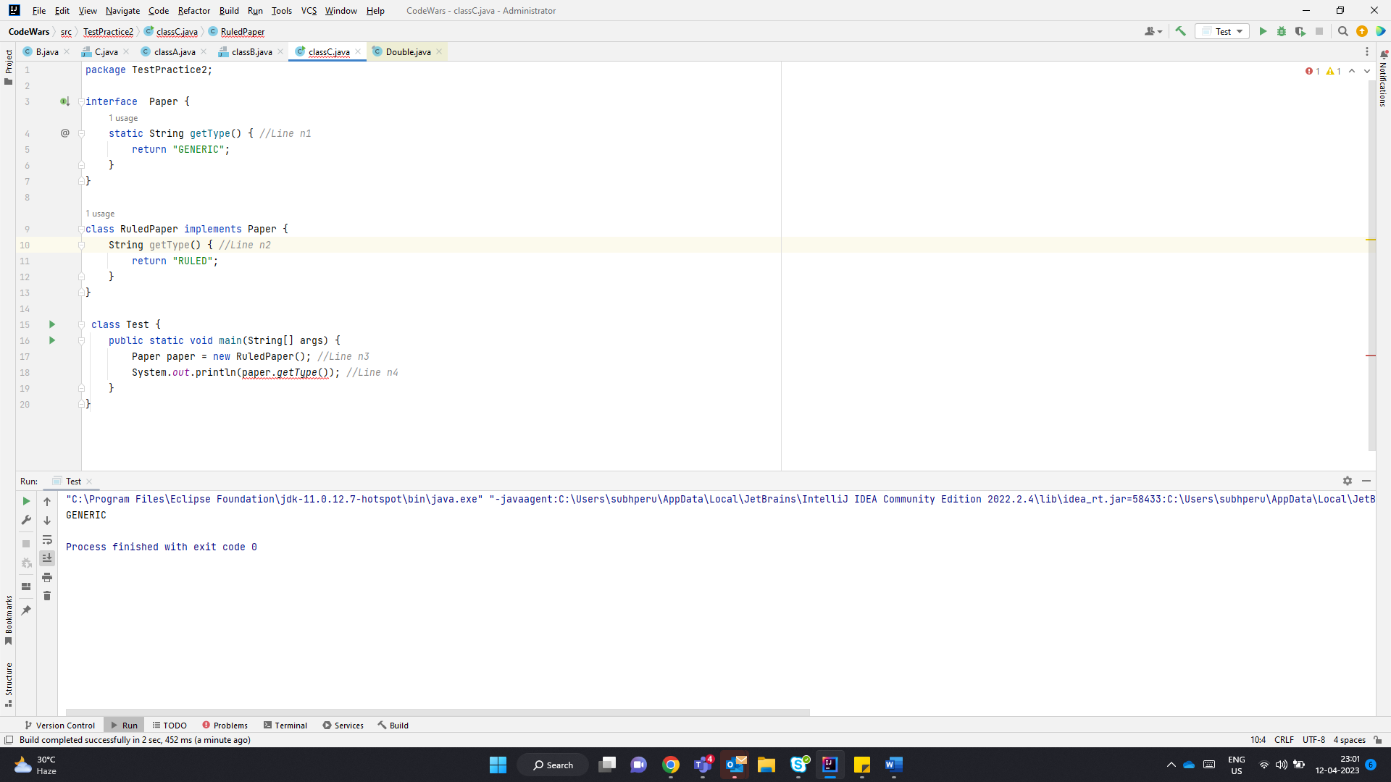

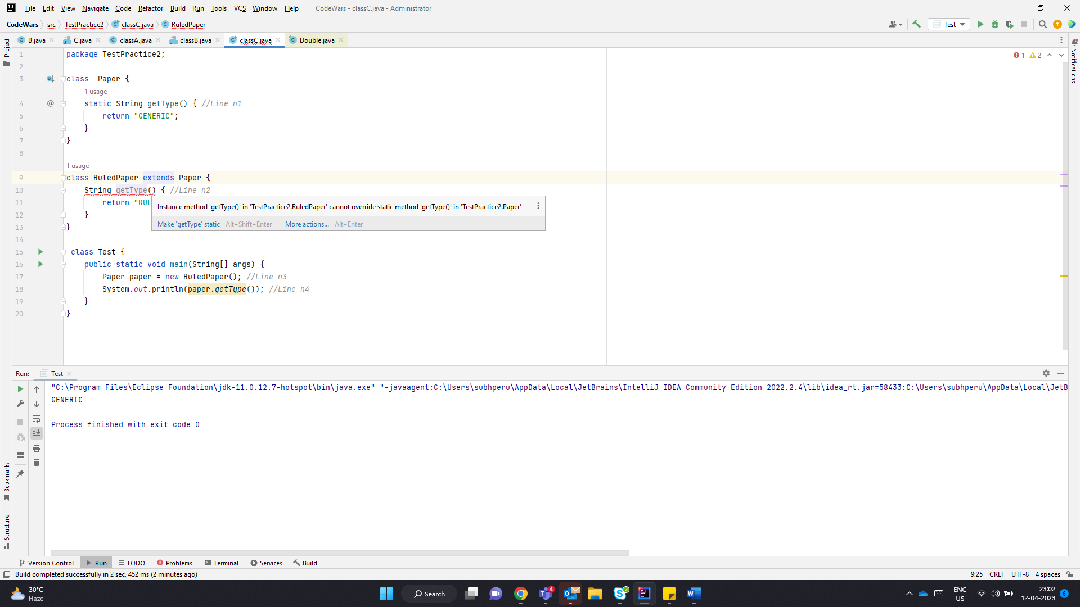

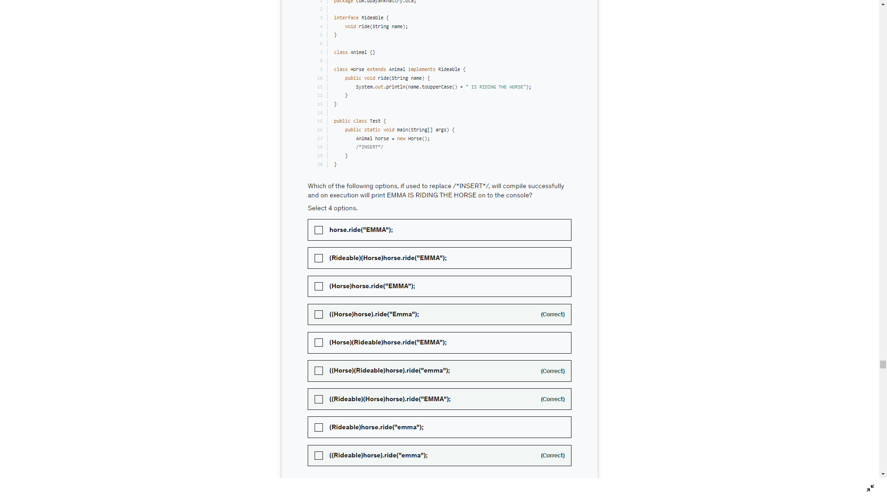

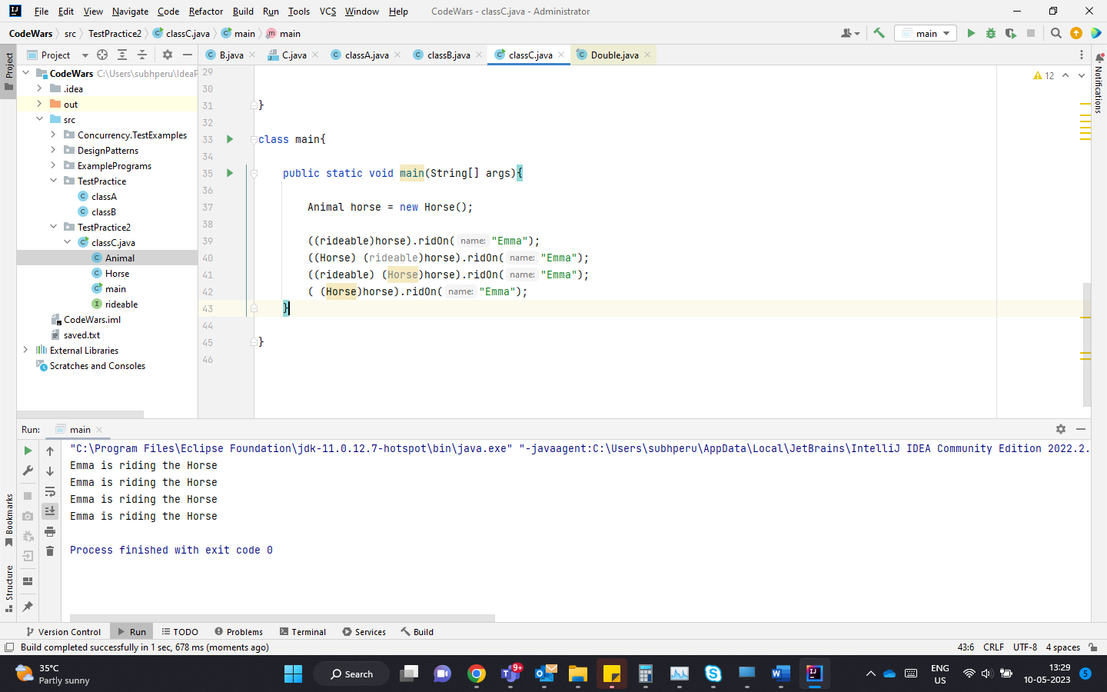

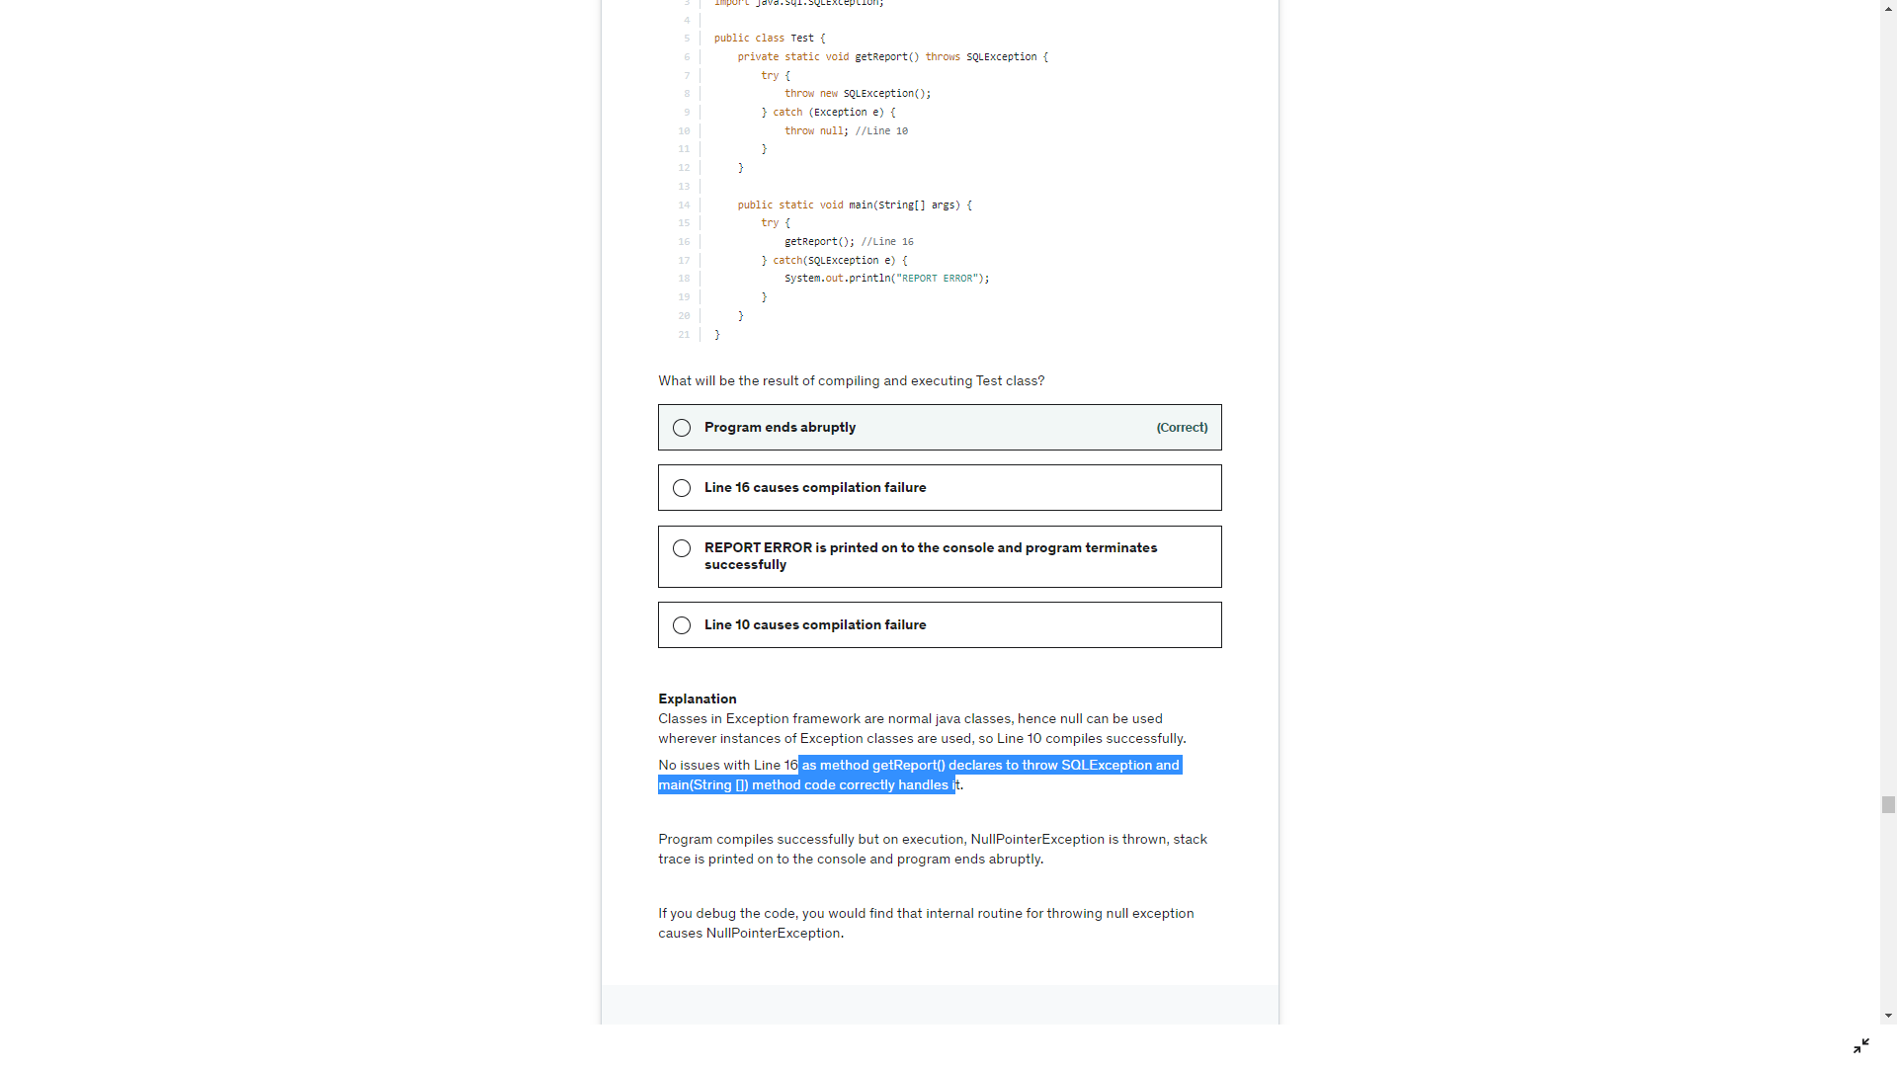

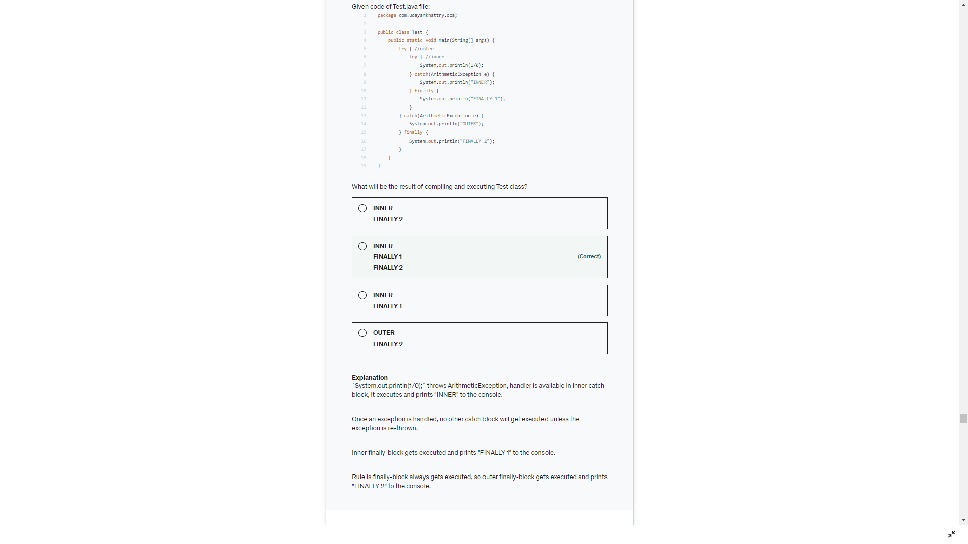

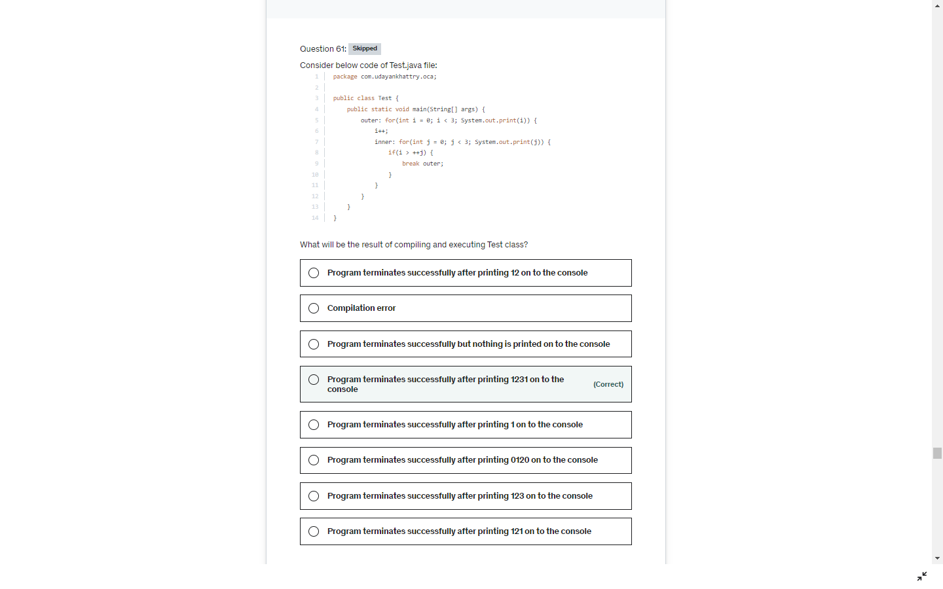

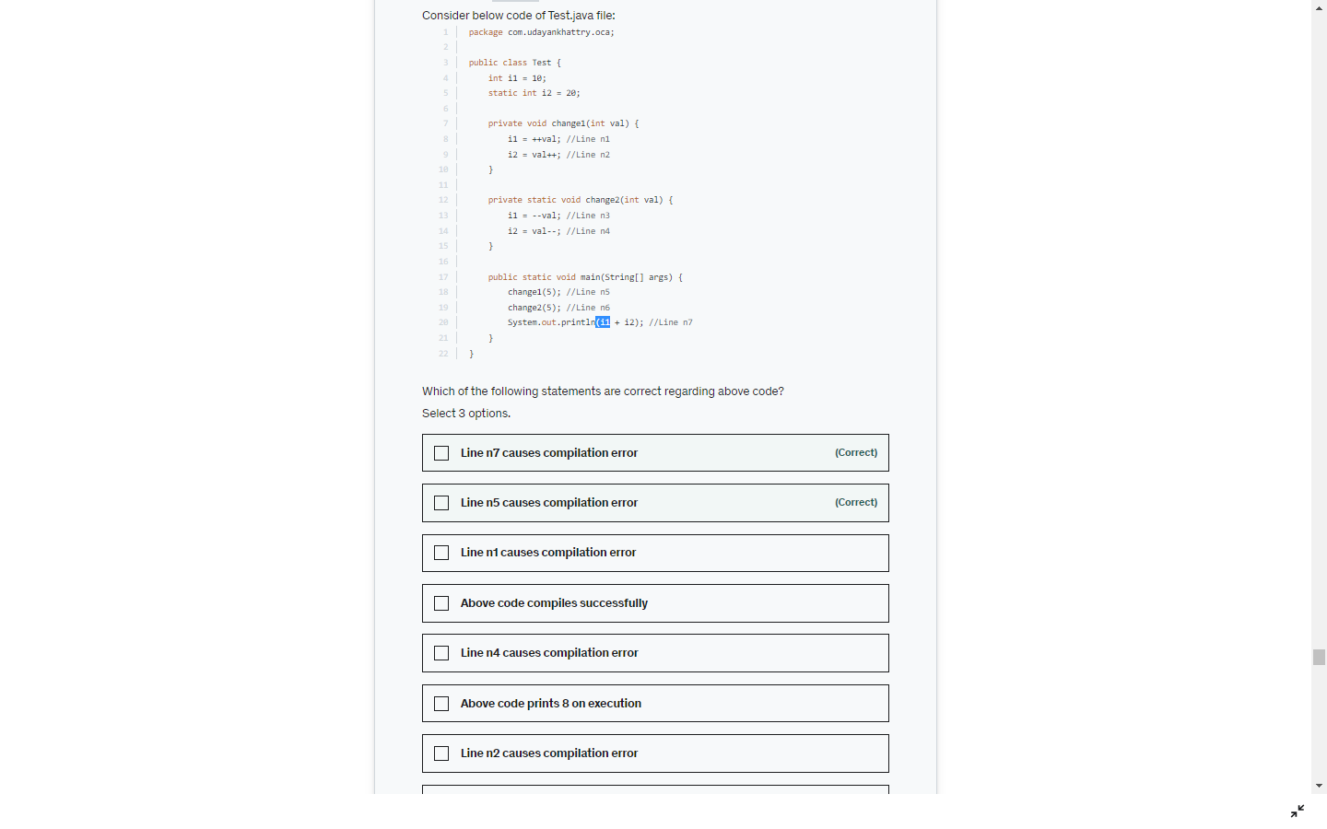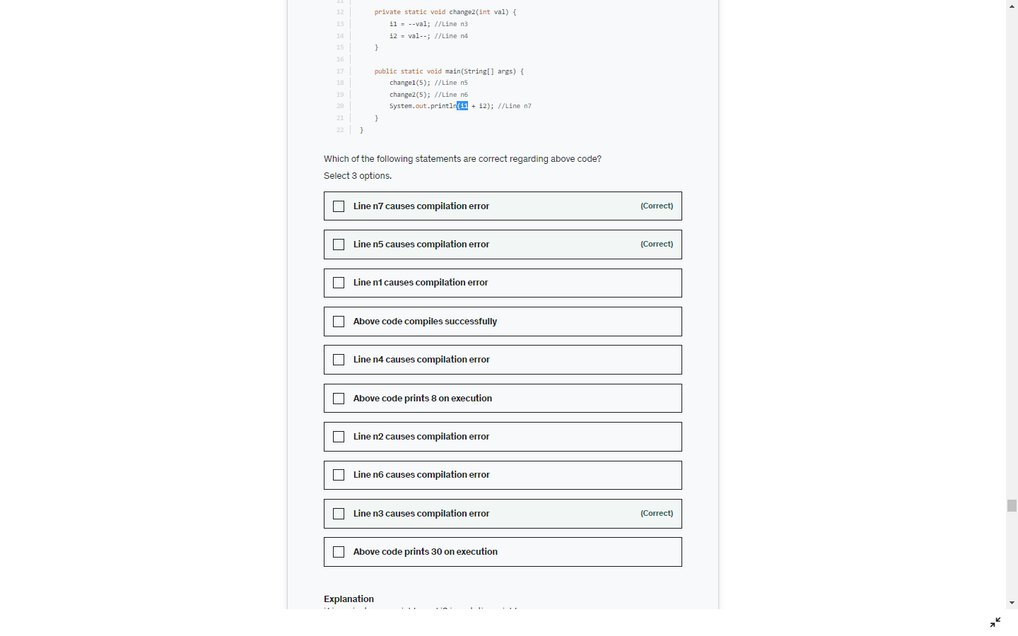

Static method calling non static methods and variables

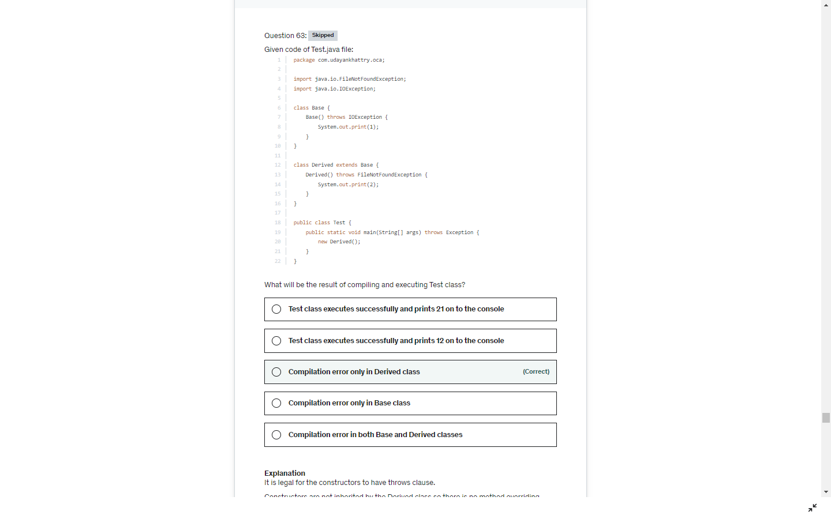`

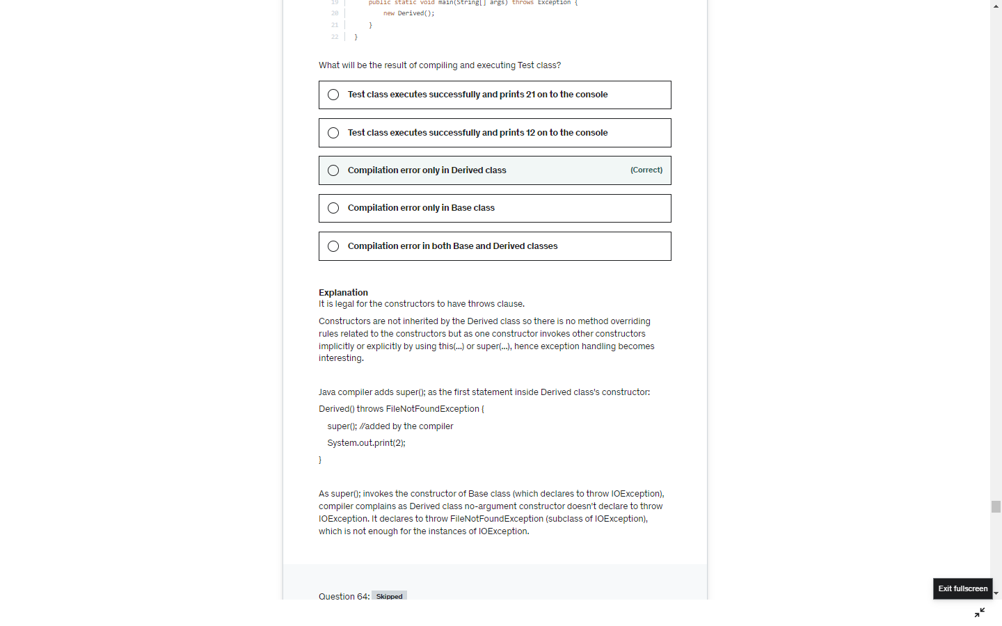

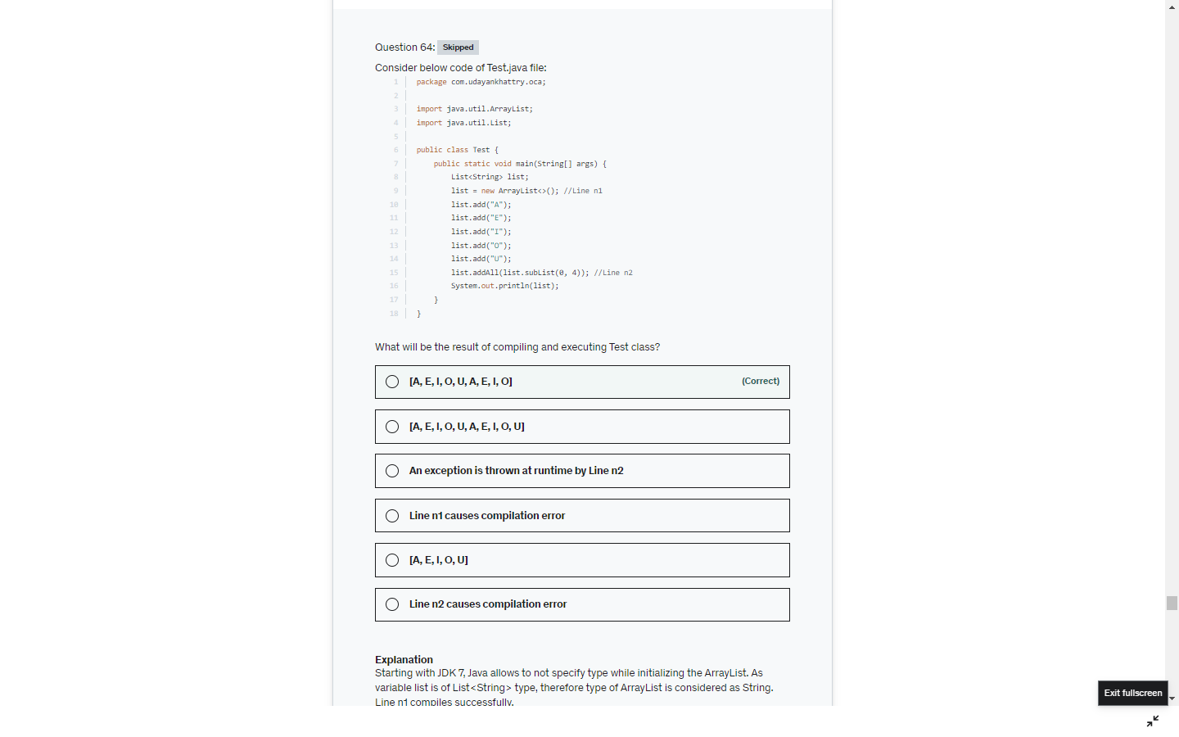

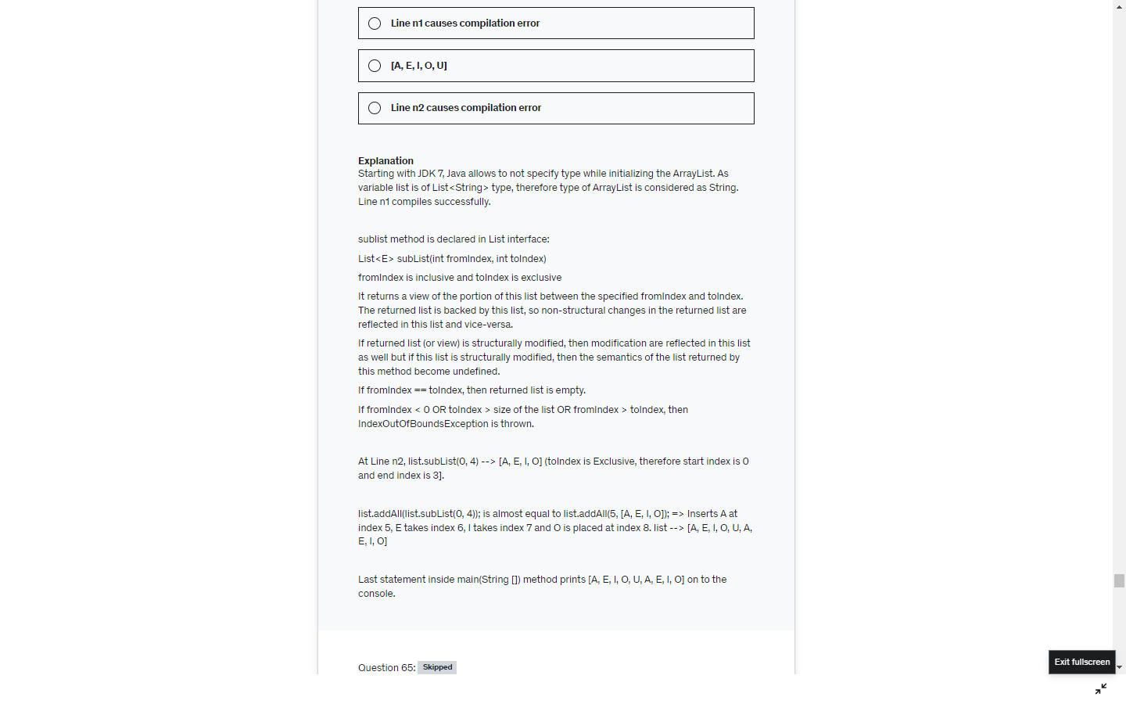

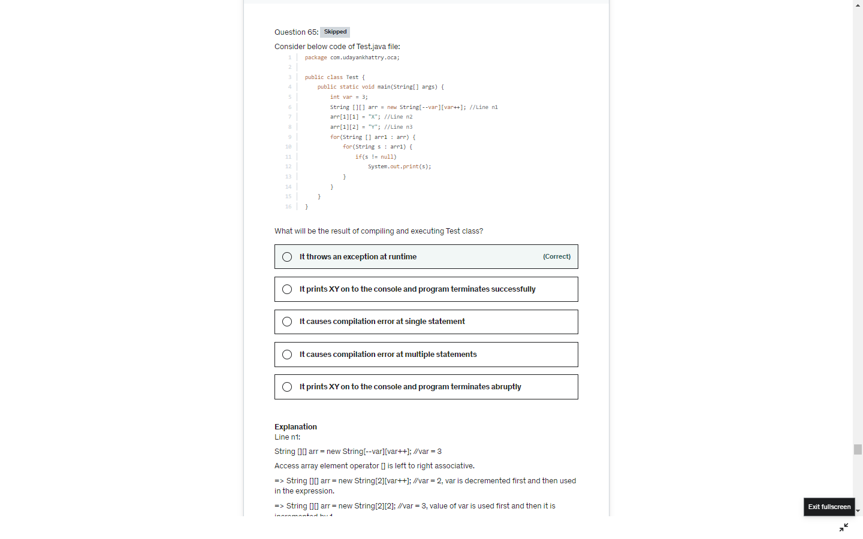`

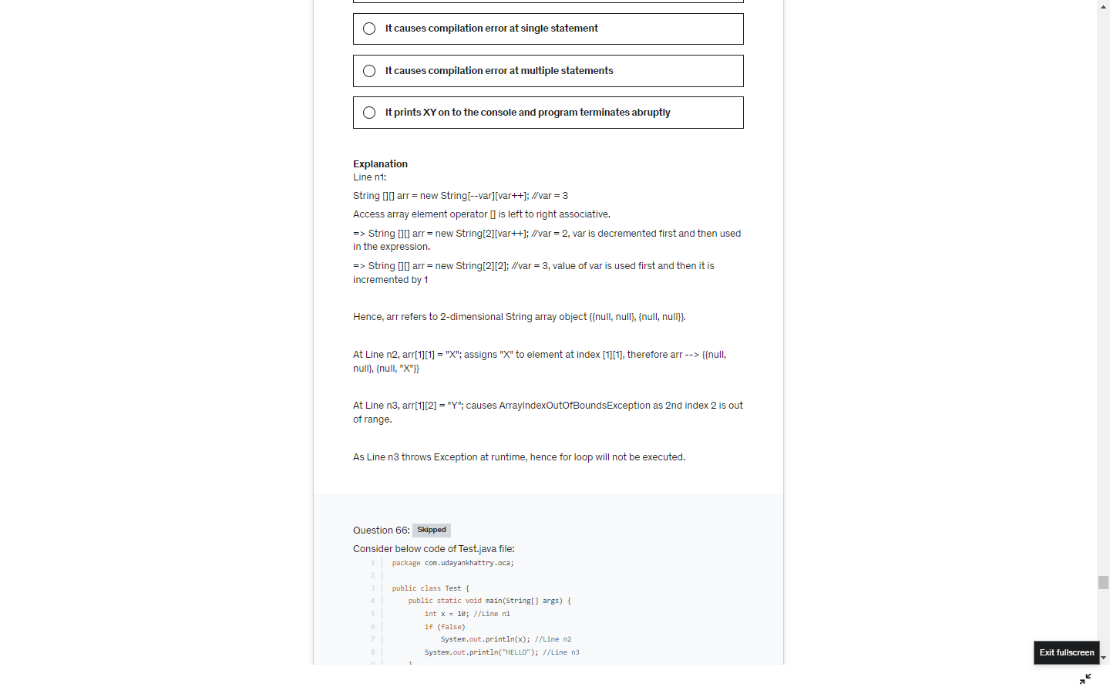

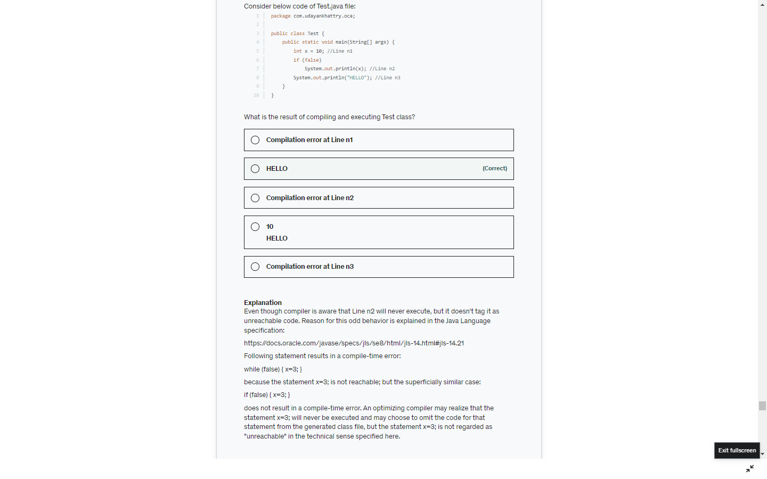

Unreachable error is thrown for while and for loop but not for if statement

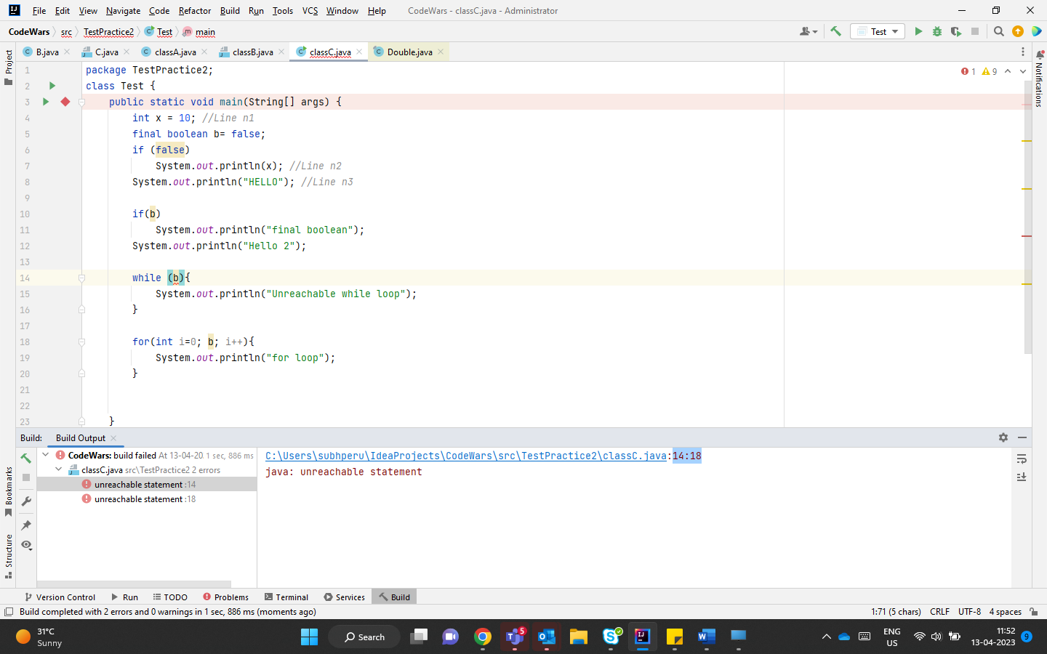

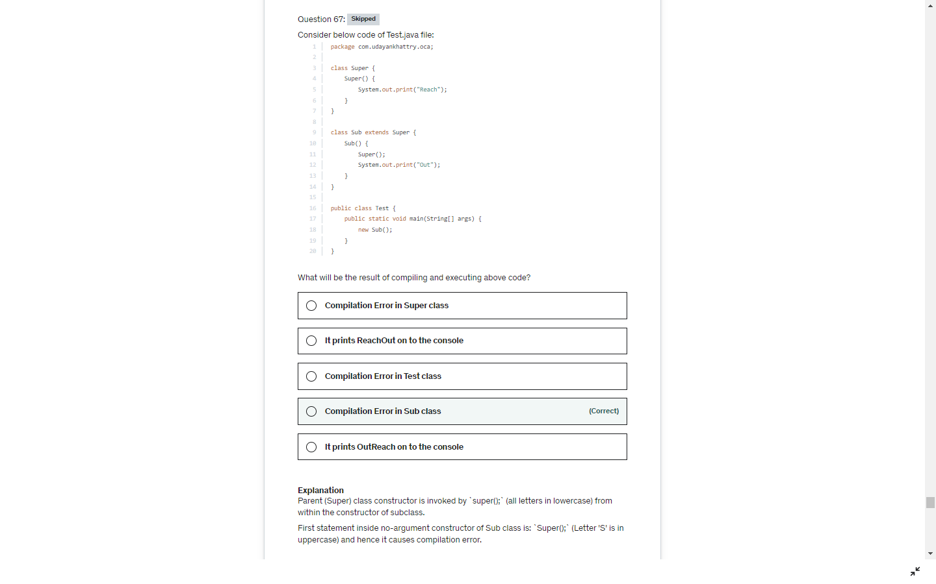

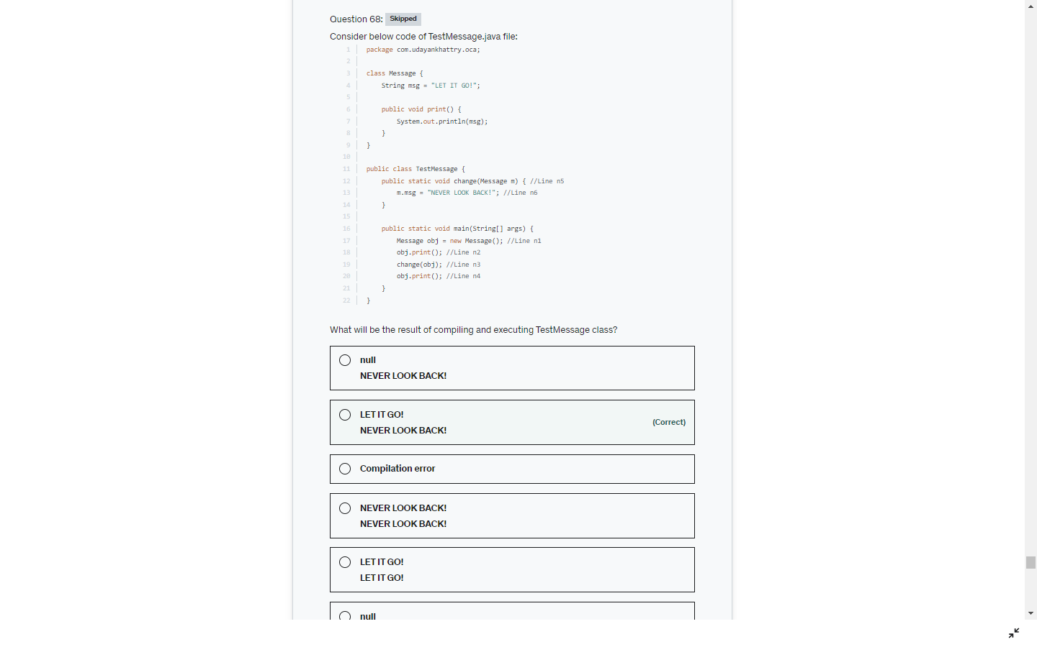

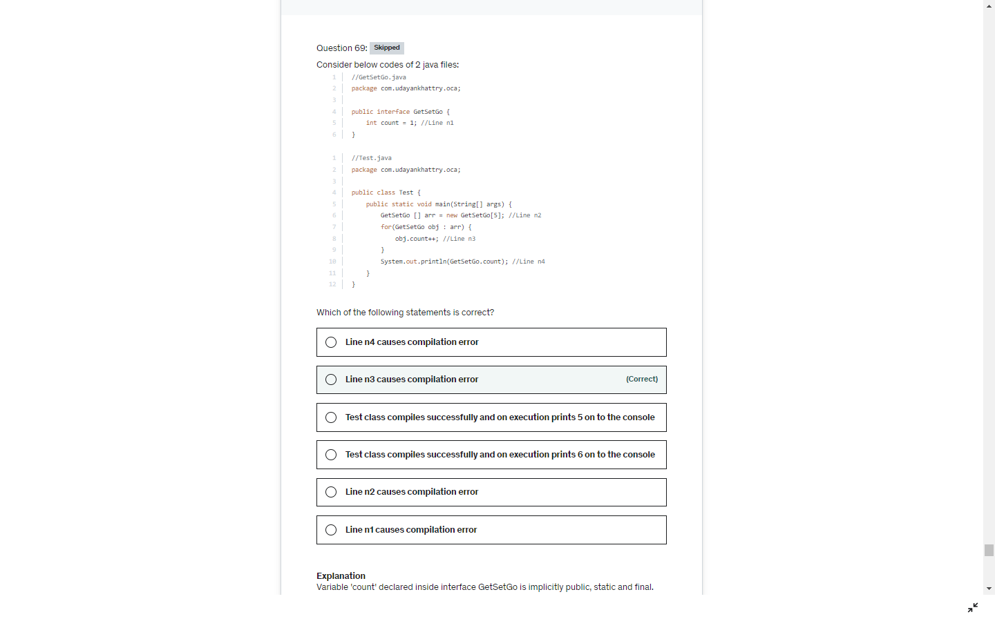

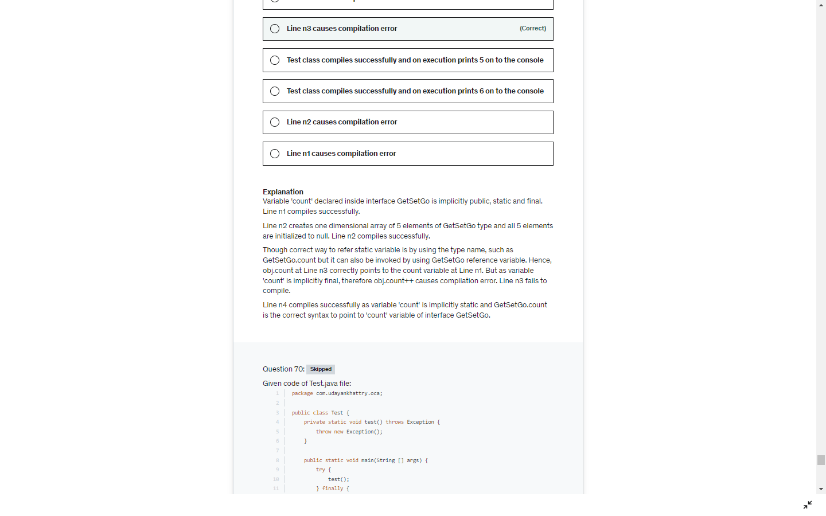

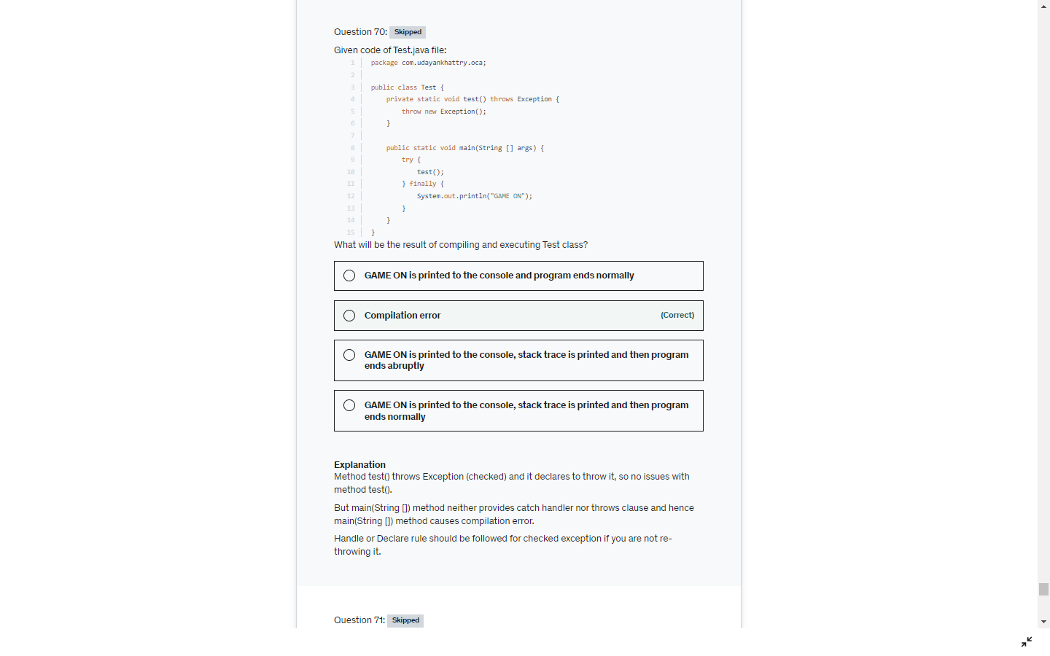

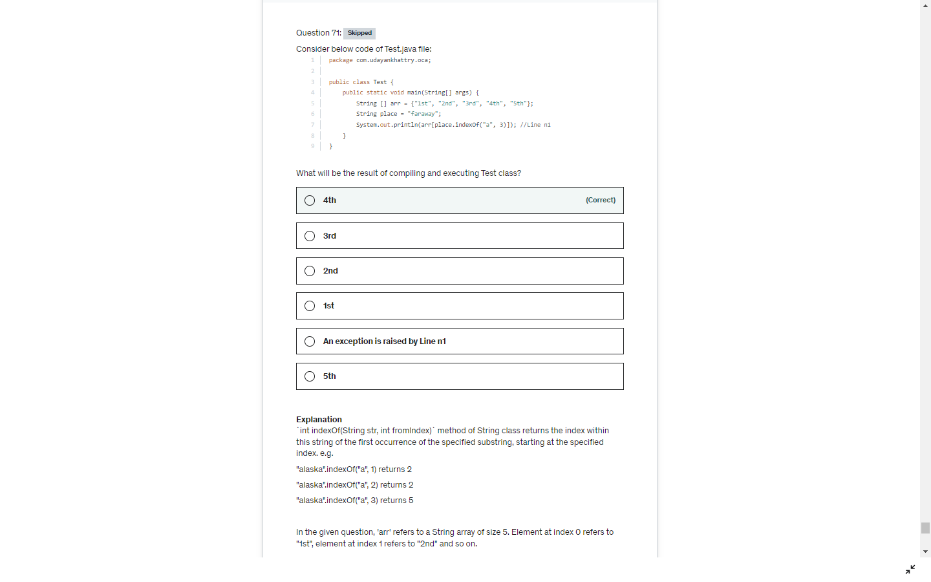

Let's solve the given expression of Line n1:

arr[place.indexOf("a", 3)]

= arr["faraway".indexOf("a", 3)] //Starts looking for "a" from index 3 of the given String "faraway" and "a" is found at index 3.

= arr[3]

= "4th" //Array element at index 3 refers to "4th".

Hence, 4th is printed on to the console.

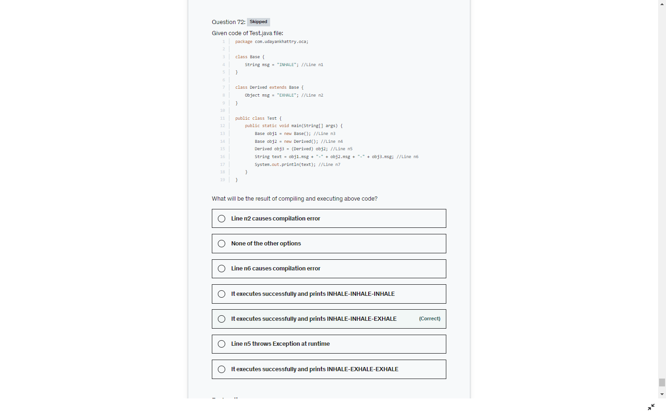

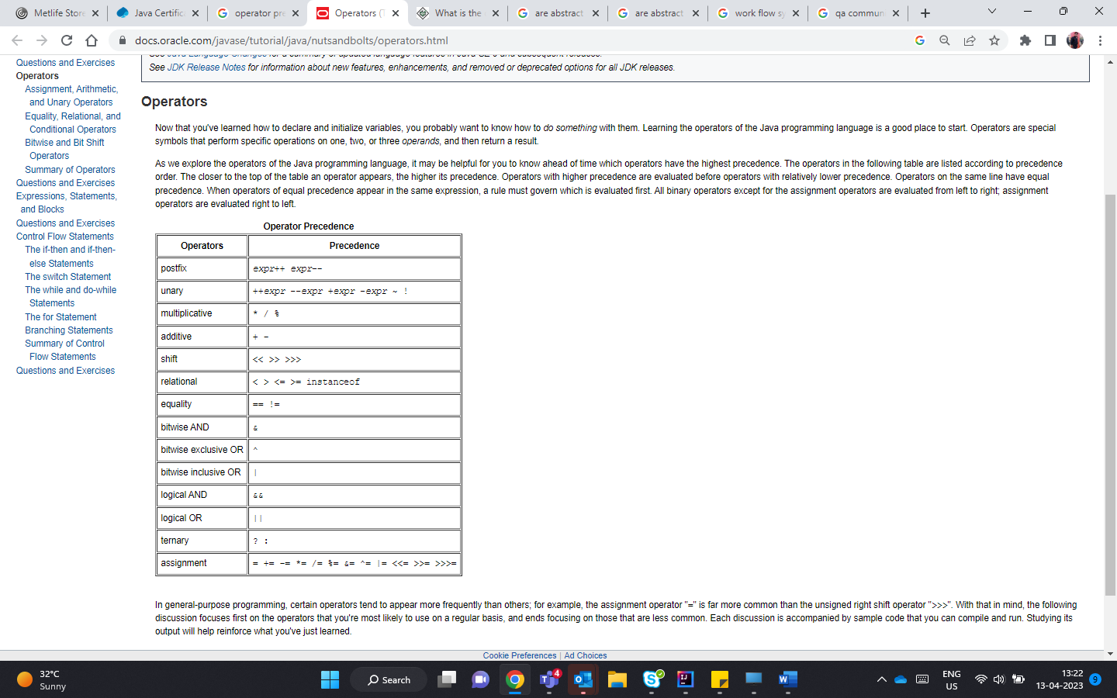

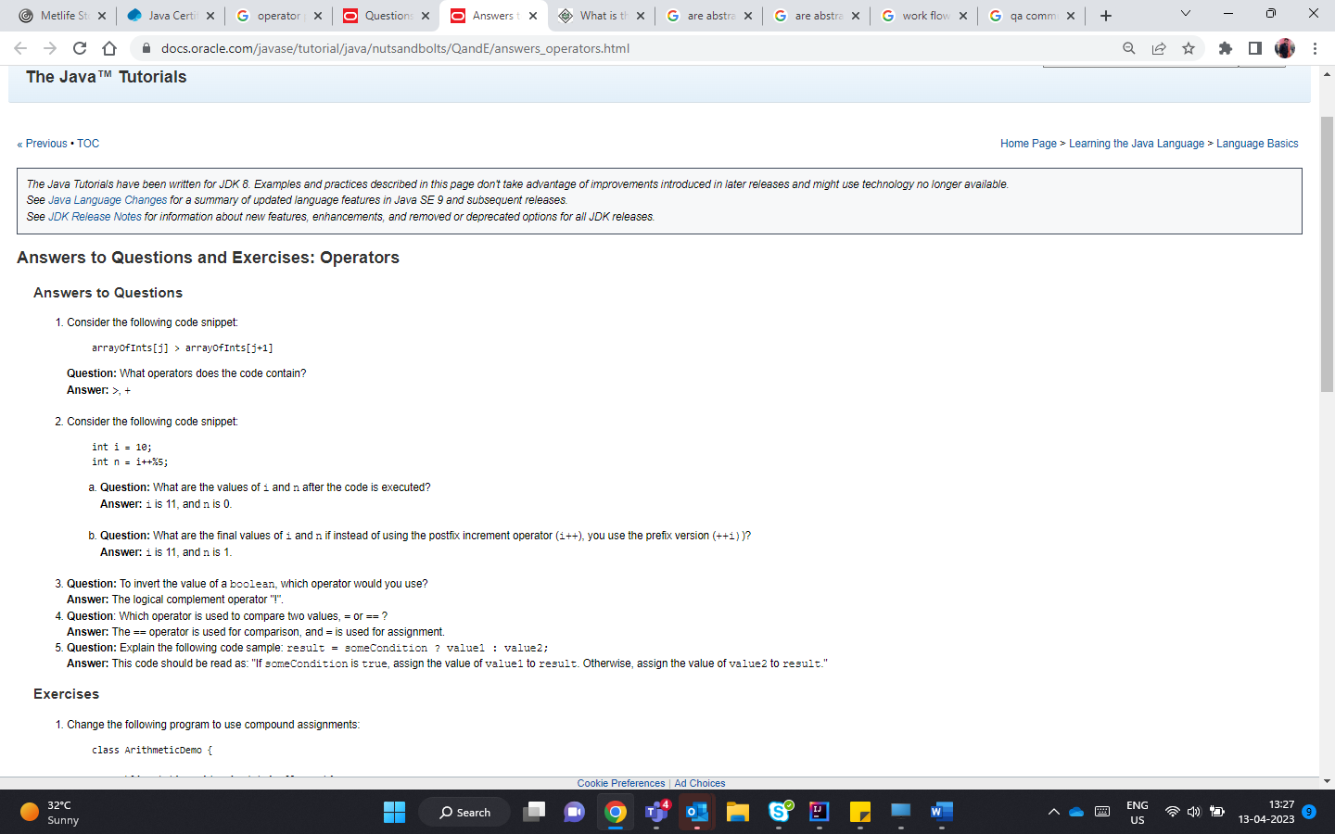

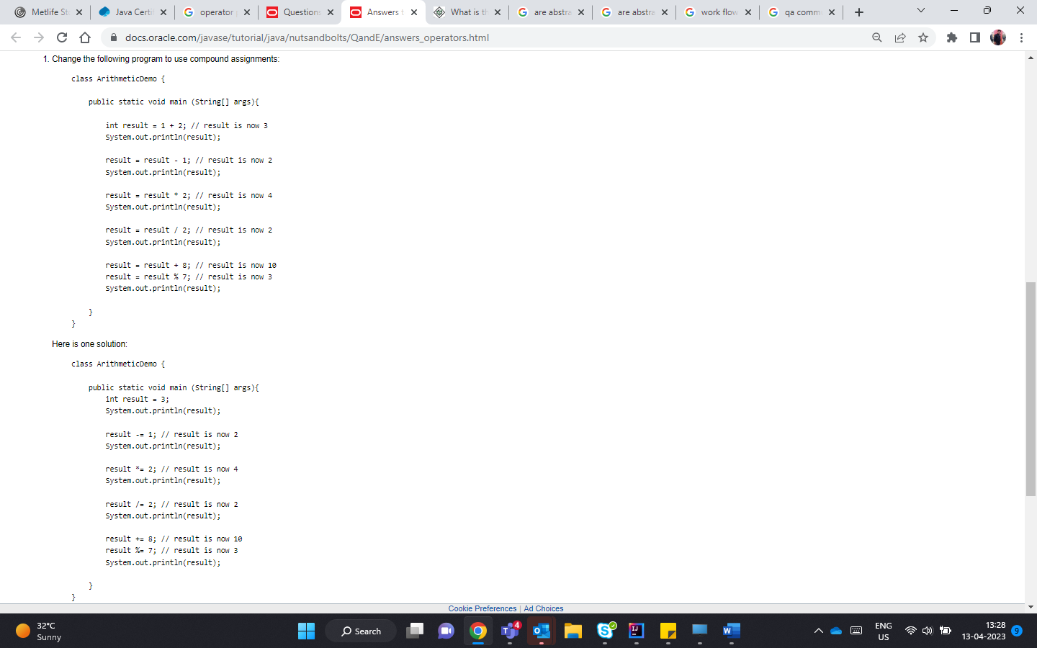

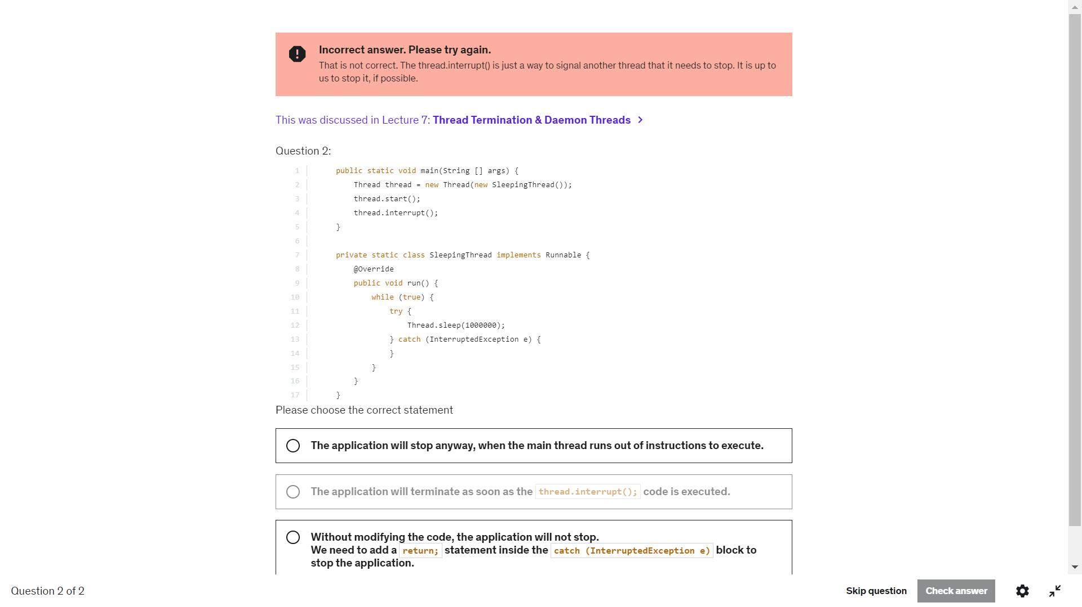

Main thread reads b.join . Main thread goes to sleeping until b thread is dead. This is not recommended cos as it has to wait until the thread is done. What if there are 1000s of lines.

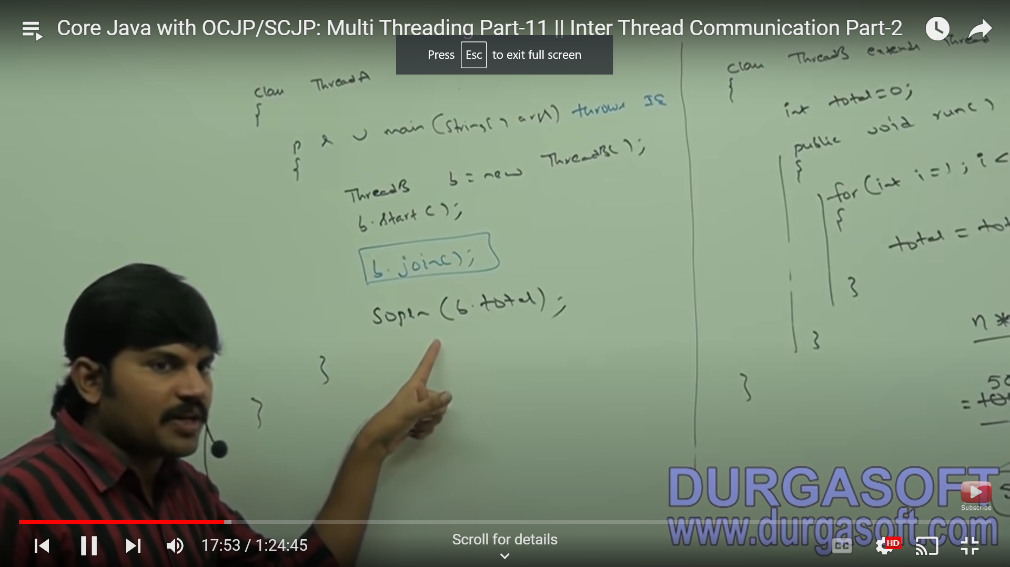

The best way is to use wait() method wait and for notify. Don’t go with join sleep or yield.

b.wait(). Wait can be used only in synchronizied method. Else Illegal monitor state exception

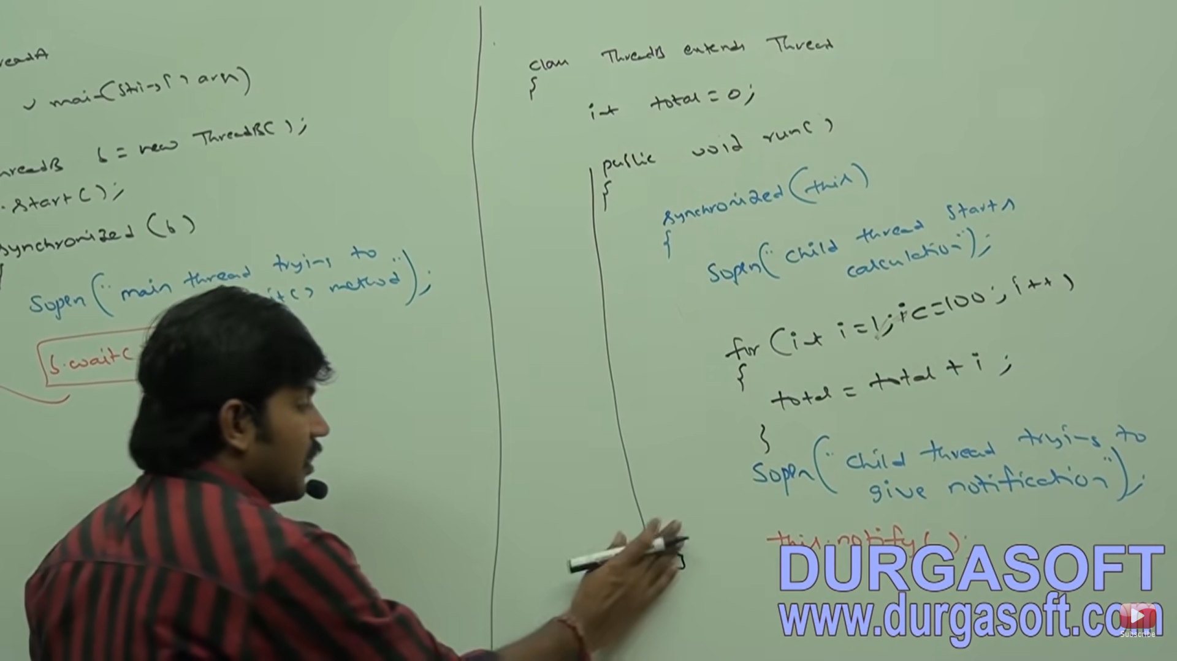

Here when Thread.sleep is done b would have been completed, Thenwhen you apply b.wait u will never be notfied

